

Lab Report

Title | Marks
Course Code: CSE-342
Course Title: Computer Graphics
Lab no: 04



Submitted By | Submitted To
Name: Junaeid Hasan Bijoy  ID: 21225103299  Intake: 49  Section: 05  Department of CSE  Bangladesh University of Business & Technology | Name: Md. Khairul Islam  Designation: Lecturer  Department of CSE  Bangladesh University of Business & Technology

Submission Date Teacher’s Signature

1.​ Title: Drawing a National Flag Using Python Turtle Graphics

2.​ Objective:
To understand the basics of Python's Turtle graphics module by designing and drawing a national flag through coding. This lab focuses on learning geometric shapes, color filling, and positioning using Turtle.

3.​ Environment:
●​ Operating System: Windows
●​ Programming Language: Python
●​ Editor: Visual Studio Code
●​ Graphics Library: PythonTurtle
●​ Hardware: Standard computer system with basic graphics capabilities

4.​ Introduction:
Python's Turtle module provides a simple way to create graphics and drawings using a virtual "turtle" that moves on the screen. It is widely used for beginner-level programming to understand loops, functions, and basic graphics handling.
In this lab, we aim to draw a national flag using Turtle. For example, we can draw the Bangladesh flag, which consists of a green rectangle with a red circle in the middle. Through this activity, students will learn coordinate positioning, color management, and shape drawing in Turtle graphics.

5.​ Algorithm:
Import the Turtle module to access drawing functions.
- Create a screen and set its background color if needed.
- Initialize the turtle and set its speed and pen size.
- Draw the green rectangle to represent the flag background:
  - Move the turtle to the starting position.
  - Draw a filled rectangle with green color.
- Draw the red circle at the center:
  - Move the turtle to the circle's starting position.
  - Draw a filled circle with red color.
- Display the flag and stop the window from closing immediately.
- End the program.

6. Code:

import turtle

# Function to draw the rectangle (Flag Background)
def draw_rectangle(t, x, y, width, height, color):
t.penup()
t.goto(x, y)
t.pendown()
t.fillcolor(color)
t.begin_fill()
for _ in range(2):
t.forward(width)
t.left(90)
t.forward(height)
t.left(90)
t.end_fill()

# Function to draw the circle
def draw_circle(t, x, y, radius, color):
t.penup()
t.goto(x, y)
t.pendown()
t.fillcolor(color)
t.begin_fill()
t.circle(radius)
t.end_fill()

# Function to draw stripe flags
def draw_stripes(t, x, y, width, height, colors):
stripe_width = width / len(colors)
for i, color in enumerate(colors):
draw_rectangle(t, x + i * stripe_width, y, stripe_width, height, color)

# Create screen and turtle
screen = turtle.Screen()
screen.setup(width=1000, height=800)
flag_turtle = turtle.Turtle()
flag_turtle.speed(10)

# Draw Bangladesh Flag
def draw_bangladesh_flag(x, y):
draw_rectangle(flag_turtle, x, y, 250, 150, "green")
draw_circle(flag_turtle, x + 110, y + 20, 50, "red")

# Draw Japan Flag
def draw_japan_flag(x, y):
draw_rectangle(flag_turtle, x, y, 250, 150, "white")
draw_circle(flag_turtle, x + 120, y + 20, 50, "red")

# Draw Germany Flag
def draw_germany_flag(x, y):
stripe_height = 50
draw_rectangle(flag_turtle, x, y, 250, stripe_height, "black")
draw_rectangle(flag_turtle, x, y - stripe_height, 250, stripe_height, "red")
draw_rectangle(flag_turtle, x, y - 2 * stripe_height, 250, stripe_height, "yellow")

# Draw France Flag (vertical stripes)
def draw_france_flag(x, y):
draw_stripes(flag_turtle, x, y, 250, 150, ["blue", "white", "red"])

# Draw Italy Flag (vertical stripes)
def draw_italy_flag(x, y):
draw_stripes(flag_turtle, x, y, 250, 150, ["green", "white", "red"])

# Drawing all flags on the screen
draw_bangladesh_flag(-450, 90)
draw_japan_flag(0, 90)
draw_germany_flag(-450, -150)
draw_france_flag(-450, -90)
draw_italy_flag(0, -100)

flag_turtle.hideturtle()
turtle.done()
7.Snapshot(Input & Output):
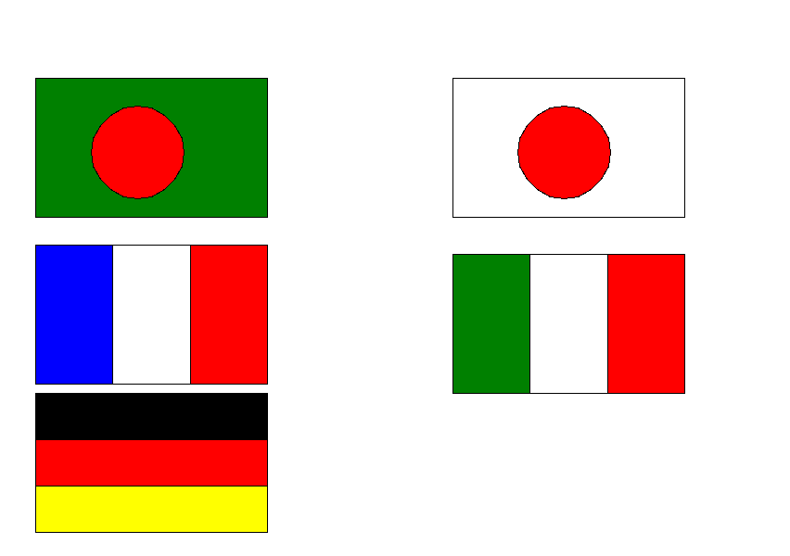

8.​ Discussion & conclusion:
The lab successfully demonstrated how Python's Turtle graphics can be used to draw simple to complex designs, such as a national flag. By completing this lab, we improved our skills in:
- Basic graphics programming.
- Managing coordinates and shapes.
- Applying logic for drawing patterns and objects.
This activity reinforced programming logic and visual problem-solving, which are essential in graphical user interface (GUI) design and game development.

