|  |
| --- |
| *Ahsanullah University of Science & Technology*logo.jpgDepartment of Computer Science & Engineering |
| Student Management System |
| SOFTWARE DEVELOPMENT 3 |
|  |
|  |
|  |

|  |  |
| --- | --- |
| Submitted By: | |
| Nazmus Sakib | 16.01.04.072 |
| Md. Junaeid | 16.01.04.055 |
|  |  |
|  |  |

|  |
| --- |
|  |

INTRODUCTION  
  
Our project name is Student Management System which simply amplified the basic needs of students daily purpose. It is mainly a desktop based software with student management features. Now a days many educational institution still not have digitalized database system for their institution. This software aim to meet their goal with some effective extends.  
  
  
  
MOTIVATION  
  
  
Our project mainly looking forward to develop a useful software to maintain an Educational institution. As we see there are so many Educational institution , but only enormous enterprise business group is fully digitalized but the smaller one is far behind from the advance student management tools. So we are trying to develop student management software. The main aim of the project to ensure a convenient software with very user friendly operation .   
  
  
*PLATFORMS*  
OS: WINDOWS 10  
  
Programming language: Java,Html,CSS,Bootstrap  
  
Tools: visual studio 2010/ 2012, Microsoft sql server  
  
Database: sql server 2008/ 2012  
  
  
 FEATURES  
FEATURES:  
  
1. Main software is divided into 4 parts  
   
 <1> Admin Section  
   
 -Modification of student personal information  
 -Modification of students related info  
 -Admin can add admin ,teacher and student data

-Effective update on every record

<2> User Section  
  
 -There are Three types of User

1.Adminstrator

2.Student

3.Faculty

Here Only Administrator can add a student and Teacher

On the Other Hand Teacher and Student can only show their

Information They can’t edit their info.

<3> Login Section

Here Student, Teacher and Administrator can login their account by using their Own Id and Password.

-

ENTITY RELATIONSHIP DIAGRAM  
  
  
 

ADDS

Enrolls

ADDSA

Adminstrator

Department

Belongs

Employed

Student

Faculty

Teaches

Offered

Course

**DESIGN AND TECHNICAL RESOURCE**:  
  
This software is fully followed relational databases. Because of using RDMS  
the complexity is in minimal range and the data retrieve possibility is very effective. Data redundancy is overruled, every constrain of the databases is followed the theoretical relational core database theory.  
  
  
  
  
   
IMPLEMENTATION

Every expected features should be added correctly and it is a challenge for us, as expected we modify our proposed proposal to ease the overall performance. For example we use more tables in databases which slightly violate our ERD model but its improve overall complexity. Student management table is divided into two parts instead of one to maintain flawless transaction.  
  
  
 **REUSEBILITY**The total software is divided into three layer architecture. They are user interface, database layer and business logic. The user interface provide design part to the user there is no database connection .The business layer provides security by adopting private variable which comes from user interface. In business layer the private variable sets to public by implementing proper method. The last layer is database layer every database request which comes from business layer is constructed here. Database layer build and open connection between sql server and provides the required operation based on user request. We transform the whole project into these three layer to provide other developer to work and expand our project features without any difficulty.  
  
  
  
WORK FLOW   
  
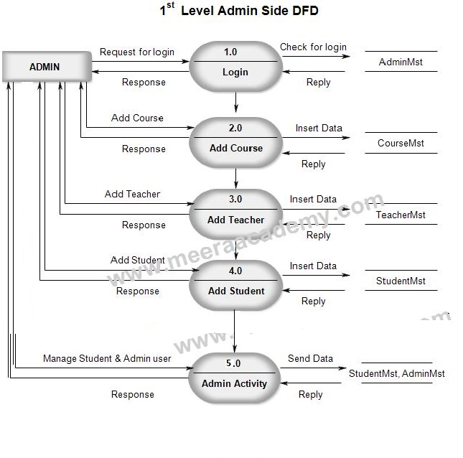  
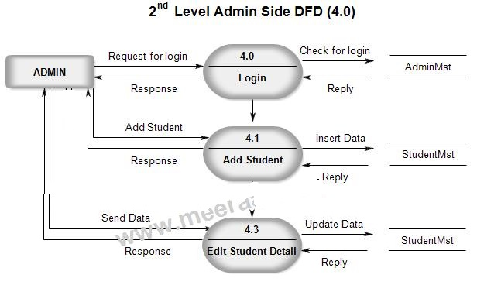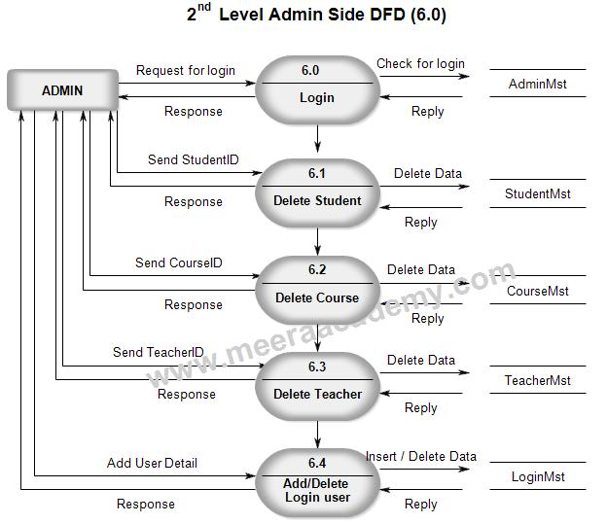  
ADVANTAGE:  
  
1.By this we can insert,delete or update student’s id,department and information details easily.  
2.Security layer is strong.  
3.User cant complain about false daily record.  
4.User Friendly.  
LIMITATIONS :  
1.Only Admin can change the student and faculty information.  
2. Daily log also has no rollback.  
3.No online support to claim any error instantly.  
  
  
FUTURE SCOPE:  
  
1.In the future the students can also be able to upload or download notes.  
2.The whole project will be made available as an android app for far more ease of use and mobility.  
  
  
Conclusion

This Software is very easy to use so all educational institute can use this frequently.So we can hope that our software will be very popular and get sponsors to develop in future.