|  |  |
| --- | --- |
|  | **Namal University, Mianwali**  **Department of Computer Science** |

Date: 23 February 2025

**Lab:: 1**

**TITLE: Introduction to Python**

**COURSE: Artificial Intelligence Lab**

**Submitted by:**

Name: Junaid Ameer Khan

Roll No: NUM-BSCS-2022-46

**Submitted to:**

**Ammar Ahmad**

**Q1:** Write a simple calculator program. Follow the steps below: Declare and define a function name “Menu” which displays a list of choices for user such as addition, subtraction, multiplication etc. It takes the choice from user as an input and return. Define and declare a separate function for each choice. In the main body of the program call respective function depending on user’s choice. Program should not terminate till user chooses last option that is “Quit”

**SOLUTION:**

In this we create the program like modern computer that we can add, subtract , multiply and divide one by one with answer and and so on . i.e. 12 + 14 = 26, then 26 – 22 = 4.  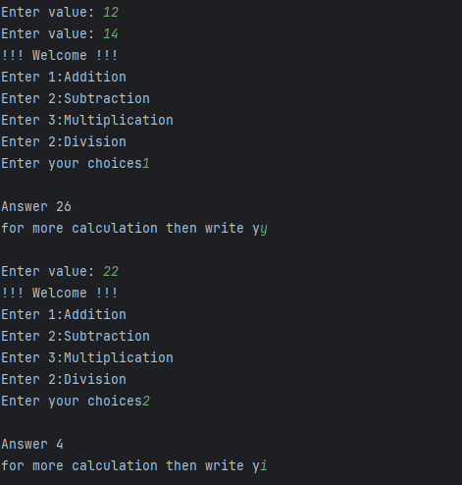

**Q2:** Write a method to calculate factorial of a number entered by the user.

**Solution:**



**Q3:** Write a program that lets the user enter in some English text, then converts the text to Pig-Latin. To review, Pig-Latin takes the first letter of a word, puts it at the end, and appends “ay”. The only exception is if the first letter is a vowel, in which case we keep it as it is and append “hay” to the end. E.g. “hello” -> “ellohay”, and “image” -> “imagehay”

Hint: Split the entered string through split() method and then iterate over the resultant list, e.g. “My name is John Smith”.split(“ ”) -> [“My”, “name”, “is”, “John”, “Smith”]

**Solution:**

**Not a vowel:**



**Vowels:**



**Conclusion:**

In this introductory lab on Python within the Artificial Intelligence course, we explored fundamental programming concepts such as function definition, user input handling, and string manipulation. By implementing a simple calculator, calculating factorials, and converting text to Pig Latin, we laid a solid foundation for further studies in Python programming and its applications in artificial intelligence.

_______________________________