STRATUM-Desktop

QGroundControl
Architecture Analysis — From the Cockpit to the Air
A layer-by-layer dissection of QGroundControl as the substrate for STRATUM.
Baseline: v5.0.3-1086-g27065dcdd · Framework: Qt 6 / QML · Protocol: MAVLink
Prepared 23 June 2026 · Strategic Systems Architecture review

Contents

1. Executive Summary
QGroundControl is not a monolith. It is a layered set of architectural decisions, each of which trades flexibility against coupling, and each of which dictates where STRATUM can extend the system cheaply and where it cannot. This document dissects those layers — from the operator-facing QML interface down to the byte that leaves the radio — and names the interfaces, the entities, and the data that crosses each boundary.
The central finding is structural and favorable. QGC is organized around a single dominant entity — Vehicle — which aggregates the domain managers and exposes vehicle state to the UI as observable properties. Below it, a polymorphic plugin seam (the QGCCorePlugin / FirmwarePlugin pair) was deliberately engineered to absorb variation in firmware dialect and user interface. STRATUM should live in that seam, not in a fork of the tree.
Decisions dictate destiny. The most consequential decision the QGC authors made was to route every inbound and outbound message through narrow, well-named signals — MAVLinkProtocol::messageReceived on the way up and LinkInterface::sendMessageThreadSafe on the way down. Those two chokepoints are the system's nervous system, and they are the highest-leverage points STRATUM can tap.

Reading guide
- Section 2 establishes the framework and the core vocabulary used throughout.
- Section 3 presents the seven-layer stack at a glance.
- Section 4 analyzes each layer: its entities, responsibilities, and the interfaces it presents up and down.
- Section 5 traces two end-to-end paths — inbound telemetry and outbound command.
- Section 6 is an interface reference: the concrete signals and methods that cross each boundary.
- Section 7 maps the STRATUM integration tradespace and its systemic risks.

2. Architecture as a Set of Decisions
Before dissecting QGC, define the lens. An architecture is the set of decisions that are expensive to reverse. Everything else is implementation. Throughout this document the system is described in terms of entities — the things that hold state and identity — and the relationships between them: who owns whom, who signals whom, and what data crosses the wire between them.

Core terms
Term | Working definition for this analysis
Layer | A horizontal band of responsibility that depends only on the contract of the band below it. Crossing a layer should require crossing a named interface.
Entity | A long-lived object with identity and state — e.g. a Vehicle, a Link, a Fact. Architecture is largely the story of which entities own which.
Interface (seam) | The contract across which two layers communicate: a Qt signal, a virtual method, a Q_PROPERTY binding. STRATUM extends the system at seams.
Tradespace | The space of viable architectural options bounded by constraints. We do not seek the 'right' answer; we characterize the options and their costs.
Emergent property | Behavior that exists only at the system level — e.g. end-to-end command latency, or a deadlock — and cannot be read off any single layer.
Systemic risk | A failure whose blast radius crosses layers, typically because a coupling was stronger than the diagram implied.
With that vocabulary fixed, the stack itself follows.

3. Layered Architecture at a Glance
QGC resolves into six software layers above a hardware boundary. The cardinal rule holds with discipline: the UI knows nothing of MAVLink, and the link layer knows nothing of vehicles. Knowledge is brokered through the layers between them.
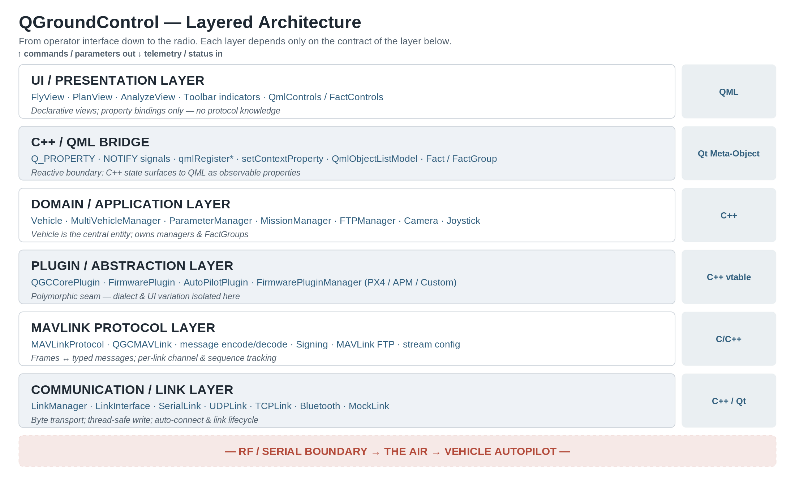
Figure 1 — The QGroundControl layer stack. Each band exposes a contract; the band above consumes it without reaching through.
Two observations carry the most weight for STRATUM. First, the Plugin / Abstraction layer sits deliberately between the domain and the protocol — it is the designed point of variation. Second, the C++/QML bridge is not a passive pass-through; it is a reactive boundary where C++ state becomes observable UI state through Qt's meta-object system. Misunderstand either, and STRATUM accrues coupling it will pay for later.

4. Layer-by-Layer Analysis

4.1 Communication / Link Layer
This is where data leaves QGC. The layer abstracts every physical transport behind one contract, LinkInterface, and manages the lifecycle of those links through LinkManager.

Entities & responsibilities
- LinkManager — singleton factory and registry. Creates, reference-counts, and tears down links; drives auto-connect; allocates MAVLink channels. QML-invokable for the connection UI.
- LinkInterface (abstract) — the universal contract. Concretions: SerialLink, UDPLink, TCPLink, BluetoothLink, and MockLink (the in-process simulator used for test).
- Each link runs its own I/O; writes are marshalled through writeBytesThreadSafe() via QMetaObject::invokeMethod, so callers from any thread are safe.

Interfaces presented
Direction | Mechanism | What crosses
Up (RX) | signal bytesReceived(link, QByteArray) | Raw inbound bytes, tagged with originating link
Down (TX) | sendMessageThreadSafe(msg) / writeBytesThreadSafe() | Serialized MAVLink frame → bytes on the wire
Lifecycle | connected() / disconnected() / communicationError() | Link state to LinkManager and protocol
Architecturally this layer is clean: it has no opinion about MAVLink. It moves bytes. That neutrality is precisely what lets STRATUM add a bespoke datalink — a proprietary radio or an encrypted tunnel — by subclassing LinkInterface and LinkConfiguration without disturbing anything above.

4.2 MAVLink Protocol Layer
The protocol layer is the translator between two worlds: undifferentiated bytes below, typed messages above. MAVLinkProtocol is a singleton that subscribes to every link's bytesReceived and feeds bytes through mavlink_parse_char against a per-link channel.

Responsibilities
- Frame assembly and CRC/signature validation, per-channel sequence and loss tracking.
- Heartbeat triage — first contact on a link emits vehicleHeartbeatInfo(...), the signal that ultimately causes a Vehicle to be created.
- Successful decode emits messageReceived(link, mavlink_message_t) — the single most important signal in the system.
- Telemetry logging, optional message forwarding, and (where configured) MAVLink signing.

Interfaces presented
Signal | Payload | Consumer
vehicleHeartbeatInfo | link, sysid, compid, autopilot, type | MultiVehicleManager (vehicle creation)
messageReceived | link, mavlink_message_t | Every Vehicle (filters by sysid)
mavlinkMessageStatus | counts: sent / received / loss | Telemetry & link-health indicators
The decision to make this a broadcast singleton rather than a per-link object is the layer's defining trade. It simplifies wiring — every Vehicle connects once — but it means message routing to the correct vehicle happens above this layer, inside each Vehicle. STRATUM message taps therefore belong either here (global) or in the firmware plugin (per-vehicle), and the choice has different blast radii.

4.3 Plugin / Abstraction Layer
This layer exists for one reason: PX4 and ArduPilot speak different dialects of the same protocol, and different customers want different cockpits. Rather than litter the domain with conditionals, QGC isolates variation behind two polymorphic families.
- FirmwarePlugin (≈80 virtuals) — the behavioral abstraction. Translates intent into dialect: setFlightMode, guidedModeTakeoff, sendHomePositionToVehicle, and crucially the message hooks adjustIncomingMavlinkMessage and adjustOutgoingMavlinkMessageThreadSafe. Specializations: PX4FirmwarePlugin, APMFirmwarePlugin.
- AutoPilotPlugin — the configuration/UI abstraction; supplies the setup pages (VehicleComponent list) per firmware.
- QGCCorePlugin — the application-level extension surface: which Analyze pages exist, which toolbar indicators show, which settings are visible, the QML root window, and a global mavlinkMessage() tap.
This is the STRATUM seam. It is reached not by editing QGC but by compiling with QGC_CUSTOM_BUILD, at which point QGCCorePlugin::instance() returns the custom subclass and a custom FirmwarePluginFactory registers STRATUM's firmware behavior. Section 7 develops this.

4.4 Domain / Application Layer
If there is a center of gravity in QGC, it is Vehicle — a ~1,300-line class that is simultaneously the system's model of the aircraft and the façade the UI binds against.

The Vehicle entity
- Subscribes once to MAVLinkProtocol::messageReceived and dispatches in _mavlinkMessageReceived: heartbeats, battery, GPS, attitude, status text, and dozens more.
- Owns the domain managers as composed children: ParameterManager, MissionManager, FTPManager, ComponentInformationManager, MavCommandQueue, plus the FirmwarePlugin and AutoPilotPlugin for its airframe.
- Exposes vehicle state to QML as a tree of FactGroup properties — gps, battery, wind, vibration, and so on — each a bundle of observable Fact values.
- Sends outbound through sendMessageOnLinkThreadSafe(); commands that expect acknowledgment route through MavCommandQueue for retry/timeout handling.

Supporting managers
Manager | Role and what it communicates
MultiVehicleManager | Listens to vehicleHeartbeatInfo, creates/destroys Vehicles, tracks the activeVehicle the UI is bound to.
ParameterManager | Synchronizes the full onboard parameter set; exposes parametersReady and per-parameter Facts; write-back to vehicle.
MissionManager | Uploads/downloads mission, geofence, and rally items via the MAVLink mission protocol; owns mission item state.
FTPManager | MAVLink-FTP transfers — parameter metadata, component info, logs.
Joystick / JoystickManager | Polls SDL devices; emits MANUAL_CONTROL or RC_CHANNELS_OVERRIDE to the active vehicle.
Camera / VideoManager | Camera control protocol and the video pipeline (separate from MAVLink telemetry).

4.5 FactSystem & the C++/QML Bridge
This layer is the reactive membrane between C++ and the UI, and it is the most distinctively QGC piece of the architecture. The unit of currency is the Fact — a single named value with metadata (units, range, enum strings, decimal places) loaded from JSON.
- Fact wraps a value and emits valueChanged when it moves. Metadata lives in FactMetaData, decoupling the value from its presentation.
- FactGroup aggregates related Facts and is exposed to QML as a Q_PROPERTY. A QML label binds to vehicle.battery.percentRemaining.value and updates automatically.
- Bridge mechanisms: Q_PROPERTY with NOTIFY signals, qmlRegisterUncreatableType, setContextProperty (e.g. joystickManager), and QmlObjectListModel for list-bound collections.
The architectural payoff is decisive: the UI is declarative and ignorant. It never polls and never parses a message. It binds to Facts and re-renders when they change. The cost is indirection — a new telemetry field must be threaded through a FactGroup and its JSON metadata before a single pixel can show it.

4.6 UI / Presentation Layer
The top layer is pure QML, organized by operator task rather than by data: FlyView (live operations), PlanView (mission authoring), AnalyzeView (logs, MAVLink inspector), and the Toolbar indicators that summarize vehicle state.
- Views compose reusable controls from QmlControls and FactControls (Fact-aware widgets that read/write Facts directly).
- User intent is expressed by invoking Q_INVOKABLE methods on domain objects — e.g. a guided-mode tap calls into Vehicle, which defers to the FirmwarePlugin.
- FlyViewCustomLayer.qml is an explicit, documented override point — the QML counterpart of the core-plugin seam.

5. End-to-End Data Flow
Layers are static. Behavior is the emergent property. Two traces show how the layers cooperate, and where latency and failure actually live.

5.1 Inbound — telemetry becomes a pixel
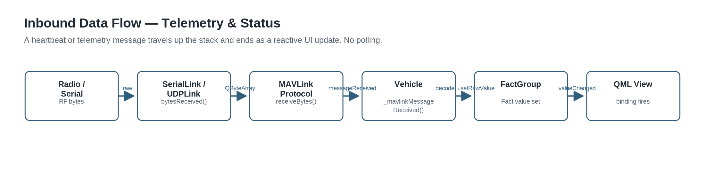
Figure 2 — Inbound path. A received frame propagates up to a reactive UI update without any polling.
Bytes arrive at a concrete link, which emits bytesReceived. MAVLinkProtocol::receiveBytes parses them into a mavlink_message_t and emits messageReceived. The matching Vehicle decodes the message in _mavlinkMessageReceived, writes the relevant Fact via its FactGroup, and the Fact's valueChanged signal fires every QML binding watching it. The interface updates. End to end, no layer reached around its neighbor.

5.2 Outbound — an action becomes a frame
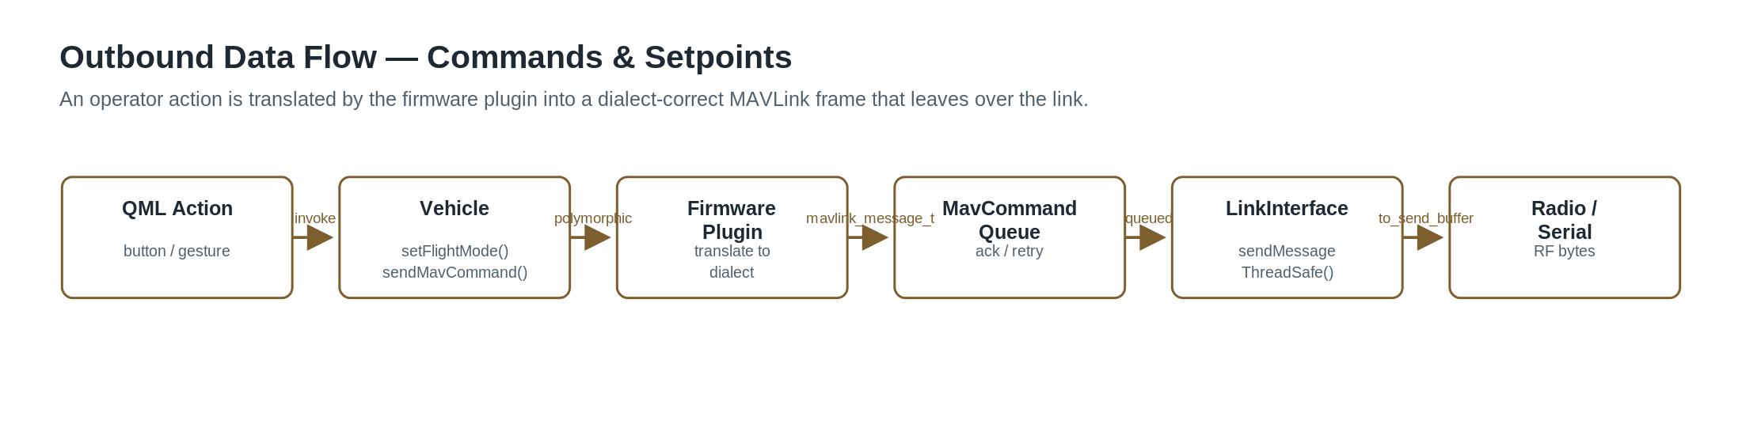
Figure 3 — Outbound path. Operator intent is translated to a dialect-correct frame by the firmware plugin before it leaves.
A QML control invokes a Vehicle method such as setFlightMode. Vehicle delegates dialect translation to its FirmwarePlugin, which produces the correct mavlink_message_t. Commands needing acknowledgment pass through MavCommandQueue (retry/timeout); the frame is then handed to the link via sendMessageThreadSafe, serialized by mavlink_msg_to_send_buffer, and written to the wire. The same firmware-plugin indirection that makes PX4 and APM interchangeable is the hook STRATUM uses to alter outgoing behavior.

6. Interface Reference
The concrete seams between layers, named so STRATUM design discussions can reference them precisely.
Boundary | Contract | What is communicated
Link → Protocol | bytesReceived(link, data) | Inbound raw bytes with link provenance
Protocol → Domain | messageReceived(link, msg) | Decoded, typed MAVLink message (broadcast)
Protocol → MVM | vehicleHeartbeatInfo(...) | First-contact identity → vehicle creation
Domain → Protocol/Link | sendMessageOnLinkThreadSafe(link,msg) | Outbound frame, post dialect-translation
Plugin seam (in) | FirmwarePlugin::adjustIncomingMavlinkMessage | Per-vehicle inbound message rewrite hook
Plugin seam (out) | adjustOutgoingMavlinkMessageThreadSafe | Per-vehicle outbound message rewrite hook
Plugin seam (app) | QGCCorePlugin::mavlinkMessage(...) | Global message tap for custom builds
Domain → Bridge | Q_PROPERTY FactGroup* + NOTIFY | Vehicle state surfaced as observable groups
Bridge → UI | Fact.value binding / valueChanged | Single reactive value to QML
UI → Domain | Q_INVOKABLE methods | Operator intent (commands, mode changes)

7. STRATUM Integration — Tradespace & Seams
The question is not whether QGC can host STRATUM, but where STRATUM should attach, and what each attachment point costs over the program's life. The architecture offers a designed answer.
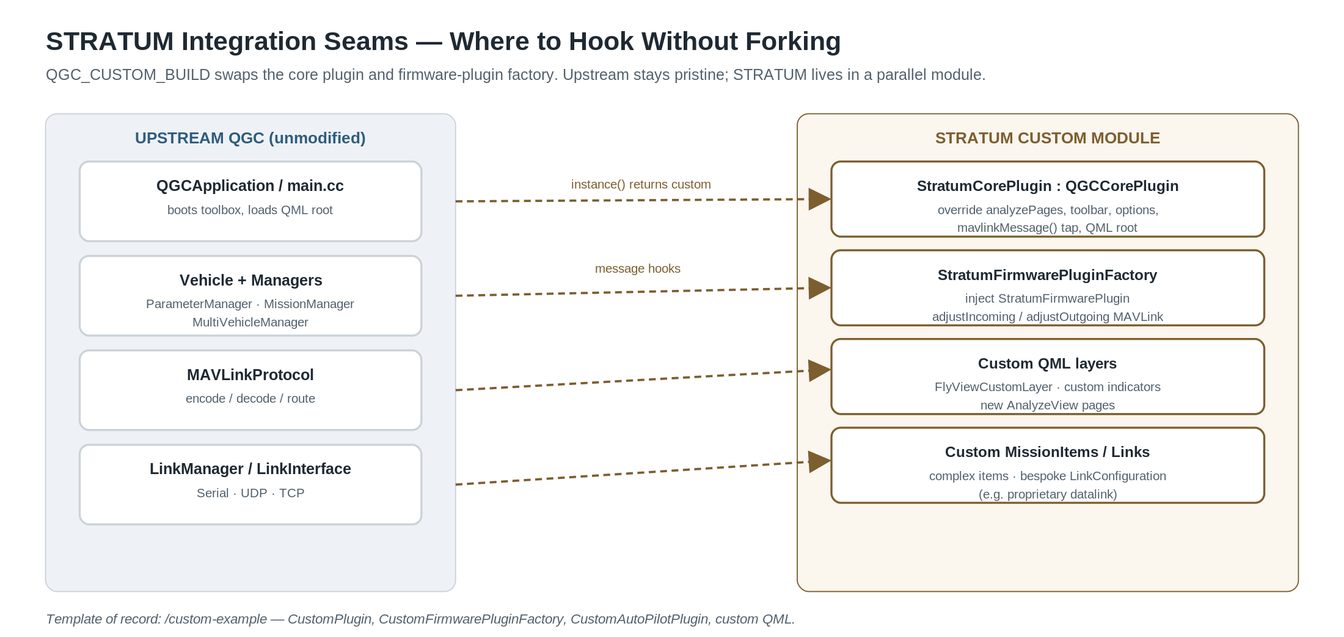
Figure 4 — Integration seams. STRATUM lives in a parallel custom module; upstream QGC is consumed, not forked.

7.1 The four viable strategies
Strategy | Mechanism | Trade
Custom build (recommended) | QGC_CUSTOM_BUILD + StratumCorePlugin/FirmwarePluginFactory; mirror /custom-example | Lowest coupling; tracks upstream cleanly; bounded surface. Constrained to provided seams.
Message taps | adjustIncoming/Outgoing + QGCCorePlugin::mavlinkMessage | Surgical behavioral change without UI work. Easy to make per-vehicle logic global by mistake.
New link / dialect | Subclass LinkInterface + LinkConfiguration | Adds proprietary datalink with zero impact upstream. Must honor thread-safe write contract.
Fork the tree | Edit QGC sources directly | Total freedom; ruinous merge debt. Reserve for changes no seam can express.

7.2 Recommended posture
Adopt the custom-build strategy as the spine and reach for taps and custom links as needed. Concretely: a StratumCorePlugin : QGCCorePlugin owns application identity (branding, Analyze pages, toolbar, visible settings); a StratumFirmwarePluginFactory injects STRATUM's protocol behavior; bespoke capability lands in custom QML layers, custom ComplexMissionItems, and — where the radio is proprietary — a custom LinkInterface. Upstream QGC remains a consumed dependency you can rebase onto.

7.3 Systemic risks
- Upstream drift. QGC moves fast (1,086 commits past the tagged release on this baseline). Every source you fork is a future merge conflict. Mitigation: confine STRATUM to the custom module and pin the upstream commit deliberately.
- Threading. Links run off the main thread; the ThreadSafe suffix is a contract, not decoration. A tap that touches UI state from a link thread is a latent crash. Mitigation: marshal across threads exactly as QGC does.
- Singleton broadcast. Because messageReceived is global, a naive global tap sees traffic from every vehicle. Mitigation: prefer the per-vehicle firmware-plugin hooks unless the logic is genuinely fleet-wide.
- FactSystem indirection. New telemetry is invisible to the UI until it is modeled as a Fact with metadata. Mitigation: budget for the FactGroup + JSON work, not just the parse.
- Emergent latency. Command-ack round-trips traverse five layers and a queue. End-to-end latency is a system property no single layer reveals. Mitigation: measure across the seam, not within a class.

7.4 Closing assessment
QGC's architecture is mature where it matters to STRATUM: the variation points were anticipated, named, and given first-class seams. The competitive advantage in building on it is leverage — STRATUM inherits a battle-tested link stack, a complete MAVLink implementation, and a reactive UI framework, and spends its engineering budget on differentiation rather than plumbing. The corresponding discipline is restraint: every line written outside the custom seam is a line that must be defended against upstream on every rebase. Decisions dictate destiny — and the decision to respect the seam is the one that compounds.

