|  |
| --- |
| SRS DOCUMENT FOR  WEDDING NOW |
| **Version 1.0** |

Table of Contents

# Introduction

1.1.Purpose of Document 1.2.Product Scope

# Overall Description

* 1. Product Functions
  2. Super Admin Classes and Characteristics 1.5.Operating Environment

# Functional Requirements Use Cases

1. Introduction

## Purpose

The purpose of this document is to enumerate and describe requirements specific to the Application. This Website Requirements Specification (SRS) defines the functionalities for the Function hall and first build of the system that shall be defined by super admin out of which some can be edited by the function hall admin.

## Product Scope

The Wedding Now is an application, where people can search, select and manage entire activities related to wedding and functions. Wedding Now will have a centralized data storage of all client information to speed up the process of supporting the client in an efficient way.

# Overall Description

## Super Admin Functions

Super admin can create, edit, and delete all the data related to function halls, mentioned under

## Super Admin Classes and Characteristics

We anticipate all the clients will use the website on a daily basis to access the information about the function halls, locations, payments and updates on products and promotions and other related activities.

Super admin, shall use the data, update, create and delete the date of function halls.

## Operating Environment

The website shall run on any system that operates on windows platform.

## Function Hall Admin Functions

Function Hall Admin can edit the information of their particular Function Hall, after logging in by the details created by the Super Admin.

# Functional Requirement

This sections details the functionalities of the system by listing the actions to be taken and defining the requirements for those features for super admin.

# Use Cases

Primary actor Primary actor is Wedding Now which authorizes the patron to

create, edit and update date of function halls.

Patron (Favored) patron is the super admin who wants to login for updating, creating

and editing all data related to function halls.

## UC1

|  |  |  |  |
| --- | --- | --- | --- |
| ID and Name: | **UC-1 SUPER ADMIN LOGIN** | | |
| Created By: | Shaik Ishaq | Date Created: | 10/08/2016 |
| Primary Actor: | SUPER ADMIN | Secondary Actors: | WN |
| Description: | Super Admin accesses the WN from the corporate intranet or from home, views the website and chooses to Login. | | |
| Trigger: | Super Admin indicates that he/she wants to Login in WN. | | |
| Preconditions: | PRE-1. Patron has valid login details. | | |
| Post conditions: | POST-1. Login is “Accepted”.  POST-2. Login is “Rejected” | | |
| Normal Flow: | * 1. **SUPER ADMIN LOGINS**      1. Super Admin opens WN      2. WN Displays Login page with a form asking username and Password.      3. Super Admin provides correct details and submits Login.      4. WN indicates that Super Admin has successfully logged in. | | |
| Alternate Flow: | * 1. **IF SUPER ADMIN FORGETS PASSWORD**      1. WN displays a page asking the details of registered Email ID in the backend.      2. Super Admin provides details.      3. WN validates the details and provides a reset password link.      4. Super Admin opens the reset password link.      5. Super Admin changes the password using the provided link.      6. Super Admin provides the new password and clicks confirm      7. WN opens Login page, asking the Super Admin to Login with new password.      8. Super Admin successfully logins. | | |
| Exceptions: | * 1. **IF SUPER ADMIN PROVIDES INVALID SUPER ADMIN ID/PASSWORD**      1. If Super Admin provides invalid Super Admin ID/Password, WN displays a pop up with a message “Invalid details” and asks to re-enter the details. | | |

|  |  |
| --- | --- |
|  | 1. If Super Admin enters invalid details for three times within a timeframe of 4 minutes, WN displays a pop up with a message “exceeded the limit”, and asks to reset the password. 2. Step no. 4 in the alternate flow from UC 1 continues. |

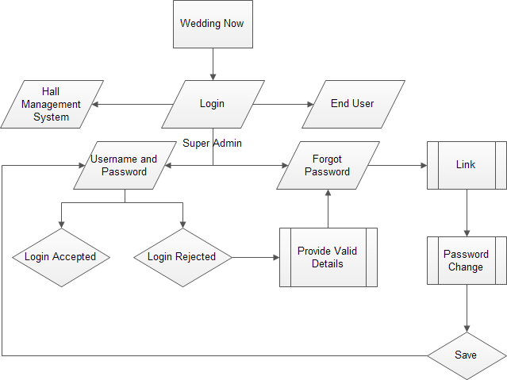

**UC2**

|  |  |  |  |
| --- | --- | --- | --- |
| ID and Name: | **UC-2 SUPER ADMIN CREATES A FUNCTION HALL** | | |
| Created By: | Shaik Ishaq | Date Created: | 10/08/2016 |
| Primary Actor: | Super Admin | Secondary Actors: | WN |
| Description: | Super Admin logins and creates a function hall with details | | |

|  |  |
| --- | --- |
| Trigger: | A Super Admin indicates that he/she wants to create a new function hall with details |
| Preconditions: | PRE-1. Patron has Logged in. |
| Post conditions: | POST-1. Super Admin creates a new function hall with valid details.  POST-2. WN displays a pop up showing a message “the function hall has already been created with same name/address.” |
| Normal Flow: | * 1. **SUPER CREATES A FUNCTION HALL**      1. WN displays a page with a form having a list to be filled by the Super Admin.      2. The form shall have the details such as,         1. Function hall name         2. Address – City (Type, Tier 1/Tier2), Area         3. Category of the function hall – Catering/Function hall/Wedding Hotel/Banquet hall/all of the above/some of the above.         4. Name of the Owner – First Name and Last Name.         5. Contact Number – Mobile and Landline.         6. Email ID of the Owner – For creating User ID (Optional).      3. Super fills the above details and submits.      4. WN displays a popup to asking for saving the details.      5. Super Admin clicks” Save” for saving the data.      6. WN saves the data and opens a page showing the details of function hall with options of editing and deleting the data. |
| Alternate Flow: | * 1. **FUNCTION HALL HAS ALREADY CREATED**      1. WN, searches the database if the provided name and address of the function hall has already been added.      2. If the data matches, then WN shows a pop up displaying a message “The Function Hall has already been added”.      3. WN asks Super Admin to provide correct details of the function hall.      4. Step no. 2 in the Normal Flow from UC 2 continues. |
| Exceptions: | * 1. **SUPER ADMIN ADDS A BRANCH OF THE FUNCTION HALL**      1. Super Admin adds a branch of the function hall.      2. Super Admin provides different address of the Function Hall with same name.      3. WN asks to confirm if the mentioned details are correct.      4. Super Admin confirms that the details are correct.      5. Step no. 2.c in the Normal Flow from UC 2 continues. |

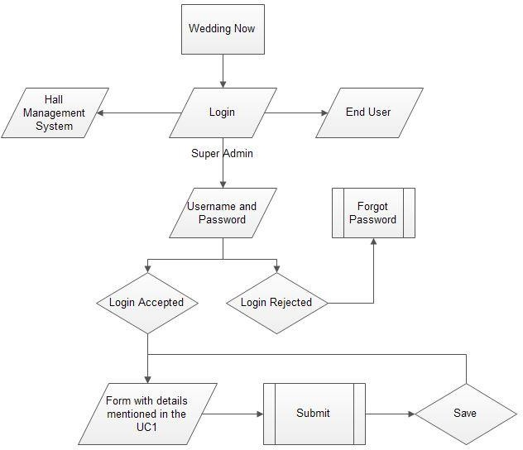

## UC3

|  |  |
| --- | --- |
| ID and Name: | **UC-3 SUPER ADMIN ADDING FACILITIES OF THE FUNCTION HALL** |

|  |  |  |  |
| --- | --- | --- | --- |
| Created By: | Shaik Ishaq | Date Created: | 10/08/2016 |
| Primary Actor: | Super Admin | Secondary Actors: | WN |
| Description: | Super Admin adds facilities of the Function Hall | | |
| Trigger: | Super Admin indicates that he/she wants to add facilities of the Function Hall | | |
| Preconditions: | PRE-1. Patron has Logged in.  PRE-2. Patron has selected a Function Hall. PRE-3. Function Hall is in the database of WN. | | |
| Post conditions: | POST-1. WN has the list of facilities mentioned under standardized for all the function halls.  POST-2. Super Admin adds the facilities of the Function Hall.  POST-3. WN directs to the third party services such as Catering, Decoration, Entertainment, Mehdi and Makeup. | | |
| Normal Flow: | * 1. **SUPER CREATES A FUNCTION HALL**      1. Super Admin opens the page of function hall.      2. WN shall a list with facilities in the page to be selected by the Super Admin.      3. List of Facilities is as follows:         1. No. of Halls in the Function Hall – In numbers         2. Seating Capacity of each hall – In numbers         3. Floating capacity of each hall – In numbers         4. Bridegroom room (Checkbox):            1. AC            2. Non AC            3. Locker Facility         5. Bride room (Checkbox):            1. AC            2. Non AC            3. Locker Facility         6. Additional rooms for Guests (Checkbox and in numbers):            1. AC/Non Ac            2. Number of rooms         7. Camera Surveillance across the venue (Checkbox):            1. Yes            2. No         8. Dining         9. Seating Capacity – In numbers   ii. Buffet Place Capacity - In numbers  i. Parking Facility | | |

|  |  |
| --- | --- |
|  | 1. Four wheeler Capacity – In numbers 2. Two Wheeler Capacity – In numbers 3. Vessels availability for preparing food (Checkbox):    1. Yes – Capacity in numbers    2. No 4. Temple Availability (Checkbox):    1. Yes    2. No 5. Power backup availability (Checkbox):    1. Yes    2. No 6. Internet and Wi-Fi (Checkbox):    1. Yes – No. of Users    2. No 7. Projector availability (Checkbox):    1. Yes    2. No 8. Sound System Availability (Checkbox):    1. Yes    2. No 9. Catering Services availability (Checkbox):    1. Yes    2. No 10. Decoration Services availability (Checkbox):     1. Yes     2. No 11. Super Admin fills the list with correct information of the function hall. 12. Super Admin selects to save the updated data. 13. WN displays the updated page of the function hall. |
| Alternate Flow: | * 1. **WN REDIRECTS TO THIRD PARTY FACLITIES**      1. If the function hall has catering and decoration services available, then WN shall add two questions that shall be displayed in the front end.      2. Following are the two questions:         1. Interested in Catering Services (Checkbox):            1. Yes            2. No         2. Interested in Decoration Services (Checkbox):            1. Yes            2. No |

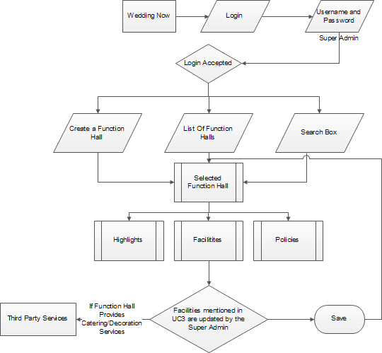

**UC4**

|  |  |  |  |
| --- | --- | --- | --- |
| ID and Name: | **UC-4 SUPER ADMIN ADDING HIGHLIGHTS OF THE FUNCTION HALL** | | |
| Created By: | Shaik Ishaq | Date Created: | 10/08/2016 |
| Primary Actor: | Super Admin | Secondary Actors: | WN |
| Description: | Super Admin adds highlights of the Function Hall | | |
| Trigger: | Super Admin indicates that he/she wants to add highlights of the Function Hall | | |

|  |  |
| --- | --- |
| Preconditions: | PRE-1. Patron has Logged in.  PRE-2. Patron has selected a Function Hall. PRE-3. Function Hall is in the database of WN. |
| Post conditions: | POST-1. WN has the list of facilities mentioned under standardized for all the function halls.  POST-2. Super Admin adds the highlights of the Function Hall. |
| Normal Flow: | * 1. **SUPER ADMIN ADDS HIGHLIGHTS OF THE FUNCTION HALL**      1. Super Admin opens the page of function hall.      2. WN displays a button “Highlights” in the page.      3. Super Admin clicks on the button “Highlights”.      4. WN displays a page with a standardized list to be checked by the Super Admin.      5. List of highlights is as follows:         1. Food provided by the venue – Checkbox.         2. Outside food/Caterer allowed at the venue – Check box.         3. Non-Veg allowed at the venue – Checkbox.         4. Alcohol drinking Allowed at the Venue – Checkbox.         5. Music Allowed at the venue – Yes/No         6. If Music is allowed, then closing time – Text Box.         7. Decoration provided by the venue – Checkbox.         8. Outside Decors allowed by the venue – Checkbox.         9. Lighting(IO) provided by the venue – Checkbox.         10. Outside Light(IO) allowed – Yes/No         11. DJ Allowed – Yes/No         12. If yes, then closing time – Text Box.         13. Halls are air conditioned – Checkbox.         14. Ample Parking – Checkbox.         15. Distance from:             1. Airport – Text Box with standard unit KM.             2. Bus Stop – Text Box with standard unit KM.             3. Railway Station – Text Box with standard unit KM.         16. Ideally Suited for:             1. Anniversary – Checkbox.             2. Reception – Checkbox             3. Sangeet – Checkbox.             4. Seemantham – Checkbox.             5. Wedding / Marriage – Checkbox.             6. Annual Function – Checkbox.             7. Exhibition – Checkbox.             8. Project Party – Checkbox.             9. Seminars – Checkbox. |

|  |  |
| --- | --- |
|  | x. Team Outing – Checkbox.   1. Super Admin fills the list with correct information of the function hall. 2. Super Admin selects to save the updated data. 3. WN displays the updated page of the function hall. |

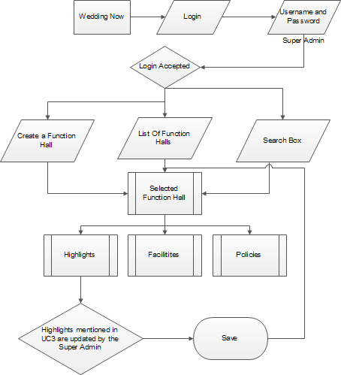

## UC5

|  |  |  |  |
| --- | --- | --- | --- |
| ID and Name: | **UC-5 SUPER ADMIN CREATES A USER ID FOR FUNCTION HALL ADMIN** | | |
| Created By: | Shaik Ishaq | Date Created: | 10/08/2016 |
| Primary Actor: | Super Admin | Secondary Actors: | WN |
| Description: | Super Admin logins and creates a User ID for Function Hall Admin. | | |
| Trigger: | A Super Admin indicates that he/she wants to create a new User ID for Function Hall admin. | | |
| Preconditions: | PRE-1. Patron has Logged in. | | |
| Post conditions: | POST-1. Super Admin creates a new User ID for Function Hall Admin.  POST-2. WN displays a pop up showing a message “the function hall admin has already been registered”. | | |
| Normal Flow: | * 1. **SUPER ADMIN CREATES A USER ID FOR FUNCTION HALL ADMIN**      1. Super Admin logins to WN portal.      2. WN displays a page with one of the options as “Function Halls”.      3. Super Admin selects a function hall from the list.      4. WN displays an option for creating a user for the Function Hall.      5. Super Admin selects the option.      6. WN displays a form to be filled by the Super Admin.      7. Following is the form to be filled by the Super Admin.         1. Select type of the user – Admin/Manager         2. First Name of the User.         3. Last Name of the User.         4. Email ID of the User.         5. Password.         6. Re-type Password.         7. Save.      8. Super Admin fills the above details and saves.      9. WN saves the details and displays a pop-up message showing “User ID has been created successfully”.      10. WN saves the User ID in the data base.      11. WN creates a page “User IDs”, if the user ID created is the first one of all. | | |
| Alternate Flow: | * 1. **FUNCTION HALL USER ID HAS ALREADY BEEN CREATED**      1. After 1-6 steps from Normal Flow in the UC5, when Super Admin Types Save option. | | |

|  |  |
| --- | --- |
|  | 1. If the User Id with same email ID has already created, then WN displays a pop-up showing “User ID has already created with this email ID”. 2. WN reloads the form and asks the Super Admin to fill the correct details. 3. Step no. 8 from Normal Flow in the UC5 continues.    1. **SUPER ADMIN SEARCHES FOR THE FUNCTION HALL FROM SEARCH BUTTON TO CREATE A USER ID**       1. WN displays one of the options “Function Halls”       2. Super Admin types the name of the function hall in the search button.       3. WN searches for the function hall with given name in the database.       4. WN displays the function hall if it is saved in the database.       5. Step no. 3 form the Normal Flow in UC5 continues. |
| Exceptions: | * 1. **SUPER ADMIN CREATES MORE THAN ONE ID FOR THE FUNCTION HALL ADMIN.**      1. Super Admin selects “Manager” category in the list while creating the User ID.      2. Step no. 7.a from the Normal Flow in UC5 continues.      3. WN displays the User IDs created for the Function hall and saves them in the database. |

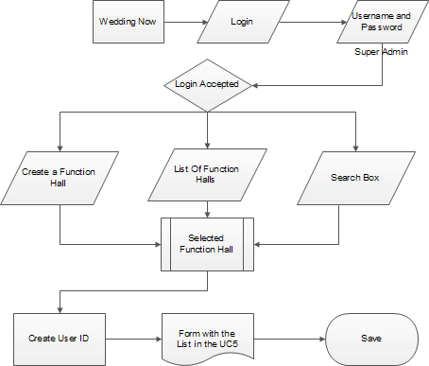

**UC6**

|  |  |  |  |
| --- | --- | --- | --- |
| ID and Name: | **UC-6 FUNCTION HALL ADMIN LOGIN** | | |
| Created By: | Shaik Ishaq | Date Created: | 10/08/2016 |
| Primary Actor: | Function Hall Admin | Secondary Actors: | WN |
| Description: | Function Hall Admin accesses the WN from the corporate intranet or from home, views the website and chooses to Login. | | |
| Trigger: | Function Hall Admin indicates that he/she wants to Login in WN. | | |
| Preconditions: | PRE-1. Function Hall Admin has valid login details. | | |
| Post conditions: | POST-1. Login is “Accepted”.  POST-2. Login is “Rejected” | | |
| Normal Flow: | * 1. **FUNCTION HALL ADMIN LOGINS**      1. Function Hall Admin opens Login Page.      2. WN Displays Login page with a form asking username and Password.      3. Function Hall Admin provides correct details and submits Login.      4. WN indicates that Function Hall Admin has successfully logged in. | | |
| Alternate Flow: | * 1. **IF Function Hall ADMIN FORGETS PASSWORD**      1. WN displays a page asking the details of registered Email ID in the backend.      2. Function Hall Admin provides details.      3. WN validates the details and provides a reset password link.      4. Function Hall Admin opens the reset password link.      5. Function Hall Admin changes the password using the provided link.      6. Function Hall Admin provides the new password and clicks confirm      7. WN opens Login page, asking the Function Hall Admin to Login with new password.      8. Function Hall successfully logins. | | |
| Exceptions: | * 1. **IF Function Hall ADMIN PROVIDES INVALID SUPER ADMIN ID/PASSWORD**      1. If Function Hall Admin provides invalid User ID/Password, WN displays a pop up with a message “Invalid details” and asks to re-enter the details.      2. If Function Hall Admin enters invalid details for three times within a   timeframe of 4 minutes, WN displays a pop up with a message “exceeded the limit”, and asks to reset the password.   * + 1. Step no. 4 in the alternate flow from UC 6 continues. | | |

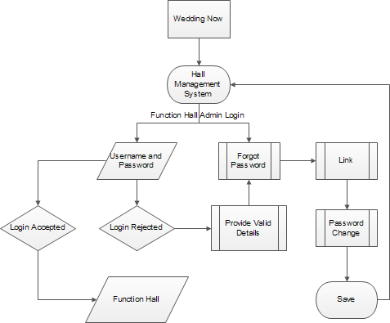

## UC7

|  |  |  |  |
| --- | --- | --- | --- |
| ID and Name: | **UC-7 FUNCTION HALL ADMIN EDIT THE DATA OF FUNCTION HALL** | | |
| Created By: | Shaik Ishaq | Date Created: | 10/08/2016 |
| Primary Actor: | Function Hall Admin | Secondary Actors: | WN |
| Description: | Function Hall Admin accesses the WN from the corporate intranet or from home, views the website and chooses to Login. | | |
| Trigger: | Function Hall Admin indicates that he/she wants to Login in WN. | | |
| Preconditions: | PRE-1. Function Hall Admin has logged in. | | |
| Post conditions: | POST-1. Login is “Accepted”. | | |
| Normal Flow: | * 1. **FUNCTION HALL ADMIN EDITS THE DATA OF FUNCTION HALL**      1. Function Hall Admin logins to the dashboard.      2. WN validates the details and opens the Function Hall Page. | | |

|  |  |
| --- | --- |
|  | 1. Function Hall Admin selects to Edit the data of the Function Hall. 2. WN displays the list of Facilities, Features, Highlights and other details of the Function Hall. 3. Function Hall Admin edits the data of Function Hall and saves the data. 4. WN displays the updated list after updating. |

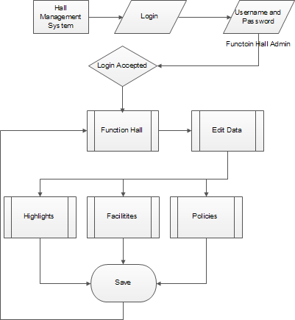

**UC8**

|  |  |  |  |
| --- | --- | --- | --- |
| ID and Name: | **UC-8 FUNCTION HALL ADMIN BOOKING THE HALL** | | |
| Created By: | Shaik Ishaq | Date Created: | 10/20/2016 |
| Primary Actor: | Function Hall Admin | Secondary Actors: | WN |
| Description: | Function Hall Admin logins and books the function hall. | | |

|  |  |
| --- | --- |
| Trigger: | Function Hall Admin indicates that he/she wants to book the hall. |
| Preconditions: | PRE-1. Function Hall Admin has logged in. |
| Post conditions: | POST-1. Booking is “Accepted”.  POST-2. Booking is “Rejected” |
| Normal Flow: | * 1. **FUNCTION HALL ADMIN BOOKS THE HALL**      1. Function Hall Admin logins to the dashboard.      2. WN displays a page with “book hall” option.      3. Function Hall Admin selects “book hall” option.      4. WP opens a page with following options.         1. Select the venue (if multiple venues).         2. Select the type of function out of following:            1. Wedding/Marriage            2. Reception            3. Birthday            4. Corporate Team Build            5. Accept the Terms and Conditions.            6. Others         3. Select the date and time of the function.         4. Pay advance amount for booking.         5. Confirm booking.      5. WP saves the details in the calendar.      6. WP confirms booking and saves the details in database. |
| Alternate Flow: | * 1. **IF THE FUNCTION HALL IS ALREADY BOOKED**      1. If the function hall is already booked, then WP displays a message “Function Hall is already booked”.      2. WP asks the Admin to select a different date for booking.      3. Function Hall Admin selects different date.      4. Step no. 4.d in the Normal Flow from UC8 continues. |

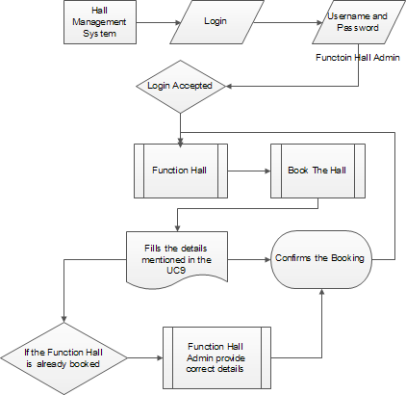

## UC9

|  |  |  |  |
| --- | --- | --- | --- |
| ID and Name: | **UC-9 END USER REGISTERS ON WN** | | |
| Created By: | Shaik Ishaq | Date Created: | 10/20/2016 |
| Primary Actor: | End User | Secondary Actors: | WN |
| Description: | End User Registers on WP | | |
| Trigger: | End User indicates that he/she wants to register on WP. | | |
| Preconditions: | PRE-1. End User has not already registered.  PRE-2. End User has selected valid options to register. | | |
| Post conditions: | POST-1. Registration is “Accepted”. | | |

|  |  |
| --- | --- |
|  | POST-2. Registration is “Rejected” |
| Normal Flow: | * 1. **END USER REGISTERS ON WN**      1. End User opens WN home page.      2. WN displays the home page with different options.      3. End User selects “Register” option from WN.      4. WN opens a page with following options.         1. Register Using Google+.         2. Register Using Facebook.         3. Register using Email.      5. End User selects an option from the above (a/b).      6. WN validates the details provided by End User.      7. WN displays a message “Successfully Registers”.      8. WN redirects to the Login page. |
| Alternate Flow: | * 1. **IF THE END USER HAS ALREADY REGISTERED**      1. If the End user has already registered.      2. WN displays a message “Already Registered”.      3. WN asks to provide correct details.      4. End User provides correct details.      5. Step no. 6 in the Normal Flow of UC 9 continues.   2. **IF THE END USER SELECTS BOOK THE FUNCTION HALL OPTION**      1. End User access WN and explore it.      2. End User selects a function hall/banquet hall/any other option from WN.      3. End user selects to book the function hall/banquet/any other service.      4. WN displays the Register page if the end user is not registered.      5. Step no. 4 in the Normal Flow from UC 9 continues. |
| Exceptions: | **9.4 IF THE END USER SELECTS TO REGISTER USING EMAIL**   1. End User selects to register using email option. 2. WN opens a form with following details.    1. Full Name.    2. Email ID.    3. Password.    4. Confirm Password.    5. Save. 3. End User fills the form. 4. WN validates the details and send an email confirmation to the End User. 5. If End user opens the link, WN confirms the link and opens Login Page. |

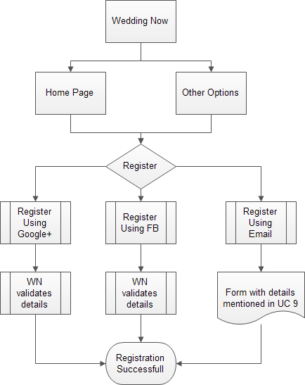

**UC10**

|  |  |  |  |
| --- | --- | --- | --- |
| ID and Name: | **UC-10 FUNCTION HALL ADMIN BOOKING THE HALL** | | |
| Created By: | Shaik Ishaq | Date Created: | 10/20/2016 |
| Primary Actor: | End User | Secondary Actors: | WN |
| Description: | End User logins and books the function hall. | | |
| Trigger: | End User indicates that he/she wants to book the hall. | | |
| Preconditions: | PRE-1. End User has logged in. | | |
| Post conditions: | POST-1. Booking is “Accepted”.  POST-2. Booking is “Rejected” | | |

|  |  |
| --- | --- |
| Normal Flow: | * 1. **FUNCTION HALL ADMIN BOOKS THE HALL**      1. End User logins to the WN.      2. WN displays a page with “book hall” option.      3. End User Admin selects “book hall” option.      4. WP opens a page with following options.         1. Select the venue (if multiple venues).         2. Select the type of function out of following:            1. Wedding/Marriage            2. Reception            3. Birthday            4. Corporate Team Build            5. Accept the Terms and Conditions.            6. Others         3. Select the date and time of the function.         4. Pay advance amount for booking.         5. Confirm booking.      5. WP saves the details in the calendar.      6. WP confirms booking and saves the details in database. |
| Alternate Flow: | * 1. **IF THE FUNCTION HALL IS ALREADY BOOKED**      1. If the function hall is already booked, then WP displays a message “Function Hall is already booked”.      2. WP asks the Admin to select a different date for booking.      3. Function Hall Admin selects different date.      4. Step no. 4.d in the Normal Flow from UC8 continues. |

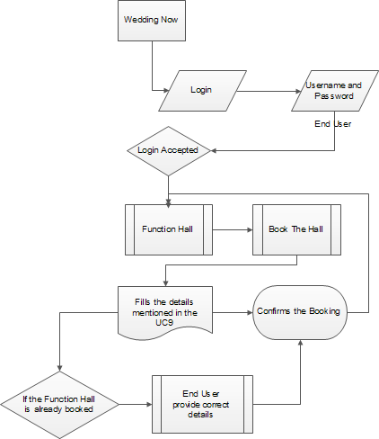

x