**Dep task 3**

**Web Performance & Analysis**

**Introduction:**

**Task:** Analyze and optimize the website that is given for Dep task 2 (Tech Shop Website)

Technologies used for website:

* HTML
* CSS
* Bootstrap
* JavaScript
* React Js

**Initial Analysis:** Report before optimization:

**Key Issues:**

1. Not using alternate attribute property with the image tag.
2. Display Images with no actual aspect ratio.
3. Heading elements are not in a sequentially descending order.
4. As the website is not deployed, some issues also occur.

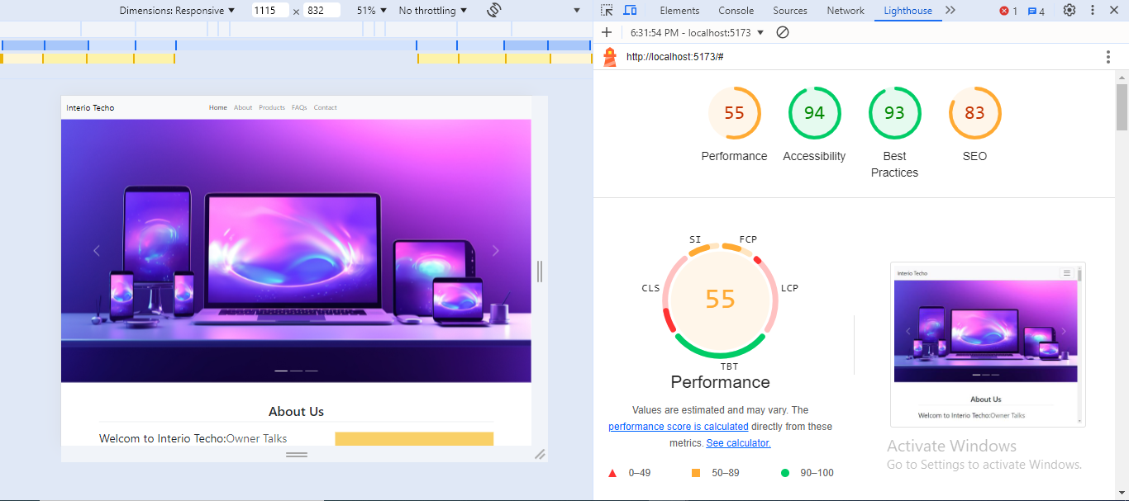

**Optimization steps:**

1. Add alt to image tags.
2. Compress images to reduce their size. (using Squoosh)
3. Add meta tags to optimize the performance of the website.
4. Remove unnecessary CSS.

**Final Analysis:**

|  |  |  |
| --- | --- | --- |
|  | **Before** | **After** |
| Performance | 55% | 83% |
| Accessibility | 94% | 94% |
| Best Practices | 93% | 96% |
| SEO | 83% | 92% |

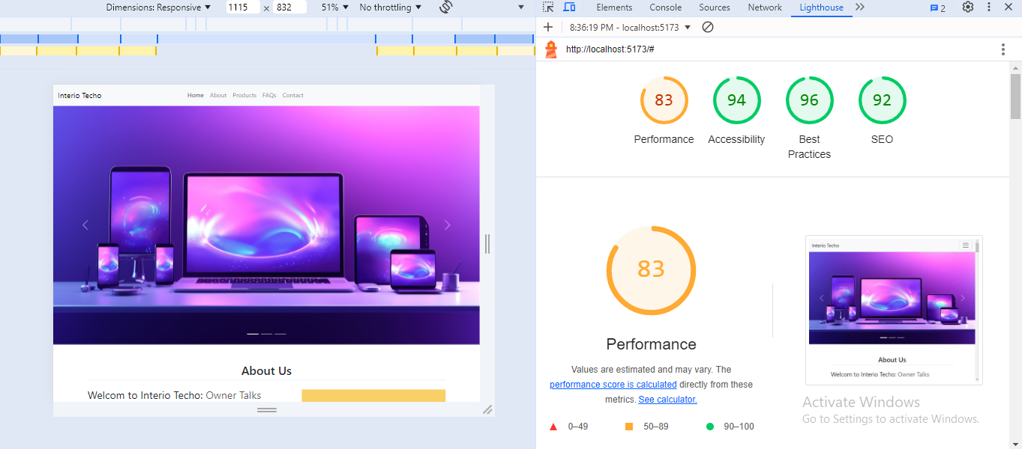

**Conclusion:**

I have taken major steps to enhance my website's performance and boost its search engine visibility. To improve loading speeds, I’ve implemented alt tags for all images and used Squoosh to compress them, which has reduced file sizes significantly. I’ve also optimized the website’s code by removing unnecessary CSS, thus refining overall performance and improving the user experience. Key meta tags—such as titles, descriptions, keywords,s and viewport settings—have been added to strengthen search engine optimization. These changes have effectively increased my website's speed, improved its search engine rankings, and led to greater user engagement and conversion rates.