# Codex Project

## Glossary

* **Entity** – Represents a client. Can be a person or a company
* **Relationship** – represents a link between clients. Relationships are hierarchical so there’s always a parent and a child in the relationship. There are also different types of relationships
* **Limit** – The amount of money the bank as approved to lend the client
* **Exposure** – The amount of money the client has already drawn from his loan with the bank
* **Facility** – In the context of this piece of work represents a type of loan
* **Risk Taker** – Represents the division of the bank that has granted the loan to the client

## Data provided

We’ve provided a spreadsheet with 2 sheets of data

* **Entity Relationships** – Contains a sample set of entities and their relationships to each other. These relationships form a hierarchical structure similar to the representation in the image below.
* **Entity Limits** – contains a list of limits for some of the entities in the entity relationships tab. This is just sample data which can be amended for testing purposes if required.

## Requirements

The requirements is to build an interactive screen that consultants can use to visualise the entities and their relationships.

They also need the ability to view the set of limits for specific entities.

***The image below is just an example of one of the possible ways to represent the data***. This is by no means the look and feel we are after. Find creative ways to represent the data.

The screen needs to be interactive. For example, clicking to expand and collapse items or double clicking to view the limits for an entity.

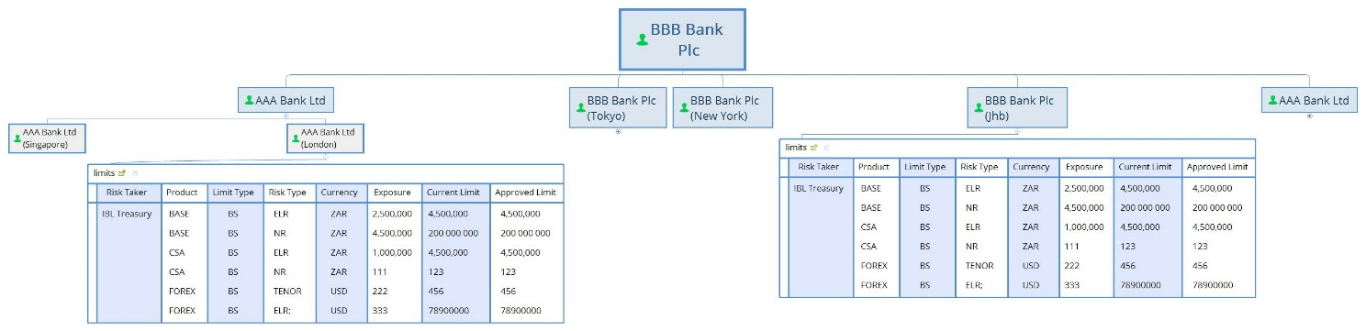

## Technical Requirements

* Solution needs to be compatible with AngularJS
* We prefer open source alternatives
* The screens should pull required data in JSON format from restful services
* Some level of automated tests would be preferred