Easypaisa
Assignment # 04



Submitted by:
Muhammad Affaf Abdullah (FA25-BCS-003),
Junaid Irfan (FA25-BCS-005),
Bilal Ahmed (FA25-BCS-037).

Section: A

SUBMITTED TO: DR. NADIR SHAH
SUBJECT: OBJECT ORIENTED PROGRAMMING

SUBMIT DATE: 05/12/2026

Table of Contents
Description 2
Algorithm 2
UML Diagram 6
Screenshots 6

Description
This is a GUI-based EasyPaisa application built in Java using JavaFX. It allows users to register and log in using their CNIC and PIN, check their wallet balance, send money to other users, and view their transaction history. All user data and transactions are saved and read from text files. The application uses core OOP concepts like inheritance, encapsulation, and exception handling.

Algorithm
- START
- Program enters main() method
- Calls Application.launch() which initializes JavaFX and calls the start() method
- start() method runs:
- Set appStage title to "EasyPaisa"
- Build assetDir path from the current working directory
- Call splashScene() and display it on appStage
- splashScene():
- Load easypaisavideo.mp4 using Media and MediaPlayer
- Play the video in a full-screen MediaView
- On video end → call phoneInputScene() and navigate to it
- navigateTo(next: Scene):
- Load loading.mp4, play at 2.5x speed
- On video end → switch appStage scene to the target scene
- phoneInputScene():
- Display background image and a TextField for mobile number entry
- On Verify button press:
- Call inputChecker.validatePhone(number)
- If valid → store in mobileNumber, call navigateTo(idVerifyScene())
- If invalid → show Alert: "Must start with 03 and have 11 digits"
- idVerifyScene():
- Display background image and a TextField for CNIC entry
- On Next button press:
- Call inputChecker.validateCnic(cnicInput)
- Strip dashes/spaces from input
- Create FileHandler object, call fh.isRegistered(cnic)
- If NOT registered → navigateTo(setupPinScene(cnic))
- If registered → navigateTo(loginScene(cnic))
- Catch Exception and print stack trace
- If invalid → show Alert: "Invalid CNIC!"
- Back button → navigateTo(phoneInputScene())
- setupPinScene(cnic):
- Display background image, two PasswordFields (PIN and confirm PIN)
- On Create PIN button press:
- Verify both PINs are 5 digits, numeric, and matching
- If valid → navigateTo(registerNameScene(cnic, pin))
- If invalid → show Alert: "PIN must be 5 digits and both must match"
- Back button → navigateTo(idVerifyScene())
- loginScene(cnic):
- Display background image and a PasswordField for PIN entry
- On PROCEED button press:
- Create FileHandler, call fh.getPin(cnic)
- If entered PIN matches stored PIN → navigateTo(dashboardScene(cnic))
- Else → show Alert: "Incorrect PIN!", reveal FORGOT PIN button
- Catch Exception and print stack trace
  - FORGOT PIN button → retrieve and display stored PIN in an Alert
  - Back button → navigateTo(idVerifyScene())
- registerNameScene(cnic, pin):
- Display a TextField for full name entry
- On Save & Continue button press:
- Validate name length >= 3 characters
- Create FileHandler, call fh.registerUser(cnic, fullName, mobileNumber, pin)
- Show success Alert: "Account Created Successfully!"
- navigateTo(dashboardScene(cnic))
- Catch Exception and print stack trace
- Back button → navigateTo(setupPinScene(cnic))
- dashboardScene(cnic):
- Display main background image
- Create FileHandler, call fh.fetchBalance(cnic)
- Show balance in a styled Label (e.g. "Rs. 15000.00")
- Show Send Money button (ImageView):
- On click → navigateTo(transferMoneyScene(cnic))
- Show Transaction History button:
  - On click → navigateTo(txHistoryScene(cnic))
- Catch Exception and print stack trace
- transferMoneyScene(senderCnic):
- Display background image and TextField for recipient phone number
- On Next button press:
- Call inputChecker.validatePhone(phone)
- If invalid → show Alert: "Invalid phone number!"
- Create FileHandler, call fh.findByPhone(phone)
- If recipient not found → show Alert: "No user found with this number!"
- If found → navigateTo(amountInputScene(senderCnic, recipient[]))
- Catch Exception and print stack trace
- Back button → navigateTo(dashboardScene(senderCnic))
- amountInputScene(senderCnic, recipient[]):
- Display background image, recipient name and phone Labels, TextField for amount
- On Next button press:
- Parse amount from TextField → catch NumberFormatException, show Alert
- If amount <= 0 → show Alert: "Amount must be greater than zero!"
- Create FileHandler, call fh.fetchBalance(senderCnic)
- If amount > senderBalance → show Alert: "Insufficient balance!"
- Call fh.writeBalance(senderCnic, senderBalance - amount)
- Call fh.writeBalance(recipient[0], recipientBalance + amount)
- Call fh.logTransaction(senderCnic, "SENT", amount, recipient phone)
- Call fh.logTransaction(recipient[0], "RECEIVED", amount, "From sender")
- navigateTo(transferSuccessScene(senderCnic, recipient[], amount))
- Catch Exception and print stack trace
- Back button → navigateTo(transferMoneyScene(senderCnic))
- transferSuccessScene(senderCnic, recipient[], amount):
- Display success background image
- Show sent amount, recipient name, and recipient phone as Labels
- OK button → navigateTo(dashboardScene(senderCnic))
- txHistoryScene(cnic):
- Display a header bar with back button and "Transaction History" title
- Create FileHandler, call fh.getTxHistory(cnic)
- If list is empty → show Label: "No transactions found."
- Else → for each transaction record, create a styled card Label and add to ScrollPane
- Catch Exception and print stack trace
- Back button → navigateTo(dashboardScene(cnic))
- FileHandler operations (all throw Exception):
- isRegistered(cnic) → scan users.txt, return true if CNIC found
- registerUser(...) → append new user record to users.txt with Rs. 15000.0 starting balance
- fetchBalance(cnic) → scan users.txt, return balance field (index 4)
- getPin(cnic) → scan users.txt, return PIN field (index 3)
- findByPhone(phone) → scan users.txt, return full record array for matching phone
- writeBalance(cnic, amt) → rewrite users.txt with updated balance for given CNIC
- getTxHistory(cnic) → scan transactions.txt, collect and format all records for given CNIC
- logTransaction(...) → append one transaction line to transactions.txt with timestamp
- Validator operations:
- validatePhone(number) → return true if starts with "03", length == 11, all digits
- validateCnic(cnic) → return true if length == 13 and all digits
- STOP

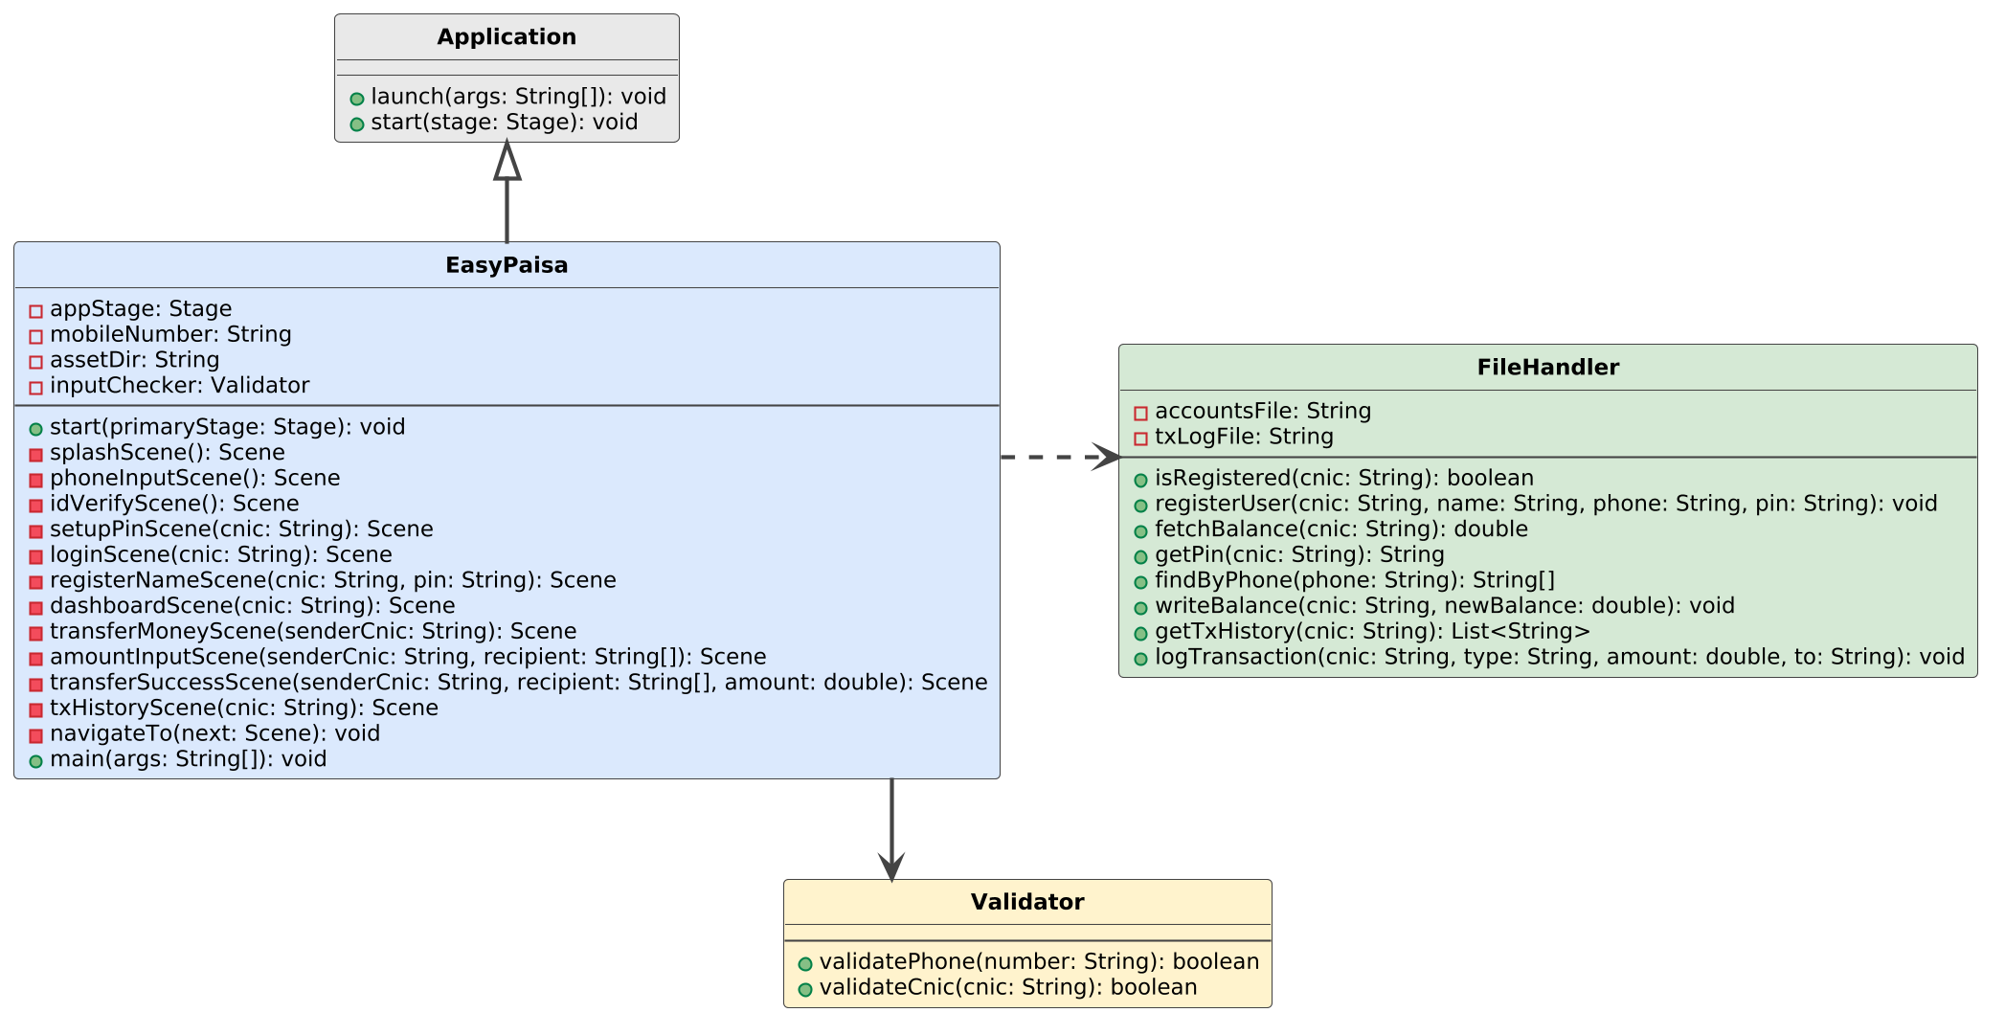
UML Diagram

Screenshots
