**Definition of Data**

**According to Cambridge English Dictionary**

**Information, especially facts or numbers, collected to be examined and considered and used to help decision making.**

**Another Definition of Data**

**“A set of values of qualitative or quantitative variables.”**

Set: In statistics, the population you are trying to discover something about.

Example:

A group student enroll in specific program.

Variable: Measurement or characteristics of an item.

Qualitative variable: Measurements or information about qualities.

Example:

A group student enroll in specific program. What are their eye color or hair color.

Quantitative variable: Measurements or information about quantities or numerical items.

Example:

A group student enroll in specific program. How many subject students selected in this program which are numbers and grades of students.

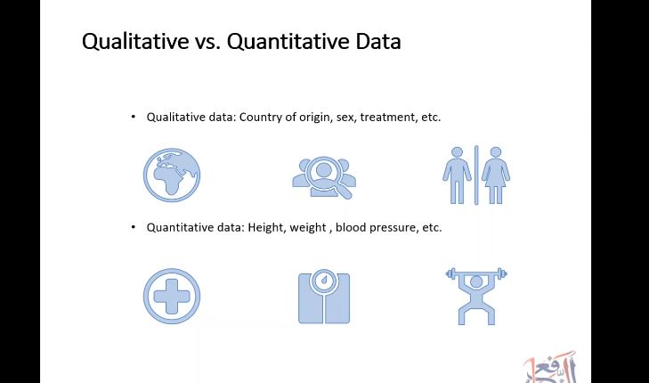

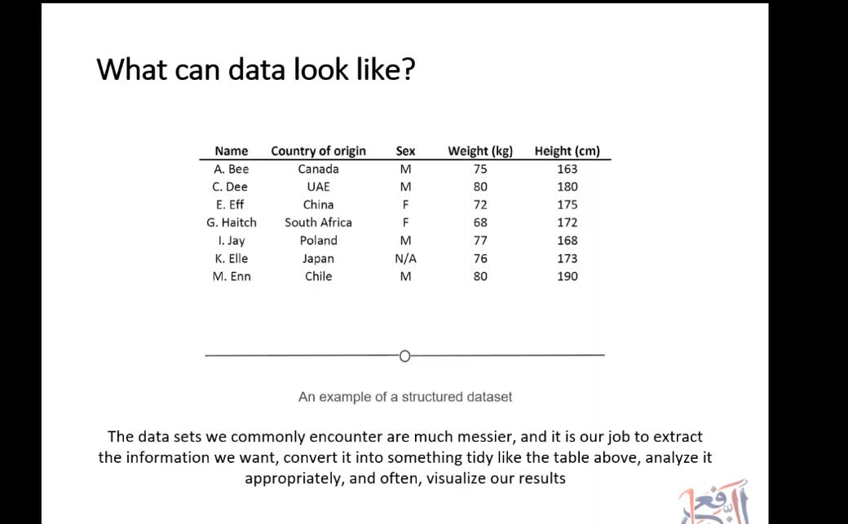

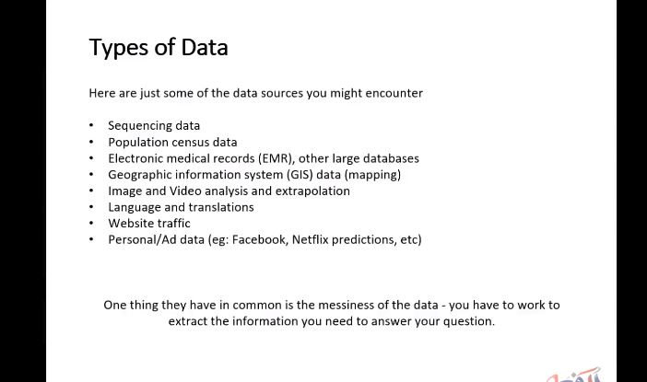

Type of Machine learning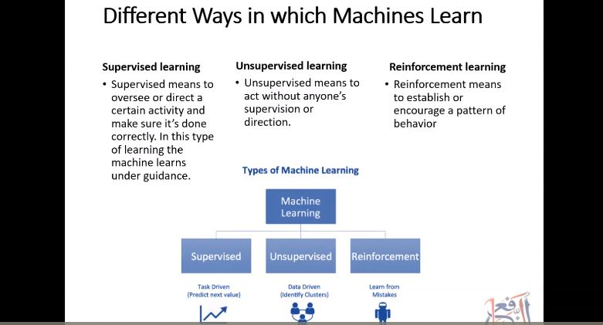

Type of Algorithms

