NAME: JUNAID ALI
ROLL NO: 20SW066
TOPIC: POWER BI

TASK 01:
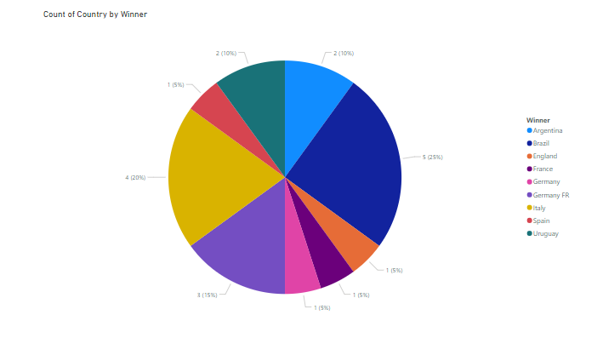

TASK 02:
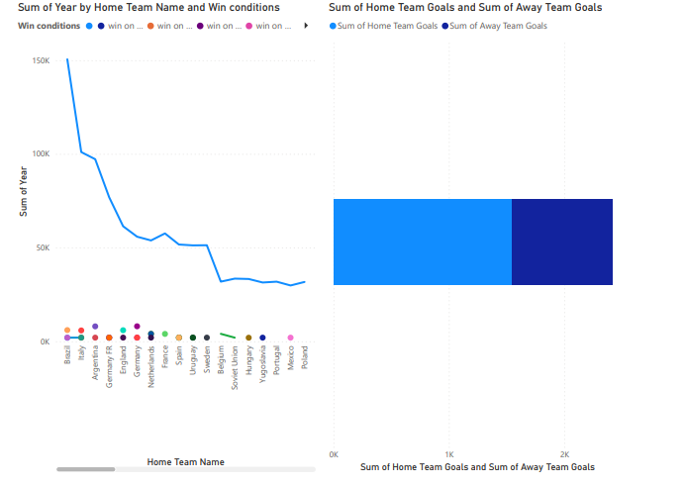

TASK 03: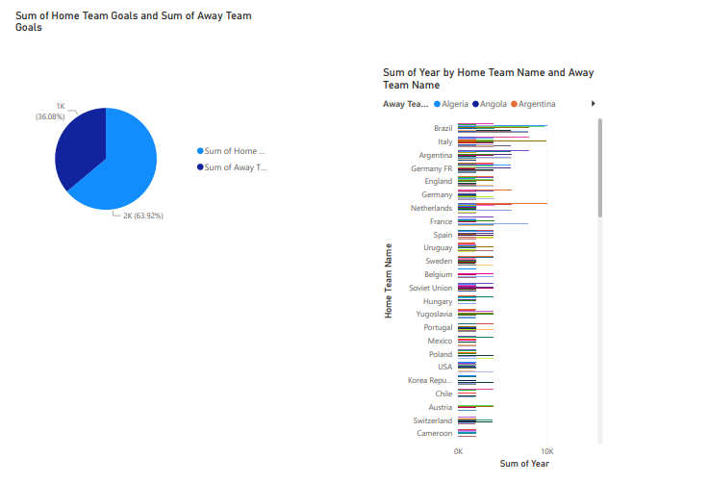

TASK 04:
