**PROJECT**

**1. Complex Filters & Projections:**

**Q1**. List the names and departments of students who have more than 85% attendance and are skilled in both "MongoDB" and "Python".

**Solution:** **Output:**

db.students.find(

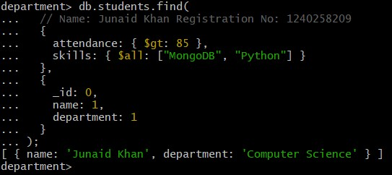 {

attendance: { $gt: 85 }, skills: { $all: ["MongoDB",

"Python"] }

},

{

_id: 0, name: 1,

department: 1

}

);

**Q2.** Show all faculty who are teaching more than 2 courses. Display their names and the total number of courses they teach.

**Solution: Output:**

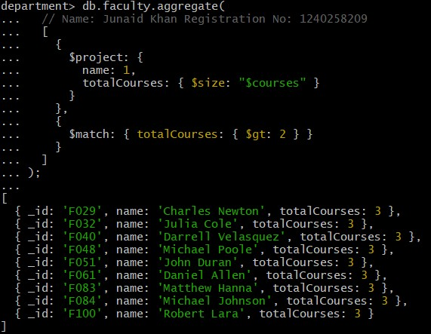db.faculty.aggregate(

[ {

$project: { name: 1, totalCourses: { $size:

"$courses" }

} },

{

$match: {

totalCourses: { $gt: 2 } }

}]);

**2. Joins ($lookup) and Aggregations:**

**Q3.** Write a query to show each student’s name along with the course titles they are enrolled in (use $lookup between enrollments, students, and courses).

**Solution:**

db.enrollments.aggregate( [

{

$lookup: { from: "students", localField: "student_id", foreignField: "_id", as: "studentInfo"

}

},

{

$lookup: { from: "courses", localField: "course_id", foreignField: "_id", as: "courseInfo"

}

},

{

$project: {

_id: 0,

studentName: { $arrayElemAt: ["$studentInfo.name", 0] }, courseTitles: "$courseInfo.title"

}

}

]

);

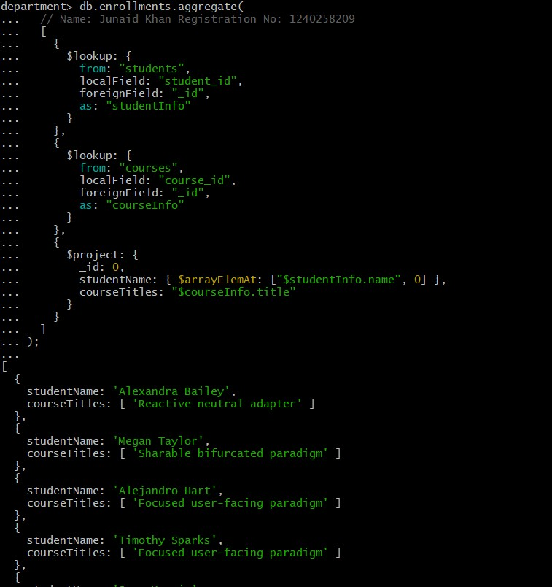

**Q4.** For each course, display the course title, number of students enrolled, and average marks (use $group).

**Solution:**

db.enrollments.aggregate( [

{

$group: {

_id: "$course_id", totalStudents: { $sum: 1 }, averageMarks: { $avg: "$marks" }

}

},

{

$lookup: { from: "courses", localField: "_id", foreignField: "_id", as: "courseInfo"

}

},

{

$project: { _id: 0, courseTitle: { $arrayElemAt: ["$courseInfo.title", 0] }, totalStudents: 1, averageMarks: 1

}

}

]

);

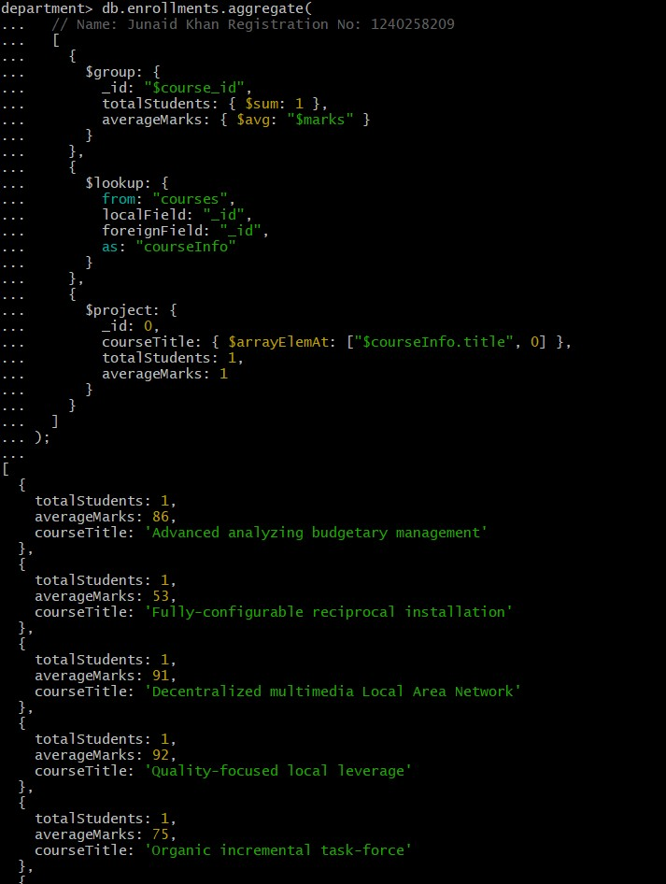

**3. Grouping, Sorting, and Limiting:**

**Q5.** Find the top 3 students with the highest average marks across all enrolled courses.

**Solution:**

db.enrollments.aggregate( [

{

$group: {

_id: "$student_id", averageMarks: { $avg: "$marks" }

} },

{

$sort: { averageMarks: -1 }

},

{

$limit:3

},

{ $lookup: { from: "students", localField: "_id", foreignField: "_id", as: "studentInfo"

} },

{ $project: {

_id: 0,

studentName: { $arrayElemAt: ["$studentInfo.name", 0] }, averageMarks: 1

}

}

]

);

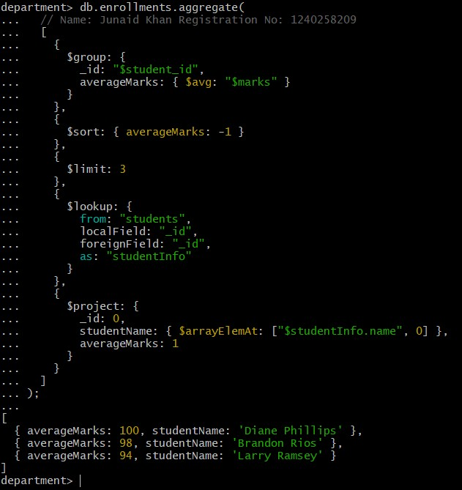

**Q6.** Count how many students are in each department. Display the department with the highest number of students.

|  |  |
| --- | --- |
| **Solution:** db.students.aggregate( [ | **Output:** |

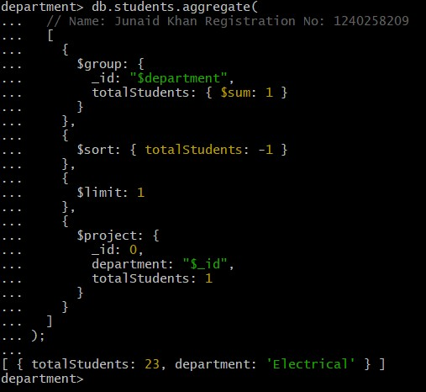 {

$group: {

_id: "$department",

totalStudents: { $sum: 1 }

}

},

{

$sort: { totalStudents: -1 }

},

{

$limit: 1

},

{

$project: { _id: 0,

department: "$_id",

totalStudents: 1

}

}

]

);

**4. Update, Insert, and Delete:**

**Q7.** Update attendance to 100% for all students who won any "Hackathon".

**Solution: Output:**

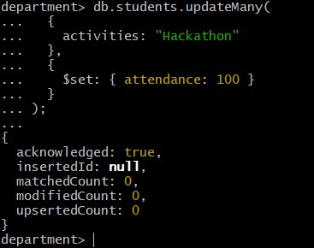db.students.updateMany(

{

activities: "Hackathon"

},

{

$set: { attendance: 100 }

}

);

**Q8.** Delete all student activity records where the activity year is before 2022.

**Solution: Output:**

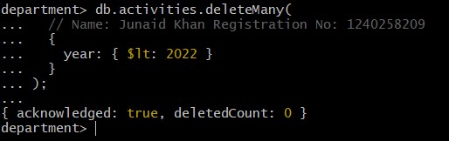db.activities.deleteMany(

{

year: { $lt: 2022 }

}

);

**Q9.** Insert a course record for "Data Structures" with ID "C150" and credits 4—if it doesn’t exist, insert it; otherwise update its title to "Advanced Data Structures".

**Solution: Output:**

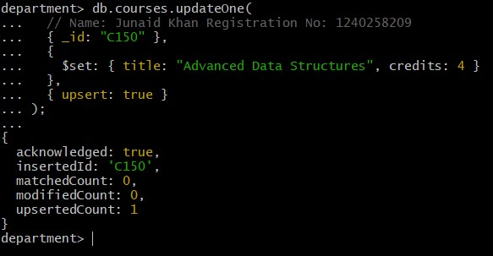db.courses.updateOne(

{ _id: "C150" },

{

$set: { title: "Advanced Data Structures", credits:

4 }

},

{ upsert: true }

);

**5. Array & Operator Usage:**

**Q10.** Find all students who have "Python" as a skill but not "C++".

**Solution: Output:** db.students.find(

{

$and: [

{ skills: "Python" },

{ skills: { $ne: "C++" } }

]

},

{

_id: 0, name: 1, skills: 1

}

);

**Q11.** Return names of students who participated in "Seminar" and "Hackathon" both.

**Solution: Output:**

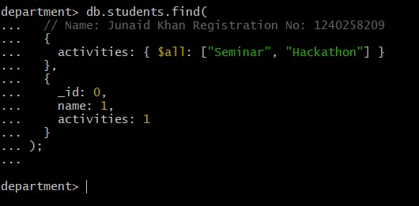db.students.find(

{ activities: { $all:

["Seminar", "Hackathon"] }

},

{

_id: 0, name: 1,

activities: 1

}

);

**6. Subdocuments and Nested Conditions:**

**Q12.** Find students who scored more than 80 in "Web Development" only if they belong to the "Computer Science" department.

**Solution:** **Output:**

db.enrollments.find(

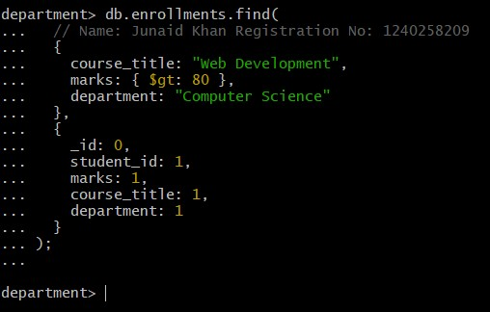{

course_title: "Web Development", marks: { $gt: 80 },

department: "Computer Science"

},

{

_id: 0, student_id: 1, marks: 1, course_title: 1,

department: 1

}

);

**7. Advanced Aggregation (Challenge Level):**

**Q13.** For each faculty member, list the names of all students enrolled in their courses along with

average marks per student per faculty.

**Solution:**

db.faculty.aggregate( [

{

$lookup: { from: "courses", localField: "courses", foreignField: "_id",

as: "courseInfo"

}

},

{ $unwind: "$courseInfo" },

{

$lookup: { from: "enrollments", localField: "courseInfo._id", foreignField: "course_id",

as: "enrolledStudents"

}

},

{ $unwind: "$enrolledStudents" },

{

$lookup: { from: "students", localField: "enrolledStudents.student_id",

foreignField: "_id",

as: "studentInfo"

}

},

{

$project: {

_id: 0,

facultyName: "$name", studentName: { $arrayElemAt: ["$studentInfo.name",0] },

marks: "$enrolledStudents.marks"

} },

{

$group: {

_id: { facultyName: "$facultyName", studentName:

"$studentName" }, averageMarks: { $avg: "$marks" }

}

},

{

$project: {

_id: 0,

facultyName: "$_id.facultyName", studentName: "$_id.studentName", averageMarks: 1

}

},

{

$sort: { facultyName: 1, studentName: 1 }

}

]

);

**Output:**

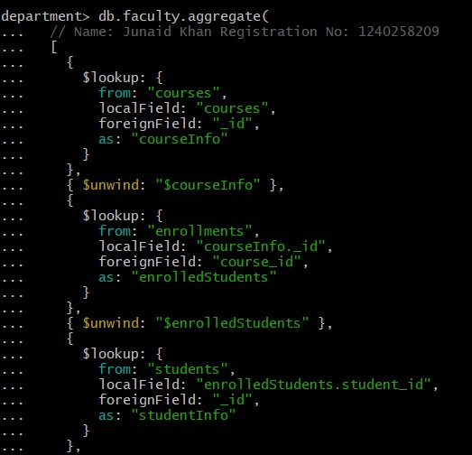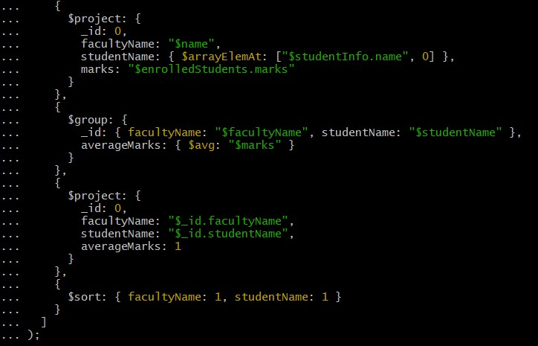

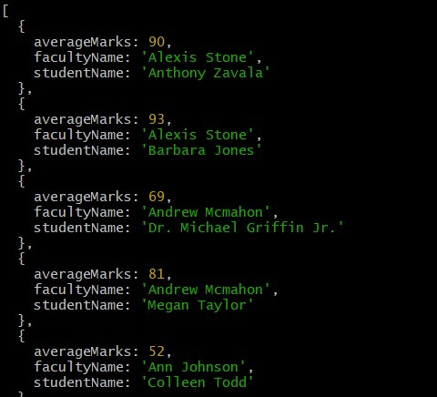

**Q14.** Show the most popular activity type (e.g., Hackathon, Seminar, etc.) by number of student participants.

**Solution: Output:**

db.students.aggregate( [

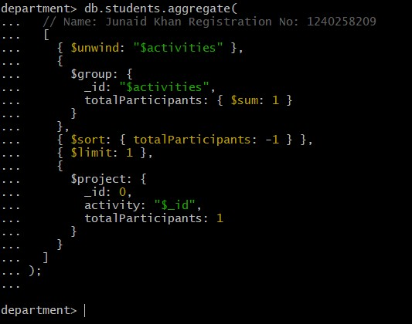 { $unwind: "$activities" },

{

$group: {

_id: "$activities",

totalParticipants: { $sum: 1 }

}

},

{ $sort: { totalParticipants: -1 } },

{ $limit: 1 },

{

$project: { _id: 0, activity: "$_id",

totalParticipants: 1

}

}

]

);