Babu Banarasi Das
University



Case Study

On

(UPI Transaction Analysis using Hadoop Framework)

SUBMITTED TO: SUBMITTED BY:
MR. Vikas Group A
Batch: BCADS23
Members:
Junaid Khan (1240258209)
Apoorv Sharma (1240258116)
Jai Prakash (1240258204)
Bipendra Kumar Pandey
(1240258150)
Project Description

This project focuses on analyzing UPI-based banking transactions using the Hadoop ecosystem. With the rapid growth of digital payments, understanding transaction patterns, identifying peak usage times, and analyzing transaction behavior has become important.
The dataset contains transaction details such as amount, transaction type, status, time, and fraud indicators. The goal of this project is to process large-scale transaction data and extract meaningful insights using distributed computing techniques.

Architecture

The project is built using the Hadoop ecosystem, which includes:
- HDFS (Hadoop Distributed File System): Used to store large transaction datasets in a distributed manner.
- MapReduce: Used to process and analyze data in parallel across nodes.
- Hive: Used to perform SQL-like queries for data analysis.
- Cloudera: Provides the environment to run Hadoop services.
This architecture ensures scalability, fault tolerance, and efficient processing of big data.

Data Flow

Raw Data → HDFS → MapReduce → Hive → Insights

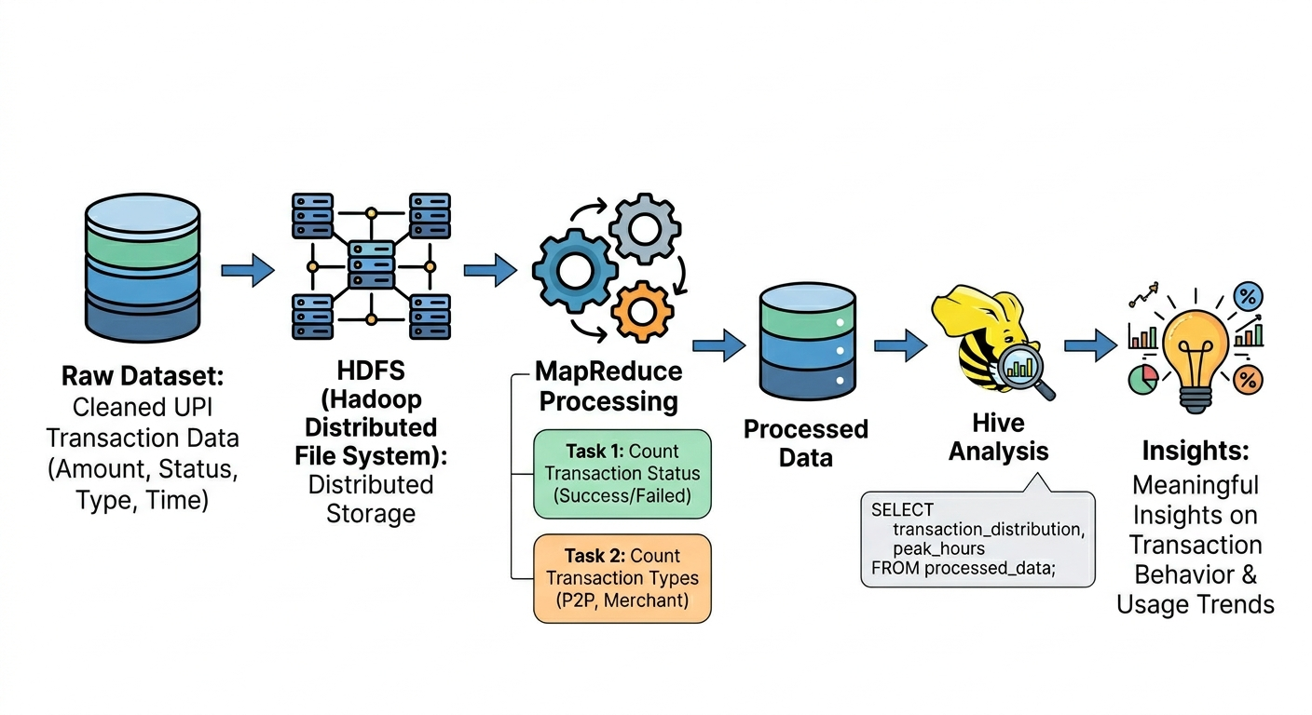

Explanation

Data Upload to HDFS
The cleaned UPI transaction dataset, containing details like transaction amount, status, type, and time, is uploaded to HDFS for distributed storage.
Data Processing using MapReduce
MapReduce is applied to process the data by counting transaction status (success/failed) and transaction types (P2P, merchant).
Data Analysis using Hive
The dataset is then analyzed using Hive queries to identify patterns such as transaction distribution and peak hours.
Insights Generation
Finally, meaningful insights about transaction behavior and usage trends are derived from the results.

Tools And Technologies

Tools: | Technologies:
- Cloudera VM | - Python (for MapReduce using Hadoop Streaming)
- Hadoop Distributed File System (HDFS) | - SQL (Hive Query Language)
- MapReduce (Hadoop Streaming using Python) | - CSV dataset
- Hive (for data analysis)
- Linux Terminal
- ChatGPT (Generative AI tool)

Use of Generative AI in the Project

Generative AI tools such as ChatGPT were used during the development of this project to assist in various stages of implementation. These tools helped in simplifying complex tasks, improving code quality, and speeding up the development process.

Areas Where AI Was Used:
- Code Generation:
AI was used to generate MapReduce programs (mapper and reducer) using Python.
- Debugging:
AI helped in identifying and fixing errors related to Python version compatibility and Hadoop execution.
- Query Writing:
AI assisted in writing Hive queries for analyzing transaction data.

Benefits of Using AI
- Faster Development:
Reduced the time required to write and test code.
- Error Reduction:
Helped in debugging and improving code accuracy.
- Better Logic Suggestions:
Provided optimized approaches for data processing and analysis.

Project Implementation
Dataset Description:
The dataset used in this project is a UPI transaction dataset containing information about digital payment activities. It includes attributes such as transaction ID, merchant category, transaction amount, transaction status, transaction type, time details (hour and day), and fraud indicators. This structured dataset is used to analyze transaction patterns, usage trends, and overall payment behavior.

Overview of dataset:
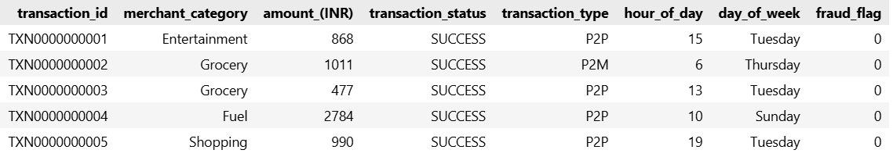

Implementation Steps:

Step 1: HDFS Setup and Data Upload:
- Created input directory in HDFS:
hdfs dfs -mkdir -p /user/cloudera/input
- Uploaded dataset to HDFS:
hdfs dfs -put upi_transactions_2024_cleaned.csv /user/cloudera/input
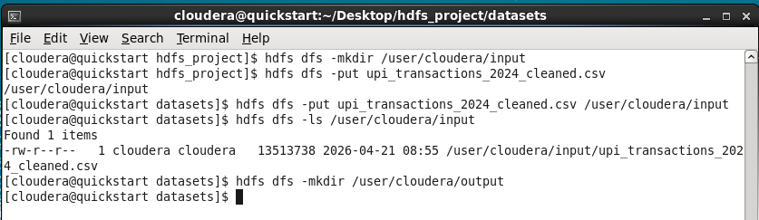

Step 3: MapReduce Implementation
- Developed Python-based mapper and reducer using Hadoop Streaming.
- Task 1: Count transaction status (success/failed)
- Task 2: Count transaction types (P2P, merchant)
The map reduce code is provided in the repo

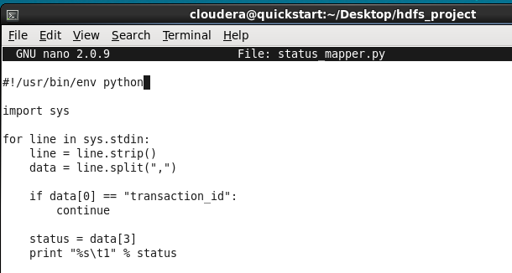 | 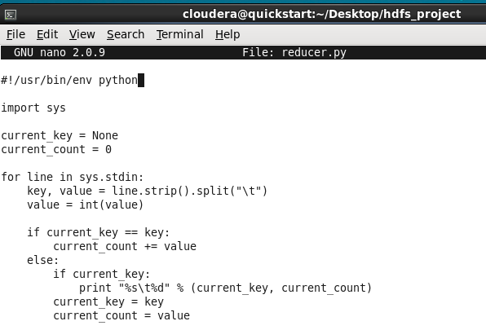
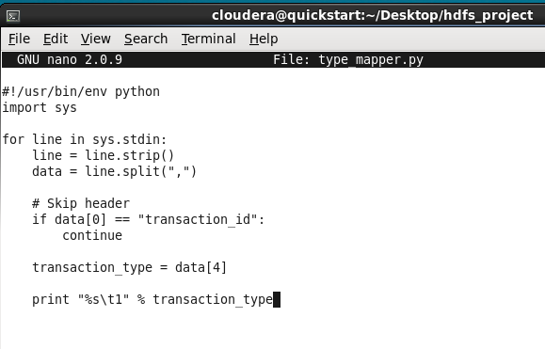

Image 1 mapper for status, image 2 reducer.py for both MapReduce operation, image 3 mapper for type

Performing task 1:
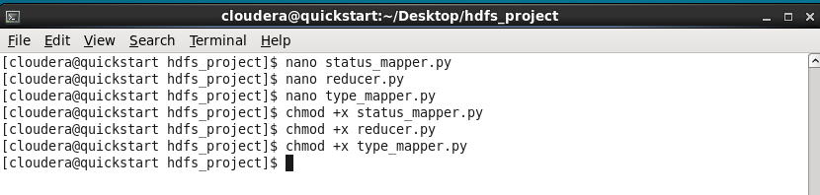
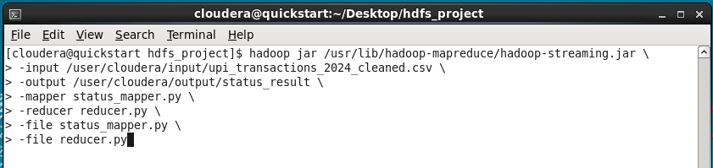
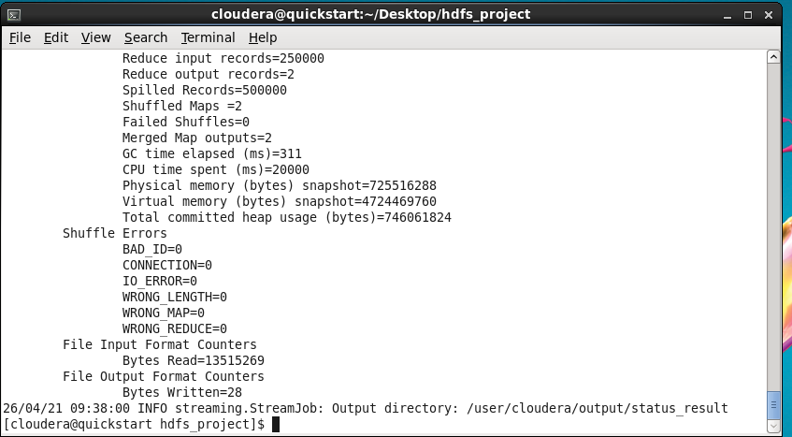

Output of Task 1:
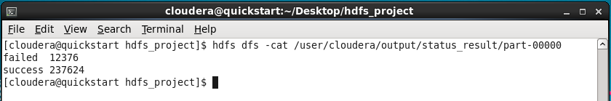

Performing task 2:
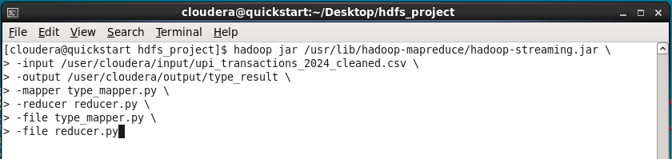
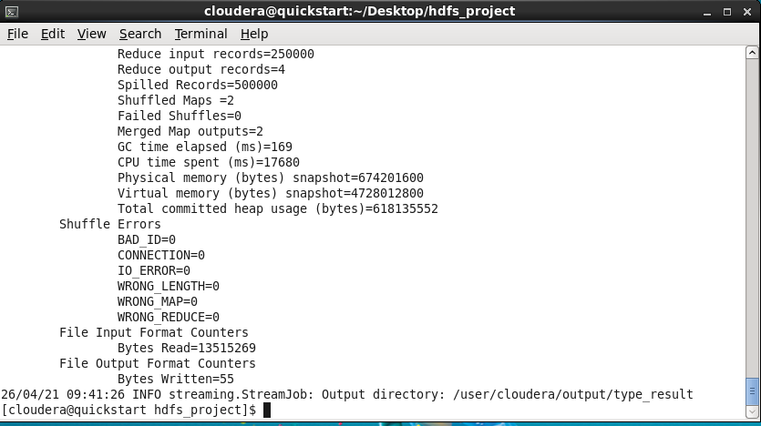

Output of Task 2:
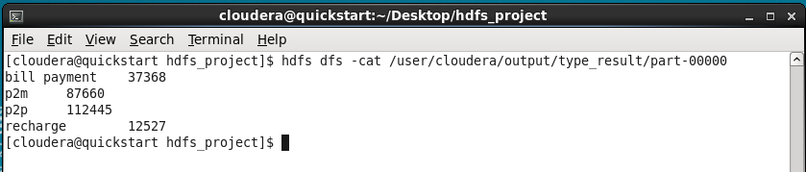

Step 4: Hive Implementation:
- Created Hive table for the dataset:

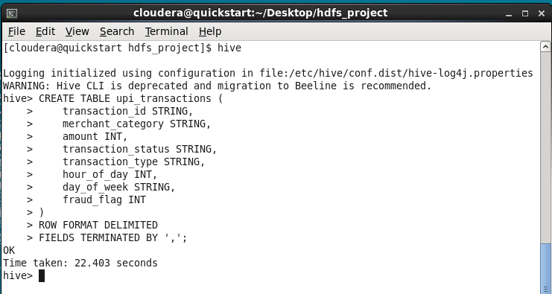

- Loaded data into Hive:

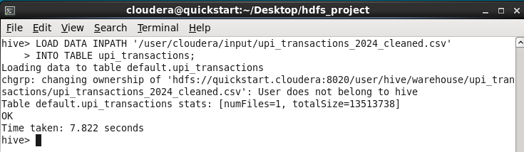

- Verifying the loaded Data:

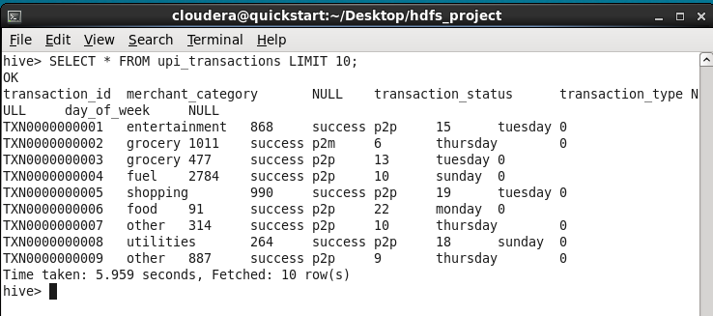

Step 5: Data Analysis using Hive:
1. Transaction Status Distribution:
SELECT transaction_status, COUNT(*)
FROM upi_transactions
GROUP BY transaction_status;

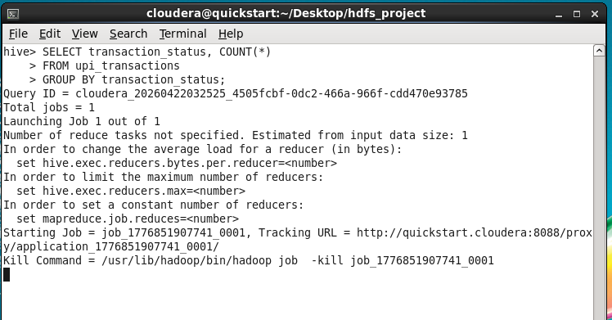 | 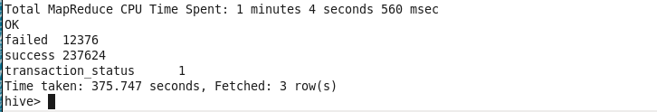
Insight:
The majority of transactions are successful (237,624) compared to failed transactions (12,376), indicating a highly reliable and efficient UPI payment system.

2. Peak Transaction Hours:

SELECT hour_of_day, COUNT(*) AS total
FROM upi_transactions
GROUP BY hour_of_day
ORDER BY total DESC;

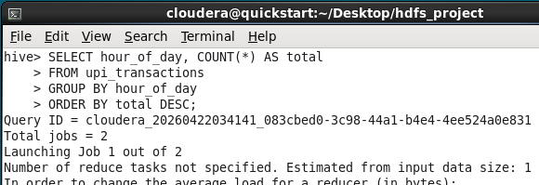 | 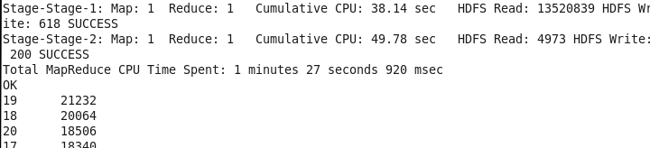
Insight:
The highest number of transactions occurs around 7 PM (hour 19), followed by 6 PM and 8 PM, indicating that evening is the peak usage time for UPI transactions.

3. Merchant Category Usage:
SELECT merchant_category, COUNT(*)
FROM upi_transactions
GROUP BY merchant_category;

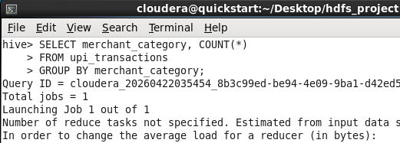 | 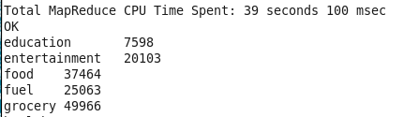

Insight:
Transactions related to fuel and utilities are consistently high, suggesting that users rely on UPI for routine payments like fuel and bill payments.
4. Average Transaction Amount

SELECT AVG(amount)
FROM upi_transactions;

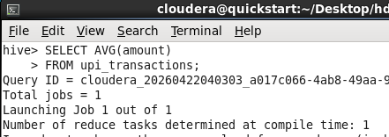 | 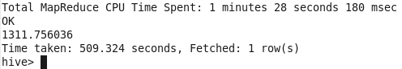

Insight:
Average Amount → 1311.75 INR
The average transaction amount highlights UPI’s role as a convenient medium for routine and mid-range financial transactions.

End of The Project
Thank You

