# MSE426 - Coding Assignment 1

# Golden Section Method

# Junaid Jawed Khan

# 301308300

Golden Section Algorithm

# Objectives

1. Code golden section method,
2. Report the total number of function evaluations, the optimal point, and the minimum function for each of the following functions.

# Given functions

1. 
2. 
3. 

# Golden Section Function

The golden section search algorithm was implemented and test in MATLAB. I’ve included my code in a text file, as stated in the instructions.

The function takes the initial lower & upper bound, the desired tolerance level, the desired number of iterations, and prints, the number of iterations taken to find a minimum in the given interval, the number of function evaluations taken to find the minimum, and the optimum point location.

## Function 1

The following figure is the plot of function 1 shown from [-1 1].

Figure 1: Plot of function 1 including the given search interval.

The given search interval is [0 0.7]. As we can note from the figure above, the minimum in this interval occurs at x=0. Therefore, the golden section search algorithm should converge towards x =0.

The result of the golden section search for this function with the iteration limit set to 100 and tolerance set to  is given below:

|  |  |  |  |
| --- | --- | --- | --- |
| Number of Iterations | Number of function evaluations | Optimal Point | Minimum value |
| 19 | 21 |  |  |

Table 1: Golden Section search result for function 1.

## Function 2

The following figure is the plot of function 2 shown from [-0.2 3.2].

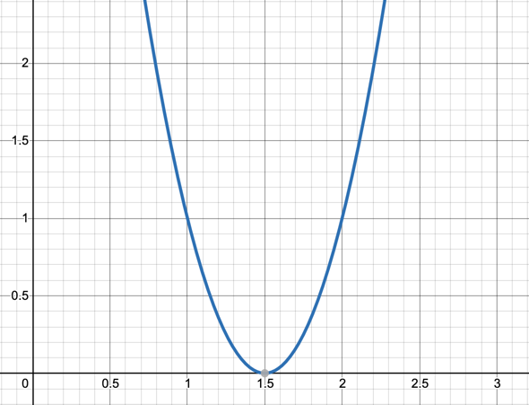

Figure 2: Plot of function 2 including the given search interval.

The given search interval is [0 3]. As we can note from the figure above, the minimum in this interval occurs at x = 1.5.Therefore, the golden section algorithm search should converge towards x=1.5.

The result of the golden section search for this function with the iteration limit set to 100 and tolerance set to  is given below:

|  |  |  |  |
| --- | --- | --- | --- |
| Number of Iterations | Number of function evaluations | Optimal Point | Minimum value |
| 31 | 33 |  |  |

Table 2: Golden Section search result for function 2.

# Function 3

The following figure is the plot of function 3 shown from [-10 10].

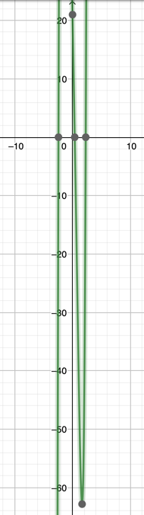

Figure 3: Plot of function 3 including the given search interval.

The given search interval is [0 3]. As we can note from the figure above, the minimum in this interval occurs between x = 0 and x=2. The result of the golden section search for this function with the iteration limit set to 100 and tolerance set to  is given below:

|  |  |  |  |
| --- | --- | --- | --- |
| Number of Iterations | Number of function evaluations | Optimal Point | Minimum value |
| 31 | 33 |  |  |

Table 3: Golden Section Search result for function 3.