QUESTION 1

Write a Python program to print the following string in a specific format (see the output).

Twinkle, twinkle, little star,

How I wonder what you are!

Up above the world so high,

Like a diamond in the sky.

Twinkle, twinkle, little star,

How I wonder what you are

CODING

print("Twinkle, twinkle, little star, \n\t How I Wonder What you are! \n\t\t Up above the would so high, \n\t\t Like a diamond in the sky. \n Twinkle, twinkle, little star, \n\t How I wonder what you are ")

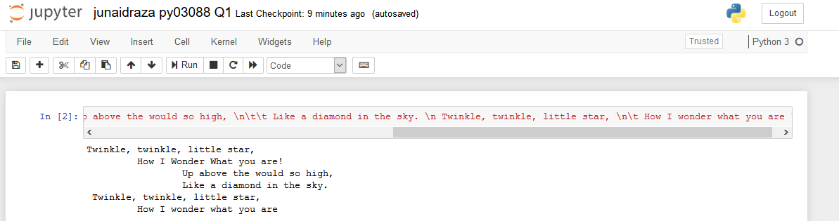

QUESTION 2 Write a Python program to get the Python version you are using

CODING

import sys

print("PYTHON VERSION")

print(sys.version)

print("VERSION INFOMATION")

print(sys.version_info)

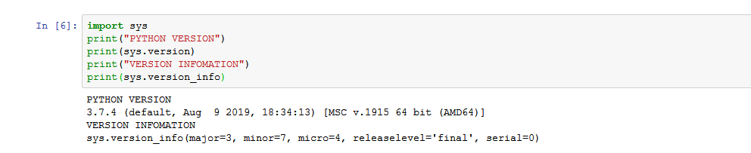

QUESTION 3 Write a Python program to display the current date and time.

CODING

from datetime import date

from datetime import datetime

today = date.today()

print("TODAY DATE IS:",today)

now = datetime.now()

print("CURRENT TIME IS:",now)

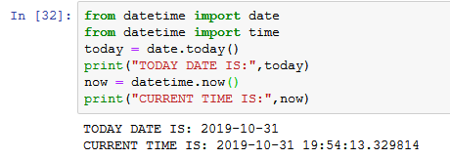

QUESTION 4

Write a Python program which accepts the radius of a circle from the user and compute the area.

CODING

pi=3.142

radius=float(input("ENTER VALUE OF RADIUS :",))

print("AREA OF CIRCLE "+str(radius)+" IS: " + str(pi * radius**2) )

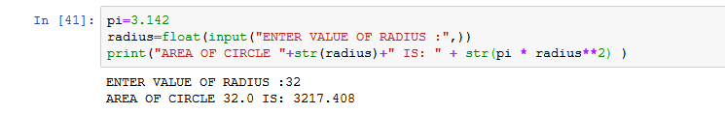

QUESTION 5

Write a Python program which accepts the user's first and last name and print them in reverse order with a space between them.

CODING

firstname = (input("ENTER YOUR FIRSTNAME:"))

lastname = (input("ENTER YOUR LASTNAME:"))

print(lastname +" " +firstname )

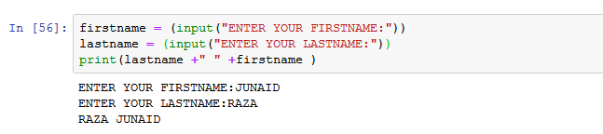

QUESTION 6

Write a python program which takes two inputs from user and print them addition

CODING

firstnumber=int(input("ENTER FIRST NUMBER: "))

secondnumber=int(input("ENTER SECOND NUMBER: "))

third=firstnumber+secondnumber;

print("ADDITION VALUE IS:"+str(third))

