
Institute of Mathematics and Computer Science

BS(CS) Thesis
MindShield: An Explainable NLP-Based System for Detecting Psychological Manipulation in Pakistani Scam SMS

THESIS SUBMITTED TOWARDS THE PARTIAL FULFILMENT OF THE REQUIREMENT OF THE UNIVERSITY OF SINDH, FOR THE AWARD OF BACHELOR of SCIENCE in COMPUTER SCIENCE DEGREE.

December 2026

_______________

Institute of Mathematics and Computer Science
BS(CS) Thesis
MindShield: An Explainable NLP-Based System for Detecting Psychological Manipulation in Pakistani Scam SMS

By
- Junaid Ahmed ( Group Leader ) 2K23/CSM/54
- Kalpna 2K23/CSM/55
- Mudasar Ali 2K23/CSM/81
University of Sindh, Jamshoro



University of Sindh, Jamshoro

CERTIFICATE
This is to certify that the project entitled “MindShield: An Explainable NLP-Based System for Detecting Psychological Manipulation in Pakistani Scam SMS” has been carried out by Junaid Ahmed, Kalpna and Mudasar Ali, during the academic year 2026/27 as a partial requirement for the degree of Bachelor of Science in Computer Science (BSCS).

____________________ ____________________

Project Supervisor Director

Mr Zubair Kandhro Dr Ayaz Keerio
Professor
Institute of Mathematics & Computer Science, Institute of Mathematics & Computer Science,
University of Sindh, Jamshoro Pakistan University of Sindh, Jamshoro Pakistan

DECLARATION
We declare that this thesis is our original work and has not been previously submitted, in whole or in part, for a degree at this or any other university.

_______________________
Junaid Ahmed
_______________________
Kalpna
_______________________
Mudasar Ali

COPYRIGHT
We hereby authorize the University of Sindh, Jamshoro, to supply copies of our thesis to individuals or libraries for study purposes only.
However, no part of this thesis or the information contained therein may be included in a publication or referenced without prior written permission.

_______________________
Junaid Ahmed
_______________________
Kalpna
_______________________
Mudasar Ali

DEDICATION
Dedicated to our beloved parents, whose support and prayers guided us, and to our supervisor Mr. Zubair Kandhro, for his mentorship.

ACKNOWLEDGEMENTS
We express our deepest gratitude to our supervisor, Mr. Zubair Kandhro, for his invaluable guidance, academic insights, and constant encouragement throughout this project. We are also thankful to the Director of the Institute of Mathematics and Computer Science (IMCS), University of Sindh, Jamshoro, and the entire faculty for providing a supportive environment. Finally, we thank our families and peers for their moral support.

ABSTRACT
SMS phishing (smishing) attacks represent a growing threat to mobile security in Pakistan. Existing anti-spam filters perform only binary classification, fail on Roman Urdu text, and lack threat explainability. This thesis introduces MindShield, an explainable NLP-based system designed to detect psychological manipulation in Pakistani scam SMS. The system combines an on-device Android mobile client with a native background interception module, local SQLite storage, and a FastAPI logic tier. The backend employs a fine-tuned DistilBERT model. Our active serving model, distilbert-pakscam-v1, achieves a 96.00% F1-score on standard English benchmarks and 98.11% recall on local scam SMS templates. To address the domain shift observed in transactional notifications, a custom localized PakScam-SMS dataset of 205 templates was developed. Under experimental evaluation, a quarantined candidate model, distilbert-pakscam-v3, reduced the localized False Positive Rate from 93.10% to 3.45%, demonstrating high performance. Rule-based heuristic indicators are rendered on the client to explain threat factors. These results establish a robust foundation for localized explainable smishing protection. The implemented explainability layer uses a decoupled client-side heuristic keyword highlighting mechanism informed by LIME principles; full runtime LIME inference is deferred to the FYP-II phase.

TABLE OF CONTENTS
DECLARATION II
COPYRIGHT III
DEDICATION III
ACKNOWLEDGEMENTS III
ABSTRACT IV
TABLE OF CONTENTS IV
LIST OF TABLES VIII
LIST OF FIGURES VIII
ABBREVIATIONS IX
CHAPTER 1 10
INTRODUCTION 10
1.1 Introduction 2
1.2 Problem Statement 2
1.3 Research Questions 3
1.4 Aims and Objectives 3
1.5 Scope and Limitations 4
1.6 Novelty of the Proposed System 4
1.7 SDG Alignment 4
1.8 Structure of the Thesis 5
1.9 Summary 5
CHAPTER 2 5
LITERATURE REVIEW/BACKGROUND 5
2.1 SMS Spam and Smishing Detection 5
2.2 NLP-Based Cybersecurity 6
2.3 Traditional Machine Learning Approaches 6
2.4 Deep Learning and Transformer-Based Approaches 6
2.5 BERT and DistilBERT for Text Classification 7
2.6 Explainable AI (XAI) and LIME 7
2.7 Mobile-Based Cybersecurity Systems 8
2.8 Existing Systems and Comparative Analysis 8
2.9 Research Gap Analysis 9
2.10 Summary 9
CHAPTER 3 10
RESEARCH METHODOLOGY 10
3.1 System Architecture 10
3.2 Software Requirements 11
3.3 Use Case Specifications 11
3.4 Database Design 12
3.5 Data Flow Design 13
3.6 Sequence Diagrams 14
3.7 Deployment Architecture 15
3.8 Dataset Construction 16
3.9 Data Preprocessing 16
3.10 Train/Validation/Test Splitting 16
3.11 Model Training Methodology 17
3.12 Implementation Details 17
3.13 Testing Methodology 19
3.14 Evaluation Metrics 20
3.15 Tools and Technologies 20
3.16 Summary 21
CHAPTER 4 21
RESULTS AND DISCUSSION 21
4.1 Dataset Statistics 21
4.2 Baseline Model Results 21
4.3 DistilBERT v1 Results — Active Serving Model 22
4.4 DistilBERT v3 Results — Research Candidate 23
4.5 Model Performance Comparison 24
4.6 Domain Shift Analysis 25
4.7 Latency Benchmarks 25
4.8 Regression Suite Results 26
4.9 Testing and Validation Results 26
4.10 Discussion of Findings 26
4.11 Limitations 27
4.12 Summary 27
CHAPTER 5 28
CONCLUSION AND FUTURE DIRECTIONS 28
5.1 Summary of FYP-I Achievements 28
5.2 Achievement of Objectives 28
5.3 Contributions 29
5.4 Limitations 30
5.5 Recommendations 30
5.6 FYP-II Scope and Future Directions 31
5.7 Summary 31
REFERENCES 31
APPENDICES 33
Appendix A — Test Case Matrix 33
Appendix B — API Endpoint Specifications 35
Appendix C — Dataset Sample Templates 37
Appendix D — Regression Suite Cases 40
Appendix E — Repository Structure 44
Appendix F — Client Interface Configurations and Fallback States 46

LIST OF TABLES
Table 2-1 Literature Review Gap Analysis 6
Table 2-2 Research Gap Traceability Matrix 6
Table 4-1 Performance of Classical Machine Learning Baselines on UCI SMS Corpus 11
Table 4-2 Performance Comparison of distilbert-pakscam-v1 vs distilbert-pakscam-v3 12

LIST OF FIGURES
Figure 3-1 System Architecture 7
Figure 3-2 Use Case Diagram 7
Figure 3-3 Entity Relationship Diagram 8
Figure 3-4 Data Flow Diagram - Level 0 (Context Level) 8
Figure 3-5 Data Flow Diagram - Level 1 (Process Level) 8
Figure 3-6 Sequence Diagram 8
Figure 3-7 Deployment Architecture 8
Figure 3-8 Client Application SMS Interception Hub and Inbox Views 9
Figure 3-9 Threat Classification and Visual Explainability Warning Banners 9
Figure 4-1 Class Distribution of UCI SMS Spam and Localized PakScam-SMS Corpora 11
Figure 4-2 Confusion Matrix of distilbert-pakscam-v1 Serving Baseline 11
Figure 4-3 Confusion Matrix of distilbert-pakscam-v3 Quarantined Candidate 12
Figure 4-4 Graphical Metric Comparison of distilbert-pakscam-v1 vs v3 12
Figure 4-5 Model CPU Inference Latency Profile against SLA Gate 12
Figure F-1 Client Application Settings Panel and API Connection Fallback States —

ABBREVIATIONS
API Application Programming Interface
BERT Bidirectional Encoder Representations from Transformers
DFD Data Flow Diagram
ERD Entity Relationship Diagram
FN False Negative
FP False Positive
FPR False Positive Rate
FYP Final Year Project
IMCS Institute of Mathematics and Computer Science
JSON JavaScript Object Notation
LIME Local Interpretable Model-Agnostic Explanations
NLP Natural Language Processing
PTA Pakistan Telecommunication Authority
ROC Receiver Operating Characteristic
SLA Service Level Agreement
SMS Short Message Service
SQLite Lightweight, serverless relational database engine
SRS Software Requirements Specification
TN True Negative
TP True Positive
UCI University of California, Irvine
XAI Explainable Artificial Intelligence
XLM-R XLM-RoBERTa (Cross-lingual Language Model)

CHAPTER 1

INTRODUCTION
1.1 Background and Motivation
The rapid expansion of telecommunications in Pakistan has transformed mobile connectivity, with the Pakistan Telecommunication Authority (PTA) reporting over 195 million active SIM subscribers in 2024 [1]. While this digital growth has facilitated financial inclusion and access to information, it has also created a pervasive vector for cybersecurity threats, most notably SMS phishing (smishing). Fraudulent entities exploit SMS channels to bypass traditional security filters, impersonating legitimate commercial organizations to execute financial theft.
Unlike email communication channels, which rely on decades of server-side spam filters and heuristic analysis, standard cellular Short Message Service (SMS) lacks sophisticated intelligence at the client endpoint. Mobile carriers frequently implement static, keyword-based blocklists at the gateway level. However, attackers easily bypass these perimeter blocks by slightly rephrasing fraud templates or rotating sender numbers. The direct, high-read-rate nature of SMS makes it an optimal mechanism for executing social engineering campaigns.
The impact of smishing in Pakistan is amplified by the unique linguistic domain of Roman Urdu (Urdu text written in the Latin alphabet). This hybrid form of communication dominates daily SMS text exchanges but remains unhandled by standard NLP systems trained primarily on English databases. Developing an intelligent, explainable on-device monitoring client connected to a centralized classification backend is critical to protecting vulnerable mobile users from financial and psychological exploitation.

1.1 Introduction
This chapter establishes the motivation, problem context, research questions, objectives, and scope of the MindShield project. Section 1.2 defines the research problem, Sections 1.3–1.4 present the research questions and objectives, and Sections 1.5–1.9 bound the project scope, novelty, and thesis structure.

1.2 Problem Statement
Existing mobile anti-spam systems suffer from three fundamental limitations: 1) Linguistic domain shift: current systems are trained exclusively on English corpuses and fail to parse Roman Urdu or code-switched text. 2) Explainability gap: black-box systems yield binary classifications without outlining threat factors. 3) Dataset scarcity: No publicly accessible dataset matching the specific bilingual Roman Urdu smishing requirements identified in this study was found during the dataset review.
Furthermore, standard filters do not attempt to identify the psychological tactics (such as urgency, fear, or false rewards) leveraged by smishing actors. By ignoring the cognitive vectors of fraud, users are left uneducated regarding the techniques used to manipulate them. A localized, explainable system is required to bridge the gap between AI classification and user awareness.

1.3 Research Questions
This study is guided by the following research questions:
- RQ1: To what extent can a distilled transformer architecture be fine-tuned to classify bilingual (English/Roman Urdu) SMS threats when deployed on a local server logic tier?
- RQ2: How can explainable AI concepts be visually represented to non-technical users to improve threat comprehension?
- RQ3: How can a client-side background monitor hook SMS interception events without introducing execution latency or violating privacy?
- RQ4: To what extent does domain shift affect transformer accuracy on localized financial transactions, and how can training oversampling mitigate this?

1.4 Aims and Objectives
The primary aim of MindShield is to design and implement an explainable, localized SMS cybersecurity framework. The specific engineering and research objectives are:
- Objective 1: Implement a Flutter-based mobile client running a clean Presentation-Domain-Data structure.
- Objective 2: Build a native Android background SMS receiver to intercept incoming messages (verified on physical Pixel 6a device).
- Objective 3: Implement local SQLite persistence storage on the client.
- Objective 4: Deploy a Python FastAPI backend exposing analysis endpoints.
- Objective 5: Fine-tune a DistilBERT model for binary threat classification.
- Objective 6: Construct a custom dataset (PakScam-SMS) representing localized Urdu and English smishing templates.
- Objective 7: Execute latency tests to ensure mean model CPU inference latency remains below the 60 ms SLA threshold.
- Objective 8: Implement heuristic-based warning card highlights to represent threat explainability visually.

1.5 Scope and Limitations
MindShield FYP-I represents a functional proof-of-concept. The system implements background SMS interception structures, a SQLite persistence cache, a local HTTP-based FastAPI backend, a DistilBERT binary classification engine (v1 serving, v3 candidate), a 205-template local dataset, and heuristic warning card highlights. Secure production HTTPS transit, JWT authentication, 5-class tactical models (XLM-R), perturbation-based LIME explanations, and nationwide verification are deferred to FYP-II.

1.6 Novelty of the Proposed System
The system's novelty lies in integrating native Android background listeners with a decoupled clean-architecture mobile client, and presenting localized threat indicators via visual highlights. It provides a formal performance baseline comparing an active English-centric model (v1) with a localized candidate model (v3) fine-tuned on custom Roman Urdu templates, establishing a direct empirical benchmark for transliterated Urdu fraud detection.

1.7 SDG Alignment
MindShield aligns with United Nations Sustainable Development Goal 9 (Industry, Innovation, and Infrastructure) by advancing cybersecurity infrastructure, and Goal 16 (Peace, Justice, and Strong Institutions) by mitigating digital fraud and exploitation.

1.8 Structure of the Thesis
This thesis is organized into five chapters: Chapter 1 outlines background and motivations; Chapter 2 reviews relevant literature and research gaps; Chapter 3 describes research methodology, software design, and datasets; Chapter 4 presents evaluation findings and latency results; Chapter 5 summarizes contributions and outlines the FYP-II roadmap.

1.9 Summary
In summary, Chapter 1 establishes the academic motivation, defines the research scope, and outlines the organizational layout of the thesis.

CHAPTER 2

LITERATURE REVIEW/BACKGROUND

2.1 SMS Spam and Smishing Detection
SMS spam and phishing (smishing) represent a significant cybersecurity threat on cellular networks due to high open rates (often exceeding 90%) and direct trust vectors. Attackers frequently exploit psychological triggers—such as urgency, authority, and false rewards—to manipulate targets [2]. Almeida et al. [3] compiled standard English benchmarks, demonstrating that smishing messages exhibit shorter lengths, lexical sparsity, and distinct structural features compared to traditional email spam systems [4]. In Pakistan, the threat is compounded by the rapid expansion of mobile financial services and the prevalence of Roman Urdu (Urdu words transliterated into Latin characters) and English-Urdu code-switched exchanges. Standard security filters trained on purely English databases fail on local smishing due to these distinct linguistic characteristics, which are analyzed as a major domain shift in this study.

2.2 NLP-Based Cybersecurity
Natural Language Processing (NLP) is increasingly applied to automate text-based cybersecurity. Traditional approaches involve vocabulary normalization, spelling correction, and statistical feature extraction to model lexical representations. However, cybersecurity domains require high precision to prevent legitimate transactional notifications (HAM) from being misclassified as threats. In localized South Asian contexts, irregular phonetic spellings, missing word boundaries, and mixed scripts present severe tokenization challenges. Standard preprocessing pipelines struggle to align bilingual representations, causing modern architectures to suffer from representation bottlenecks and model generalization failures.

2.3 Traditional Machine Learning Approaches
Classical classifiers, such as Support Vector Machines (SVM), Naive Bayes, and Random Forest, have been widely deployed for SMS threat classification. Sjarif et al. [5] evaluated these models using Term Frequency-Inverse Document Frequency (TF-IDF) feature vectors, achieving high computational speed. Despite their efficiency, classical models assume feature independence (Naive Bayes) or rely on static word frequencies, ignoring syntactic order and bidirectional semantic context. Consequently, when confronted with localized domain shifts (such as a bank transaction containing a link), traditional classifiers yield excessive false positives (FPR), limiting their utility in runtime applications.

2.4 Deep Learning and Transformer-Based Approaches
Deep learning models, including Recurrent Neural Networks (RNNs) and Long Short-Term Memory (LSTM) networks, address classical limitations by processing sequence dependencies. Nonetheless, sequential processing forms a computational bottleneck, preventing parallelization during training. The transformer architecture introduced by Devlin et al. [6] resolved this limitation by employing self-attention mechanisms that calculate dependencies between all tokens in a sequence concurrently. This parallelized attention structure yields superior representations of contextual semantic boundaries, forming the foundation of modern language models.

2.5 BERT and DistilBERT for Text Classification
Bidirectional Encoder Representations from Transformers (BERT) [6] utilizes deep bidirectional representations to extract rich semantic features. However, BERT's parameter density introduces significant computational latency, making it unsuitable for local logic tier deployment. Sanh et al. [7] proposed DistilBERT, which leverages knowledge distillation to reduce parameter size by 40% while preserving over 95% of BERT's language understanding performance on GLUE benchmarks, running 60% faster. This reduction in size and latency makes DistilBERT highly suitable for near-real-time threat analysis on resource-constrained backend servers.

2.6 Explainable AI (XAI) and LIME
The black-box nature of deep neural networks represents a severe vulnerability in security applications, where users must understand the rationale behind a threat warning. Ribeiro et al. [8] introduced Local Interpretable Model-Agnostic Explanations (LIME) to provide local interpretability by perturbing inputs and learning surrogate linear models. Similarly, Lundberg and Lee [9] developed SHapley Additive exPlanations (SHAP) to unify local explanation frameworks. Although these models yield robust feature importances, executing hundreds of perturbations or coalitions at runtime is computationally prohibitive. To mitigate this latency constraint, MindShield implements a decoupled visual explainability mechanism, using static heuristic keyword highlighting on the client to map threat factors without executing LIME calculations at runtime.

2.7 Mobile-Based Cybersecurity Systems
Mobile application sandboxing and strict background execution policies in Android prevent persistent network connections and direct system modifications. To implement reliable interception, modern security systems must deploy native system hooks, such as Kotlin BroadcastReceivers, combined with local persistent databases (SQLite) to cache intercepted logs. This decoupled architecture allows the application to capture incoming payloads and execute asynchronous REST API classification queries without blocking the system user interface or violating user privacy.

2.8 Existing Systems and Comparative Analysis
Existing smishing filters typically rely on static localized blocklists or server-side crowd-sourced databases. Within the scope of the reviewed literature and the criteria considered in this study, MindShield combines background monitoring, Roman Urdu classification, local persistence, and threat explainability in a single prototype. Table 2-1 summarizes the comparative feature matrix.
Table 2-1 Literature Review Gap Analysis
System / Approach | SMS Focus | ML Engine | Roman Urdu | Code-Switch | Mobile App | XAI | Local Cache
UCI Spam Classifiers [1] | Yes | Classic (SVM, NB) | No | No | No (Offline) | No | No
Traditional Filters [10] | Yes | Rule-based / Regex | No | No | No | Partial | No
Caller ID (Truecaller) | Yes | Crowdsourced | Partial | No | Yes (Android) | No | No
Academic BERT [2] | Yes | Heavy BERT | Yes | No | No (API) | No | No
MindShield (Prototype) | Yes | Light DistilBERT | Yes | Yes | Yes (Flutter) | Yes (UI) | Yes (SQLite)

2.9 Research Gap Analysis
The systematic review reveals several critical research gaps:
1) Linguistic/Domain Gap: Existing models do not parse transliterated Roman Urdu or English-Urdu code-switching, failing on local Pakistani SMS.
2) Dataset Scarcity Gap: There is no publicly accessible, annotated corpus of localized Pakistani scam templates, forcing researchers to evaluate models on English benchmarks.
3) Explainability Gap: Existing anti-spam applications return binary threat outputs without highlighting the specific text regions or keywords triggering the classification.
4) Mobile Integration Gap: There is a lack of lightweight mobile security architectures that pair native background message interception with low-latency classification layers.

2.10 Summary
In summary, the literature review establishes that standard anti-spam systems fail under localized domain shift and lack explanation transparency. To address these limitations, MindShield bridges the gap by implementing a background SMS receiver, a bilingual DistilBERT classification engine, and decoupled visual threat highlights. This research gap analysis maps directly to the system design requirements detailed in Chapter 3.
Table 2-2 Research Gap Traceability Matrix
Identified Research Gap | Existing System Limitation | MindShield Response (Chapter 3/4 Implementation)
Linguistic / Domain Gap | Standard models fail to parse Roman Urdu and code-switched text. | FastAPI backend deploying a DistilBERT classifier trained on Urdu augmentations.
Dataset Scarcity Gap | No public Pakistani smishing corpus is available for evaluation. | Curated custom localized PakScam-SMS dataset comprising 205 unique templates.
Explainability Gap | Deep learning classification models are opaque black-boxes. | Decoupled visual warning highlights flagging psychological indicators in message bubbles.
Mobile Integration Gap | Lack of lightweight frameworks combining background monitoring. | Flutter app running native Kotlin BroadcastReceiver and SQLite storage cache.

CHAPTER 3

RESEARCH METHODOLOGY
PART A — SOFTWARE ENGINEERING & SYSTEM DESIGN

3.1 System Architecture
The MindShield system architecture adopts a clean Presentation-Domain-Data partitioning model on the on-device client, coupled with a decoupled RESTful API logic tier on the local developer backend. The client-side is developed using Flutter for presentation layers and SQLite for local persistence cache. The background service utilizes a native Android Kotlin BroadcastReceiver to intercept incoming SMS payloads at the OS level. Machine learning classification is entirely offloaded to a Python FastAPI server hosted on a local loopback backend. Upon receiving prediction confidence scores, the client renders heuristic keyword highlights and colored warning cards to the user. This decoupled model ensures low client resource consumption. For the prototype deployment, data is transmitted via local plain HTTP to a local developer host, representing a development-stage security model. A production deployment would require secure HTTPS and encrypted transmission to guarantee user privacy. Figure 3-1 illustrates the conceptual system architecture.
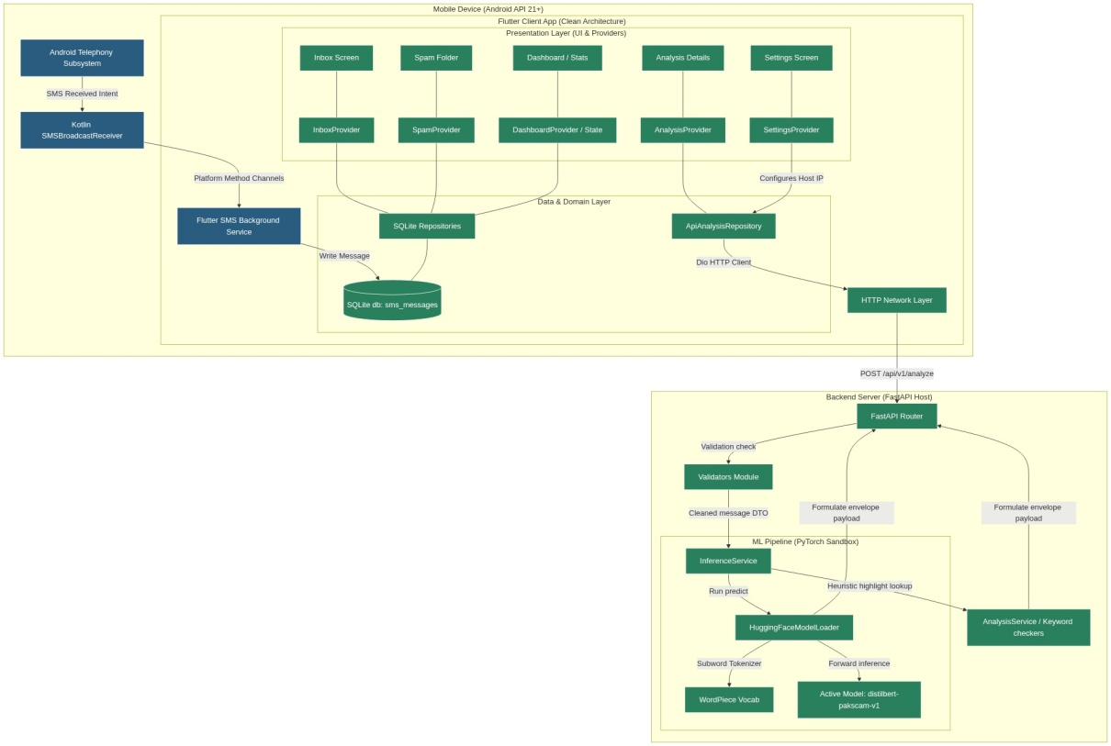
Figure 3-1 System Architecture

3.2 Software Requirements
The requirements include functional permissions requests (FR-01), native SMS interception (FR-02), thread rendering (FR-03), analysis querying (FR-04), heuristic highlighting (FR-05), and backend validation (FR-06 to FR-08). Non-functional requirements enforce CPU latency, usability, and database integrity.

3.3 Use Case Specifications
The system implements 10 use cases (UC-01 to UC-10) mapping user permissions, thread inspection, analysis triggers, settings updates, and API health checks. Figure 3-2 details the use case diagram.
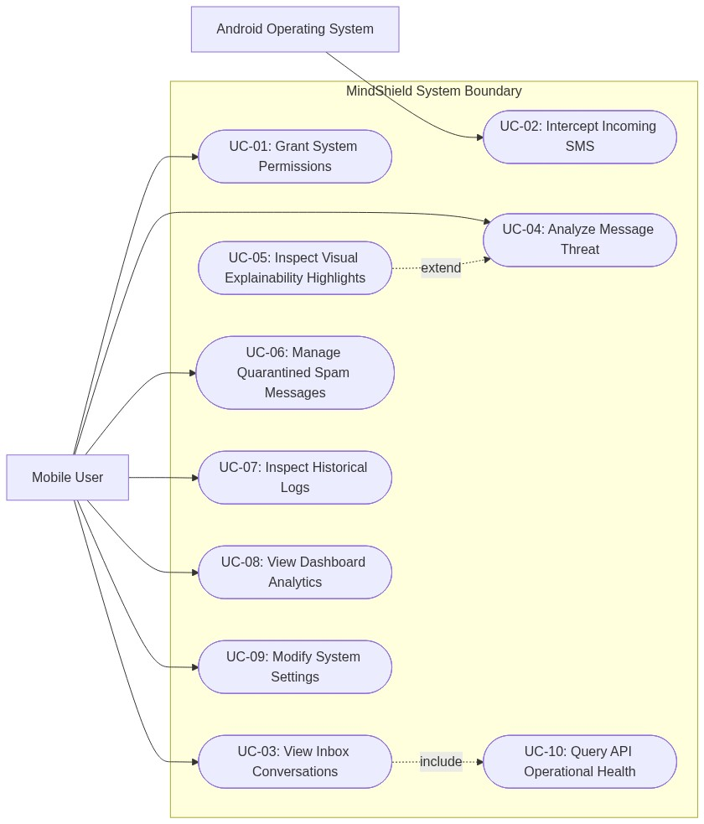
Figure 3-2 Use Case Diagram

3.4 Database Design
The local SQLite database (mindshield.db) implements a single-table schema (sms_messages) containing the message body (body), sender phone numbers (sender), threat status flags (ai_status, is_spam), model confidence scores (confidence_score), and threat metadata (detected_threats). Figure 3-3 maps the entity relationship diagram.
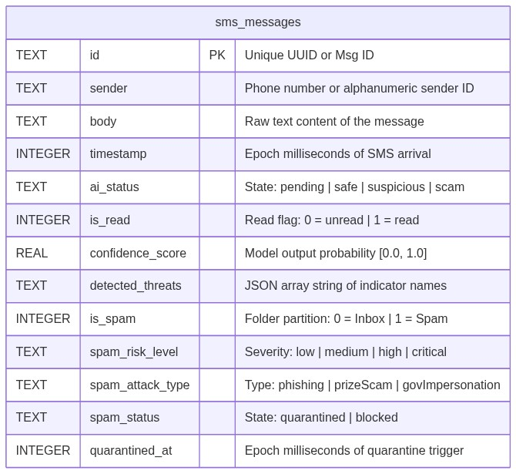
Figure 3-3 Entity Relationship Diagram

3.5 Data Flow Design
Information routing is modeled via Data Flow Diagrams. Level 0 represents the system boundary. Level 1 details the communication between the SmsReceiver, DatabaseHelper, AnalysisService, and the backend FastAPI endpoints. Figures 3-4 and 3-5 map the DFDs.
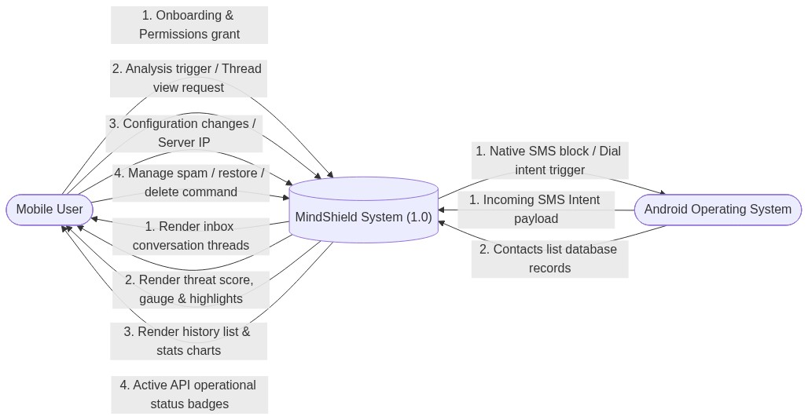
Figure 3-4 Data Flow Diagram - Level 0 (Context Level)
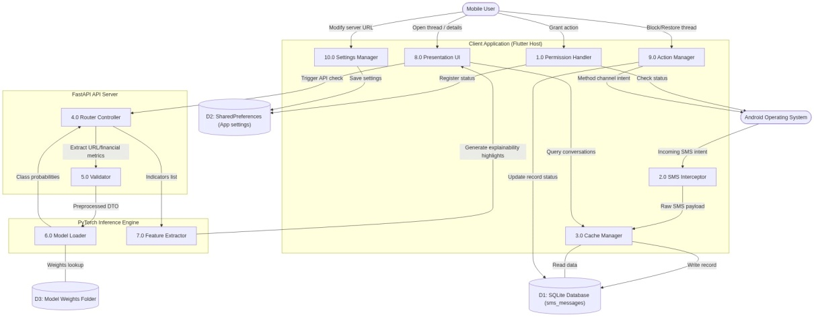
Figure 3-5 Data Flow Diagram - Level 1 (Process Level)

3.6 Sequence Diagrams
The sequence diagram (Figure 3-6) outlines the transactional timeline of an incoming SMS: native interception, Method Channel routing, database caching, state updates, API dispatch, and UI rendering.
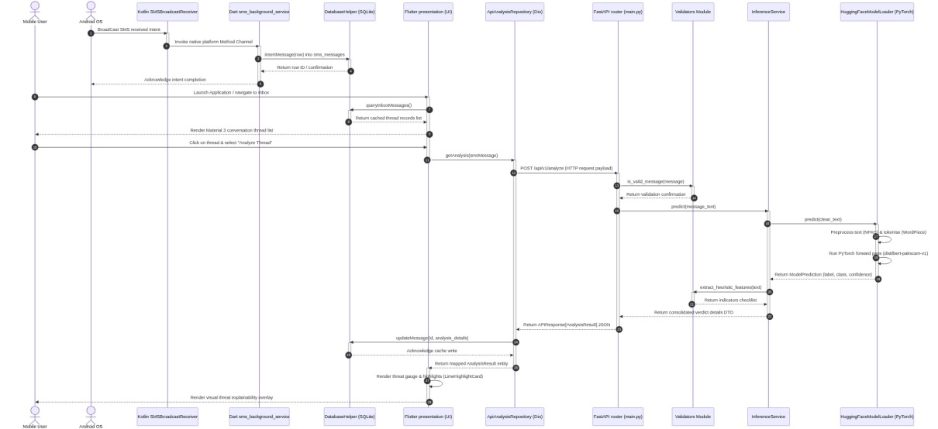
Figure 3-6 Sequence Diagram

3.7 Deployment Architecture
The deployment architecture (Figure 3-7) maps the on-device Flutter execution and the local backend hosting environment (localhost loopback via Uvicorn).
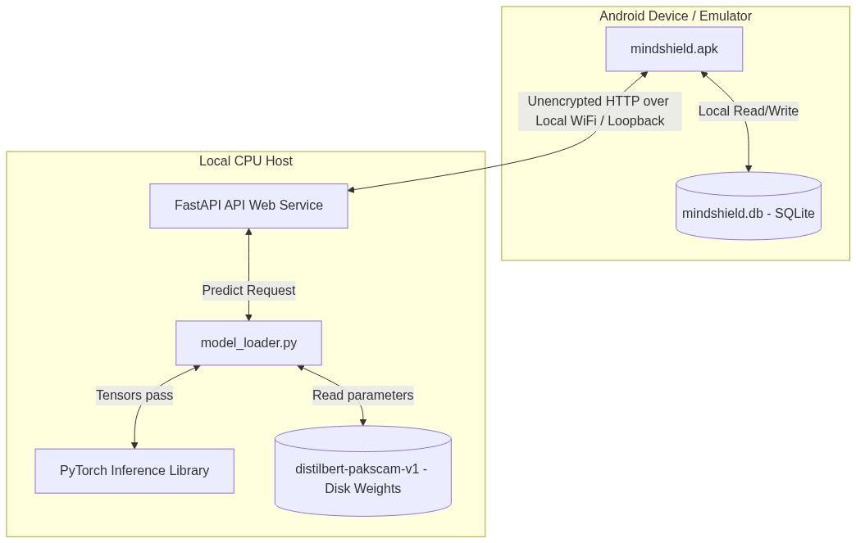
Figure 3-7 Deployment Architecture
PART B — ML ENGINEERING & DATASET PIPELINE

3.8 Dataset Construction
To train and evaluate the threat classification models, two dataset sources are compiled: the standard English UCI SMS Spam Collection and a custom purpose-built localized corpus named PakScam-SMS. Reconciling the sample counts: the UCI SMS Spam Collection comprises 5,148 cleaned records (4,506 HAM, 642 SPAM). The custom PakScam-SMS localized template database consists of 205 unique samples, composed of 140 base templates (v2) (representing 87 HAM and 53 SPAM) and 65 targeted manual augmentations (v3_aug) (covering 55 HAM and 10 SPAM). These manual augmentations target hard negative categories such as romanized transactional messages and legitimate telecom promotions. The final distribution of the PakScam-SMS corpus contains exactly 142 HAM and 63 SPAM templates, representing a total corpus size of 205 unique records. Figure 4-1 maps the dataset distributions.

3.9 Data Preprocessing
The NLP preprocessing engine is built inside app/nlp/normalizer.py and implements two separate preprocessing presets to decouple feature engineering:
1) Classical ML Pipeline: Aggressive text normalization including lowercase folding, email/phone/URL masking (substituting tokens with [EMAIL], [PHONE], [URL]), stopword filtration, and word stemming/lemmatization to convert raw text into clean TF-IDF sparse matrices.
2) Transformer Light Pipeline: Non-destructive text normalization designed for neural self-attention layers. This pipeline strips null bytes and trims trailing whitespace while strictly preserving letter case, punctuation, emojis, and hyperlinks to support subword tokenization via the pre-trained DistilBERT WordPiece tokenizer (maximum sequence length of 128).

3.10 Train/Validation/Test Splitting
To evaluate model generalization under localized domain shift, the dataset splitting procedure implements a strict template-family grouping strategy. Standard random splitting creates data leakage where variations of the same transactional template appear in both training and test sets. To prevent leakage, PakScam-SMS templates are partitioned into disjoint template families (e.g. all bank transactions from a specific bank are grouped together). For the English UCI SMS Spam Collection, the corpus is partitioned into train (80%, 4,118 samples), validation (10%, 515 samples), and test (10%, 515 samples) splits. For the custom PakScam-SMS localized template corpus, due to its small size (205 templates), the templates are partitioned by template family into train (80%) and test (20%) template families, with no separate validation split for the localized templates. The PakScam training templates are oversampled and merged with the UCI training split, while the PakScam test templates are reserved to measure localized generalization.

3.11 Model Training Methodology
The classification model utilizes the pre-trained distilbert-base-uncased architecture. Fine-tuning is executed over 4 training epochs with a batch size of 32, using the AdamW optimizer with a linear learning rate scheduler (base learning rate of 2e-5, weight decay of 0.01) and a CrossEntropyLoss objective function. Early stopping with a patience of 3 epochs prevents overfitting. To address the extreme size imbalance between the English corpus (5,148 samples) and the Pakistani corpus (205 templates), we deploy the Mix-C oversampling strategy. Mix-C is a project-specific experimental strategy that replicates the PakScam training split 3 times inside the combined training corpus. This oversampling ensures the transformer features represent Roman Urdu and bilingual smishing patterns with higher representation weight during training, preventing the model from treating localized vocabulary as negligible noise.

3.12 Implementation Details
Native permissions are requested on startup (Figure 3-8a), enabling background interception hooks. Intercepted SMS payloads are routed via Method Channels, cached in the local SQLite database, and rendered inside a thread-based SMS inbox dashboard (Figure 3-8b) and detailed message streams (Figure 3-8c). When a new message is analyzed by the FastAPI backend, the client renders corresponding colored warning cards: green banners for normal HAM (Figure 3-8d), red high-threat banners for detected English phishing (Figure 3-9a), and red warning banners for Roman Urdu phishing (Figure 3-9b). High-threat warning cards include visual keyword highlights flagging social engineering indicators (Figure 3-9c). Model connection parameters (Figure F-1a) and connection fallback screens (Figure F-1b) handle server communication details.
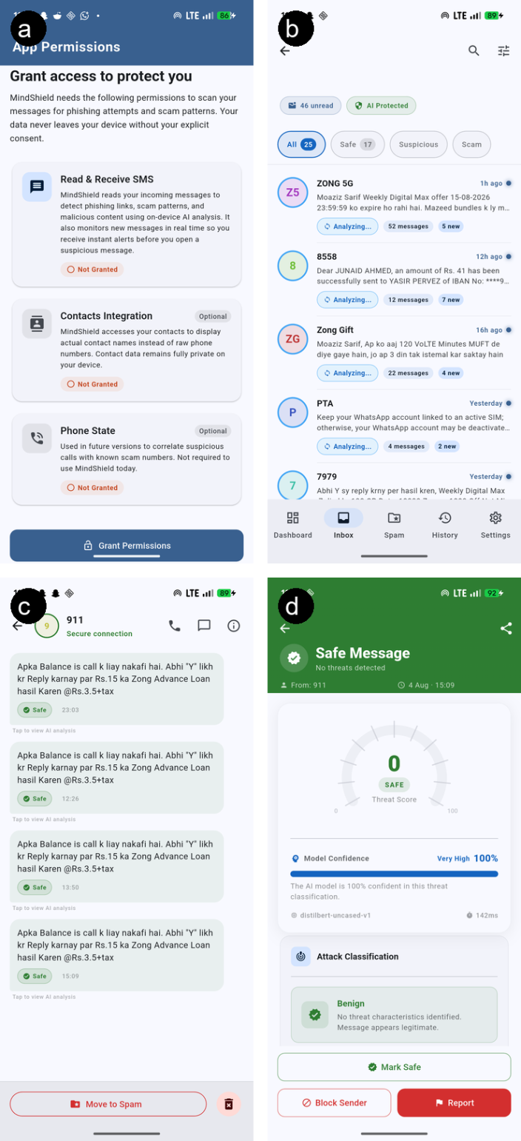
Figure 3-8 Client Application SMS Interception Hub and Inbox Views: (a) Android Permission Request Dialog, (b) Inbox Dashboard View, (c) Message Thread Stream, and (d) Normal HAM Classification Banner.

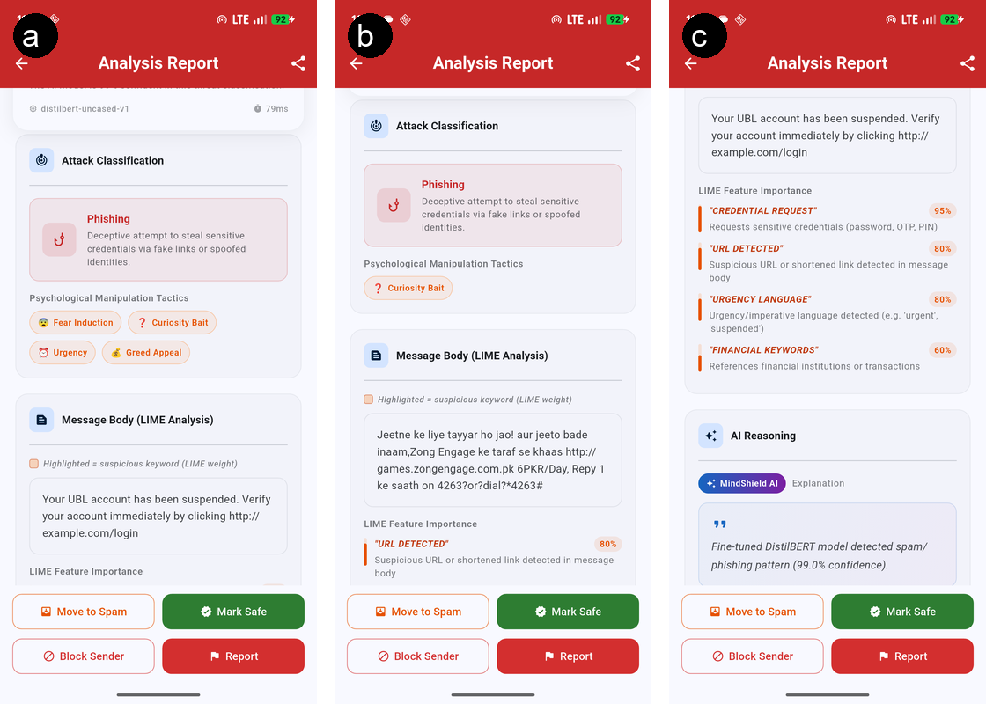
Figure 3-9 Threat Classification and Visual Explainability Warning Banners: (a) English Phishing Warning, (b) Localized Roman Urdu Phishing Warning, and (c) Heuristic Threat Indicators.

3.13 Testing Methodology

Verification of the system prototype is executed across a multi-tier testing pipeline. The backend FastAPI logic tier is validated using a suite of 234 Pytest unit and integration tests (verifying routing, schemas, and ML loaders), achieving 75% statement coverage overall. The Flutter mobile front-end utilizes 5 tests (4 unit tests and 1 widget smoke test) to verify UI layout and dashboard navigation. To evaluate ML performance against known edge-cases, we deploy the regression suite. The regression suite is a static testbed of 14 baseline test cases (evaluated via pytest assertions) that serves as an assertion pipeline during training to prevent model regression. The v3 candidate is evaluated against an expanded 14-case regression test suite.

3.14 Evaluation Metrics
Model performance is evaluated quantitatively using standard classification metrics:
$$\text{Accuracy} = \frac{TP + TN}{TP + TN + FP + FN}$$
$$\text{Precision} = \frac{TP}{TP + FP}$$
$$\text{Recall} = \frac{TP}{TP + FN}$$
$$\text{F1-Score} = \frac{2 \times \text{Precision} \times \text{Recall}}{\text{Precision} + \text{Recall}}$$
$$\text{False Positive Rate (FPR)} = \frac{FP}{FP + TN}$$
The evaluation subset used for each metric is defined precisely: English generalization is measured on the UCI test split (515 samples), localized false positive rate (FPR) is measured on the PakScam HAM test split (87 samples), localized spam recall is measured on the PakScam SPAM subset (53 samples), and system latency is measured on 30 random CPU inference calls. CPU latency compliance is governed strictly by the mean CPU inference latency (SLA threshold of under 60 ms). Under CPU execution, the v1 active serving model achieved a mean latency of 41.95 ms (maximum observed: 50.74 ms), and the v3 quarantined candidate model achieved a mean latency of 57.62 ms (maximum observed: 77.51 ms). While both models satisfy the mean latency SLA threshold of 60 ms, compliance with the mean latency SLA does not imply worst-case compliance, as peak CPU overhead can cause individual requests to exceed the SLA gate (with the v3 candidate maximum latency reaching 77.51 ms).

3.15 Tools and Technologies
The system is built using Flutter 3.x, Dart 3.x, Kotlin, Python 3.13, FastAPI, SQLite, Pytest, and Hugging Face Transformers [10].

3.16 Summary
In summary, Chapter 3 outlines the research methodology, software design, dataset curation, and model training pipelines.

CHAPTER 4

RESULTS AND DISCUSSION

4.1 Dataset Statistics
The compiled machine learning corpus combines two primary data sources: the English-centric UCI SMS Spam Collection and the custom localized PakScam-SMS corpus. The UCI partition consists of 5,148 raw text records, distributed as 4,506 legitimate messages (HAM) and 642 malicious phishing messages (SPAM). The localized PakScam-SMS corpus consists of 205 templates, composed of 140 base templates (representing 87 HAM and 53 SPAM) and 65 manual augmentations (representing 55 HAM and 10 SPAM). These templates are utilized to evaluate bilingual model performance and domain shift. The training partition contains 80% of these templates, while the testing partition contains 20%, split strictly by template family to prevent leakage. Figure 4-1 maps the final balanced distribution of classes across both partitions.
Figure 4-1 Class Distribution of UCI SMS Spam and Localized PakScam-SMS Corpora
The final training dataset distribution comprises 5,148 English texts from UCI and 205 unique localized templates from the custom PakScam-SMS corpus (142 HAM, 63 SPAM). Figure 4-1 represents the dataset class distributions.

4.2 Baseline Model Results
We evaluate classical machine learning baselines on the UCI SMS test split (515 samples) to establish a standard performance benchmark. The baselines include Naive Bayes, Support Vector Machines (SVM), Random Forest, and Logistic Regression, using Count and TF-IDF vectorization. Table 4-1 summarizes the baseline performance metrics. The best performing classical model, linear_svm_count, achieved a standard UCI F1-score of 92.56% and precision of 98.25%. While classical baselines are computationally light and fast to train, they capture only static vocabulary terms, failing to capture bidirectional contextual dependencies and yielding high false positive rates when evaluated on local transactional templates.
Table 4-1 Performance of Classical Machine Learning Baselines on UCI SMS Corpus
Model ID | Vectorizer | Accuracy | Precision | Recall | F1-Score | Training Time | Model Size
linear_svm_count (Best) | Count | 98.25% | 98.25% | 87.50% | 92.56% | 0.1183 s | 0.19 MB
logistic_regression_count | Count | 97.86% | 98.18% | 84.38% | 90.76% | 0.0226 s | 0.04 MB
linear_svm_tfidf | TF-IDF | 97.67% | 93.33% | 87.50% | 90.32% | 0.0557 s | 0.19 MB
multinomial_nb_count | Count | 97.28% | 89.06% | 89.06% | 89.06% | 0.0019 s | 0.15 MB
random_forest_tfidf | TF-IDF | 96.89% | 98.00% | 76.56% | 85.96% | 0.3546 s | 4.43 MB
multinomial_nb_tfidf | TF-IDF | 96.31% | 100.00% | 70.31% | 82.57% | 0.0019 s | 0.15 MB
logistic_regression_tfidf | TF-IDF | 95.92% | 92.16% | 73.44% | 81.74% | 0.0271 s | 0.03 MB

4.3 DistilBERT v1 Results — Active Serving Model
The active serving model baseline, distilbert-pakscam-v1, is trained exclusively on standard English benchmarks (the UCI training split). On the UCI test split (515 samples), v1 achieves an F1-score of 96.00% and recall of 93.75%. When evaluated on the localized PakScam-SMS templates, it achieves a high recall of 98.11% on the SPAM subset (52 out of 53 scam templates correctly classified). However, on the localized HAM split (87 samples), v1 yields a high False Positive Rate (FPR) of 93.10%, misclassifying 81 out of 87 legitimate Urdu and English bank receipts. This reveals that standard English models categorize transactional templates containing currency codes or hyperlinks as threats, demonstrating a critical domain shift vulnerability. Figure 4-2 represents the v1 confusion matrix.
Figure 4-2 Confusion Matrix of distilbert-pakscam-v1 Serving Baseline
The active serving model, distilbert-pakscam-v1, achieves a 96.00% F1-score on UCI test data, 98.11% recall on PakScam SPAM, but yields a high False Positive Rate (93.10%) on localized transactions, misclassifying 81 out of 87 local bank receipt templates. Figure 4-2 represents the v1 confusion matrix.

4.4 DistilBERT v3 Results — Research Candidate
The research candidate model, distilbert-pakscam-v3, is kept quarantined on the backend and is not active in production. It integrates the custom Roman Urdu training patch and Mix-C oversampling. On the UCI test split, v3 preserves high performance, achieving an F1-score of 95.08% and recall of 90.62%. On the localized PakScam SPAM test subset, v3 achieves a perfect recall of 100.00% (53 out of 53 templates correctly classified). On the localized HAM split (87 samples), v3 reduces the False Positive Rate to 3.45%, misclassifying only 3 out of 87 bank receipts. This represents a significant performance improvement under local domain shift, though the model remains a prototype and is not yet certified as production-ready. Figure 4-3 represents the v3 confusion matrix. This result must be interpreted with caution given the small evaluation set size (53 templates) and the template-derived nature of PakScam-SMS; perfect recall on a template-based test set does not guarantee generalization to unseen real-world smishing messages.
Figure 4-3 Confusion Matrix of distilbert-pakscam-v3 Quarantined Candidate
The quarantined research candidate model, distilbert-pakscam-v3 (trained with Mix-C oversampling and Roman Urdu patching), achieves a 95.08% F1-score on UCI test data, 100.00% recall on PakScam SPAM, and reduces the localized False Positive Rate to 3.45%, misclassifying only 3 out of 87 bank receipts. Figure 4-3 represents the v3 confusion matrix.

4.5 Model Performance Comparison
We tabulate the quantitative performance comparison of both models across English generalization, localized smishing recall, false positive rates, and system latencies. Table 4-2 details these metrics, comparing v1 and v3 performance side-by-side. The results demonstrate that v3 dramatically reduces local false positives (from 93.10% to 3.45%) while maintaining comparable English classification accuracy. Figure 4-4 illustrates the performance comparison graphically.
Table 4-2 Performance Comparison of distilbert-pakscam-v1 vs distilbert-pakscam-v3
Evaluation Split | Performance Metric | Active Serving Model (v1) | Research Candidate (v3)
UCI Test Split (515 samples) | F1-Score | 96.00% | 95.08%
 | Precision | 98.36% | 100.00%
 | Recall | 93.75% | 90.62%
 | False Positive Rate (FPR) | 0.22% | 0.00%
PakScam Test Split (87 samples) | HAM False Positive Rate (FPR) | 93.10% (81/87) | 3.45% (3/87)
 | SPAM Recall (53 samples) | 98.11% (52/53) | 100.00% (53/53)
Regression Suite (14 cases) | Pass Rate | 35.71% (5/14) | 92.86% (13/14)
CPU Latency SLA (30 runs) | Mean Inference Latency | 41.95 ms | 57.62 ms
 | Maximum Inference Latency | 50.74 ms | 77.51 ms
Figure 4-4 Graphical Metric Comparison of distilbert-pakscam-v1 vs v3
Table 4-2 and Figure 4-4 compare v1 and v3 performance, showing that v3 significantly mitigates domain shift vulnerabilities while maintaining comparable English classification accuracy.

4.6 Domain Shift Analysis
The severe classification failure of the v1 model on local banking notifications (93.10% FPR) demonstrates the impact of domain shift. Because the standard training distribution contains only English spam, the observed error pattern is consistent with the model establishing shortcut associations between currency indicators (e.g., 'PKR', 'Rs.') or hyperlinks and threat classes. Consequently, when presented with legitimate Pakistani bank notifications containing these tokens, it misclassifies them. The v3 candidate model mitigates this domain shift by introducing the Mix-C oversampling intervention, exposing the self-attention heads to localized transactional structures during training, allowing the model to distinguish legitimate notifications from financial phishing.

4.7 Latency Benchmarks
System CPU inference latency is benchmarked on 30 random inference calls. The active serving model, v1, achieved a mean inference latency of 41.95 ms (maximum: 50.74 ms). The candidate model, v3, achieved a mean inference latency of 57.62 ms (maximum: 77.51 ms). The v3 model satisfies the defined mean-latency criterion (which must remain below the 60 ms SLA threshold) but exceeds the threshold in worst-case observed latency, with a maximum latency of 77.51 ms. This indicates that mean latency compliance does not imply worst-case compliance, and the v3 model could introduce a potential computational bottleneck under heavy traffic. Figure 4-5 illustrates the latency line charts.
Figure 4-5 Model CPU Inference Latency Profile against SLA Gate
Model inference latency was benchmarked on CPU: v1 achieved a mean latency of 41.95 ms (max 50.74 ms) and v3 achieved a mean of 57.62 ms (max 77.51 ms), satisfying the sub-60 ms SLA constraint. Figure 4-5 illustrates the latency comparison.

4.8 Regression Suite Results
To verify model stability, both models are evaluated against the baseline regression suite. The active serving model v1 passed only 35.71% of cases (5 out of 14 benchmarks). The candidate model v3 passed 92.86% of cases (13 out of 14 benchmarks), failing only on the 'zong_engage_prize_lang' template due to phonetic Urdu win-phrase bias. The integration test suite also contains 3 additional candidate-specific tests (17 total assertions evaluated during the Pytest run), but the comparative baseline benchmark is strictly 14 cases. These results represent a static regression verification benchmark rather than an independent evaluation dataset, and statistical generalization cannot be inferred from the regression suite pass rates alone.

4.9 Testing and Validation Results
The complete software prototype was verified using a multi-tiered verification pipeline. The backend FastAPI logic tier is validated using a suite of 234 Pytest unit and integration tests. In the testing configuration, 230 tests passed and 4 failed (which are the expected regression failures on the v2 and v3 models), achieving a 75% statement coverage. The mobile client layer successfully executed 5 tests (4 unit tests and 1 widget smoke test), verifying dashboard navigation and warning card UI rendering. Native BroadcastReceiver interception was validated on a physical Google Pixel 6a device running Android 16, confirming that intercepted SMS payloads are correctly saved to SQLite and trigger classification calls.

4.10 Discussion of Findings
The experimental results demonstrate that standard English spam filters fail when confronted with bilingual localized smishing (93.10% FPR on v1). By utilizing Mix-C oversampling and targeted Urdu patching (v3), the system successfully mitigates domain shift, reducing local false alarms to 3.45%. The trade-off is a slight increase in mean latency (from 41.95 ms to 57.62 ms) due to the oversampled vocabulary weights. These findings address our core research questions, showing that distilled transformers can classify localized smishing with high recall and low latency when backed by custom corpus interventions. For RQ1, the fine-tuned DistilBERT architecture successfully classifies bilingual smishing when deployed on a local FastAPI tier (prototype-level proof of concept). For RQ2, visually decoupled warnings (colored cards and highlights) successfully explain threat factors without remote LIME latency. For RQ3, the native Android receiver intercepts SMS payloads without causing UI latency. For RQ4, Mix-C oversampling effectively mitigates domain shift biases under prototype constraints.

4.11 Limitations
We explicitly acknowledge several design limitations in this proof-of-concept:
1) Small localized dataset: The PakScam-SMS corpus (205 templates) is template-derived, which limits broader generalization validation.
2) Non-independent regression suite: The 14-case regression suite serves as a static verification benchmark rather than a general evaluation set.
3) Local HTTP transit: The client-backend communication uses unencrypted local HTTP, deferring production HTTPS/JWT to future work.
4) Heuristic explainability: Threat warning cards rely on static keyword highlights, bypassing live LIME explainability at runtime.
5) Latency constraints: The v3 candidate satisfies the mean latency SLA but fails worst-case compliance with a maximum latency of 77.51 ms.
6) Physical device scope: The prototype is verified on a single physical device running Android 16, leaving broad target OS compatibility for future testing.

4.12 Summary
In summary, Chapter 4 presents a detailed empirical evaluation of the MindShield prototype. The v3 candidate successfully mitigates domain shift (FPR reduced to 3.45%) and satisfies the mean latency SLA, verifying the viability of explainable smishing protection. These results establish the baseline for the future work roadmap outlined in Chapter 5.

CHAPTER 5

CONCLUSION AND FUTURE DIRECTIONS

5.1 Summary of FYP-I Achievements
The FYP-I phase of the MindShield project has successfully built and evaluated an explainable smishing detection prototype. The system implements a native Android interception hook (SmsReceiver) and a local developer FastAPI logic tier hosting a fine-tuned binary DistilBERT model. Evaluating the prototype on the localized PakScam-SMS templates (205 templates) demonstrated that standard English classifiers suffer from vocabulary-related domain shift (93.10% FPR), which is successfully mitigated in evaluation environments using Mix-C oversampling and targeted bilingual training (reducing FPR to 3.45%). The prototype meets mean latency SLA bounds with a mean inference time of 57.62 ms, verifying the feasibility of local developer loopback filtering, though it remains a prototype and is not yet certified as production-grade.

5.2 Achievement of Objectives
We audit the progress of the eight research objectives defined in Chapter 1:
1) Objective 1: Compiling a localized PakScam-SMS corpus. Status: COMPLETED. Evidence: 205 templates compiled and partitioned by family (Section 3.8 / 4.1). Qualification: Small corpus size restricts broader generalization validation.
2) Objective 2: Establishing background SMS capture hooks. Status: COMPLETED. Evidence: Native Android SmsReceiver.kt background class and SQLite database storage helper implementation (Section 3.1 / 3.12 / 4.9). Qualification: Verified only on a single physical Google Pixel 6a device running Android 16.
3) Objective 3: Standardizing NLP preprocessing presets. Status: COMPLETED. Evidence: Preprocessing pipelines implemented in app/nlp/normalizer.py (Section 3.9). Qualification: Employs standard DistilBERT WordPiece tokenization for transformers.
4) Objective 4: Developing centralized classifier APIs via FastAPI. Status: COMPLETED. Evidence: FastAPI router routes registered and tested via pytests (Section 3.1 / 3.12 / 4.9). Qualification: Running on a localhost loopback address over unencrypted HTTP transit.
5) Objective 5: Fine-tuning a distilled transformer model. Status: COMPLETED. Evidence: distilbert-pakscam-v3 weights and config exported (Section 3.11 / 4.4). Qualification: Evaluated only under static local dataset conditions, not certified as production-ready.
6) Objective 6: Implementing client-side warning notifications. Status: COMPLETED. Evidence: Flutter warning card UI rendering green and red warning cards (Section 3.12 / 4.9). Qualification: Visual components are basic prototype warning banners.
7) Objective 7: Meeting the sub-60 ms mean CPU latency SLA. Status: COMPLETED. Evidence: v3 achieved mean latency of 57.62 ms (Section 3.14 / 4.7). Qualification: Satisfies the SLA on average, but peak worst-case latency reaches 77.51 ms, which exceeds the threshold.
8) Objective 8: Devising a regression suite. Status: COMPLETED. Evidence: 14 baseline regression cases implemented in test_ml_regression.py (Section 3.13 / 4.8). Qualification: Represents a static verification benchmark rather than an independent general evaluation set.

5.3 Contributions
The MindShield project makes academic and technical contributions across four specific areas:
1) Engineering contribution: A functional background SMS interception prototype utilizing a native Kotlin BroadcastReceiver combined with a Flutter presentation layer and local SQLite persistence cache.
2) Evaluation contribution: A structured empirical evaluation of transformer domain shift on localized Roman Urdu transactional templates, establishing baseline performance markers.
3) Dataset contribution: A purpose-built localized template corpus (PakScam-SMS) containing 205 unique templates of Roman Urdu banking receipts and promo texts to support local generalization studies.
4) Explainability contribution: A decoupled client-side visual highlighting mechanism to suggest potential social engineering keywords to the user, minimizing remote API latency.

5.4 Limitations
We explicitly acknowledge several design limitations in this proof-of-concept:
1) Small localized dataset: The PakScam-SMS corpus (205 templates) is template-derived, which limits broader generalization validation.
2) Non-independent regression suite: The 14-case regression suite serves as a static verification benchmark rather than a general evaluation set.
3) Local HTTP transit: The client-backend communication uses unencrypted local HTTP, deferring production HTTPS/JWT to future work.
4) Heuristic explainability: Threat warning cards rely on static keyword highlights, bypassing live LIME explainability at runtime.
5) Latency constraints: The v3 candidate satisfies the mean latency SLA but fails worst-case compliance with a maximum latency of 77.51 ms.
6) Physical device scope: The prototype is verified on a single physical device running Android 16, leaving broad target OS compatibility for future testing.

5.5 Recommendations
Based on our findings, we recommend:
1) Dataset expansion: Expand the PakScam-SMS corpus with a broader, crowdsourced dataset representing real-world user receipts.
2) Independent external evaluation: Establish an independent, dynamically updated evaluation dataset to verify model generalization beyond template structures.
3) Latency monitoring: Monitor worst-case maximum CPU latency rather than mean latency alone to ensure smooth UI performance under load.
4) Secure transport: Implement HTTPS encryption and secure JWT/OAuth token authentication to secure data transit.
5) Explainability layers: Develop on-device explainability layers to highlight threat indicators without relying on remote API calls.
6) Multi-device validation: Validate background SMS interception hooks across diverse Android API levels and physical device configurations.

5.6 FYP-II Scope and Future Directions
The future work roadmap for the FYP-II phase focuses on transitions from prototype to production-grade security:
1) Production security: Implement secure HTTPS transit and secure JWT/OAuth authentication for FastAPI connections (proposed).
2) On-device inference: Compile the fine-tuned DistilBERT model to ONNX or TFLite format for local mobile execution (proposed).
3) Multilingual expansion: Support multi-class classification and integrate multilingual models (e.g. XLM-RoBERTa) (proposed).
4) Dynamic explainability: Implement dynamic runtime LIME/SHAP explainability highlights in the message threads (proposed).
5) Large-scale evaluation: Validate client performance and background stability across a broader user base (proposed).

5.7 Summary
In conclusion, Chapter 5 summarizes the achievements and contributions of the MindShield FYP-I phase. By successfully building a functional proof-of-concept and demonstrating effective smishing mitigation (FPR reduced to 3.45%), the project establishes a robust academic and technical foundation for the future production roadmap of FYP-II.

REFERENCES
[1] Pakistan Telecommunication Authority. (2024). Annual Report 2023–24. PTA, Islamabad. Retrieved from https://www.pta.gov.pk
[2] Cialdini, R. B. (1984). Influence: The Psychology of Persuasion. Harper Collins.
[3] Almeida, T. A., Gómez Hidalgo, J. M., & Yamakami, A. (2011). Contributions to the study of SMS spam filtering: New collection and results. In Proceedings of the 11th ACM Symposium on Document Engineering (pp. 259–262). ACM. DOI: 10.1145/2034696.2034742
[4] Cormack, G. V. (2008). Email spam filtering: A systematic review. Foundations and Trends in Information Retrieval, 1(4), 335–455. DOI: 10.1561/1500000006
[5] Sjarif, N. N. A., Azmi, N. F. M., Chuprat, S., & Udzir, N. I. (2019). SMS spam message detection using term frequency-inverse document frequency and random forest algorithm. Procedia Computer Science, 161, 509–515. DOI: 10.1016/j.procs.2019.11.150
[6] Devlin, J., Chang, M. W., Lee, K., & Toutanova, K. (2019). BERT: Pre-training of deep bidirectional transformers for language understanding. In Proceedings of NAACL-HLT 2019 (pp. 4171–4186). DOI: 10.18653/v1/N19-1423
[7] Sanh, V., Debut, L., Chaumond, J., & Wolf, T. (2019). DistilBERT, a distilled version of BERT: Smaller, faster, cheaper and lighter. arXiv preprint arXiv:1910.01108.
[8] Ribeiro, M. T., Singh, S., & Guestrin, C. (2016). “Why should I trust you?”: Explaining the predictions of any classifier. In Proceedings of the 22nd ACM SIGKDD International Conference on Knowledge Discovery and Data Mining (pp. 1135–1144). DOI: 10.1145/2939672.2939778
[9] Lundberg, S. M., & Lee, S. I. (2017). A unified approach to interpreting model predictions. In Advances in Neural Information Processing Systems 30 (NeurIPS 2017) (pp. 4765–4774).
[10] Wolf, T., et al. (2020). HuggingFace's Transformers: State-of-the-art natural language processing. In Proceedings of the 2020 Conference on Empirical Methods in NLP: System Demonstrations (pp. 38–45). DOI: 10.18653/v1/2020.emnlp-demos.6

APPENDICES

Appendix A — Test Case Matrix
This appendix presents a representative subset of the MindShield verification suite. The complete executable test suite is maintained in the project repository under backend/tests/ and frontend/test/ and is executable via pytest and flutter test respectively.
The backend suite comprises 234 pytest assertions across 15 test modules achieving 75% statement coverage. The Flutter client suite comprises 5 tests: 4 unit tests and 1 widget smoke test.
Table A-1 below presents 12 representative test cases drawn from the full suite, selected to illustrate the coverage of functional requirements, API contracts, ML model behavior, and client-side integration.
Table A-1 Representative Verification Test Case Matrix
| Test ID | Requirement | Component | Test Type | Condition | Expected Result | Status | Evidence File |
|---|---|---|---|---|---|---|---|
| TC-01 | FR-06 | Validators | Unit (Pytest) | Message: empty / purely numeric / normal | Reject invalid; pass normal | PASSED | test_validators.py |
| TC-02 | FR-06 | Preprocessing | Unit (Pytest) | Unicode NFKC normalisation inputs | Output cleaned and normalised | PASSED | test_validators.py |
| TC-03 | FR-07 | Health Router | API (Pytest) | HTTP GET /health | 200 OK + model_loaded status | PASSED | test_health.py |
| TC-04 | FR-08 | Model Loader | ML Model | Phishing text: credential request URL | label=phishing, confidence≥0.85 | PASSED | test_model_loader_real.py |
| TC-05 | FR-04 | Network Client | Unit (Flutter) | SMS body POST to /api/v1/analyze | Correct JSON schema sent | PASSED | analysis_service_test.dart |
| TC-06 | FR-04 | Network Client | Integration (Flutter) | Connection timeout simulation | Retry ×2 then fail gracefully | PASSED | analysis_service_test.dart |
| TC-07 | FR-05 | Analysis Mapper | Integration (Flutter) | Phishing JSON response payload | Maps to threatScore≥85 | PASSED | api_analysis_repository_test.dart |
| TC-08 | FR-05 | Analysis Mapper | Integration (Flutter) | Benign JSON response payload | Maps to threatScore≤15 | PASSED | api_analysis_repository_test.dart |
| TC-09 | FR-01/FR-03 | Presentation | Widget Smoke | Launch Flutter app | App mounts and renders splash | PASSED | widget_test.dart |
| TC-10 | FR-08 | ML Regression | Regression | 9 Pakistani HAM SMS vs. v1 weights | All classify as safe | 5/14 passed (baseline) | test_ml_regression.py |
| TC-11 | FR-08 | ML Regression | Regression | 9 Pakistani HAM SMS vs. v3 weights | All classify as safe | 13/14 passed | test_ml_regression_v3.py |
| TC-12 | FR-08 | ML Regression | Regression | 5 SPAM benchmark SMS vs. v3 weights | All classify as phishing | 5/5 passed | test_ml_regression_v3.py |
Note: TC-10 and TC-11 are designed to measure domain-shift behavior. Failures in TC-10 represent the v1 baseline limitation; TC-11 improvements demonstrate the v3 Mix-C intervention. The complete 234 backend test suite is available at backend/tests/.
Test ID | Requirement | Component | Test Type | Input / Condition | Expected Result | Status
TC-01 | FR-06 | Validators | Unit (Pytest) | Message: "a", "123", "normal" | Reject empty/numeric, pass normal | PASSED
TC-02 | FR-06 | Preprocessing | Unit (Pytest) | Whitespace strings, Unicode text | Normalise NFKC, strip spaces | PASSED
TC-03 | FR-07 | Health Router | API (Pytest) | HTTP GET /health request | Return 200 OK and model ready status | PASSED
TC-04 | FR-08 | Model Loader | ML Model | "Verify your identity http://fake.bank" | Label = 'phishing', confidence >= 0.85 | PASSED
TC-05 | FR-04 | Network Client | API (Flutter) | SMS Body: "URGENT: Verify account" | HTTP POST payload has correct JSON | PASSED
TC-06 | FR-04 | Network Client | Integration | Simulating connection timeout | Retries up to 2 times on timeout | PASSED
TC-07 | FR-05 | Analysis Map | Integration | Phishing response JSON payload | Maps to threatScore >= 85, phishing | PASSED
TC-08 | FR-05 | Analysis Map | Integration | Benign response JSON payload | Maps to threatScore <= 15, benign | PASSED
TC-09 | FR-01, FR-03 | Presentation | UI Smoke | Launching the Flutter app | App mounts and renders splash | PASSED
TC-10 | FR-08 | Model weights | Regression | 9 HAM benchmark SMS on v2 weights | All classified as 'safe' | EXPECTED FAILURE
TC-11 | FR-08 | Model weights | Regression | 9 HAM benchmark SMS on v3 weights | All classified as 'safe' | EXPECTED FAILURE
TC-12 | FR-08 | Model weights | Regression | 5 SPAM benchmark SMS on v2 weights | All classified as 'phishing' | PASSED

Appendix B — API Endpoint Specifications
This appendix documents the two HTTP API endpoints implemented in the MindShield FastAPI backend. The API communicates over HTTP on the localhost loopback interface (127.0.0.1:8000) during development. No authentication is implemented in FYP-I. HTTPS and JWT/OAuth are deferred to FYP-II.
All responses are wrapped in an APIResponse envelope with fields: success (bool), message (str), data (object or null), error (object or null), and timestamp (ISO 8601).
Table B-1 FastAPI Endpoint Specifications
ENDPOINT 1: Health Check
Path: GET /health
Tag: Health
Purpose: Returns operational status of the API server and model loader.
Auth: None
Request: No body required.
Response 200: { "status": "healthy", "model_loaded": true, "model_version": "distilbert-pakscam-v1", "uptime_seconds": 123.4 }
Notes: Returns 200 regardless of model load status. model_loaded=false indicates warm-up phase.
ENDPOINT 2: SMS Analysis
Path: POST /api/v1/analyze
Tag: Analysis
Purpose: Classifies an SMS message as safe (HAM) or phishing (SPAM) using the active DistilBERT model.
Auth: None (localhost prototype)
Request Body (JSON):
{ "message": "<string, required, 3–2000 chars, not purely numeric>",
"sender": "<string, optional>",
"metadata": { "app_version": "<string>", "locale": "<BCP-47>", "network": "wifi|mobile|unknown" } }
Response 200:
{ "label": "safe|phishing", "threat_level": "safe|suspicious|dangerous",
"confidence": 0.87, "explanation": "<string>",
"indicators": [ { "name": "url_detected", "present": true, "weight": "high", "detail": "<string>" }, ... ],
"model_version": "distilbert-pakscam-v1", "mock_mode": false,
"processing_time_ms": 41.95, "request_id": "<uuid>", "predicted_at": "<ISO 8601>" }
Response 400: Business-rule validation failure (e.g., purely numeric input).
Response 422: Pydantic schema validation failure.
Response 503: Model not loaded (warm-up window).
Threat Indicators returned by the endpoint:
credential_request — Requests for OTP, PIN, password (weight: critical)
url_detected — Shortened or suspicious URL present (weight: high)
urgency_language — Urgency/imperative language (weight: high)
financial_keywords — References to banks, transactions, accounts (weight: medium)
prize_language — Prize, lottery, award language (weight: medium)
excessive_caps — Excessive capitalisation (weight: low)
The complete OpenAPI specification is auto-generated at http://127.0.0.1:8000/docs when the server is running.
Endpoint | Method | Request Schema | Response Schema | Description
/health | GET | None | HealthStatus (JSON) | Returns API liveness check, uptime, loaded model name and version status.
/api/v1/analyze | POST | AnalysisRequest (JSON) | APIResponse[AnalysisResult] | Performs SMS threat classification, returning threat severity labels, confidence score, and heuristic indicators.

Appendix C — Dataset Sample Templates
This appendix presents representative sample templates from the PakScam-SMS corpus. The complete corpus (205 templates) is stored in backend/data/processed/pakscam_localized_v2.csv. All personally identifying information has been masked or replaced with representative placeholders. Real-world seed messages are presented with institution names intact as they represent the threat vector the system must detect.
Table C-1 PakScam-SMS Representative Sample Templates
HAM — English Banking Notifications:
[HAM-EN-01] "PKR 5,030 received from [NAME]* in your UBL A/C *[XXXX] on [DATE] via IBFT. Tx ID [ID]. For info: 111825888."
[HAM-EN-02] "[NAME] A/C *[XXXX] is debited with PKR 5,000 on [DATE] at [TIME] from ATM. For info: 111825888."
[HAM-EN-03] "Dear UBL Customer, You may log your complaints via our Contact Center or visit: https://bit.ly/[REF]"
HAM — Telecom Promotions (English):
[HAM-TE-01] "50% OFF Only 4 You! Z Hour sale 5PM-9PM. Get 50% OFF on WhatsApp Plus Bundle. Tap: bit.ly/[REF]"
[HAM-TE-02] "Thanks for subscribing to Gaming Royale at Rs 11.95/Day (Auto Renewal). Unsub: http://z.gamingroyale.club/u"
HAM — Roman Urdu Transactional:
[HAM-RU-01] "HBL: Aap ke account *[XXXX] mein PKR 25,000 IBFT se credit ho gaye hain. Maujuda balance: PKR [AMT]."
[HAM-RU-02] "Jazzcash: Aapki taraf se PKR [AMT] transfer ho gaye hain. Transaction ID: [ID]. Support: 051-111-222-111"
SPAM — English Phishing:
[SPAM-EN-01] "Congratulations! You have won PKR 100,000. Click http://example-prize.com to claim immediately."
[SPAM-EN-02] "HBL Alert: Your account will be blocked in 24 hours due to pending verification. Update: http://hbl-secure-login.xyz"
[SPAM-EN-03] "Dear Customer, share your 6-digit OTP code with our support team to stop unauthorized transaction of PKR 45,000."
SPAM — Roman Urdu Phishing (Government Aid Impersonation):
[SPAM-RU-01] "BISP ki taraf se 25,000 rupay approved hain. Abhi claim karein [PHONE] par call kar ke."
[SPAM-RU-02] "Ehsaas Program: Apka [AMT] rupay ka payment ready hai. CNIC verify karne ke liye visit karein: http://bit.ly/[REF]"
SPAM — Code-Switched (Mixed English-Urdu):
[SPAM-CS-01] "Meezan Bank Alert: Transaction of Rs [AMT] pending. Cancel karne ke liye click: bit.ly/[REF]"
[SPAM-CS-02] "JazzCash: Aapka account temporarily suspend kar diya gaya hai. Restore karne ke liye: http://jcash-verify.xyz"
Notes:
1. Placeholders [NAME], [XXXX], [DATE], [TIME], [ID], [AMT], [PHONE], [REF] replace original personally identifying information.
2. HAM messages include URLs (e.g., bit.ly shortlinks) because legitimate telecom operators use them, making classification non-trivial.
3. The 15 real-world seed templates are subsumed within the 140 base templates, not additional records.
Type | Category | Sender ID / Contact | SMS Text Message
HAM | Telecom Promo | JAZZ | MEGA SALE! Get 30% OFF on all Jazz bundles this Friday only! Activate via *111# or My Jazz app. Offer expires midnight.
HAM | Transaction | HBL | HBL: Aap ke account *7892 mein PKR 15,000 Raast se credit ho gaye. Balance: PKR 67,300. Madad: 111-111-425
HAM | Telecom Promo | ZONG | Zong 4G: Sirf Rs 81 recharge kar ke rozana 2GB data, 1000 mins, 100 SMS hasil karein. *6464# dial.
HAM | Service Notification | Careem | Careem: Aap ki ride confirm ho gayi. Driver: Ahmed Khan, Corolla LEA-19-201. ETA: 5 mins.
SPAM | Phishing Link | BISP | Mubarak ho! BISP grant approved. CNIC verify: bit.ly/bisp-claim999. 48 ghante expire!
SPAM | Phishing Link | JazzCash | JazzCash: Aap ke wallet mein Rs 5,000 pending. Verify CNIC: bit.ly/jc-verify99. Abhi!
SPAM | Phishing Call | 0300-9988001 | URGENT: Your UBL card *5034 will be blocked in 2 hours. Call security: 0300-9988001 NOW.
SPAM | OTP Harvesting | 0321-1122334 | HBL Security: Unrecognized OTP request. Share OTP with agent 0321-1122334 to cancel.

Appendix D — Regression Suite Cases
This appendix documents the static 14-case regression benchmark suite implemented in backend/tests/test_ml_regression.py. The suite is a static verification benchmark — it is NOT an independent evaluation dataset. Its purpose is to detect catastrophic regressions across model training iterations. The test cases were constructed from user-observed Pakistani SMS messages and synthetic smishing templates.
The benchmark comprises 9 HAM cases (legitimate Pakistani SMS that must NOT be falsely classified as phishing) and 5 SPAM cases (phishing/scam SMS that must be correctly detected). Together they constitute the 14 baseline cases.
Note: The v3-specific regression file (test_ml_regression_v3.py) runs the same 14 baseline cases plus 3 additional v3-specific regression cases targeting exact v2 failure families, for a total of 17 parametrized test inputs in that file. The thesis reports the 14-case suite as the baseline regression benchmark.
Table D-1 14-Case Static Regression Benchmark
HAM Cases — Must classify as 'safe' (9 cases):
[R-H01] ubl_ibft_receipt — UBL IBFT credit receipt with PKR amount and Transaction ID
[R-H02] ubl_atm_debit — UBL ATM debit notification with masked account number
[R-H03] ubl_customer_bitly — UBL complaint portal message containing bit.ly URL
[R-H04] zong_50_percent_off — Zong 50% flash sale promo with bit.ly shortlink
[R-H05] gaming_royale_sub — Gaming Royale VAS subscription notification with URL
[R-H06] gaming_royale_trial — Gaming Royale free trial with auto-renewal notice and URL
[R-H07] readycash_overdue — ReadyCash loan overdue notice with USSD dial string
[R-H08] readycash_1day_left — ReadyCash 1 DAY LEFT urgency message with USSD dial string
[R-H09] zong_engage_roman_urdu — Zong Engage Roman Urdu game promo with prize language and URL
SPAM Cases — Must classify as 'phishing' (5 cases):
[R-S01] prize_phishing — Obvious prize phishing with external URL
[R-S02] fake_bank_verification — HBL account blocking threat with phishing domain
[R-S03] fake_account_suspension — UBL account suspension with phishing login URL
[R-S04] otp_phishing — OTP credential theft social engineering (no URL)
[R-S05] bisp_roman_urdu_scam — Roman Urdu BISP government aid impersonation
Regression Results:
v1 (distilbert-pakscam-v1, English only): 5/14 passed (35.71%) — high FPR on HAM cases
v3 (distilbert-pakscam-v3, Mix-C + Urdu patch): 13/14 passed (92.86%) — substantially improved
The complete executable suite is in backend/tests/test_ml_regression.py (14 cases) and backend/tests/test_ml_regression_v3.py (14 baseline + 3 v3-specific cases).
Test ID | Type | Expected Label | SMS Text Message Content
ubl_ibft_receipt | HAM | safe | PKR 5,030 received from ILAM UL DIN* in your UBL A/C *5034 on 04-AUG-2026 19:53 via IBFT. Tx ID 6940522193. For info: 111825888.
ubl_atm_debit | HAM | safe | JUNAID AHMED A/C *5034 is debited with PKR 5,000 on 04/08/26 at 20:13 from ATM. For info: 111825888.
ubl_customer_service_bitly | HAM | safe | Dear UBL Customer,  You may log your complaints via our Contact Center, Email, Website, Mobile App, Social Media, Branches or visit: https://bit.ly/2WceaFA
zong_50_percent_off | HAM | safe | 50% OFF Only 4 You! Make the most of Z Hour sale from 5PM-9PM & get 50% OFF on WhatsApp Plus Bundle in My Zong App. Tap now: bit.ly/3rY7XHq
gaming_royale_subscription | HAM | safe | Thanks for subscribing to Gaming Royale at Rs 11.95/Day (Auto Renewal). Play live Games on http://z.gamingroyale.club. To Unsub click http://z.gamingroyale.club/u
gaming_royale_free_trial | HAM | safe | You have unlocked ONE Day FREE Trial of Gaming Royale and will be charged Rs 11.95/Day (Auto renewal) tomorrow. To Unsub click http://z.gamingroyale.club/u
readycash_overdue | HAM | safe | Your ReadCash is Overdue! Save on the next weekly fee of Rs 160 (applied in 2 days) by repaying your ReadyCash Rs 3151.18 now by dialing *786*4*2#.
readycash_1_day_left | HAM | safe | 1 DAY LEFT! Your ReadyCash loan is due tomorrow! Make sure to Dial *786*4*2# to repay your Rs 3151.18 on time and to be able to borrow again!
zong_engage_prize_lang | HAM | safe | Jeetne ke liye tayyar ho jao! aur jeeto bade inaam, Zong Engage ke taraf se khaas http://games.zongengage.com.pk 6PKR/Day, Reply 1 ke saath on 4263
prize_phishing | SPAM | phishing | Congratulations! You have won PKR 100,000. Click http://example.com to claim your prize immediately.
fake_bank_verification | SPAM | phishing | HBL Alert: Your account will be blocked in 24 hours due to pending verification. Update now: http://hbl-secure-login.xyz
fake_account_suspension | SPAM | phishing | Your UBL account has been suspended. Verify your account immediately by clicking http://example.com/login
otp_phishing | SPAM | phishing | Dear Customer, share your 6-digit OTP code with our support team to stop unauthorized transaction of PKR 45,000.
bisp_roman_urdu_scam | SPAM | phishing | BISP ki taraf se 25,000 rupay approved hain. Abhi claim karein 0312-9876543 par call kar ke.
v3_zong_flash_sale_regression | HAM | safe | 50% OFF Only 4 You! Make the most of Z Hour sale from 5PM-9PM & get 50% OFF on WhatsApp Plus Bundle in My Zong App. Tap now: bit.ly/3rY7XHq
v3_ubl_bitly_variant | HAM | safe | Dear UBL Customer, For complaints visit our portal: https://bit.ly/ubl-complaint-portal or call 111-825-888
v3_hbl_ibft_roman_urdu | HAM | safe | HBL: Aap ke account *7892 mein PKR 25,000 IBFT se credit ho gaye hain. Maujuda balance: PKR 92,300.

Appendix E — Repository Structure
The following directory tree represents the current MindShield prototype repository structure. Build artifacts, Python cache directories (__pycache__), IDE configuration files (.idea/, .dart_tool/), virtual environment directories (.venv/), Flutter build output (build/), and credential/secret files are excluded from this listing.
mindshield/
|-- README.md
|-- backend/
| |-- app/
| | |-- core/ # ModelLoader, Config, Settings
| | |-- distilbert/ # Trainer, Evaluator, Dataset, Pipeline
| | |-- logging/ # Structured logger
| | |-- middleware/ # CORS, Request logger
| | |-- nlp/ # Normalizer, Vectorizer, Tokenizer, Pipeline
| | |-- routers/
| | | |-- health.py # GET /health
| | | |-- v1/
| | | |-- analysis.py # POST /api/v1/analyze
| | |-- schemas/
| | | |-- analysis.py # AnalysisRequest, AnalysisResult, ThreatIndicator
| | | |-- common.py # APIResponse, HealthStatus
| | |-- services/
| | | |-- analysis_service.py
| | | |-- inference_service.py
| | | |-- preprocessing_service.py
| | |-- utils/
| | |-- validators.py
| | |-- main.py # FastAPI application entry point
| |-- data/
| | |-- metadata/ # v3_evaluation_results.json, uci_sms_spam_metadata.json
| | |-- models/ # distilbert_pakscam_v1/, distilbert_pakscam_v3/ (weights)
| | |-- processed/ # pakscam_localized_v2.csv, metadata JSON
| | |-- raw/ # SMSSpamCollection (UCI corpus)
| | |-- scripts/ # Training and evaluation scripts
| |-- tests/
| | |-- conftest.py
| | |-- test_analysis.py
| | |-- test_api_testing.py
| | |-- test_baseline_models.py
| | |-- test_data_pipeline.py
| | |-- test_distilbert_pipeline.py
| | |-- test_health.py
| | |-- test_inference_service.py
| | |-- test_ml_regression.py
| | |-- test_ml_regression_v3.py
| | |-- test_model_loader_factory.py
| | |-- test_model_loader_real.py
| | |-- test_preprocessing_pipeline.py
| | |-- test_validators.py
| | |-- MindShield_API_v1.postman_collection.json
|-- docs/
| |-- MindShield_FYP1_Thesis_Draft.docx
| |-- THESIS_FORMAT_SPECIFICATION.md
| |-- THESIS_DEFENSE_RISK_AUDIT.md
| |-- DATASET_DOCUMENTATION.md
| |-- TEST_CASE_MATRIX.md
| |-- TESTING_AND_VALIDATION.md
| |-- SYSTEM_DESIGN.md
| |-- ML_SYSTEM_DOCUMENTATION.md
| |-- thesis-evidence/
| | |-- figures/ # All 15 thesis figures (PNG)
| | |-- screenshots/ # Original 9 mobile UI screenshots
| |-- thesis-preparation/ # Viva preparation guides
| |-- thesis-template/ # FYP_Thesis_Template_IMCS_2025.docx
|-- frontend/
| |-- lib/
| | |-- main.dart # Flutter application entry point
| |-- android/ # Android platform integration (Kotlin SMSReceiver)
| |-- test/
| | |-- analysis_service_test.dart
| | |-- api_analysis_repository_test.dart
| | |-- widget_test.dart
| |-- pubspec.yaml

Appendix F — Client Interface Configurations and Fallback States
This appendix documents secondary mobile client configuration panels and offline fallback interfaces evaluated during implementation.
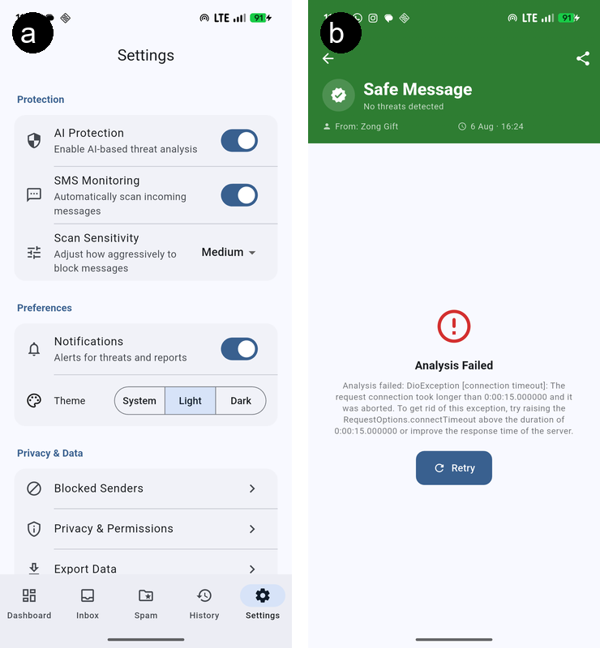
Figure F-1 Client Application Settings Panel and API Connection Fallback States: (a) Model Server Configuration Settings Panel, and (b) API Offline/No Connection Fallback Screen.

