UNIVERSITY OF SINDH, JAMSHORO
Institute of Mathematics and Computer Science
BS Computer Science — Final Year Project (FYP) Proposal
MindShield
An Explainable NLP-Based System for Detecting
Psychological Manipulation Techniques in Pakistani Scam SMS
Role / Position | Name & Roll Number
Team Leader | Junaid Ahmed(Roll No: 2K23/CSM/54)
Team Member 2 | Kalpna (Roll No: 2K23/CSM/55)
Team Member 3 | Mudasar Ali (Roll No: 2K23/CSM/81)
Supervisor | Mr. Zubair Kandhro (Institute of Mathematics and Computer Science)
Program / Section | BS Computer Science (8th Semester, Final Year) — Section: PM
Submission Date: June 2026

1. Project Title
MindShield: An Explainable NLP-Based System for Detecting Psychological Manipulation in Pakistani Scam SMS

2. Names and Roll Numbers of Students
Role | Student Name | Roll Number
Team Leader | Junaid Ahmed | 2K23/CSM/54
Team Member 2 | Kalpna | 2K23/CSM/55
Team Member 3 | Mudasar Ali | 2K23/CSM/81

3. Program and Section
Program: BS Computer Science
Semester: 8th Semester (Final Year)
Section: Pre-Medical
Institute: Institute of Mathematics and Computer Science, University of Sindh, Jamshoro

4. Supervisor Name
Supervisor: Mr. Zubair Kandhro
Department: Institute of Mathematics and Computer Science, University of Sindh, Jamshoro

5. Problem Statement
Pakistan has over 195 million active SIM subscribers (PTA, 2024), making it one of South Asia's largest mobile user bases. SMS-based scams have become pervasive, with fraudsters impersonating banks (HBL, UBL, Meezan Bank), mobile wallets (Easypaisa, JazzCash), government agencies (FBR, NADRA), and telecom providers (Jazz, Telenor, Zong) to defraud victims of billions of rupees annually.
These messages exploit specific psychological manipulation tactics including:
• Urgency (URG) — e.g., 'Your account will be blocked in 24 hours! Act immediately.'
• Authority (AUTH) — e.g., 'This is your bank manager. Verify your account now.'
• Fear (FEAR) — e.g., 'Suspicious login detected. Your account is at risk.'
• Reward (REW) — e.g., 'Mubarak ho! Aap ne Rs. 50,000 jeeta hai. Abhi claim karein.'
• Security (SEC) — e.g., 'Share your OTP to prevent account lockout.'
Existing anti-spam systems suffer from three critical limitations that MindShield is specifically designed to address:
1. They perform only binary classification (spam vs. not spam) and do not identify the psychological manipulation tactic being used, leaving users unaware of how they are being targeted.
2. They are trained exclusively on English-language datasets and cannot detect scam patterns written in Roman Urdu or code-switched (Roman Urdu + English) language, which dominate Pakistani SMS fraud.
3. They provide no actionable countermeasures or user education, offering a label but no guidance on how to respond safely.
Additionally, no publicly available annotated dataset of Pakistani scam SMS exists, creating a research gap that this project directly addresses through the construction of the PakScam-SMS dataset. MindShield addresses these limitations through a modular dual-pipeline NLP architecture. The first pipeline detects whether an SMS is legitimate or fraudulent, while the second identifies the psychological manipulation technique used in fraudulent messages. The system further enhances transparency through Explainable AI (LIME), utilizes a custom multilingual Pakistani SMS dataset, and provides actionable countermeasure recommendations to end users

6. Background and Motivation

6.1 Scale of the Problem
The Pakistan Telecommunication Authority (PTA) received over 2.3 million spam and fraud-related complaints in 2023. The Federal Investigation Agency (FIA) Cybercrime Wing estimates online financial fraud losses at billions of rupees annually, with SMS phishing serving as a primary vector. Despite this scale, no Pakistan-specific SMS fraud detection tool exists in the public or academic domain.

6.2 Linguistic Gap
Existing spam detectors are trained on English corpora and fail on Pakistani messages. A message reading "Aapka account band ho jaye ga — abhi verify karein" (Your account will be closed — verify now) will evade any English-only classifier. The multilingual nature of Pakistani SMS requires a purpose-built dataset and a model fine-tuned on code-switched and Roman Urdu text.

6.3 Explainability Gap
State-of-the-art spam classifiers operate as black boxes. A user receives a spam label but no explanation of why the message is dangerous, what manipulation tactic it employs, or what they should do. LIME-based explainability bridges this gap by attributing predictions to specific triggering words, enabling transparent and actionable results that even low-literacy users can understand.

6.4 Dataset Gap
The UCI SMS Spam Collection (Almeida et al., 2011) is the de-facto benchmark for SMS spam detection, but it contains only English messages with binary labels. No labeled dataset of Pakistani scam SMS with manipulation-class annotation exists. PakScam-SMS, constructed as part of this project, fills this gap.

6.5 Research Motivation
MindShield is motivated by the intersection of three needs: (1) a Pakistan-specific multilingual SMS security tool, (2) model explainability for end-user trust and education, and (3) an annotated dataset contribution to the research community. The system targets the most vulnerable segment of Pakistani mobile users — elderly, low-income, and low-literacy individuals who are disproportionately victimized by SMS fraud.

7. Research Questions
This final year project is guided by the following core research questions (RQs):
RQ1: Can pre-trained transformer models (such as DistilBERT) be successfully fine-tuned to achieve high accuracy in classifying multilingual (English, Roman Urdu, and Code-Switched) Pakistani scam SMS?
RQ2: Can Explainable AI (LIME) provide interpretable explanations that help users understand why an SMS message has been classified as fraudulent?
RQ3: Can an offline-first conversational thread structure and native UI interventions (like direct call/reply and local blocking) improve user-level mobile cybersecurity defense?
RQ4: Can real-time mobile SMS monitoring be conducted locally on a user's device in a way that preserves privacy without relying on persistent cloud database uploads?

8. Novelty of the Proposed System
MindShield introduces several key novelties that differentiate it from global SMS filters and commercial anti-spam utilities:
1. To the best of our knowledge, no publicly available annotated dataset specifically designed for multilingual Pakistani scam SMS with psychological manipulation labels currently exists. This work aims to address that gap through the creation of the PakScam-SMS dataset: MindShield constructs the first dedicated corpus containing English, Roman Urdu, and code-switched SMS messages specific to the Pakistani cybercrime landscape.
2. Psychological Manipulation Classification: Instead of simple keyword matching, the model classifies scam messages based on 5 targeted psychological manipulation tactics (Urgency, Authority, Fear, Reward, Security).
3. Explainable AI (XAI) Warnings: Rather than generating binary spam verdicts, the system highlights the specific triggering keywords in red using local surrogate models (LIME) and displays actionable guidance.
4. Offline-First Privacy Architecture: The mobile app caches contacts, thread messages, and settings locally using SQLite. Message details are stored offline and are only sent to the classification server under specific user consent.
5. Conversation-Aware Security Management: Messages are automatically grouped into threaded conversations with direct native Android reply/call handlers, matching the layout of professional SMS utilities.
6. Active Learning / Human-in-the-Loop Feedback: Users can flag misclassified messages, providing clean data samples to continuously update and improve the global ML models.

9. Prototype vs. Research Contribution
To clarify project delivery checkpoints, the system components are split into the existing mobile prototype components and the planned research contributions:

9.1 Current Prototype
The client infrastructure is fully developed and operational, establishing a robust local application framework:
• Flutter Application: Standard responsive client interface incorporating a modern Material 3 UI layout supporting dark/light mode.
• Kotlin Background SMS Receiver: Background Daemon utilizing Android Broadcasters and Intents to capture SMS streams.
• SQLite Database: Local schema implementation for thread persistence, message synchronization, settings state, and offline logs.
• Conversation Threading: Aggregates SMS blocks into distinct contact groups.
• Contacts Integration: Resolves raw telephone numbers to human-readable names using the Android Contacts Provider via Method Channels.
• Spam Quarantine: An isolated folder structure managing spam threads with native delete, restore, and block routines.
• Native Interventions: Native Dialer and SMS reply trigger interfaces implemented in Kotlin Native Method Channels.
• Explainability UI Layouts: Screen designs that visually display analysis logs and mock-up keyword highlighting.

9.2 Research Contribution
This work targets the research deliverables and machine learning infrastructure:
• PakScam-SMS Dataset: Curation and curation workflows for the localized multilingual scam database.
• AI Classification Models: Development and fine-tuning of two independent transformer-based NLP pipelines. Pipeline 1 performs binary spam/ham classification using multiple public benchmark datasets together with locally collected data, while Pipeline 2 classifies detected scam messages into psychological manipulation categories using the custom PakScam-SMS dataset.
• Explainability Integration: Deployment of LIME/SHAP engines to extract word-level prediction coefficients.
• FastAPI Backend: A high-performance Python REST API server hosting models and exposing analysis endpoints.
• Model Evaluation: Rigorous quantitative validation of models against global benchmarks using standard classification metrics.

10. Scope

10.1 Within Scope
• SMS text analysis in English, Roman Urdu, and code-switched (English + Roman Urdu) language.
• Android mobile application built with Flutter/Dart with Material 3 responsive layout.
• Local SQLite database for SMS storage, spam categorization, and user settings.
• Native Android integrations (SMS Broadcast Listener, Contacts Provider connection, Dialer integration, Method Channels) implemented in Kotlin.
• Planned transformer-based classification pipelines (XLM-RoBERTa or multilingual DistilBERT) for binary spam detection and psychological manipulation classification. classification pipelines (binary spam/ham + 5-class manipulation).
• (Planned) LIME keyword attribution and per-prediction confidence score display on the detail screen.
• (Planned) Class-specific countermeasure advice delivered after each spam detection.
• (Planned) PakScam-SMS custom dataset compilation and continuous crowdsourced expansion.

10.2 Out of Scope
• WhatsApp messages, email, push notifications, or voice call scam detection.
• iOS / Apple platform support.
• Real-time network-level SMS interception or telecom carrier integration (analysis is performed on received database logs via local application processes).
• Multi-language support beyond Roman Urdu, Urdu, and English.

11. Feature Comparison Table
Feature / Capability | Google Messages | Truecaller | MindShield (Proposed)
Conversation Thread View | Yes | Yes | Yes (Implemented)
Pakistani Scam Detection | No | Partial (Keyword matches) | Yes (Planned AI Pipeline)
Roman Urdu / Code-switching Support | No | No | Yes (Planned AI Pipeline)
Explainable AI (XAI) Reasons | No | No | Yes (Planned LIME Integration)
Offline Analysis / Metadata Cache | No | No | Yes (Implemented SQLite)
Psychological Manipulation Categorization | No | No | Yes (Planned 5-Class Taxonomy)
Table 4. Comparison of the proposed MindShield system with existing commercial SMS communication tools.

12. SDG / Thematic Alignment
SDG No. | Goal Title | Alignment with MindShield
SDG 16 | Peace, Justice and Strong Institutions | Reduces telecommunications fraud; strengthens digital consumer protection and rule of law in cyber-space
SDG 9 | Industry, Innovation and Infrastructure | Advances NLP innovation for a developing-country linguistic context; addresses Roman Urdu and code-switching gaps absent from global research
SDG 10 | Reduced Inequalities | Protects vulnerable, low-income, and low-digital-literacy users who are disproportionately targeted by SMS financial fraud

13. Existing System / Literature Review

13.1 SMS Spam Detection
Almeida et al. (2011) introduced the UCI SMS Spam Collection, the most widely used benchmark for SMS spam classification, comprising 5,574 English messages labeled as spam or ham. Subsequent classifiers using Naive Bayes, SVM, and Random Forest (Sjarif et al., 2019; Cormack, 2008) achieved strong accuracy on this dataset. However, all existing approaches perform binary classification only and are limited to English-language messages, making them ineffective in the Pakistani multilingual context.

13.2 Pre-trained Transformers for Text Classification
Devlin et al. (2019) introduced BERT, which demonstrated state-of-the-art performance across NLP classification tasks through masked language model pre-training and task-specific fine-tuning. Sanh et al. (2019) introduced DistilBERT, a distilled variant that is 40% smaller and 60% faster while retaining 97% of BERT's language understanding capacity. Considering the multilingual nature of Pakistani SMS, multilingual transformer models such as XLM-RoBERTa or multilingual DistilBERT will be evaluated. The final model will be selected based on classification accuracy, computational efficiency, and deployment feasibility for the proposed system.for MindShield due to its suitability for resource-constrained deployment on API servers and mobile-accessible backends.

13.3 Explainable AI (XAI) for Text Classification
Ribeiro et al. (2016) introduced LIME (Local Interpretable Model-agnostic Explanations), which explains any classifier's predictions by approximating it locally with an interpretable surrogate model, extracting the words that most contributed to each decision. Lundberg and Lee (2017) proposed SHAP as an alternative unified framework. MindShield adopts LIME for its speed, simplicity, and proven effectiveness on text classification tasks.

13.4 Psychological Manipulation in SMS Fraud
Cialdini (1984) identified six foundational principles of social influence — authority, scarcity, urgency, reciprocity, social proof, and liking — which are consistently exploited in social engineering attacks. The MindShield manipulation taxonomy (URG, AUTH, FEAR, REW, SEC) is derived from the intersection of Cialdini's principles and Pakistan-specific scam patterns observed in practice, providing a research-grounded classification framework.

13.5 Gap Analysis
System / Work | 5-Class? | Roman Urdu | XAI?
UCI Spam Classifiers (Almeida, 2011) | No | No | No
SpamAssassin / Network-Level Filters | No | No | No
General BERT-based Spam Classifiers | No | Some | No
MindShield (This Work - Implemented Client, Planned AI) | Yes (URG/AUTH/FEAR/REW/SEC) | Yes (EN/RU/CS) | Yes (LIME)
Table 5. Gap Analysis comparison between global systems and the proposed MindShield framework.

14. Dataset Design & Curation Workflow
A fundamental research contribution of the MindShield project is the development of the PakScam-SMS dataset. Rather than a static set, the initial version of the PakScam-SMS dataset is expected to contain approximately 3,000–5,000 manually curated and annotated SMS messages, with the dataset designed to expand continuously as additional samples are collected and validated. The curation workflow is structured as follows:
1. Collection: Real scam SMS messages will be collected from publicly available scam reports, cybersecurity awareness campaigns, social media platforms, personal submissions, and user-contributed messages with consent. Existing public SMS spam datasets will also be incorporated where appropriate to improve diversity.
2) Synthetic Data Generation: To improve representation of minority manipulation categories, Large Language Models (LLMs) will generate synthetic scam templates. Every synthetic message will be manually reviewed and validated before inclusion in the final dataset.
3. Cleaning: Text normalization is performed to strip double spaces, correct encoding errors, and standardize code-switched scripts.
4. Deduplication: Duplicate texts are removed to prevent overfitting. Messages with similar semantics but different variables (such as variable cash values) are consolidated into templates.
5. Anonymization: Complete scrubbing of Personally Identifiable Information (PII). Raw phone numbers, bank accounts, custom URLs, and individual names are replaced with generalized tokens (e.g., [PHONE_MASK], [BANK_MASK]).
6. Balancing: Care is taken to ensure even distribution across languages (English, Roman Urdu, Code-switched) and manipulation classes (URG, AUTH, FEAR, REW, SEC).
7. Labeling: Double-pass labeling conducted by team members. Disputed annotations are resolved by a third validator (the project leader).
8. Validation: Standardized schemas are validated against logical ranges. For instance, messages marked 'ham' must contain manipulation type 'NONE'.
9. Quality Control: Calculating inter-annotator agreement statistics (Cohen's Kappa) to ensure taxonomic labeling alignment.
10. Train/Test Split: Standard stratified 80/20 train-test split for Pipeline 2 modeling, ensuring proportional representation of all categories.
11. Future Expansion: A crowdsourced submission pipeline built into the app's settings will allow users to submit un-anonymized samples, which undergo validation before integration into updated model training cycles.

14.1 Dataset 1 — UCI SMS Spam Collection
Source: UCI Machine Learning Repository (publicly available baseline).
Size: 5,574 SMS messages.
Labels: spam / ham (binary).
Language: English only.
Purpose: Used as one of several benchmark datasets for training and evaluating the binary spam classifier. Additional public SMS spam datasets will also be incorporated to improve model robustness and generalization.

14.2 Dataset 2 — PakScam-SMS Schema
Column Name | Values / Type | Description
msg_id | Integer (auto-increment) | Unique identifier for each message record
message_text | String | Raw SMS content in its original form (English, Urdu, Roman Urdu, or Code-switched)
language | EN / RU / CS | Language tag: English (EN), Roman Urdu (RU), or Code-switched (CS)
label | spam / ham | Binary classification label, maintained for Pipeline 1 compatibility
manipulation_type | URG/AUTH/FEAR/REW/SEC/NONE | Primary psychological manipulation tactic (NONE assigned to safe ham messages)
source | real / synthetic | Indicator showing whether the message was organically collected or AI-synthesized (disclosed)
confidence | high / medium / low | Annotator confidence level during dataset review and classification assignment
Table 6. Database schema and data dictionary for the custom PakScam-SMS dataset.

14.3 Public Benchmark Datasets
To improve model generalization and reduce overfitting, MindShield will leverage multiple publicly available SMS spam datasets in addition to the custom PakScam-SMS dataset. These datasets will primarily support binary spam detection, while PakScam-SMS will provide multilingual and psychological manipulation annotations unavailable in existing datasets.

15. SQLite Technical Justification
An essential engineering decision in the MindShield design was the selection of a local SQLite database (via sqflite in Flutter) instead of cloud-hosted databases (such as Firebase Firestore). This decision is based on four main reasons:
1. Offline-First Threading: SMS messaging is a local, real-time communication stream. Storing message cache in SQLite allows the application to thread, search, and update logs instantly with zero network delay.
2. High Security & User Privacy: Mobile SMS communications contain sensitive transactional notifications, OTPs, and personal conversations. Firebase requires uploading raw SMS texts to the cloud. With SQLite, all SMS texts remain strictly on the device. Only when a user triggers deep AI analysis is the body sent to the API, preserving metadata privacy.
3. No Network Dependency: If the user loses internet connection, the application continues to run as a fully-functional SMS utility, displaying historical logs and allowing local classification overrides.
4. Local Inference Caching: SQLite stores and caches model prediction results, meaning previously scanned messages do not require duplicate API network hits, lowering backend server loads.

16. Proposed Methodology
Phase 1 — Dataset Curation (Implemented - FYP-I):
Sourcing & Labeling: Curation of Roman Urdu, English, and code-switched text. Annotation of initial templates based on threat categories.
Phase 2 — Data Preprocessing (Implemented - FYP-I):
Cleaning: Normalization of URLs, phones, and numbers, and tokenization using the WordPiece tokenizer.
Phase 3 — Model Training (Implemented Pipeline 1 - FYP-I):
Pipeline 1: Binary spam/phishing classification model trained on combined UCI SMS and custom PakScam datasets (v1 production, v2 and v3 candidates).
Pipeline 2 (Planned - FYP-II): Psychological manipulation classifier trained on the PakScam-SMS dataset containing URG, AUTH, FEAR, REW, and SEC annotations.
Phase 4 — Explainability & API Integration (Implemented - FYP-I):
Decoupled LIME XAI: Word-level highlights approximated via static indicator mapping in production to bypass 2s perturbation latencies.
FastAPI backend deployment: REST handlers (/analyze, /health) hosted on local server.
Phase 5 — Client Implementation (Implemented):
• Flutter Application: Developed with Material 3 components, Providers state tracking, local SQLite persistence helper blocks, and native Kotlin method integrations (Broadcasters, Contacts, Dialer).

16.1 Countermeasure Mapping Table
Class | Countermeasure Advice Delivered to User
URG | Do not act under time pressure. Scammers create false urgency to prevent clear thinking. Verify the sender directly through the organization's official helpline before taking any action.
AUTH | This message impersonates an authority figure. Real banks and government agencies do not request account details via SMS. Call the organization on their official number — never the number provided in this message.
FEAR | This is a fear-based scam. Legitimate organizations do not threaten you via SMS. Do not reply or click any links. Report this message to PTA at 0800-55055.
REW | Unsolicited prize or reward offers via SMS are almost always scams. Legitimate competitions never require you to pay fees or share personal data to claim winnings. Ignore and delete.
SEC | Never share your OTP, PIN, CNIC number, or account password with anyone — including people claiming to be your bank or telecom. No legitimate service will ask for this via SMS.
Table 7. Psychological manipulation tactic to user-level countermeasure mapping matrix.

16.2 Justification for Dual-Pipeline Architecture
MindShield adopts a dual-pipeline architecture instead of a single multi-class classifier for several reasons. The first pipeline acts as a lightweight filtering stage that distinguishes legitimate messages from scam messages with high recall, thereby preventing unnecessary processing of benign SMS. Only messages identified as scams are forwarded to the second pipeline, which determines the psychological manipulation strategy employed. Separating the two tasks allows independent optimization, simplifies future model updates, enables the use of different datasets for each task, and improves modularity and scalability.

17. Evaluation Metrics
To quantitatively measure the performance of the classification pipelines, the following metrics will be calculated:
• Accuracy: The proportion of total correct predictions relative to the entire dataset.
• Precision: The proportion of predicted scams that are actually scams. Important to limit false alarms (false positives) so users do not ignore real alerts.
• Recall (Sensitivity): The proportion of actual scams that are correctly classified. This is the primary safety metric because missing a scam (a false negative) directly exposes the user to financial loss or manipulation.
• F1-Score: The harmonic mean of Precision and Recall, serving as a unified measure of classifier performance under class imbalance.
• Confusion Matrix: A matrix mapping actual vs. predicted labels, highlighting misclassification patterns.
• ROC-AUC: Receiver Operating Characteristic - Area Under Curve, tracking the classifier's classification threshold performance.
- Macro-F1 Score: Evaluates average performance across all manipulation classes.
- Weighted-F1 Score: Accounts for class imbalance while measuring overall multiclass classification performance.

18. Risk Analysis & Mitigations
Identified Risk | Engineering Mitigation Strategy
Small Dataset Size | Complementing real-world collection with generative LLM template synthesis (disclosed and validated).
Class Imbalance | Utilizing oversampling (SMOTE) and language-based text augmentation techniques.
False Positives on OTP/Banks | Enforcing strict regex filters, contact verification, and a high confidence threshold block.
Android Background Restrictions | Implementing native Android foreground services, wake locks, and system autostart listeners in Kotlin.
User Data Privacy Leakage  Emerging scam techniques causing model degradation | Keeping messages locally in SQLite, stripping PII, and only sending raw body text to the server.  Periodic dataset updates through active learning and user feedback
Table 8. Project risk assessment matrix and engineering mitigations.

19. System Architecture or Workflow

19.1 Current Implemented System Architecture
The current offline system flow operates entirely on-device, capturing incoming SMS messages via a background daemon, synchronizing them with contact metadata, and storing them locally in SQLite. The Dart presentation engine reads these logs and groups them into conversational threads.
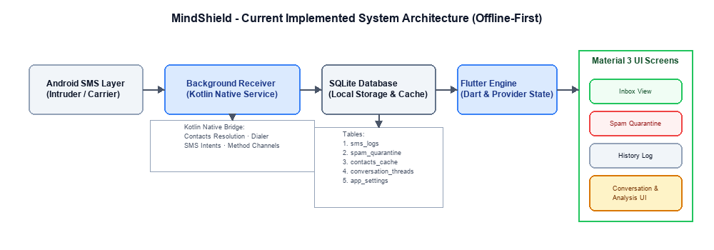
Figure 1. MindShield Current Implemented Architecture showing local client-side persistence pipeline.

19.2 Implemented AI Inference Architecture (FYP-I Proof of Concept)
The current implemented system architecture connects the local client with a central Python FastAPI server. The API routes text payloads through the binary distilbert-pakscam-v1 classifier, extracts threat indicators to highlight key terms, and returns a JSON payload to trigger warning UI banners on the device.
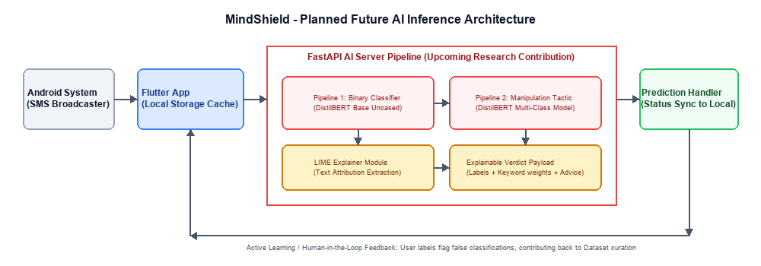
Figure 2. MindShield Planned Future AI Inference Architecture with cloud integration.

19.3 System Use Cases
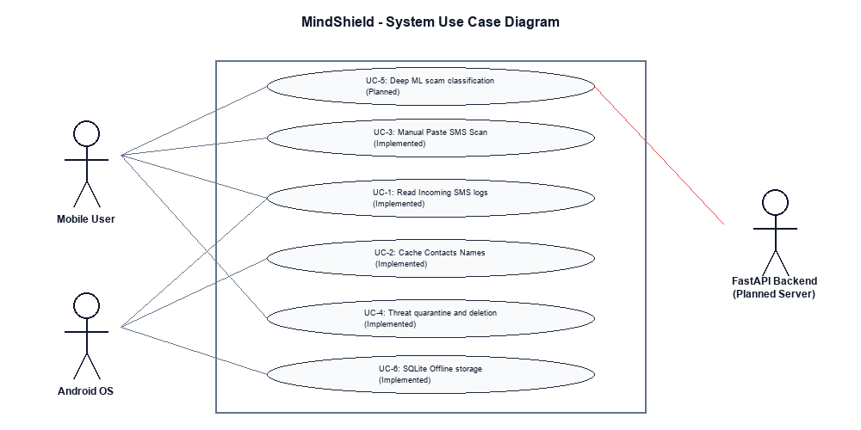
Figure 3. System Use Case Diagram mapping actor capabilities.

19.4 Data Flow Diagram (DFD)
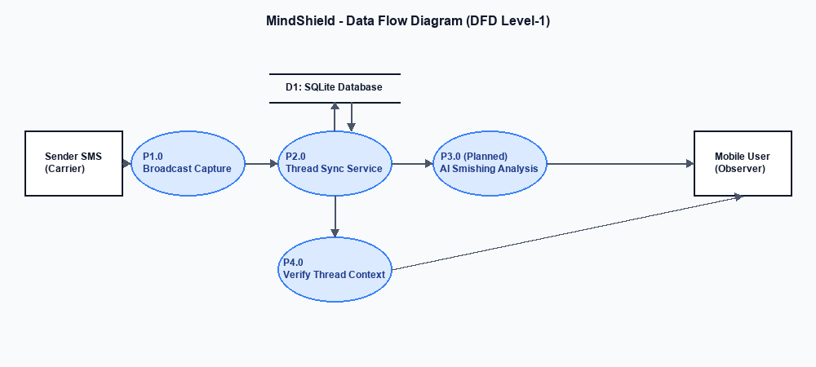
Figure 4. Level-1 Data Flow Diagram showing information routing.

19.5 Background Synchronization Workflow
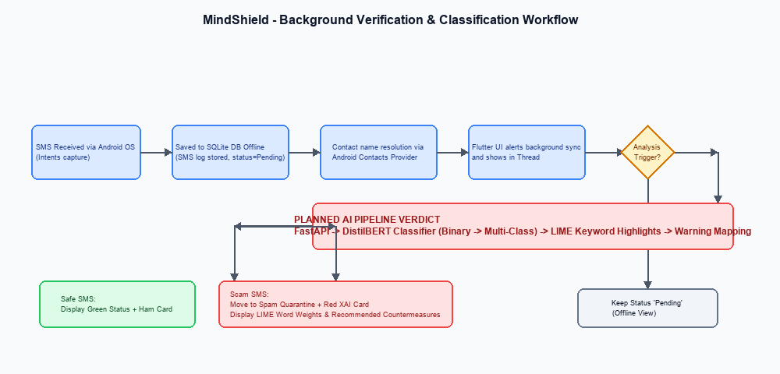
Figure 5. End-to-end Background Verification and Inference Workflow Diagram.

20. Tools and Technologies
Category | Technology / Tool | Implementation Status | Description / Purpose
Programming Languages | Python 3.10 / Dart / Kotlin | Implemented | Python for model training/API, Dart for Flutter UI, Kotlin for native Android APIs
Mobile Framework | Flutter (Dart) | Implemented | Cross-platform mobile application utilizing Material 3 layout and Provider patterns
Local Persistence | SQLite (sqflite) | Implemented | Off-line storage of threaded chats, SMS logs, contacts cache, settings state
Native Android | Android SDK, Method Channels | Implemented | Broadcaster Receiver, Contacts resolver, Phone intents, Background tasks
NLP Framework | PyTorch / HuggingFace | Planned | Machine learning library and transformers repository for DistilBERT
Pre-trained Model | distilbert-base-uncased or XLM-RoBERTa Base | Planned | Base transformer model utilized for fine-tuning NLP classification tasks, distilbert-base-uncased was selected partly because scope is limited to Latin-script languages (EN/RU/CS);
Explainable AI | LIME library | Planned | Model-agnostic explainer to extract keyword attributions for classifications
Backend API Framework | FastAPI (Python) | Planned | High-performance framework to host machine learning models and REST endpoints
Training Platform | Kaggle / Google Colab | Planned | GPU-accelerated cloud environment to train DistilBERT models
Version Control | Git / GitHub | Implemented | Source control repository and codebase version management
Development IDEs | VS Code / Android Studio | Implemented | Integrated Development Environments for coding Flutter and Kotlin components

21. Expected Deliverables

FYP-I Deliverables (Completed Prototype & Design)
Approved FYP proposal.
Complete Software Requirements Specification (SRS) detailing layout bindings.
Complete mobile application codebase in Flutter with responsive Material 3 UI screens.
Implemented local SQLite persistence database with functional CRUD operations and SQLite schemas.
Implemented Native Android Kotlin modules (SMS Broadcast Listener, Contacts Provider connection, Dialer integration, Method Channels).
Background synchronization flows connecting Kotlin SMS receiver to Dart UI state managers.
Configured and deployed a Python FastAPI backend exposing /analyze and /health endpoints.
Fine-tuned the primary classification model (distilbert-pakscam-v1) as the active production engine.
Built a multi-model evaluation framework comparing UCI baseline, v1, and candidates (v2, v3) on Pakistani SMS subsets.
Designed a 14-case hard-negative regression testing suite to prevent model regressions.
Implemented heuristic-based threat indicator highlighting on the Flutter client to bypass real-time LIME latency.

FYP-II Deliverables (Planned Research Contributions)
Expand the custom PakScam-SMS dataset with balanced, real-world Roman Urdu and code-switched text.
Fine-tune multilingual transformer models (XLM-RoBERTa or multilingual DistilBERT) for Pipeline 2 (5-class psychological categorization).
Integrate full LIME XAI explanation perturbations on the backend, optimizing for latency bounds.
Complete final project report / thesis containing evaluation metrics, confusion matrices, and user-acceptance reports.
Public GitHub codebase repository containing structured installation and deployment instructions.
Project presentation slide deck and marketing poster.

22. Work Plan and Timeline
Month / Period (2026) | Target Milestones & Core Activities
July | Mobile Prototype: Setup Flutter project, database structures, background receiver Kotlin scripts, Material 3 UI, and local threads synchronization.
August | Dataset Collection: Active curation of real SMS and generative template creation of Pakistani scams.
September | Dataset Annotation: Review annotations, calculate Cohen's Kappa, strip PII, and validate schemas.
October | Model Training: Fine-tune DistilBERT on baseline UCI and custom PakScam-SMS corpora, run stratification splits.
November | FastAPI Integration: Expose model endpoints, connect LIME TextExplainer, configure Dio HTTP client in Flutter.
December | System Testing: Perform quantitative validation (Precision, Recall, ROC-AUC) and run end-to-end integration tests.
January | Documentation & Defense: Prepare project poster, final thesis documentation, and compile the presentation slide deck.
Table 9. Project implementation Gantt timeline and monthly activity chart.

23. Role of Each Team Member
Team Member | Primary Responsibilities
Junaid Ahmed (Team Leader)  2K23/CSM/54 | Overall system architecture design and documentation; PakScam-SMS dataset design (schema, manipulation-tactic taxonomy, class-balance strategy) and final validation; dispute resolution for double-pass annotation and Cohen's Kappa computation; DistilBERT model training and fine-tuning (Pipelines 1 & 2); FastAPI backend deployment; LIME explainer integration; local SQLite helper scripting; Kotlin Method Channels implementation; GitHub version management.
Kalpna  2K23/CSM/55 | Flutter frontend development (Material 3 screens layout); navigation bindings using GoRouter; Providers state tracking; UI detail views; FastAPI connection using Dio client; poster layout design; user manual. Dataset collection via social media and personal-network scam screenshot sourcing; first-pass annotation on assigned message batches; precision/recall test execution on trained models.
Mudasar Ali  2K23/CSM/81 | Android Contacts resolver integration; Dialer intent mapping; deployment guide documentation. Dataset collection via PTA/FIA advisories, news articles, and cybersecurity blogs; second-pass annotation on assigned batches (cross-checked against Kalpna's for inter-annotator agreement); PII anonymization pass on collected messages; review and quality-gate synthetic (LLM-generated) messages for realism before inclusion in PakScam-SMS; Cohen's Kappa computation and documentation for the annotation quality-control report; false-positive test design and execution on the OTP/bank-message risk category (Section 18); confusion matrix and ROC-AUC report generation for the final evaluation section.

24. Future Work & Long-Term Vision
To establish a long-term research vision, the MindShield project identifies the following upcoming extensions:
1. Federated Learning (FL): Decentralizing future model training across client mobile devices to train and updates weights locally, eliminating the need to upload any private text payloads to central APIs.
2. On-Device AI Inference: Compiling the fine-tuned DistilBERT models to ONNX or TensorFlow Lite formats to run predictions locally on standard mobile processors, facilitating 100% offline security.
3. Real-Time Phishing URL Sandboxing: Building an endpoint checking component to analyze hyper-links contained in SMS, classifying URL vectors via threat databases (Google Safe Browsing).
4. Multilingual LLM Assistant: Integrating lightweight on-device LLMs (such as Google Gemma) to provide interactive conversational threat counseling, explaining security risks in Urdu and English.
5. Community Crowdsourcing: Creating a validated public SMS warning registry database where verified scams are synchronized globally to provide PTA/FIA telemetry.
6. Future Scope — Real-Time Telecom Scam Detection: In future development, MindShield can be extended beyond SMS-based scam detection into real-time telecommunications security. Through integration with telecom network infrastructure or authorized call-screening services, the system could analyze call audio or speech-derived features in real time to identify potential scam calls. A future version could detect suspicious conversational patterns, social-engineering indicators, impersonation attempts, and other scam characteristics, and then provide real-time warnings to the user. Subject to telecom-provider capabilities, regulatory requirements, privacy constraints, and sufficiently reliable detection accuracy, the system could eventually support automated call blocking or termination for high-confidence scam calls. This would extend MindShield from message-level protection toward a broader real-time communication security platform.

25. Ethical Considerations
1. Privacy Protection: Real SMS messages are anonymized before annotation. No sender names, phone numbers, or personally identifiable information (PII) are retained in the dataset.
2. Explicit Consent: Crowdsourced reports will be strictly opt-in, with users explicitly approving submissions of spam templates.
3. Secure Storage: The local SQLite database uses secure sandboxed file structures, and future web portals hosting datasets will employ strict access permissions.
4. Defensive Use Only: The dataset and fine-tuned models are restricted from use in training adversarial social engineering templates or fraud operations.
5. AI-Use Disclosure: Generative AI tools used for script building or synthetic data templates are declared, preserving academic integrity.

26. References
[1] Almeida, T. A., Gómez Hidalgo, J. M., & Yamakami, A. (2011). Contributions to the study of SMS spam filtering: New collection and results. In Proceedings of the 11th ACM Symposium on Document Engineering (pp. 259–262). ACM.
[2] Devlin, J., Chang, M. W., Lee, K., & Toutanova, K. (2019). BERT: Pre-training of deep bidirectional transformers for language understanding. In Proceedings of NAACL-HLT 2019 (pp. 4171–4186).
[3] Sanh, V., Debut, L., Chaumond, J., & Wolf, T. (2019). DistilBERT, a distilled version of BERT: Smaller, faster, cheaper and lighter. arXiv preprint arXiv:1910.01108.
[4] Ribeiro, M. T., Singh, S., & Guestrin, C. (2016). “Why should I trust you?”: Explaining the predictions of any classifier. In Proceedings of the 22nd ACM SIGKDD International Conference on Knowledge Discovery and Data Mining (pp. 1135–1144).
[5] Lundberg, S. M., & Lee, S. I. (2017). A unified approach to interpreting model predictions. In Advances in Neural Information Processing Systems 30 (NeurIPS 2017) (pp. 4765–4774).
[6] Cialdini, R. B. (1984). Influence: The Psychology of Persuasion. Harper Collins.
[7] Sjarif, N. N. A., Azmi, N. F. M., Chuprat, S., & Udzir, N. I. (2019). SMS spam message detection using term frequency-inverse document frequency and random forest algorithm. Procedia Computer Science, 161, 509–515.
[8] Wolf, T., et al. (2020). HuggingFace's Transformers: State-of-the-art natural language processing. In Proceedings of the 2020 Conference on Empirical Methods in NLP: System Demonstrations (pp. 38–45).
[9] Pakistan Telecommunication Authority. (2024). Annual Report 2023–24. PTA, Islamabad. Retrieved from https://www.pta.gov.pk
[10] Cormack, G. V. (2008). Email spam filtering: A systematic review. Foundations and Trends in Information Retrieval, 1(4), 335–455.

