(the related codes are inside cpp file)

---------------------- Question 1 ----------------------------

**************************** Q1.1 *******************************

Q:Calculate the fair value of the bond in eq(1.1)？

Answer: BFV = 100.99

******************************* Q1.2 ********************************

Q:Calculate the yield of the bond in eq(1.1) if the bond market price is Bfv?

Answer: yield = 2.24%

******************************* Q1.3 ********************************

Q:find the value of c?

Answer: c = 2.75

------------------------- Question 2 ------------------------

**************************** Q2.1 (Case 1) **************************

Q:Formulate an arbitrage strategy:

Answer:

1:Short one stock

2:Short one American put option

3:long one American call option

profit (when we close out all position)

= (P + S - C)*e^r(t-t0) - K

= ( 100.5 )*e^r(t-t0) - 100 > 0

it means that the profit for this strategy is always positive

*************************** Q2.2 (Case 2) ***************************

Q:Formulate an arbitrage strategy:

Answer:

1:Short C1

2:Long C2

profit (when we close out all position) at time t

= (C1 - C2)*e^r(t-t0) where St < K1

-(St - K1) + (C1 - C2)*e^r(t-t0) where K1 <= St <= K2

-(K2 - K1) + (C1 - C2)*e^r(t-t0) where St > K2

> 0 for all scenario(When C1 - C2 > K2 - K1)

it means that the profit for this strategy is always positive

*************************** Q2.3 (Case 3) ***************************

Q:Formulate an arbitrage strategy:

Answer:

1:Short P2

2:Long P1

profit (when we close out all position) at time t

= -(K2 - K1) + (P2 - P1)*e^r(t-t0) where St < K1

(St - K2) + (P2 - P1)*e^r(t-t0) where K1 <= St <= K2

(P2 - P1)*e^r(t-t0) where St > K2

> 0 for all scenario(When P2 - P1 > K2 - K1)

it means that the profit for this strategy is always positive

---------------------- Question 3 -----------------------

******************************* Q3.1 ********************************

Q:Use eq (3.1) to prove relation

Proof:

according to put call parity,

c1 - p1 = S - K1*e^-r(T-t)

2*c2 - 2*p2 = 2*S - 2*(K2*e^-r(T-t))

c3 - p3 = S - K3*e^-r(T-t)

====> c1 + c3 - p1 - p3 - 2*c2 + 2*p2 = 0

====> c1 - 2*c2 + c3 = p1 + p3 - 2p2

************************ Q3.21 American Call ************************

Intrinsic value diagram

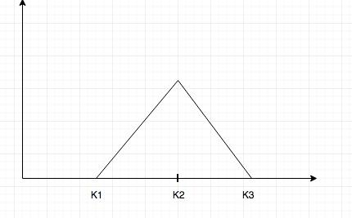

Q:Show that Bcall(S,t) < 0 if the following equations holds

C2(S, t) > (C1(S, t) + C3(S, t))/2

Answer:

Bcall(S,t) = C1(S,t) + C3(S,t) - 2C2(S,t)

if C2(S,t) > (C1(S,t) + C3(S,t)) / 2

====> (C1(S,t) + C3(S,t)) - 2C2(S,t) < 0

====> Bcall(S,t) < 0

****************************** Q3.22 ********************************

Q:Formulate an arbitrage trade if C2(S, t) > (C1(S, t) + C3(S, t))/2.

Answer:

We form arbitrage by long the butterfly spread

We pay C1, get 2C2, pay C3

in the end we have cash (2C2(S,t) - C1(S,t) - C3(S,t)) in the bank

the terminal diagram show that the payoff >= 0 in all scenario

plus we have positive amount of money in the bank

Thus this trades always yield positive profit

******************************* Q3.23 ********************************

Q:Therefore deduce the following inequality must be true at any time t <= T

C2(S, t) <= (C1(S, t) + C3(S, t))/2

Answer:

if C2(S,t) > (C1(S,t) + C3(S,t)) / 2

We can form arbitrage by the trade described above

*********************** Q3.31 American puts *************************

Intrinsic Value



Q:Show that Bput(S,t) < 0 if the following equations holds

P2(S, t) > (P1(S, t) + P3(S, t))/2

Answer:

Bput(S,t) = P1(S,t) + P3(S,t) - 2P2(S,t)

if P2(S,t) > (P1(S,t) + P3(S,t)) / 2

====> (P1(S,t) + P3(S,t)) - 2P2(S,t) < 0

====> Bput(S,t) < 0

******************************* Q3.32 ********************************

Q:Formulate an arbitrage trade if P2(S, t) > (P1(S, t) + P3(S, t))/2.

Answer:

We form arbitrage by long the butterfly spread

We pay P1, get 2P2, pay P3

in the end we have cash (2P2(S,t) - P1(S,t) - P3(S,t)) in the bank

the terminal diagram show that the payoff >= 0 in all scenario

plus we have positive amount of money in the bank

Thus this trades always yield positive profit

******************************* Q3.33 ********************************

Q:Therefore deduce the following inequality must be true at any time t <= T

P2(S, t) <= (P1(S, t) + P3(S, t))/2

Answer:

if P2(S,t) > (P1(S,t) + P3(S,t)) / 2

We can form arbitrage by the trade described above

---------------------------- Question 6 ---------------------------

******************************* Q6.1 *******************************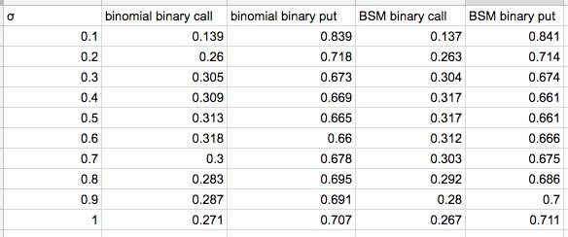

Binary call:

1. Binomial Model

fv

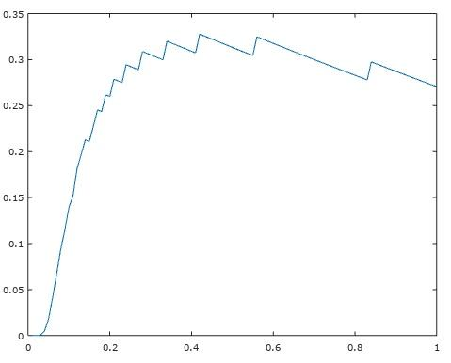(sigma)

2)Black–Scholes–Merton

(fv)

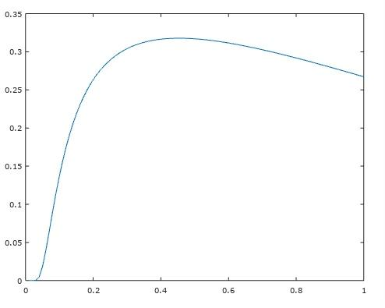(sigma)

Binary Put:

1)Binomial Model

(fv)

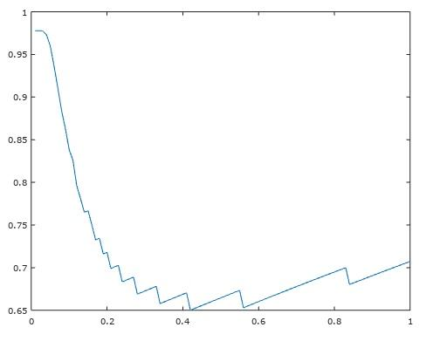(sigma)

2)Black–Scholes–Merton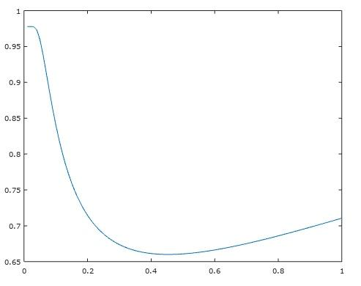

---------------------------- Question 7 ---------------------------

****************************** Q7.1 ********************************

Q:Prove that V >= PV(K) for a zero coupon convertible bond

A:

If V < PV(K), we can form a Arbitrage by going long the convertible bond

Case 1:, St >= B > K for t0 < t < T

then our profit = St - Ve^r(t-t0) > St - K > 0

Case 2:, if St < B for t0 < t < T, then at expiration date

we get profit max(ST, K) > K > V*e^r(T-t0) > 0, we also get profit

hence it is arbitrage

******************************* Q7.2 ********************************

Q:Plot a graph of the fair value of a convertible bond with the above parameters

using a volatility of σ = 0.5.

(Fv)

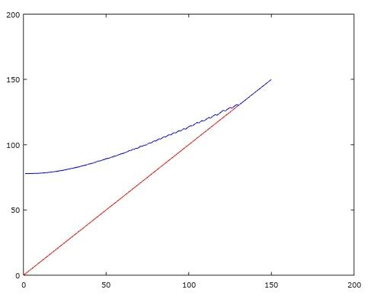(S)

****************************** Bonus *******************************

Q:Explain why the fair value at S -> 0 is the same in both graphs

A:

Because S0 --> 0, the volatility doesn't impact the stock price

in the binomial tree nodes in a big way, So the calculated fair value becomes

relatively independent of volatility

****************************** Q7.3 ********************************

delta S1 = 0.2351

delta S2 = -0.0362

-------------------------------- day 0 ----------------------------------

implied volatility is 0.3736

delta 0 = 0.480518

money_y0 = -61.17

-------------------------------- day 1 ----------------------------------

implied volatility is 0.3743

delta1 = 0.481383

money_y1 = -61.12

-------------------------------- day 2 ----------------------------------

implied volatility is 0.3737

delta2 = 0.480749

money_y2 = -61.15

-------------------------------- end of day 2 ------------------------

my profit is 0.0545