AI DRIVEN MULTI-CHANNEL CITIZEN CONCERN TRIAGE AND
PRIORITIZATION SYSTEM FOR BARANGAY SARAY



AN UNDERGRAUATED CAPSTONE PROJECT

Presented to
the Faculty of
the College of Computer Studies
St. Peters College
Iligan Ctiy

In Partial Fulfillment
of the Requirements for the Degree of
BACHELOR OF SCIENCE IN INFORMATION TECHNOLOGY

BENDOY, JUNARD V.

CHAPTER 1

INTRODUCTION
This chapter presents the issues involving the management of complaints within Barangay Saray and how the AI-Driven Multi-Channel Triaging and Prioritizing System for Citizen Concerns can be used to resolve these problems.

1.1 Background of the Study
Local government units (LGUs) in the Philippines, namely the barangays, are the primary government units for citizens to seek help concerning various issues, from safety and health matters to conflict resolution between citizens. Being the smallest political subdivision in the Philippines, it is expected that the barangay level will address the problems brought by the citizens with swiftness and justice despite the lack of resources. Barangay Saray, being an energetic community, has close ties between residents, which leads to frequent reports being made by the citizens regarding concerns including safety and health, infrastructure, health and noise, and conflict resolution among other issues, which are mostly offered either manually or via online media. The present research aims to address the issues faced by Barangay Saray by suggesting an AI-Driven Multi-Channel Citizen Concern Triage and Prioritization System for Barangay Saray, which would organize and prioritize the concerns brought by the citizens in order to ensure faster and more efficient resolution.
As for now, complaint handling in Barangay Saray is currently manual. Residents go to the front desk of the barangay office to report cases like violation of safety rules, damaged infrastructures, medical assistance, noise complaints, drug abuses, threats, cyberbullying, and physical assault through text messages, social media platforms, and walk-in cases. Since complaints can be through various ways, it necessitates the staff to categorize and prioritize them manually before it goes to the lupon for conflict resolution. This becomes more difficult when cases inflow at a higher rate or during emergency cases wherein many residents report to the barangay at once, causing the number of cases to exceed the number of tanods, staff, and lupon members available at that time, causing some cases to get overlooked and left hanging since they were not prioritized. Not to mention that since there is no unified database for the staff to keep track of reported cases, they have difficulty following up, referring back, and rescheduling lupon meetings for unresolved cases, and checking if social media complaints have been seen by the right people. All of these contribute to the dissatisfaction of the residents with barangay services since they feel that their problems are not being addressed immediately and accordingly and the stress among the personnel, tanods, and lupon members who have to deal with a large amount of disorganized cases with little to no aide in handling them
To resolve this, this study proposes an AI-driven citizen concern triage and prioritization system that makes use of a learning algorithm to determine the category (e.g. safety, infrastructure, health, noises, disputes) and urgency (based on the complainant’s message or, in the case of images or attachments, their visual content) to which a given concern reported via SMS, social media, or web forms would be routed for faster resolution. This is to ensure that reports that require immediate government action (e.g. interpersonal disputes that may be resolved by the Lupon or peace and order issues that may be resolved by the tanod) will be prioritized by the system and directed to the proper barangay authorities without the need for manual sorting.
The existing system in place for handling complaints within a barangay is mostly limited to manual log keeping and recordkeeping, without much processing and understanding of the complaint itself. Most of the applications of artificial intelligence for managing public concerns have been directed at either healthcare or criminal justice, leaving local government units underserved in terms of automated complaint management. This paper attempts to apply Machine Learning classification algorithms, such as Naive Bayes or Logistic Regression, to classify unstructured data from various sources in terms of category and urgency, a need that has not been addressed in most of the existing literature on applying artificial intelligence in complaint management systems.
The proposed system will be designed as a web dashboard accessible through web browsers by the barangay officials rather than a mobile app since internet access is more likely to be available at the barangay hall than mobile network access for residents. The dashboard will serve as an aggregator of SMS, social media, and webform complaints with an inbox functionality and access management features so that only the tanod, Lupon members, and barangay captain can view and act on assigned cases with end-to-end audit capability. The system will be built using PHP and CodeIgniter or Laravel frameworks because they are lightweights and can be hosted on the same web servers as the barangay’s existing complaint management system (Esperança et al., 2025).
This system is very beneficial for several entities. For the residents and visitors of Barangay Saray, it would be easier for them to report their concerns to the local government and monitor the progress of the action taken to address the issues through the most comfortable medium for them. For the tanods, the Lupon members, and other officers tasked to handle the complaints, the automated sorting feature of the system could help them work more efficiently while still maintaining administrative discretion in determining the priority level of a complaint case. On the other hand, barangay as an entity could monitor the status of cases in the system which is searchable for better transparency and accountability, and the local government could use the system to make crucial policy decisions for the improvement of the community.
By automating the process of classifying, prioritizing, and routing complaints in accordance with established official procedures, the proposed system will significantly reduce the time spent by barangay staff in performing this task, enabling them to devote more time and effort to actually resolving the issues raised by the citizens. This will lead to faster resolution of problems reported by citizens, reduced number of complaints that are forgotten or overlooked due to insufficient staff capacity, and more uniform processing of complaints regardless of their nature or channel of reporting. Additionally, the collected data will provide the local government with valuable information about the nature and frequency of problems in the community, thereby facilitating effective governance and restoring public confidence in the ability of the government to serve and protect its constituents.
1.2 Conceptual Framework
The conceptual framework presents how the main parts or variables of the study relate to each other. It synthesizes the information obtained from sources, which then forms the basis of the proposed model describing how the data will be gathered from the participants and transformed into the study’s final outputs and outcomes.
As described by its name, the Input-Process-Output (IPO) Model highlights the flow of information beginning with the input, followed by the processes to achieve specific goals, and finally, the output. This model provided the basis for the proposed conceptual framework of this study. The model is primarily chosen for its structure’s simplicity and ease of interpretation: information flow gathered from the participants is converted into processes within the scope of the study, resulting in the final output.
In line with the IPO Model, the input encompasses the information needed by the platform to handle complaints. These include the data provided by the citizens, the complaint itself, the issue’s context, and the files or documents attached by the complainant through the system’s reporting tools. Through these collected data, the system will be able to classify and prioritize the reported issues.
On the other hand, the process will involve the system’s first task, which is to store all data in the database. Next, it will utilize the Naïve Bayes machine learning algorithm to classify and prioritize the complaints based on criteria such as context and significance. Using these processes, the system will be able to report and deliver the relevant information to the appropriate receivers, whether it is the barangay officials or tanod assigned to handle the issue. This way, the system can ensure that complaints, especially those urgent and time-sensitive issues, will be prioritized and resolved faster than traditional reporting methods.
Lastly, the system will be able to generate alerts, reports, and notifications to the authorities handling the reported issues. It will also present the input data, complaint, context, and resolution progress in an organized manner to ensure effective monitoring and supervision of the complaints. As such, the IPO Model-based conceptual framework is expected to highlight the flow of information from the citizen-complainers to the Barangay Saray authorities through the proposed system, as presented below:
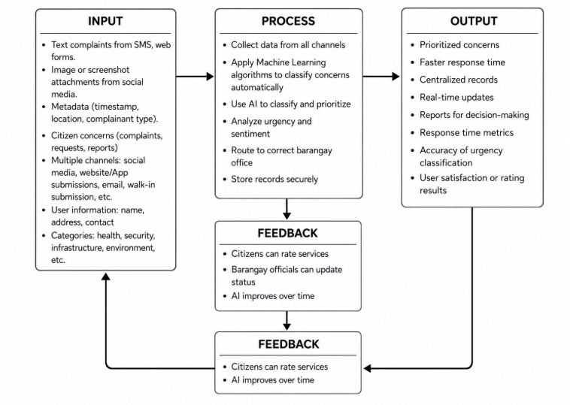
Figure 1: Conceptual Paradigm using IPO Model
Figure 1 represents the Input-Process-Output (IPO) model, which shows how the input, process, and output are related within the system. The Input-process-output (IPO) model is generally considered to be one of the basic ways of understanding how systems work in general and particularly how different programming languages work. This model is used to describe a specific class of systems that operate on information, that is, accept inputs, process them, and then produce new information based on them. It is used in systems analysis to represent the overall design of an information processing program, both to understand what it does and to effectively perform calculations.
1.3 System Framework
The platform has three main components, namely: the end-users, the system process, and the repository, where all the information is stored. Community members can file a complaint using the application via end-users. The second consists of the process that starts when users log in to the website or platform, receives the complaints, handles inquiries, tracks cases, and sends reminders or notifications. The repository serves as the storage of all the information and data for easy access and consistency of the system’s information. One of the most important features of the system is the handling of complaints. First, the Intake Module will be used to receive complaints through the end-user portal. Second, the Triage Module will process the message, determine its category, and assess its priority. Fourth, the Case Management Module will then assign the complaint to a specific person, whether it be the barangay officials, tanod, or Lupon members. The Notification Module is also essential to ensure that all parties involved are updated on all the pertinent details of the complaint.
The users themselves will have a website where they can file a request, view tracking information about their complaint, and receive notifications about their issue. On the other hand, officials and employees can monitor cases, take notes about their progress, and report directly within the system. The Super Administrator is responsible for configuring the system’s settings and creating accounts in the system. The system stores all the data in the repository, from user accounts to complaints, schedules, case details, updates, and triage results. This way, it can provide easy access to all authorized users, ensuring that they can find the information they need without having to use multiple systems.

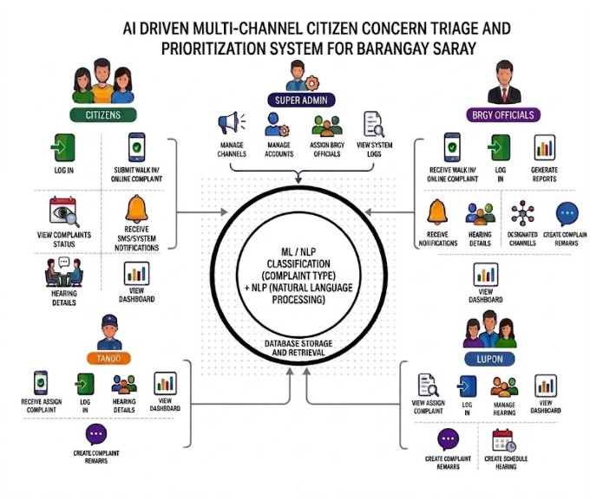

Figure 2. System Framework
In figure 2, the process is visualized as a series of components, from the receipt of complaints, processing and triaging, to the generation of cases, notifications, and reports. The primary objective of the proposed system is to increase efficiency while providing transparency and convenience for the Barangay Saray community. The complaint management system is developed to be easy to use, intuitive, and uncomplicated. The system aims to serve the barangay in making faster, more accessible, and transparent complaint management processes.

The system provides specific functions for each user based on their responsibilities in handling citizen complaints.
CITIZEN
The Citizen is the user who can raise any concerns or complaints and can view the progress of their complaints in order to address their issues.

Features:
- Log In: A citizen can enter his/her account.
- Submit Walk-in/Online Complaint: Can submit any walk-in or online complaint into the system.
- View Complaints: Can view submitted complaints along with their status.
- Receive SMS/System Notifications: Can receive SMS or system notifications regarding their complaints.
- View Hearing Details: Can view details regarding hearings, if any.
- Rate Services: Can rate or give feedback about the services provided.
TANOD
The Tanod aids with handling complaints that are related to community safety, peace, and order, and other cases that require field assistance. They also help the barangay by responding and addressing the assigned complaints. This section will discuss the available features for the Tanod.
Features:
- Receive Complaint – The Tanod can view the complaints received or assigned to them.
- Log In – The Tanod can log in to the system using the provided credentials.
- View Dashboard – The Tanod can view the dashboard containing the list of complaints and their progress.
- View Complaint Details – The Tanod can view the details of the selected complaint.
- Create Complaint Remarks – The Tanod can write or create remarks, observations, or any other details related to the complaint.

Barangay Officials
Barangay Officials are responsible for handling and addressing the concerns of the citizens. They can use this system to track complaints, collaborate with other staff, and provide updates on the progress of the case to the people in the barangay.
Features:
- Receive Walk-in/Online Complaints: The system allows the officials to receive complaints from various sources.
- Log In: The system provides access to the user.
- Generate Reports: The officials can generate reports based on the complaints recorded and the data in the system.
- Receive Notifications: The officials will receive notifications about the complaints.
- Hearing Details: The officials can view and manage the details of a hearing.
- Document Channels: The system allows the user to organize or document the channels used to communicate with complainants.
- Create Complaint Remarks: The user can view and manage remarks about the complaint.
- View Dashboard: The dashboard provides an overview of the complaints, priorities, and the status of each case.
Lupon
The Lupon resolves complaints that need mediation, settlement, or other barangay dispute-resolution procedures. The Lupon members can view assigned complaints and log in to register. They can manage a hearing and view the dashboard. Moreover, they can create complaint remarks and schedule.
Features:
- View Assigned Complaint – allows the Lupon members to check the assigned complaint
- Log In – grants access to the application
- Manage Hearing – helps the Lupon members manage the hearing
- View Dashboard – displays the dashboard that shows the assigned cases
- Create Complaint Remarks – lets the Lupon members record the hearing results, observations, and actions
- Create Schedule – allows the Lupon members to document or manage the schedule
Super Administrator
The Super Admin is the entity that has access to the highest level of the system. It is the one that handles everything regarding the system, users, communication channels, and barangay configuration.
Features:
- Manage Channels – to handle all the channels that citizens can use to report their issues
- Manage Accounts – to create, update and maintain users and their credentials
- Assign Barangay Officials – to assign citizens’ complaints to the corresponding barangay officials
- View Logs – to view all logs related to the system for monitoring purposes.
1.4 Objectives of the Study
The study aims to develop a Complaint Triage and Prioritization System for Barangay Saray using the Naïve Bayes algorithm to classify and prioritize complaints automatically and evaluate the system’s quality using ISO/IEC 25010 standards.
Specifically, the study aims to:
1. Design and develop a Complaint Triage and Prioritization System that will have the following modules:
1.1 Citizen: login, walk-in and online complaint form, complaint status, SMS/system notification, hearing details, and dashboard
1.2 Super Admin: channel management, user management, complaint assignment to barangay officials, and system logs
1.3 Barangay Officials: walk-in and online complaint receipt, report generation, notifications, hearing details, channel management, and complaint remarks
1.4 Tanod: login, assigned complaints, hearing details, dashboard, and complaint remarks
1.5 Lupon: login, assigned complaints, assigned hearing management, dashboard, complaint remarks, and hearing schedule
1.6 Automatic complaint classification and prioritization using the Naïve Bayes algorithm
2. Evaluate the software’s quality using ISO/IEC 25010 by testing the system’s
2.1 Functional suitability
2.2 Reliability
2.3 Usability
2.4 Performance efficiency
2.5 Maintainability
2.6 Portability
2.7 User satisfaction/acceptability

1.5 Scope and Limitations of the Study
This study focused on the development and evaluation of a website-based complaint triage system for Barangay Saray. The research was conducted during the semester of AY 2025-2026, with sixty-seven stakeholders participating in the study.
These stakeholders include officials, tanod, Lupon members, staff, and residents, who were all tasked to trial and evaluate the system in terms of ML/NLP scope. The machine learning component is centered around text categorization, with Naïve Bayes algorithm utilized to classify the written complaints based on categories and urgency levels: high, medium, low.
The algorithm was trained on text data in the Tagalog language and does not account for images, videos, or audio. The performance of the ML model was assessed in terms of accuracy, precision, recall, and F1. The system has modules for receiving the complaints through various channels, including walk-in, SMS, and online forms, AI triage and sending the information to responsible persons with notifications, central database, and report generation. The system was evaluated in accordance with the ISO/IEC 25010 standard to determine its quality and ability to receive complaints from stakeholders in other barangays.
Since this research focused on a prototype, there are no plans for continued development and long-term maintenance of the system. The system does not utilize computer vision, speech recognition, or other complex deep learning mechanisms. It is designed to operate with text-based data and is limited to the Tagalog language. Finally, it is important to note that the current system only serves the needs of Barangay Saray, and may require additional adjustments to operate efficiently in other communities. While the system can be useful in other local government units, it is not designed to predict any additional factors beyond urgency levels.
1.6 Significance of the Study
The proposed system is expected to help the following groups that're part of the complaint management process in Barangay Saray.

Citizens. Residents get access to different ways to report problems and can see the current status of their complaints in real time which makes it easier to track and reduces the need to go in person for updates.

Barangay Officials. The system automatically. Ranks complaints, which makes it easier for officials to handle tasks without spending too much time on manual work allowing them to focus more on making decisions and solving cases.

Barangay Tanods Real-time notifications for cases help them respond quickly to emergencies and the central system helps them work better with other people in the barangay.

Lupon Members. Organized records of cases, hearing dates and tracking of settlements make the mediation process more efficient. Reduce the amount of paperwork.

Barangay Saray as a Whole. A single digital system makes the whole process more open, fair and efficient which helps people trust the government more.

Other Local Government Units. The system can be used as a model by barangays that want to use AI for handling complaints with changes made to fit their own situations.

Future Researchers. The results, the way the research was done and the system design described in this study give a starting point for research on AI tools that help with governance at the community level.

Definition of Terms

The proposed system is expected to benefit the following groups involved in the complaint management process in Barangay Saray.

Artificial Intelligence (AI). Computer technology that can examine complaints, classify them, assess the urgency, and help route them appropriately (Esperança et al., 2025; Verma, 2025). In this study, AI is used to classify and prioritize the complaints of the residents.

Citizen Concern. It entails all concerns, reports, and requests that need to be brought to the attention of the local government. In this study, citizen concerns include public safety problems, arguments, noise, infrastructure damages, harassment, and health issues.

Complaint Management System. A digital platform used for receiving, recording, tracking, and resolving citizens’ complaints (Stanley et al., 2023). In the present study, it is a web-based and artificial intelligence – driven system that helps classify, prioritize and route residents’ grievances in Barangay Saray (Verma, 2025).

Machine Learning (ML). This term refers to a discipline of AI that trains models on the basis of which subsequent information classification and decision-making take place (Verma, 2025; Hsu et al., 2022). Within the scope of the present research, ML is used in combination with the Naïve Bayes algorithm for classifying and prioritizing residents’ complaints.
Multi-Channel Complaint Submission. It entails allowing complainants to submit their complaints, reports, and requests through multiple communication channels like face-to-face, text, and online forms (Gartner, n.d.). In this study, multi-channel complaint submission allows the residents of Barangay Saray to submit their concerns through their preferred medium.

Naïve Bayes. An algorithm designed to implement a machine learning model based on Bayes’ theorem and the assumption of independence between features (scikit-learn developers, n.d.). In this study, naïve Bayes is used to analyze the complaint description and classify the concern based on the categories and priority levels set.

Natural Language Processing (NLP). It is a concept within AI that involves teaching computer systems to understand and process human language (European Commission, n.d.). In this study, NLP is used to preprocess the complaint descriptions before they are fed into the naïve Bayes model.

Prioritization. It is the process of determining the priority level of requests, issues, concerns, and cases. In this study, prioritization involves setting the level of urgency for each complaint based on the classification.

Triage. It entails the process of determining the level of urgency or the degree of priority of a case received, especially in emergency departments (World Health Organization, n.d.). In this study, triage is the process of analyzing the complaints to determine the level of urgency and assign them to appropriate officials.

User Acceptance. It refers to the extent to which a system is maximized leading to improved performance and productivity due to its easy usage and applicability. In this study, the acceptance level of the complaint management system is evaluated among the residents and the government officials using ISO/IEC 25010 and Technology Acceptance Model (TAM) acceptance surveys (Davis, 1989; International Organization for Standardization, 2023).

CHAPTER 2
Review of Related Literature
The chapter will present the review of related literature and studies that will serve as a basis for the proposed system for Barangay Saray. The related literature will be divided into three subsections namely AI-driven frameworks for proactive complaint triage, AI-assisted multi-channel citizen concern triage , andAI applications for community empowerment and predictive prioritization . Each section will discuss the related studies and identify gaps that the proposed system can address.

2.1 AI-Driven Frameworks for Proactive Complaint Triage and Management
A significant number of studies have demonstrated the effectiveness of Artificial Intelligence, Machine Learning, and Natural Language Processing in handling complaints in various fields. Esperança et al. (2025) developed an innovative framework that uses AI and NLP to analyze citizens’ complaints and identify patterns, helping organizations recognize emerging trends to take appropriate action. The study demonstrated the effectiveness of Artificial Intelligence in expediting decision-making in government organizations. However, the researchers did not address how AI could automatically route or prioritize the complaints received by local government units. Verma (2025) demonstrated how text classification using NLP could help reduce manual efforts needed in complaint management. In contrast to Esperança et al. (2025), who focused only on identifying complaint categories, Verma proposed a method that can automatically determine the urgency of the complaint and route the request accordingly. Vairetti et al. (2024) applied NLP and deep learning in managing customer complaints and reports, achieving remarkably accurate results. As a result, it was possible to use automated text classification to identify relevant information in complaint records. Patil et al. (2025) demonstrated how their proposed system could be used to classify reports and route them to the appropriate department while expediting record management in rural areas. Although these researchers demonstrated that AI-supported text classification could be applied successfully in various fields, their methods were designed to address the needs of specific industries. Moreover, most of them failed to consider the requirements of the barangay in resolving citizens’ complaints and reducing the processing time.
2.2 AI-Assisted Multi-Channel Citizen Concern Triage
Multi-channel communication is another key aspect of the complaint management system. Wahid et al. (2025) evaluated how AI can be used in social media to identify emergency cases during a crisis. They acknowledged the benefits of using social media as a channel for relaying information to the authorities since the government can receive first-hand information about an unfolding incident. However, they highlighted the risks associated with the accuracy of the information gathered from the channel (Wahid et al., 2025). Ndunagu et al. (2022) demonstrated the ability of chatbots to communicate with users while automating the process. The system is advantageous in situations where the audience expects an immediate response, such as in the case of an e-governance system handling complaints. Although the researchers applied the chatbot in an educational setting, it can be adopted in a barangay to guide citizens through the complaint process and provide information on frequently asked questions. Javed and B.L. (2015) found that providing multiple communication channels increases citizen engagement with the government. The study recommends the adoption of multiple channels for improving governance but does not address prioritizing the complaints received on the different platforms. On the other hand, Stanley et al. (2023) designed the e-Reklamo system, which allowed citizens to submit electronic complaints. However, the process of classifying and prioritizing the submitted problems was done manually, which can cause delays in processing a high number of complaints. In general, the reviewed articles demonstrate the benefits of adopting multiple channels for complaint management. However, the volume of complaints may increase, especially when the system provides an easier portal for submission. Therefore, a complaint management system would benefit from having multiple portals for citizen submission and an automated system for sorting and prioritizing the complaints received.
2.3 AI Applications for Community Empowerment and Predictive Prioritization
Decision support and prioritization is a third area of related research. Porto (2024) evaluated the use of ML and NLP in emergency department triage and concluded that algorithms can help identify patients who require immediate intervention thus reducing waiting time. While the study was conducted in a healthcare setting, the principles can be applied to complaint management as urgent matters need to be prioritized. Barhate et al. (2025) discussed the role of AI and ML in criminal investigation and how the algorithms can support law enforcement in processing reports and planning responses. In a similar manner, NLP can be used to analyze complaints and help the barangay determine the most appropriate response. Hsu et al. (2022) found that even basic ML algorithms can be used to support administrators in making better decisions with limited data. The study is relevant to the current one as it shows that AI can be applied even when there is limited infrastructure to support the use of more sophisticated models. Wernly et al. (2021) showed that ML models can make accurate predictions even when only a few variables are used. This is important to the current study as it implies that NLP can be used to analyze short complaints and prioritize them based on the few words used. There is a need for more research on the use of AI and NLP to support citizens in the barangay. Lim (2022) developed the Barangay Integrated Management System with Mobile Support (BIMS-MS) for collecting disaster-related information. However, the study did not explore the role of AI in prioritizing the complaints received. Chaudhary et al. (2025) showed that AI algorithms can be used to produce accurate results on low-end computers which can be used in the barangay to support decision-making. Fuse et al. (2025) discussed the use of AI to classify recyclable waste thus reducing the amount of manual work required to sort waste. Therefore, AI can be used to sort complaints and reduce the amount of manual work required to process them. Overall, the reviewed articles provide evidence that AI and NLP can be used to classify complaints, that multiple communication channels increase citizen engagement, and that decision support systems can be used to prioritize complaints. However, there is a lack of research on systems that combine communication channels, AI-based text classification, prioritization, routing, notifications, and case management to support complaint management in the barangay. This study addresses the research gap by developing a web-based complaint management system for Barangay Saray.
2.4 ISO/IEC 25010 for Software Quality Evaluation
Software quality evaluation plays a significant role in ascertaining whether a developed system is fit for its intended purpose and target audience. ISO/IEC 25010 software quality model can be applied to assess software products in relation to specific quality attributes that influence the determination of whether their performance is satisfactory or not. It is through these attributes that researchers can evaluate whether a system is performing its intended functions effectively, as well as being user-friendly, reliable, efficient, maintainable, and adaptable. In relation to the development of a complaint management system for Barangay Saray, the subject software quality model is effective in ensuring that the new system has the ability to perform its intended functions while being easy to use by the citizens and barangay personnel. For instance, a complaint management system that is effective in classifying and triaging citizen complaints but is not user-friendly is not fit for its intended purpose because it causes inconveniences to its intended users. Similarly, a complaint management system that is easy to use but is inefficient and does not perform its intended functions is also unsuitable for use. It is therefore essential to evaluate the attributes of the system under consideration so that it is possible to determine its overall quality in terms of performance and level of convenience. ISO/IEC 25010 standards are pertinent to the current study because the proposed AI-Driven Multi-Channel Citizen Concern Triage and Prioritization System for Barangay Saray involves multiple stakeholders. This system needs to perform its functions effectively and be user-friendly in order to meet the demands of its stakeholders. The evaluation process will focus on several key ISO/IEC 25010 attributes, including functional suitability, usability, reliability, performance efficiency, maintainability, and portability. The study will also consider user satisfaction, which helps in ensuring that the system under consideration is user-friendly, reliable, efficient, and fit for its intended purpose. It is through the ISO/IEC 25010 that the current research will evaluate the quality of the AI-Driven Multi-Channel Citizen Concern Triage and Prioritization System for Barangay Saray. Previous studies have demonstrated the potential of AI, Machine Learning, NLP, and multi-channel in addressing the requirements of diverse stakeholders. Nevertheless, the current study is focused on developing an AI-based system for handling and prioritizing citizen complaints, as well as assessing its overall quality based on certain software attributes. In this regard, it is notable that previous research has not provided a comprehensive understanding of how an AI-driven complaint management system can be evaluated in terms of its overall quality for barangay-level application.

CHAPTER 3
METHODOLOGY
This study followed a systematic research process in designing, developing, and evaluating the proposed system. The methodology utilized ensured that the system was designed according to the target barangay’s requirements and was thoroughly tested to determine whether citizen requests would be adequately received, organized, and prioritized.
3.1 Research Design

This study utilized the developmental research design of Richey and Klein (2007). The choice of this design was justified by the fact that this study focused on the design, development, and evaluation of a software artifact (AI-assisted complaint management system) rather than testing a theory or an experiment. Developmental research is best suited for studies that require iterative cycles of design and evaluation. This design was appropriate to address the research objective of this study, which was to design the system and evaluate its ability to support the barangay’s complaint management processes.

The developmental research design involved a series of stages, which included planning, analysis, design, implementation, testing, and evaluation. As part of the implementation process, the complaint data were prepared and processed using Natural Language Processing. The complaints were categorized and prioritized using the Naïve Bayes machine learning algorithm. Once the algorithm was trained, it was deployed to the system to classify, prioritize, and route the complaints to the appropriate government officials in the Barangay Saray.

The developed system was then evaluated to determine if it could meet the desired success criteria. The ISO/IEC 25010 software quality model was used to assess the quality of the developed system against such criteria as functionality, reliability, usability, performance, and maintainability.

The Technology Acceptance Model and the Diffusion of Innovation theory were each used as evaluation frameworks. The Technology Acceptance Model was used to evaluate the level of acceptance of the system by the users and its influence on their behavior. On the other hand, the Diffusion of Innovations theory was used to determine the extent to which the system met the criteria of relative advantage, compatibility, ease of use, trialability, and observability. The DOI framework was applied because it provided a theoretical basis for understanding the factors that influenced the rate of the system’s adoption by the barangay’s stakeholders. Focus groups of tanods, Lupon members, and government officials and staff, as well as ordinary citizens, were used to conduct the evaluation. The findings of the DOI analysis were used to determine the extent to which the proposed system was desirable for use in Barangay Saray.

3.1.1 SDLC Model
This study used the Iterative Software Development Life Cycle model to develop the platform. The platform was. Improved in stages rather than all at once. Each stage included planning, analysis, design, implementation, testing and evaluation. The researchers chose this model because it allows for improvement based on user feedback and test results. This approach helped improve the system features and the machine learning component to better meet the needs of Barangay Saray.
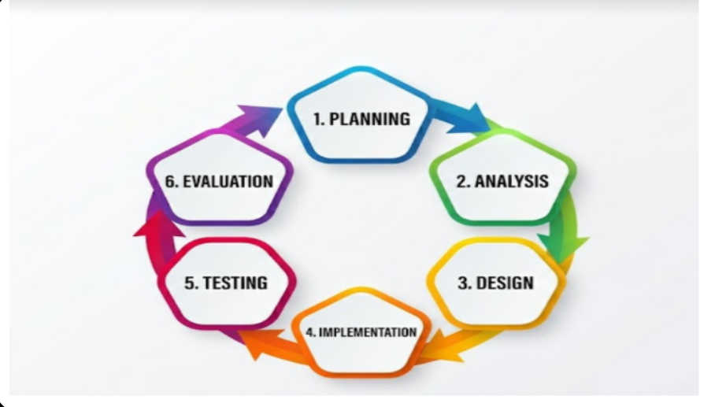
Figure 3. Iterative Software Development Life Cycle (SDLC) Model

PLANNING PHASE
The planning phase was done to determine the scope of the platform and its intended purpose. The researchers identified the target users of the platform which are the citizens, Barangay Officials, Barangay Tanods and Lupon Members. The researchers determined what features should be prioritized for the machine learning process such as classifying complaints and determining the urgency of complaints. They also gathered complaint records and information that could help the machine learning process to be successful. The end result of this phase is the completion of the project proposal, problem statement and preparation of research data collection.

ANALYSIS PHASE
The analysis phase was done by observing how the Barangay Saray handles complaints and by gathering information about the procedures in handling complaints. The researchers interviewed personnel and observed the process of complaint handling to determine the categories and urgency of complaints for the machine learning feature. The records of complaints were analyzed to identify patterns and to prepare the data for the implementation of the machine learning part. Some of the data were tagged accordingly to help the machine learning process. The end result of this phase is the completion of the requirement list, data analysis report and tagging guidelines.
DESIGN PHASE
The design phase was done to establish the system requirement specifications such as the system interface and database. The researchers came up with a process of handling text data complaint records in both Tagalog and English. The TF-IDF vectorization process is utilized to classify text data in complaint records. They also identified evaluation metrics that can measure the performance of the machine learning part such as accuracy, precision and recall. The end result of this phase is the completion of system diagram, database design, and technical specifications.
IMPLEMENTATION PHASE
The implementation phase was done by applying the system design to the development of the database, interface and other system components. Cleaning of complaint records of Barangay Saray was done and proper tags were placed accordingly to prepare the data for training the machine learning model. The data was divided into training and testing data set. The Naive Bayes Classifier was implemented to classify the complaints and determine the urgency of each complaint and to route them to the appropriate personnel. The end result of this phase is the completion of the system components, implementation of machine learning model and accomplishment of documentation.
TESTING PHASE
The testing phase was done to observe whether the components of the system were operating into its intended purpose and to check if it is user friendly. The researchers conducted a module testing to ensure that every part of the system is working appropriately and to identify possible problems that could arise. Testing of the software was also done by the Barangay Officials, Barangay Tanods, Lupon Members and citizens to confirm user friendliness. The testing of the machine learning component was done using data to classify whether the machine learning part can classify complaints accordingly. The feedback from the tests was utilized to improve the platform.
EVALUATION PHASE
The machine learning model was evaluated using accuracy, precision, and recall metrics to determine how good the model classifies complaints. The researchers also gathered feedback from users using surveys to determine the overall quality of the system and its acceptability by the target audience. The results of the evaluation were used to improve the system. The Iterative Software Development Life Cycle model was utilized which enabled the researchers to develop a complaint handling platform that is fit for use by Barangay Saray. The machine learning component was improved to ensure that complaints are classified appropriately and routed to the right personnel based on the urgency. The system was also evaluated to ensure that it has a user-friendly interface.
3.1.2 Physical Environment and Resources
The development and testing of the system needs hardware and software tools. The minimum requirements for running the system are different from the setup used during the development. This applies to devices.
Hardware Requirements:
The system requires that a Core i5/Ryzen processor, 8 GB RAM, and a 128 GB SSD computer shall be provided for development, testing, and database storing purposes. Android smartphones and iPhones shall be provided for the Tanods and barangay officials that will access the system.
Component | Specification | Purpose / Justification
Processor (CPU) | Intel Core, Ryzen | Supports development tools, AI model training/inference, and local emulation
Memory (RAM) | 8 GB or higher | Ensures smooth multitasking, browser‑based testing, and IDE usage during development
Storage | 128 GB SSD minimum | Provides fast read/write speeds for local databases, logs, and AI‑model files.
Mobile Devices | Android smartphones, Iphone | Used by tanod and officials for field testing and dashboard access.

Software requirements
The system will be designed using the Windows 10 or its equivalent operating system, React.js framework, and Tailwind CSS. The application will use HTML5 to structure web pages. The backend will be built using Nodejs, Express framework, and PostgreSQL or Supabase as the database. For the AI component, the system will adopt scikit-learn to achieve Naïve Bayes for complaints classification and prioritization.
Category | Software / Technology | Purpose
Operating System | Windows 10 (64‑bit) or equivalent | Standard development environment compatible with major IT tools and SDKs
Front-end Framework | React.js (or similar JS framework) | Used to build responsive and reusable web UI components for the dashboard.
Styling Library | Tailwind CSS or similar utility‑first CSS | Enables fast, consistent, and maintainable styling across the system.
Markup Language | HTML5 | Structures the web content of the application.
Backend & Database | Node.js with Express and PostgreSQL (or Supabase) | Implements server‑side logic and stores citizen complaints, case records, and user data.
AI / ML Framework | TensorFlow / scikit‑learn / Hugging Face models | Supports multi‑agent reinforcement learning and basic graph‑neural‑network‑inspired components for triage and prioritization.

The machine learning process was done using the scikit-learn library in Python. The complaint text was turned into numbers using TF-IDF vectorization with n-gram range (1 2) to get both words and pairs of words. The data had complaint records from Barangay Saray sorted into categories like public safety damage to buildings, noise issues, health problems, drug cases, threats, bullying and arguments between people.
For complaints that had both Tagalog and English the process used a way to split words and remove words using a list that worked for both languages. Complaints that fit more than one category got a main category based on the main idea found using keyword checks. The model was trained on a laptop that had average hardware (Intel Core i5 10th gen or AMD Ryzen 5 8GB RAM).. Good for tasks that need to sort text into many groups, which is common when dealing with complaints (Verma, 2025). The method assumes that all parts of the data are separate from each other which is not always true. It still works well in real situations where there are a lot of parts to the data.

3.1.3 Tools and Techniques Used in the Study

This section contains diagrams usecase, context, dfd, erd. The diagrams were developed to illustrate the design and operation of the AI-based Complaint Management System.
UseCase Diagram
The use case diagram defines the functional requirements of the platform by illustrating how each user role interacts with the available features. It serves as a reference for system functionality from the user's perspective, detailing the actions each role can perform within the complaint management workflow.
Citizens interact with the platform primarily as complaint submitters and case trackers. Their workflow includes creating an account, logging in, submitting concerns through walk-in, SMS, or online forms, and monitoring the status of their reports. The notification channel keeps citizens informed of case updates and hearing schedules. notifications and view updates. After a concern is submitted to the system the solution analyzes the report, identifies its category, determines its priority and forwards it to the appropriate barangay personnel.
Barangay Officials manage the overall complaint workflow. Their primary responsibilities include reviewing incoming reports, validating or adjusting the AI-suggested category and priority, assigning cases to Barangay Tanods or Lupon members, scheduling mediation meetings, and monitoring case resolution progress.
Barangay Tanods are responsible for field response to peace and order or public safety concerns. Their system interactions focus on viewing assigned cases, updating case progress after field response, adding notes from the scene, and receiving real-time notifications for urgent matters. Members can schedule meetings, record settlement results, update case information and notify citizens about meeting schedules and outcomes in the platform.
The Super Administrator is responsible for platform-wide configuration and oversight. This role manages user accounts, configures reporting channels, oversees complaint assignments, adjusts system settings, and monitors activity logs to ensure proper operation of the entire platform.
Overall, the use case diagram illustrates how the platform integrates complaint submission, automated classification, prioritization, case assignment, progress tracking, and notification delivery across the different user roles involved in the barangay complaint management process.

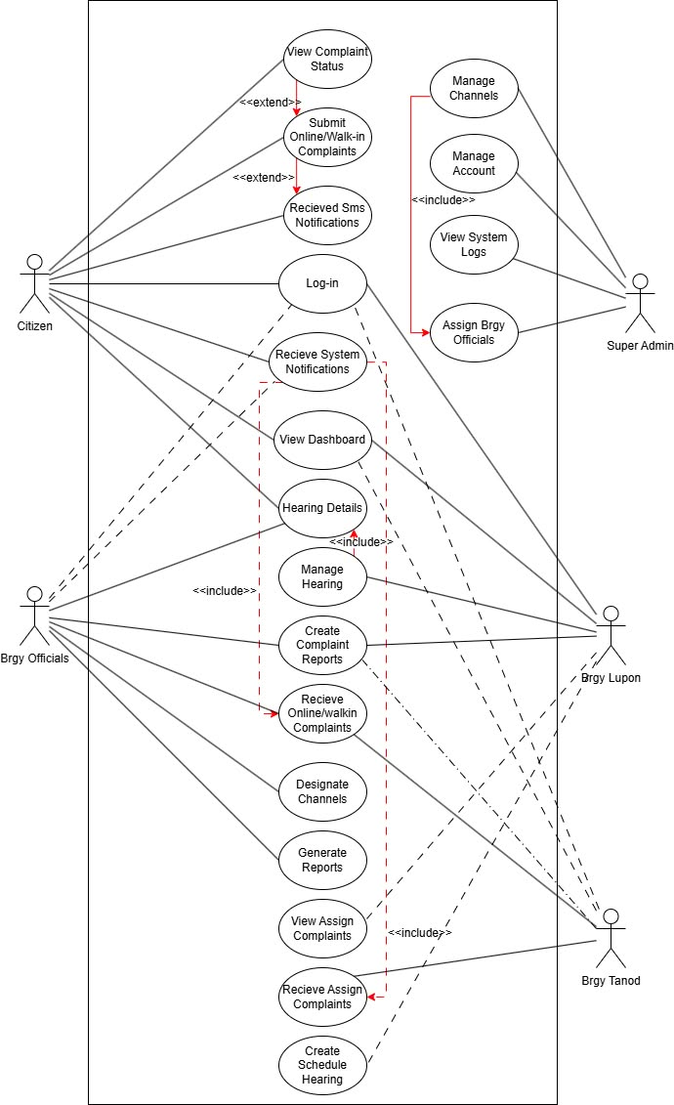
Figure 4. Use Case Diagram
Figure 4 below presents the use case diagram of the complaint management system that was designed to meet the needs of the barangay personnel in terms of complaint submission, Naïve Bayes classification, prioritization, assignment, monitoring, resolution, and notification of concerned parties for efficient processing of the complaints brought to their attention.
Context Diagram
The context diagram provides the general scope of the system or platform. The context diagram differs from the use case diagram because, in the use case, the analyst focuses on describing internal actors, whereas, in the context diagram, the analyst focuses on showing the flow of information and external entities without showing internal interactions.

The Citizen external entity sends the complaint data to the platform using manual, SMS, and online methods. The application uses notification data to provide information about the complaint hearing schedules to the Citizen external entity. The notification uses Natural Language Processing and the Naïve Bayes algorithm to classify the complaint data, determine the priority level, and forward the request to the Barangay Official external entity. In the same way, the citizen can use notification data to check on the status of their complaint, receive alerts, and get updates from the platform.

The Barangay Official external entity provides review and approval of the request and sends back the status of the complaint to the platform. This way, the external entity can monitor progress and take action when necessary.

The Barangay Tanod external entity takes action on the assigned cases and provides feedback to the platform by sending the progress and incident notes after attending to the case. The notification channel provides alert data to the Barangay Tanod external entity.

The Barangay Lupon external entity provides hearing schedules, settlement records, and case closure data to the platform while receiving notification data regarding the case hearing schedules and case updates from the application.

The Super Administrator external entity provides configuration data, account management, and commands to the platform and receives log data, status, and activity data from the application.

On the other hand, the administrator monitors the performance of the new platform to ensure that it serves its intended purpose of receiving, classifying, prioritizing, dispatching, and providing complaint updates to the relevant official without hindrance.
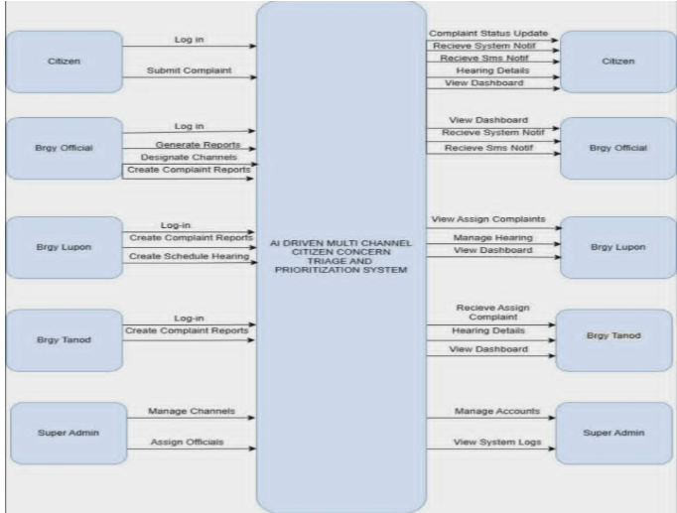
Figure 5. Context Diagram
Figure 5 below represents the roles and responsibilities of all the identified users in the proposed system. It also shows the features and functions of the system that will collectively help Barangay Saray in the efficient management of complaints through the submission of issues, AI-powered classification and prioritization of cases, assigning, monitoring, responding, hearing or settling, and resolving complaints.
Data Flow Diagram (DFD) Diagram

A Data Flow Diagram (DFD) is a graphical representation of the flow of data within an information system, which displays external entities, processes, data storage, and data flow. The context diagram below represents the flow of complaints and information in the proposed system between citizens, barangay officials, and the complaint management system itself.

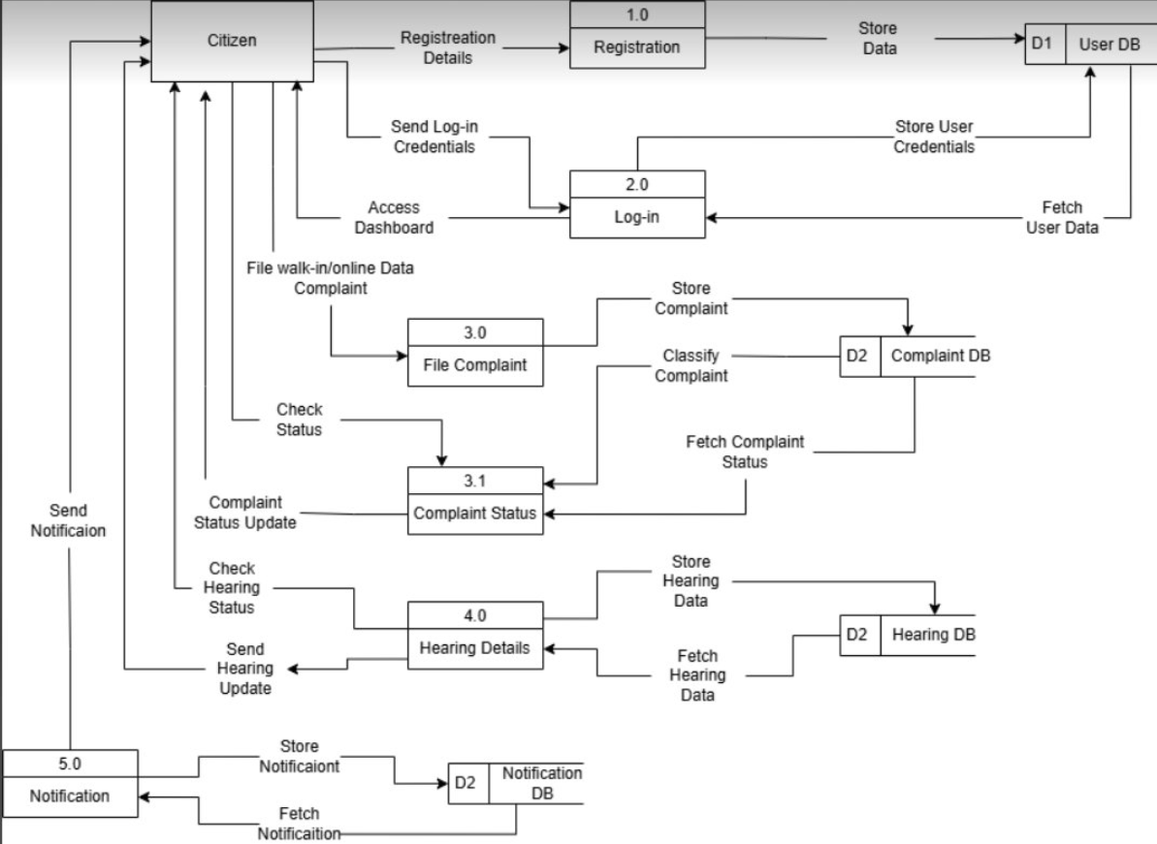

Figure 2. Citizen Data Flow Diagram
The Citizen Data Flow Diagram shows how complaint data moves around the platform. The diagram shows how information moves as people use parts of the system like creating an account, logging in, submitting a complaint, checking the status, managing hearing schedules and getting notifications. The system. Gets data from the database at every step. The process starts when a citizen registers; their details are kept in the User Database so they can log in later. People then put forward their problems using the file case process and the platform sorts each complaint before putting it in the Complaint Database. Users can watch how their complaints are going through the complaint status process, which gets updates from the database. For cases that need to be settled the hearing details process handles schedules and records by keeping and getting information from the Hearing Database. The notification process sends messages about the status of the complaint, the time of the hearing and other news so that people stay up to date during the process. In total the diagram shows the movement of information, inside the platform showing how each part helps with handling complaints and makes it easier for people to talk with the barangay staff.

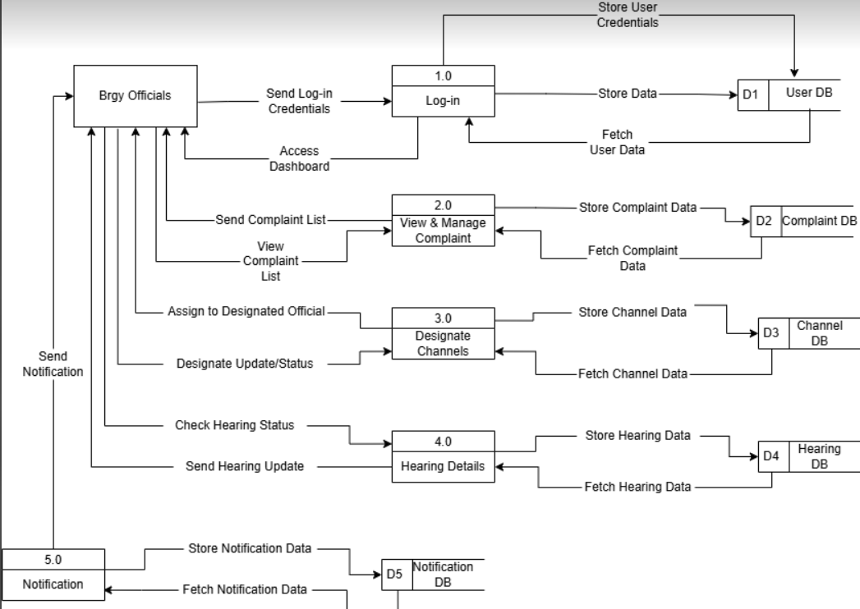
Figure 3. Barangay Officials Data Flow Diagram
The Barangay Officials Data Flow Diagram below shows the flow of data through the processes that are managed by the Barangay Official. It starts when the platform provides dashboard data after a successful authentication. The official then accesses complaint records from the Complaint Data Store through the complaint review process and updates the assignment decisions in the Complaints Database. Manage complaint records and assign cases to the appropriate channels for complaints resolution while selecting the most suitable complaint hearing options. All complaint, channel, and hearing data and information are stored securely in the platform’s databases, ensuring complete documentation. Notably, the software allows community officials to access hearing information, update case status, and notify the concerned parties. Doing so ensures that users are constantly reminded of their cases’ status. In addition, barangay officials can use the processes described to manage complaints effectively. Moreover, the system can help in maintaining well-organized records and providing faster and more organized public services as proposed in the system.
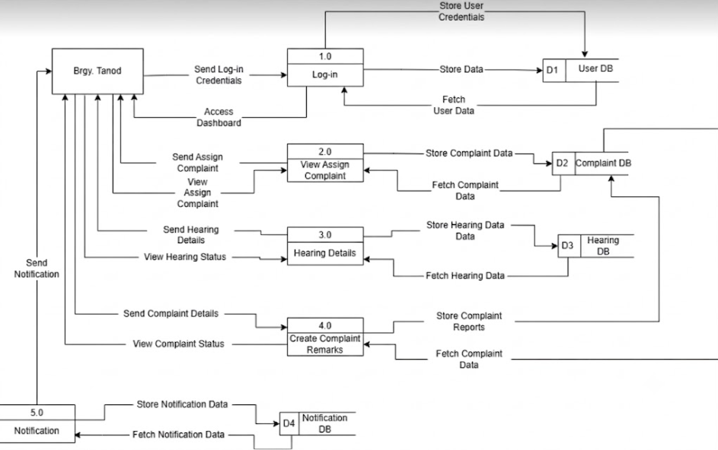

Figure 4. Barangay Tanod Data Flow Diagram
The Barangay Tanod Data Flow Diagram below indicates how the data will flow within the Tanod and the system. First, the Tanod logs in to the system, and he/she will see the assigned complaint records from the Complaints Data Store for his/her area. Using the case update process, the Tanod can update the case status and progress notes that will be reflected in the database through the case update process.

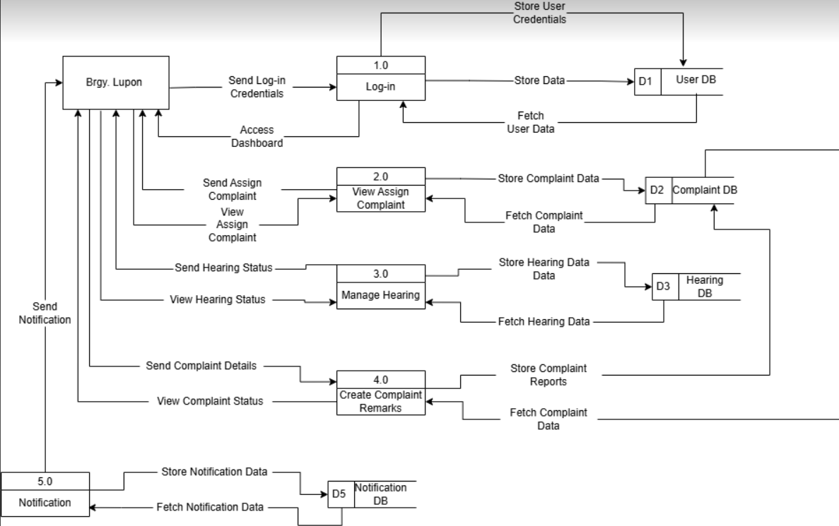
Figure 5. Barangay Lupon Diagram

The Barangay Lupon Data Flow Diagram indicates that after the authentication process, the Lupon member accesses the case data in the Complaints Data Store. The process of hearing scheduling then writes the scheduled data into the Hearing Data Store. The case update process, on the other hand, will save the settlement and resolution data in the complaints database.

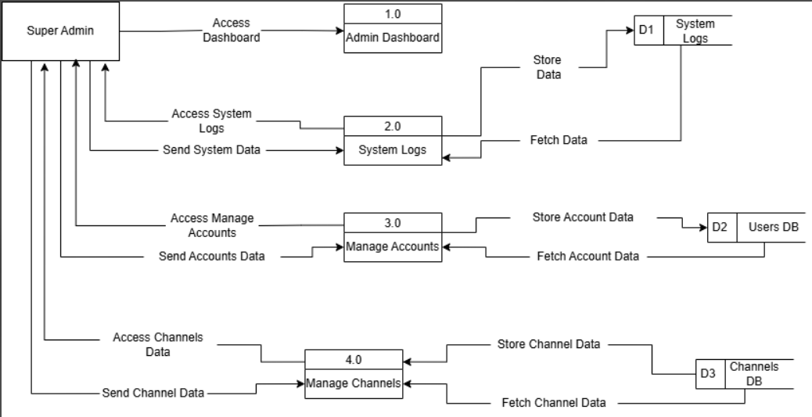

Figure 6. Super Admin Data Flow Diagram

The Super Admin Data Flow Diagram below represents the data flow between the system’s administrative processes. The main source of data for the Super Administrator is the User Data Store, from which the information about accounts is retrieved, and the System Log Data Store, from which the audit trail is accessed. Additionally, changes in configuration are passed to the admin process, resulting in updates to the System Config Data Store and User Database.

Entity Relationship Diagram (ERD)
The Entity Relationship Diagram below represents the database’s structure for the proposed platform. It demonstrates how the data is organized and interconnected. The Entity Relationship Diagram below includes such entities as users, complaints, complaint categories, hearings, notifications, channels, responsible persons, remarks, evidence files, triage results of the AI, roles, and system logs. These entities are interconnected and integrated into the unified database, which ensures information safety, easy access to the required data in case of necessity, and appropriate management of the content related to the complaint lifecycle for the platform’s efficient functioning. The database is structured into tables, which allows for convenient storage of all records, avoiding duplication of information and providing an excellent overview of the content. This organization is essential for managing citizens’ requests from their receipt until the moment of resolution. In addition, the Entity Relationship Diagram plays a crucial role in system development by providing a general overview of the database structure, which facilitates the proper functioning of the software in question

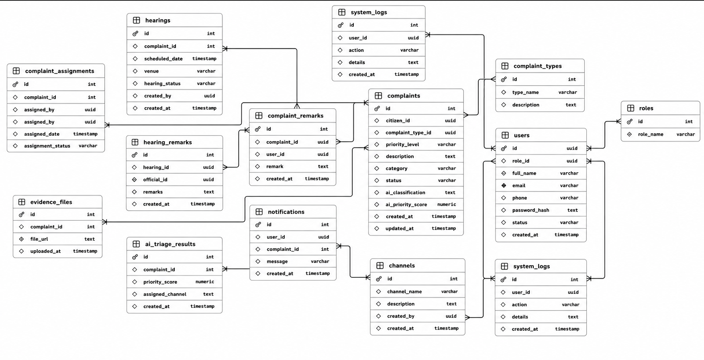

Figure 6. Entity Relationship Diagram (ERD)
Figure 6 below indicates how the aforementioned entities are connected to ensure that complaints go through the lifecycle process starting from submission, AI-driven aided processing to determine priority level and categorization, assignment, investigating, hearing or mediation, updating and finally closing as resolved. The database structure shown below is efficient to eliminate duplication records, improve information accessibility and ensure appropriate processing of the complaint by the agency.

3.2 Research Locale

The study was conducted in Barangay Saray located at Barangay Administrative Office, Barangay Saray, Iligan City, Lanao Del Norte. This is the place where the citizens can report any kind of problems and concerns. The Barangay Administrative Office handles all kinds of cases, both civil and criminal problems and issues involving road, building, and other concerns affecting the community in Barangay Saray. The Barangay officials, tanod, lupon and the administrative staff are working hand in hand to serve and assist the citizens and to handle different cases presented before the office.

Usually, the complainant goes directly to the office to report any incident or concerns. Calls, text messages, and other forms of communication are also used by the complainant to inform the Barangay or to seek for assistance. All complaints and concerns are being documented by the staff in a manual record and in the computer. Problems and concerns reported are being relayed to the appropriate authority for necessary actions to be taken by them. However, most of the cases require a manual process which may be time-consuming especially when there are many cases to be handled by the Barangay Saray.

The cases experienced by Barangay Saray indicated that a complaint-handling system is needed in order to effectively address the concerns of the people of Barangay Saray by creating an efficient, effective and organized system for recording, managing and monitoring reports and complaints. The suggested system should aid the Barangay Administrative Office to handle effectively and efficiently all reports and complaints which will improve the service delivery of the Barangay Saray, Lanao del Norte to the community. The barangay Saray will utilize the system as a tool for addressing the complaints of the people.
3.3 Sampling Design

This study used purposive sampling to select participants who have direct experience with complaint handling in Barangay Saray. Purposive sampling was appropriate because the study required respondents with specific knowledge of barangay complaint management procedures, and the target population was limited to individuals actively involved in the complaint workflow. or using the platform. Since there are 67 people in the group the study is looking at the study included all of them in the study so that every person who is involved would have a say in the evaluation.

Inclusion Criteria

The people the study chose had to meet these requirements:

* They had to be officials from Barangay Saray or Barangay Tanods or members of the Lupon or individuals who live in Barangay Saray and are involved in handling or sending in complaints.

* They had to be 18 years old.

* They had to be able to use digital devices like smartphones or computers to get to the platform on the web.

* They had to be willing to help test and evaluate the platform.

* They had to be available when the study were going to test and evaluate the platform.

Exclusion Criteria

The study did not include these people in the study:

* People who are not involved in handling complaints or have not used the platform.

* People who could not or did not want to participate in the evaluation.

* People who were not available when the study were testing the platform.

* People who did not finish the questionnaire about the platform.

The study included all 67 individuals who were qualified which is made up of 8 Barangay officials, 12 Barangay Tanods, 12 members of the Lupon and 35 residents. By including all of them, the study made sure that all groups of individuals who are involved had a say in the evaluation of the platform for Barangay Saray. The people in the study tested the platform. Filled out the evaluation forms to see how well the platform works, how easy it is to use and if people like it. If the study use the Technology Acceptance Model and the Diffusion of Innovations to evaluate the software then the answers from the people in the study will also help the study see if the proposed system for Barangay Saray is useful and user-friendly and if people will accept it.
.
3.4 Respondents of the Study

The respondents of this study were users and those involved in the process of complaint management of Barangay Saray. Purposive sampling was done to select participants from the said group. The respondents of this research were those who were involved in reporting, processing, responding, and resolving citizen complaints. This technique was deemed appropriate for this study as it targeted those people who had knowledge and experience about the process being studied. The respondents of this study were 67 in number. There were 8 Barangay Officials, 12 Barangay tanods, 12 Lupon Members, and 35 Barangay Saray Residents. Officials, tanods, and lupon members were the users of the complaint management system. On the other hand, barangay residents were citizens that could utilize the service and monitor how complaints would be resolved. The respondents provided their assessment of the proposed system in terms of its use, value, and potential adoption in the community. Furthermore, this study also looked into the possible acceptance and diffusion of the proposed technology by the target respondents.

Inclusion Criteria

- The participants included in the study must meet the following requirements:
- Must be a Barangay Official, Barangay Tanod, Lupon Member, or resident of Barangay Saray.
- Must be 18 years old or above.
- Must have experience in submitting, receiving, or managing community complaints within the last six months.
- Must have basic knowledge of using digital devices such as smartphones, tablets, or computers for accessing the web-based system.
- Must be willing to participate in the beta testing and complete the platform evaluation questionnaire.

Exclusion Criteria

- The following individuals were not included in the study:

- Individuals who are not residents of Barangay Saray or are not part of its authorized personnel.
- Individuals who have no involvement in submitting or handling citizen complaints.
- Individuals who do not have the basic skills needed to access and use the platform.
- Barangay personnel who were not around during the platform evaluation were not part of the study.
- Some people did not want to be part of the study. They could not finish the testing. These people were also not included.
- The individuals who were part of the study gave the study useful ideas based on what they thought of the new system. What they said helped the study see if the platform is good for managing complaints and if it can make things better in Barangay Saray. The platform is supposed to help Barangay Saray and the individuals who used it told the study what they think about the software and how it can help with complaint management, in Barangay Saray.

Respondent Type | Population (N) | Sample Size (n) | Sampling Technique
Barangay Officials | 8 | 8 | Purposive Sampling
Tanods | 12 | 12 | Purposive Sampling
Residents | 35 | 35 | Purposive Sampling
Lupon | 12 | 12 | Purposive Sampling
Total | 67 | 67

3.5 Research Instrument
The instrument of the study consisted of 67 inhabitants of Barangay Saray, represented by 8 Barangay Officials, 12 Barangay Tanods, 12 Lupon Members, and 35 residents. The respondents were selected through purposive sampling, as they are expected to report, respond to, or monitor any issues being raised (Ahmad & Wilkins, 2025).The assessment of the developed system was based on Technology Acceptance Model (TAM) and intended to identify the extent to which the technology is perceived as useful and easy to use. Indeed, perceived usefulness and ease of use are critical in determining the level at which end-users will accept and utilize the technology (Adnan et al., 2025). In addition, the study evaluated the influence of technology adoption and innovation diffusion on the integration of the proposed system within the existing complaint management practices of the barangay (Ghimire & Edwards, 2024).
Inclusion Criteria
The participants included in the study must meet the following requirements:
Must be a Barangay Official, Barangay Tanod, Lupon Member, or resident of Barangay Saray.
Must be 18 years old or above.
Must have experience in submitting, receiving, or managing community complaints within the last six months.
Must have basic knowledge of using digital devices such as smartphones, tablets, or computers for accessing the web-based system.
Must be willing to participate in the beta testing and complete the platform evaluation questionnaire.
Exclusion Criteria
The following individuals were not included in the study:
Individuals who are not residents of Barangay Saray or are not part of its authorized personnel.
Individuals who have no involvement in submitting or handling citizen complaints.
Individuals who do not have the basic skills needed to access and use the platform.
Barangay personnel who were not around during the platform evaluation were not part of the study.
Some people did not want to be part of the study. They could not finish the testing. These people were also not included.
The individuals who were part of the study gave the study useful ideas based on what they thought of the new system. What they said helped the study see if the platform is good for managing complaints and if it can make things better in Barangay Saray. The platform is supposed to help Barangay Saray and the individuals who used it told the study what they think about the software and how it can help with complaint management, in Barangay Saray.
Scale Value | Verbal Interpretation
5 | Strongly Agree
4 | Agree
3 | Neutral/Undecided
2 | Disagree
1 | Strongly Disagree

3.6 Validity and Reliability of the Instrument
The instrument used was adopted from software quality questions based on ISO 9126 standards, and an established Scale based on the Technology Acceptance Model (TAM). Only a few changes were made to fit the context of the current study, such as changes in names and institutional references. No changes were made to the meaning of the items. Since the instruments adopted had gone through the validity and reliability tests, no further tests were done for this study. The results of Cronbach's alpha analysis of the data would be discussed in chapter 4.
3.7 Data Gathering Procedure
The study has gained approval from the institution as well as the officials of Barangay Saray before initiating the research and engaging the selected participants. A request letter was sent to the authorities to seek authorization for the research and obtainment of the cooperation of the targeted respondents. In this regard, the study gained the official approval from the authorities which facilitated the conduct of the research.
The study oriented the respondents regarding the general objectives of the research as well as the intended proposals for the development of the social media-based reporting system. It was emphasized that participation in the study was voluntary and that the respondents could withdraw their consent at any point. The respondents were also informed of the confidentiality of the information gathered from them and provided informed consents before proceeding with the study.
The proposed system was demonstrated to the participants for them to understand the general design and features of the software. The participants were informed of the capabilities of the application which include registering citizen concerns, tracking of reports, prioritization of cases, receiving of notifications and management of cases. The participants were allowed to use the system to gain a deeper understanding of the system’s interface and capabilities prior to the start of the evaluation.
The participants took part in filling out a questionnaire where information regarding the usefulness of the application was gathered. The rationale of the questionnaire as well as assistance in filling it out was provided by the study. The participants were requested to provide responses based on their views regarding the proposed system.
The questionnaires of the participants were collected and reviewed to ensure that they had provided complete responses. In cases where some respondents failed to provide responses based on their actual opinions, their questionnaires were disregarded. This stage enabled the study to ensure that the data collected are reliable and valid for the purpose of the research
The collected responses were encoded and analyzed using Microsoft Excel and SPSS. The analysis focused on evaluating the performance of the system based on the scores provided by the participants. The results of the data analysis were discussed in Chapter 4 of the study.
3.8 Scoring Procedure
Parts II (System Quality) and III (User Acceptance) use a 5-point Likert scale with the following numerical assignment:
5 = Strongly Agree, 4 = Agree, 3 = Neutral/Undecided, 2 = Disagree, 1 = Strongly Disagree.
For each construct (the ISO/IEC 25010 quality dimensions and the TAM constructs), the mean score is computed as:

where
N
N is the number of respondents and
k
k is the number of items per construct.
The resulting mean scores are interpreted using the following scale
Scale Range | Verbal Interpretation | Description
4.21 – 5.00 | Strongly Agree / Excellent | Respondents highly endorse the criterion
3.41 - 4.20 | Agree / Very Good | Respondents agree the criterion is met
2.61 – 3.40 | Neutral / Good | Respondents are neutral/moderately satisfied
1.81 – 2.60 | Disagree / Fair | Respondents disagree with the criterion
1.00 – 1.80 | Strongly Disagree / Poor | Respondents strongly reject the criterion
Example Computation:
If 38 respondents rate 3 Usability items with total score = 456, then:
Mean = 456 ÷ (38 × 3) = 4.00 ("Agree/VeryGood")
This consistent scoring scale will be applied throughout Chapter 4 to interpret all evaluation results for system quality (ISO/IEC 25010) and user acceptance (TAM).
3.9 Statistical Treatment
Survey responses were analyzed using inferential statistics. The choice of method depended on the type of data and the research questions being addressed.
Weighted Mean
The weighted mean was used to analyze the responses obtained from the Likert-scale items in Part II (System Quality Evaluation) and Part III (User Acceptance Evaluation) of the questionnaire. This measure determines the rating of respondents for each criterion and summarizes their overall perception of the proposed system.
The formula is:
WM=
N
∑(fx)
Where:
WM = weighted mean
f = frequency of responses for each scale value
x = assigned scale value (1 to 5)
N = total number of respondents
Standard Deviation
Standard deviation was used to measure the dispersion of respondents’ ratings around the mean. A lower standard deviation indicates that responses are more consistent and closely grouped while a higher standard deviation indicates variation in respondents’ opinions. This measure was used to determine the consistency of evaluation results for each system quality and acceptance construct.
The formula is:
SD=
N
∑(x−
x
ˉ
)
2
Where:
SD = deviation
x = individual response value
x̄ = mean of responses
N = total number of respondents
Frequency and Percentage
Frequency and percentage were used to summarize the profile of respondents including their role, user type and other demographic characteristics. Frequency represents the number of respondents under each category while percentage represents the proportion of respondents to the total number of participants.
The formula is:
Percentage=
N
f
×100
Where:
f = frequency of respondents in a given category
N = total number of respondents
Independent Samples t-Test and One-Way ANOVA
An independent sample t-test was used to determine whether there were differences between the mean ratings of two respondent groups. For comparisons involving three or more groups, a one-way Analysis of Variance (ANOVA) was applied.
A significance level of 0.05 was used in interpreting the results. A value lower than 0.05 indicates that a statistically significant difference exists among the compared groups.
Correlation Analysis
Pearson's r was used to check the relationship between perceived usefulness, ease of use and intention to use. If the data did not meet normality assumptions Spearman's rho was used instead.
The coefficient indicated the strength and direction of the relationship between variables.
Statistical Software
The statistical computations and data analysis were performed using Microsoft Excel and/or SPSS depending on the requirements of each procedure. These tools were used for organizing data, calculating values and generating results for interpretation and discussion, in Chapter 4.
3.10 Ethical Considerations
The research followed the rules for working with human participants. Permission was taken from the organization and from the officials of Barangay Saray before the study began.
Each participant was given information about the study. They were told what the study was, about what their role would be and that they could leave at any time without any problems.
All answers were kept secret. The data was kept safe. Only used for this study. All sources are mentioned properly according to the Data Privacy Act of 2012 (RA 10173).

REFERENCES
(Barhate et al. 2025)
Barhate, M. Y. Deshmukh, S. S. Deshmukh, A. D. Deshmukh, M. V. Deshmukh, S. J. & Deshmukh, V. P. (2025). Transformative integration of AI/ML technologies in law enforcement: A holistic approach for enhanced efficiency and public safety. Applications of Artificial Intelligence in 5G and Internet of Things - Proceedings of the 1st International Conference on Applications of AI in 5G and IOT, ICAAI5GI 2024. https://doi.org/10.1201/9781003532521-8910.1201/9781003532521-89https://doi.org/10.1201/9781003532521-89
(Esperança et al. 2025)
Esperança, M. Freitas, D. Paixão, P. V. Marcos, T. A. Martins, R. A. & Ferreira, J. C. (2025). Proactive Complaint Management in Public Sector Informatics Using AI: A Semantic Pattern Recognition Framework. Applied Sciences (Switzerland), 15(12). https://doi.org/10.3390/app1512667310.3390/app15126673https://doi.org/10.3390/app15126673
(Porto, 2024)
Porto, B. M. (2024). Improving triage performance in emergency departments using machine learning and natural language processing: a systematic review. In BMC Emergency Medicine (Vol. 24, Number 1). https://doi.org/10.1186/s12873-024-01135-210.1186/s12873-024-01135-2https://doi.org/10.1186/s12873-024-01135-2
(Stanley et al. 2023)
(Verma, 2025)
Stanley, E. Brucal, G. E. Ryan, J. John, A. Go, C. Guerrero, D. A. & Sabater, M. A. (2023). Development of an Online Report Management System for Local Government Officials and Residents (e-Reklamo) Development of an Online Report Management System for Local Government Officials and Residents: (e-Reklamo). CHRONICLE, 1(1).
(Verma, D. 2025).
Complaint Classification Model Using NLP. International Journal for Research in Applied Science and Engineering Technology, 13(5). https://doi.org/10.22214/ijraset.2025.7157310.22214/ijraset.2025.71573https://doi.org/10.22214/ijraset.2025.71573
(Fuse et al. 2025)
Fuse, S. G. Kathkoriya, R. N. Lahane, D. A. Nagane, R. S. & Chhajed, K. K. (2025). AI-Based Waste Classification & Reporting System. International Journal of Research Publication and Reviews Journal Homepage: Www. Ijrpr. Com, 6.
(Javed & B.L. 2015)
Javed, N. & B.L. M. (2015). Framework for Participative and Collaborative Governance using Social Media Mining Techniques. International Journal of Computer Applications, 123(8).
(Ndunagu et al. 2022)
Ndunagu, J. N. Jimoh, R. G. Chidiebere, U. & Opeoluwa, G. D. (2022). Enhanced Open and Distance Learning Using an Artificial Intelligence (AI)-Powered Chatbot: A Conceptual Framework. Proceedings of the 5th International Conference on Information Technology for Education and Development: Changing the Narratives Through Building a Secure Society with Disruptive Technologies, ITED 2022.
(Patil et al. 2025)
Patil, P. Bage, D. D. Khaire, S. Kharat, P. Patil, D. & Pachore, T. (2025). AI-Powered Smart Complaint Management System For Rural Area. International Journal on Emerging Trends in Technology, 12(2).
(Wahid et al. 2025)
Wahid, J. A. Xu, M. Ayoub, M. Jiang, X. Lei, S. Gao, Y. Hussain, S. & Yang, Y. (2025). AI-driven social media text analysis during crisis: A review for natural disasters and pandemics. In Applied Soft Computing (Vol. 171). https://doi.org/10.1016/j.asoc.2025.11277410.1016/j.asoc.2025.112774https://doi.org/10.1016/j.asoc.2025.112774
(Chaudhary et al. 2025)
Chaudhary, P. Bandhekar, S. Dhage, P. U. Tembhare, L. Preethi, V. & Nikhade, P. H. (2025). Enabling real-time tuberculosis detection in hospital radiology through scalable actor-learner architectures for distributed deep reinforcement learning. In Indian Journal of Tuberculosis.
(Hsu et al. 2022)
Hsu, Y. C. Huang, T. H. ‘Kenneth,’ Verma, H. Mauri, A. Nourbakhsh, I. & Bozzon, A. (2022). Empowering local communities using artificial intelligence. In Patterns (Vol. 3, Number 3).
(Wernly et al. 2021)
Wernly, B. Mamandipoor, B. Baldia, P. Jung, C. & Osmani, V. (2021). Machine learning predicts mortality in septic patients using only routinely available ABG variables: a multi-centre evaluation. International Journal of Medical Informatics, 145.
(Vairetti et al. 2024)
Vairetti, C. Aránguiz, I. Maldonado, S. Karmy, J. P. & Leal, A. (2024). Analytics-driven complaint prioritisation via deep learning and multicriteria decision-making. European Journal of Operational Research, 312(3). https://doi.org/10.1016/j.ejor.2023.08.027 https://doi.org/10.1016/j.ejor.2023.08.027 https://doi.org/10.1016/j.ejor.2023.08.027
(Lim, 2022)
Lim, J. P. (2022). International Journal of Computer Science and Mobile Computing Barangay Integrated Management System with Mobile Support. International Journal of Computer Science and Mobile Computing, 11(7)

