Exercise 1

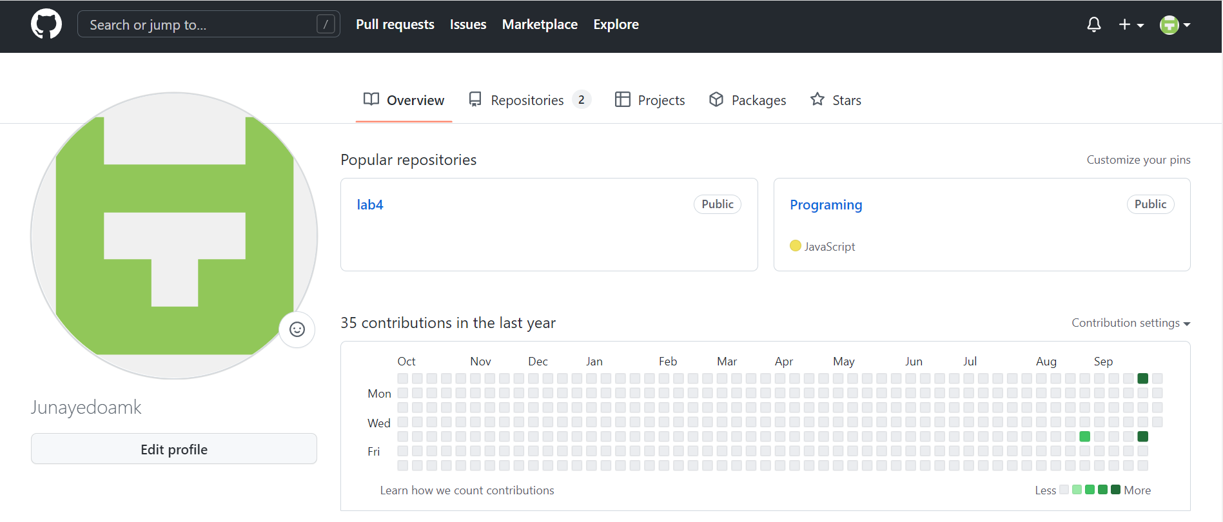

Exercise 2

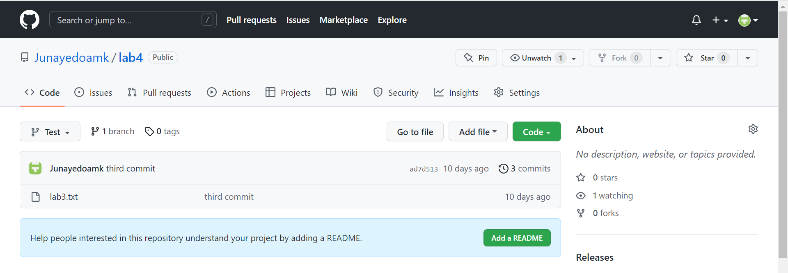

Exercise 3

Exercise 4

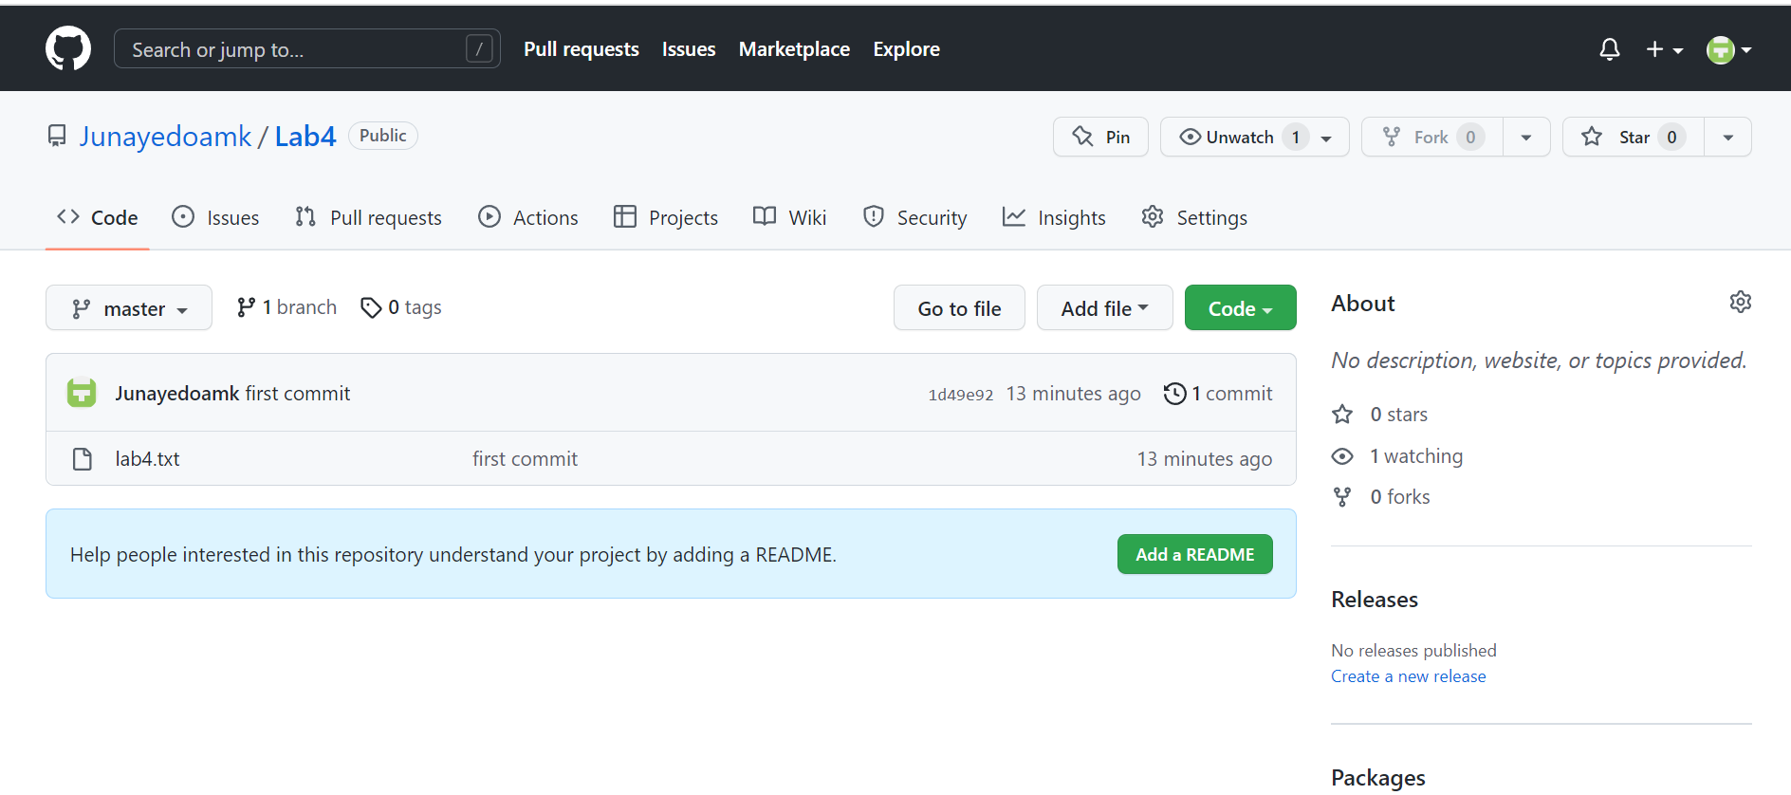

Edit the file in GITHUB and pull to local repo

Exercise 5

Create local branch and checkout that branch

Make some changes to file

push and create remote branch

Create pull request and merge branch to master in GITHUB

Delete remote branch in GITHUB

Checkout local master and delete local branch

pull master from GITHUB

