# MAE5009: Continuum Mechanics B Assignment 04: Formulation of Problems in Elasticity

**Due November 2, 2021**

1. Verify the following equations for plane strain problems with constant

*fx* and

*f y* :

(a)

(b)

✰ 2*u* 

*y*

✰ 2*u* 

*x*

✰ 2*v*

*x*

✰ 2*v*  0

*y*

(c) 4*u*  4*v*  0 , where 4  2 2  .

1. A bar of constant mass density  hangs under its own weight and is supported by

the uniform stress 0 as shown in the figure. Assume that the stresses *x* ,  *y* , *xy* ,

*xz*

and  *yz*

are all zero,

* 1. based on the above assumption, reduce 15 governing equations to seven equations in terms of *z* , *x* ,  *y* , *z* , *u*, *v* and *w*
  2. integrate the equilibrium equation to show that

*z*  *gz*

where *g* is the acceleration due to gravity. Also show that the prescribed boundary conditions are satisfied by this solution

* 1. find *x* ,  *y* , *z*from the generalized Hooke’s law
  2. if the displacement and rotation components are zero at the point (0,0,*l*), determine the displacement component *u* and *v*
  3. prove that

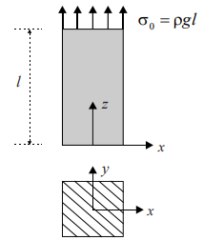*w*  *g z*2  *x*2  *y*2  *l* 2

 

2*E*

1. Express the boundary conditions for the following plate subjected to plate strain condition. The surface forces are functions of *x* and *y* only.

