Install Docker Desktop
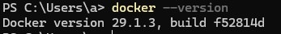
Successfully downloaded and run Gitea.
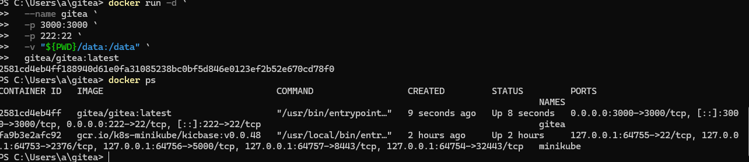
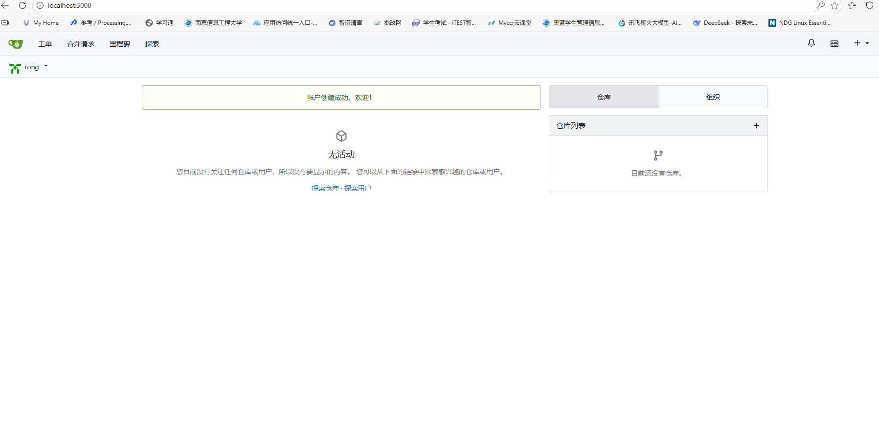
it support LFS
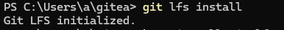
Create a repo with a large file (1G+)
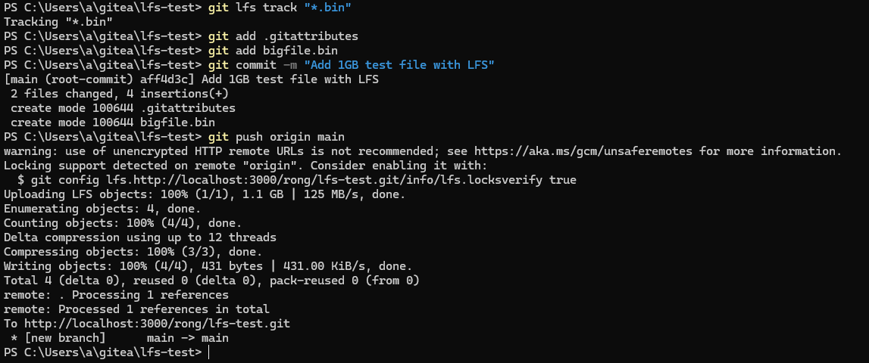
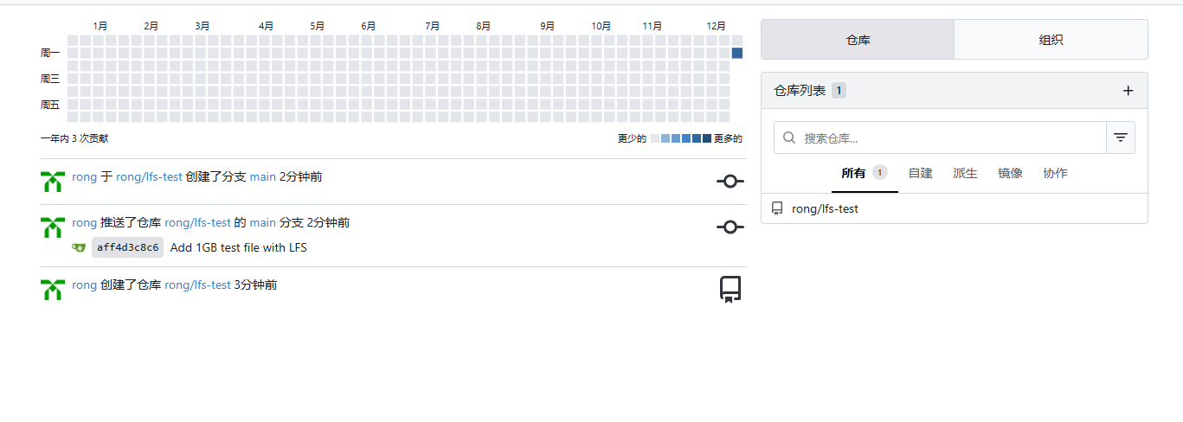
Gitea supports Git LFS. The 1GB test file was successfully tracked and pushed using Git LFS.

Create a repo for this module and commit lab1&2 to this repo.
