NFC(DFR0231) - Mega보드

1. 연결하기

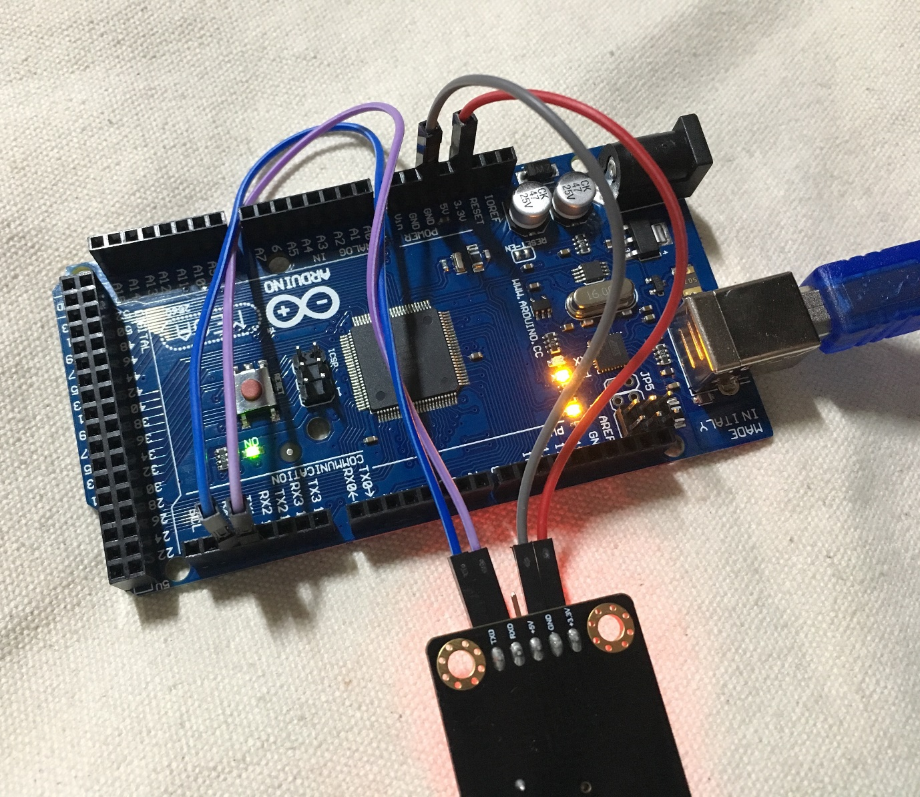

NFC → MEGA : 3.3V → 3.3V, GND → GND, RXD → TX1, TXD → RX1 연결

1. 소스코드 (구매한 사이트에서 제공해주는 기본 소스코드)

/*

PN532 reads the tag by Arduino mega/Leonardo

command list:

#wake up reader

send: 55 55 00 00 00 00 00 00 00 00 00 00 00 00 00 00 ff 03 fd d4 14 01 17 00

return: 00 00 FF 00 FF 00 00 00 FF 02 FE D5 15 16 00

#get firmware

send: 00 00 FF 02 FE D4 02 2A 00

return: 00 00 FF 00 FF 00 00 00 FF 06 FA D5 03 32 01 06 07 E8 00

#read the tag

send: 00 00 FF 04 FC D4 4A 01 00 E1 00

return: 00 00 FF 00 FF 00 00 00 FF 0C F4 D5 4B 01 01 00 04 08 04 XX XX XX XX 5A 00

XX is tag.

*/

const unsigned char wake[24]={0x55,0x55,0x00,0x00,0x00,0x00,0x00,0x00,0x00,0x00,0x00,0x00,0x00,0x00,0x00,0x00,0xff,0x03,0xfd,0xd4,0x14,0x01,0x17,0x00};//wake up NFC module

const unsigned char firmware[9]={0x00,0x00,0xFF,0x02,0xFE,0xD4,0x02,0x2A,0x00};//

const unsigned char tag[11]={0x00,0x00,0xFF,0x04,0xFC,0xD4,0x4A,0x01,0x00,0xE1,0x00};//detecting tag command

unsigned char receive_ACK[25];//Command receiving buffer

int inByte = 0; //incoming serial byte buffer

#if defined(ARDUINO) && ARDUINO >= 100

#include "Arduino.h"

#define print1Byte(args) Serial1.write(args)

#define print1lnByte(args) Serial1.write(args),Serial1.println()

#else

#include "WProgram.h"

#define print1Byte(args) Serial1.print(args,BYTE)

#define print1lnByte(args) Serial1.println(args,BYTE)

#endif

void setup()

{

Serial.begin(9600); // open serial锛宻et Baund rate 9600 bps

Serial1.begin(115200);

//Serial2.begin(115200);

wake_card();

delay(100);

array_ACK(15);

delay(100);

dsplay(15);

}

void loop()

{

if (Serial.available() > 0)

{

// get incoming byte:

inByte = Serial.read();

if (inByte=='r')

{

read_tag();

delay(100);

array_ACK(25);

delay(100);

dsplay(25);

}

else if (inByte=='v')

{

firmware_version();

delay(100);

array_ACK(19);

delay(100);

dsplay(19);

}

}

}

void UART1_Send_Byte(unsigned char command_data)

{

//Serial1.print(command_data);

print1Byte(command_data);// command send to device

#if defined(ARDUINO) && ARDUINO >= 100

Serial1.flush();// complete the transmission of outgoing serial data

#endif

}

void UART_Send_Byte(unsigned char command_data)//, unsigned charBYTE

{

Serial.print(command_data,HEX);

Serial.print(" ");

}

void array_ACK(unsigned char temp)

{

for(unsigned char i=0;i<temp;i++)

{

receive_ACK[i]= Serial1.read();

delay(100);

}

}

void wake_card(void)

{

unsigned char i;

for(i=0;i<24;i++) //send command

UART1_Send_Byte(wake[i]);

}

void firmware_version(void)

{

unsigned char i;

for(i=0;i<9;i++) //send command

UART1_Send_Byte(firmware[i]);

}

void read_tag(void)

{

unsigned char i;

for(i=0;i<11;i++) //send command

UART1_Send_Byte(tag[i]);

}

void dsplay(unsigned char tem)

{

unsigned char i;

for(i=0;i<tem;i++) //send command

UART_Send_Byte(receive_ACK[i]);

Serial.println();

}

1. 실행결과

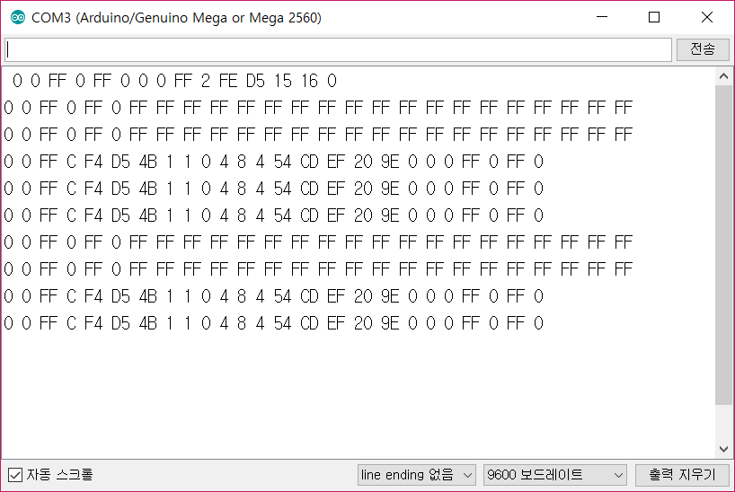

그림 1 – 시리얼통신으로 출력되는 태그 값

1. 처음에 계속 태그 값이 바뀌었는데 현재는 똑같이 출력됨

태그 값 출력에 왜 오류가 발생했는지 발견하지 못함