Process update

1. Context
GEE is our catalog + cloud compute layer (no full-country raster downloads). Zambia: Hansen admin‑2 loss + fire pilots (2013–14 window). Zimbabwe: same fire EDA pattern for the 2016 exposure year ahead of 2017 survey

2. Progress
EE auth and project setup are working; Hansen admin‑2 CSV for Zambia is in place; Zambia and Zimbabwe fire notebooks run the same MODIS / FIRMS zonal template on GAUL 2015 admin‑2

3. Findings

Hansen
- Source: Hansen GFC 2025 v1.13, lossyear = 2013; regions: FAO GAUL 2015 level 2, Zambia
- Table: 72 rows (one ADM2); national ~158k ha summed loss_area_ha (30 m loss mask; not fire)
- Use: reasonable for relative district comparison until linked to survey geography with an explicit rule

Fire — Zambia
- GEE: zonal stats to GAUL 2015 admin‑2; burn_area_ha = MCD64A1 burned mask summed to ha per district; hot_area_ha = FIRMS T21 proxy (ha).
- Survey link: prov / dist etc.; 72 GAUL ADM2 vs 61 / 53 distinct dist (male / female PUD)—reconcile with a crosswalk before merging.
- Still need: dist → GAUL names or official code → ADM2_CODE for a clean join.
Zambia snapshot — August 2013 MODIS burn (one month): province-level “top district per ADM1” below (nine ADM1 labels in this GAUL extract). National sum of district burn_area_ha that month ≈ 8.0M ha (order-of-magnitude headline from the pilot run).
ADM1 (province) | ADM2 (max burn in province) | burn_area_ha
Central | Serenje | 631,504.6
Copperbelt | Mpongwe | 136,534.4
Eastern | Chama | 231,592.1
Luapula | Mwense | 388,950.6
Lusaka | Chongwe | 120,989.5
North-Western | Kasempa | 238,272.9
Northern | Mpika | 525,815.5
Southern | Kazungula | 187,299.6
Western | Sesheke | 394,425.0

ADM1 (province) | ADM2 (max hot-area proxy in province) | hot_area_ha
Central | Serenje | 614,581.4
Copperbelt | Lufwanyama | 250,912.2
Eastern | Chama | 303,184.3
Luapula | Mwense | 313,396.7
Lusaka | Chongwe | 175,103.1
North-Western | Solwezi | 497,378.5
Northern | Mpika | 682,904.0
Southern | Kazungula | 255,246.2
Western | Sesheke | 609,776.6

Fire — Zimbabwe
January 2016 (first month of the exposure year in the notebook): ~701 ha summed over 62 GAUL districts for burn_area_ha—same MCD64→ha definition as Zambia, different country and month than the Zambia table above, so totals are not directly comparable as a “Zambia vs Zimbabwe” scorecard.
ADM1_NAME | ADM2_NAME | burn_area_ha (sample)
Mashonaland East | Chikomba | 94.2
Bulawayo | Bulawayo | 0.0
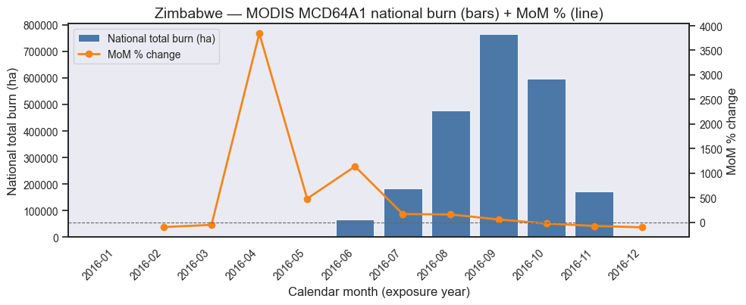
very little classified burn early in 2016, a September peak, then a fall off toward year end.

