Name: Junda Tu

NetID: jtt3923

**351 ProjectC**

**User’s Guide:**

* To move the camera around the canvas, use w, a, s, d.
* To change the direction of the camera, use i, j, k, l.
* To turn your headlight on and off, press h.
* Switch lighting modes by pressing m.
* You can turn the world light off by pressing the space bar.

**Result:**

F1: Blinn-Phong Lighting and Gouroud Shading

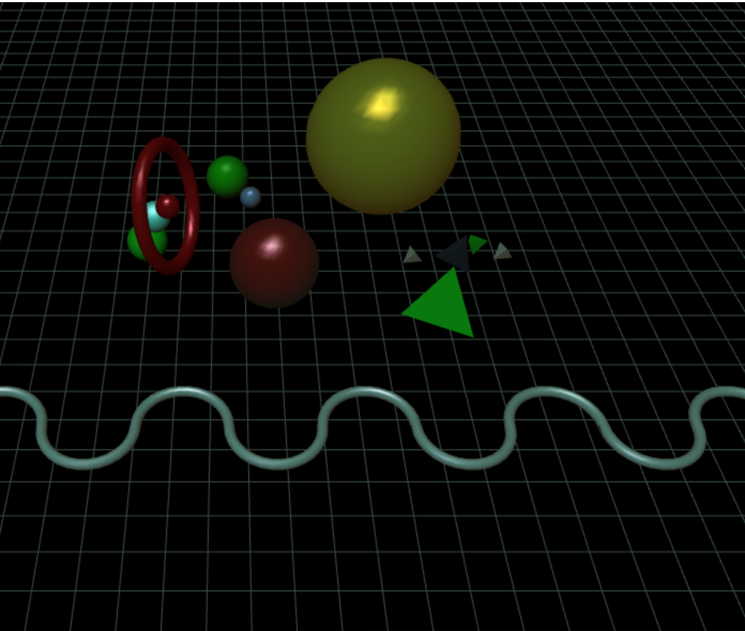

F1

F2: Blinn-Phong Lighting and Phong Shading

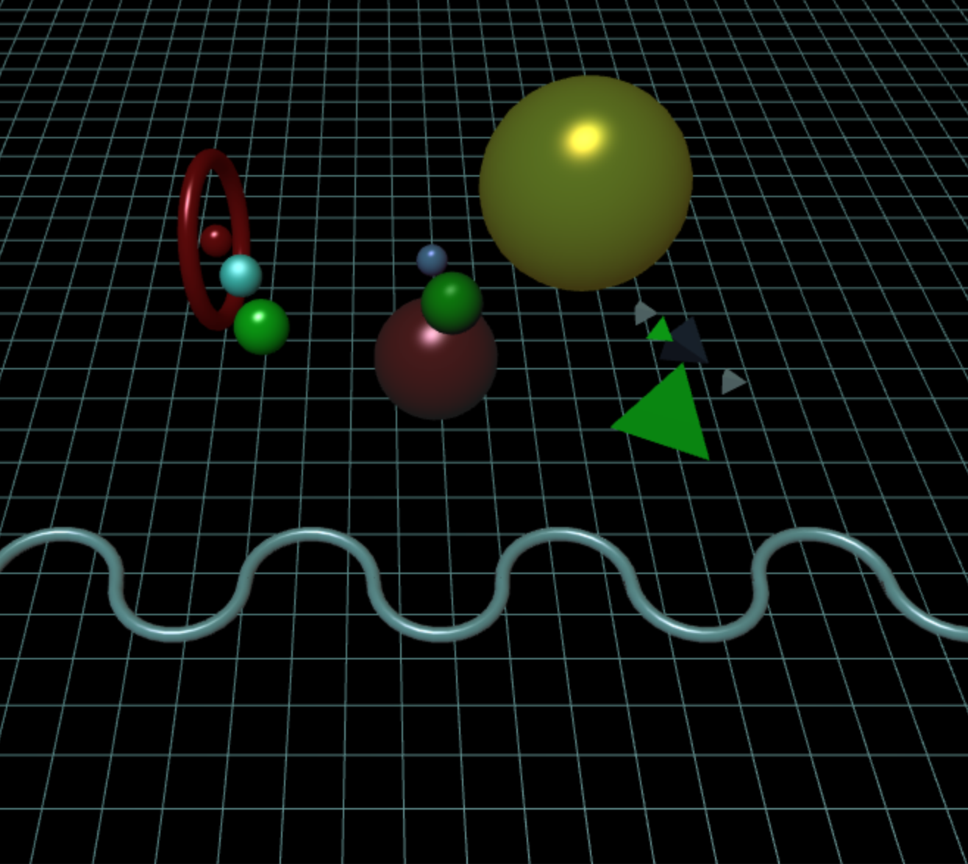

F2

F3: Phong Lighting and Gouroud Shading

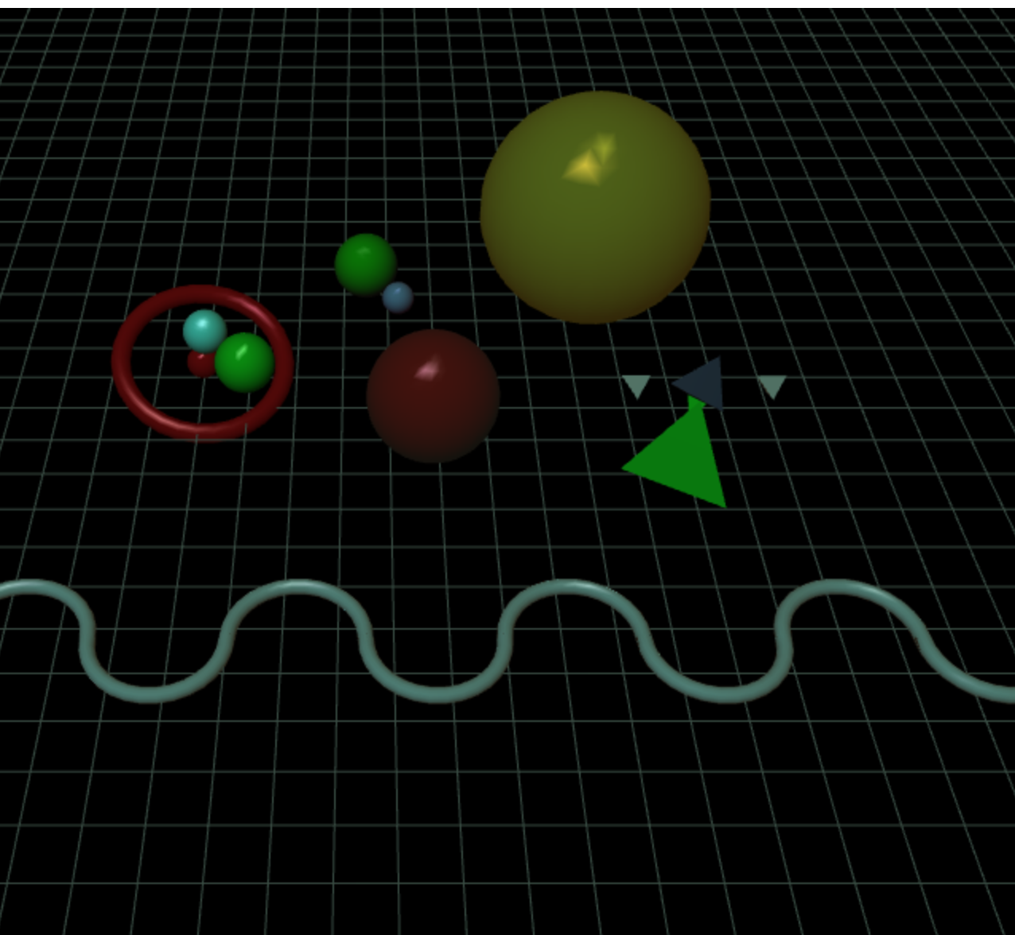

F3

F4: Phong Lighting and Phong Shading

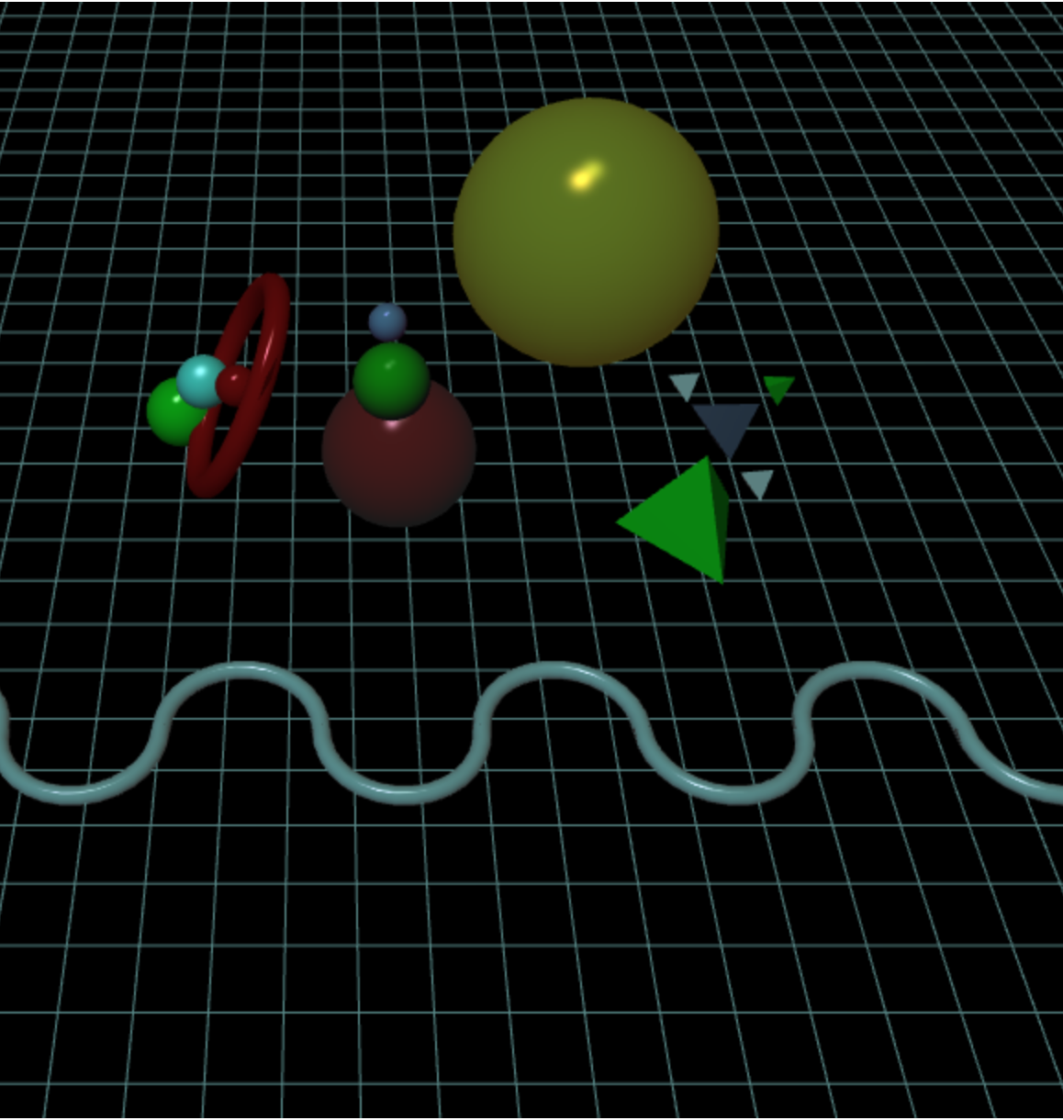

F4

F5: turn off the head light

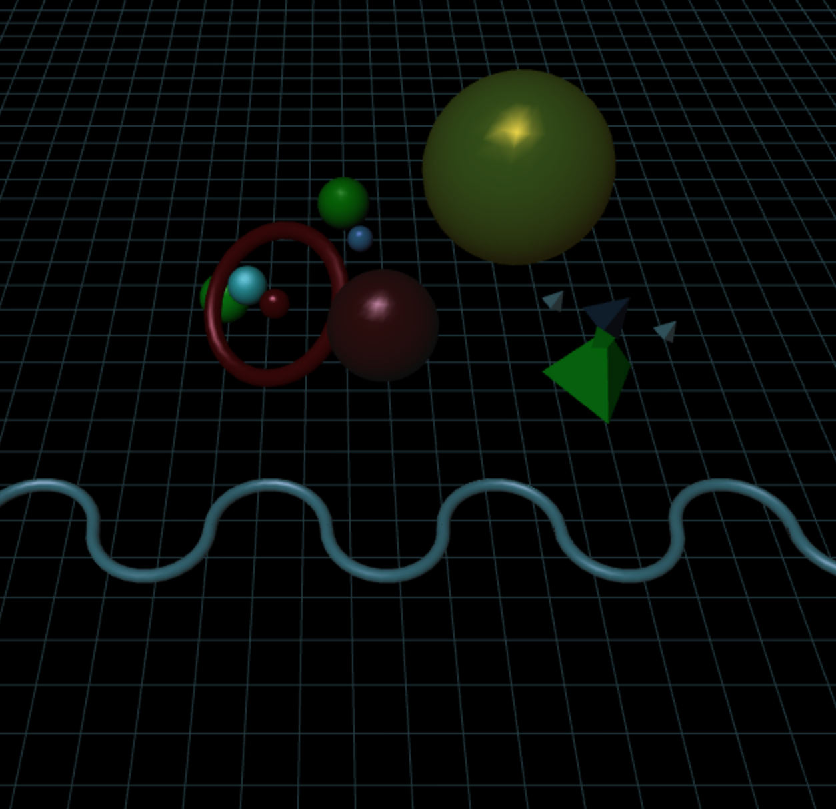

F5

F6: turn off the world light

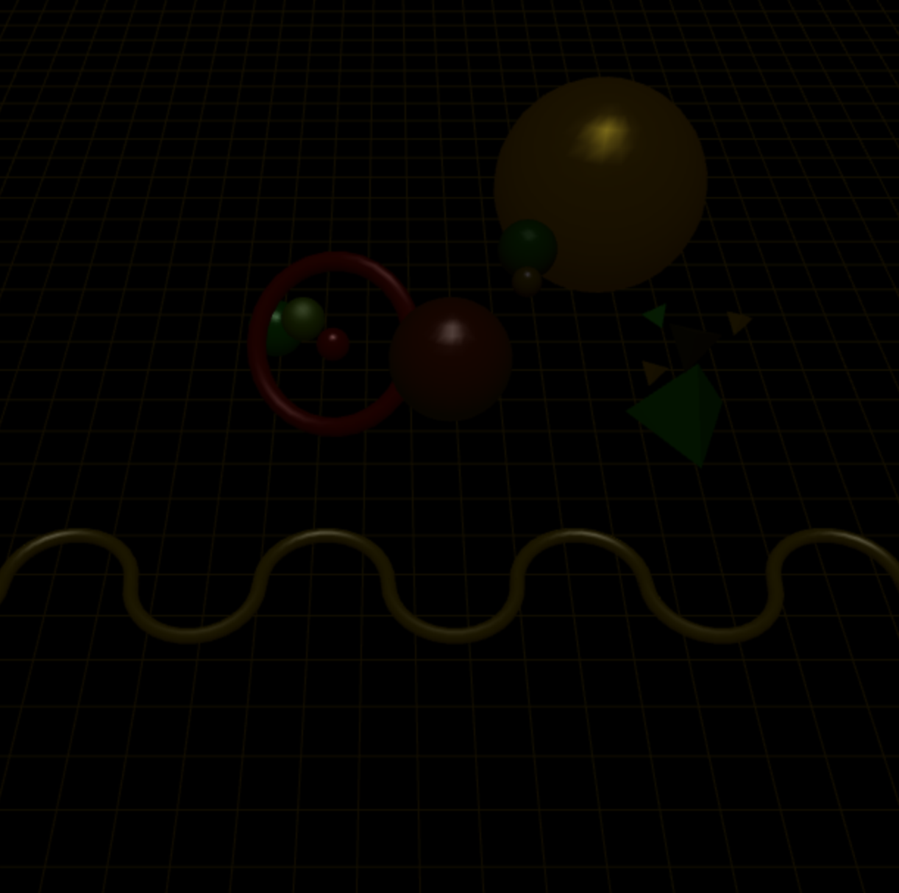

F6

**Scene Graph:**

