# Arduino Based Black Line Follower Robot

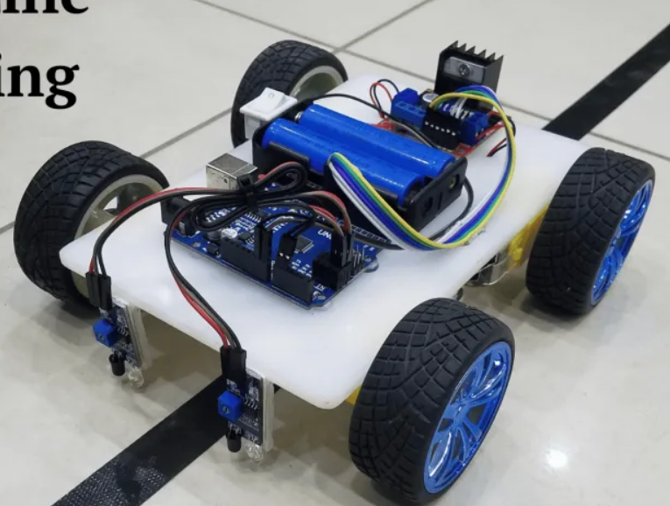

## Introduction

An interesting project that incorporates robotics, electronics, and programming is building a line follower robot. We’ll walk you through the process of creating your very own black line follower robot on an Arduino platform in this blog article. This project is a fantastic chance to practice your programming abilities in a real-world scenario, in addition to learning a lot about robotics. Now let’s dig in and discover the intriguing realm of robots that follow lines!

## Components Required

* **5mm Acrylic Sheet (20cm x 12cm) / 5mm Chases sheet**
* [**DC Gear Motor x 4**](https://marobotic.com/product/dc-gear-motor-6v-tt-yellow-gear-motor-double-shaft/) **/ 2x**
* **Front wheel 1x if 2wheels robot**
* [**Arduino UNO**](https://marobotic.com/product/arduino-uno-r3-dip-board-with-usb-cable/)
* [**IR Sensor x 2**](https://marobotic.com/product/infrared-ir-flame-sensor-module/)
* [**L298 Motor Driver**](https://marobotic.com/product/l298-motor-driver-dual-h-bridge/)
* [**Smart Robot Car Tyers Wheels**](https://marobotic.com/product/4pcs-smart-robot-car-tyres-wheels/) **x2**
* [**Male to Female Jumper Wires**](https://marobotic.com/product/male-to-female-jumper-wires-10cm/) **30x**
* [**On/Off Switch**](https://marobotic.com/product/2-pin-on-off-switch/)
* [**18650 Battery Holder – 2 Cell**](https://marobotic.com/product/18650-battery-holder-2-cell/)
* [**18650 Battery Cell 3.7V x 2**](https://marobotic.com/product/18650-battery-cell-3-7v/)

## Circuit Diagram

Knowing how the parts fit together is crucial before beginning the assembling process. A condensed circuit diagram that shows how each component works together is shown below. To guarantee correct operation, carefully follow this diagram. In this circuit diagram, an Arduino UNO is used as a microcontroller. A L293D motor driver is used that drives four dc motors. Two IR sensors are used to detect any obstacle on the way. Two cells of 3.7 volts are used as a power source. A power on/off switch is used. Output of the IR sensors are connected to A0 and A1 pin of the Arduino UNO.

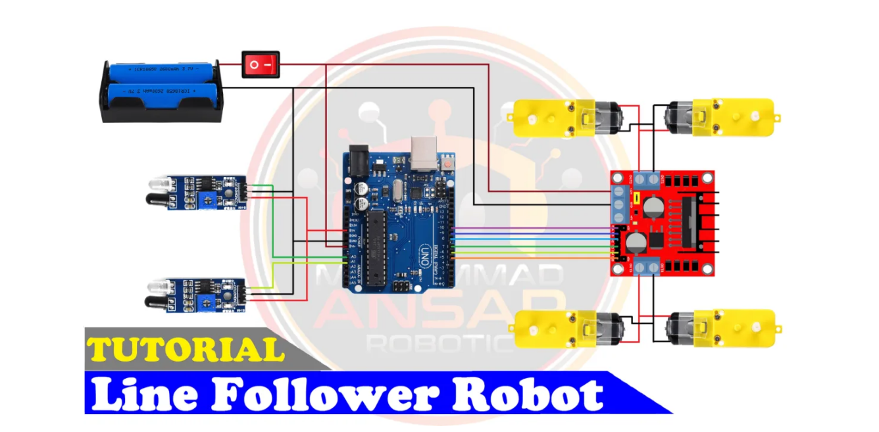

## Arduino IDE Code

**Filename: LineFollowerRobot.ino**

**#define enA 10 // Enable1 L298 Pin enA**

**#define in1 9 // Motor1 L298 Pin in1**

**#define in2 8 // Motor1 L298 Pin in2**

**#define in3 7 // Motor2 L298 Pin in3**

**#define in4 6 // Motor2 L298 Pin in4**

**#define enB 5 // Enable2 L298 Pin enB**

**#define R_S A0 // IR sensor Right**

**#define L_S A1 // IR sensor Left**

**void setup() {**

**// Initialize pins**

**pinMode(R_S, INPUT); // Declare IR sensor as input**

**pinMode(L_S, INPUT); // Declare IR sensor as input**

**pinMode(enA, OUTPUT); // Declare as output for L298 Pin enA**

**pinMode(in1, OUTPUT); // Declare as output for L298 Pin in1**

**pinMode(in2, OUTPUT); // Declare as output for L298 Pin in2**

**pinMode(in3, OUTPUT); // Declare as output for L298 Pin in3**

**pinMode(in4, OUTPUT); // Declare as output for L298 Pin in4**

**pinMode(enB, OUTPUT); // Declare as output for L298 Pin enB**

**// Set motor speeds**

**analogWrite(enA, 150); // Set speed for Motor1**

**analogWrite(enB, 150); // Set speed for Motor2**

**delay(1000); // Short delay before entering main loop**

**}**

**void loop() {**

**// Check IR sensor readings and perform corresponding actions**

**if ((digitalRead(R_S) == 0) && (digitalRead(L_S) == 0)) {**

**forward(); // Both sensors detect white, move forward**

**} else if ((digitalRead(R_S) == 1) && (digitalRead(L_S) == 0)) {**

**turnRight(); // Right sensor detects black, turn right**

**} else if ((digitalRead(R_S) == 0) && (digitalRead(L_S) == 1)) {**

**turnLeft(); // Left sensor detects black, turn left**

**} else if ((digitalRead(R_S) == 1) && (digitalRead(L_S) == 1)) {**

**stopMotors(); // Both sensors detect black, stop**

**}**

**}**

**void forward() {**

**// Move forward**

**digitalWrite(in1, HIGH);**

**digitalWrite(in2, LOW);**

**digitalWrite(in3, LOW);**

**digitalWrite(in4, HIGH);**

**}**

**void turnRight() {**

**// Turn right**

**digitalWrite(in1, LOW);**

**digitalWrite(in2, HIGH);**

**digitalWrite(in3, LOW);**

**digitalWrite(in4, HIGH);**

**}**

**void turnLeft() {**

**// Turn left**

**digitalWrite(in1, HIGH);**

**digitalWrite(in2, LOW);**

**digitalWrite(in3, HIGH);**

**digitalWrite(in4, LOW);**

**}**

**void stopMotors() {**

**// Stop motors**

**digitalWrite(in1, LOW);**

**digitalWrite(in2, LOW);**

**digitalWrite(in3, LOW);**

**digitalWrite(in4, LOW);**

**}**

## Explanation

These lines define symbolic names for different pins and sensors using #define. In Arduino programming, this is a standard procedure to improve readability and maintainability of the code. To operate the motors, the digital pins linked to the L298 motor driver are named enA, in1, in2, in3, in4, and enB. The left and right infrared (IR) sensors are attached to analog pins denoted as L_S and R_S, respectively. The pinMode parameter in the setup() method determines whether the IR sensor pins are inputs or outputs. The motor speeds are set using analogWrite. The numbers go from 0 to 255, where 255 represents maximum speed and 0 represents off. To give the motors time to stabilize, a delay is inserted. The software uses digitalRead in the loop() method to determine the current statuses of the left (L_S) and right (R_S) infrared sensors. The robot’s movement is controlled by invoking the relevant function (forword(), turnRight(), turnLeft(), or Stop()) based on the sensor data. Based on the sensor data, these routines (forword(), turnRight(), turnLeft(), and Stop()) regulate the robot’s movement. They identify each motor’s orientation by applying the proper blends of high and low signals to the motor driver pins.

## Hardware Testing

It’s time to test your line follower robot now that the circuit is put together and the programming has been uploaded. Turn it on, place it on a track with a black line, and watch it follow the course. You can modify the code or look for any faults in the circuit if necessary.

Conclusion

This project lays the groundwork for future, more difficult projects in addition to being an enjoyable and instructive method to learn about robotics and programming. Try with various line-following algorithms, improve the layout, and expose your robot to new tasks. There are countless options!