Spacegrid

Software Development Document



An Object-Oriented Programming Project Presented to the Faculty of the College of Computer Studies
University of the Immaculate Conception Father Selga St., Davao City, Philippines

Team Members:

Christian Reynz P. Agosto
Kit Jasper M. Caballero
Ethan Gabriele E. Delos Santos
Jun Mari S. Manla

OCTOBER 2026

Software Purpose

Project: "Space Grid"

Purpose:

SpaceGrid is a property rental management system for landlords and renters in Davao City. Landlords record their properties, plot each property on a grid, and assign the spots on that grid to rentable units and to shared or decorative areas such as walkways, grass, bathrooms and kitchens. Walls are drawn automatically between spaces, and doors and windows can be added by hand. Landlords create and manage lease contracts for their units, while renters see the current status of their own leases and pay their monthly rent through the application.
The project started as a Java Swing desktop application. It is being converted into a web application with an HTML, CSS and JavaScript frontend, while the backend stays in Java (Spring Boot) and the data stays in a MySQL database.

Key Value:

- For landowners (space owners) : Properties, units, floor layouts and leases are kept in one place, with lease states such as "Expiring soon" and "Expired" highlighted.

- For renters (tenants): A clear view of their lease, the days remaining, a month-by-month rent statement, and in-app rent payment.

- For Accuracy: Business rules are checked in the Java code and enforced again by the database (for example, one active lease per unit and no month paid twice).

Objectives, Features, and Modules

2.1 Core Objectives:

- [ ] Convert the existing Java Swing application into a web application with an HTML/CSS/JavaScript frontend and a Java Spring Boot backend, keeping Java and MySQL.

- [ ] Let landlords plot each property on a grid and assign each spot to a rentable unit or a common area.

- [ ] Manage lease contracts with separate views and actions for landlords and renters.

- [ ] Store all data in a MySQL relational database with integrity rules enforced by the database.

- [ ] Demonstrate four core Object-Oriented Programming (OOP) principles: Encapsulation, Inheritance, Polymorphism, and Abstraction

2.2 Key Features:

- ✅ User Authentication: Register and log in as a Landlord or Renter; passwords hashed with BCrypt; session-based login.

- ✅Property Management: Add, edit, search and filter properties by type (Apartment, Condominium, Townhouse, Commercial, Night Market, Open Space); statuses Draft, Active, Archived.

- ✅ Grid Plotting: Resize a property grid (up to 60 × 60), place rentable units and common areas (Walkway, Grass, Bathroom, Kitchen, Laundry, Lobby, Parking, Stairs) by clicking or dragging across spots.

- ✅ Customizable Look: Every zone type and status has a default color and a CSS class, so its design can be changed in CSS.

- ✅ Unit Management: Add and edit units, set utilities and rental rate, mark Under Maintenance, archive units with lease history, delete units that were never leased.

- ✅ Lease Management: Create, end, terminate and renew leases. Lease terms cannot be edited; changes are made by ending the lease and creating a new one, or by renewing it.

- ✅ Lease Status: Calculated states (Upcoming, Active, Expiring soon, Expired, Ended, Terminated, Renewed) shown to both landlords and renters.

- ✅Rent Payments: Month-by-month statement (Upcoming, Due, Overdue, Paid), paying ahead, simulated GCash, Maya and Card payments, and payment history.
✅ Public Homepage: Anyone can browse the spaces that have free units (search, filters, sorting, saved spaces and a layout preview of each property) without logging in.
✅ Lease Requests: A logged-in renter asks for an available unit from the homepage; the landlord approves or declines the request, and the renter follows the answer under My Requests. Approving a request does not create the lease: the landlord creates it afterwards in the lease form.

2.3 System Modules (OOP Structure):

```
SpaceGridApplication (Entry Point, Spring Boot)
├── controller (9): Auth, Browse, Property, RentableUnit,
│ CommonArea, File, Lease, LeaseRequest, Payment
├── service (9): Auth, Property, RentableUnit, CommonArea,
│ Lease, LeaseRequest, Payment, File, LeaseExpiryJob
├── dao (9): CrudDao<T> + 8 DAO interfaces
│ └── jdbc (8): JdbcTemplate implementation of each DAO
├── model (37)
│ ├── BaseEntity (abstract)
│ │ ├── User
│ │ ├── Property (owns its zones and the grid rules)
│ │ ├── GridZone (abstract)
│ │ │ ├── RentableUnit
│ │ │ └── CommonArea
│ │ ├── LeaseContract, LeaseRequest, Payment, StoredFile
│ ├── Value objects (11): Dimensions, Amenities, GridPosition,
│ │ GridEdge, RentDue, PaymentResult, PropertyListing,
│ │ UnitListing, GridPreview, UnitDetails, UnitRemovalCheck
│ └── Enums (16): Role, PropertyType, PropertyStatus, UnitStatus,
│ CommonAreaType, LeaseStatus, LeaseState, PaymentStatus,
│ PaymentMethod, PaymentTerms, DueStatus, RequestStatus,
│ FileKind, Side, Orientation, EdgeType
├── security: PasswordHasher, BCryptPasswordHasher, SessionManager
├── payment: PaymentGateway, FakePaymentGateway
├── exception: SpaceGridException (abstract) + 5 subclasses,
│ GlobalExceptionHandler
├── config: WebConfig (page routes such as /, /login, /requests)
└── static: HTML, CSS and JavaScript pages (View Layer)
86 classes, interfaces, enums and records in 10 packages

Technology Used

Core Technologies:
- Programming Language: Java (developed with JDK 22, compiled for Java 17)
- Backend Framework: Spring Boot 4.1.1 (Spring Web MVC for the REST API, JdbcTemplate for database access)
- Frontend: HTML, CSS and JavaScript (served by Spring Boot; pages call the API with fetch)
- Database: MySQL through XAMPP (MariaDB) with JDBC
- Build Tool: Apache Maven

Development Tools:
- IDE: Apache Netbeans IDE latest version
- Version Control: Git with GitHub repository
- Database Tools: XAMPP (database server) and MySQL Workbench
- Documentation: Docs or Docx
- Diagrams: draw.io (UML class diagram and ERD)
- Testing: JUnit 5 (through spring-boot-starter-test)

Dependencies:
- spring-boot-starter-webmvc: controllers, embedded web server, JSON (Jackson)
- spring-boot-starter-jdbc: JdbcTemplate, transactions, HikariCP connection pool
- mysql-connector-j: MySQL JDBC driver (version managed by Spring Boot)
- jb crypt 0.4: password hashing
- spring-boot-devtools: automatic restart during development
- spring-boot-starter-test: JUnit 5, AssertJ, Mockito (for testing)

User Manual

4.1 Installation & Startup:
1. Open the XAMPP Control Panel and start MySQL.
2. First time only: in MySQL Workbench, open database/spacegrid_db.sql and execute it. This creates the spacegrid_db database with sample data.
3. Run the project in NetBeans (Run Project) or with ‘mvn’ spring-boot:run.
4. Open a web browser and go to http://localhost:8080/.

Sample accounts (password for all: password123): landlords maria.santos and jose.reyes; renters ana.cruz, paolo.garcia and liza.mendoza.

4.2 First-Time Setup:
A step-by-step explanation per function, with system walkthrough and feature guide

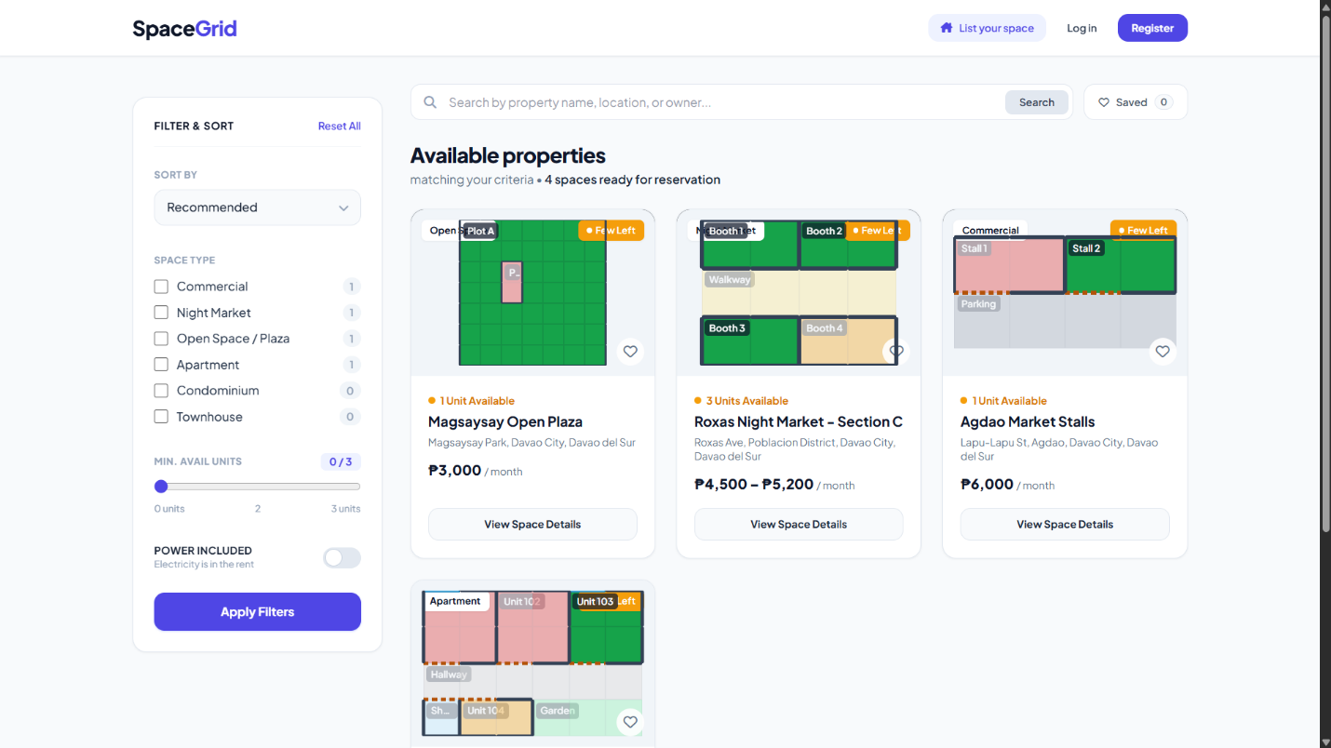
Homepage, Login and registration
- The first page of the application, with buttons to log in or to register.
- New users create an account by entering a username, password and full name, and choosing their role: Landlord or Renter.
- Usernames must be unique and passwords must be at least 8 characters long.
- Existing users enter their username and password.
- After logging in, landlords are taken to the Landlord Dashboard and renters to the Renter Dashboard.

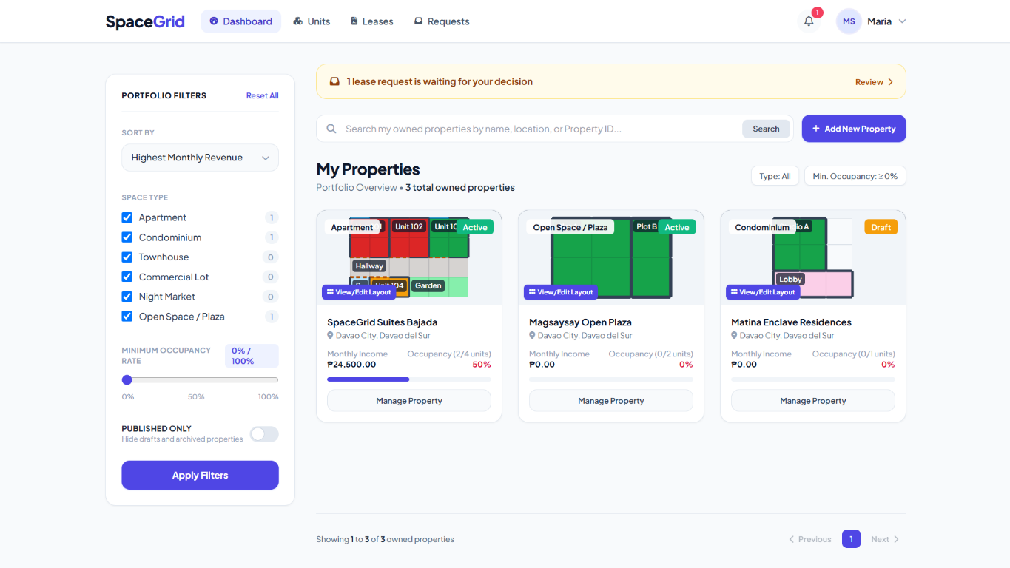
Landlord Dashboard
- Shows the landlord's properties as cards, with a search box, a property type filter and an "Add Property" button.

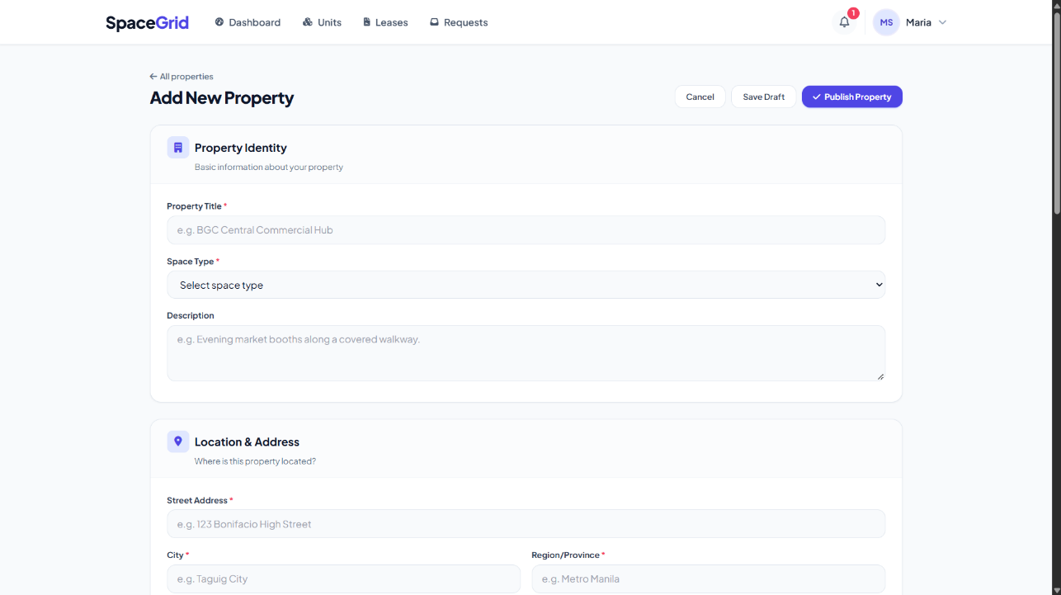
Add and Edit Property
- The landlord enters the property's name, address, type, description and size (an exact area in square meters, or a description when the size is not exact).
- A new property starts as a Draft and can be published (Active) or archived.

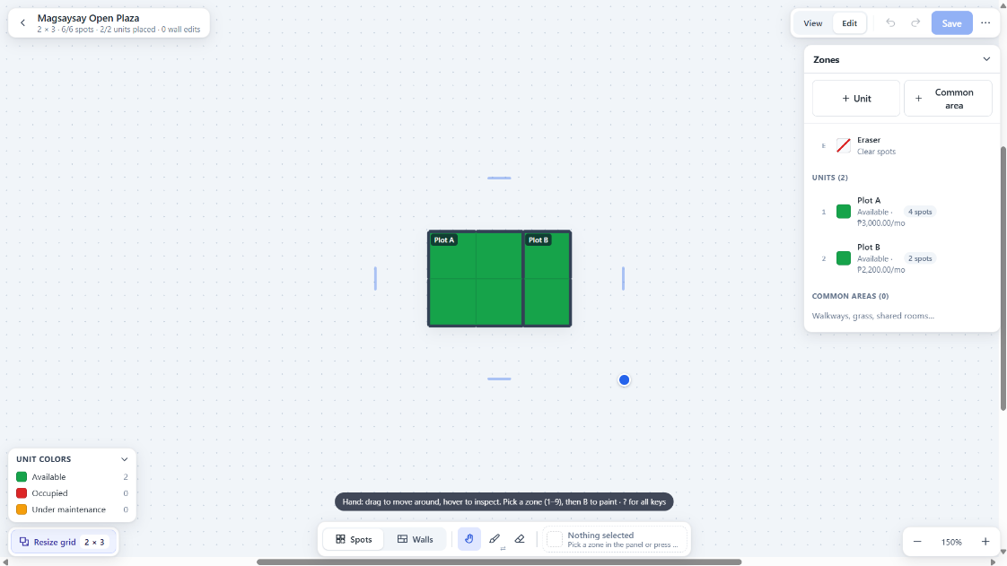
Property Grid
- The landlord sets the grid size (rows and columns, up to 60 × 60).
- The landlord picks a unit or a common area from the side panel, then clicks or drags across spots to place it. A spot belongs to only one zone; the eraser clears spots.
- Walls appear automatically between different spaces. The landlord can change any edge to a wall, door, window or opening, or reset it back to automatic.
- New units and common areas can be added from the same page. Changes are saved with the "Save layout" button.

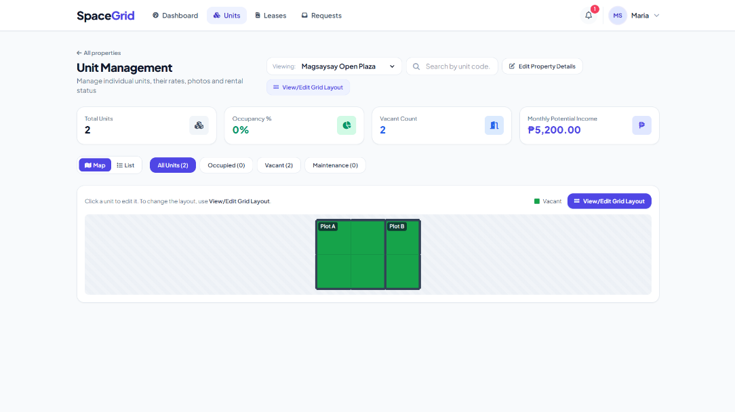
Units
- Lists the units of a property, where the landlord can add and edit units (name, rental rate, size, included electricity and water) and mark a unit as Under Maintenance.
- A unit that has been leased before is archived instead of deleted, so its lease and payment history is kept. Archived units are removed from the grid and shown under an "Archived" filter.

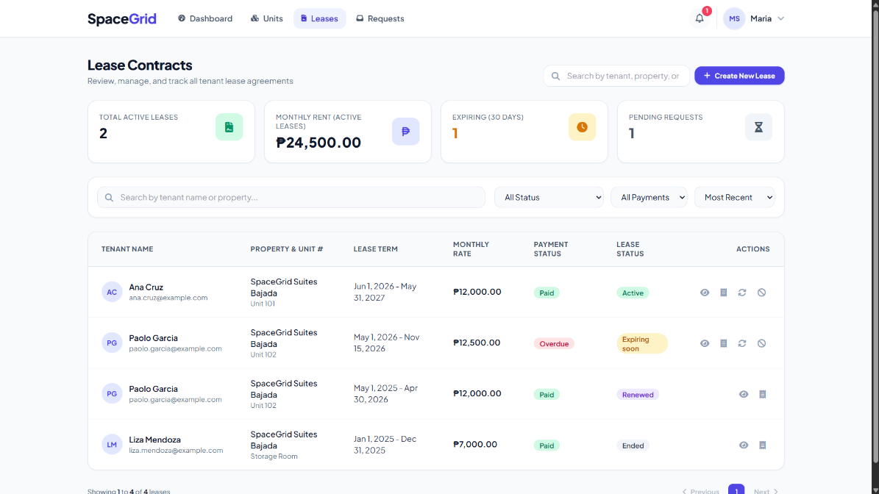
Lease (Landlord)
- Lists all leases on the landlord's properties with their current state. Leases that are Expiring soon (30 days or fewer left) or Expired are highlighted.

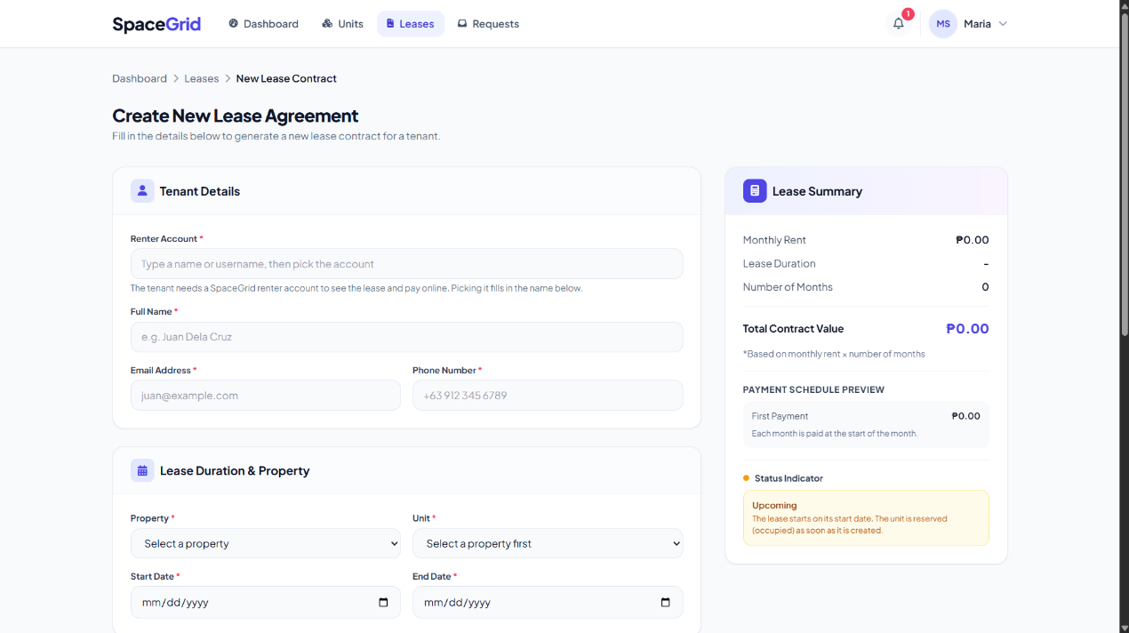
Create and Renew Lease
- To create a lease, the landlord chooses an available unit, enters the renter's username, the start and end dates and the monthly rent. The unit becomes Occupied.
- Lease terms cannot be edited. To change them, the landlord ends or terminates the lease and creates a new one, or uses Renew, which closes the current lease and creates the new one in one step, linked to the old lease.

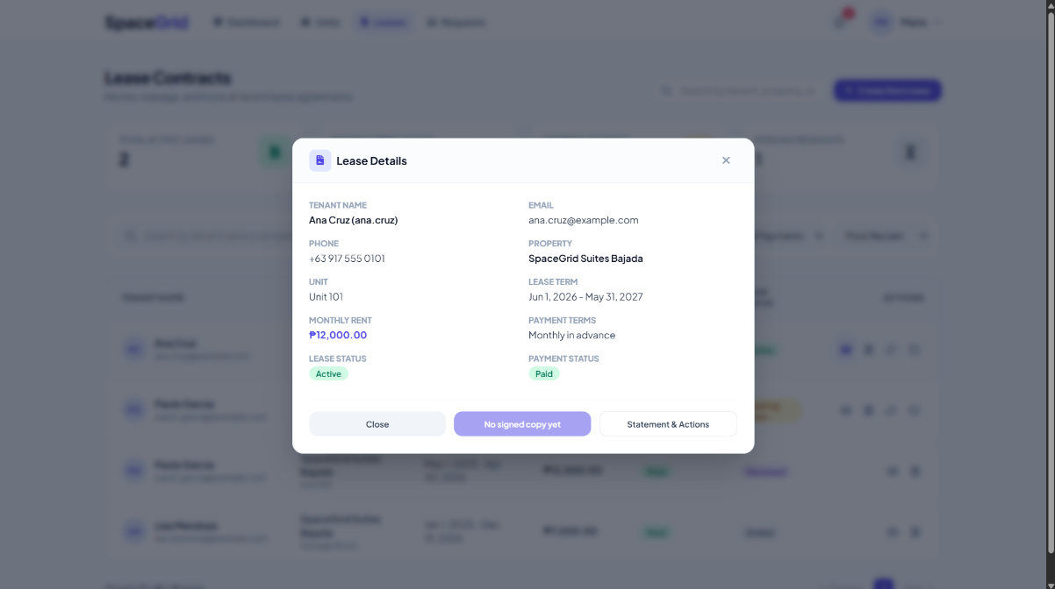
Lease Details

Shows the lease, the unit's location on the property grid, the rent statement and the payment history.

Landlords can End, Terminate or Renew the lease. Renters see their days remaining and a "Pay" button on months that can be paid
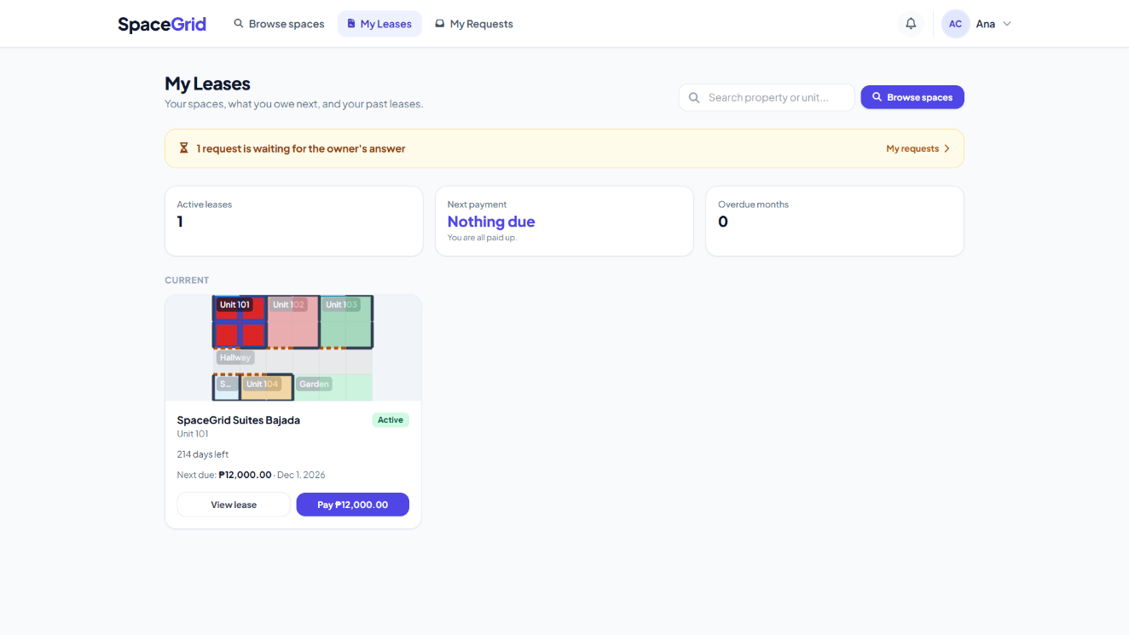

Renter Dashboard

Shows the renter's own leases, the days remaining and the next amount due.

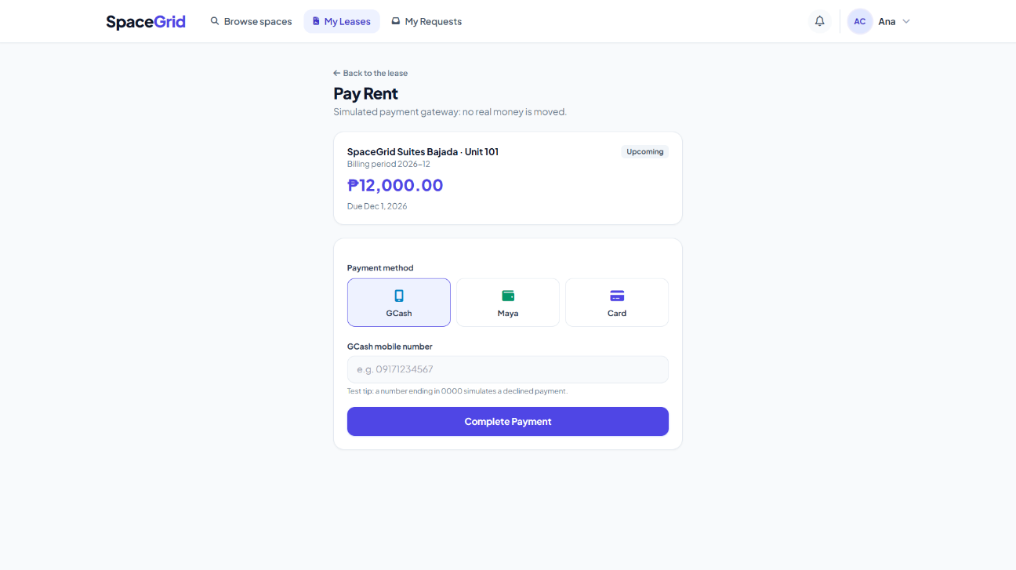

Paying Rent

The renter chooses a payment method (GCash, Maya or Card) and enters an account number. Months are paid in order, oldest unpaid first, and future months can be paid ahead.

Payments are simulated: every payment is approved except account numbers ending in 0000, which are declined to demonstrate a failed payment. A declined payment can be retried.

Technical Manual

5.1 Development Environment Setup:

- Operating system: Windows 10+
- JDK version: Java 17 or newer (develop with JDK 22)
- Database user: root, no password (XAMPP default)
- Xampp : default port 3306
- Build System: Apache Maven 3.10

5.2 Database Schema(SQL Creation Script):

DROP DATABASE IF EXISTS spacegrid_db;
CREATE DATABASE spacegrid_db CHARACTER SET utf8mb4 COLLATE
utf8mb4_unicode_ci;
USE spacegrid_db;

-- 1. users (Java: User)
CREATE TABLE users (
id INT NOT NULL AUTO_INCREMENT,
username VARCHAR(50) NOT NULL,
password_hash CHAR(60) NOT NULL,
full_name VARCHAR(100) NOT NULL,
email VARCHAR(100) NULL,
phone VARCHAR(30) NULL,
role VARCHAR(20) NOT NULL,
created_at DATETIME NOT NULL DEFAULT CURRENT_TIMESTAMP,
CONSTRAINT pk_users PRIMARY KEY (id),
CONSTRAINT uq_users_username UNIQUE (username),
CONSTRAINT ck_users_role CHECK (role IN ('LANDLORD', 'RENTER'))
) ENGINE = InnoDB;

-- 2. properties (Java: Property; size columns = Dimensions value object)
CREATE TABLE properties (
id INT NOT NULL AUTO_INCREMENT,
landlord_id INT NOT NULL,
name VARCHAR(100) NOT NULL,
address VARCHAR(255) NOT NULL,
city VARCHAR(100) NOT NULL,
region VARCHAR(100) NOT NULL,
property_type VARCHAR(20) NOT NULL,
description TEXT NULL,
is_exact_size BOOLEAN NULL,
size_description VARCHAR(100) NULL,
area_sqm DECIMAL(10,2) NULL,
default_rate DECIMAL(10,2) NULL,
has_parking BOOLEAN NOT NULL DEFAULT FALSE,
has_power_backup BOOLEAN NOT NULL DEFAULT FALSE,
has_security BOOLEAN NOT NULL DEFAULT FALSE,
has_water_access BOOLEAN NOT NULL DEFAULT FALSE,
is_open_24h BOOLEAN NOT NULL DEFAULT FALSE,
status VARCHAR(20) NOT NULL DEFAULT 'DRAFT',
grid_rows TINYINT NOT NULL DEFAULT 1,
grid_columns TINYINT NOT NULL DEFAULT 1,
created_at DATETIME NOT NULL DEFAULT CURRENT_TIMESTAMP,
CONSTRAINT pk_properties PRIMARY KEY (id),
CONSTRAINT fk_properties_landlord FOREIGN KEY (landlord_id) REFERENCES
users (id)
ON DELETE RESTRICT ON UPDATE RESTRICT,
CONSTRAINT ck_properties_type CHECK (property_type IN ('APARTMENT',
'CONDOMINIUM', 'TOWNHOUSE', 'COMMERCIAL', 'NIGHT_MARKET',
'OPEN_SPACE')),
CONSTRAINT ck_properties_status CHECK (status IN ('DRAFT', 'ACTIVE',
'ARCHIVED')),
CONSTRAINT ck_properties_rate CHECK (default_rate IS NULL OR
default_rate >= 0),
CONSTRAINT ck_properties_rows CHECK (grid_rows BETWEEN 1 AND 60),
CONSTRAINT ck_properties_cols CHECK (grid_columns BETWEEN 1 AND 60),
CONSTRAINT ck_properties_size CHECK (
is_exact_size IS NULL
OR (is_exact_size = TRUE AND area_sqm IS NOT NULL AND area_sqm >
0)
OR (is_exact_size = FALSE AND size_description IS NOT NULL))
) ENGINE = InnoDB;

-- 3. grid_zones (Java: abstract GridZone - the shared part)
-- Inheritance, "class table" style: each zone has ONE extra row in
-- either
-- rentable_units (zone_kind = 'UNIT') or common_areas (zone_kind =
-- 'COMMON'),
-- with the same id.
CREATE TABLE grid_zones (
id INT NOT NULL AUTO_INCREMENT,
property_id INT NOT NULL,
zone_kind VARCHAR(10) NOT NULL,
name VARCHAR(100) NOT NULL,
created_at DATETIME NOT NULL DEFAULT CURRENT_TIMESTAMP,
CONSTRAINT pk_grid_zones PRIMARY KEY (id),
CONSTRAINT uq_grid_zones_id_property UNIQUE (id, property_id),
CONSTRAINT fk_grid_zones_property FOREIGN KEY (property_id) REFERENCES
properties (id)
ON DELETE CASCADE ON UPDATE RESTRICT,
CONSTRAINT ck_grid_zones_kind CHECK (zone_kind IN ('UNIT', 'COMMON'))
) ENGINE = InnoDB;

-- 4. rentable_units (Java: RentableUnit extends GridZone)
CREATE TABLE rentable_units (
zone_id INT NOT NULL,
rental_rate DECIMAL(10,2) NOT NULL,
is_exact_size BOOLEAN NULL,
size_description VARCHAR(100) NULL,
area_sqm DECIMAL(10,2) NULL,
includes_electricity BOOLEAN NOT NULL DEFAULT FALSE,
includes_water BOOLEAN NOT NULL DEFAULT FALSE,
status VARCHAR(20) NOT NULL DEFAULT 'AVAILABLE',
CONSTRAINT pk_rentable_units PRIMARY KEY (zone_id),
CONSTRAINT fk_rentable_units_zone FOREIGN KEY (zone_id) REFERENCES
grid_zones (id)
ON DELETE CASCADE ON UPDATE RESTRICT,
CONSTRAINT ck_rentable_units_rate CHECK (rental_rate >= 0),
CONSTRAINT ck_rentable_units_status CHECK (status IN ('AVAILABLE',
'OCCUPIED', 'UNDER_MAINTENANCE', 'ARCHIVED')),
CONSTRAINT ck_rentable_units_size CHECK (
is_exact_size IS NULL
OR (is_exact_size = TRUE AND area_sqm IS NOT NULL AND area_sqm >
0)
OR (is_exact_size = FALSE AND size_description IS NOT NULL))
) ENGINE = InnoDB;

-- 5. common_areas (Java: CommonArea extends GridZone)
CREATE TABLE common_areas (
zone_id INT NOT NULL,
area_type VARCHAR(20) NOT NULL,
color CHAR(7) NULL,
CONSTRAINT pk_common_areas PRIMARY KEY (zone_id),
CONSTRAINT fk_common_areas_zone FOREIGN KEY (zone_id) REFERENCES
grid_zones (id)
ON DELETE CASCADE ON UPDATE RESTRICT,
CONSTRAINT ck_common_areas_type CHECK (area_type IN
('WALKWAY', 'GRASS', 'BATHROOM', 'KITCHEN', 'LAUNDRY', 'LOBBY',
'PARKING', 'STAIRS')),
CONSTRAINT ck_common_areas_color CHECK (color IS NULL OR color REGEXP
'^#[0-9a-f]{6}$')
) ENGINE = InnoDB;

-- 6. zone_cells (Java: GridZone.positions - one row per GridPosition)
-- PK (property_id, row_idx, col_idx) = one zone per spot.
-- Composite FK = the zone must belong to the same property.
CREATE TABLE zone_cells (
property_id INT NOT NULL,
row_idx TINYINT NOT NULL,
col_idx TINYINT NOT NULL,
zone_id INT NOT NULL,
CONSTRAINT pk_zone_cells PRIMARY KEY (property_id, row_idx, col_idx),
CONSTRAINT fk_zone_cells_zone FOREIGN KEY (zone_id, property_id)
REFERENCES grid_zones (id, property_id)
ON DELETE CASCADE ON UPDATE RESTRICT,
CONSTRAINT ck_zone_cells_row CHECK (row_idx BETWEEN 0 AND 59),
CONSTRAINT ck_zone_cells_col CHECK (col_idx BETWEEN 0 AND 59)
) ENGINE = InnoDB;

-- 7. edge_overrides (Java: Property.edgeOverrides Map<GridEdge,
-- EdgeType>)
-- Only manual changes are stored; automatic walls are calculated in
-- Java.
-- HORIZONTAL (r, c) = line ABOVE spot (r, c) rows 0..60 (60 = bottom
-- border)
-- VERTICAL (r, c) = line LEFT OF spot (r, c) cols 0..60 (60 = right
-- border)
CREATE TABLE edge_overrides (
property_id INT NOT NULL,
row_idx TINYINT NOT NULL,
col_idx TINYINT NOT NULL,
orientation VARCHAR(10) NOT NULL,
edge_type VARCHAR(10) NOT NULL,
CONSTRAINT pk_edge_overrides PRIMARY KEY (property_id, row_idx,
col_idx, orientation),
CONSTRAINT fk_edge_overrides_property FOREIGN KEY (property_id)
REFERENCES properties (id)
ON DELETE CASCADE ON UPDATE RESTRICT,
CONSTRAINT ck_edge_overrides_row CHECK (row_idx BETWEEN 0 AND
60),
CONSTRAINT ck_edge_overrides_col CHECK (col_idx BETWEEN 0 AND
60),
CONSTRAINT ck_edge_overrides_orientation CHECK (orientation IN
('HORIZONTAL', 'VERTICAL')),
CONSTRAINT ck_edge_overrides_type CHECK (edge_type IN ('WALL',
'DOOR', 'WINDOW', 'OPEN'))
) ENGINE = InnoDB;

-- 8. lease_contracts (Java: LeaseContract)
-- active_unit_id is calculated by the database: it holds the unit id
-- only
-- while the lease is ACTIVE (otherwise NULL). Its UNIQUE rule
-- therefore
-- blocks two ACTIVE leases on the same unit (NULLs don't count as
-- duplicates).
CREATE TABLE lease_contracts (
id INT NOT NULL AUTO_INCREMENT,
rentable_unit_id INT NOT NULL,
renter_id INT NOT NULL,
previous_lease_id INT NULL,
start_date DATE NOT NULL,
end_date DATE NOT NULL,
monthly_rent DECIMAL(10,2) NOT NULL,
payment_terms VARCHAR(20) NOT NULL DEFAULT 'MONTHLY_ADVANCE',
tenant_name VARCHAR(100) NOT NULL,
tenant_email VARCHAR(100) NULL,
tenant_phone VARCHAR(30) NULL,
status VARCHAR(20) NOT NULL DEFAULT 'ACTIVE',
closed_on DATE NULL,
termination_reason VARCHAR(255) NULL,
released_on DATE NULL,
ended_automatically BOOLEAN NOT NULL DEFAULT FALSE,
created_at DATETIME NOT NULL DEFAULT CURRENT_TIMESTAMP,
active_unit_id INT AS (IF(status = 'ACTIVE', rentable_unit_id,
NULL)) STORED,
CONSTRAINT pk_lease_contracts PRIMARY KEY (id),
CONSTRAINT uq_lease_contracts_previous UNIQUE (previous_lease_id),
CONSTRAINT uq_lease_contracts_active_unit UNIQUE (active_unit_id),
CONSTRAINT fk_lease_contracts_unit FOREIGN KEY (rentable_unit_id)
REFERENCES rentable_units (zone_id)
ON DELETE RESTRICT ON UPDATE RESTRICT,
CONSTRAINT fk_lease_contracts_renter FOREIGN KEY (renter_id)
REFERENCES users (id)
ON DELETE RESTRICT ON UPDATE RESTRICT,
CONSTRAINT fk_lease_contracts_previous FOREIGN KEY (previous_lease_id)
REFERENCES lease_contracts (id)
ON DELETE RESTRICT ON UPDATE RESTRICT,
CONSTRAINT ck_lease_contracts_dates CHECK (end_date > start_date),
CONSTRAINT ck_lease_contracts_rent CHECK (monthly_rent >= 0),
CONSTRAINT ck_lease_contracts_status CHECK (status IN ('ACTIVE',
'ENDED', 'TERMINATED', 'RENEWED')),
CONSTRAINT ck_lease_contracts_terms CHECK (payment_terms IN
('MONTHLY_ADVANCE', 'MONTHLY_ARREARS', 'QUARTERLY_ADVANCE',
'SEMI_ANNUAL_ADVANCE', 'ANNUAL_ADVANCE')),
CONSTRAINT ck_lease_contracts_closed CHECK (
(status = 'ACTIVE' AND closed_on IS NULL) OR (status <> 'ACTIVE'
AND closed_on IS NOT NULL)),
CONSTRAINT ck_lease_contracts_reason CHECK (termination_reason IS NULL
OR status = 'TERMINATED'),
CONSTRAINT ck_lease_contracts_auto CHECK (ended_automatically =
FALSE OR status = 'ENDED'),
CONSTRAINT ck_lease_contracts_released CHECK (released_on IS NULL OR
status IN ('ENDED', 'TERMINATED'))
) ENGINE = InnoDB;

-- 9. payments (Java: Payment; billing_month = YearMonth stored as the
-- 1st of the month)
-- billing_month is the FIRST month of the period paid (one month, or 3
-- / 6 / 12 with
-- quarterly / semi-annual / annual payment terms); amount covers the
-- whole period.
-- paid_lease_id is calculated: the lease id only when status = 'PAID'.
-- UNIQUE (paid_lease_id, billing_month) blocks paying the same month
-- twice,
-- while FAILED / PENDING attempts can repeat.
CREATE TABLE payments (
id INT NOT NULL AUTO_INCREMENT,
lease_id INT NOT NULL,
renter_id INT NOT NULL,
billing_month DATE NOT NULL,
amount DECIMAL(10,2) NOT NULL,
method VARCHAR(10) NOT NULL,
status VARCHAR(10) NOT NULL DEFAULT 'PENDING',
reference_no VARCHAR(40) NULL,
paid_at DATETIME NULL,
created_at DATETIME NOT NULL DEFAULT CURRENT_TIMESTAMP,
paid_lease_id INT AS (IF(status = 'PAID', lease_id, NULL)) STORED,
CONSTRAINT pk_payments PRIMARY KEY (id),
CONSTRAINT uq_payments_reference UNIQUE (reference_no),
CONSTRAINT uq_payments_paid_month UNIQUE (paid_lease_id,
billing_month),
CONSTRAINT fk_payments_lease FOREIGN KEY (lease_id) REFERENCES
lease_contracts (id)
ON DELETE RESTRICT ON UPDATE RESTRICT,
CONSTRAINT fk_payments_renter FOREIGN KEY (renter_id) REFERENCES users
(id)
ON DELETE RESTRICT ON UPDATE RESTRICT,
CONSTRAINT ck_payments_month CHECK (DAYOFMONTH(billing_month) = 1),
CONSTRAINT ck_payments_amount CHECK (amount > 0),
CONSTRAINT ck_payments_method CHECK (method IN ('GCASH', 'MAYA',
'CARD')),
CONSTRAINT ck_payments_status CHECK (status IN ('PENDING', 'PAID',
'FAILED')),
CONSTRAINT ck_payments_paid CHECK (
(status = 'PAID' AND reference_no IS NOT NULL AND paid_at IS NOT
NULL) OR status <> 'PAID')
) ENGINE = InnoDB;

CREATE INDEX ix_payments_lease_month ON payments (lease_id,
billing_month);

-- 10. uploaded_files (Java: StoredFile) - photos, site plans and
-- contract PDFs.
-- The file itself is saved in the uploads/ folder
-- (spacegrid.upload-dir) under stored_name;
-- this row says what it belongs to. Exactly one owner column is set,
-- matching file_kind:
-- PROPERTY_PHOTO, SITE_PLAN -> property_id UNIT_PHOTO -> unit_id
-- CONTRACT -> lease_id
CREATE TABLE uploaded_files (
id INT NOT NULL AUTO_INCREMENT,
file_kind VARCHAR(20) NOT NULL,
property_id INT NULL,
unit_id INT NULL,
lease_id INT NULL,
file_name VARCHAR(255) NOT NULL,
stored_name VARCHAR(100) NOT NULL,
content_type VARCHAR(50) NOT NULL,
created_at DATETIME NOT NULL DEFAULT CURRENT_TIMESTAMP,
CONSTRAINT pk_uploaded_files PRIMARY KEY (id),
CONSTRAINT uq_uploaded_files_stored UNIQUE (stored_name),
CONSTRAINT fk_uploaded_files_property FOREIGN KEY (property_id)
REFERENCES properties (id)
ON DELETE CASCADE ON UPDATE RESTRICT,
CONSTRAINT fk_uploaded_files_unit FOREIGN KEY (unit_id) REFERENCES
rentable_units (zone_id)
ON DELETE CASCADE ON UPDATE RESTRICT,
CONSTRAINT fk_uploaded_files_lease FOREIGN KEY (lease_id) REFERENCES
lease_contracts (id)
ON DELETE CASCADE ON UPDATE RESTRICT,
CONSTRAINT ck_uploaded_files_kind CHECK (file_kind IN
('PROPERTY_PHOTO', 'SITE_PLAN', 'UNIT_PHOTO', 'CONTRACT')),
CONSTRAINT ck_uploaded_files_owner CHECK (
(file_kind IN ('PROPERTY_PHOTO', 'SITE_PLAN') AND property_id IS
NOT NULL AND unit_id IS NULL AND lease_id IS NULL)
OR (file_kind = 'UNIT_PHOTO' AND unit_id IS NOT NULL AND
property_id IS NULL AND lease_id IS NULL)
OR (file_kind = 'CONTRACT' AND lease_id IS NOT NULL AND
property_id IS NULL AND unit_id IS NULL))
) ENGINE = InnoDB;

-- View used by JdbcLeaseContractDao: lease + the display names
-- (LeaseContract.unitName / propertyName / renterName), the landlord id
-- and the unit's first photo.
CREATE VIEW lease_details AS
SELECT l.id, l.rentable_unit_id, l.renter_id, l.previous_lease_id,
l.start_date, l.end_date, l.monthly_rent, l.payment_terms,
l.tenant_name, l.tenant_email, l.tenant_phone,
l.status, l.closed_on, l.termination_reason,
l.ended_automatically, l.released_on, l.created_at,
z.name AS unit_name,
p.id AS property_id,
p.name AS property_name,
p.landlord_id AS landlord_id,
u.full_name AS renter_name,
u.username AS renter_username,
(SELECT MIN(f.id) FROM uploaded_files f
WHERE f.unit_id = l.rentable_unit_id AND f.file_kind =
'UNIT_PHOTO') AS unit_photo_id
FROM lease_contracts l
JOIN grid_zones z ON z.id = l.rentable_unit_id
JOIN properties p ON p.id = z.property_id
JOIN users u ON u.id = l.renter_id;

-- 11. lease_requests (Java: LeaseRequest) - a renter asks to lease an
-- AVAILABLE unit
-- found on the homepage; the landlord approves or declines it, then
-- creates the lease.
-- pending_key is calculated: it holds "unit-renter" only while the
-- request is PENDING,
-- so its UNIQUE rule blocks the same renter from having two open
-- requests on one unit.
CREATE TABLE lease_requests (
id INT NOT NULL AUTO_INCREMENT,
rentable_unit_id INT NULL,
unit_label VARCHAR(100) NOT NULL,
property_label VARCHAR(100) NOT NULL,
renter_id INT NOT NULL,
desired_start DATE NOT NULL,
months TINYINT NOT NULL,
message VARCHAR(500) NULL,
status VARCHAR(20) NOT NULL DEFAULT 'PENDING',
decided_at DATETIME NULL,
created_at DATETIME NOT NULL DEFAULT CURRENT_TIMESTAMP,
pending_key VARCHAR(30) AS (IF(status = 'PENDING',
CONCAT(rentable_unit_id, '-', renter_id), NULL)) STORED,
CONSTRAINT pk_lease_requests PRIMARY KEY (id),
CONSTRAINT uq_lease_requests_pending UNIQUE (pending_key),
-- Deleting a unit keeps its requests (they are declined first) so the
-- renter still sees what happened.
CONSTRAINT fk_lease_requests_unit FOREIGN KEY (rentable_unit_id)
REFERENCES rentable_units (zone_id)
ON DELETE SET NULL ON UPDATE RESTRICT,
CONSTRAINT fk_lease_requests_renter FOREIGN KEY (renter_id) REFERENCES
users (id)
ON DELETE RESTRICT ON UPDATE RESTRICT,
CONSTRAINT ck_lease_requests_months CHECK (months BETWEEN 1 AND 60),
CONSTRAINT ck_lease_requests_status CHECK (status IN ('PENDING',
'APPROVED', 'DECLINED', 'CANCELLED')),
CONSTRAINT ck_lease_requests_decided CHECK (
(status = 'PENDING' AND decided_at IS NULL) OR (status <>
'PENDING' AND decided_at IS NOT NULL))
) ENGINE = InnoDB;

-- View used by JdbcLeaseRequestDao: request + display names, the unit's
-- rate and the landlord id.
-- After the unit was deleted the names come from the labels saved with
-- the request, and rate/property/landlord are NULL.
CREATE VIEW lease_request_details AS
SELECT r.id, r.rentable_unit_id, r.renter_id, r.desired_start, r.months,
r.message,
r.status, r.decided_at, r.created_at,
COALESCE(z.name, r.unit_label) AS unit_name,
u.rental_rate AS rental_rate,
p.id AS property_id,
COALESCE(p.name, r.property_label) AS property_name,
p.landlord_id AS landlord_id,
usr.full_name AS renter_name
FROM lease_requests r
LEFT JOIN grid_zones z ON z.id = r.rentable_unit_id
LEFT JOIN rentable_units u ON u.zone_id = z.id
LEFT JOIN properties p ON p.id = z.property_id
JOIN users usr ON usr.id = r.renter_id;

5.3 Project Setup Instructions:

Step-by-Step Guide:

1. Open the project in NetBeans: File → Open Project → select the SpaceGrid folder. Right-click the project → Reload POM, then Build with Dependencies (downloads the libraries; needs internet the first time).

2. Create the database: start MySQL in XAMPP, then run database/spacegrid_db.sql in MySQL Workbench. The script drops and recreates spacegrid_db with sample data.

3. Check the database settings in src/main/resources/application.properties:

spring.application.name=SpaceGrid
server.port=8080
spring.datasource.url=jdbc:mysql://localhost:3306/spacegrid_db?serverTimezone=Asia/Manila&characterEncoding=UTF-8
spring.datasource.username=root
spring.datasource.password=
spring.sql.init.mode=never
server.servlet.session.timeout=30m
server.servlet.session.cookie.http-only=true
logging.level.com.techhub.spacegridapplication=DEBUG
spacegrid.upload-dir=uploads
spring.servlet.multipart.max-file-size=10MB
spring.servlet.multipart.max-request-size=10MB

4. Build the project: mvn clean package

5. Run the application (or use Run Project in NetBeans), then open http://localhost:8080/:

mvn spring-boot:run
# or run the packaged JAR
java -jar target/SpaceGridApplication-1.0-SNAPSHOT.jar

Project Development Phases:

Weekly Progress Snapshot:

- Week 1-2: Project Proposal, Requirements Analysis, and Specification

- Week 3-4: Planned the move from Java Swing to an HTML frontend with a Java Spring Boot backend and the existing MySQL database; mapped each Swing frame to an HTML page; built a first grid plotter prototype.

- Week 5-7: Redesigned the classes from scratch (64 classes) following OOP principles; produced the UML class diagram (Domain Model and Application Layers) and the class specification.

- Week 8-10: Designed the MySQL schema (9 tables and 1 view), wrote the SQL script with sample data, tested its rules on MariaDB, and produced the ERD.

- Week 11-12: Mapped the Spring Boot Maven file structure and created the pom.xml.
- Week 12-13 (additions of 2026-10-28 and 2026-10-29): added the public homepage and lease requests; connected the landlord pages to the API with property details, photo and file uploads, tenant contact details and payment terms; added the lease lifecycle rules (expired leases end automatically, a termination reason, move-out confirmation), contact details on accounts, a shared top bar with notifications, a printable lease agreement and layout previews. The final project has 86 classes, interfaces, enums and records, 11 database tables and 2 views.

- Week 13: Final System polishing and Manuscript Documentation

Limitations and Future Development

7.1 Current Limitations:

Technical Limitations:
- ❌ Simulated payments: FakePaymentGateway approves or declines payments without moving real money.
- ❌ Local setup: runs on the developer's computer with XAMPP (localhost).
- ❌ No e-mail or SMS: notifications exist only inside the application (the bell in the top bar).
- ❌ Database testing: the SQL script was tested on MariaDB; it was written for MySQL 8 but not run on it.
- ❌ Rules checked only in Java: a zone's type matching its detail table, and spots fitting inside the current grid size, are checked by the services, not by the database.
- ❌ Two-step save: saving a grid layout sends two requests (spots, then wall edits).

Functional Limitations:
- ❌ Lease terms cannot be edited; changes require ending the lease and creating a new one, or renewing it.
- ❌ Approving a lease request does not create the lease: the landlord creates it afterwards in the lease form.
- ❌ A renter who stays after the lease has ended is not modelled: the landlord confirms the move-out or creates a new lease.
- ❌ Grids are limited to 60 rows × 60 columns.
- ❌ Shared spaces (such as a shared bathroom) are not linked to the units that use them.
- ❌ Payment methods are limited to GCash, Maya and Card; months must be paid one at a time, oldest first.

7.2 Future Development Plan:

Short-term Enhancements (Next Version):
- [ ] Write the planned unit tests (SpaceGridApplicationTests, PropertyTest, LeaseContractTest).
- [ ] Commercial-ready flags and business / food permit uploads with manual landlord review (designed, not built yet).
- [ ] Test the database script on MySQL 8.

Long-term Roadmap:
- [ ] Connect a real payment provider (such as GCash or PayMongo) by adding a new PaymentGateway implementation.
- [ ] Notifications for lease changes, expiring leases and receiving payments.
- [ ] Link shared spaces to the units that use them.
- [ ] Additional pages, such as a landlord overview of all payments and a user profile page.

Technical Debt & Refactoring:
- [ ] Refractor persistence layer using Hibernate ORM for enhanced using management
- [ ] Implement dependency injection and comprehensive unit testing coverage using JUnit 5

Appendix

A. UML Package and Class Diagrams:
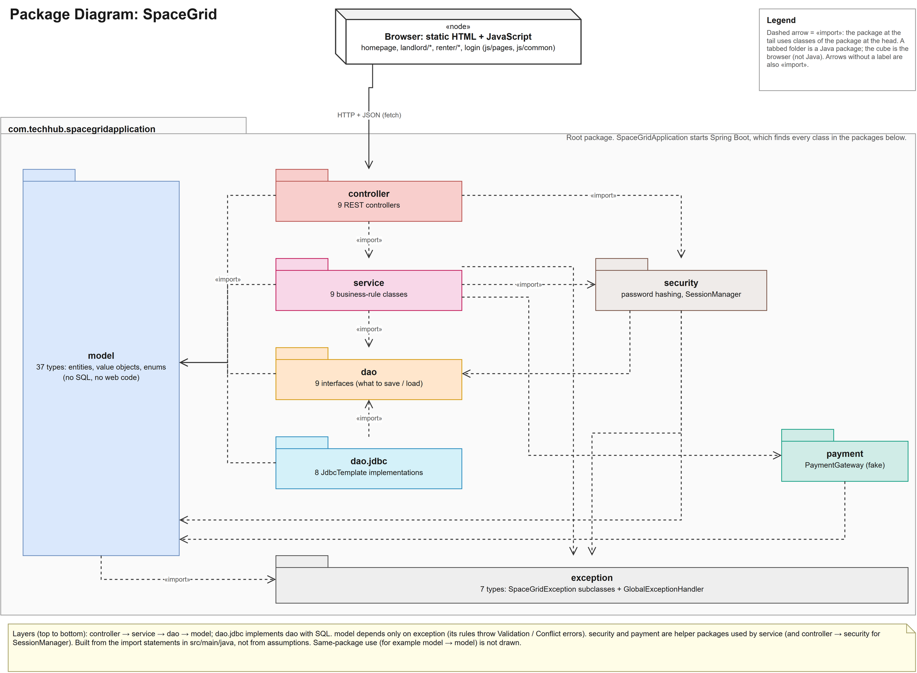
Figure A.1: Package diagram of SpaceGrid
The packages of com.techhub.spacegridapplication and the browser, with the imports between them (built from the Java import statements).
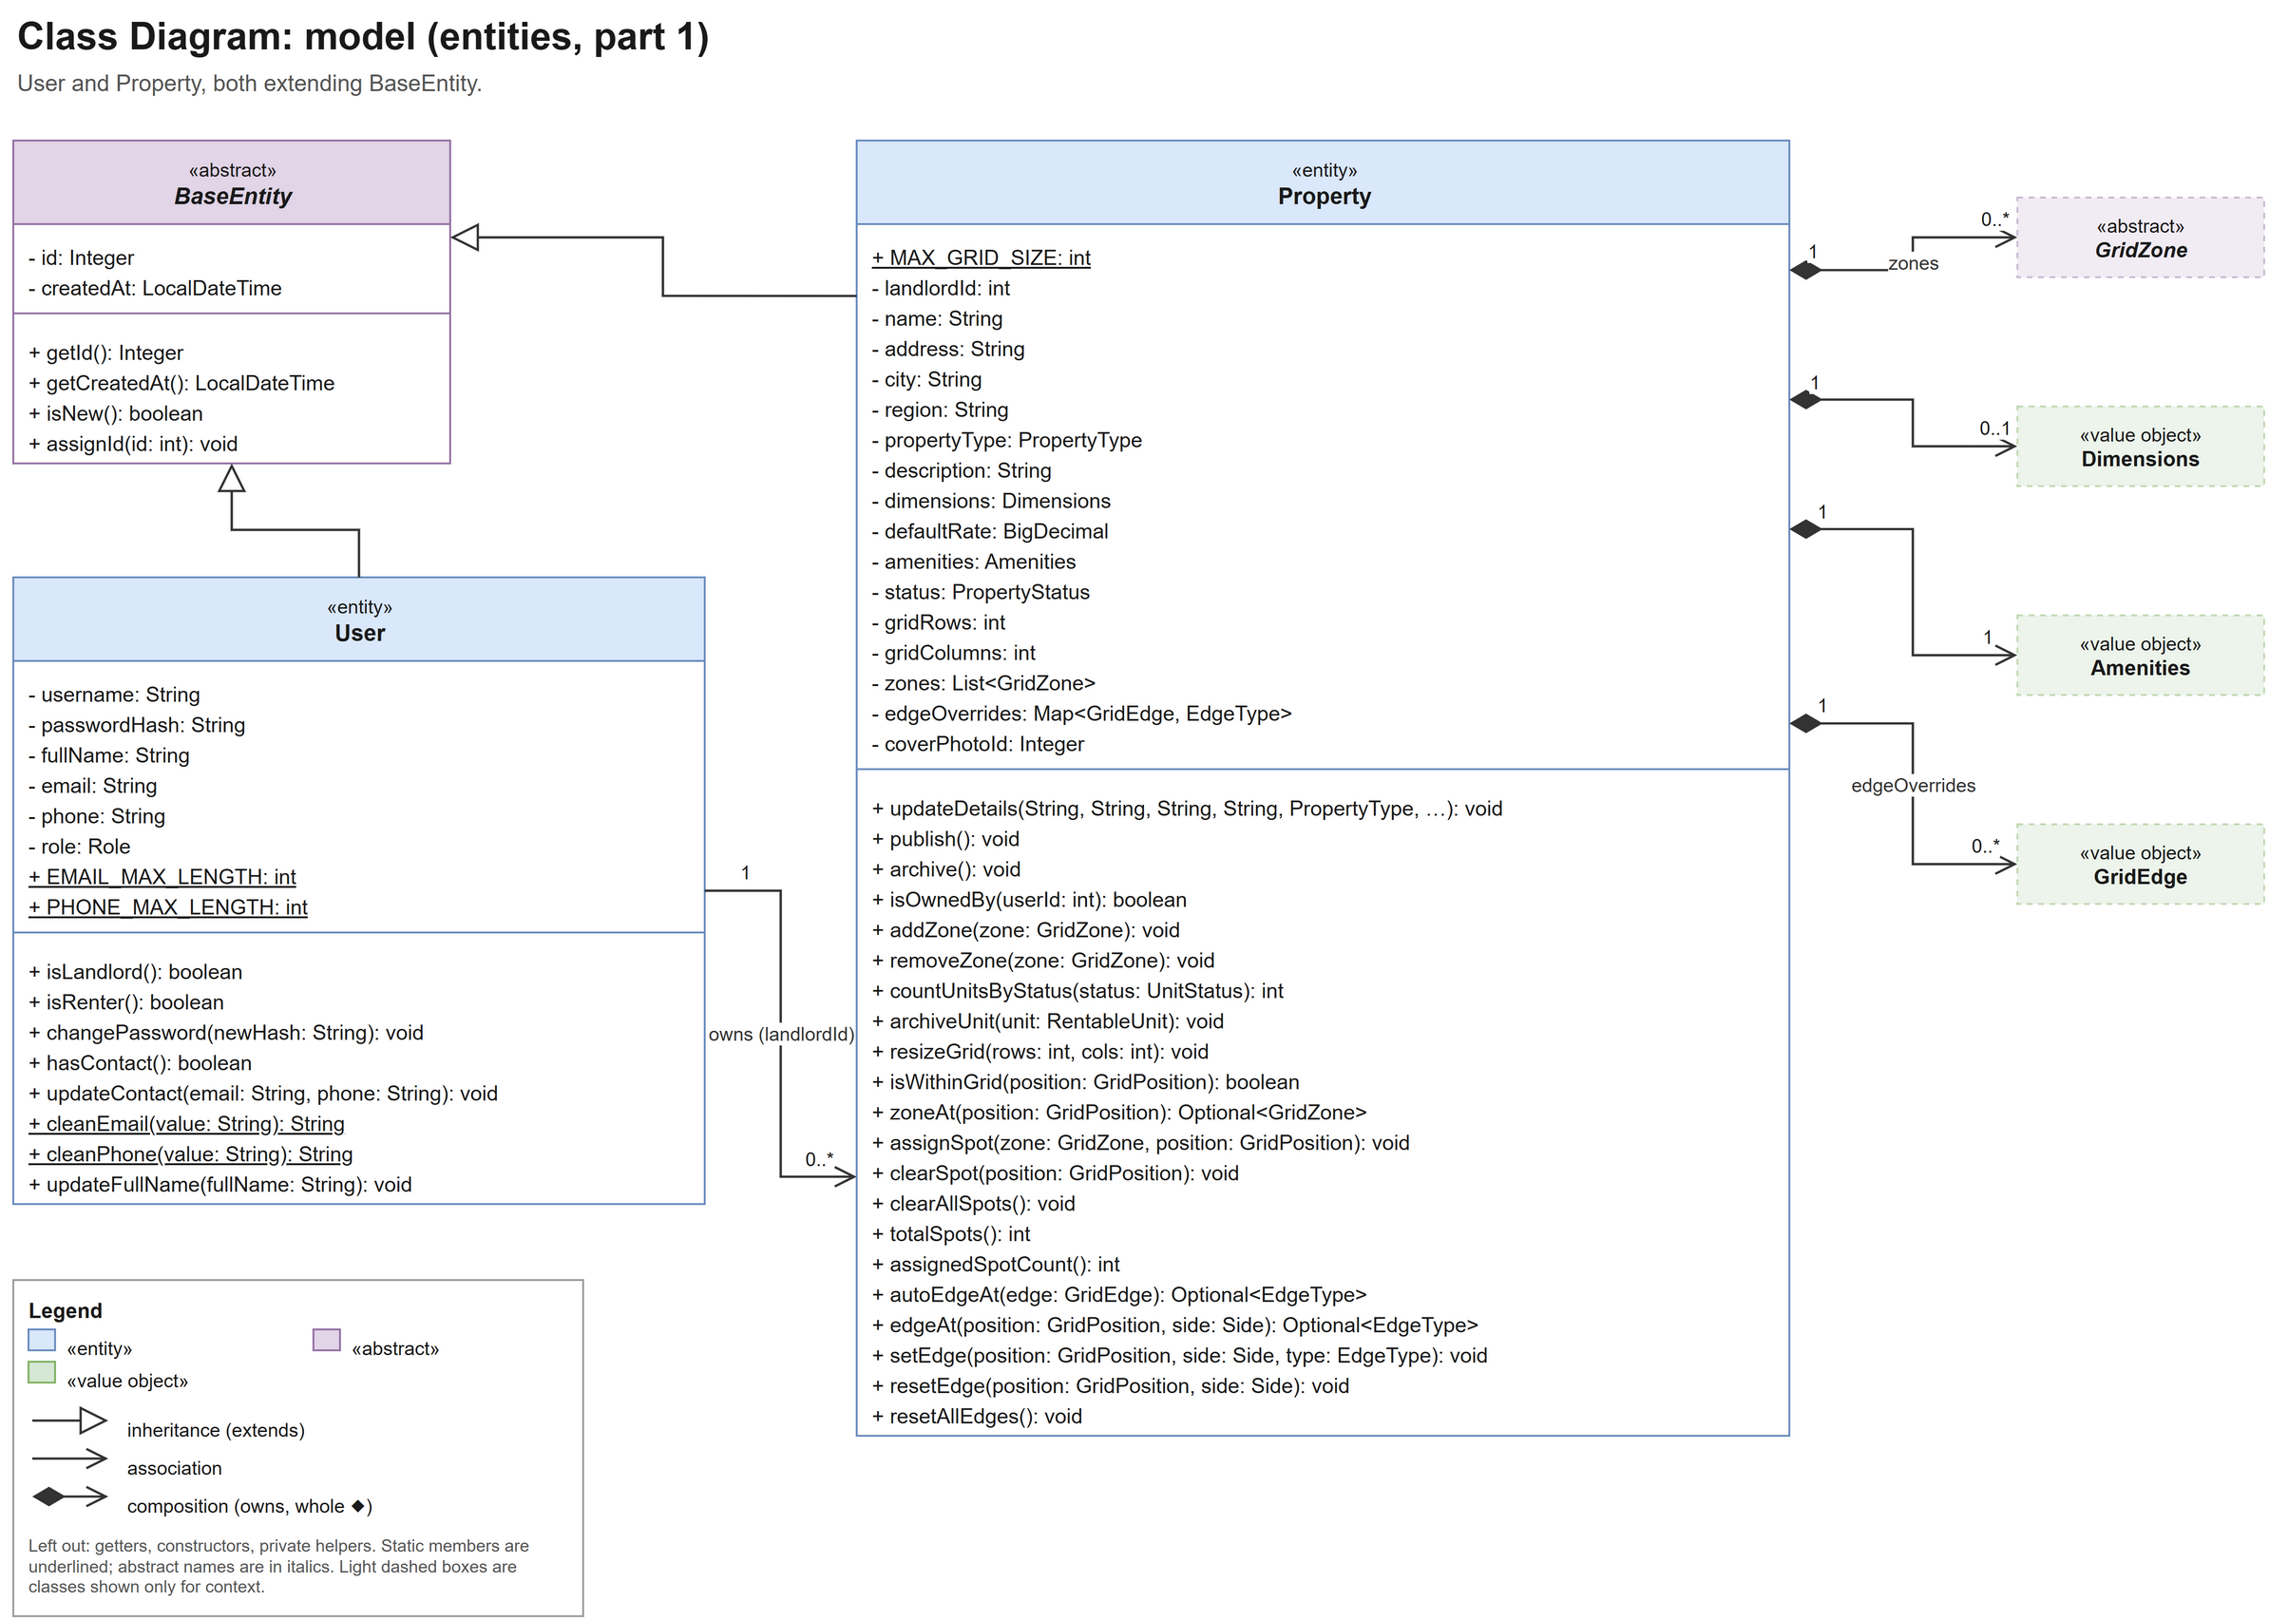
Figure A.2: Class diagram, model package (entities, part 1)
User and Property, both extending BaseEntity, with the value objects Property owns.
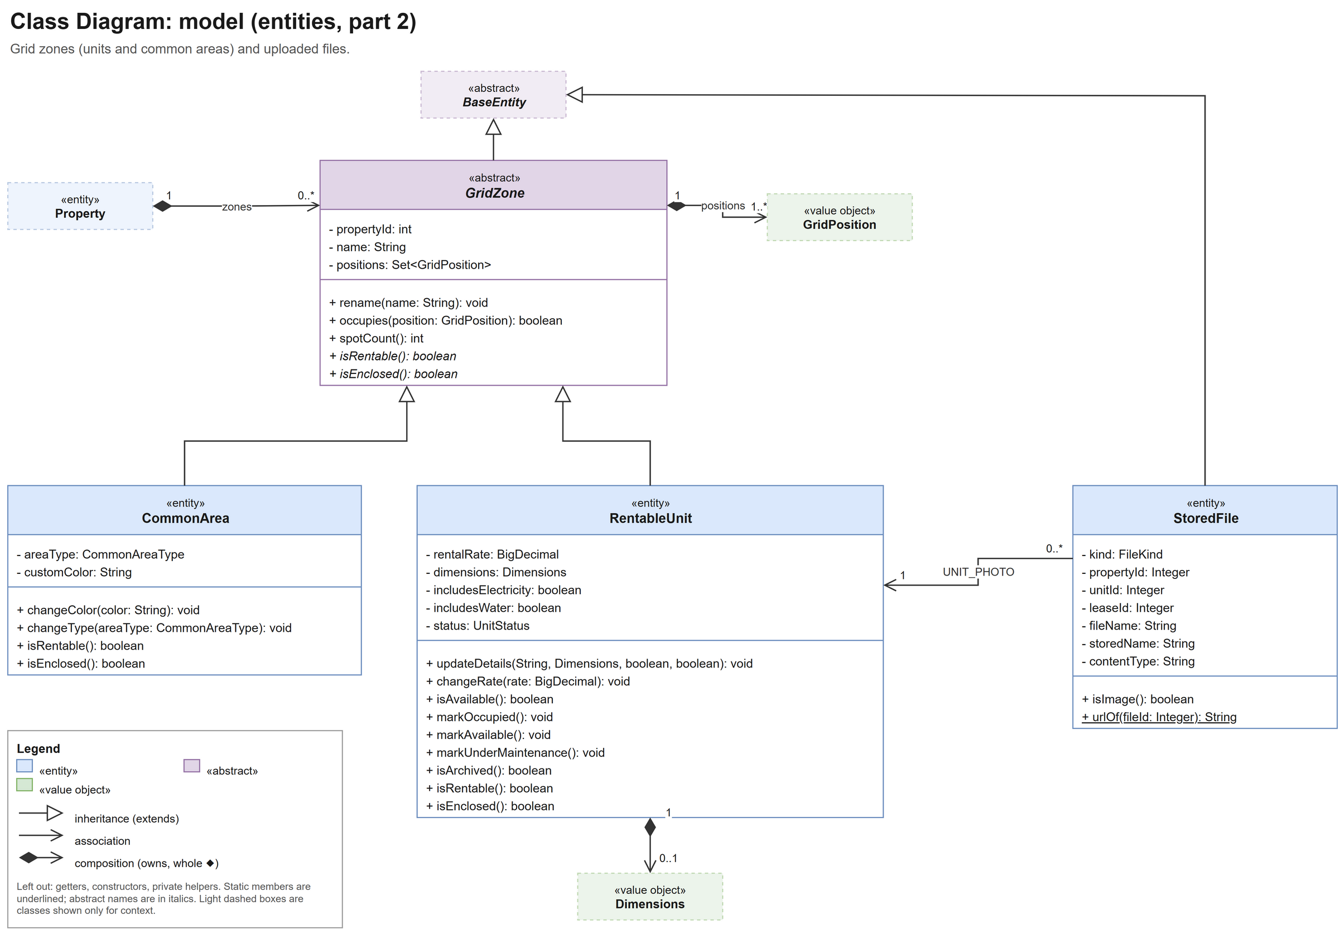
Figure A.3: Class diagram, model package (entities, part 2)
GridZone with RentableUnit and CommonArea, and StoredFile.
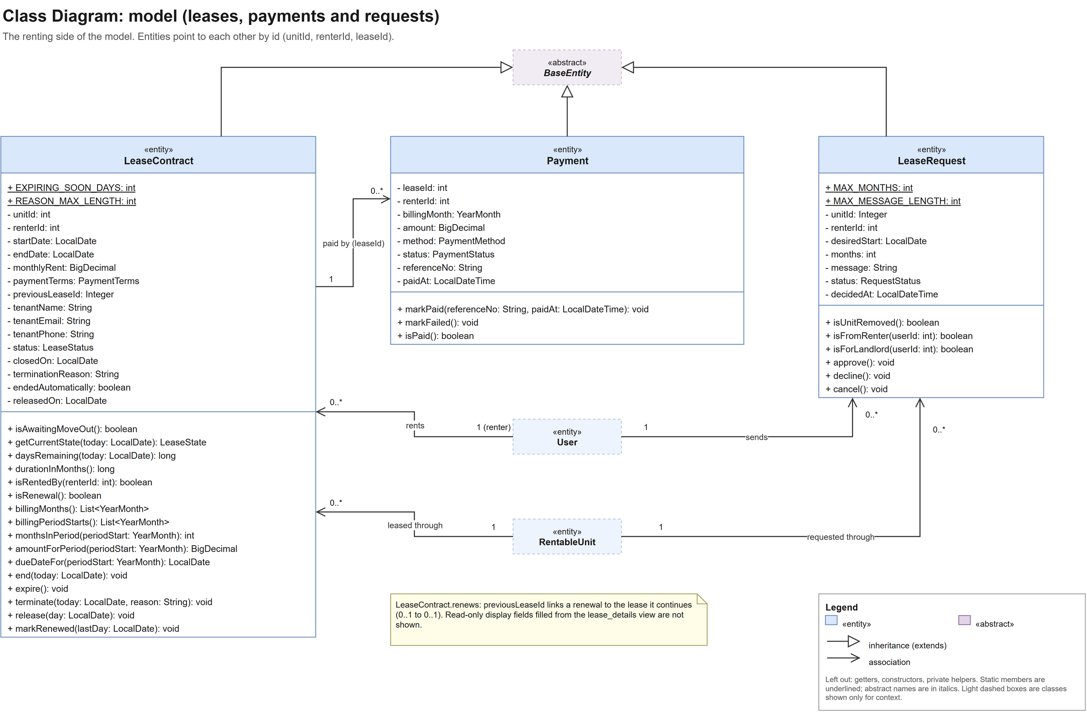
Figure A.4: Class diagram, model package (leases, payments and requests)
LeaseContract, Payment and LeaseRequest and how they refer to User and RentableUnit by id.
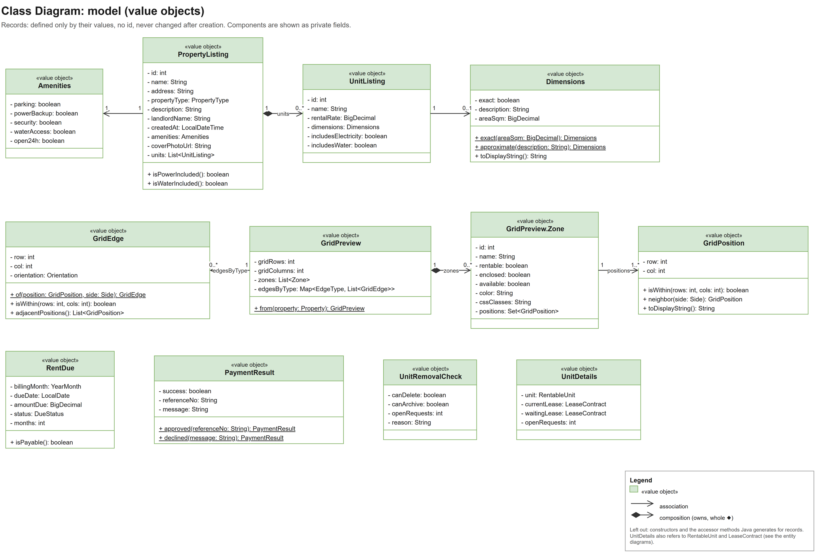
Figure A.5: Class diagram, model package (value objects)
The records: Dimensions, Amenities, GridPosition, GridEdge, RentDue, PaymentResult and the listing, preview and check objects.
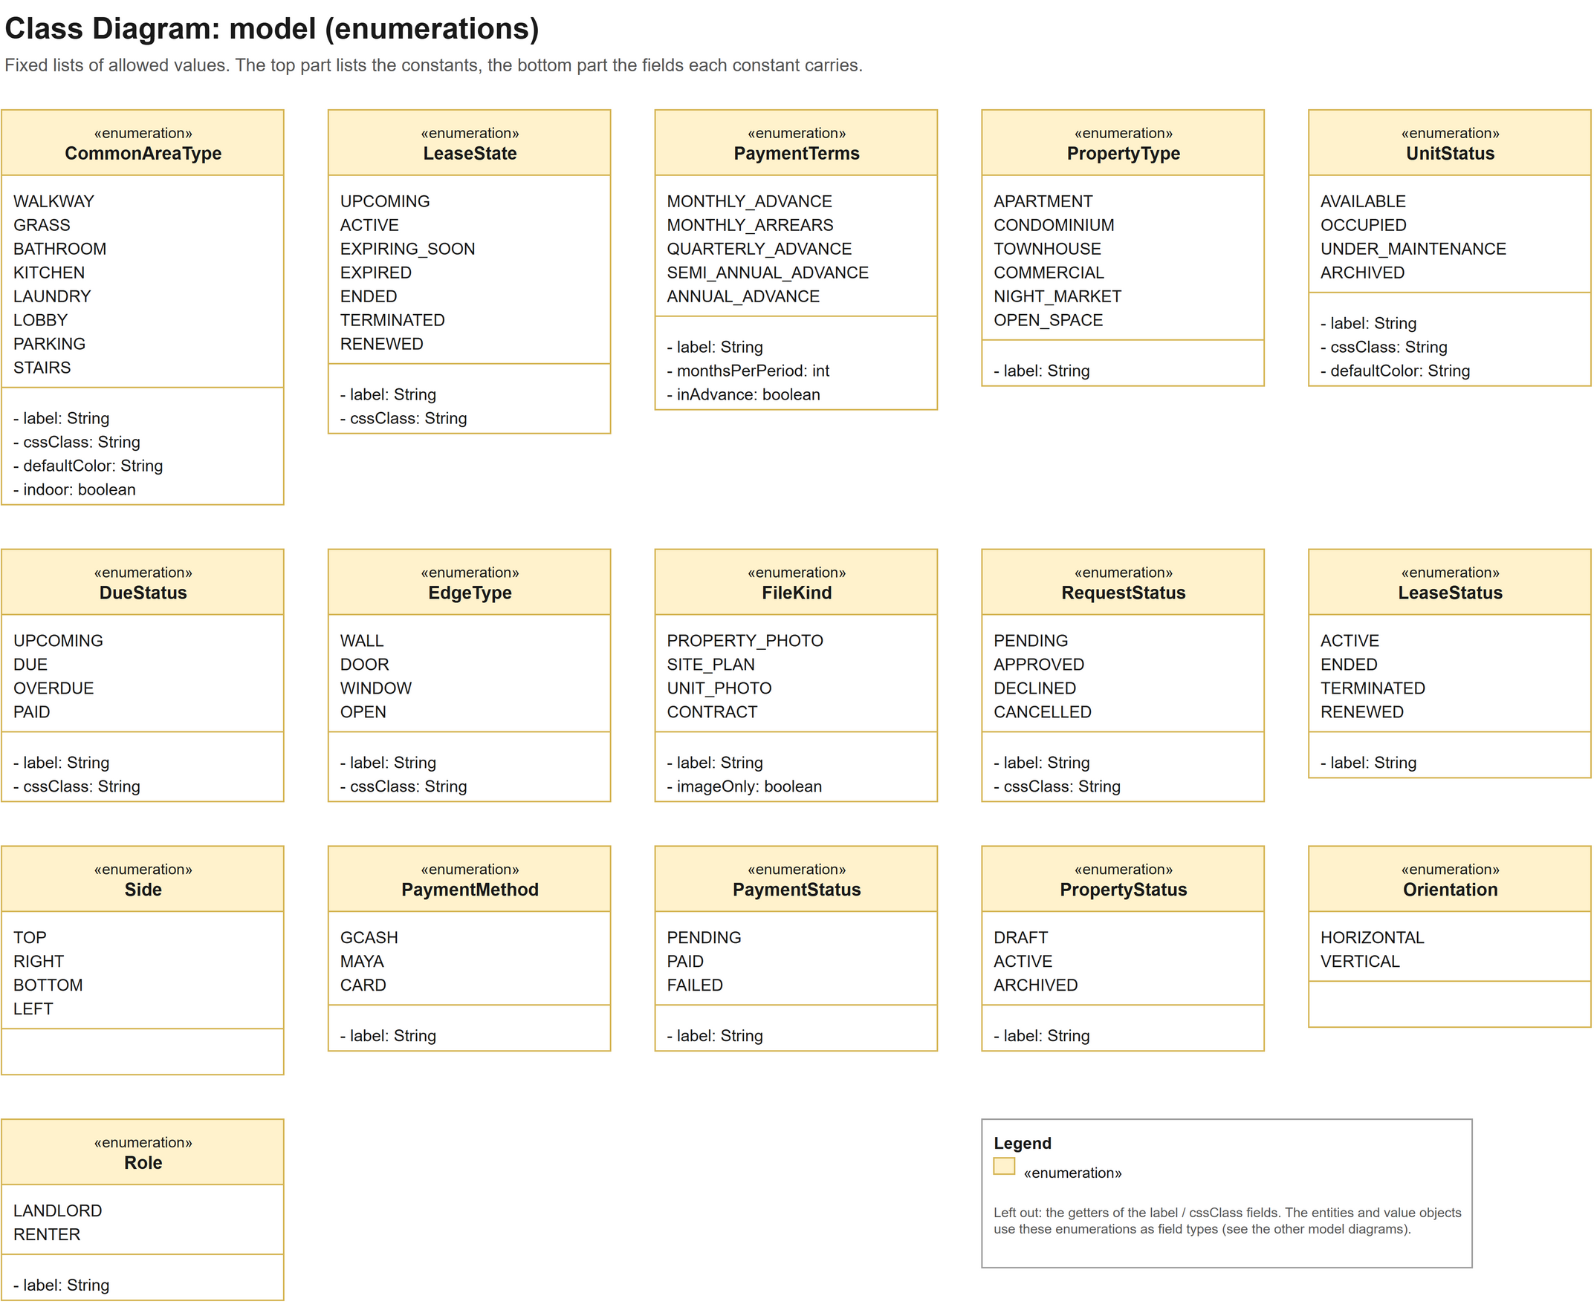
Figure A.6: Class diagram, model package (enumerations)
The 16 enumerations with their constants and fields.
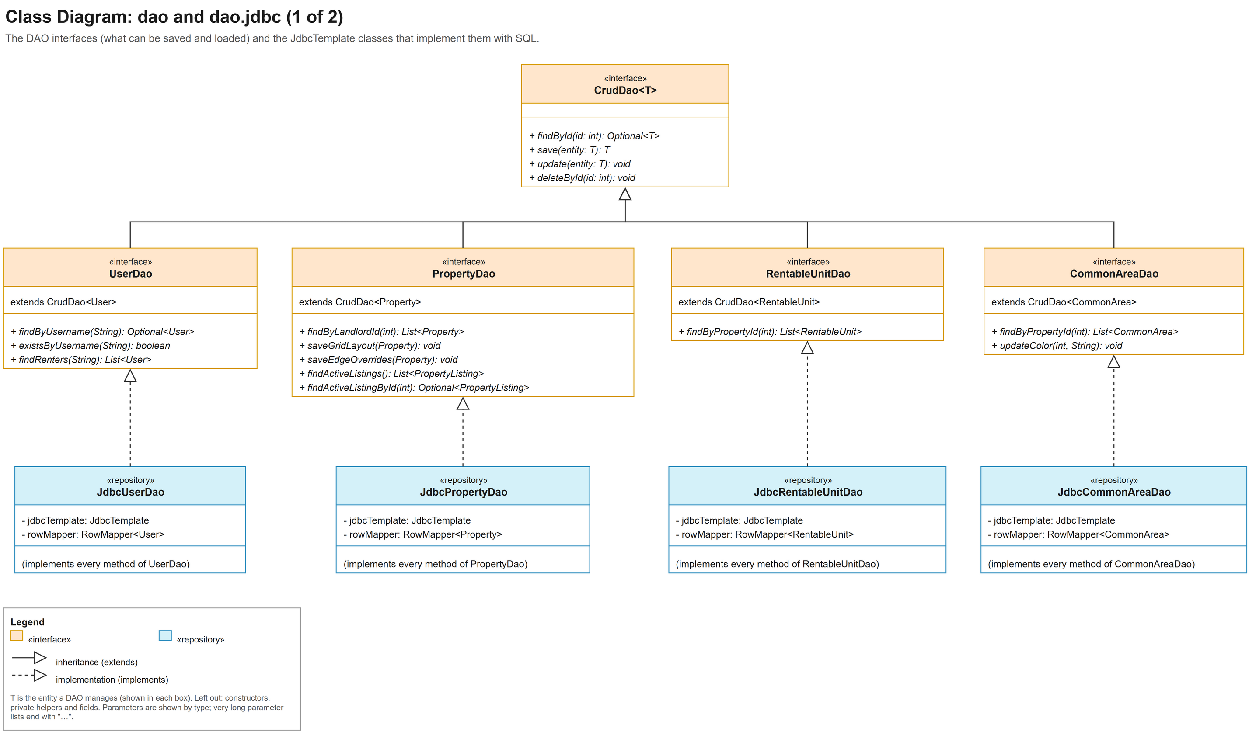
Figure A.7: Class diagram, dao and dao.jdbc packages (1 of 2)
CrudDao, the user, property, unit and common-area DAO interfaces, and their JdbcTemplate implementations.
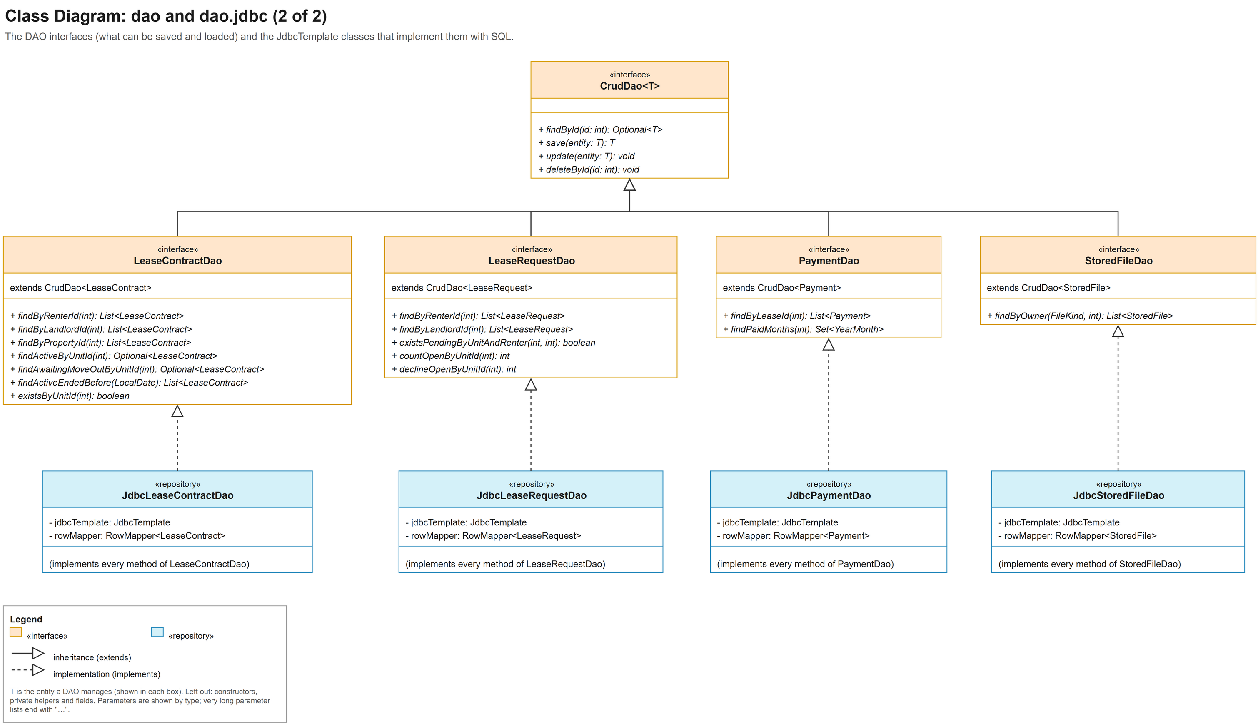
Figure A.8: Class diagram, dao and dao.jdbc packages (2 of 2)
The lease, lease request, payment and file DAO interfaces and their implementations.
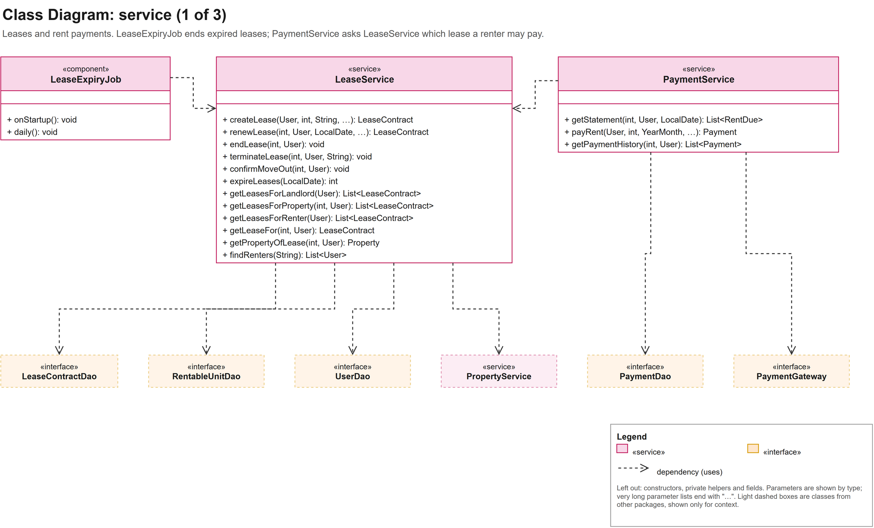
Figure A.9: Class diagram, service package (1 of 3)
LeaseExpiryJob, LeaseService and PaymentService with the classes they use.
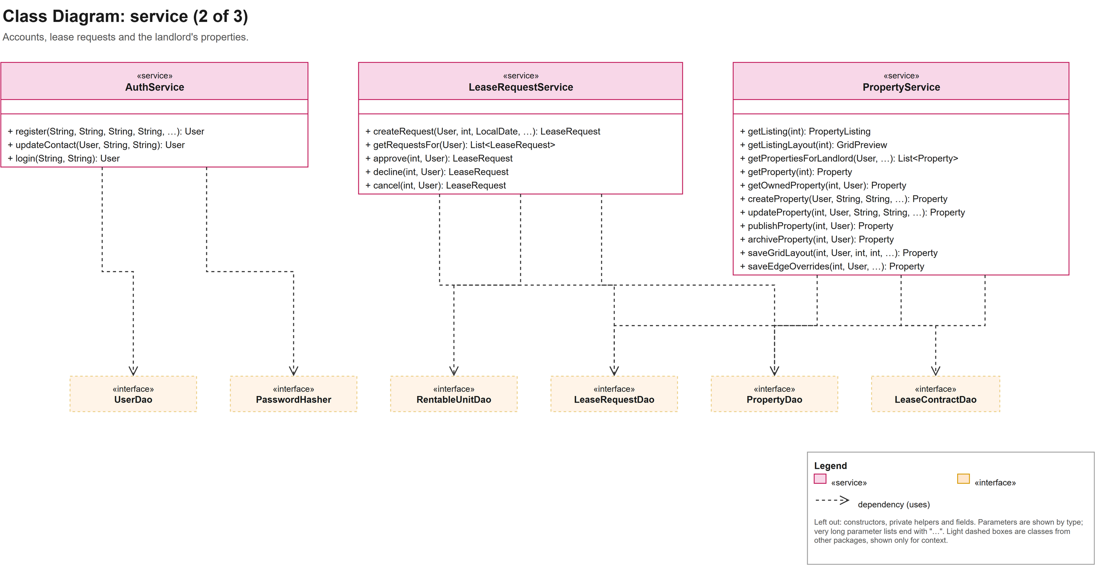
Figure A.10: Class diagram, service package (2 of 3)
AuthService, LeaseRequestService and PropertyService with the classes they use.
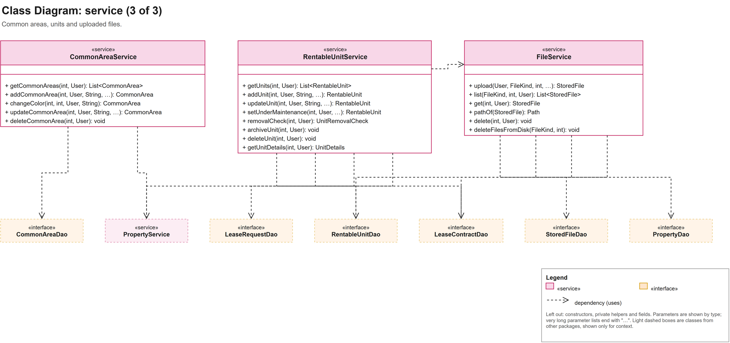
Figure A.11: Class diagram, service package (3 of 3)
CommonAreaService, RentableUnitService and FileService with the classes they use.
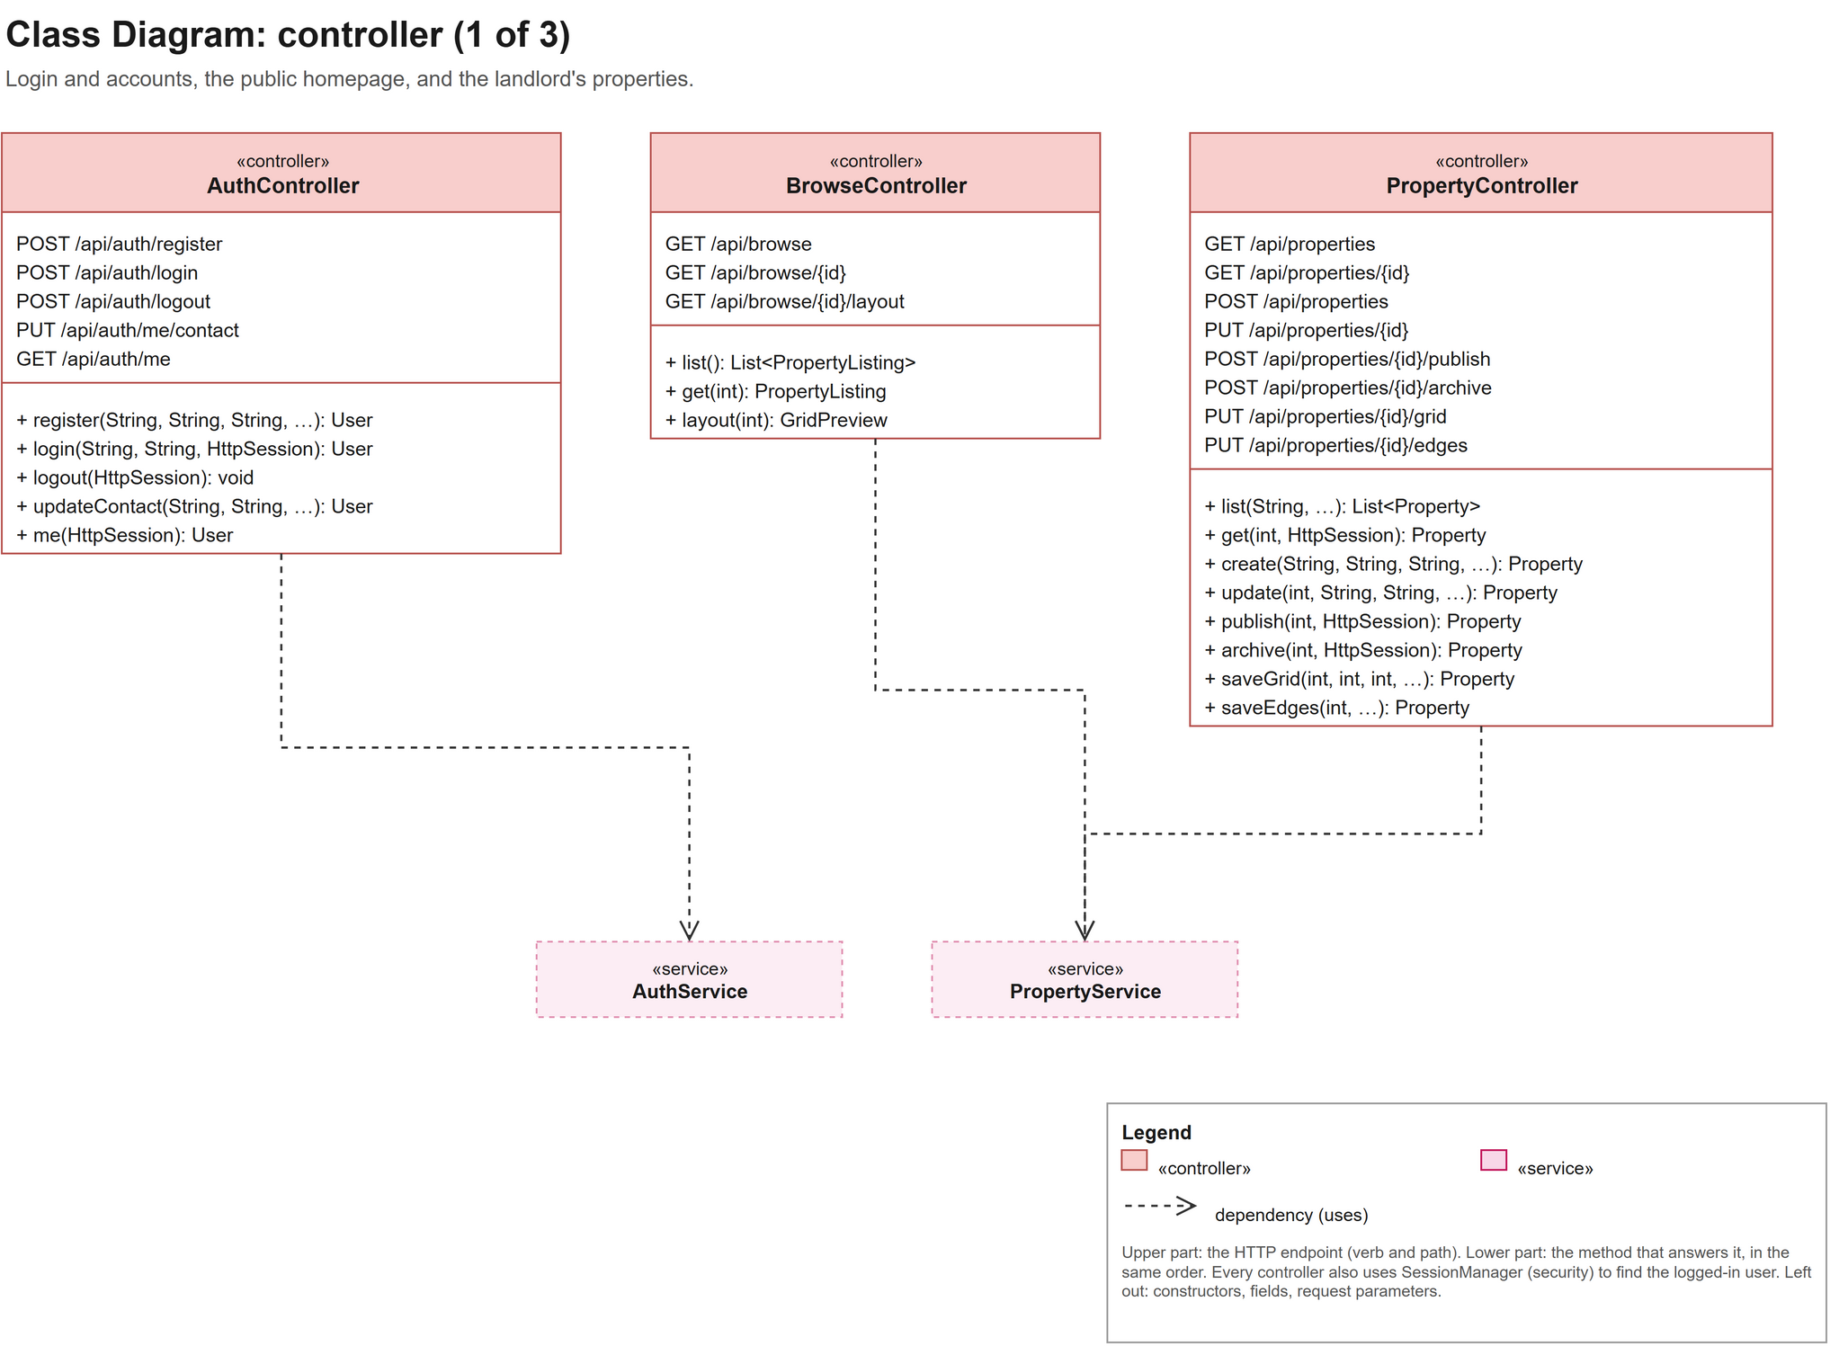
Figure A.12: Class diagram, controller package (1 of 3)
AuthController, BrowseController and PropertyController with their HTTP endpoints.
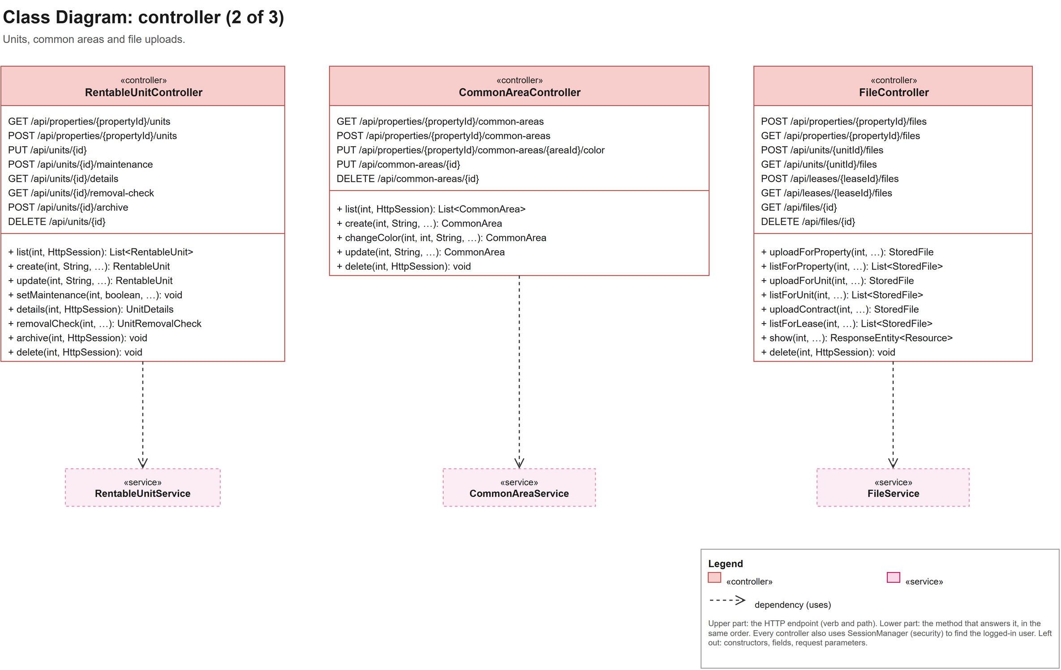
Figure A.13: Class diagram, controller package (2 of 3)
RentableUnitController, CommonAreaController and FileController with their HTTP endpoints.
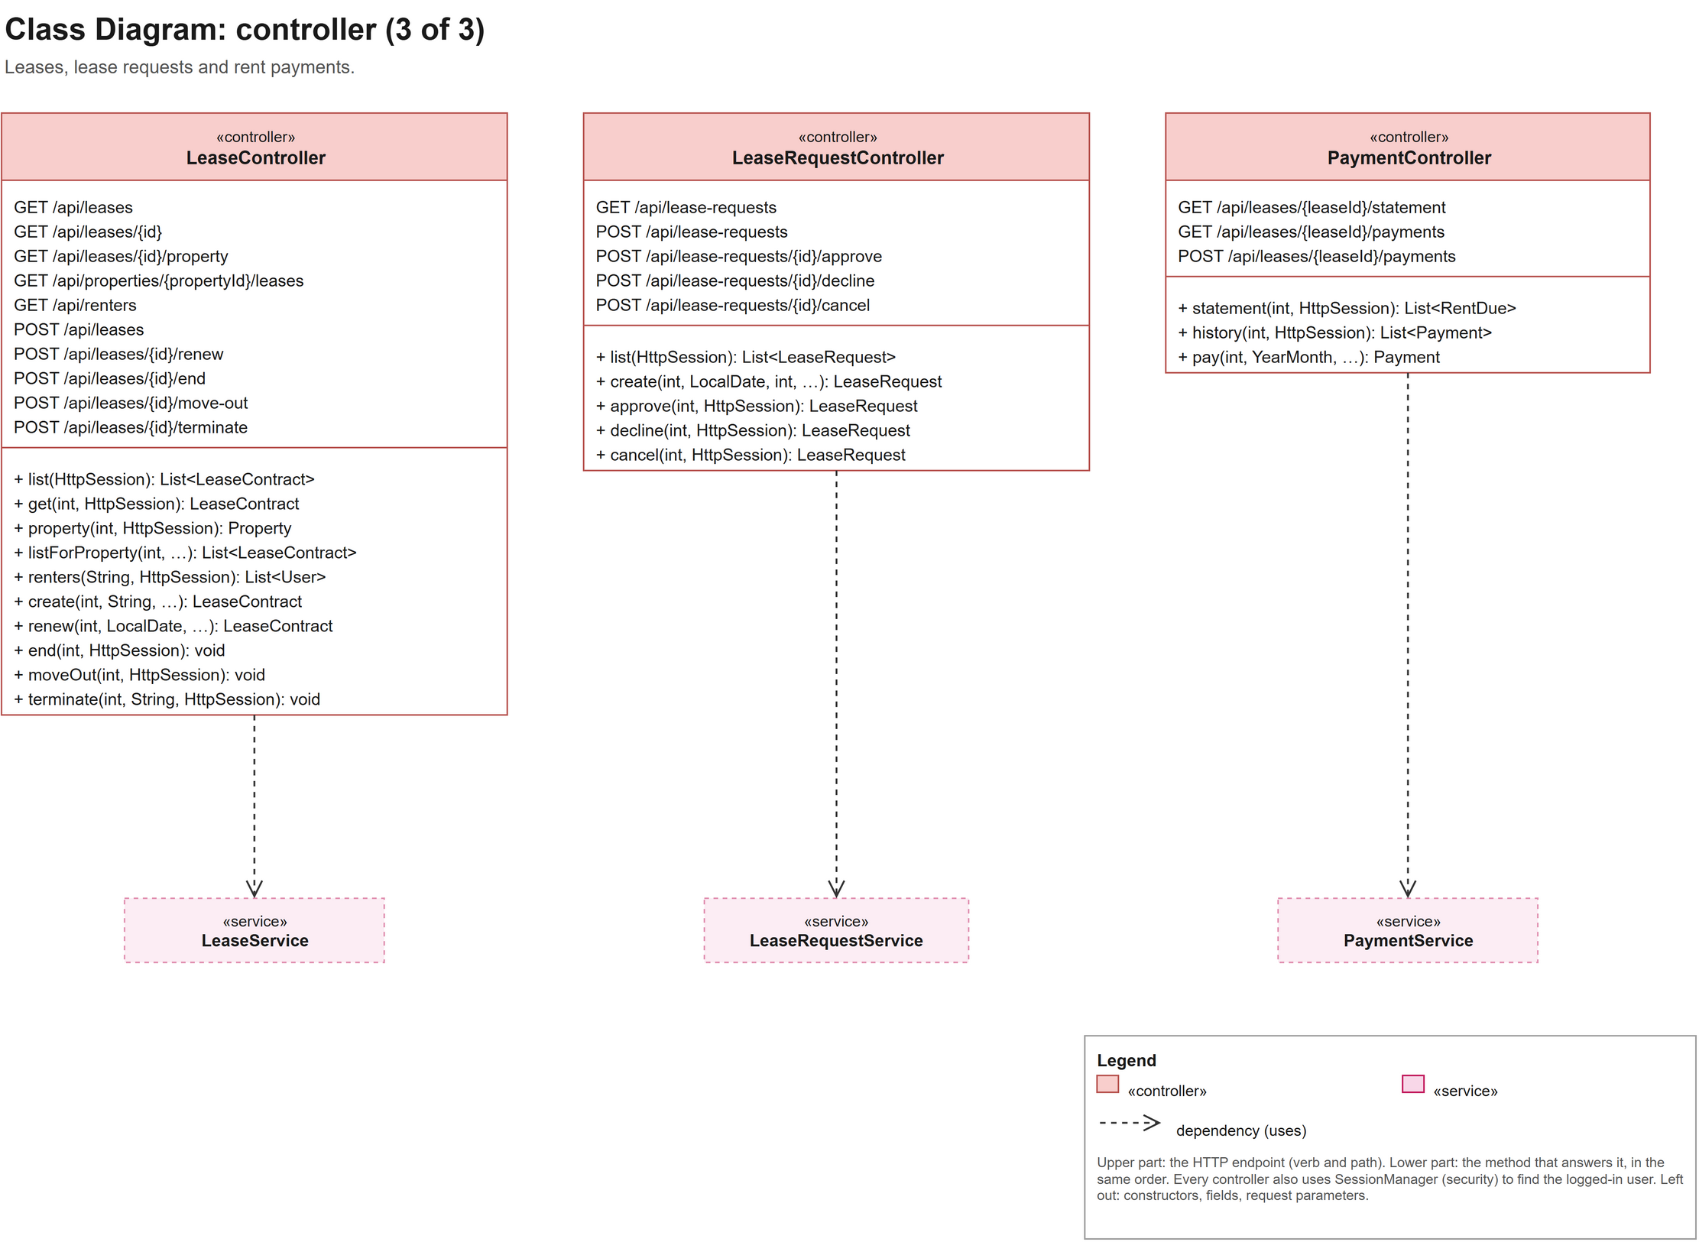
Figure A.14: Class diagram, controller package (3 of 3)
LeaseController, LeaseRequestController and PaymentController with their HTTP endpoints.
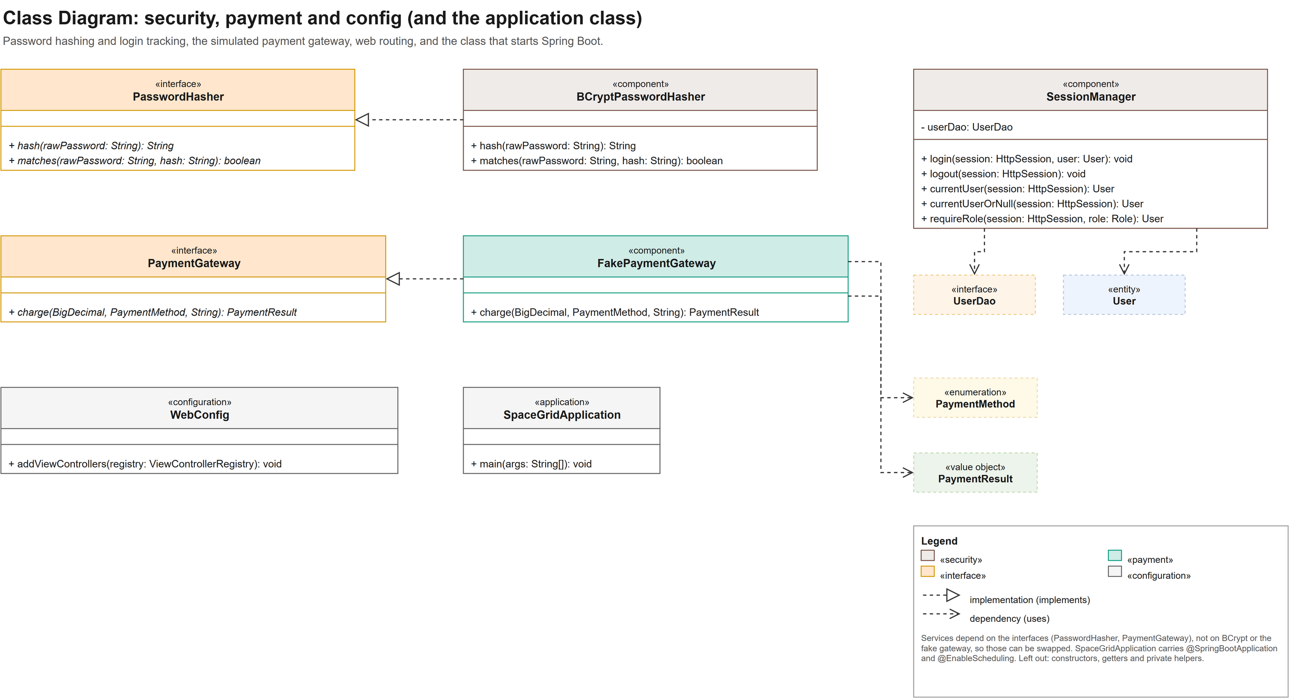
Figure A.15: Class diagram, security, payment and config packages
Password hashing, SessionManager, the payment gateway, WebConfig and the SpaceGridApplication class.
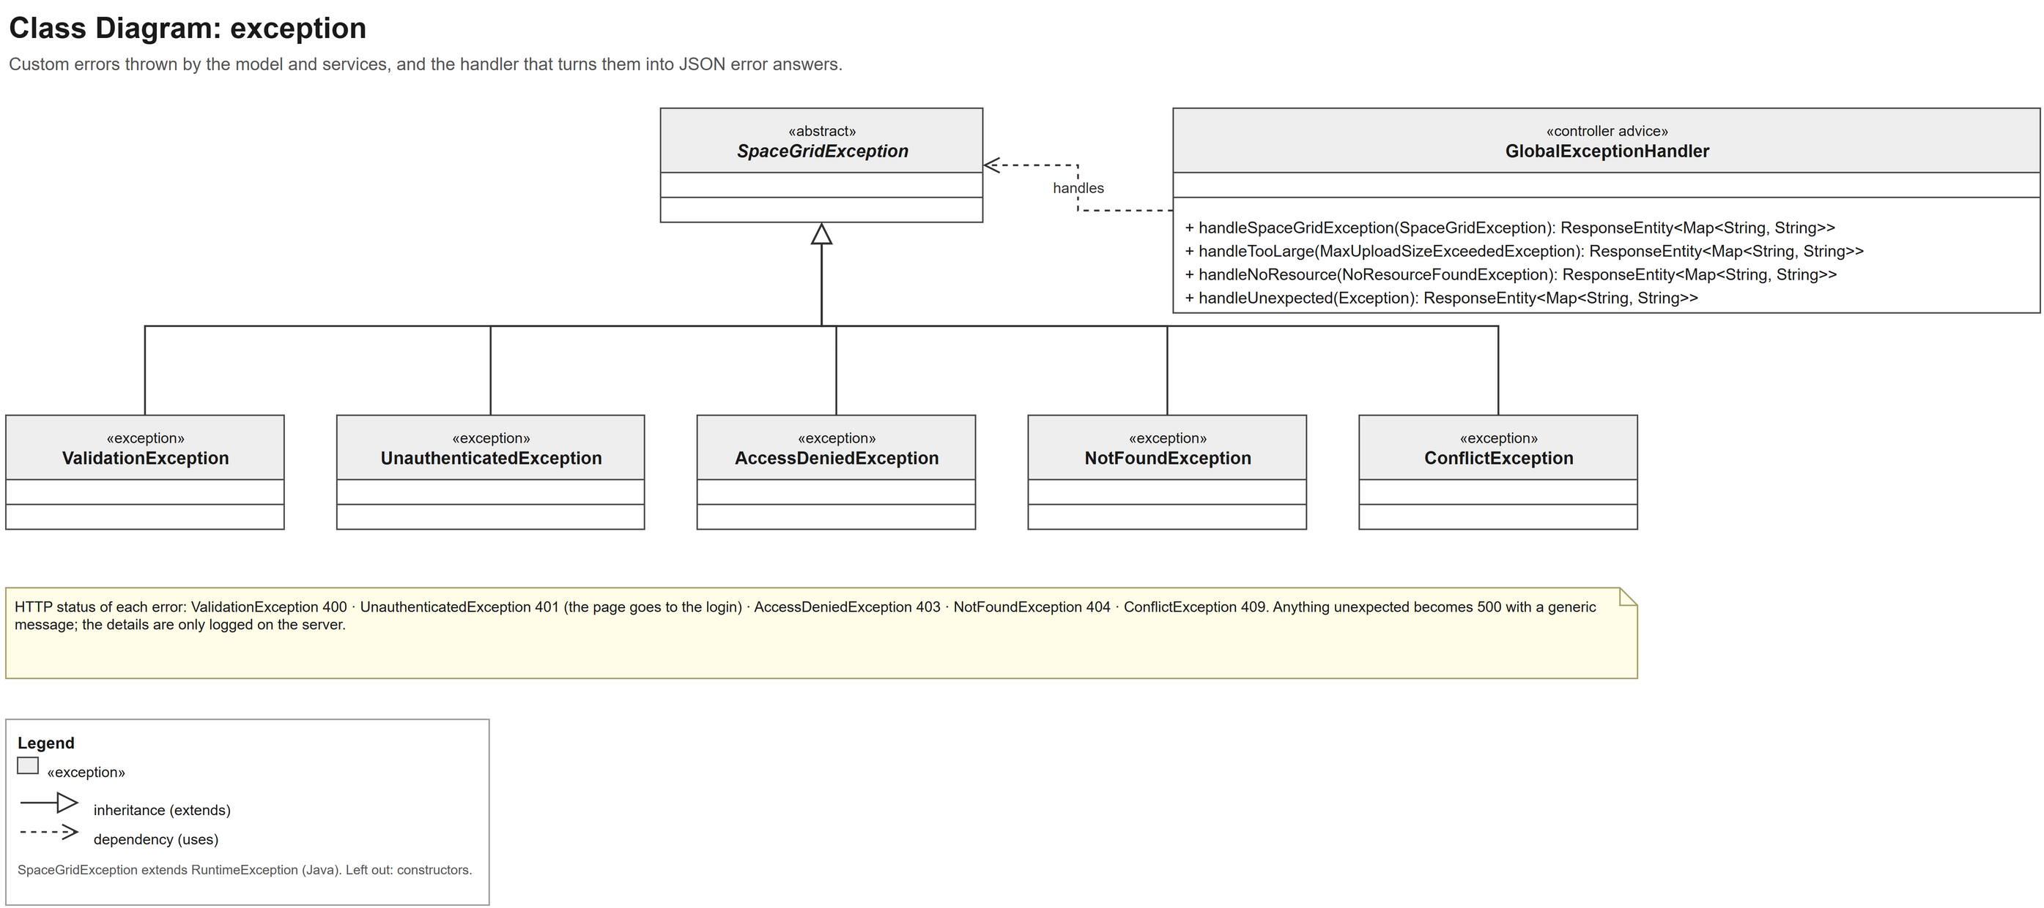
Figure A.16: Class diagram, exception package
SpaceGridException with its five subclasses and GlobalExceptionHandler.
B. UML Sequence Diagram
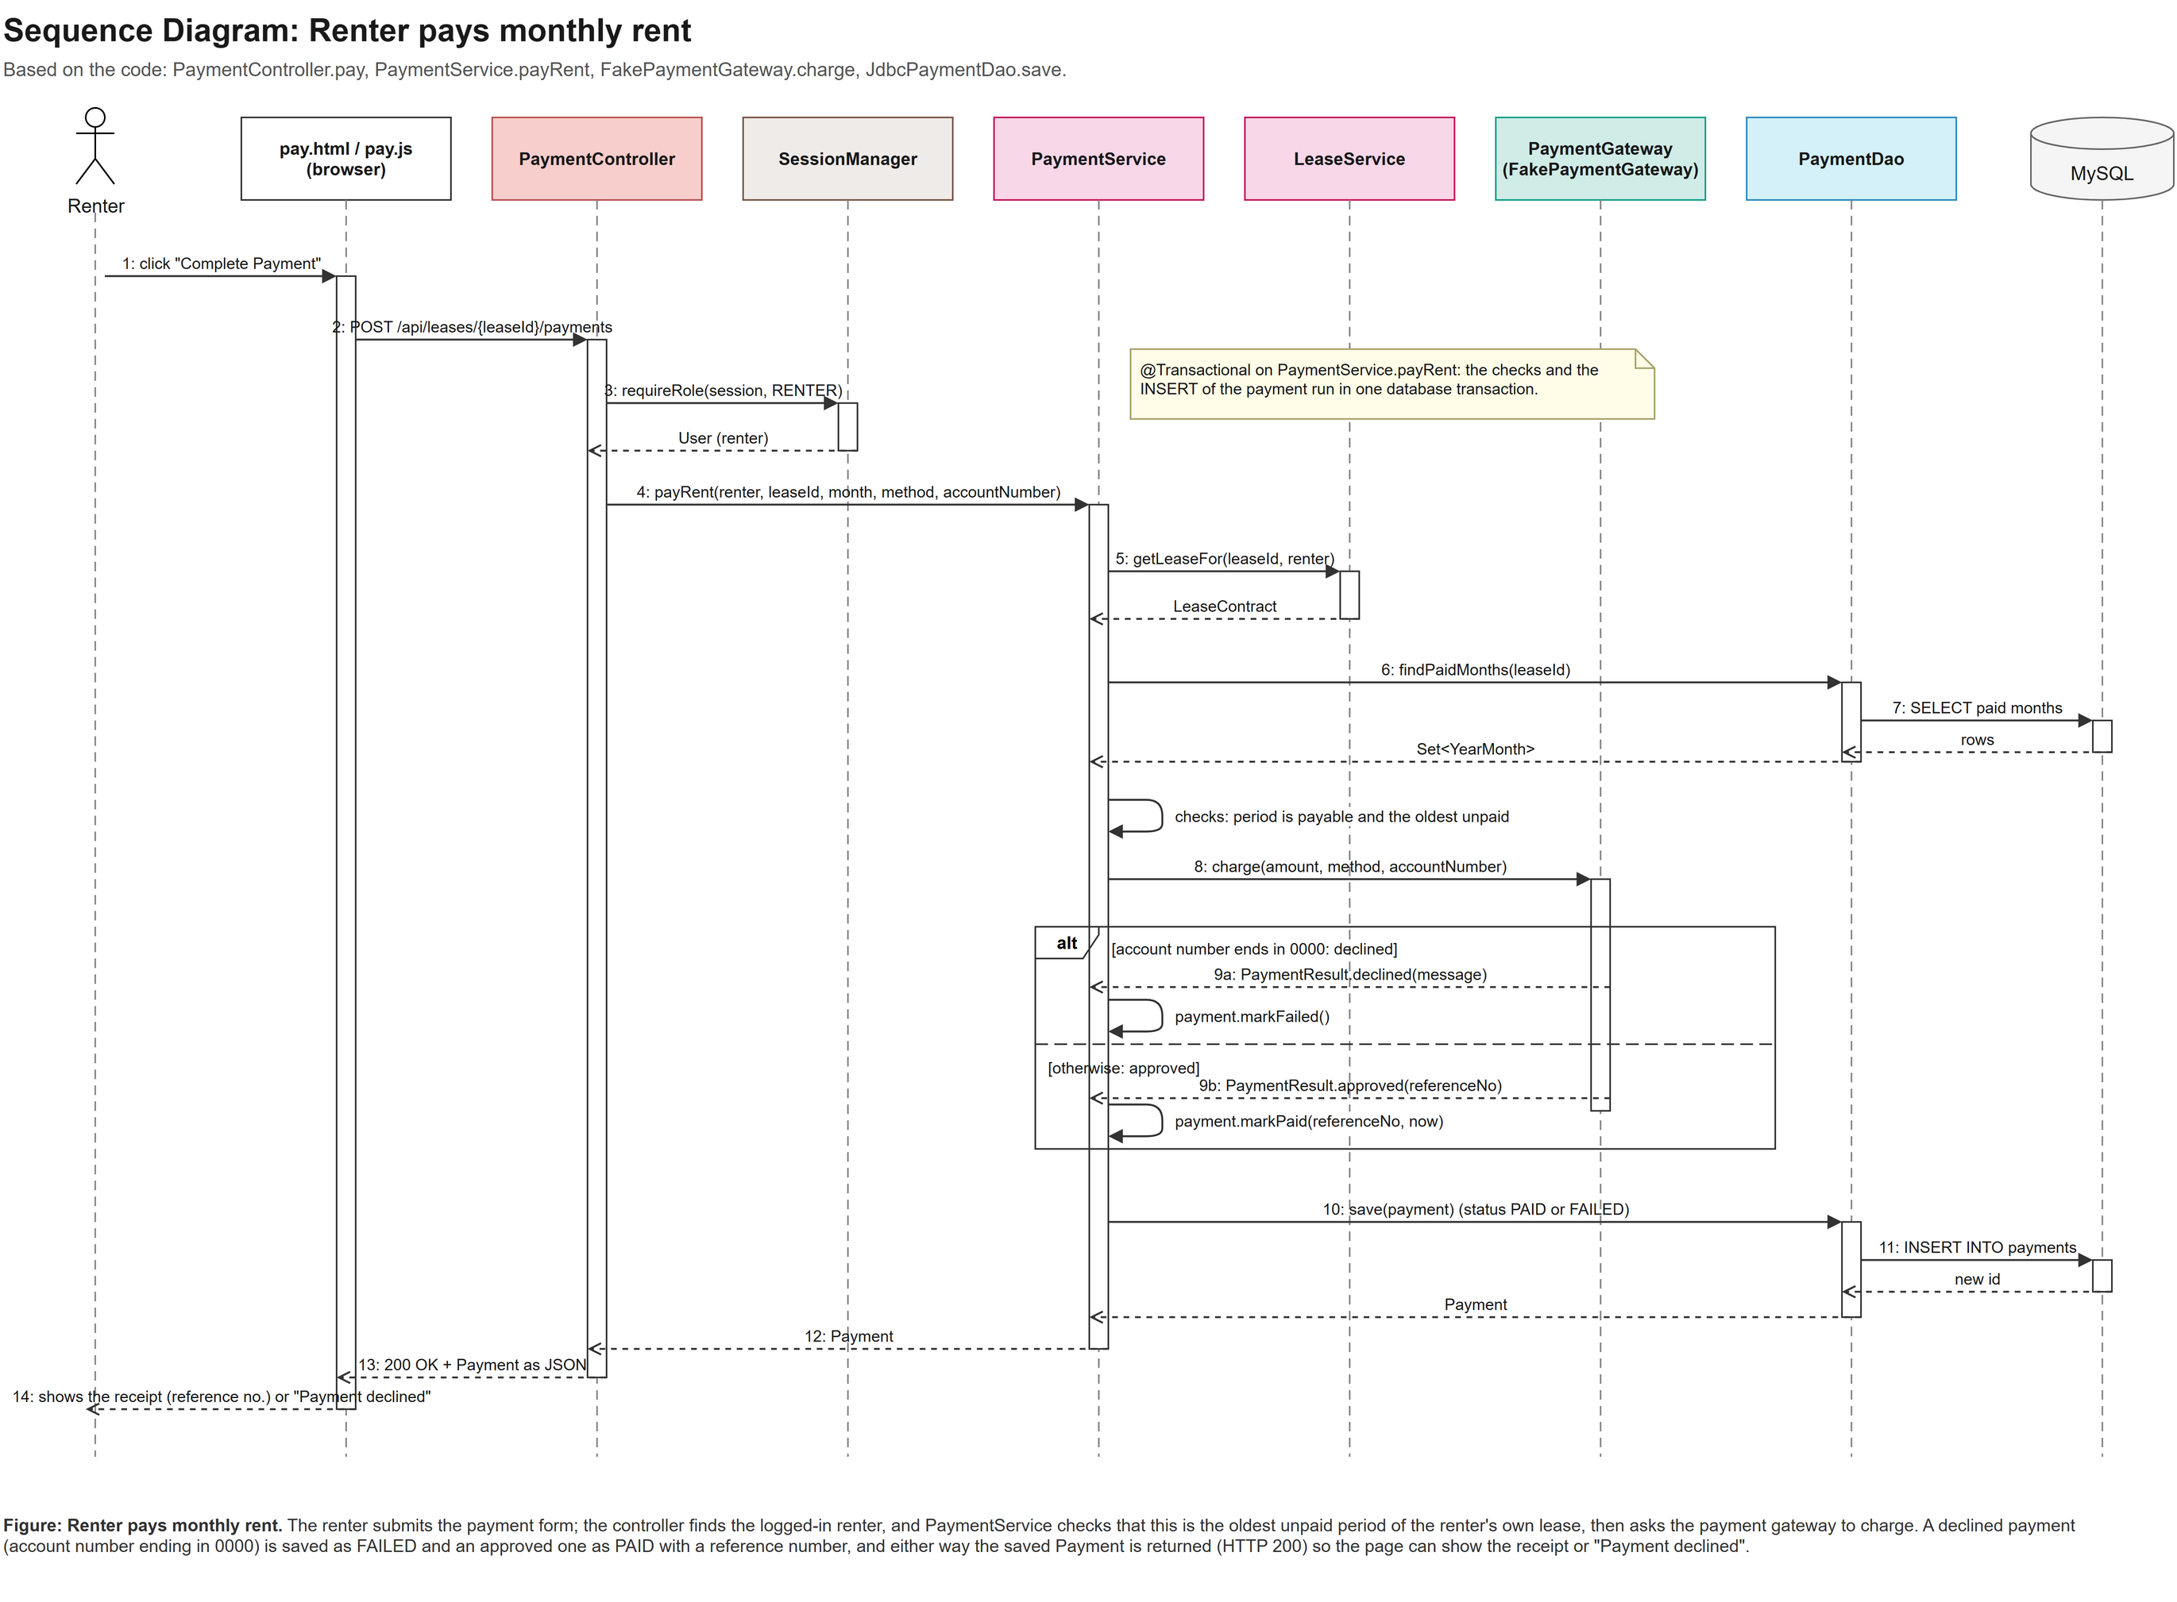
Figure B.1: Sequence diagram, renter pays monthly rent
The renter submits the payment form; PaymentController finds the logged-in renter, and PaymentService checks that this is the oldest unpaid period of the renter's own lease and then asks the payment gateway to charge. A declined payment (account number ending in 0000) is saved as FAILED and an approved one as PAID with a reference number; either way the saved Payment is returned so the page can show the receipt or "Payment declined". The diagram follows the code (PaymentController.pay, PaymentService.payRent); @Transactional covers payRent.
C. Database Relationship Diagram:
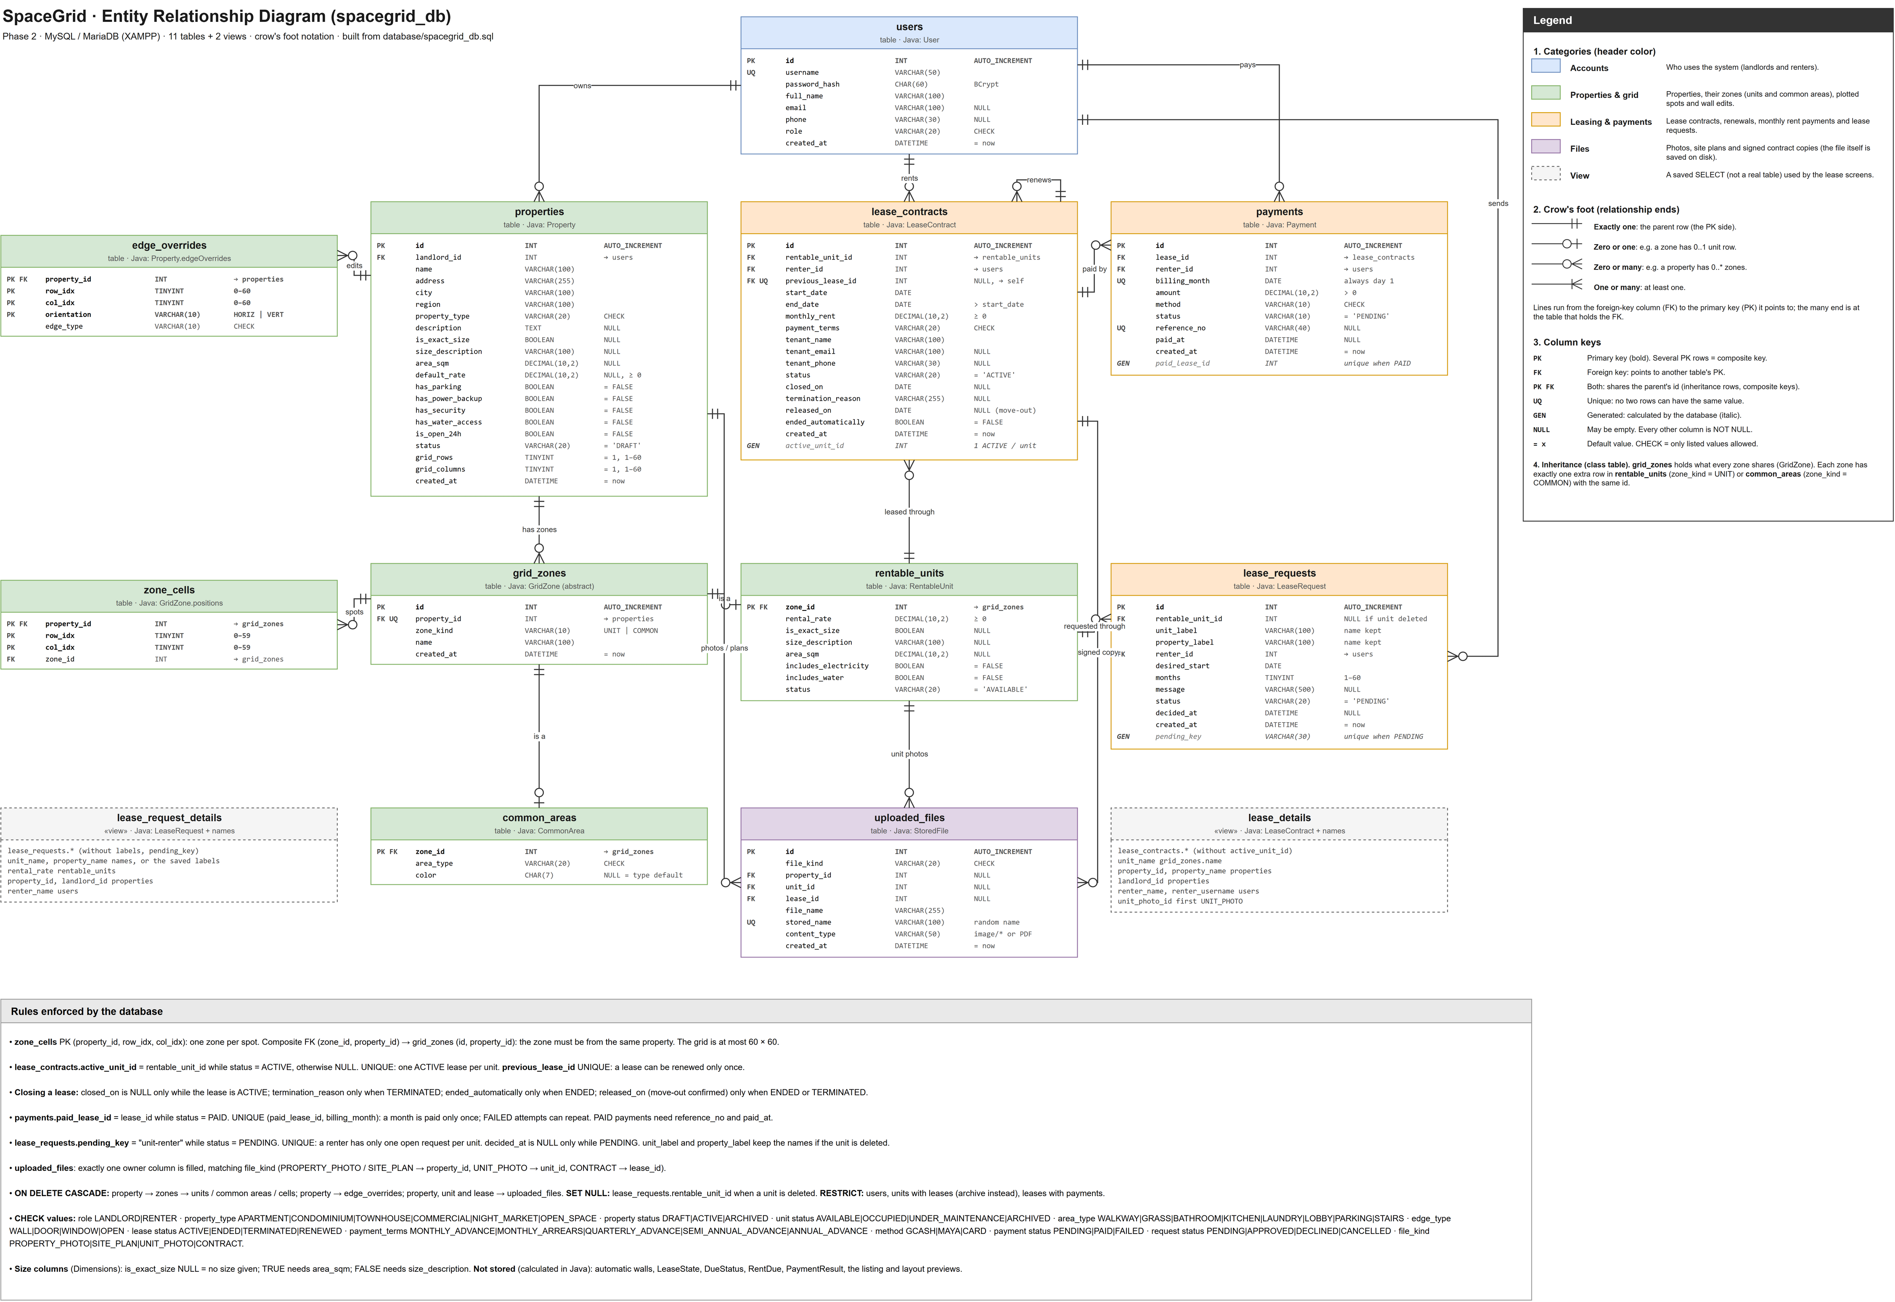
Figure C.1: SpaceGrid Entity Relationship Diagram (spacegrid_db: 11 tables and 2 views)
Crow's foot notation. The image is large; zoom in the digital copy or open docs/SpaceGrid-Phase2-ERD.drawio. The legend and the rules enforced by the database are part of the diagram.

D. Test Cases Summary:

Table D-1: User account and login testing

Feature | Test Case | EXPECTED RESULT | STATUS
Landlord login | Go to the login page, select Landlord, type username and password then click Log In. | You are logged in successfully and taken straight to the Landlord Dashboard showing property cards. | Passed
Incorrect Password | User enters an invalid Username or password | System displays an error message “invalid credentials” | Passed
Property filtering | Renter applies filters (space type, price type, price slider) on the public landing portal | System dynamically updates the listing grid to display only matching available properties | Passed
Renter login | Log in as renter | You are taken to the Renter Dashboard, which shows your personal lease details and rent due instead of landlord controls. | Passed

Table D-2: Property Management and Grid plotter testing

Feature | Test Case | Expected Outcome | Result
Adding a Property | On the Landlord Dashboard, click Add Property, enter property details (e.g., "Bajada Commercial"), select property type, set size, and save. | The new property appears on your dashboard as a Draft property card. | Passed
Placing Grid | Open property grid, click a Rentable Unit from the side panel, and drag it across grid spots next to a Walkway common area. | The spots get assigned to the unit, and the system automatically draws a Wall between the unit and walkway. | Passed
Overwriting Grid Spots | Drag a Bathroom common area over a grid spot that already has a unit placed on it. | The spot updates cleanly,, replacing the old assignment. | Passed
Archiving a Unit | Go to the unit list of a property and click Archive on a unit that has previous tenant leases. | The unit is cleared from the grid canvas, its status changes to Archived, and its old lease records stay safe under the Archived filter. | Passed

Table D-3: lease contracts and rent payment testing

Feature | Test Case | Expected Outcome | Status
Creating a Lease | Pick an available unit, select renter, set start date, end date, and monthly rent, then submit. | The lease is created with Active status, and the unit automatically updates from Available to Occupied. | Passed
Preventing Double Leases | Try creating another active lease on the exact same unit while the current tenant's lease is still active. | The system rejects the action, preventing two active leases on one unit. | Passed

Comments/Grading:

Criteria/Section | Maximum Score | Actual Score
Software Purpose
Objective & Feature Accomplished
Technology Stack
User Manual
Code Quality
UML Diagram
Database Structure & ERD
Total

Instructor Feedback:

_________________________________________________________

Final Grade: ________/100

Instructor Signature: _________________________

Date: _________________________

---

