gRPC Documentation:

Installation:

1. export MY_INSTALL_DIR=$HOME/.local

2. mkdir -p $MY_INSTALL_DIR

3. export PATH="$MY_INSTALL_DIR/bin:$PATH"

4. sudo apt install cmake

5. If 4 doesn’t work:

wget -q -O cmake-linux.sh https://github.com/Kitware/CMake/releases/download/v3.19.6/cmake-3.19.6-Linux-x86_64.sh

sh cmake-linux.sh -- --skip-license –prefix=$MY_INSTALL_DIR

rm cmake-linux.sh

7. sudo apt install -y build-essential autoconf libtool pkg-config

8. git clone --recurse-submodules -b v1.58.0 --depth 1 --shallow-submodules https://github.com/grpc/grpc

Build and install gRPC and Protocol Buffers

1. cd grpc

2. mkdir -p cmake/build

3. pushd cmake/build

4. cmake -DgRPC_INSTALL=ON \
-DgRPC_BUILD_TESTS=OFF \
-DCMAKE_INSTALL_PREFIX=$MY_INSTALL_DIR \
../..
5. make -j 4
6. make install

7. popd

Running an Example:

Hello World Example:

cd examples/cpp/helloworld

mkdir -p cmake/build
$ pushd cmake/build
$ cmake -DCMAKE_PREFIX_PATH=$MY_INSTALL_DIR ../..
$ make -j 4

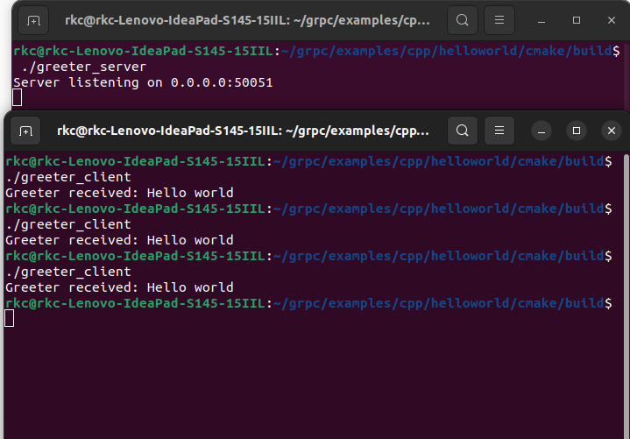
l

Creating own service routines:

Files needed:

1. .proto (to be created in examples/protos)

2. Makefile (in working directory)

make your_service.grpc.pb.o

Which generates the files in working directory:

1.route_guide.pb.h, the header which declares your generated message classes
2. route_guide.pb.cc, which contains the implementation of your message classes
3.route_guide.grpc.pb.h, the header which declares your generated service classes
4.route_guide.grpc.pb.cc, which contains the implementation of your service classes

3. Create client and servers. your_service_server.cc and your_service_client.cc

make – to run them and generate executable files

(https://grpc.io/docs/languages/cpp/basics/)

Source:

1.https://grpc.io/docs/languages/cpp/quickstart/#install-grpc
2.https://grpc.io/docs/languages/cpp/basics/
3. https://grpc.io/docs/languages/cpp/quickstart/
4.https://grpc.io/docs/what-is-grpc/introduction/
5.https://github.com/grpc/grpc/blob/v1.58.0/examples/cpp/route_guide/CMakeLists.txt

