
Chapter 1 - Sorting Algorithm (Task A) 4
1.1 Task A Overview and Ranking Rule 4
1.2 Sorting Algorithm Implementation 4
1.3 Runtime Measurement Method 5
1.4 Dataset Profile 6
1.5 Sorting Results and Top 10 Selected Targets 6
1.6 Performance Analysis and Final Choice 8
1.7 Time and Space Decision Support 9
Chapter 2 - Graph Algorithm (Task B) 10
2.1 Task B Overview 10
2.2 Weighted Graph Construction 11
2.3 Dijkstra Algorithm Implementation 11
2.4 Required Shortest-Path Cases and Waypoint Composition 12
2.5 Complexity Analysis 13
2.6 Algorithm Evaluation and Alternatives 15
Chapter 3 - Design of the Overall Application (Task C) 16
3.1 Overall Workflow and Package Structure 16
3.2 Data Structures and Class Responsibilities 17
3.3 Class and Function Collaboration 19
3.4 Object-Oriented Principles and Design Justification 20
Chapter 4 - Project Reflection (Task D) 21
4.1 AI-Assisted Planning and Collaboration Tools 21
4.2 Equality, Diversity, and Inclusion 22
4.3 Life-long Learning and Team Contribution 23
4.4 Future Improvements 23
Chapter 5 - Program Code 24
Chapter 6 - Appendix 60
6.1 Complete Runtime Logs 60
6.2 Complete Shortest-Path Output 65
6.3 Validation Evidence 66
6.4 Selected Console Screenshots 66
6.5 Planning and Implementation Evidence 67
6.6 Reflection and Tool Usage Evidence 72
Chapter 7 - Contribution Form 73

CPT204 Group Project Report

Chapter 1 - Sorting Algorithm (Task A)

1.1 Task A Overview and Ranking Rule
This chapter presents the sorting part of the Urban Infrastructure Inspection System. The program reads three candidate-location datasets: candidates_A.csv, candidates_B.csv, and candidates_C.csv. Each dataset contains 1000 records, and each record includes a location_id and a priority_score. The priority_score represents the inspection priority of a location.
The program implements Bubble Sort, Quick Sort, and Merge Sort manually. All three algorithms use the same ranking rule: candidates are sorted by priority_score in descending order. If two candidates have the same priority_score, they are sorted by location_id in ascending order. This rule is implemented in LocationCandidate.compareTo(), so the three sorting algorithms use the same comparison logic.
After sorting each dataset, the program selects the Top 10 candidates. The selected targets are labelled as A1-A10, B1-B10, and C1-C10. These 30 targets are then used in Chapter 2 as important query nodes for the graph algorithm task.

1.2 Sorting Algorithm Implementation
The sorting module uses a SortingAlgorithm interface to define a common sort() method. BubbleSort, QuickSort, and MergeSort implement this interface, so the planner and timer can run all algorithms through the same type. An AbstractSortingAlgorithm class provides shared helper methods such as compare() and swap().
Bubble Sort is used as a simple baseline. It repeatedly compares adjacent candidates and swaps them when their order is incorrect. Its time complexity is O(n^2), so it is expected to be slower when the dataset is unordered or large.
Quick Sort is implemented as a recursive divide-and-conquer algorithm. It partitions the list around a pivot and recursively sorts the two partitions. Its average time complexity is O(n log n), but its worst case can become O(n^2) if the partitions are highly unbalanced.
Merge Sort is also implemented using divide and conquer. It recursively divides the list and merges sorted sublists. Its time complexity is consistently O(n log n), but it requires O(n) extra memory during merging. Figure 1 summarises the Task A sorting workflow and supporting classes.
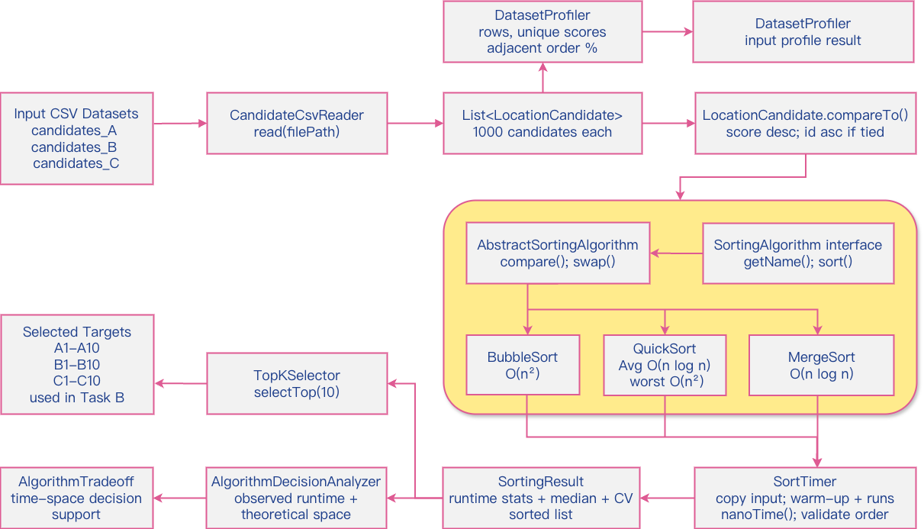
Figure 1. Sorting workflow and supporting classes for Task A.

1.3 Runtime Measurement Method
To ensure a fair comparison, the original dataset is loaded once and copied before each sorting run. Therefore, Bubble Sort, Quick Sort, and Merge Sort receive the same input order in every measured run. SortTimer measures only the sorting operation itself, while file reading, data copying, validation, and output printing are kept outside the timed section.
In the final experiment, each algorithm is tested with 5 warm-up rounds and 30 measured rounds. The warm-up rounds are not included in the final runtime table because Java programs may run more slowly at the beginning due to JVM initialization, class loading, and other start-up effects. After warm-up, the program records repeated measured runs and reports the mean runtime, median runtime, standard deviation, minimum runtime, maximum runtime, and coefficient of variation. Runtime values are shown in milliseconds and rounded for readability.
The coefficient of variation is calculated as standard deviation divided by mean runtime. It is used to compare runtime stability across repeated runs. The program also checks whether Bubble Sort, Quick Sort, and Merge Sort produce the same final order before comparing their runtime results. This validation ensures that the runtime comparison is based on equivalent sorting outputs.

1.4 Dataset Profile
Before comparing runtime results, the program analyses the input characteristics of the three candidate datasets. This dataset profile is generated by DatasetProfiler and stored in DatasetProfile objects. The profile includes the number of rows, the number of unique priority scores, the number of rows with duplicated priority scores, the adjacent correct order percentage, and whether the whole dataset is already sorted according to the required ranking rule. The dataset profile results are summarised in Table 1.
Dataset | Rows | Unique Scores | Duplicate Score Rows | Adjacent Correct Order | Already Sorted?
Dataset A | 1000 | 1000 | 0 | 98.30% | No; Nearly sorted
Dataset B | 1000 | 1000 | 0 | 49.15% | No; Mixed order
Dataset C | 1000 | 41 | 1000 | 51.45% | No; Mixed order with many ties
Table 1. Dataset Profile before Sorting
The dataset profile helps explain why the same sorting algorithm behaves differently across Dataset A, Dataset B, and Dataset C. A higher adjacent correct order percentage means that many neighbouring records are already close to the required order, which can benefit Bubble Sort because fewer adjacent swaps are needed. A lower percentage suggests that more local reordering is required. The number of unique priority scores and duplicated score rows also helps explain how often the tie-breaking rule based on location_id is used. This is especially useful for understanding datasets with many equal priority_score values.

1.5 Sorting Results and Top 10 Selected Targets
After applying the three sorting algorithms to each dataset, the runtime results are recorded and compared. The program also checks whether the three algorithms produce the same final ordering. If all three algorithms produce the same order, the selected target list is taken from the validated Merge Sort result. This gives one canonical Top 10 list for each dataset while still allowing Bubble Sort, Quick Sort, and Merge Sort to be compared fairly. The measured runtime results are summarised in Table 2, and the visual comparison is shown in Figure 2.
Dataset | Bubble Sort Time  (ms, mean +/- SD) | Quick Sort Time  (ms, mean +/- SD) | Merge Sort Time  (ms, mean +/- SD) | Same Order? | Top 10 Selected  Locations
Dataset A | 0.063 +/- 0.008 | 0.432 +/- 0.042 | 0.110 +/- 0.002 | Yes | A1-A10
Dataset B | 1.891 +/- 0.042 | 0.036 +/- 0.002 | 0.091 +/- 0.050 | Yes | B1-B10
Dataset C | 0.169 +/- 0.002 | 0.088 +/- 0.002 | 0.039 +/- 0.001 | Yes | C1-C10
Table 2. Sorting Runtime Summary after 5 Warm-up Runs and 30 Measured Runs
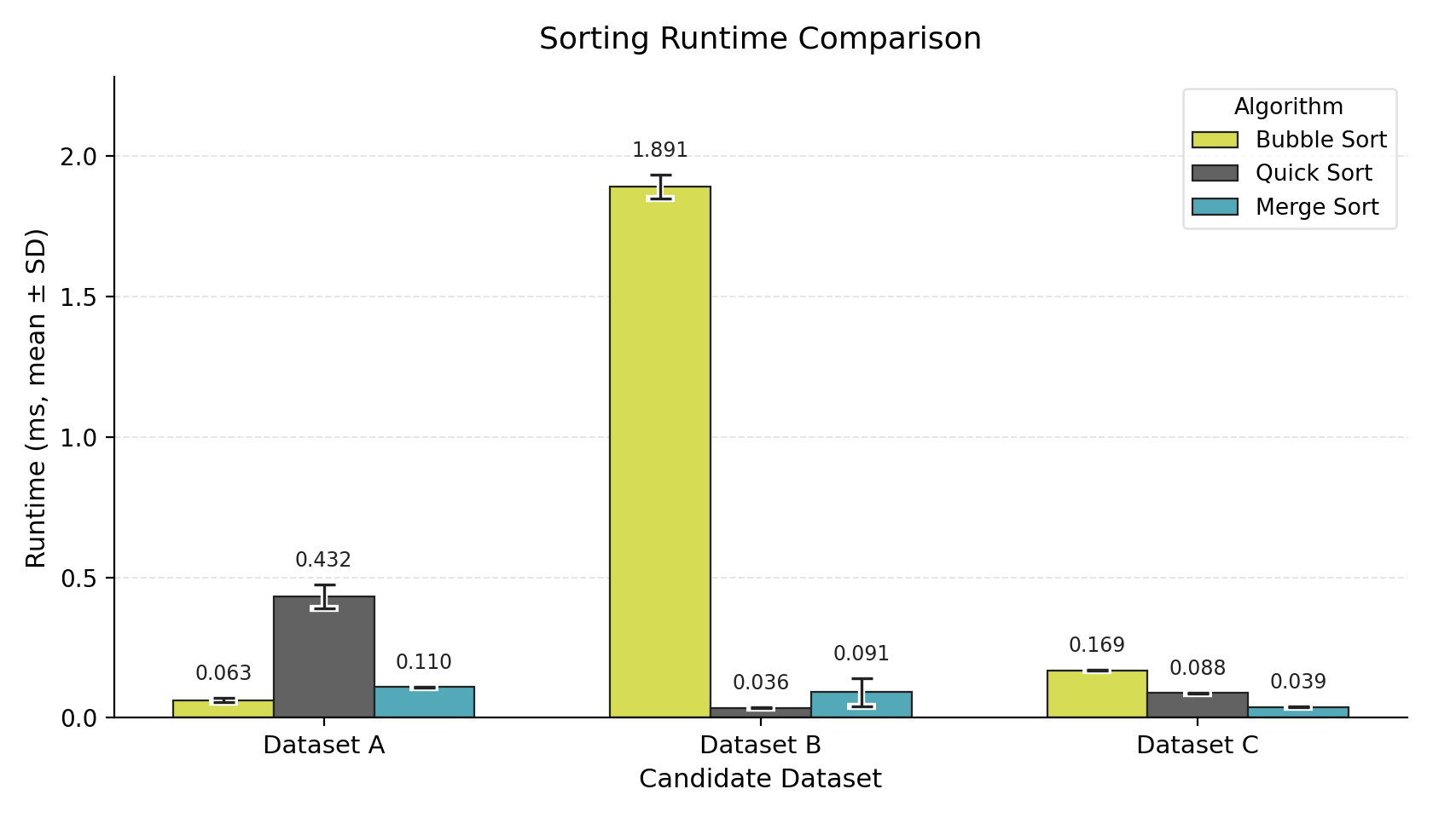Figure 2. Sorting runtime comparison across candidate datasets.
Based on Table 2 and Figure 2, the fastest algorithm differs across the three datasets. On Dataset A, Bubble Sort has the lowest mean runtime because the input is nearly sorted and the implementation can stop early after a pass with no swaps, so it requires fewer passes and fewer local swaps. On Dataset B, Quick Sort performs best in the measured runs because its partitioning is efficient for this mixed-order input. On Dataset C, Merge Sort performs best because its divide-and-merge process is less affected by duplicated priority scores and frequent tie-breaking. However, Merge Sort is still selected as the final overall choice because it provides predictable O(n log n) behaviour, the smallest cross-dataset runtime range, and acceptable O(n) extra memory for 1000 records.
The Same Order column confirms that all three algorithms produced identical rankings on each dataset. Therefore, the runtime comparison is based on equivalent outputs, and the selected Top 10 targets are taken from the validated sorted results.
The runtime comparison does not rely on a single measured value. Instead, each value is based on repeated measurements after warm-up rounds. In addition to the mean runtime and standard deviation, the program also records the median, minimum, maximum, and coefficient of variation. These extra statistics help show whether an algorithm is only fast in one run or behaves consistently across repeated runs. The full runtime details are included in the appendix as supporting evidence. The final Top 10 selected targets are listed in Table 3.
Rank | Dataset A ID | Dataset A Score | Dataset B ID | Dataset B Score | Dataset C ID | Dataset C Score
1 | A1: L0001 | 10000 | B1: L0101 | 10000 | C1: L0201 | 5000
2 | A2: L0002 | 9999 | B2: L0102 | 9999 | C2: L0202 | 5000
3 | A3: L0003 | 9998 | B3: L0103 | 9998 | C3: L0203 | 5000
4 | A4: L0004 | 9997 | B4: L0104 | 9997 | C4: L0204 | 5000
5 | A5: L0005 | 9996 | B5: L0105 | 9996 | C5: L0205 | 5000
6 | A6: L0006 | 9995 | B6: L0106 | 9995 | C6: L0206 | 5000
7 | A7: L0007 | 9994 | B7: L0107 | 9994 | C7: L0207 | 5000
8 | A8: L0008 | 9993 | B8: L0108 | 9993 | C8: L0208 | 5000
9 | A9: L0009 | 9992 | B9: L0109 | 9992 | C9: L0209 | 5000
10 | A10: L0010 | 9991 | B10: L0110 | 9991 | C10: L0210 | 5000
Table 3. Top 10 Selected Inspection Targets
These 30 selected locations are used in Chapter 2 as the important inspection targets for the required shortest-path cases. In particular, A1 is L0001, A10 is L0010, B1 is L0101, B5 is L0105, C1 is L0201, and C5 is L0205.

1.6 Performance Analysis and Final Choice
The runtime results show that the fastest algorithm may differ across the three datasets. This difference is related to both the algorithm design and the input dataset profile. Therefore, the final choice should not be based only on the fastest result in one dataset. It should also consider consistency, scalability, and memory usage.
Dataset A is analysed together with its dataset profile. If the adjacent correct order percentage is high, Bubble Sort can benefit because fewer adjacent swaps are needed. However, Bubble Sort still has O(n^2) time complexity, so it is not suitable as the general final choice.
Dataset B is used to show how algorithm performance changes when the input order is less favourable for adjacent-swap sorting. Quick Sort may perform well if the pivot produces reasonably balanced partitions, but the current implementation still uses a simple fixed pivot strategy, so its performance can be input-sensitive.
Dataset C is important because duplicated priority scores make the location_id tie-breaking rule more visible. Merge Sort is less sensitive to the original input order because it follows a fixed divide-and-merge structure, which makes it a strong choice when predictable runtime behaviour is important.
Consistency is considered in two ways in this report. Repeated-run stability is measured by the coefficient of variation within the timing experiment. Cross-dataset consistency is measured by comparing the mean runtimes across Dataset A, Dataset B, and Dataset C. The appendix shows that Merge Sort has the smallest cross-dataset runtime range among the three algorithms, which means its mean runtime changes least across the three dataset profiles.
The repeated-run CV values should be interpreted carefully because all measured runtimes are very small. In particular, sub-millisecond Java timing can be affected by JVM and system noise. Therefore, the final choice of Merge Sort is based mainly on its predictable O(n log n) time complexity, lower sensitivity to input order, and acceptable memory cost, rather than simply on the lowest repeated-run CV.
If only one sorting algorithm were allowed in the final system, Merge Sort would be the most suitable overall choice. Bubble Sort is useful as a simple baseline and performs well on the nearly sorted Dataset A, but its O(n^2) time complexity makes it unsuitable for larger or less ordered datasets. Quick Sort is efficient on average and uses less extra memory than Merge Sort, but the current fixed-pivot implementation is more input-sensitive. Merge Sort requires O(n) extra memory, but for 1000 candidate records this cost is acceptable, and its predictable O(n log n) behaviour makes it the safest final choice for this coursework system.

1.7 Time and Space Decision Support
The program also prints a time-and-space decision support table, as shown in Table 4. This table is generated by AlgorithmDecisionAnalyzer and stored using AlgorithmTradeoff objects. It combines the observed runtime results with the theoretical time and space complexity of the three sorting algorithms. This supports the follow-up question of how the algorithm choice would change if both runtime efficiency and memory usage are considered.
Algorithm | Avg Mean Time (ms) | Avg Run CV | Time Complexity | Extra Space | Decision Note | Cross-Dataset Range (ms)
Bubble Sort | 0.708 | 0.0509 | O(n^2) | O(1) | Lowest extra memory, but poor runtime scalability. | 1.828
Quick Sort | 0.185 | 0.0611 | Average O(n log n), worst O(n^2) | Average O(log n), worst O(n) stack | Good time-space balance, but input-sensitive. | 0.396
Merge Sort | 0.080 | 0.1968 | O(n log n) | O(n) | Lowest cross-dataset runtime range; predictable O(n log n), but requires O(n) extra memory. | 0.070
Table 4. Time and Space Decision Support
If memory usage is the only concern, Bubble Sort has the lowest extra space usage because it sorts in place with O(1) extra space. However, its O(n^2) time complexity makes it unsuitable for larger or less ordered datasets. Quick Sort provides a better time-space balance because it normally uses O(log n) extra stack space on average, but its worst-case runtime can still become O(n^2). Merge Sort requires O(n) extra space, but it provides predictable O(n log n) runtime.
Considering both runtime and memory usage, Merge Sort remains the final choice for this coursework system. Although it requires O(n) extra memory, this cost is acceptable for 1000 records. Its predictable O(n log n) runtime also makes it easier to justify than Bubble Sort and less input-sensitive than the current fixed-pivot Quick Sort. If memory became the main limitation in a larger system, Quick Sort with an improved pivot strategy could be considered as an alternative.

Chapter 2 - Graph Algorithm (Task B)

2.1 Task B Overview
This chapter presents the graph algorithm part of the Urban Infrastructure Inspection System. After Task A, the program obtains 30 selected inspection targets: A1-A10, B1-B10, and C1-C10. These targets are used as important query nodes in the weighted infrastructure graph provided by paths.csv.
The graph in paths.csv represents the complete infrastructure network. Therefore, the program constructs the complete infrastructure network from the full paths.csv file, with the 30 selected targets treated as important query nodes within that network. The chapter reports the four required shortest-path cases, including the self-to-itself case, the direct case, and the waypoint-based cases.

2.2 Weighted Graph Construction
The graph is constructed from paths.csv. Each row contains from_location, to_location, and weight. Since the graph is undirected, every edge is inserted in both directions.
The WeightedGraph class stores the graph as an adjacency list: Map<String, List<Edge>> adjacencyList. This structure matches the edge-based format of paths.csv. It also allows the program to access the neighbours of a node directly during shortest-path computation. For example, if paths.csv contains an edge L0001 -> L0030 with weight 15, the program adds both L0001 -> L0030 and L0030 -> L0001. Figure 3 shows the weighted graph construction and Task B query workflow.
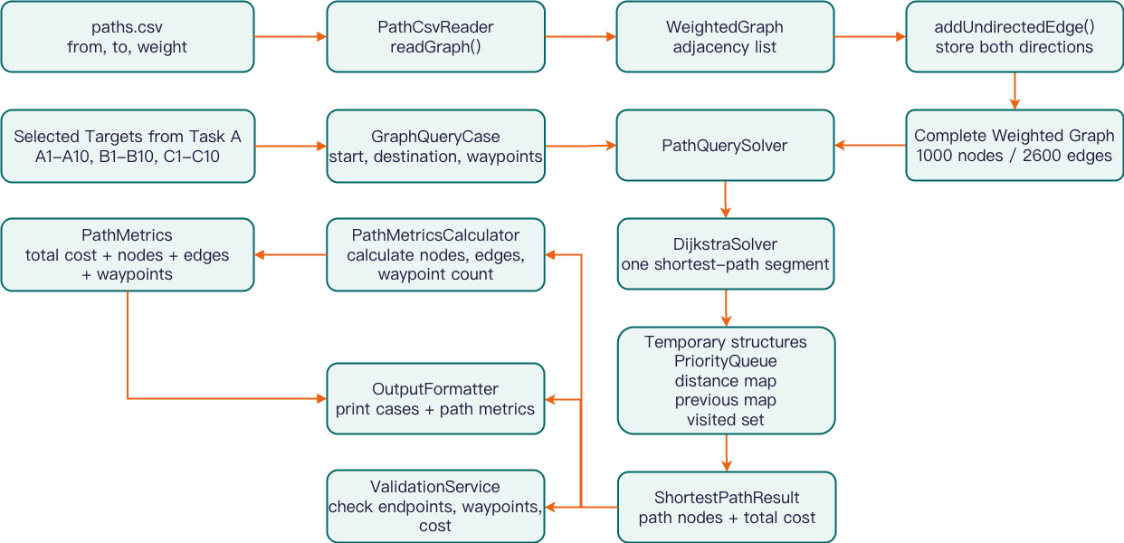
Figure 3. Weighted graph construction and Task B query workflow.

2.3 Dijkstra Algorithm Implementation
Dijkstra's algorithm is used because the coursework graph is weighted and the edge weights are non-negative. The DijkstraSolver class computes one shortest path from a start node to a destination node.
For each query, DijkstraSolver creates a new PriorityQueue, distance map, previous-node map, and visited set. The PriorityQueue selects the unvisited node with the smallest current distance. The distance map records the best known cost from the start node, and the previous-node map is used to reconstruct the final path.
The solver is designed to be stateless. All temporary data structures are created inside each shortest-path call, so one query case cannot affect another query case. The final result is stored in a ShortestPathResult object, which contains the path nodes, total cost, reachable status, and message.

2.4 Required Shortest-Path Cases and Waypoint Composition
The coursework requires four shortest-path cases based on the selected targets from Task A. Case 1 is a self-to-itself query from A1 to A1, so the path only contains A1 and the total cost is 0. Case 2 is a direct query from A1 to A10.
Case 3 and Case 4 include required waypoints. The program does not modify Dijkstra's algorithm for these cases. Instead, PathQuerySolver splits a waypoint query into several normal shortest-path segments. Case 3 is solved as A1 -> B5 and B5 -> B1. Case 4 is solved as A1 -> B5, B5 -> C5, and C5 -> C1. The final path is produced by joining the segment paths. When joining paths, the first node of each later segment is skipped to avoid duplicated waypoint nodes. The required case outputs are summarised in Table 5, and the waypoint-composition process is illustrated in Figure 4.
Case | Start | Destination | Required Waypoint(s) | Total Cost | Path Summary | Status
Case 1 | L0001 | L0001 | - | 0 | Self-to-self path | OK
Case 2 | L0001 | L0010 | - | 27 | Direct shortest path, 8 nodes / 7 edges | OK
Case 3 | L0001 | L0101 | L0105 | 39 | Combined from 2 Dijkstra segments | OK
Case 4 | L0001 | L0201 | L0105, L0205 | 48 | Combined from 3 Dijkstra segments | OK
Table 5. Required Shortest-Path Cases and Results
To keep the main report readable, Table 5 summarises the required start, destination, waypoint(s), total cost, and path status for each case. The complete shortest-path node sequence for each required case is reported in Appendix 6.2.1 as part of the required graph output, with the corresponding console evidence in Appendix 6.2.
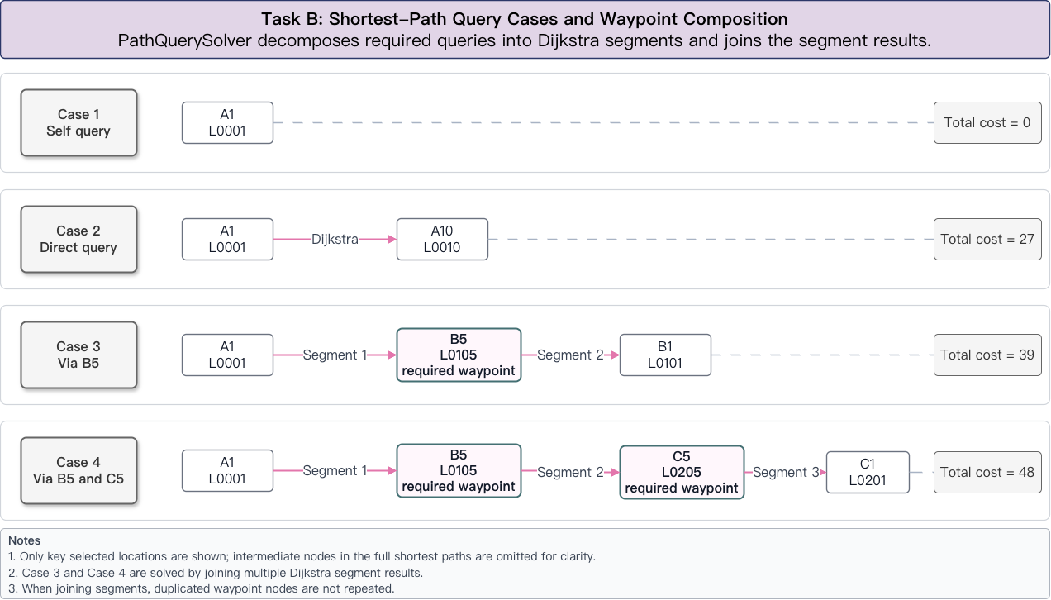Figure 4. Required shortest-path query cases and waypoint composition.
The results show that all four required cases are reachable. Case 1 correctly returns a self-to-itself path with only one node and a total cost of 0. Case 2 is solved as one direct Dijkstra query. Case 3 is solved by combining two Dijkstra segments through B5. Case 4 is solved by combining three Dijkstra segments through B5 and C5 in the required order. The validation output confirms that the reported path costs match the edge weights in the graph and that the required waypoint order is preserved.
Additional path metrics, including total cost, node count, edge count, and waypoint count, are provided in Appendix 6.2.2 as supporting evidence. These metrics confirm that the reported paths are evaluated using total weighted cost.

2.5 Complexity Analysis
The system uses an adjacency list and a priority queue to implement Dijkstra's algorithm on the full infrastructure graph loaded from paths.csv. Let V be the number of nodes in the complete graph and E be the number of edges in the graph.
Using an adjacency list, the program only visits the neighbours of each node instead of scanning all possible nodes. The priority queue helps the program select the node with the smallest current distance efficiently. Therefore, the time complexity of Dijkstra's algorithm in this design is O((V + E) log V). The graph storage requires O(V + E) space. Each Dijkstra query uses O(V) space for the distance map, previous-node map, and visited set. Since the Java PriorityQueue may contain multiple tentative entries for the same node, the auxiliary priority-queue space can be O(E) in the worst case. Therefore, the per-query auxiliary space can be described as O(V + E) in this implementation, and the overall space requirement is also O(V + E) when graph storage is included.
For waypoint queries, the program runs Dijkstra multiple times. If a query has m segments, the total time complexity is m x O((V + E) log V). In this coursework, Case 3 has two segments and Case 4 has three segments. Since the number of required segments is small, this approach is suitable and easy to explain. Table 6 summarises the time and space complexity of the main graph operations and query cases.
Operation | Time Complexity | Space Complexity | Explanation
Build graph from paths.csv | O(E) | O(V + E) | Each edge is read and inserted into the adjacency list.
Add undirected edge | O(1) average | O(1) per inserted edge | Each CSV edge is inserted in both directions.
Dijkstra with adjacency list and priority queue | O((V + E) log V) | O(V + E) auxiliary in this implementation; O(V + E) including graph storage | Suitable for weighted graphs with non-negative edge weights.
Case 1: A1 -> A1 | O(1) | O(1) | Special self-to-itself case.
Case 2: A1 -> A10 | O((V + E) log V) | O(V + E) auxiliary in this implementation; O(V + E) including graph storage | One Dijkstra query.
Case 3: A1 -> B5 -> B1 | 2 x O((V + E) log V) | O(V + E) auxiliary per segment; O(V + E) graph storage | Two Dijkstra segments.
Case 4: A1 -> B5 -> C5 -> C1 | 3 x O((V + E) log V) | O(V + E) auxiliary per segment; O(V + E) graph storage | Three Dijkstra segments.
Table 6. Graph Algorithm Complexity Analysis
This complexity is acceptable for the coursework because the program only needs to answer four required query cases. The design also remains clear and directly aligned with the weighted graph requirement.

2.6 Algorithm Evaluation and Alternatives
Dijkstra's algorithm guarantees the shortest path for a given start and destination when all edge weights are non-negative. Therefore, each direct segment solved by the program is optimal for that segment. In Case 3 and Case 4, the waypoint order is fixed by the coursework requirement, so the program obtains the shortest possible route under that fixed waypoint order by combining optimal Dijkstra segments.
However, solving these individual shortest-path queries does not mean that the whole inspection-planning problem is globally optimized. The coursework only requires four fixed query cases, and the waypoint order in Case 3 and Case 4 is already specified. The program does not decide the best visiting order for all 30 selected targets, nor does it minimize the total route for visiting every selected inspection location. A full inspection-planning problem would be closer to a route-optimization or travelling-salesperson-style problem, where the system must decide the visiting order across many targets. That broader optimization problem is outside the required scope of this coursework.
If the graph were unweighted, Breadth-First Search could be used to find the path with the fewest edges, but it would not handle different edge weights. If node coordinates were available, A* search could be considered because a heuristic may reduce unnecessary exploration. If many shortest-path queries were required on a moderate-sized graph, Floyd-Warshall could compute all-pairs shortest paths, but its O(V^3) time complexity makes it unsuitable for large graphs.
For a much larger graph, repeated Dijkstra queries may still be expensive if many start-destination pairs need to be answered. In that situation, the choice would depend on the query pattern. If only a few queries are needed, Dijkstra or A* would be more suitable because they avoid the high preprocessing cost of all-pairs methods. If many repeated queries are required on a moderate-sized graph, Floyd-Warshall or precomputed shortest-path indexes may reduce query time, but they require much higher preprocessing time and memory. If node coordinates are available and the heuristic is admissible, A* can reduce unnecessary exploration while still preserving shortest-path correctness. Therefore, the current Dijkstra-based design is appropriate for this coursework because the graph is weighted, the required queries are limited, and the implementation remains clear and verifiable.

Chapter 3 - Design of the Overall Application (Task C)

3.1 Overall Workflow and Package Structure
This chapter explains the overall design of the Urban Infrastructure Inspection System as a complete object-oriented Java application. The system connects Task A and Task B into one workflow: candidate datasets are sorted first, Top 10 targets are selected, the full weighted infrastructure graph is built from paths.csv, and the required shortest-path cases are then solved.
The program is designed as a console-based Java application because the coursework focuses on sorting algorithms, graph algorithms, data structures, and object-oriented design. The console-based architecture prioritizes algorithmic correctness, validation transparency, and clear class responsibilities.
The package structure is organized by responsibility. The io package handles CSV input. The model package stores candidate, edge, result, profile, trade-off, and path-metric objects. The sorting package implements the required sorting algorithms and timing logic. The graph package builds the weighted graph and solves shortest-path queries. The planner package coordinates the workflow, validates results, analyses dataset profiles, prepares time-space decision support, calculates path metrics, and formats the output. Figure 5 provides a simplified package-level view of this class collaboration.
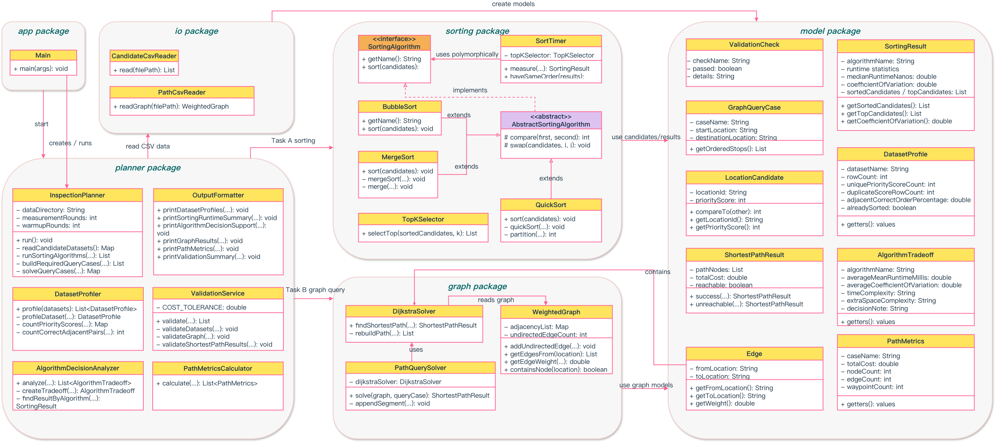Figure 5. Simplified package-level class collaboration for the overall Java application.

3.2 Data Structures and Class Responsibilities
The system uses different data structures for different parts of the application. The data structures are selected based on the access pattern required by sorting, graph construction, and shortest-path computation.
For the candidate datasets, the program uses List<LocationCandidate>. This structure is suitable because the sorting algorithms need to reorder candidate objects and traverse the data. It also supports copying the original list before each timing run, which makes the runtime comparison fair.
For the graph data, the program uses an adjacency list inside the WeightedGraph class, represented as Map<String, List<Edge>>. The key is a location ID, and the value is the list of weighted edges connected to that location. This structure is suitable for paths.csv because the file is edge-based and the graph is likely to be sparse. It also allows Dijkstra's algorithm to visit only the actual neighbours of each node.
For Dijkstra's algorithm, the program uses a PriorityQueue, maps, and a set. The priority queue selects the next node with the smallest current distance. The distance map stores the current shortest known cost. The previous-node map supports path reconstruction. The visited set prevents repeated final processing of the same node.
The system also uses small model classes to store analysis results. DatasetProfile stores dataset-level features such as unique score count, duplicated score rows, adjacent correct order percentage, and sorted status. AlgorithmTradeoff stores time-space comparison information for each sorting algorithm. PathMetrics stores total cost, node count, edge count, and waypoint count for each shortest-path case. These model classes keep the analysis data separate from the core sorting and graph algorithms. Table 7 summarises the main data structures and class responsibilities.
Package / Class | Main Responsibility
Main | Starts the application and calls InspectionPlanner.
InspectionPlanner | Coordinates data loading, sorting, target selection, graph queries, validation, analysis, and output.
LocationCandidate | Stores candidate data and defines the common ranking rule.
SortingAlgorithm | Provides a common interface for Bubble Sort, Quick Sort, and Merge Sort.
SortTimer | Runs warm-up and measured sorting rounds fairly.
WeightedGraph | Stores the full undirected weighted graph using an adjacency list.
DijkstraSolver | Computes one shortest path using Dijkstra’s algorithm.
PathQuerySolver | Combines multiple Dijkstra segments for waypoint queries.
ValidationService | Checks sorting results, selected targets, graph consistency, and path outputs.
OutputFormatter | Produces clear report-ready console output.
Table 7. Core Data Structures and Class Responsibilities
The complete class responsibility table is provided in Appendix 6.5.1 as supporting implementation evidence.
This class design avoids placing all logic inside Main.java. Each class has a focused responsibility. For example, sorting classes only implement sorting algorithms and do not read CSV files. Similarly, PathCsvReader reads graph data but does not compute shortest paths. This improves readability, maintainability, and testing.

3.3 Class and Function Collaboration
The application workflow is mainly coordinated by InspectionPlanner. The Main class only starts the program, while InspectionPlanner calls the reader, profiling, sorting, graph, validation, metrics, and output classes in order.
The collaboration process can be summarized as follows. This workflow also shows how Task A and Task B are integrated into one coherent Java application instead of being implemented as unrelated functions:
Main -> InspectionPlanner -> CandidateCsvReader -> DatasetProfiler -> SortTimer with BubbleSort / QuickSort / MergeSort -> TopKSelector -> AlgorithmDecisionAnalyzer -> PathCsvReader -> WeightedGraph -> GraphQueryCase -> DijkstraSolver / PathQuerySolver -> PathMetricsCalculator -> ValidationService -> OutputFormatter
First, InspectionPlanner uses CandidateCsvReader to load the three candidate datasets. DatasetProfiler then analyses the original input data and produces dataset profile results before sorting. Next, InspectionPlanner passes copied candidate lists to SortTimer, which runs Bubble Sort, Quick Sort, and Merge Sort through the common SortingAlgorithm interface. After sorting, TopKSelector extracts A1-A10, B1-B10, and C1-C10. AlgorithmDecisionAnalyzer then uses the SortingResult objects to produce time-and-space decision support for the three sorting algorithms.
Next, PathCsvReader reads paths.csv, and WeightedGraph stores the complete infrastructure network as an undirected weighted graph. For the graph task, InspectionPlanner creates the required GraphQueryCase objects. Direct cases are solved by DijkstraSolver, while waypoint cases are handled by PathQuerySolver, which calls DijkstraSolver for each segment and then combines the segment results. PathMetricsCalculator then calculates extra path metrics from the existing shortest-path results. ValidationService checks dataset sizes, unique location IDs, same-order sorting results, selected target counts, graph bidirectionality, path endpoints, waypoint order, and path-cost consistency. Finally, OutputFormatter prints the dataset profiles, runtime results, time-space decision support, selected targets, shortest-path cases, path metrics, and validation summary in a clear format for the report. A detailed summary of key public methods and helper methods is provided in Appendix 6.5.2. The final program also passed 39 validation checks, including dataset size checks, sorting-order checks, selected-target checks, graph bidirectionality checks, waypoint-order checks, and path-cost recalculation checks. The complete validation output is provided in Appendix 6.3.

3.4 Object-Oriented Principles and Design Justification
The system applies encapsulation, abstraction, inheritance, polymorphism, composition, and separation of concerns. These principles are reflected in the actual class design rather than only being discussed theoretically. Table 8 maps these object-oriented principles to the actual implementation.
OOP Principle | Where It Appears | How It Is Applied
Encapsulation | LocationCandidate, Edge, SortingResult, ShortestPathResult, ValidationCheck, DatasetProfile, AlgorithmTradeoff, PathMetrics | Fields are kept private and accessed through controlled methods. This protects candidate data, edge data, result data, profile data, trade-off data, path metric data, and validation details from accidental modification.
Abstraction | SortingAlgorithm interface | The planner and timer call the common sort() method without needing to know the internal logic of each sorting algorithm.
Inheritance | AbstractSortingAlgorithm and concrete sorting classes | Shared helper methods such as compare() and swap() are reused by Bubble Sort, Quick Sort, and Merge Sort.
Polymorphism | List<SortingAlgorithm> and SortTimer | Different sorting algorithm objects can be handled through the same interface type.
Composition | WeightedGraph contains Edge; PathQuerySolver uses DijkstraSolver; InspectionPlanner uses reader, sorting, graph, validation, analysis, metrics, and output classes | Complex system behaviour is built from smaller cooperating objects.
Separation of Concerns | io, model, sorting, graph, planner packages | Different responsibilities are divided into different packages, making the program easier to understand and maintain.
Table 8. OOP Principles Mapping
The OOP design improves clarity and maintainability by keeping data, algorithms, validation, and output formatting in separate classes. The clearest example is the SortingAlgorithm interface: BubbleSort, QuickSort, and MergeSort can all be stored as SortingAlgorithm objects, so SortTimer and InspectionPlanner can call sort() without checking the concrete algorithm type. This reduces repeated code and makes the timing workflow reusable.
The final design focuses on the required sorting algorithms, Dijkstra-based graph workflow, and object-oriented structure. DatasetProfiler, AlgorithmDecisionAnalyzer, and PathMetricsCalculator are kept as lightweight analysis modules that improve explainability while keeping the core algorithm workflow clear.

Chapter 4 - Project Reflection (Task D)

4.1 AI-Assisted Planning and Collaboration Tools
In this project, the team used Jira, GitHub, and limited AI-assisted support to manage the development process. Jira was used for task planning, task allocation, progress tracking, and deadline management. GitHub was used for version control, code backup, commit history, and integration of different parts of the Java application. AI-assisted support was used only for non-substantive project support, including project-management checklist review, formatting suggestions, grammar improvement, and wording clarity. The team did not use AI to generate the Java implementation or final technical answers. All algorithm choices, code, program runs, runtime results, validation evidence, and final explanations were manually completed, checked, and verified by the team.
The project was divided into sorting implementation, graph implementation, object-oriented design, testing, report writing, and presentation preparation. These tasks were created as Jira issues and moved through the workflow: To Do -> In Progress -> Review -> Done. GitHub then helped connect the planning process with the actual implementation through commits and code history. The corresponding Jira planning board, GitHub commit history, and repository/package structure evidence are provided in Appendix 6.5. These materials show how the team planned implementation, allocated tasks, tracked progress, and connected project management with the actual Java implementation. Table 9 summarises the main planning and collaboration tools used in this project.
Tool | Use in This Project | Advantage | Limitation
Jira | Task planning, task allocation, progress tracking, and deadline management | Makes tasks visible and helps divide the project into smaller issues. | Requires manual updates; the board may become inaccurate if members forget to update task status.
GitHub | Version control, code backup, commit history, and integration | Records code changes and supports collaboration between team members. | Merge conflicts may occur if related files are edited at the same time.
Team Communication | Discussion of task status, bugs, and integration problems | Helps solve problems that tools cannot automatically handle. | Requires active communication from both members.
AI-assisted tools | Project-management support, task-decomposition suggestions, checklist-style report review, formatting suggestions, and wording clarity | Helps improve planning efficiency and report clarity while keeping human verification central. | Suggestions must be checked manually; the team still needs to design the algorithms, run the program, verify the output, and explain the code independently.
Table 9. Planning and Collaboration Tools
A concrete challenge during the project was runtime measurement noise. At first, a single timing run could make one algorithm appear faster or slower by accident, especially because the datasets contain only 1000 rows and the measured times are very small. To address this, the team changed the measurement design to include warm-up rounds, repeated measured rounds, and additional statistics such as mean, median, standard deviation, and coefficient of variation. This experience showed that algorithm evaluation is not only about implementing the algorithm correctly, but also about designing a fair and explainable experiment.
Overall, Jira helped the team manage tasks, while GitHub helped the team manage code. These tools improved organization and traceability, but they did not replace direct communication and manual review.

4.2 Equality, Diversity, and Inclusion
Equality, diversity, and inclusion are relevant because future users of an infrastructure inspection system may have different abilities, languages, devices, and technical backgrounds. The current coursework system is console-based, but its output should still be clear, readable, and understandable for different users.
Future improvements could include large-font or high-contrast output, exportable route summaries, text-to-speech support, multi-language labels, and plain-language explanations of priority_score and location_id tie-breaking. These features are not part of the core coursework implementation, but they show how the system could become more accessible after the algorithmic workflow is stable. The main challenge is that accessibility features such as text-to-speech, multi-language output, and dashboards require extra interface design and user testing, so they should be added gradually after the core algorithm workflow has been validated. Additional EDI improvement details are provided in Appendix 6.6.1.

4.3 Life-long Learning and Team Contribution
This project helped the team understand that correct results are not enough; the implementation also needs fair measurement, clear validation, and maintainable design. Task A demonstrated the necessity of multi-metric algorithm evaluation, incorporating runtime, stability, memory usage, input characteristics, and scalability. In Task B, we learned that the graph must be built from the complete paths.csv file and that shortest-path correctness depends on total weighted cost and waypoint order. In Task C, we learned to organize the Java program into focused packages and classes instead of placing all logic in Main.java.
2360743 mainly contributed to the sorting module, runtime measurement, dataset profiling, time-space decision support, and Top 10 target selection. 2363304 mainly contributed to graph construction, Dijkstra’s algorithm, waypoint-based shortest-path cases, and path-metric validation. Both students contributed to object-oriented design, testing, report writing, and presentation preparation.

4.4 Future Improvements
Future development could focus on scalability, testing, collaboration, and accessibility. For larger candidate datasets, a Min-Heap Top-K method could be added when only the highest-priority locations are needed. For larger or coordinate-aware graphs, A* search, precomputed shortest-path indexes, or all-pairs shortest-path methods could be considered depending on query frequency and memory budget. The team would also add automated tests for sorting order, tie-breaking, graph loading, waypoint composition, and path-cost recalculation. A stricter GitHub branch and pull-request workflow could further reduce integration risk.

Chapter 5 - Program Code
This chapter includes the final Java source files from the src directory as text. Non-Java supporting files such as CSV datasets, generated .class files, Git metadata, screenshots, and diagram-generation scripts are not included in Chapter 5. The implementation uses only standard Java libraries such as java.io and java.util. No third-party libraries are used.

5.1 src/app/Main.java
package app;

import planner.InspectionPlanner;

public class Main {
private static final String DEFAULT_DATA_DIRECTORY = "Data";
private static final int DEFAULT_MEASUREMENT_ROUNDS = 30;
private static final int DEFAULT_WARMUP_ROUNDS = 5;

public static void main(String[] args) {
String dataDirectory = args.length >= 1 ? args[0] : DEFAULT_DATA_DIRECTORY;
int measurementRounds = args.length >= 2
? parsePositiveInteger(args[1], "measurement rounds", DEFAULT_MEASUREMENT_ROUNDS)
: DEFAULT_MEASUREMENT_ROUNDS;
int warmupRounds = args.length >= 3
? parseNonNegativeInteger(args[2], "warm-up rounds", DEFAULT_WARMUP_ROUNDS)
: DEFAULT_WARMUP_ROUNDS;

try {
InspectionPlanner planner = new InspectionPlanner(dataDirectory, measurementRounds, warmupRounds);
planner.run();
} catch (Exception exception) {
System.err.println("Application failed: " + exception.getMessage());
exception.printStackTrace(System.err);
System.exit(1);
}
}

private static int parsePositiveInteger(String value, String label, int defaultValue) {
try {
int parsed = Integer.parseInt(value);
if (parsed <= 0) {
System.out.println(label + " must be positive. Using default: " + defaultValue);
return defaultValue;
}
return parsed;
} catch (NumberFormatException exception) {
System.out.println("Invalid " + label + ". Using default: " + defaultValue);
return defaultValue;
}
}

private static int parseNonNegativeInteger(String value, String label, int defaultValue) {
try {
int parsed = Integer.parseInt(value);
if (parsed < 0) {
System.out.println(label + " must not be negative. Using default: " + defaultValue);
return defaultValue;
}
return parsed;
} catch (NumberFormatException exception) {
System.out.println("Invalid " + label + ". Using default: " + defaultValue);
return defaultValue;
}
}
}

5.2 src/io/CandidateCsvReader.java
package io;

import java.io.BufferedReader;
import java.io.FileReader;
import java.io.IOException;
import java.util.ArrayList;
import java.util.List;

import model.LocationCandidate;

public class CandidateCsvReader {
public List<LocationCandidate> read(String filePath) throws IOException {
List<LocationCandidate> candidates = new ArrayList<LocationCandidate>();

try (BufferedReader reader = new BufferedReader(new FileReader(filePath))) {
String line = reader.readLine();
int rowNumber = 1;

while ((line = reader.readLine()) != null) {
rowNumber++;
if (line.trim().isEmpty()) {
continue;
}

String[] parts = line.split(",");
if (parts.length != 2) {
throw new IOException("Invalid candidate row at " + filePath + ":" + rowNumber);
}

String locationId = parts[0].trim();
int priorityScore = parseInteger(parts[1].trim(), filePath, rowNumber);
candidates.add(new LocationCandidate(locationId, priorityScore));
}
}

return candidates;
}

private int parseInteger(String value, String filePath, int rowNumber) throws IOException {
try {
return Integer.parseInt(value);
} catch (NumberFormatException exception) {
throw new IOException("Invalid priority_score at " + filePath + ":" + rowNumber, exception);
}
}
}

5.3 src/io/PathCsvReader.java
package io;

import graph.WeightedGraph;

import java.io.BufferedReader;
import java.io.FileReader;
import java.io.IOException;

public class PathCsvReader {
public WeightedGraph readGraph(String filePath) throws IOException {
WeightedGraph graph = new WeightedGraph();

try (BufferedReader reader = new BufferedReader(new FileReader(filePath))) {
String line = reader.readLine();
int rowNumber = 1;

while ((line = reader.readLine()) != null) {
rowNumber++;
if (line.trim().isEmpty()) {
continue;
}

String[] parts = line.split(",");
if (parts.length != 3) {
throw new IOException("Invalid path row at " + filePath + ":" + rowNumber);
}

String fromLocation = parts[0].trim();
String toLocation = parts[1].trim();
double weight = parseDouble(parts[2].trim(), filePath, rowNumber);
if (weight < 0.0 || Double.isNaN(weight) || Double.isInfinite(weight)) {
throw new IOException(
"Invalid Dijkstra edge weight at " + filePath + ":" + rowNumber
+ ". Weight must be finite and non-negative.");
}
graph.addUndirectedEdge(fromLocation, toLocation, weight);
}
}

return graph;
}

private double parseDouble(String value, String filePath, int rowNumber) throws IOException {
try {
return Double.parseDouble(value);
} catch (NumberFormatException exception) {
throw new IOException("Invalid weight at " + filePath + ":" + rowNumber, exception);
}
}
}

5.4 src/model/LocationCandidate.java
package model;

import java.util.Objects;

public class LocationCandidate implements Comparable<LocationCandidate> {
private final String locationId;
private final int priorityScore;

public LocationCandidate(String locationId, int priorityScore) {
if (locationId == null || locationId.trim().isEmpty()) {
throw new IllegalArgumentException("locationId must not be empty");
}
this.locationId = locationId.trim();
this.priorityScore = priorityScore;
}

public String getLocationId() {
return locationId;
}

public int getPriorityScore() {
return priorityScore;
}

@Override
public int compareTo(LocationCandidate other) {
// Higher priority scores should come first
int scoreComparison = Integer.compare(other.priorityScore, this.priorityScore);
if (scoreComparison != 0) {
return scoreComparison;
}
// Use the id as a tie breaker so the order stays stable
return this.locationId.compareTo(other.locationId);
}

@Override
public boolean equals(Object object) {
if (this == object) {
return true;
}
if (!(object instanceof LocationCandidate)) {
return false;
}
LocationCandidate that = (LocationCandidate) object;
return priorityScore == that.priorityScore && locationId.equals(that.locationId);
}

@Override
public int hashCode() {
return Objects.hash(locationId, priorityScore);
}

@Override
public String toString() {
return locationId + "(" + priorityScore + ")";
}
}

5.5 src/model/Edge.java
package model;

public class Edge {
private final String fromLocation;
private final String toLocation;
private final double weight;

public Edge(String fromLocation, String toLocation, double weight) {
if (fromLocation == null || fromLocation.trim().isEmpty()) {
throw new IllegalArgumentException("fromLocation must not be empty");
}
if (toLocation == null || toLocation.trim().isEmpty()) {
throw new IllegalArgumentException("toLocation must not be empty");
}
if (weight < 0) {
throw new IllegalArgumentException("Dijkstra requires non-negative edge weights");
}
this.fromLocation = fromLocation.trim();
this.toLocation = toLocation.trim();
this.weight = weight;
}

public String getFromLocation() {
return fromLocation;
}

public String getToLocation() {
return toLocation;
}

public double getWeight() {
return weight;
}
}

5.6 src/model/SortingResult.java
package model;

import java.util.ArrayList;
import java.util.Collections;
import java.util.List;

public class SortingResult {
private final String datasetName;
private final String algorithmName;
private final double meanRuntimeNanos;
private final double standardDeviationRuntimeNanos;
private final double medianRuntimeNanos;
private final long minRuntimeNanos;
private final long maxRuntimeNanos;
private final double coefficientOfVariation;
private final int measurementRounds;
private final int warmupRounds;
private final List<LocationCandidate> sortedCandidates;
private final List<LocationCandidate> topCandidates;

public SortingResult(
String datasetName,
String algorithmName,
double meanRuntimeNanos,
double standardDeviationRuntimeNanos,
double medianRuntimeNanos,
long minRuntimeNanos,
long maxRuntimeNanos,
double coefficientOfVariation,
int measurementRounds,
int warmupRounds,
List<LocationCandidate> sortedCandidates,
List<LocationCandidate> topCandidates) {
this.datasetName = datasetName;
this.algorithmName = algorithmName;
this.meanRuntimeNanos = meanRuntimeNanos;
this.standardDeviationRuntimeNanos = standardDeviationRuntimeNanos;
this.medianRuntimeNanos = medianRuntimeNanos;
this.minRuntimeNanos = minRuntimeNanos;
this.maxRuntimeNanos = maxRuntimeNanos;
this.coefficientOfVariation = coefficientOfVariation;
this.measurementRounds = measurementRounds;
this.warmupRounds = warmupRounds;
this.sortedCandidates = Collections.unmodifiableList(new ArrayList<LocationCandidate>(sortedCandidates));
this.topCandidates = Collections.unmodifiableList(new ArrayList<LocationCandidate>(topCandidates));
}

public String getDatasetName() {
return datasetName;
}

public String getAlgorithmName() {
return algorithmName;
}

public double getMeanRuntimeNanos() {
return meanRuntimeNanos;
}

public double getStandardDeviationRuntimeNanos() {
return standardDeviationRuntimeNanos;
}

public double getMedianRuntimeNanos() {
return medianRuntimeNanos;
}

public long getMinRuntimeNanos() {
return minRuntimeNanos;
}

public long getMaxRuntimeNanos() {
return maxRuntimeNanos;
}

public double getCoefficientOfVariation() {
return coefficientOfVariation;
}

public int getMeasurementRounds() {
return measurementRounds;
}

public int getWarmupRounds() {
return warmupRounds;
}

public List<LocationCandidate> getSortedCandidates() {
return sortedCandidates;
}

public List<LocationCandidate> getTopCandidates() {
return topCandidates;
}
}

5.7 src/model/ShortestPathResult.java
package model;

import java.util.ArrayList;
import java.util.Collections;
import java.util.List;

public class ShortestPathResult {
private final List<String> pathNodes;
private final double totalCost;
private final boolean reachable;
private final String message;

private ShortestPathResult(List<String> pathNodes, double totalCost, boolean reachable, String message) {
this.pathNodes = Collections.unmodifiableList(new ArrayList<String>(pathNodes));
this.totalCost = totalCost;
this.reachable = reachable;
this.message = message;
}

public static ShortestPathResult success(List<String> pathNodes, double totalCost) {
return new ShortestPathResult(pathNodes, totalCost, true, "OK");
}

public static ShortestPathResult unreachable(String message) {
return new ShortestPathResult(Collections.<String>emptyList(), Double.POSITIVE_INFINITY, false, message);
}

public List<String> getPathNodes() {
return pathNodes;
}

public double getTotalCost() {
return totalCost;
}

public boolean isReachable() {
return reachable;
}

public String getMessage() {
return message;
}
}

5.8 src/model/GraphQueryCase.java
package model;

import java.util.ArrayList;
import java.util.Collections;
import java.util.List;

public class GraphQueryCase {
private final String caseName;
private final String startLocation;
private final String destinationLocation;
private final List<String> waypointLocations;

public GraphQueryCase(
String caseName,
String startLocation,
String destinationLocation,
List<String> waypointLocations) {
if (caseName == null || caseName.trim().isEmpty()) {
throw new IllegalArgumentException("caseName must not be empty");
}
if (startLocation == null || startLocation.trim().isEmpty()) {
throw new IllegalArgumentException("startLocation must not be empty");
}
if (destinationLocation == null || destinationLocation.trim().isEmpty()) {
throw new IllegalArgumentException("destinationLocation must not be empty");
}
this.caseName = caseName.trim();
this.startLocation = startLocation.trim();
this.destinationLocation = destinationLocation.trim();
if (waypointLocations == null) {
this.waypointLocations = Collections.emptyList();
} else {
// Copy waypoints so the case cannot change later by accident
this.waypointLocations = Collections.unmodifiableList(new ArrayList<String>(waypointLocations));
}
}

public String getCaseName() {
return caseName;
}

public String getStartLocation() {
return startLocation;
}

public String getDestinationLocation() {
return destinationLocation;
}

public List<String> getWaypointLocations() {
return waypointLocations;
}

public List<String> getOrderedStops() {
List<String> stops = new ArrayList<String>();
// The solver links each neighboring pair in this list
stops.add(startLocation);
stops.addAll(waypointLocations);
stops.add(destinationLocation);
return stops;
}
}

5.9 src/model/DatasetProfile.java
package model;

public class DatasetProfile {
private final String datasetName;
private final int rowCount;
private final int uniquePriorityScoreCount;
private final int duplicateScoreRowCount;
private final int adjacentOutOfOrderPairCount;
private final double adjacentCorrectOrderPercentage;
private final double adjacentOutOfOrderPercentage;
private final boolean alreadySorted;
private final String inputOrderDescription;

public DatasetProfile(
String datasetName,
int rowCount,
int uniquePriorityScoreCount,
int duplicateScoreRowCount,
int adjacentOutOfOrderPairCount,
double adjacentCorrectOrderPercentage,
double adjacentOutOfOrderPercentage,
boolean alreadySorted,
String inputOrderDescription) {
this.datasetName = datasetName;
this.rowCount = rowCount;
this.uniquePriorityScoreCount = uniquePriorityScoreCount;
this.duplicateScoreRowCount = duplicateScoreRowCount;
this.adjacentOutOfOrderPairCount = adjacentOutOfOrderPairCount;
this.adjacentCorrectOrderPercentage = adjacentCorrectOrderPercentage;
this.adjacentOutOfOrderPercentage = adjacentOutOfOrderPercentage;
this.alreadySorted = alreadySorted;
this.inputOrderDescription = inputOrderDescription;
}

public String getDatasetName() {
return datasetName;
}

public int getRowCount() {
return rowCount;
}

public int getUniquePriorityScoreCount() {
return uniquePriorityScoreCount;
}

public int getDuplicateScoreRowCount() {
return duplicateScoreRowCount;
}

public int getAdjacentOutOfOrderPairCount() {
return adjacentOutOfOrderPairCount;
}

public double getAdjacentCorrectOrderPercentage() {
return adjacentCorrectOrderPercentage;
}

public double getAdjacentOutOfOrderPercentage() {
return adjacentOutOfOrderPercentage;
}

public boolean isAlreadySorted() {
return alreadySorted;
}

public String getInputOrderDescription() {
return inputOrderDescription;
}
}

5.10 src/model/AlgorithmTradeoff.java
package model;

public class AlgorithmTradeoff {
private final String algorithmName;
private final double averageMeanRuntimeMillis;
private final double averageRunCoefficientOfVariation;
private final double crossDatasetCoefficientOfVariation;
private final double crossDatasetRuntimeRangeMillis;
private final String timeComplexity;
private final String extraSpaceComplexity;
private final String decisionNote;

public AlgorithmTradeoff(
String algorithmName,
double averageMeanRuntimeMillis,
double averageRunCoefficientOfVariation,
double crossDatasetCoefficientOfVariation,
double crossDatasetRuntimeRangeMillis,
String timeComplexity,
String extraSpaceComplexity,
String decisionNote) {
this.algorithmName = algorithmName;
this.averageMeanRuntimeMillis = averageMeanRuntimeMillis;
this.averageRunCoefficientOfVariation = averageRunCoefficientOfVariation;
this.crossDatasetCoefficientOfVariation = crossDatasetCoefficientOfVariation;
this.crossDatasetRuntimeRangeMillis = crossDatasetRuntimeRangeMillis;
this.timeComplexity = timeComplexity;
this.extraSpaceComplexity = extraSpaceComplexity;
this.decisionNote = decisionNote;
}

public String getAlgorithmName() {
return algorithmName;
}

public double getAverageMeanRuntimeMillis() {
return averageMeanRuntimeMillis;
}

public double getAverageRunCoefficientOfVariation() {
return averageRunCoefficientOfVariation;
}

public double getCrossDatasetCoefficientOfVariation() {
return crossDatasetCoefficientOfVariation;
}

public double getCrossDatasetRuntimeRangeMillis() {
return crossDatasetRuntimeRangeMillis;
}

public String getTimeComplexity() {
return timeComplexity;
}

public String getExtraSpaceComplexity() {
return extraSpaceComplexity;
}

public String getDecisionNote() {
return decisionNote;
}
}

5.11 src/model/PathMetrics.java
package model;

public class PathMetrics {
private final String caseName;
private final double totalCost;
private final int nodeCount;
private final int edgeCount;
private final int waypointCount;

public PathMetrics(
String caseName,
double totalCost,
int nodeCount,
int edgeCount,
int waypointCount) {
this.caseName = caseName;
this.totalCost = totalCost;
this.nodeCount = nodeCount;
this.edgeCount = edgeCount;
this.waypointCount = waypointCount;
}

public String getCaseName() {
return caseName;
}

public double getTotalCost() {
return totalCost;
}

public int getNodeCount() {
return nodeCount;
}

public int getEdgeCount() {
return edgeCount;
}

public int getWaypointCount() {
return waypointCount;
}
}

5.12 src/model/ValidationCheck.java
package model;

public class ValidationCheck {
private final String checkName;
private final boolean passed;
private final String details;

public ValidationCheck(String checkName, boolean passed, String details) {
if (checkName == null || checkName.trim().isEmpty()) {
throw new IllegalArgumentException("checkName must not be empty");
}
this.checkName = checkName.trim();
this.passed = passed;
this.details = details == null ? "" : details.trim();
}

public String getCheckName() {
return checkName;
}

public boolean isPassed() {
return passed;
}

public String getDetails() {
return details;
}
}

5.13 src/sorting/SortingAlgorithm.java
package sorting;

import java.util.List;

import model.LocationCandidate;

public interface SortingAlgorithm {
String getName();

void sort(List<LocationCandidate> candidates);
}

5.14 src/sorting/AbstractSortingAlgorithm.java
package sorting;

import java.util.List;

import model.LocationCandidate;

public abstract class AbstractSortingAlgorithm implements SortingAlgorithm {
protected int compare(LocationCandidate first, LocationCandidate second) {
return first.compareTo(second);
}

protected void swap(List<LocationCandidate> candidates, int firstIndex, int secondIndex) {
if (firstIndex == secondIndex) {
return;
}
LocationCandidate temporary = candidates.get(firstIndex);
candidates.set(firstIndex, candidates.get(secondIndex));
candidates.set(secondIndex, temporary);
}
}

5.15 src/sorting/BubbleSort.java
package sorting;

import java.util.List;

import model.LocationCandidate;

public class BubbleSort extends AbstractSortingAlgorithm {
@Override
public String getName() {
return "Bubble Sort";
}

@Override
public void sort(List<LocationCandidate> candidates) {
int size = candidates.size();
boolean swapped = true;

// Stop early if a full pass did not swap anything
for (int pass = 0; pass < size - 1 && swapped; pass++) {
swapped = false;
for (int index = 0; index < size - pass - 1; index++) {
if (compare(candidates.get(index), candidates.get(index + 1)) > 0) {
swap(candidates, index, index + 1);
swapped = true;
}
}
}
}
}

5.16 src/sorting/QuickSort.java
package sorting;

import java.util.List;

import model.LocationCandidate;

public class QuickSort extends AbstractSortingAlgorithm {
@Override
public String getName() {
return "Quick Sort";
}

@Override
public void sort(List<LocationCandidate> candidates) {
quickSort(candidates, 0, candidates.size() - 1);
}

private void quickSort(List<LocationCandidate> candidates, int low, int high) {
if (low >= high) {
return;
}

int pivotIndex = partition(candidates, low, high);
quickSort(candidates, low, pivotIndex - 1);
quickSort(candidates, pivotIndex + 1, high);
}

private int partition(List<LocationCandidate> candidates, int low, int high) {
// Use the last item as the pivot here
LocationCandidate pivot = candidates.get(high);
int smallerBoundary = low - 1;

for (int index = low; index < high; index++) {
if (compare(candidates.get(index), pivot) <= 0) {
smallerBoundary++;
swap(candidates, smallerBoundary, index);
}
}

swap(candidates, smallerBoundary + 1, high);
return smallerBoundary + 1;
}
}

5.17 src/sorting/MergeSort.java
package sorting;

import java.util.ArrayList;
import java.util.List;

import model.LocationCandidate;

public class MergeSort extends AbstractSortingAlgorithm {
@Override
public String getName() {
return "Merge Sort";
}

@Override
public void sort(List<LocationCandidate> candidates) {
if (candidates.size() <= 1) {
return;
}
// Temp list so merge can read old values while writing back
List<LocationCandidate> temporary = new ArrayList<LocationCandidate>(candidates);
mergeSort(candidates, temporary, 0, candidates.size() - 1);
}

private void mergeSort(List<LocationCandidate> candidates, List<LocationCandidate> temporary, int left, int right) {
if (left >= right) {
return;
}

int middle = left + (right - left) / 2;
mergeSort(candidates, temporary, left, middle);
mergeSort(candidates, temporary, middle + 1, right);
merge(candidates, temporary, left, middle, right);
}

private void merge(
List<LocationCandidate> candidates,
List<LocationCandidate> temporary,
int left,
int middle,
int right) {
for (int index = left; index <= right; index++) {
temporary.set(index, candidates.get(index));
}

int leftIndex = left;
int rightIndex = middle + 1;
int targetIndex = left;

while (leftIndex <= middle && rightIndex <= right) {
if (compare(temporary.get(leftIndex), temporary.get(rightIndex)) <= 0) {
candidates.set(targetIndex, temporary.get(leftIndex));
leftIndex++;
} else {
candidates.set(targetIndex, temporary.get(rightIndex));
rightIndex++;
}
targetIndex++;
}

while (leftIndex <= middle) {
candidates.set(targetIndex, temporary.get(leftIndex));
leftIndex++;
targetIndex++;
}
}
}

5.18 src/sorting/SortTimer.java
package sorting;

import java.util.ArrayList;
import java.util.Arrays;
import java.util.List;

import model.LocationCandidate;
import model.SortingResult;

public class SortTimer {
private final TopKSelector topKSelector;

public SortTimer(TopKSelector topKSelector) {
this.topKSelector = topKSelector;
}

public SortingResult measure(
String datasetName,
List<LocationCandidate> originalCandidates,
SortingAlgorithm algorithm,
int rounds,
int warmupRounds,
int topK) {
// Warm-up runs are not counted in the final timing
for (int warmup = 0; warmup < warmupRounds; warmup++) {
List<LocationCandidate> warmupCopy = new ArrayList<LocationCandidate>(originalCandidates);
algorithm.sort(warmupCopy);
validateSorted(warmupCopy, algorithm.getName(), datasetName);
}

long[] durations = new long[rounds];
List<LocationCandidate> lastSortedCopy = new ArrayList<LocationCandidate>();

for (int round = 0; round < rounds; round++) {
// Sort a fresh copy so each round starts the same
List<LocationCandidate> workingCopy = new ArrayList<LocationCandidate>(originalCandidates);

long startTime = System.nanoTime();
algorithm.sort(workingCopy);
long endTime = System.nanoTime();

validateSorted(workingCopy, algorithm.getName(), datasetName);
durations[round] = endTime - startTime;
lastSortedCopy = workingCopy;
}

double meanRuntime = calculateMean(durations);
double standardDeviation = calculateStandardDeviation(durations, meanRuntime);
double medianRuntime = calculateMedian(durations);
long minRuntime = findMin(durations);
long maxRuntime = findMax(durations);
double coefficientOfVariation = meanRuntime == 0.0 ? 0.0 : standardDeviation / meanRuntime;
List<LocationCandidate> topCandidates = topKSelector.selectTop(lastSortedCopy, topK);

return new SortingResult(
datasetName,
algorithm.getName(),
meanRuntime,
standardDeviation,
medianRuntime,
minRuntime,
maxRuntime,
coefficientOfVariation,
rounds,
warmupRounds,
lastSortedCopy,
topCandidates);
}

public boolean haveSameOrder(List<SortingResult> results) {
if (results.size() <= 1) {
return true;
}

List<LocationCandidate> expected = results.get(0).getSortedCandidates();
// Compare the full order before trusting one algorithm's top 10
for (int index = 1; index < results.size(); index++) {
if (!expected.equals(results.get(index).getSortedCandidates())) {
return false;
}
}
return true;
}

private void validateSorted(List<LocationCandidate> candidates, String algorithmName, String datasetName) {
for (int index = 1; index < candidates.size(); index++) {
if (candidates.get(index - 1).compareTo(candidates.get(index)) > 0) {
throw new IllegalStateException(
algorithmName + " produced invalid order for " + datasetName + " at index " + index);
}
}
}

private double calculateMean(long[] durations) {
long total = 0L;
for (long duration : durations) {
total += duration;
}
return total / (double) durations.length;
}

private double calculateStandardDeviation(long[] durations, double mean) {
double squaredDifferenceTotal = 0.0;
for (long duration : durations) {
double difference = duration - mean;
squaredDifferenceTotal += difference * difference;
}
return Math.sqrt(squaredDifferenceTotal / durations.length);
}

private double calculateMedian(long[] durations) {
long[] sortedDurations = Arrays.copyOf(durations, durations.length);
Arrays.sort(sortedDurations);

int middle = sortedDurations.length / 2;
if (sortedDurations.length % 2 == 1) {
return sortedDurations[middle];
}
return (sortedDurations[middle - 1] + sortedDurations[middle]) / 2.0;
}

private long findMin(long[] durations) {
long min = durations[0];
for (long duration : durations) {
if (duration < min) {
min = duration;
}
}
return min;
}

private long findMax(long[] durations) {
long max = durations[0];
for (long duration : durations) {
if (duration > max) {
max = duration;
}
}
return max;
}
}

5.19 src/sorting/TopKSelector.java
package sorting;

import java.util.ArrayList;
import java.util.List;

import model.LocationCandidate;

public class TopKSelector {
public List<LocationCandidate> selectTop(List<LocationCandidate> sortedCandidates, int k) {
// Avoid asking for more rows than the list actually has
int limit = Math.min(k, sortedCandidates.size());
return new ArrayList<LocationCandidate>(sortedCandidates.subList(0, limit));
}
}

5.20 src/graph/WeightedGraph.java
package graph;

import model.Edge;

import java.util.ArrayList;
import java.util.Collections;
import java.util.LinkedHashMap;
import java.util.List;
import java.util.Map;
import java.util.Set;

public class WeightedGraph {
private final Map<String, List<Edge>> adjacencyList;
private int undirectedEdgeCount;

public WeightedGraph() {
this.adjacencyList = new LinkedHashMap<String, List<Edge>>();
this.undirectedEdgeCount = 0;
}

public void addUndirectedEdge(String fromLocation, String toLocation, double weight) {
addDirectedEdge(fromLocation, toLocation, weight);
addDirectedEdge(toLocation, fromLocation, weight);
undirectedEdgeCount++;
}

public List<Edge> getEdgesFrom(String location) {
List<Edge> edges = adjacencyList.get(location);
if (edges == null) {
return Collections.emptyList();
}
return Collections.unmodifiableList(edges);
}

public double getEdgeWeight(String fromLocation, String toLocation) {
List<Edge> edges = adjacencyList.get(fromLocation);
if (edges == null) {
return Double.POSITIVE_INFINITY;
}

double bestWeight = Double.POSITIVE_INFINITY;
for (Edge edge : edges) {
// If the CSV has repeated edges, use the cheapest one
if (edge.getToLocation().equals(toLocation) && edge.getWeight() < bestWeight) {
bestWeight = edge.getWeight();
}
}
return bestWeight;
}

public boolean containsNode(String location) {
return adjacencyList.containsKey(location);
}

public int getNodeCount() {
return adjacencyList.size();
}

public int getUndirectedEdgeCount() {
return undirectedEdgeCount;
}

public double getMinimumEdgeWeight() {
double minimum = Double.POSITIVE_INFINITY;
for (List<Edge> edges : adjacencyList.values()) {
for (Edge edge : edges) {
if (edge.getWeight() < minimum) {
minimum = edge.getWeight();
}
}
}
return minimum;
}

public double getMaximumEdgeWeight() {
double maximum = Double.NEGATIVE_INFINITY;
for (List<Edge> edges : adjacencyList.values()) {
for (Edge edge : edges) {
if (edge.getWeight() > maximum) {
maximum = edge.getWeight();
}
}
}
return maximum;
}

public boolean hasOnlyNonNegativeWeights() {
for (List<Edge> edges : adjacencyList.values()) {
for (Edge edge : edges) {
if (edge.getWeight() < 0.0) {
return false;
}
}
}
return true;
}

public Set<String> getNodes() {
return Collections.unmodifiableSet(adjacencyList.keySet());
}

private void addDirectedEdge(String fromLocation, String toLocation, double weight) {
if (!adjacencyList.containsKey(fromLocation)) {
adjacencyList.put(fromLocation, new ArrayList<Edge>());
}
if (!adjacencyList.containsKey(toLocation)) {
adjacencyList.put(toLocation, new ArrayList<Edge>());
}
adjacencyList.get(fromLocation).add(new Edge(fromLocation, toLocation, weight));
}
}

5.21 src/graph/DijkstraSolver.java
package graph;

import model.Edge;
import model.ShortestPathResult;

import java.util.ArrayList;
import java.util.Collections;
import java.util.Comparator;
import java.util.HashMap;
import java.util.HashSet;
import java.util.List;
import java.util.Map;
import java.util.PriorityQueue;
import java.util.Set;

public class DijkstraSolver {
public ShortestPathResult findShortestPath(WeightedGraph graph, String startLocation, String destinationLocation) {
if (!graph.containsNode(startLocation)) {
return ShortestPathResult.unreachable("Start node not found in graph: " + startLocation);
}
if (!graph.containsNode(destinationLocation)) {
return ShortestPathResult.unreachable("Destination node not found in graph: " + destinationLocation);
}
if (startLocation.equals(destinationLocation)) {
return ShortestPathResult.success(Collections.singletonList(startLocation), 0.0);
}

Map<String, Double> distances = new HashMap<String, Double>();
Map<String, String> previousNodes = new HashMap<String, String>();
Set<String> visited = new HashSet<String>();
// Queue keeps the next cheapest node to try
PriorityQueue<NodeDistance> priorityQueue = new PriorityQueue<NodeDistance>(
Comparator.comparingDouble(NodeDistance::getDistance).thenComparing(NodeDistance::getLocation));

distances.put(startLocation, 0.0);
priorityQueue.add(new NodeDistance(startLocation, 0.0));

while (!priorityQueue.isEmpty()) {
NodeDistance current = priorityQueue.poll();
if (visited.contains(current.getLocation())) {
continue;
}
visited.add(current.getLocation());

if (current.getLocation().equals(destinationLocation)) {
break;
}

for (Edge edge : graph.getEdgesFrom(current.getLocation())) {
String neighbor = edge.getToLocation();
if (visited.contains(neighbor)) {
continue;
}

double currentDistance = distances.get(current.getLocation());
double candidateDistance = currentDistance + edge.getWeight();
double knownDistance = distances.containsKey(neighbor)
? distances.get(neighbor)
: Double.POSITIVE_INFINITY;

if (candidateDistance < knownDistance) {
// Keep the best cost found so far for each neighbor
distances.put(neighbor, candidateDistance);
previousNodes.put(neighbor, current.getLocation());
priorityQueue.add(new NodeDistance(neighbor, candidateDistance));
}
}
}

if (!distances.containsKey(destinationLocation)) {
return ShortestPathResult.unreachable(
"No path found from " + startLocation + " to " + destinationLocation);
}

List<String> path = rebuildPath(previousNodes, startLocation, destinationLocation);
return ShortestPathResult.success(path, distances.get(destinationLocation));
}

private List<String> rebuildPath(
Map<String, String> previousNodes,
String startLocation,
String destinationLocation) {
List<String> path = new ArrayList<String>();
String current = destinationLocation;

while (current != null) {
path.add(current);
if (current.equals(startLocation)) {
break;
}
current = previousNodes.get(current);
}

Collections.reverse(path);
return path;
}

private static class NodeDistance {
private final String location;
private final double distance;

NodeDistance(String location, double distance) {
this.location = location;
this.distance = distance;
}

String getLocation() {
return location;
}

double getDistance() {
return distance;
}
}
}

5.22 src/graph/PathQuerySolver.java
package graph;

import model.GraphQueryCase;
import model.ShortestPathResult;

import java.util.ArrayList;
import java.util.List;

public class PathQuerySolver {
private final DijkstraSolver dijkstraSolver;

public PathQuerySolver(DijkstraSolver dijkstraSolver) {
this.dijkstraSolver = dijkstraSolver;
}

public ShortestPathResult solve(WeightedGraph graph, GraphQueryCase queryCase) {
List<String> orderedStops = queryCase.getOrderedStops();
List<String> completePath = new ArrayList<String>();
double totalCost = 0.0;

for (int index = 0; index < orderedStops.size() - 1; index++) {
String segmentStart = orderedStops.get(index);
String segmentDestination = orderedStops.get(index + 1);

ShortestPathResult segmentResult = dijkstraSolver.findShortestPath(
graph,
segmentStart,
segmentDestination);

if (!segmentResult.isReachable()) {
return ShortestPathResult.unreachable(
queryCase.getCaseName()
+ " failed between "
+ segmentStart
+ " and "
+ segmentDestination
+ ": "
+ segmentResult.getMessage());
}

appendSegment(completePath, segmentResult.getPathNodes());
totalCost += segmentResult.getTotalCost();
}

return ShortestPathResult.success(completePath, totalCost);
}

private void appendSegment(List<String> completePath, List<String> segmentPath) {
if (segmentPath.isEmpty()) {
return;
}
if (completePath.isEmpty()) {
completePath.addAll(segmentPath);
return;
}
// Skip the first node so the waypoint is not added twice
for (int index = 1; index < segmentPath.size(); index++) {
completePath.add(segmentPath.get(index));
}
}
}

5.23 src/planner/InspectionPlanner.java
package planner;

import graph.DijkstraSolver;
import graph.PathQuerySolver;
import graph.WeightedGraph;
import io.CandidateCsvReader;
import io.PathCsvReader;
import model.AlgorithmTradeoff;
import model.DatasetProfile;
import model.GraphQueryCase;
import model.LocationCandidate;
import model.PathMetrics;
import model.ShortestPathResult;
import model.SortingResult;
import model.ValidationCheck;
import sorting.BubbleSort;
import sorting.MergeSort;
import sorting.QuickSort;
import sorting.SortTimer;
import sorting.SortingAlgorithm;
import sorting.TopKSelector;

import java.io.File;
import java.io.IOException;
import java.util.ArrayList;
import java.util.Arrays;
import java.util.LinkedHashMap;
import java.util.List;
import java.util.Map;

public class InspectionPlanner {
private static final int TOP_TARGET_COUNT = 10;
private static final int EXPECTED_CANDIDATE_COUNT = 1000;
private static final int EXPECTED_GRAPH_NODE_COUNT = 1000;
private static final int EXPECTED_GRAPH_EDGE_COUNT = 2600;
private static final String DATASET_A = "Dataset A";
private static final String DATASET_B = "Dataset B";
private static final String DATASET_C = "Dataset C";
private static final String CASE_ONE_NAME = "Case 1: A1 to A1";

private final String dataDirectory;
private final int measurementRounds;
private final int warmupRounds;
private final CandidateCsvReader candidateCsvReader;
private final PathCsvReader pathCsvReader;
private final SortTimer sortTimer;
private final PathQuerySolver pathQuerySolver;
private final OutputFormatter outputFormatter;
private final ValidationService validationService;
private final DatasetProfiler datasetProfiler;
private final AlgorithmDecisionAnalyzer algorithmDecisionAnalyzer;
private final PathMetricsCalculator pathMetricsCalculator;
private final List<SortingAlgorithm> sortingAlgorithms;

public InspectionPlanner(String dataDirectory, int measurementRounds, int warmupRounds) {
this.dataDirectory = dataDirectory;
this.measurementRounds = measurementRounds;
this.warmupRounds = warmupRounds;
this.candidateCsvReader = new CandidateCsvReader();
this.pathCsvReader = new PathCsvReader();
this.sortTimer = new SortTimer(new TopKSelector());
this.pathQuerySolver = new PathQuerySolver(new DijkstraSolver());
this.outputFormatter = new OutputFormatter();
this.validationService = new ValidationService();
this.datasetProfiler = new DatasetProfiler();
this.algorithmDecisionAnalyzer = new AlgorithmDecisionAnalyzer();
this.pathMetricsCalculator = new PathMetricsCalculator();
this.sortingAlgorithms = Arrays.<SortingAlgorithm>asList(
new BubbleSort(),
new QuickSort(),
new MergeSort());
}

public void run() throws IOException {
outputFormatter.printHeader(dataDirectory, measurementRounds, warmupRounds);

Map<String, List<LocationCandidate>> datasets = readCandidateDatasets();
List<DatasetProfile> datasetProfiles = datasetProfiler.profile(datasets);
Map<String, List<SortingResult>> sortingResultsByDataset = new LinkedHashMap<String, List<SortingResult>>();
Map<String, Boolean> sameOrderByDataset = new LinkedHashMap<String, Boolean>();
Map<String, List<LocationCandidate>> selectedTargetsByDataset = new LinkedHashMap<String, List<LocationCandidate>>();

for (Map.Entry<String, List<LocationCandidate>> datasetEntry : datasets.entrySet()) {
List<SortingResult> sortingResults = runSortingAlgorithms(
datasetEntry.getKey(),
datasetEntry.getValue());
boolean sameOrder = sortTimer.haveSameOrder(sortingResults);

sortingResultsByDataset.put(datasetEntry.getKey(), sortingResults);
sameOrderByDataset.put(datasetEntry.getKey(), sameOrder);

if (!sameOrder) {
throw new IllegalStateException(
"Sorting algorithms produced different orders for " + datasetEntry.getKey());
}

selectedTargetsByDataset.put(datasetEntry.getKey(), findResultByAlgorithm(sortingResults, "Merge Sort").getTopCandidates());
}

List<AlgorithmTradeoff> algorithmTradeoffs = algorithmDecisionAnalyzer.analyze(sortingResultsByDataset);
WeightedGraph graph = pathCsvReader.readGraph(resolveDataFile("paths.csv"));
List<GraphQueryCase> queryCases = buildRequiredQueryCases(selectedTargetsByDataset);
Map<String, ShortestPathResult> shortestPathResults = solveQueryCases(graph, queryCases);
List<PathMetrics> pathMetrics = pathMetricsCalculator.calculate(queryCases, shortestPathResults);
List<ValidationCheck> validationChecks = validationService.validate(
datasets,
sortingResultsByDataset,
sameOrderByDataset,
selectedTargetsByDataset,
graph,
queryCases,
shortestPathResults,
EXPECTED_CANDIDATE_COUNT,
EXPECTED_GRAPH_NODE_COUNT,
EXPECTED_GRAPH_EDGE_COUNT);

outputFormatter.printDatasetSummary(datasets, graph);
outputFormatter.printDatasetProfiles(datasetProfiles);
outputFormatter.printSortingRuntimeSummary(sortingResultsByDataset, sameOrderByDataset);
outputFormatter.printAlgorithmDecisionSupport(algorithmTradeoffs);
outputFormatter.printSelectedTargets(selectedTargetsByDataset);
outputFormatter.printGraphWeightSummary(graph);
outputFormatter.printGraphResults(queryCases, shortestPathResults);
outputFormatter.printPathMetrics(pathMetrics);
outputFormatter.printValidationSummary(validationChecks);
}

private Map<String, List<LocationCandidate>> readCandidateDatasets() throws IOException {
Map<String, List<LocationCandidate>> datasets = new LinkedHashMap<String, List<LocationCandidate>>();
datasets.put(DATASET_A, candidateCsvReader.read(resolveDataFile("candidates_A.csv")));
datasets.put(DATASET_B, candidateCsvReader.read(resolveDataFile("candidates_B.csv")));
datasets.put(DATASET_C, candidateCsvReader.read(resolveDataFile("candidates_C.csv")));
return datasets;
}

private List<SortingResult> runSortingAlgorithms(
String datasetName,
List<LocationCandidate> originalCandidates) {
List<SortingResult> results = new ArrayList<SortingResult>();
for (SortingAlgorithm algorithm : sortingAlgorithms) {
results.add(sortTimer.measure(
datasetName,
originalCandidates,
algorithm,
measurementRounds,
warmupRounds,
TOP_TARGET_COUNT));
}
return results;
}

private List<GraphQueryCase> buildRequiredQueryCases(
Map<String, List<LocationCandidate>> selectedTargetsByDataset) {
List<LocationCandidate> datasetATargets = selectedTargetsByDataset.get(DATASET_A);
List<LocationCandidate> datasetBTargets = selectedTargetsByDataset.get(DATASET_B);
List<LocationCandidate> datasetCTargets = selectedTargetsByDataset.get(DATASET_C);

String a1 = getLocationId(datasetATargets, 0);
String a10 = getLocationId(datasetATargets, 9);
String b1 = getLocationId(datasetBTargets, 0);
String b5 = getLocationId(datasetBTargets, 4);
String c1 = getLocationId(datasetCTargets, 0);
String c5 = getLocationId(datasetCTargets, 4);

List<GraphQueryCase> cases = new ArrayList<GraphQueryCase>();
cases.add(new GraphQueryCase(CASE_ONE_NAME, a1, a1, new ArrayList<String>()));
cases.add(new GraphQueryCase("Case 2: A1 to A10", a1, a10, new ArrayList<String>()));
cases.add(new GraphQueryCase("Case 3: A1 to B1 via B5", a1, b1, Arrays.asList(b5)));
cases.add(new GraphQueryCase("Case 4: A1 to C1 via B5 and C5", a1, c1, Arrays.asList(b5, c5)));
return cases;
}

private Map<String, ShortestPathResult> solveQueryCases(
WeightedGraph graph,
List<GraphQueryCase> queryCases) {
Map<String, ShortestPathResult> results = new LinkedHashMap<String, ShortestPathResult>();
for (GraphQueryCase queryCase : queryCases) {
results.put(queryCase.getCaseName(), pathQuerySolver.solve(graph, queryCase));
}
return results;
}

private SortingResult findResultByAlgorithm(List<SortingResult> results, String algorithmName) {
for (SortingResult result : results) {
if (result.getAlgorithmName().equals(algorithmName)) {
return result;
}
}
throw new IllegalArgumentException("Missing sorting result for algorithm: " + algorithmName);
}

private String getLocationId(List<LocationCandidate> candidates, int index) {
if (candidates.size() <= index) {
throw new IllegalArgumentException("Not enough selected targets to access rank " + (index + 1));
}
return candidates.get(index).getLocationId();
}

private String resolveDataFile(String fileName) {
return new File(dataDirectory, fileName).getPath();
}
}

5.24 src/planner/OutputFormatter.java
package planner;

import graph.WeightedGraph;
import model.AlgorithmTradeoff;
import model.DatasetProfile;
import model.GraphQueryCase;
import model.LocationCandidate;
import model.PathMetrics;
import model.ShortestPathResult;
import model.SortingResult;
import model.ValidationCheck;

import java.util.List;
import java.util.Locale;
import java.util.Map;

public class OutputFormatter {
public void printHeader(String dataDirectory, int measurementRounds, int warmupRounds) {
printDivider();
System.out.println("Urban Infrastructure Inspection System");
System.out.println("Java version: " + System.getProperty("java.version", "Unknown"));
System.out.println("JVM: " + System.getProperty("java.vm.name", "Unknown"));
System.out.println("OS: " + System.getProperty("os.name", "Unknown")
+ " " + System.getProperty("os.version", ""));
System.out.println("Data directory: " + dataDirectory);
System.out.println("Measurement rounds per sorting algorithm: " + measurementRounds);
System.out.println("Warm-up rounds per sorting algorithm: " + warmupRounds);
printDivider();
}

public void printDatasetSummary(Map<String, List<LocationCandidate>> datasets, WeightedGraph graph) {
System.out.println();
System.out.println("DATA SUMMARY");
for (Map.Entry<String, List<LocationCandidate>> entry : datasets.entrySet()) {
System.out.printf("%-10s candidates: %d%n", entry.getKey(), entry.getValue().size());
}
System.out.printf("Graph nodes: %d%n", graph.getNodeCount());
System.out.printf("Graph undirected edges: %d%n", graph.getUndirectedEdgeCount());
}

public void printDatasetProfiles(List<DatasetProfile> datasetProfiles) {
System.out.println();
System.out.println("TASK A - DATASET PROFILE");
System.out.printf(
"%-10s | %-6s | %-13s | %-20s | %-18s | %-18s | %-24s%n",
"Dataset",
"Rows",
"Unique Scores",
"Duplicate Score Rows",
"Adjacent OK (%)",
"Adjacent Wrong",
"Input Order Note");
printDivider();
for (DatasetProfile profile : datasetProfiles) {
System.out.printf(
"%-10s | %-6d | %-13d | %-20d | %-18s | %-18s | %-24s%n",
profile.getDatasetName(),
profile.getRowCount(),
profile.getUniquePriorityScoreCount(),
profile.getDuplicateScoreRowCount(),
formatPercentage(profile.getAdjacentCorrectOrderPercentage()),
profile.getAdjacentOutOfOrderPairCount()
+ " (" + formatPercentage(profile.getAdjacentOutOfOrderPercentage()) + ")",
profile.getInputOrderDescription());
}
System.out.println("Adjacent OK/Wrong uses the required ranking rule, so it estimates how ordered the raw input is before sorting.");
}

public void printSortingRuntimeSummary(
Map<String, List<SortingResult>> sortingResultsByDataset,
Map<String, Boolean> sameOrderByDataset) {
System.out.println();
System.out.println("TASK A - SORTING RUNTIME SUMMARY (MEAN +/- STANDARD DEVIATION)");
System.out.printf(
"%-10s | %-28s | %-28s | %-28s | %-11s%n",
"Dataset",
"Bubble",
"Quick",
"Merge",
"Same Order");
printDivider();

for (Map.Entry<String, List<SortingResult>> entry : sortingResultsByDataset.entrySet()) {
List<SortingResult> results = entry.getValue();
System.out.printf(
"%-10s | %-28s | %-28s | %-28s | %-11s%n",
entry.getKey(),
formatMeanAndStandardDeviation(findResult(results, "Bubble Sort")),
formatMeanAndStandardDeviation(findResult(results, "Quick Sort")),
formatMeanAndStandardDeviation(findResult(results, "Merge Sort")),
sameOrderByDataset.get(entry.getKey()) ? "Yes" : "No");
}

System.out.println();
System.out.println("TASK A - SORTING RUNTIME DETAILS");
System.out.printf(
"%-10s | %-12s | %-6s | %-6s | %-10s | %-10s | %-10s | %-10s | %-10s | %-8s%n",
"Dataset",
"Algorithm",
"Warmup",
"Runs",
"Mean(ms)",
"Median(ms)",
"StdDev(ms)",
"Min(ms)",
"Max(ms)",
"CV");
printDivider();
for (Map.Entry<String, List<SortingResult>> entry : sortingResultsByDataset.entrySet()) {
for (SortingResult result : entry.getValue()) {
System.out.printf(
"%-10s | %-12s | %-6d | %-6d | %-10s | %-10s | %-10s | %-10s | %-10s | %-8s%n",
entry.getKey(),
shortAlgorithmName(result.getAlgorithmName()),
result.getWarmupRounds(),
result.getMeasurementRounds(),
formatMilliseconds(result.getMeanRuntimeNanos()),
formatMilliseconds(result.getMedianRuntimeNanos()),
formatMilliseconds(result.getStandardDeviationRuntimeNanos()),
formatMilliseconds(result.getMinRuntimeNanos()),
formatMilliseconds(result.getMaxRuntimeNanos()),
formatCoefficientOfVariation(result.getCoefficientOfVariation()));
}
}
}

public void printAlgorithmDecisionSupport(List<AlgorithmTradeoff> algorithmTradeoffs) {
System.out.println();
System.out.println("TASK A - TIME AND STABILITY DECISION SUPPORT");
System.out.println("Avg Run CV measures repeated-run timing noise; Cross-Data CV/Range compares mean runtime across Dataset A-C.");
System.out.printf(
"%-12s | %-12s | %-10s | %-13s | %-14s%n",
"Algorithm",
"Avg Mean(ms)",
"Avg Run CV",
"Cross-Data CV",
"Range(ms)");
printDivider();
for (AlgorithmTradeoff tradeoff : algorithmTradeoffs) {
System.out.printf(
"%-12s | %-12s | %-10s | %-13s | %-14s%n",
tradeoff.getAlgorithmName(),
formatPlainMilliseconds(tradeoff.getAverageMeanRuntimeMillis()),
formatCoefficientOfVariation(tradeoff.getAverageRunCoefficientOfVariation()),
formatCoefficientOfVariation(tradeoff.getCrossDatasetCoefficientOfVariation()),
formatPlainMilliseconds(tradeoff.getCrossDatasetRuntimeRangeMillis()));
}

System.out.println();
System.out.println("TASK A - TIME AND SPACE DECISION SUPPORT");
System.out.printf(
"%-12s | %-34s | %-46s | %s%n",
"Algorithm",
"Time Complexity",
"Extra Space",
"Decision Note");
printDivider();
for (AlgorithmTradeoff tradeoff : algorithmTradeoffs) {
System.out.printf(
"%-12s | %-34s | %-46s | %s%n",
tradeoff.getAlgorithmName(),
tradeoff.getTimeComplexity(),
tradeoff.getExtraSpaceComplexity(),
tradeoff.getDecisionNote());
}

System.out.println();
System.out.println("Suggested final choice when both time and space are considered: Merge Sort.");
System.out.println("Reason: Merge Sort has predictable O(n log n) runtime and good observed performance across the three datasets. Its O(n) extra space is acceptable for 1000 candidate records.");
System.out.println("Memory-limited alternative: Quick Sort.");
System.out.println("Reason: Quick Sort normally uses less extra memory than Merge Sort, but it is more sensitive to input order and has O(n^2) worst-case time.");
}

public void printSelectedTargets(Map<String, List<LocationCandidate>> selectedTargetsByDataset) {
System.out.println();
System.out.println("TASK A - TOP 10 SELECTED INSPECTION TARGETS (A1-A10, B1-B10, C1-C10)");
System.out.println("Canonical selected lists are taken from Merge Sort after same-order validation.");
System.out.printf(
"%-6s | %-8s | %-18s | %-8s | %-18s | %-8s | %-18s%n",
"Rank",
"A Label",
"Dataset A",
"B Label",
"Dataset B",
"C Label",
"Dataset C");
printDivider();

List<LocationCandidate> datasetA = selectedTargetsByDataset.get("Dataset A");
List<LocationCandidate> datasetB = selectedTargetsByDataset.get("Dataset B");
List<LocationCandidate> datasetC = selectedTargetsByDataset.get("Dataset C");

int rowCount = Math.min(datasetA.size(), Math.min(datasetB.size(), datasetC.size()));
for (int index = 0; index < rowCount; index++) {
System.out.printf(
"%-6d | %-8s | %-18s | %-8s | %-18s | %-8s | %-18s%n",
index + 1,
"A" + (index + 1),
datasetA.get(index),
"B" + (index + 1),
datasetB.get(index),
"C" + (index + 1),
datasetC.get(index));
}
}

public void printGraphWeightSummary(WeightedGraph graph) {
System.out.println();
System.out.println("TASK B - GRAPH WEIGHT SUMMARY");
System.out.printf(
"Minimum edge weight: %s; Maximum edge weight: %s; Non-negative for Dijkstra: %s%n",
formatCost(graph.getMinimumEdgeWeight()),
formatCost(graph.getMaximumEdgeWeight()),
graph.hasOnlyNonNegativeWeights() ? "Yes" : "No");
}

public void printGraphResults(
List<GraphQueryCase> queryCases,
Map<String, ShortestPathResult> shortestPathResults) {
System.out.println();
System.out.println("TASK B - SHORTEST PATH RESULTS");

for (GraphQueryCase queryCase : queryCases) {
ShortestPathResult result = shortestPathResults.get(queryCase.getCaseName());
System.out.println();
System.out.println(queryCase.getCaseName());
System.out.println("Start: " + queryCase.getStartLocation());
System.out.println("Waypoints: " + formatWaypoints(queryCase.getWaypointLocations()));
System.out.println("Destination: " + queryCase.getDestinationLocation());
System.out.println("Status: " + result.getMessage());
System.out.println("Total cost: " + formatCost(result.getTotalCost()));
System.out.println("Path: " + formatPath(result));
}
}

public void printPathMetrics(List<PathMetrics> pathMetrics) {
System.out.println();
System.out.println("TASK B - PATH METRICS");
System.out.printf(
"%-42s | %-10s | %-13s | %-13s | %-14s%n",
"Case",
"Total Cost",
"Nodes in Path",
"Edges in Path",
"Waypoint Count");
printDivider();
for (PathMetrics metrics : pathMetrics) {
System.out.printf(
"%-42s | %-10s | %-13d | %-13d | %-14d%n",
metrics.getCaseName(),
formatCost(metrics.getTotalCost()),
metrics.getNodeCount(),
metrics.getEdgeCount(),
metrics.getWaypointCount());
}
}

public void printValidationSummary(List<ValidationCheck> validationChecks) {
System.out.println();
System.out.println("VALIDATION SUMMARY");
System.out.printf("%-55s | %-6s | %-60s%n", "Check", "Result", "Details");
printDivider();
for (ValidationCheck check : validationChecks) {
System.out.printf(
"%-55s | %-6s | %-60s%n",
check.getCheckName(),
check.isPassed() ? "PASS" : "FAIL",
shorten(check.getDetails(), 60));
}

int passed = 0;
for (ValidationCheck check : validationChecks) {
if (check.isPassed()) {
passed++;
}
}
System.out.println("Validation checks passed: " + passed + "/" + validationChecks.size());
}

private SortingResult findResult(List<SortingResult> results, String algorithmName) {
for (SortingResult result : results) {
if (result.getAlgorithmName().equals(algorithmName)) {
return result;
}
}
return null;
}

private String formatMeanAndStandardDeviation(SortingResult result) {
if (result == null) {
return "N/A";
}
return String.format(
Locale.US,
"%.3f +/- %.3f ms",
result.getMeanRuntimeNanos() / 1_000_000.0,
result.getStandardDeviationRuntimeNanos() / 1_000_000.0);
}

private String formatPercentage(double percentage) {
return String.format(Locale.US, "%.2f%%", percentage);
}

private String formatCost(double cost) {
if (Double.isInfinite(cost)) {
return "Infinity";
}
if (cost == Math.rint(cost)) {
return String.format(Locale.US, "%.0f", cost);
}
return String.format(Locale.US, "%.3f", cost);
}

private String formatWaypoints(List<String> waypoints) {
if (waypoints.isEmpty()) {
return "-";
}
return String.join(" -> ", waypoints);
}

private String formatPath(ShortestPathResult result) {
if (!result.isReachable()) {
return "-";
}
return String.join(" -> ", result.getPathNodes());
}

private String formatMilliseconds(double nanos) {
return String.format(Locale.US, "%.3f", nanos / 1_000_000.0);
}

private String formatPlainMilliseconds(double milliseconds) {
return String.format(Locale.US, "%.3f", milliseconds);
}

private String formatCoefficientOfVariation(double coefficientOfVariation) {
return String.format(Locale.US, "%.4f", coefficientOfVariation);
}

private String shortAlgorithmName(String algorithmName) {
if (algorithmName.endsWith(" Sort")) {
return algorithmName.substring(0, algorithmName.length() - 5);
}
return algorithmName;
}

private String shorten(String value, int maxLength) {
if (value == null) {
return "";
}
if (value.length() <= maxLength) {
return value;
}
return value.substring(0, Math.max(0, maxLength - 3)) + "...";
}

private void printDivider() {
System.out.println("--------------------------------------------------------------------------------");
}
}

5.25 src/planner/DatasetProfiler.java
package planner;

import model.DatasetProfile;
import model.LocationCandidate;

import java.util.ArrayList;
import java.util.HashMap;
import java.util.List;
import java.util.Map;

public class DatasetProfiler {
public List<DatasetProfile> profile(Map<String, List<LocationCandidate>> datasets) {
List<DatasetProfile> profiles = new ArrayList<DatasetProfile>();
for (Map.Entry<String, List<LocationCandidate>> entry : datasets.entrySet()) {
profiles.add(profileDataset(entry.getKey(), entry.getValue()));
}
return profiles;
}

private DatasetProfile profileDataset(String datasetName, List<LocationCandidate> candidates) {
Map<Integer, Integer> scoreCounts = countPriorityScores(candidates);
int duplicateScoreRows = countDuplicateScoreRows(scoreCounts);
int correctAdjacentPairs = countCorrectAdjacentPairs(candidates);
int adjacentPairCount = Math.max(0, candidates.size() - 1);
int outOfOrderAdjacentPairs = adjacentPairCount - correctAdjacentPairs;
double adjacentCorrectPercentage = adjacentPairCount == 0
? 100.0
: correctAdjacentPairs * 100.0 / adjacentPairCount;
double adjacentOutOfOrderPercentage = adjacentPairCount == 0
? 0.0
: outOfOrderAdjacentPairs * 100.0 / adjacentPairCount;
boolean alreadySorted = correctAdjacentPairs == adjacentPairCount;

return new DatasetProfile(
datasetName,
candidates.size(),
scoreCounts.size(),
duplicateScoreRows,
outOfOrderAdjacentPairs,
adjacentCorrectPercentage,
adjacentOutOfOrderPercentage,
alreadySorted,
describeInputOrder(alreadySorted, adjacentCorrectPercentage, duplicateScoreRows));
}

private Map<Integer, Integer> countPriorityScores(List<LocationCandidate> candidates) {
Map<Integer, Integer> scoreCounts = new HashMap<Integer, Integer>();
for (LocationCandidate candidate : candidates) {
int score = candidate.getPriorityScore();
Integer currentCount = scoreCounts.get(score);
if (currentCount == null) {
scoreCounts.put(score, 1);
} else {
scoreCounts.put(score, currentCount + 1);
}
}
return scoreCounts;
}

private int countDuplicateScoreRows(Map<Integer, Integer> scoreCounts) {
int duplicateRows = 0;
for (int count : scoreCounts.values()) {
if (count > 1) {
duplicateRows += count;
}
}
return duplicateRows;
}

private int countCorrectAdjacentPairs(List<LocationCandidate> candidates) {
int correctPairs = 0;
for (int index = 1; index < candidates.size(); index++) {
if (candidates.get(index - 1).compareTo(candidates.get(index)) <= 0) {
correctPairs++;
}
}
return correctPairs;
}

private String describeInputOrder(
boolean alreadySorted,
double adjacentCorrectPercentage,
int duplicateScoreRows) {
if (alreadySorted) {
return "Already sorted";
}
if (adjacentCorrectPercentage >= 90.0) {
return "Nearly sorted";
}
if (duplicateScoreRows > 0) {
return "Mixed order with many ties";
}
return "Mixed order";
}
}

5.26 src/planner/AlgorithmDecisionAnalyzer.java
package planner;

import model.AlgorithmTradeoff;
import model.SortingResult;

import java.util.ArrayList;
import java.util.List;
import java.util.Map;

public class AlgorithmDecisionAnalyzer {
public List<AlgorithmTradeoff> analyze(Map<String, List<SortingResult>> sortingResultsByDataset) {
List<AlgorithmTradeoff> tradeoffs = new ArrayList<AlgorithmTradeoff>();
tradeoffs.add(createTradeoff(
"Bubble Sort",
sortingResultsByDataset,
"O(n^2)",
"O(1)",
"Lowest extra memory, but inefficient for general use because runtime grows quadratically."));
tradeoffs.add(createTradeoff(
"Quick Sort",
sortingResultsByDataset,
"Average O(n log n), Worst O(n^2)",
"Average O(log n) recursion stack, Worst O(n)",
"Good time-space balance, but the current simple pivot implementation is input-sensitive."));
tradeoffs.add(createTradeoff(
"Merge Sort",
sortingResultsByDataset,
"O(n log n)",
"O(n)",
"Predictable runtime and strong overall performance, but needs extra memory."));
return tradeoffs;
}

private AlgorithmTradeoff createTradeoff(
String algorithmName,
Map<String, List<SortingResult>> sortingResultsByDataset,
String timeComplexity,
String extraSpaceComplexity,
String decisionNote) {
double totalMeanRuntimeMillis = 0.0;
double totalRunCoefficientOfVariation = 0.0;
List<Double> datasetMeanRuntimeMillis = new ArrayList<Double>();
int resultCount = 0;

for (List<SortingResult> results : sortingResultsByDataset.values()) {
SortingResult result = findResultByAlgorithm(results, algorithmName);
if (result != null) {
double meanRuntimeMillis = result.getMeanRuntimeNanos() / 1_000_000.0;
totalMeanRuntimeMillis += meanRuntimeMillis;
totalRunCoefficientOfVariation += result.getCoefficientOfVariation();
datasetMeanRuntimeMillis.add(meanRuntimeMillis);
resultCount++;
}
}

double averageMeanRuntimeMillis = resultCount == 0 ? 0.0 : totalMeanRuntimeMillis / resultCount;
double averageRunCoefficientOfVariation = resultCount == 0 ? 0.0 : totalRunCoefficientOfVariation / resultCount;
double crossDatasetStandardDeviation = calculateStandardDeviation(
datasetMeanRuntimeMillis,
averageMeanRuntimeMillis);
double crossDatasetCoefficientOfVariation = averageMeanRuntimeMillis == 0.0
? 0.0
: crossDatasetStandardDeviation / averageMeanRuntimeMillis;
double crossDatasetRuntimeRangeMillis = calculateRange(datasetMeanRuntimeMillis);

return new AlgorithmTradeoff(
algorithmName,
averageMeanRuntimeMillis,
averageRunCoefficientOfVariation,
crossDatasetCoefficientOfVariation,
crossDatasetRuntimeRangeMillis,
timeComplexity,
extraSpaceComplexity,
decisionNote);
}

private double calculateStandardDeviation(List<Double> values, double mean) {
if (values.isEmpty()) {
return 0.0;
}

double squaredDifferenceTotal = 0.0;
for (double value : values) {
double difference = value - mean;
squaredDifferenceTotal += difference * difference;
}
return Math.sqrt(squaredDifferenceTotal / values.size());
}

private double calculateRange(List<Double> values) {
if (values.isEmpty()) {
return 0.0;
}

double minimum = values.get(0);
double maximum = values.get(0);
for (double value : values) {
if (value < minimum) {
minimum = value;
}
if (value > maximum) {
maximum = value;
}
}
return maximum - minimum;
}

private SortingResult findResultByAlgorithm(List<SortingResult> results, String algorithmName) {
for (SortingResult result : results) {
if (result.getAlgorithmName().equals(algorithmName)) {
return result;
}
}
return null;
}
}

5.27 src/planner/PathMetricsCalculator.java
package planner;

import model.GraphQueryCase;
import model.PathMetrics;
import model.ShortestPathResult;

import java.util.ArrayList;
import java.util.List;
import java.util.Map;

public class PathMetricsCalculator {
public List<PathMetrics> calculate(
List<GraphQueryCase> queryCases,
Map<String, ShortestPathResult> shortestPathResults) {
List<PathMetrics> metrics = new ArrayList<PathMetrics>();
for (GraphQueryCase queryCase : queryCases) {
ShortestPathResult result = shortestPathResults.get(queryCase.getCaseName());
int nodeCount = result == null ? 0 : result.getPathNodes().size();
// A reachable path with n nodes has n - 1 edges
int edgeCount = result != null && result.isReachable() && nodeCount > 0 ? nodeCount - 1 : 0;
double totalCost = result == null ? Double.POSITIVE_INFINITY : result.getTotalCost();

metrics.add(new PathMetrics(
queryCase.getCaseName(),
totalCost,
nodeCount,
edgeCount,
queryCase.getWaypointLocations().size()));
}
return metrics;
}
}

5.28 src/planner/ValidationService.java
package planner;

import graph.WeightedGraph;
import model.Edge;
import model.GraphQueryCase;
import model.LocationCandidate;
import model.ShortestPathResult;
import model.SortingResult;
import model.ValidationCheck;

import java.util.ArrayList;
import java.util.HashSet;
import java.util.List;
import java.util.Locale;
import java.util.Map;
import java.util.Set;

public class ValidationService {
private static final double COST_TOLERANCE = 0.000001;

public List<ValidationCheck> validate(
Map<String, List<LocationCandidate>> datasets,
Map<String, List<SortingResult>> sortingResultsByDataset,
Map<String, Boolean> sameOrderByDataset,
Map<String, List<LocationCandidate>> selectedTargetsByDataset,
WeightedGraph graph,
List<GraphQueryCase> queryCases,
Map<String, ShortestPathResult> shortestPathResults,
int expectedCandidateCount,
int expectedGraphNodeCount,
int expectedGraphEdgeCount) {
List<ValidationCheck> checks = new ArrayList<ValidationCheck>();
validateDatasets(checks, datasets, expectedCandidateCount);
validateSortingResults(checks, sortingResultsByDataset, sameOrderByDataset);
validateSelectedTargets(checks, selectedTargetsByDataset, graph);
validateGraph(checks, graph, expectedGraphNodeCount, expectedGraphEdgeCount);
validateShortestPathResults(checks, graph, queryCases, shortestPathResults);
return checks;
}

private void validateDatasets(
List<ValidationCheck> checks,
Map<String, List<LocationCandidate>> datasets,
int expectedCandidateCount) {
for (Map.Entry<String, List<LocationCandidate>> entry : datasets.entrySet()) {
List<LocationCandidate> candidates = entry.getValue();
checks.add(new ValidationCheck(
entry.getKey() + " row count",
candidates.size() == expectedCandidateCount,
"actual=" + candidates.size() + ", expected=" + expectedCandidateCount));

Set<String> locationIds = new HashSet<String>();
boolean allUnique = true;
for (LocationCandidate candidate : candidates) {
if (!locationIds.add(candidate.getLocationId())) {
allUnique = false;
break;
}
}
checks.add(new ValidationCheck(
entry.getKey() + " unique location_id",
allUnique,
"unique=" + locationIds.size() + ", rows=" + candidates.size()));
}
}

private void validateSortingResults(
List<ValidationCheck> checks,
Map<String, List<SortingResult>> sortingResultsByDataset,
Map<String, Boolean> sameOrderByDataset) {
for (Map.Entry<String, List<SortingResult>> entry : sortingResultsByDataset.entrySet()) {
boolean allAlgorithmsPresent = entry.getValue().size() == 3;
checks.add(new ValidationCheck(
entry.getKey() + " sorting algorithms executed",
allAlgorithmsPresent,
"executed=" + entry.getValue().size() + ", expected=3"));

Boolean sameOrder = sameOrderByDataset.get(entry.getKey());
checks.add(new ValidationCheck(
entry.getKey() + " same sorted order",
Boolean.TRUE.equals(sameOrder),
"Bubble, Quick, and Merge outputs are compared"));
}
}

private void validateSelectedTargets(
List<ValidationCheck> checks,
Map<String, List<LocationCandidate>> selectedTargetsByDataset,
WeightedGraph graph) {
for (Map.Entry<String, List<LocationCandidate>> entry : selectedTargetsByDataset.entrySet()) {
List<LocationCandidate> selectedTargets = entry.getValue();
checks.add(new ValidationCheck(
entry.getKey() + " selected target count",
selectedTargets.size() == 10,
"selected=" + selectedTargets.size() + ", expected=10"));

boolean allInGraph = true;
for (LocationCandidate candidate : selectedTargets) {
if (!graph.containsNode(candidate.getLocationId())) {
allInGraph = false;
break;
}
}
checks.add(new ValidationCheck(
entry.getKey() + " selected targets exist in graph",
allInGraph,
"all selected targets must be query nodes in paths.csv"));
}
}

private void validateGraph(
List<ValidationCheck> checks,
WeightedGraph graph,
int expectedGraphNodeCount,
int expectedGraphEdgeCount) {
checks.add(new ValidationCheck(
"Graph node count",
graph.getNodeCount() == expectedGraphNodeCount,
"actual=" + graph.getNodeCount() + ", expected=" + expectedGraphNodeCount));
checks.add(new ValidationCheck(
"Graph undirected edge count",
graph.getUndirectedEdgeCount() == expectedGraphEdgeCount,
"actual=" + graph.getUndirectedEdgeCount() + ", expected=" + expectedGraphEdgeCount));
checks.add(new ValidationCheck(
"Graph edge weights are non-negative",
graph.hasOnlyNonNegativeWeights(),
"min=" + formatCost(graph.getMinimumEdgeWeight())
+ ", max=" + formatCost(graph.getMaximumEdgeWeight())));

boolean allEdgesHaveReverse = true;
for (String node : graph.getNodes()) {
for (Edge edge : graph.getEdgesFrom(node)) {
double reverseWeight = graph.getEdgeWeight(edge.getToLocation(), edge.getFromLocation());
if (Double.isInfinite(reverseWeight)
|| Math.abs(reverseWeight - edge.getWeight()) > COST_TOLERANCE) {
allEdgesHaveReverse = false;
break;
}
}
if (!allEdgesHaveReverse) {
break;
}
}
checks.add(new ValidationCheck(
"Graph edges are bidirectional",
allEdgesHaveReverse,
"each from->to edge has matching to->from edge"));
}

private void validateShortestPathResults(
List<ValidationCheck> checks,
WeightedGraph graph,
List<GraphQueryCase> queryCases,
Map<String, ShortestPathResult> shortestPathResults) {
for (GraphQueryCase queryCase : queryCases) {
ShortestPathResult result = shortestPathResults.get(queryCase.getCaseName());
checks.add(new ValidationCheck(
queryCase.getCaseName() + " reachable",
result != null && result.isReachable(),
result == null ? "missing result" : result.getMessage()));

if (result == null || !result.isReachable()) {
continue;
}

checks.add(new ValidationCheck(
queryCase.getCaseName() + " start/destination",
hasExpectedEndpoints(queryCase, result),
"path starts at " + queryCase.getStartLocation()
+ " and ends at " + queryCase.getDestinationLocation()));

checks.add(new ValidationCheck(
queryCase.getCaseName() + " waypoint order",
containsWaypointsInOrder(queryCase, result),
"required waypoints=" + queryCase.getWaypointLocations()));

double recalculatedCost = calculatePathCost(graph, result.getPathNodes());
boolean costMatches = !Double.isInfinite(recalculatedCost)
&& Math.abs(recalculatedCost - result.getTotalCost()) <= COST_TOLERANCE;
checks.add(new ValidationCheck(
queryCase.getCaseName() + " path cost matches graph",
costMatches,
"reported=" + formatCost(result.getTotalCost())
+ ", recalculated=" + formatCost(recalculatedCost)));

if (queryCase.getStartLocation().equals(queryCase.getDestinationLocation())) {
boolean selfPathCorrect = result.getPathNodes().size() == 1
&& Math.abs(result.getTotalCost()) <= COST_TOLERANCE;
checks.add(new ValidationCheck(
queryCase.getCaseName() + " self path",
selfPathCorrect,
"self query should return one node and cost 0"));
}
}
}

private boolean hasExpectedEndpoints(GraphQueryCase queryCase, ShortestPathResult result) {
List<String> pathNodes = result.getPathNodes();
if (pathNodes.isEmpty()) {
return false;
}
return pathNodes.get(0).equals(queryCase.getStartLocation())
&& pathNodes.get(pathNodes.size() - 1).equals(queryCase.getDestinationLocation());
}

private boolean containsWaypointsInOrder(GraphQueryCase queryCase, ShortestPathResult result) {
int searchStart = 0;
for (String waypoint : queryCase.getWaypointLocations()) {
int foundIndex = findNodeAtOrAfter(result.getPathNodes(), waypoint, searchStart);
if (foundIndex < 0) {
return false;
}
searchStart = foundIndex + 1;
}
return true;
}

private int findNodeAtOrAfter(List<String> pathNodes, String targetNode, int startIndex) {
for (int index = startIndex; index < pathNodes.size(); index++) {
if (pathNodes.get(index).equals(targetNode)) {
return index;
}
}
return -1;
}

private double calculatePathCost(WeightedGraph graph, List<String> pathNodes) {
double total = 0.0;
for (int index = 0; index < pathNodes.size() - 1; index++) {
double edgeWeight = graph.getEdgeWeight(pathNodes.get(index), pathNodes.get(index + 1));
if (Double.isInfinite(edgeWeight)) {
return Double.POSITIVE_INFINITY;
}
total += edgeWeight;
}
return total;
}

private String formatCost(double cost) {
if (Double.isInfinite(cost)) {
return "Infinity";
}
// Keep cost formatting the same on different computers
if (cost == Math.rint(cost)) {
return String.format(Locale.US, "%.0f", cost);
}
return String.format(Locale.US, "%.3f", cost);
}
}

Chapter 6 - Appendix

6.1 Complete Runtime Logs
Appendix 6.1 includes the final console output used as runtime and validation evidence. The log records the Java runtime environment, data summary, 5 warm-up rounds, 30 measured rounds, dataset profile, sorting runtime summary, runtime details, time-space decision support, Top 10 selected targets, shortest-path results, path metrics, and validation summary. The runtime details include mean runtime, median runtime, standard deviation, minimum runtime, maximum runtime, and coefficient of variation.
--------------------------------------------------------------------------------
Urban Infrastructure Inspection System
Java version: 25.0.2
JVM: OpenJDK 64-Bit Server VM
OS: Mac OS X 26.4.1
Data directory: Data
Measurement rounds per sorting algorithm: 30
Warm-up rounds per sorting algorithm: 5
--------------------------------------------------------------------------------

DATA SUMMARY
Dataset A candidates: 1000
Dataset B candidates: 1000
Dataset C candidates: 1000
Graph nodes: 1000
Graph undirected edges: 2600

TASK A - DATASET PROFILE
Dataset | Rows | Unique Scores | Duplicate Score Rows | Adjacent OK (%) | Adjacent Wrong | Input Order Note
--------------------------------------------------------------------------------
Dataset A | 1000 | 1000 | 0 | 98.30% | 17 (1.70%) | Nearly sorted
Dataset B | 1000 | 1000 | 0 | 49.15% | 508 (50.85%) | Mixed order
Dataset C | 1000 | 41 | 1000 | 51.45% | 485 (48.55%) | Mixed order with many ties
Adjacent OK/Wrong uses the required ranking rule, so it estimates how ordered the raw input is before sorting.

TASK A - SORTING RUNTIME SUMMARY (MEAN +/- STANDARD DEVIATION)
Dataset | Bubble | Quick | Merge | Same Order
--------------------------------------------------------------------------------
Dataset A | 0.063 +/- 0.008 ms | 0.432 +/- 0.042 ms | 0.110 +/- 0.002 ms | Yes
Dataset B | 1.891 +/- 0.042 ms | 0.036 +/- 0.002 ms | 0.091 +/- 0.050 ms | Yes
Dataset C | 0.169 +/- 0.002 ms | 0.088 +/- 0.002 ms | 0.039 +/- 0.001 ms | Yes

TASK A - SORTING RUNTIME DETAILS
Dataset | Algorithm | Warmup | Runs | Mean(ms) | Median(ms) | StdDev(ms) | Min(ms) | Max(ms) | CV
--------------------------------------------------------------------------------
Dataset A | Bubble | 5 | 30 | 0.063 | 0.066 | 0.008 | 0.041 | 0.073 | 0.1208
Dataset A | Quick | 5 | 30 | 0.432 | 0.445 | 0.042 | 0.373 | 0.512 | 0.0975
Dataset A | Merge | 5 | 30 | 0.110 | 0.109 | 0.002 | 0.108 | 0.119 | 0.0184
Dataset B | Bubble | 5 | 30 | 1.891 | 1.900 | 0.042 | 1.808 | 1.984 | 0.0220
Dataset B | Quick | 5 | 30 | 0.036 | 0.035 | 0.002 | 0.033 | 0.043 | 0.0678
Dataset B | Merge | 5 | 30 | 0.091 | 0.081 | 0.050 | 0.079 | 0.360 | 0.5516
Dataset C | Bubble | 5 | 30 | 0.169 | 0.169 | 0.002 | 0.168 | 0.176 | 0.0098
Dataset C | Quick | 5 | 30 | 0.088 | 0.087 | 0.002 | 0.083 | 0.091 | 0.0180
Dataset C | Merge | 5 | 30 | 0.039 | 0.039 | 0.001 | 0.038 | 0.042 | 0.0204

TASK A - TIME AND STABILITY DECISION SUPPORT
Avg Run CV measures repeated-run timing noise; Cross-Data CV/Range compares mean runtime across Dataset A-C.
Algorithm | Avg Mean(ms) | Avg Run CV | Cross-Data CV | Range(ms)
--------------------------------------------------------------------------------
Bubble Sort | 0.708 | 0.0509 | 1.1834 | 1.828
Quick Sort | 0.185 | 0.0611 | 0.9486 | 0.396
Merge Sort | 0.080 | 0.1968 | 0.3713 | 0.070

TASK A - TIME AND SPACE DECISION SUPPORT
Algorithm | Time Complexity | Extra Space | Decision Note
--------------------------------------------------------------------------------
Bubble Sort | O(n^2) | O(1) | Lowest extra memory, but inefficient for general use because runtime grows quadratically.
Quick Sort | Average O(n log n), Worst O(n^2) | Average O(log n) recursion stack, Worst O(n) | Good time-space balance, but the current simple pivot implementation is input-sensitive.
Merge Sort | O(n log n) | O(n) | Predictable runtime and strong overall performance, but needs extra memory.

Suggested final choice when both time and space are considered: Merge Sort.
Reason: Merge Sort has predictable O(n log n) runtime and good observed performance across the three datasets. Its O(n) extra space is acceptable for 1000 candidate records.
Memory-limited alternative: Quick Sort.
Reason: Quick Sort normally uses less extra memory than Merge Sort, but it is more sensitive to input order and has O(n^2) worst-case time.

TASK A - TOP 10 SELECTED INSPECTION TARGETS (A1-A10, B1-B10, C1-C10)
Canonical selected lists are taken from Merge Sort after same-order validation.
Rank | A Label | Dataset A | B Label | Dataset B | C Label | Dataset C
--------------------------------------------------------------------------------
1 | A1 | L0001(10000) | B1 | L0101(10000) | C1 | L0201(5000)
2 | A2 | L0002(9999) | B2 | L0102(9999) | C2 | L0202(5000)
3 | A3 | L0003(9998) | B3 | L0103(9998) | C3 | L0203(5000)
4 | A4 | L0004(9997) | B4 | L0104(9997) | C4 | L0204(5000)
5 | A5 | L0005(9996) | B5 | L0105(9996) | C5 | L0205(5000)
6 | A6 | L0006(9995) | B6 | L0106(9995) | C6 | L0206(5000)
7 | A7 | L0007(9994) | B7 | L0107(9994) | C7 | L0207(5000)
8 | A8 | L0008(9993) | B8 | L0108(9993) | C8 | L0208(5000)
9 | A9 | L0009(9992) | B9 | L0109(9992) | C9 | L0209(5000)
10 | A10 | L0010(9991) | B10 | L0110(9991) | C10 | L0210(5000)

TASK B - GRAPH WEIGHT SUMMARY
Minimum edge weight: 1; Maximum edge weight: 15; Non-negative for Dijkstra: Yes

TASK B - SHORTEST PATH RESULTS

Case 1: A1 to A1
Start: L0001
Waypoints: -
Destination: L0001
Status: OK
Total cost: 0
Path: L0001

Case 2: A1 to A10
Start: L0001
Waypoints: -
Destination: L0010
Status: OK
Total cost: 27
Path: L0001 -> L0340 -> L0339 -> L0895 -> L0894 -> L0082 -> L0284 -> L0010

Case 3: A1 to B1 via B5
Start: L0001
Waypoints: L0105
Destination: L0101
Status: OK
Total cost: 39
Path: L0001 -> L0340 -> L0339 -> L0247 -> L0017 -> L0128 -> L0107 -> L0106 -> L0105 -> L0106 -> L0107 -> L0108 -> L0827 -> L0996 -> L0101

Case 4: A1 to C1 via B5 and C5
Start: L0001
Waypoints: L0105 -> L0205
Destination: L0201
Status: OK
Total cost: 48
Path: L0001 -> L0340 -> L0339 -> L0247 -> L0017 -> L0128 -> L0107 -> L0106 -> L0105 -> L0106 -> L0107 -> L0108 -> L0243 -> L0242 -> L0241 -> L0385 -> L0205 -> L0201

TASK B - PATH METRICS
Case | Total Cost | Nodes in Path | Edges in Path | Waypoint Count
--------------------------------------------------------------------------------
Case 1: A1 to A1 | 0 | 1 | 0 | 0
Case 2: A1 to A10 | 27 | 8 | 7 | 0
Case 3: A1 to B1 via B5 | 39 | 15 | 14 | 1
Case 4: A1 to C1 via B5 and C5 | 48 | 18 | 17 | 2

VALIDATION SUMMARY
Check | Result | Details
--------------------------------------------------------------------------------
Dataset A row count | PASS | actual=1000, expected=1000
Dataset A unique location_id | PASS | unique=1000, rows=1000
Dataset B row count | PASS | actual=1000, expected=1000
Dataset B unique location_id | PASS | unique=1000, rows=1000
Dataset C row count | PASS | actual=1000, expected=1000
Dataset C unique location_id | PASS | unique=1000, rows=1000
Dataset A sorting algorithms executed | PASS | executed=3, expected=3
Dataset A same sorted order | PASS | Bubble, Quick, and Merge outputs are compared
Dataset B sorting algorithms executed | PASS | executed=3, expected=3
Dataset B same sorted order | PASS | Bubble, Quick, and Merge outputs are compared
Dataset C sorting algorithms executed | PASS | executed=3, expected=3
Dataset C same sorted order | PASS | Bubble, Quick, and Merge outputs are compared
Dataset A selected target count | PASS | selected=10, expected=10
Dataset A selected targets exist in graph | PASS | all selected targets must be query nodes in paths.csv
Dataset B selected target count | PASS | selected=10, expected=10
Dataset B selected targets exist in graph | PASS | all selected targets must be query nodes in paths.csv
Dataset C selected target count | PASS | selected=10, expected=10
Dataset C selected targets exist in graph | PASS | all selected targets must be query nodes in paths.csv
Graph node count | PASS | actual=1000, expected=1000
Graph undirected edge count | PASS | actual=2600, expected=2600
Graph edge weights are non-negative | PASS | min=1, max=15
Graph edges are bidirectional | PASS | each from->to edge has matching to->from edge
Case 1: A1 to A1 reachable | PASS | OK
Case 1: A1 to A1 start/destination | PASS | path starts at L0001 and ends at L0001
Case 1: A1 to A1 waypoint order | PASS | required waypoints=[]
Case 1: A1 to A1 path cost matches graph | PASS | reported=0, recalculated=0
Case 1: A1 to A1 self path | PASS | self query should return one node and cost 0
Case 2: A1 to A10 reachable | PASS | OK
Case 2: A1 to A10 start/destination | PASS | path starts at L0001 and ends at L0010
Case 2: A1 to A10 waypoint order | PASS | required waypoints=[]
Case 2: A1 to A10 path cost matches graph | PASS | reported=27, recalculated=27
Case 3: A1 to B1 via B5 reachable | PASS | OK
Case 3: A1 to B1 via B5 start/destination | PASS | path starts at L0001 and ends at L0101
Case 3: A1 to B1 via B5 waypoint order | PASS | required waypoints=[L0105]
Case 3: A1 to B1 via B5 path cost matches graph | PASS | reported=39, recalculated=39
Case 4: A1 to C1 via B5 and C5 reachable | PASS | OK
Case 4: A1 to C1 via B5 and C5 start/destination | PASS | path starts at L0001 and ends at L0201
Case 4: A1 to C1 via B5 and C5 waypoint order | PASS | required waypoints=[L0105, L0205]
Case 4: A1 to C1 via B5 and C5 path cost matches graph | PASS | reported=48, recalculated=48
Validation checks passed: 39/39

6.2 Complete Shortest-Path Output

6.2.1 Required Case Outputs
The complete shortest-path sequences used in Table 5 are listed below.
Case 1: A1 to A1
Start: L0001
Waypoints: -
Destination: L0001
Status: OK
Total cost: 0
Path: L0001

Case 2: A1 to A10
Start: L0001
Waypoints: -
Destination: L0010
Status: OK
Total cost: 27
Path: L0001 -> L0340 -> L0339 -> L0895 -> L0894 -> L0082 -> L0284 -> L0010

Case 3: A1 to B1 via B5
Start: L0001
Waypoints: L0105
Destination: L0101
Status: OK
Total cost: 39
Path: L0001 -> L0340 -> L0339 -> L0247 -> L0017 -> L0128 -> L0107 -> L0106 -> L0105 -> L0106 -> L0107 -> L0108 -> L0827 -> L0996 -> L0101

Case 4: A1 to C1 via B5 and C5
Start: L0001
Waypoints: L0105 -> L0205
Destination: L0201
Status: OK
Total cost: 48
Path: L0001 -> L0340 -> L0339 -> L0247 -> L0017 -> L0128 -> L0107 -> L0106 -> L0105 -> L0106 -> L0107 -> L0108 -> L0243 -> L0242 -> L0241 -> L0385 -> L0205 -> L0201

6.2.2 Additional Path Metrics
Table A1 summarises the additional path metrics for the required shortest-path cases.
Table A1. Path Metrics for Required Shortest-Path Cases
Case | Total Cost | Nodes in Path | Edges in Path | Waypoint Count
Case 1: A1 to A1 | 0 | 1 | 0 | 0
Case 2: A1 to A10 | 27 | 8 | 7 | 0
Case 3: A1 to B1 via B5 | 39 | 15 | 14 | 1
Case 4: A1 to C1 via B5 and C5 | 48 | 18 | 17 | 2

The path metrics show that the shortest path is evaluated by total weighted cost, not simply by the number of nodes or edges. The waypoint cases contain more nodes and edges because the path must pass through required intermediate locations in the specified order. Some nodes may appear more than once because waypoint queries are solved by joining several shortest-path segments.

6.3 Validation Evidence
The validation output shows that all 39 validation checks passed. These checks include dataset row counts, unique location_id values, execution of all three sorting algorithms, same-order validation across Bubble Sort, Quick Sort, and Merge Sort, selected target counts, selected targets existing in the graph, graph bidirectionality, start and destination correctness for all four graph cases, waypoint-order validation, path-cost recalculation, and the special self-to-itself case.

6.4 Selected Console Screenshots
The full console output is already provided in Appendix 6.1 as text. The selected screenshot below is included only as a visual verification of the final validation result. This evidence is shown in Appendix Figure A1.
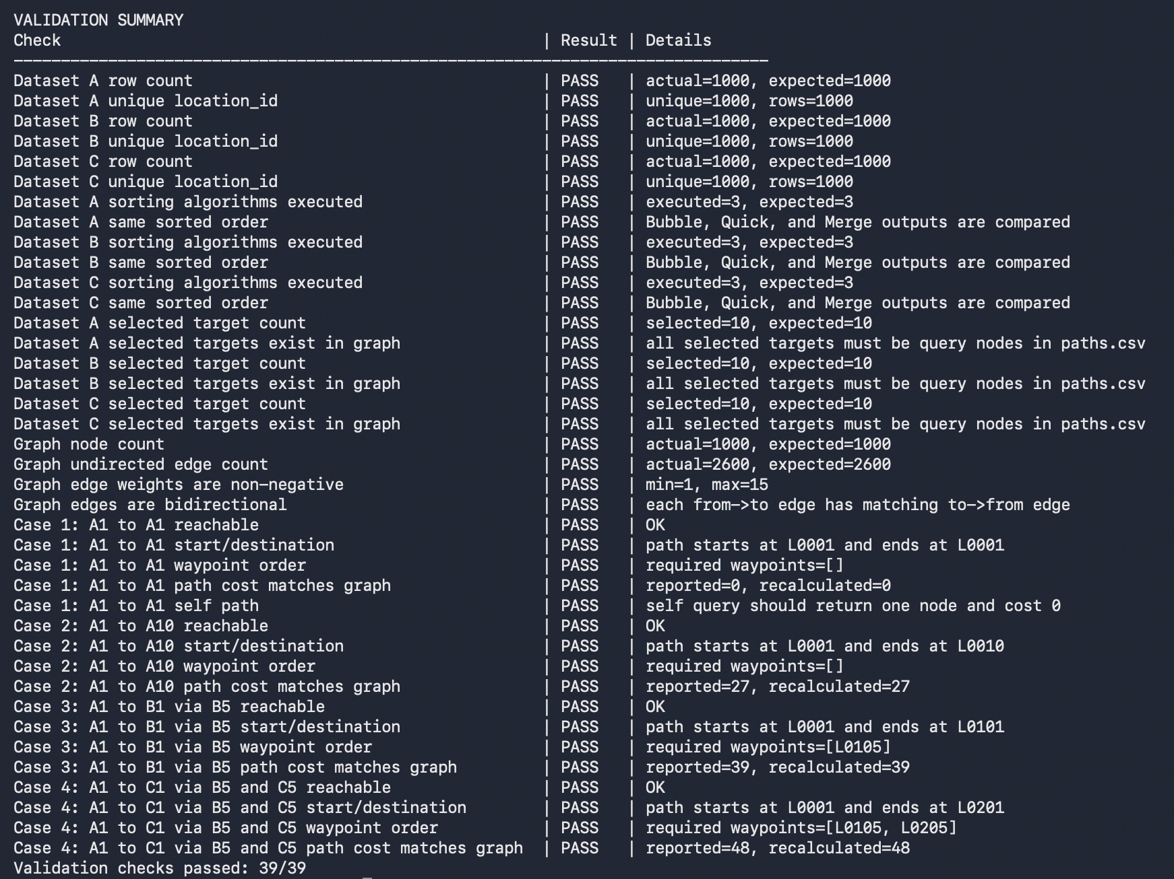Appendix Figure A1. Validation summary showing 39/39 checks passed.
The validation summary confirms that the final program passed all dataset, sorting, graph, path, waypoint, and path-cost verification checks.

6.5 Planning and Implementation Evidence
Jira board screenshots, GitHub commit history screenshots, repository/package screenshots, and class/method summary tables are used here as project-management and implementation design evidence. These materials show how the team organized implementation, testing, report writing, appendix preparation, PPT preparation, video recording, and how the final Java classes support the workflow described in Chapter 3.
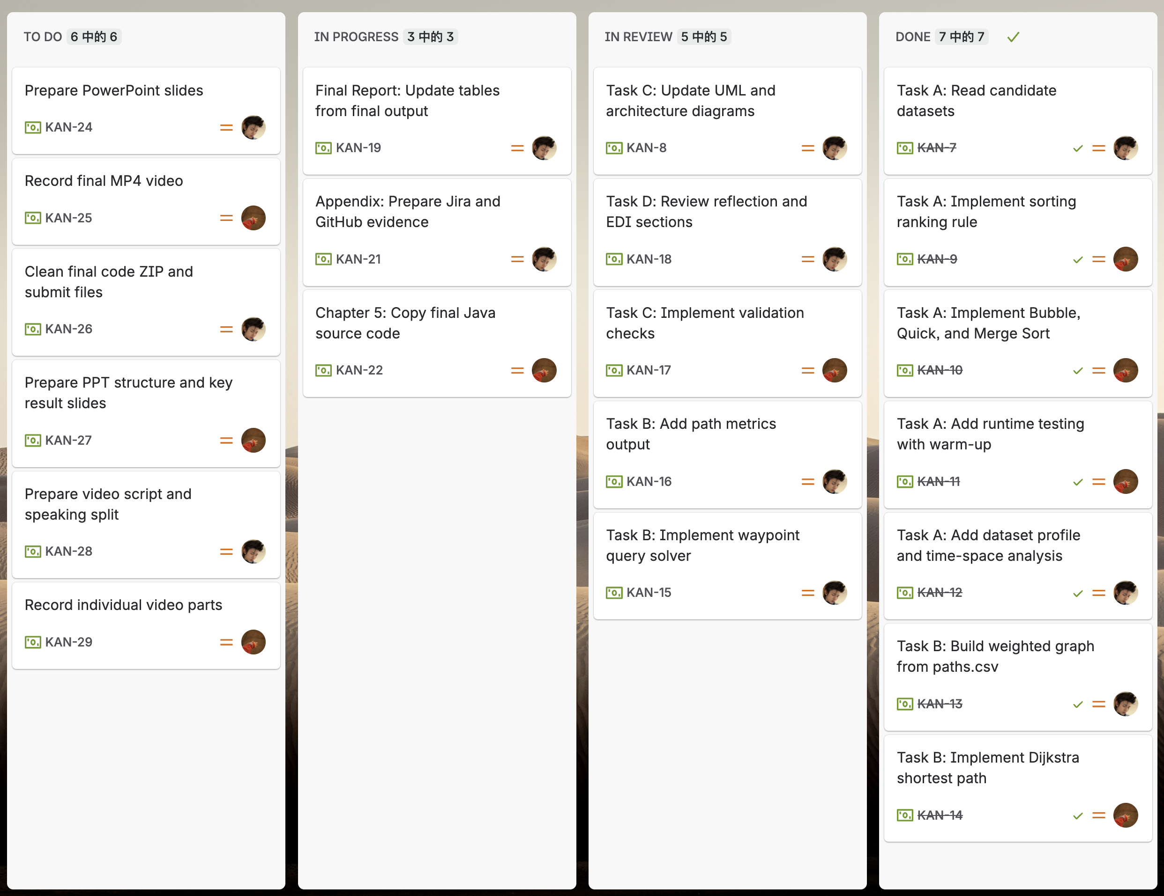Appendix Figure A2. Jira planning board for task allocation and progress tracking.
The Jira board divided the project into sorting implementation, graph implementation, object-oriented design, validation, report writing, appendix preparation, presentation preparation, video recording, and final submission tasks. Tasks were moved through To Do, In Progress, Review, and Done, which helped the team monitor progress before the deadline.
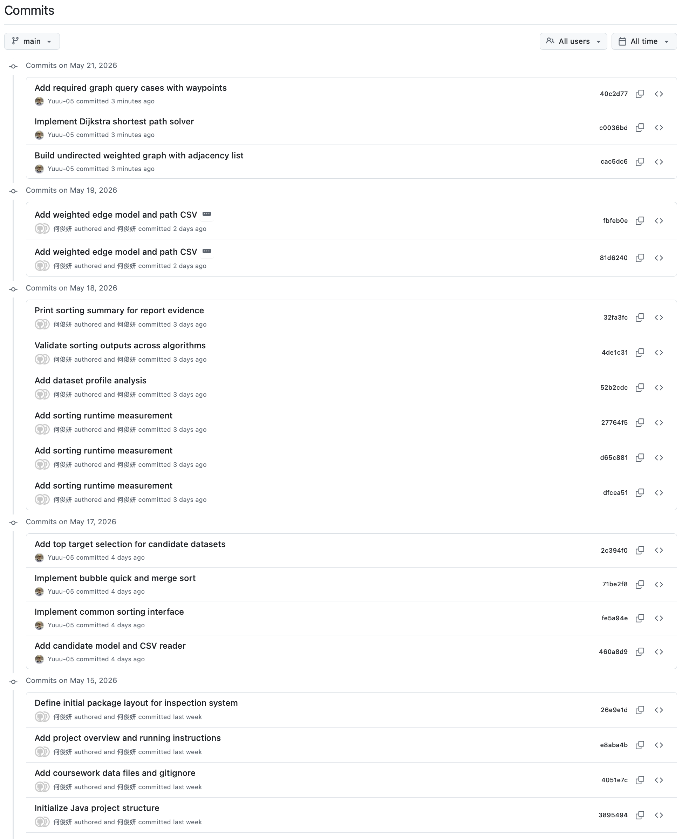
Appendix Figure A3. GitHub commit history showing incremental development.
The GitHub commit history shows that the implementation was developed incrementally rather than uploaded only at the end. Earlier commits cover the project structure, candidate CSV reading, sorting interface, Bubble Sort, Quick Sort, Merge Sort, Top-K target selection, runtime measurement, dataset profiling, and sorting validation. Later commits cover weighted graph construction, Dijkstra shortest-path solving, and required waypoint query cases. This supports the Chapter 4 discussion of GitHub as version-control evidence and shows how Task A and Task B were integrated step by step.
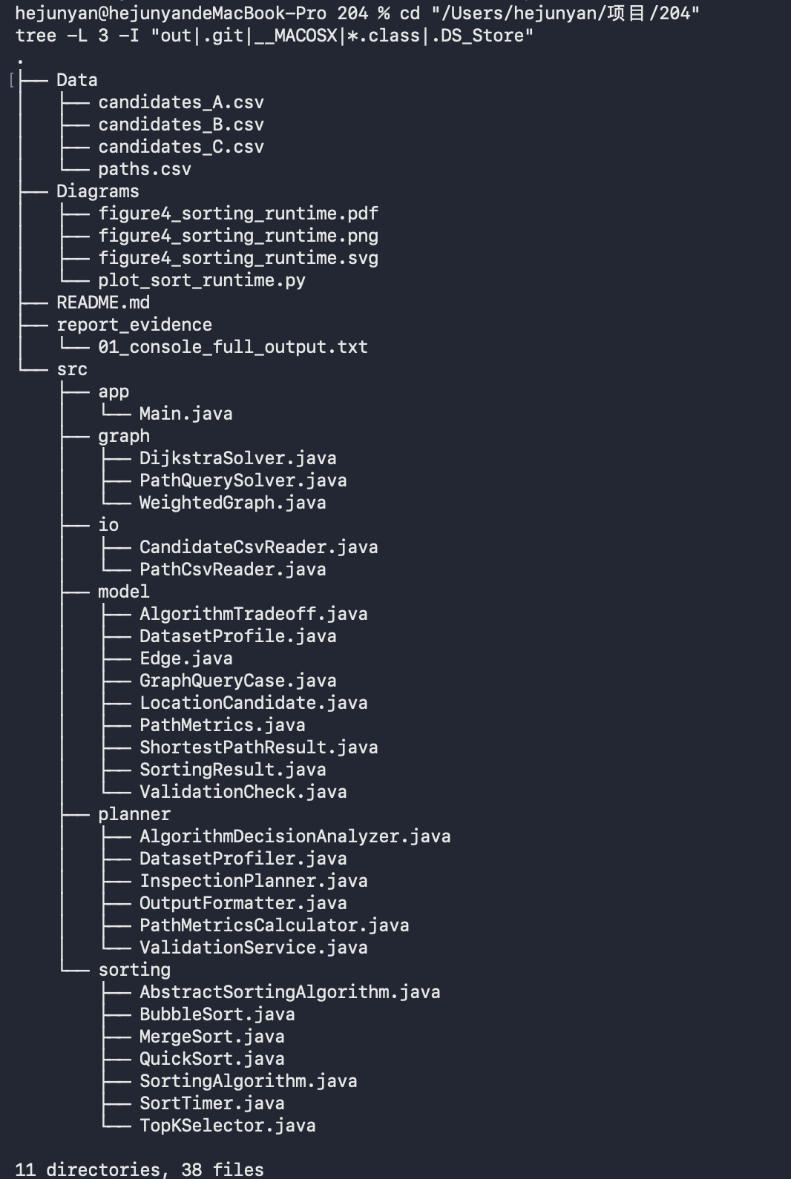
Appendix Figure A4. Repository and package structure.
The repository structure shows the submitted data files and the separation of app, graph, io, model, planner, and sorting packages, supporting the object-oriented design discussed in Chapter 3.

6.5.1 Complete Class Responsibility Table
Table A2 provides the complete class responsibility table moved from Chapter 3.2. It supports the object-oriented design discussion by showing the full set of classes used in the application.
Package | Main Class(es) | Main Responsibility
app | Main | Starts the program and calls the planner.
planner | InspectionPlanner | Coordinates data loading, sorting, target selection, graph queries, validation, analysis, and output.
planner | OutputFormatter | Produces clear console output for dataset profiles, runtime results, selected targets, path results, path metrics, and validation results.
model | LocationCandidate | Stores locationId and priorityScore; defines the common ranking rule.
model | Edge | Represents one weighted graph edge.
model | SortingResult | Stores algorithm name, runtime statistics, sorted list, and Top 10 result.
model | DatasetProfile | Stores dataset-level profile values, including row count, unique score count, duplicated score rows, adjacent correct order percentage, and sorted status.
model | AlgorithmTradeoff | Stores observed runtime summary and theoretical time-space complexity information for one sorting algorithm.
model | PathMetrics | Stores path-level metrics, including total cost, number of nodes, number of edges, and waypoint count.
model | ShortestPathResult | Stores path nodes, total cost, reachable status, and message.
model | GraphQueryCase | Represents required graph cases with start, destination, and waypoint information.
model | ValidationCheck | Stores validation check name, result, and details.
io | CandidateCsvReader | Reads the three candidate datasets from CSV files.
io | PathCsvReader | Reads paths.csv and helps build the weighted graph.
sorting | SortingAlgorithm | Defines the common sorting interface.
sorting | AbstractSortingAlgorithm | Provides shared helper methods such as compare() and swap().
sorting | BubbleSort, QuickSort, MergeSort | Implement the three required sorting algorithms manually.
sorting | SortTimer | Copies input data and measures sorting runtime fairly.
sorting | TopKSelector | Extracts the first 10 candidates after sorting.
graph | WeightedGraph | Stores the full undirected weighted infrastructure graph.
graph | DijkstraSolver | Computes one shortest path using Dijkstra's algorithm.
graph | PathQuerySolver | Handles waypoint queries by combining multiple Dijkstra segments.
planner | DatasetProfiler | Analyses the original candidate datasets before sorting and produces DatasetProfile objects.
planner | AlgorithmDecisionAnalyzer | Combines SortingResult data with theoretical complexity to support the final sorting algorithm choice.
planner | PathMetricsCalculator | Calculates PathMetrics from the existing GraphQueryCase and ShortestPathResult objects.
planner | ValidationService | Checks sorting results, selected targets, graph consistency, and path outputs.
Table A2. Complete Class Responsibility Table

6.5.2 Key Public and Helper Methods
Table A3 summarises the key public methods and helper methods used by the main workflow. It supports the function-collaboration discussion in Chapter 3.3.
Class | Important Public Method(s) | Important Private / Helper Method(s)
CandidateCsvReader | read() | parseInteger()
PathCsvReader | readGraph() | parseDouble()
SortingAlgorithm | sort(), getName() | -
AbstractSortingAlgorithm | - | compare(), swap()
BubbleSort | sort() | early-stop pass logic
QuickSort | sort() | quickSort(), partition()
MergeSort | sort() | mergeSort(), merge()
SortTimer | measure() | runtime statistic helpers
DijkstraSolver | findShortestPath() | rebuildPath()
PathQuerySolver | solve() | appendSegment()
ValidationService | validate() | endpoint, waypoint, and cost-checking helpers
Table A3. Key Public and Helper Methods

6.6 Reflection and Tool Usage Evidence

6.6.1 Additional EDI Improvement Details
Table A4 summarises the proposed EDI improvements, challenges, and responses.
EDI Direction | Possible Improvement | Target User Need | Main Challenge | Possible Response
Equality | Large-font or high-contrast output mode | Users with low vision or users working in poor lighting conditions | Requires formatted output or a future interface | Keep the console output clear now and consider a dashboard in future development.
Equality | Text-to-speech output | Users with visual impairments | Long route paths may be difficult to listen to | Provide both brief and detailed output modes.
Diversity | Multi-language output | Users from different language backgrounds | Requires translation and testing | Store key messages separately and translate important labels.
Diversity | Simple explanation of selected targets | Non-technical users | Users may not understand the ranking rule | Add a short explanation of priority_score and tie-breaking by location_id.
Inclusion | Keyboard-only operation | Users who cannot use a mouse easily | Needs careful input flow design | Use simple menu options and clear prompts.
Inclusion | Exportable route report | Inspectors and managers who need to share results | Requires file output design | Start with simple text or CSV export.
Inclusion | Accessible dashboard | Users who prefer visual summaries | Increases implementation and testing workload | Develop only after the core algorithm system is stable.
Table A4. EDI Improvements, Challenges, and Responses

6.6.2 AI Tool Usage Declaration
Table A5 records the non-substantive tool support and the corresponding human verification.
Tool | Version / Platform | Use in This Project | Human Verification
ChatGPT | GPT-5.5 Thinking | Used for report checklist review, wording suggestions, and identifying missing rubric coverage. | The team manually checked suggestions against the task sheet, source code, console output, and validation evidence.
Jira | Jira Cloud | Used for task planning, task allocation, and progress tracking. | The team manually created, assigned, updated, and reviewed the project tasks.
Grammarly | Web version | Used for grammar checking and wording clarity improvement. | The team manually reviewed each suggestion to ensure that the meaning, implementation description, and reported results were not changed.
Table A5. AI Tool Usage Declaration

Chapter 7 - Contribution Form
Student ID | Contribution
2360743 | 50%
2363304 | 50%
Total | 100%

