Part 1: Theoretical Understanding

Q1: Differences between TensorFlow and PyTorch
TensorFlow
- Uses static computation graphs (TensorFlow 1.x), now supports eager execution.
- Best for production deployment using TensorFlow Serving, TFLite.
- Strong visualization through TensorBoard.
PyTorch
- Dynamic computation graphs make debugging easy.
- Preferred in research for flexibility.
- Integrates well with Pythonic code.
When to choose:
- Choose TensorFlow for mobile/production apps.
- Choose PyTorch for rapid prototyping and research.

Q2: Use Cases for Jupyter Notebooks

- Interactive programming and experiment tracking.
- Data analysis and visualization inside cells.
- Supports step-by-step machine learning workflows.
- Perfect for AI learning, demos, and sharing results.

Q3: How spaCy Enhances NLP

spaCy is optimized for industrial NLP and includes:
- Fast tokenization, POS tagging, NER, dependency parsing.
- Better accuracy than simple Python string operations.
- Pretrained models for multiple languages.
- Pipeline components for text cleaning, vectorization, and entity extraction.Comparison: Scikit-learn vs TensorFlow
Scikit-learn:
- Great for classical ML (SVM, KNN, Decision Trees).
- Very simple API.
- Best for small and medium datasets.
TensorFlow:
- Designed for deep learning and neural networks.
- Handles large datasets and GPU acceleration.
- Production-ready deployment.
Part 2: Practical Implementation
Task 1: Scikit-learn – Iris Dataset
- Loaded dataset
- Preprocessed missing values
- Encoded labels
- Trained a Decision Tree Classifier
- Evaluated using accuracy, precision, recall
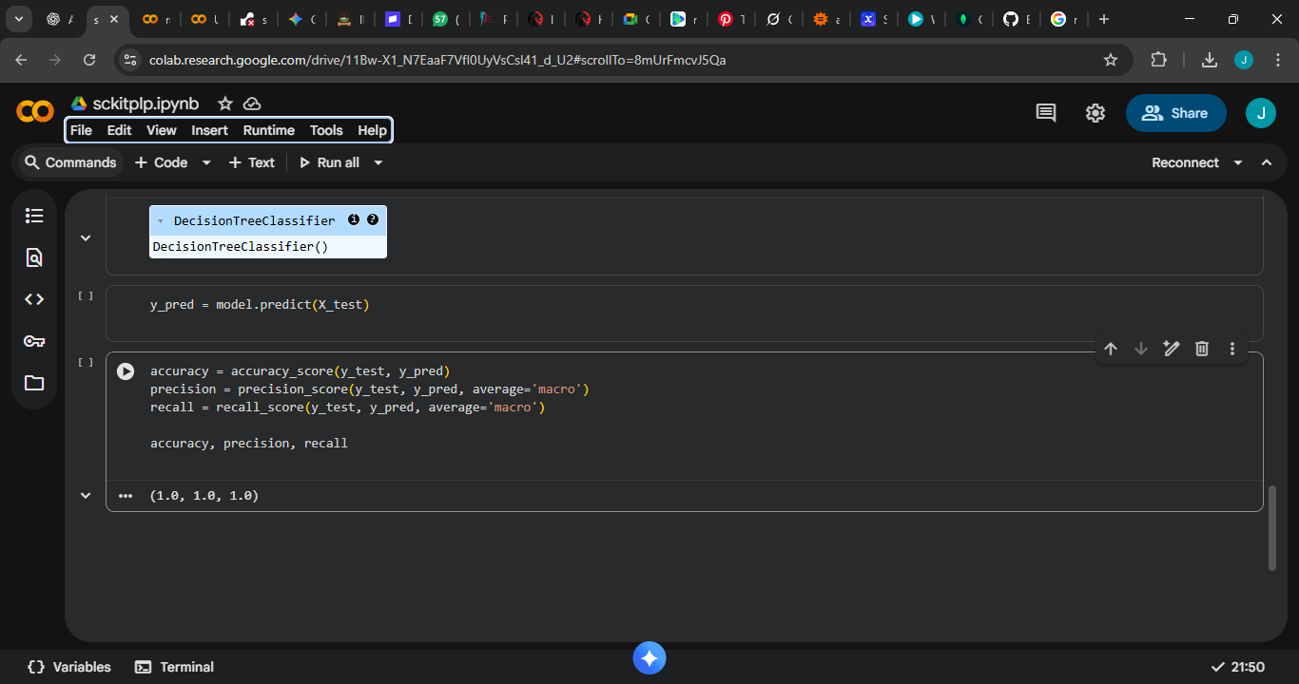

Task 2: TensorFlow CNN – MNIST Digits
- Built a Convolutional Neural Network
- Achieved over 95% accuracy
- Visualized predictions for sample images
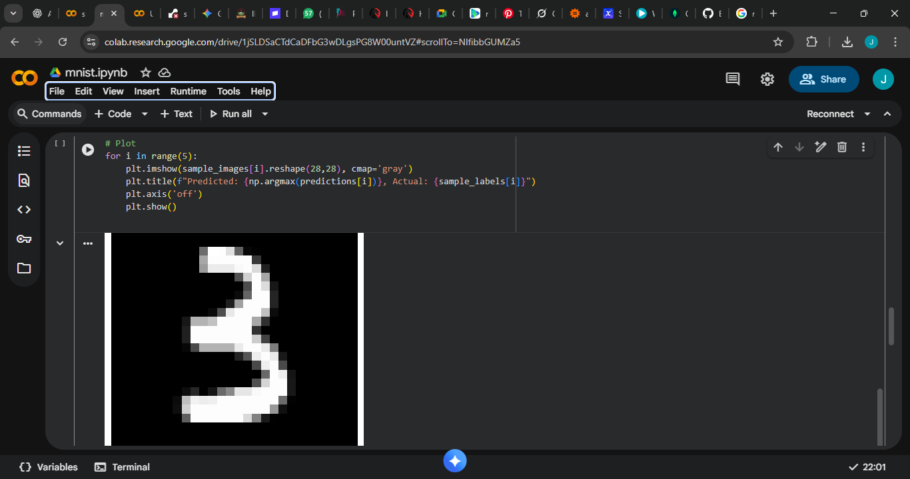

Task 3: spaCy NER & Sentiment
- Extracted named entities like brands and products
- Created rule-based sentiment analysis (positive, negative, neutral)
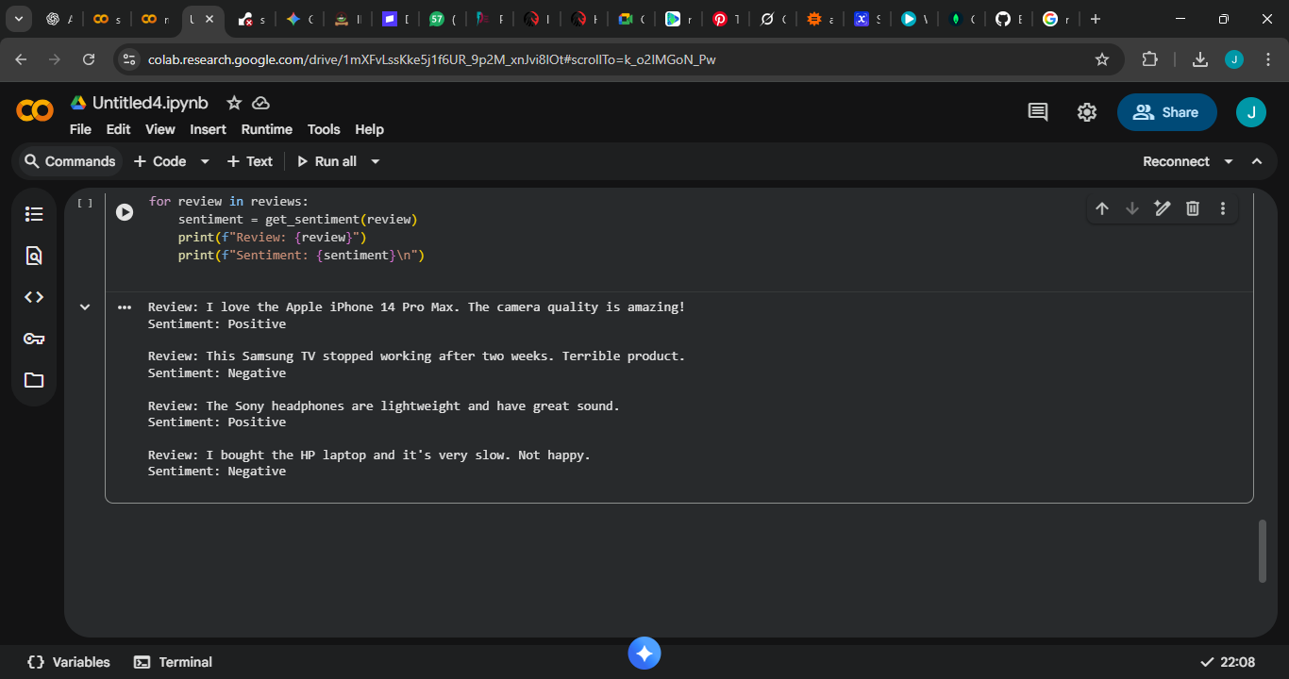

Part 3: Ethics & Optimization
Bias in MNIST Dataset
MNIST does not represent global handwriting styles.
Potential biases include:
- Poor performance for messy handwriting
- Poor performance for children/elderly
- Cultural writing differences
Mitigation:
- TensorFlow Fairness Indicators can show biased error rates.
- Data augmentation improves diversity.
Bias in spaCy NER
spaCy performs better on global brands (Apple, HP) than local ones.
Mitigation:
- Add custom training data.
- Add rule-based brand detection.
Debugging TensorFlow Code
Common fixes include:
- Correcting loss functions
- Adding proper input shapes
- Adding activation functions
- Correcting output layer sizes

