Class Diagram

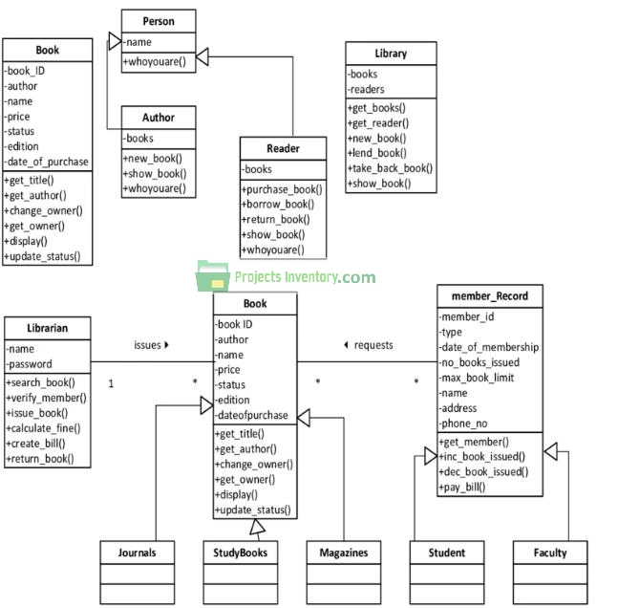

ER-Diagram

Sequence Diagram

Sequence Diagram of Library Management System Project.

Sequence Diagram of LIBRARY MANAGEMENT SYSTEM

