I will be creating a website for my home-based sewing business, Golden Threads (GT). This isn’t a real business, but it’s something that I’d love to do. I’ve been sewing for nearly ten years, and I consider myself a pretty good seamstress. I make garments, cosplays, and I also like the idea of making special quilted art bags like Loungefly but meant to be more long-wearing and better quality. The purpose of this website would be a business site to display my work and for customers to purchase from my site.
Golden Threads (GT) is a website for my personal sewing business. I’m mostly interested in offering cosplay and fandom related garments and accessories. I’m using BoxLunch, Loungefly and Hot Topic for my research to see what kinds of things they offer, and see where I can fit in gaps, I feel they’re not offering items that I want. While developing this website, I will show it to my friends and family who have similar interests to me, and see what they think of what I’m offering and how my website appears.
I will make sure that the brand logos, colors, and copy are all in line with my brand. I will ensure that the website is professional and reflect the brand’s image and styling. I will also make sure that the website is functional for both mobile and web screens. I’m going to use proper web design hallmarks like color theory, type hierarchy, and readability. I’m going to make sure the website runs smoothly and that it makes sense for people searching for items. I will test on Chrome and Edge.
The pieces I offer to my customers are things that can’t be gotten from larger companies who cater to pop-culture and classical culture consumers. BoxLunch and Hot Topic both have a lot of things for movie lovers and cosplay lovers, but oftentimes I find them not be what I’m actually looking for, not good enough quality, or too expensive. I love walking into those stores, but I rarely buy anything because I never find anything that I feel is worth my money for what they’re offering.
My alternative is cheaper, better quality, and handmade. I’ll sell dresses, skirts, some cosplay items, and quilted bags from movies, books, and tv that I personally enjoy. I’ll also plan on including a section for a small sewing portfolio for my previous sewing and a second small section for custom work that customers can commission.
The purpose of the website is to establish a base for my fictitious business, Golden Threads. It will have the items split by fandom, and lower by item.
The intended audience for my business is young people from ages 20-30 who are interested in nerdy, fandom-related items for cosplay and to add a little whimsy to their daily wear. I’m catering to college age and college-educated women primarily. My customers are women on the east coast who are generally interested in IP’s like Disney, Barbie (specifically early 2000’s Barbie nostalgia), Marvel, and popular classic literature and want clothing and accessories that are for these brands. They are middle class to upper middle class, with some money to spend for themselves, but don’t want to spend a lot of money on a Loungefly bag or a piece of clothing from Disney’s store with their lower level of quality and over-inflated pricing.
The identification of my target audience will impact the website’s look, brand style, colors, and design layout. It will influence how the website handles and the general vibes of the brand. The layout will be done according to how I think consumers my age actually shop and how they interact with websites that they visit.
The unique content that I will create and design for the website will be background images for my different categories and special art bits for titles and banners.
The content for the website I will get from other sources will primarily be fonts, from Adobe Fonts.
I think that the website’s content will be updated every three months, depending on what sells well and what sells not as well. Especially with hand-made items, things take longer to make and so I think every three months is a reasonable frame of time to make a small batch of items for a store, stock, sell, and re-make for the next batch.
As the website and the business grow and gain loyal customers, the products themselves will adjust based to that audience. The website itself may change as the audience becomes more settled, also changing based on how customers use the site. If and when certain aspects of the site become obsolete, the site can be adjusted based on how the audience interacts with it.
While developing the website, I think that it is helpful to make sure when writing functions and snippets of code, that they can be easily changed throughout the website, rather than having to go through each instance and change things manually. Having an organized stylesheet or sheets, JavaScript pages, and well-documented and commented html pages will aid in easier and more straightforward maintenance. I will also do testing at each stage of development to ensure that the website is functional, easy to use, and of course, as mentioned, easy to maintain.
The tasks required the maintain the website will be to update inventory, update banners, colors and images for specific holidays. Other tasks will include updating pricing and copy on the website. These maintenance tasks will take place at the same three-month stints.
The website content will be organized into a homepage, and sub-pages for different items. Dresses in one category, skirts in another, bags and accessories in another. I’m going to have another page for my sewing portfolio, a page about myself, and a page for commission work. Because I want people to be able to purchase items from my website, I want to have a checkout page. There will also be a page with updates for the website, with links to my social media and general updates for inventory, pricing, and local craft show events that I might be at for people to buy from my work in person.
I want the website content to be very spaced out, easy to read and colorful. I think that I want the products to speak for themselves. The content will be organized by product type each with a large product image, price listed, and a link to click on the product itself in a new page. The subtopics for the website could be by dress style and cut, bag style (tote or satchel) and more.
The pages will be (id also like to make them look like tabs that pop up as you click through them like on chrome going through tabs)
- Homepage
- Dress page
- Skirts page
- Bags
- Accessories
- Updates and Socials
- Portfolio
- Commissions
- About Me
- Checkout

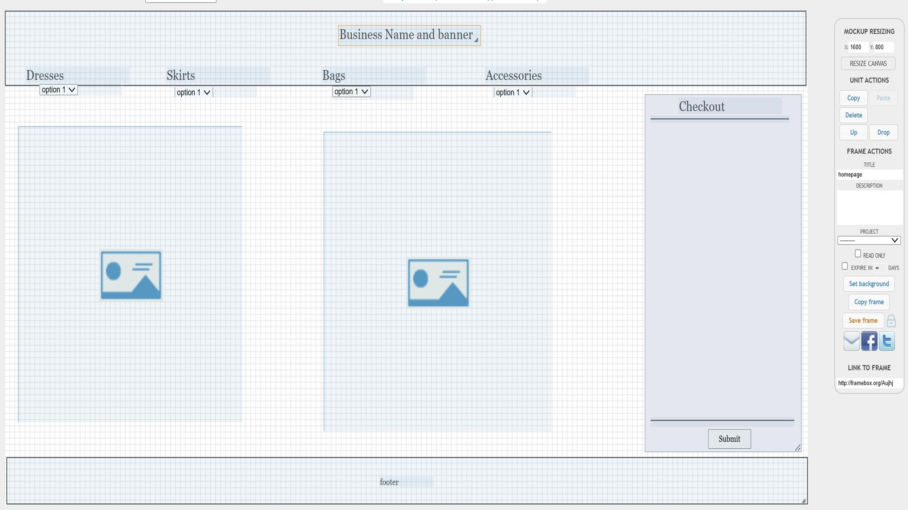
Homepage
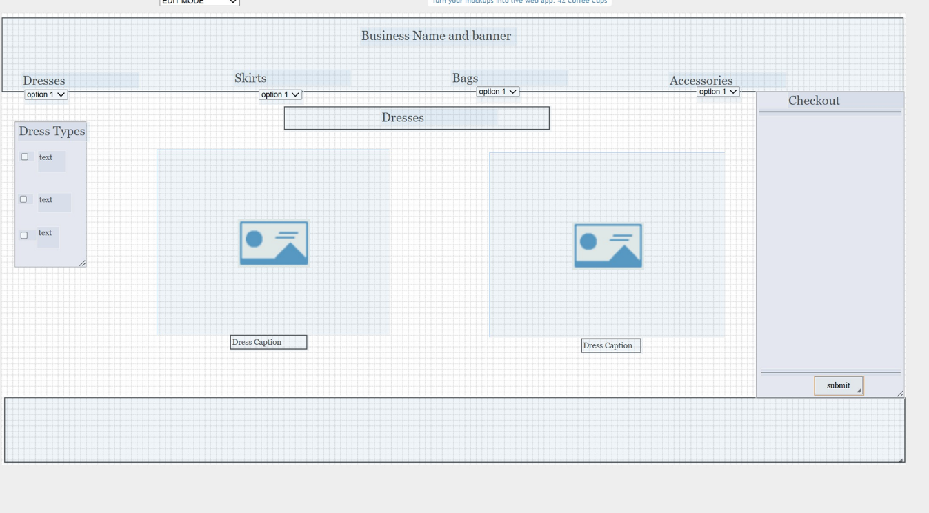
Dress Page
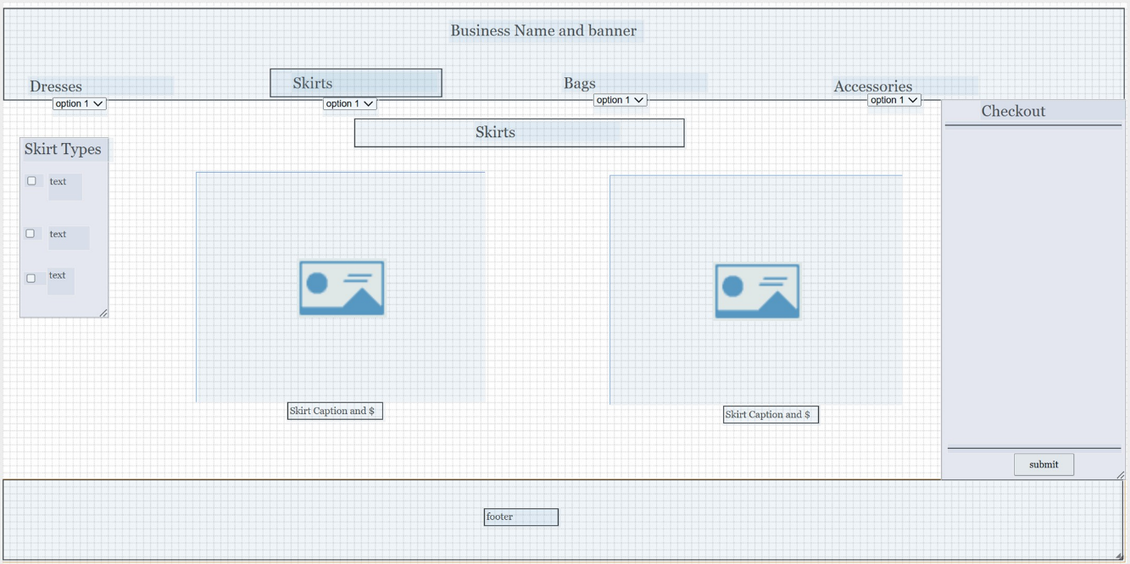
Skirt Page
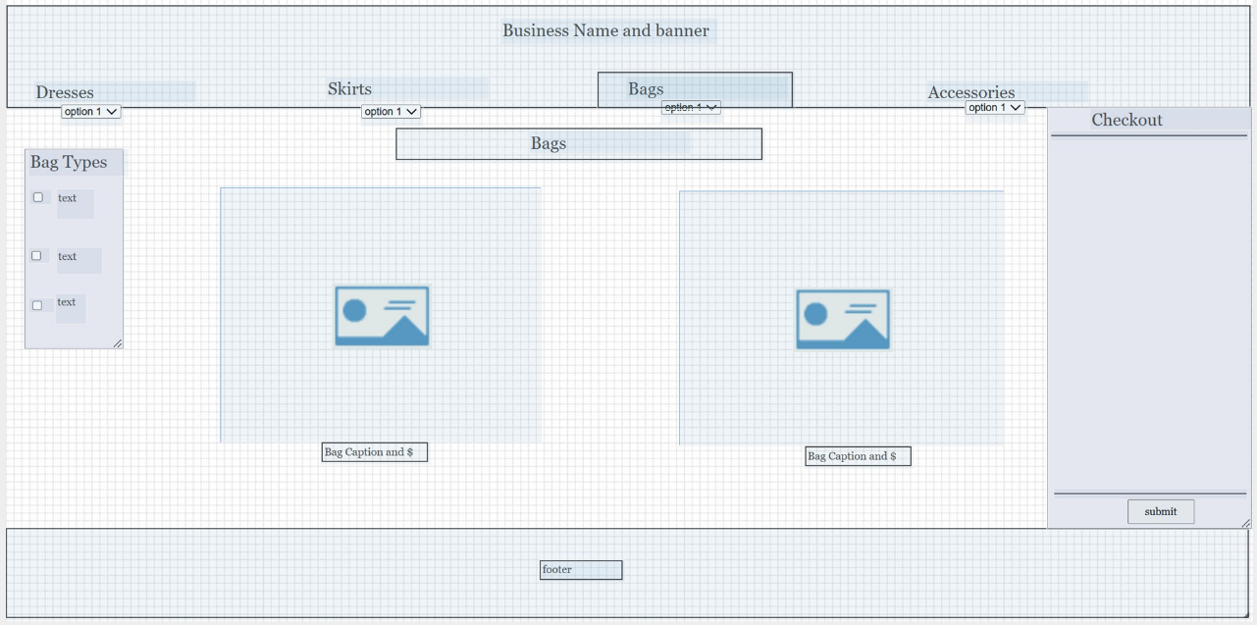
Bag page
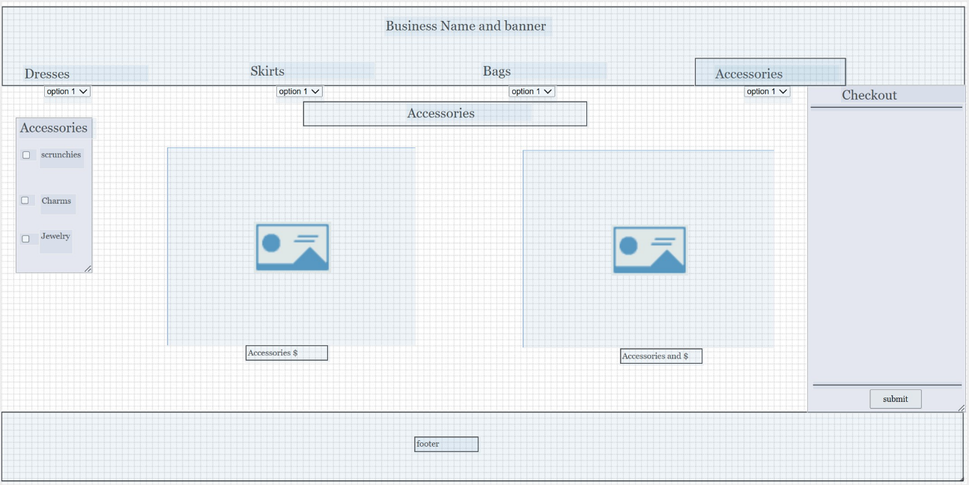
Accessories Page
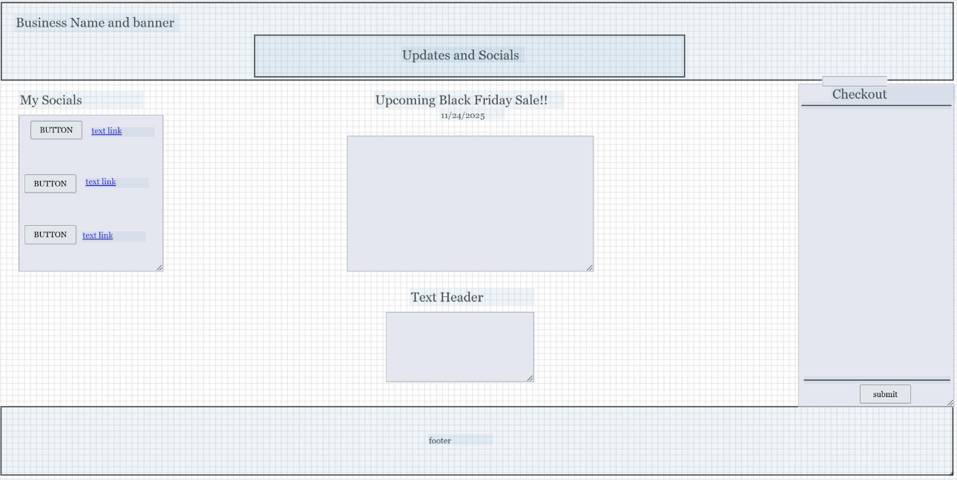
Updates and Socials
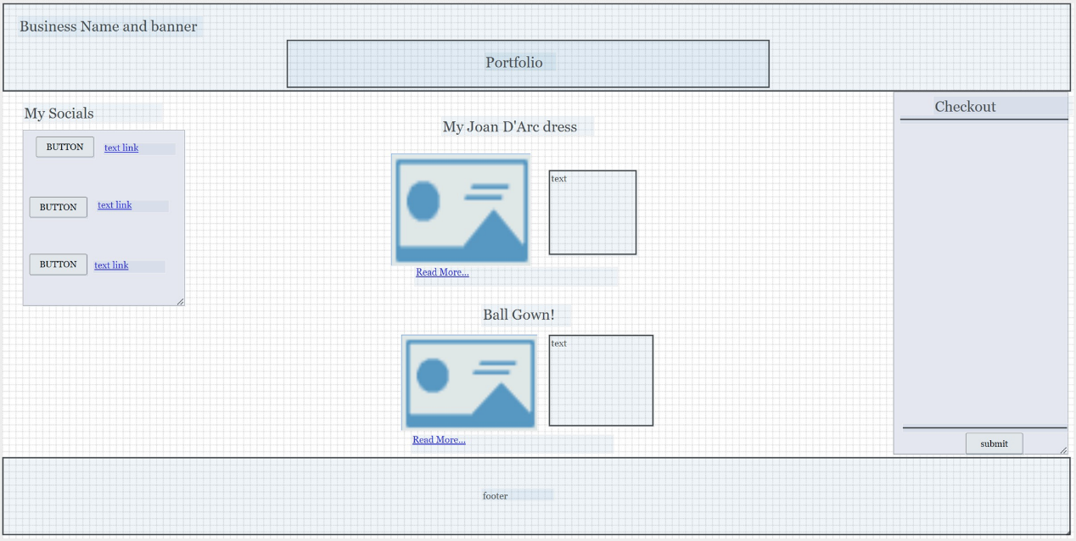
Portfolio
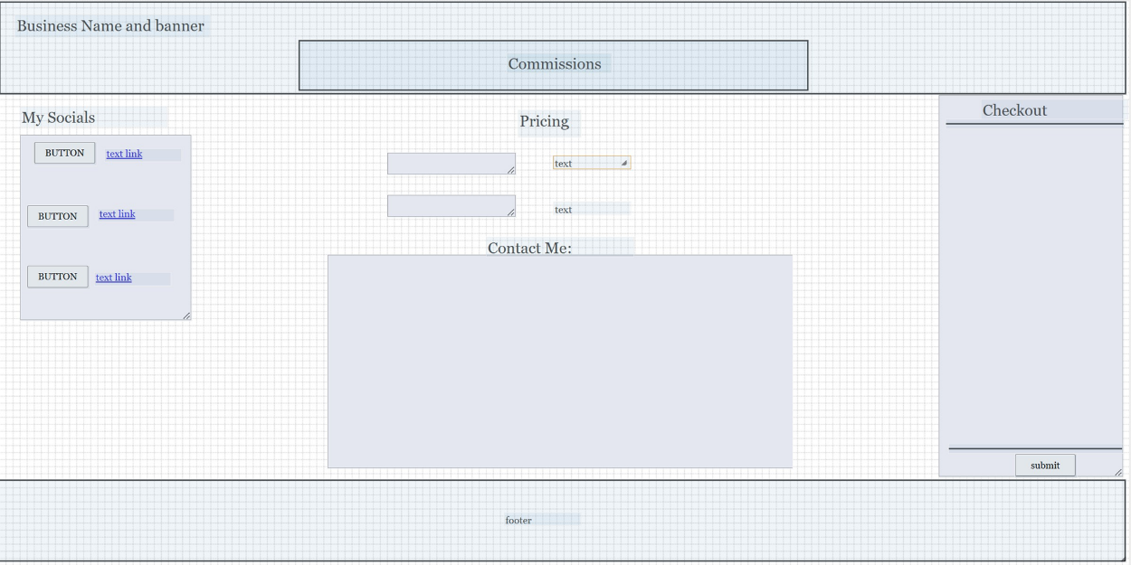
Commissions
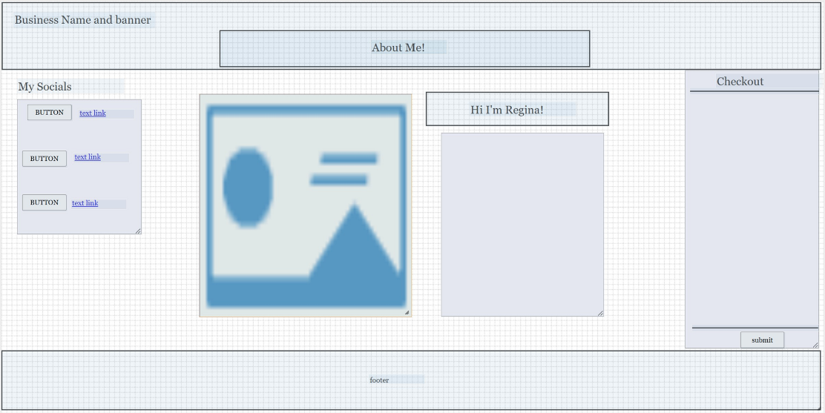
About Me
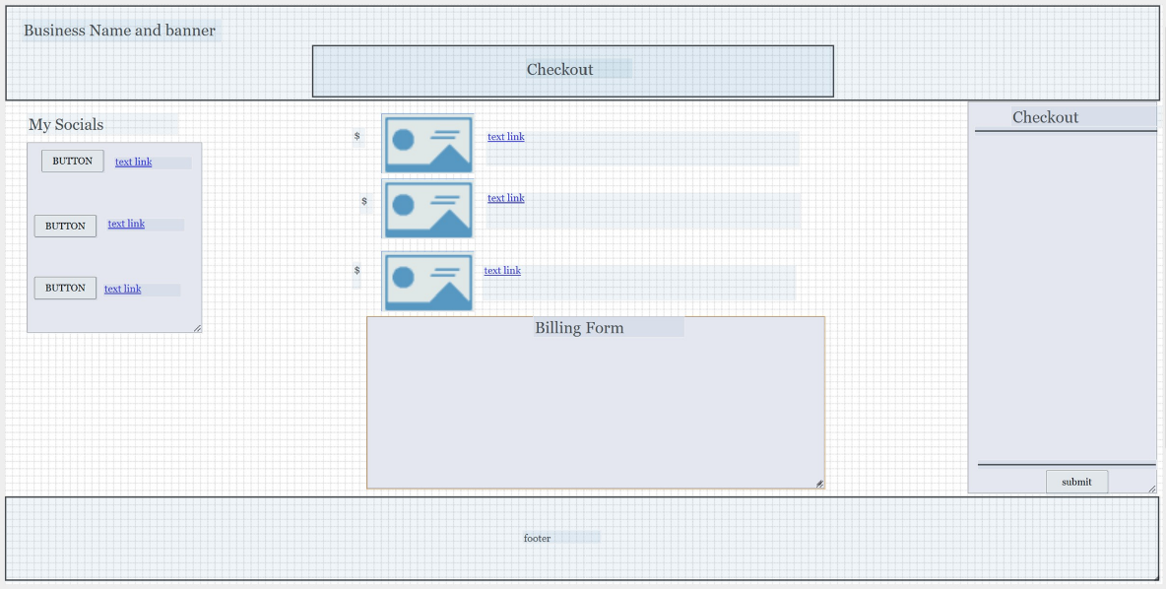
Checkout
Yes, the website will include an e-commerce component. There will be an option to buy products off the website and to commission work. Nothing on the website will be password protected, from the consumer side because there won’t be any kind of ability to make a wishlist, or anything private. The website will be solely used for viewing, and purchase. From the host-side, we can store the provided passwords in an encrypted form sent from the billing form. The website will not need users to create an account. Personally, I usually hate having to create an account when I want to buy from a website, so I figure that other people probably dislike it as well. From this website, I understand that I can use some google options and plug-in firewall options. https://www.bdc.ca/en/articles-tools/blog/7-website-security-steps-business

https://www.godaddy.com/resources/asia/skills/what-is-web-hosting-and-what-are-the-factors-in-choosing-one
https://www.business.com/articles/10-tips-for-choosing-the-right-web-hosting-company/
https://netrouting.com/11-essential-questions-to-ask-when-choosing-hosting-provider/
The criteria that is most helpful when choosing a web host is to consider bandwidth, provided security, customer support provided by the host, and back-up plans offered by the company. Bandwidth is necessary to determine how well the actual website will be able to function when multiple users are interacting at once, and is based on what kinds of things are available on the site whether they be videos, shopping, or general web surfing.
It’s important to select a web host that has strong security. This is because if your web host has bad security, it’s very easy for client information and business information to be sold to bad actors. It’s important to determine what you are actually paying for when you are looking to buy a web host and to make sure that they have the best security, that’s up to date, reliable and strong.
The special technologies needed for this website is a shopping cart feature and an SSL. The programming languages that need to be supported by the web host is HTML, CSS, and JavaScript.
Using networksolutions, I found the domain goldthreads.com.
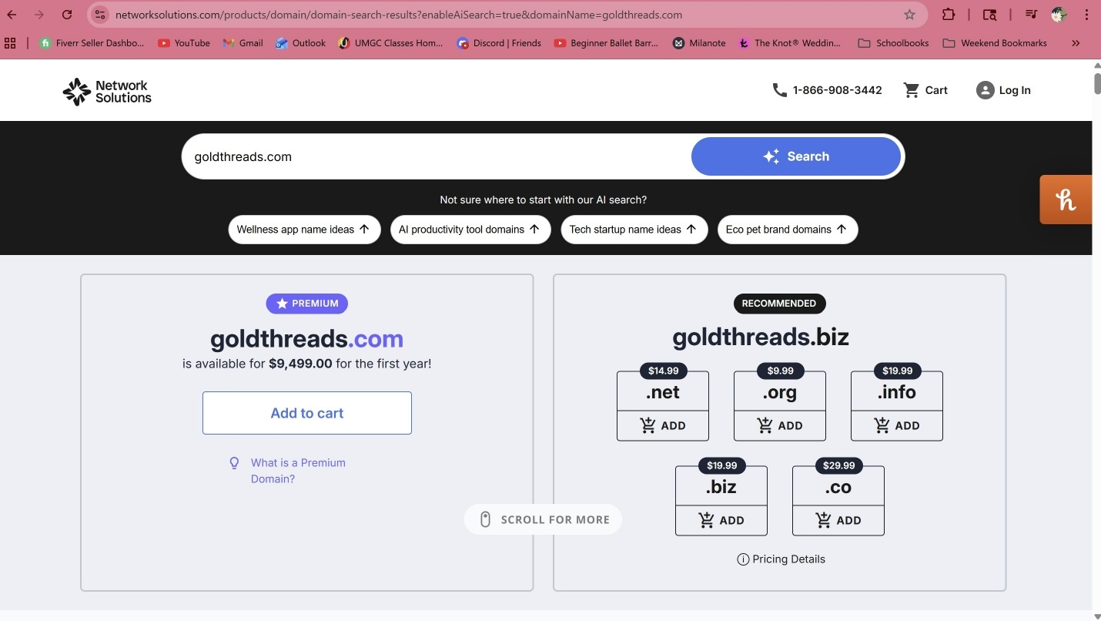

The website will be marketed as a small apparel business for young women looking for cute handmade, high quality clothing and accessories with themes from their favorite movies and books. The website will have a youthful, bubbly vibe.
I will include alt text with all my images as well as options to open images in new windows. I will organize all the different attributes by article and section and in correct hierarchy. I will include related meta tags that will help with bringing my website to the attention of searchers who want to look for products like mine.

Project Reflection
I used framebox.org to make my wireframes. I liked the program for what it is. I don’t think it has the nicest UI, but it was still a straightforward program to use. I thought it was pretty straightforward, but I would have liked the labels on the site for each type of item to be more clear. The different assets seem to overlap, I think that they should have given better explanation for what each asset does. It’s not the greatest program, but it works for making simple wireframes. It’s fairly interactive, but its weirdly wonky sometimes, especially when using CTRL Z. I think I would have been interested in trying the other program listed, but as I said previously, framebox works for what it needs to accomplish, which is simple wireframes.
While considering what my website might look like, I struggled to come up with a nice clean idea for how the website interacts when it comes to navigation. I want to include a simple search bar, but also have tabs that are clear and simple enough, that it wouldn’t really require a search bar to find what you’re looking for. It was a little difficult to picture what the site would really look like even with the aid of wireframes, but I think it will all come together.
My final website will have each category look like a tab and when you click through them, the tab position will change like on chrome or when you have those recipe cards that have the raised tabs. There will be filter options on the side and underneath each dropdown tab on the main categories there will be the sub-topics by type of product and by theme.

- Additional Instructions:
  - Link Project 2 document to Project 2 on the index.html page in the cmst386 folder.
  - Upload project2 folder and all pages/files to the Aloft Web Server.
  - Ready to upload? Check your work online after uploading the project to ensure the project link works! If you cannot see the project, when clicking on the link you supplied, neither can I and I won't be able to grade it.
- Once you have completed the exercise you must submit the URL to the Project Folder. Your submission must include the full URL of the project. Make sure it is working as well as all images included. This is a best practice part of website testing.
- Project submission requires you upload a file.
  - Paste the URL in the comments section.
  - Send the entire project, make a zipped file maintaining the proper folder hierarchy and submit it.

