Executive Summary
The Newcastle Knights Business Club 2026 Proposal outlines a strategic and scalable initiative to establish a high-value corporate engagement program aligned with the Club’s growing regional influence and commercial aspirations. Backed by in-depth benchmarking across 11 leading NRL and AFL teams, this proposal addresses a key market gap: the current Business Lounge model’s limited year-round business engagement offerings.
To meet evolving expectations of corporate partners and capitalize on local market opportunities, the Knights propose a structured, two-tier membership program:
- Core Tier ($6,000) – Designed for growing SMEs and regional businesses seeking access to professional networking, brand exposure, and premium matchday experiences.
- Partnership Tier ($11,500) – Targeted at medium to large enterprises, offering enhanced visibility, VIP access, and strategic B2B relationship-building experiences.
The proposed Business Club is supported by a robust engagement calendar that includes events such as VIP matchday hospitality, business networking luncheons, leadership workshops, and exclusive CEO breakfasts—ensuring consistent member value and touchpoints throughout the season.
Target market analysis highlights strong alignment with the Club’s existing partners across industries such as construction, mining, health, finance, and education. The proposal also outlines geographic, firmographic, and behavioural segmentation to strategically attract high-fit businesses across Newcastle, the Hunter Valley, and beyond.
To measure success, the program will track key performance indicators across customer satisfaction, sales conversion, marketing engagement, and member retention. Financial forecasts project sustainable growth over a three-year horizon, with total revenue expected to increase from $258K in Year 1 to nearly $500K by Year 3, against a manageable and scalable cost structure.

Table of Contents
Introduction 4
Research and Benchmarking Evidence 4
1. Overview of competitor programs 4
1.1. NRL 5
1.2. AFL 6
1.3. Overall Findings 7
2. Gap & market opportunities for Newcastle Knights 7
Gap identified: 7
Local market strengths: 8
Program Proposal for Newcastle Knights (2026) 8
1. Objectives 8
2. Evidence – based pricing and package recommendations 9
3. Target market 9
4. Activities and engagement plan 11
5. Measurement of success 12
Customer success metrics: 12
Sales metric 12
Marketing metrics 12
6. Financial forecasts in the next 3 years 13
Conclusion 14

Table of Figures
Figure 1: Average price of each tier level in the packages of clubs (per service per person) 3
Figure 2: Tier levels in the packages of clubs that have Branding services 4
Figure 3: Tier levels in the packages of clubs that have Gift Pack 4
Figure 4: Tier levels in the packages of NRL that have Golf Day 4
Figure 5: Tier levels in the packages of NRL that have End of Season event or Medal Night 5
Figure 6: Tier levels in the packages of NRL that have Season Launch or Match Day Hospitality 5
Figure 7: Tier levels in the packages of AFL that have Golf Day 5
Figure 8: Tier levels in the packages of AFL that have End of Season event or Medal Night 6
Figure 9: Tier levels in the packages of AF that have Season Launch or Match Day Hospitality 6

Introduction
The Newcastle Knights Business Club 2026 Proposal presents a comprehensive strategy to establish a commercially viable, community-connected, and professionally competitive business engagement program. This report is informed by a detailed benchmarking analysis of leading NRL and AFL club business offerings, revealing clear trends in tiered pricing, value-driven benefits, and event-based engagement. By identifying gaps in the current Newcastle Knights Business Lounge model, this proposal outlines an opportunity to evolve from a matchday-focused product into a year-round business partnership platform.
The proposal introduces a two-tier membership model, including Core and Partnership designed to appeal to regional SMEs and larger enterprises. It includes clearly defined objectives, value-based pricing, target market segmentation, a structured activity calendar, and measurable performance indicators. The program is grounded in financial sustainability, supported by a three-year revenue and expense forecast. Together, these components form a scalable blueprint to deepen corporate relationships, generate diversified revenue, and position the Newcastle Knights as a central hub for business-to-business (B2B) activity in the Hunter and Maitland region.

Research and Benchmarking Evidence

Overview of competitor programs
A comprehensive benchmarking analysis was conducted across 11 professional rugby teams in Australia, reviewing approximately 20 different tiered packages from clubs in both the NRL and AFL. These packages, structured as annual memberships, range in price from $1,500 to over $15,000, depending on tier level, inclusions, and the prestige of the club brand.
Most clubs offer two to three tier levels, combining networking access, matchday hospitality, branding exposure, and exclusive events. In general, the more premium the tier, the greater the number of tickets and service inclusions per member. The average price per person per benefit ranged from $220 to $900.
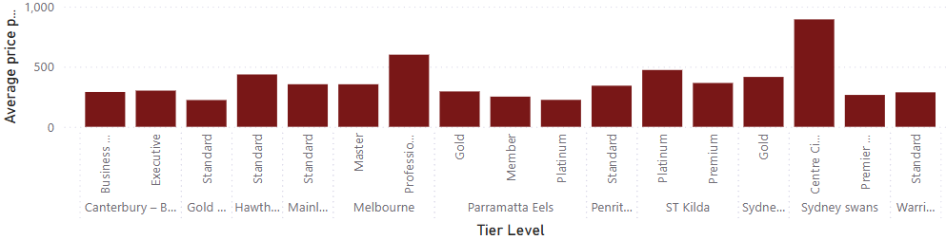
  - Figure 1: Average price of each tier level in the packages of clubs (per service per person)
Among all packages, the Sydney Swans' "Centre Circle" was the most premium, offering exclusive networking events and limited-ticket access at an estimated $900 per person per ticket. In contrast, while Parramatta Eels' Platinum and Canterbury-Bankstown Bulldogs' Executive packages were among the most expensive in total, their average per-ticket value was lower at $224 and $300, respectively, due to a larger number of event tickets included.
Basic branding and promotional services—such as logo recognition on club websites and welcome gift packs—were universally included across all tiers and clubs.
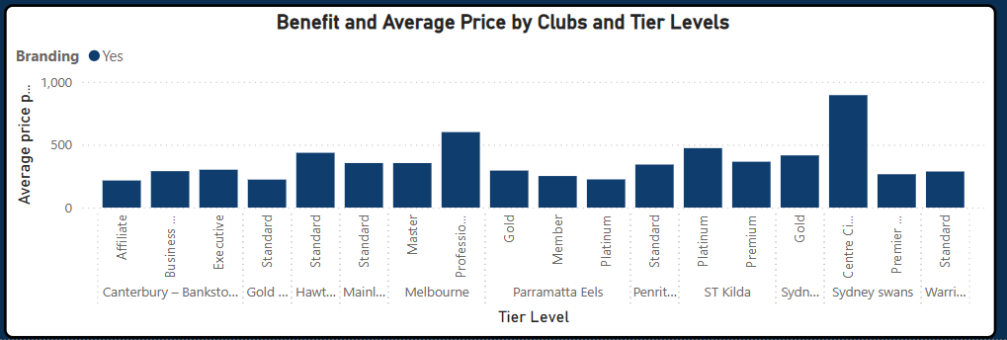
  - Figure 2: Tier levels in the packages of clubs that have Branding services
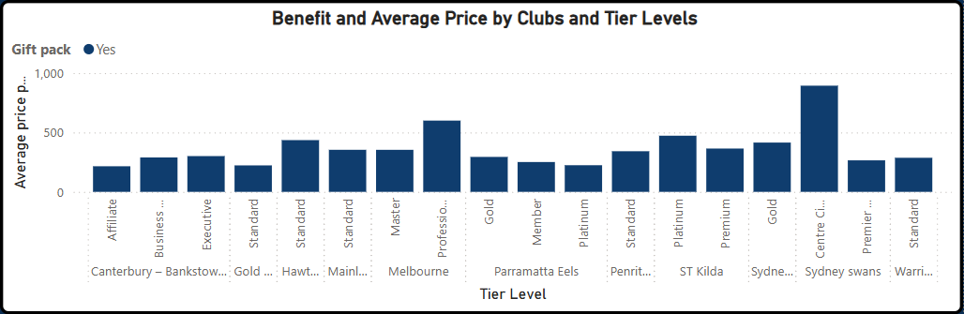
  - Figure 3: Tier levels in the packages of clubs that have Gift Pack

NRL
In the NRL Clubs, Parramatta Eels specially offer a Golf Day for their business’s members with the packages of Goal and Platinum pricing at $9350 and $15950 respectively, which are the highest tier levels in Parramatta Eels. These packages represent the highest tier levels available, catering to high-value clients seeking exclusive benefits. Other clubs, such as Canterbury – Bankstown Bulldogs and Penrith Panthers, have offered the Golf Day with extra costs per person, however, it has not been included in the Business Club membership.
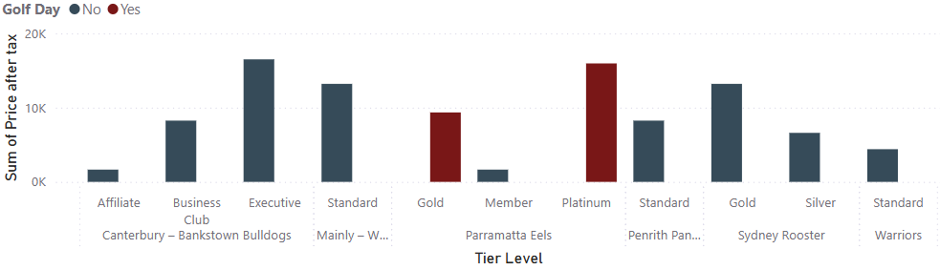
  - Figure 4: Tier levels in the packages of NRL that have Golf Day
In terms of end of season event and the medal night, six out of eleven membership packages across participating clubs include this offering. The after-tax prices for these events range from $8,250 to $16,500, with the highest costs typically associated with Platinum or other top-tier memberships.
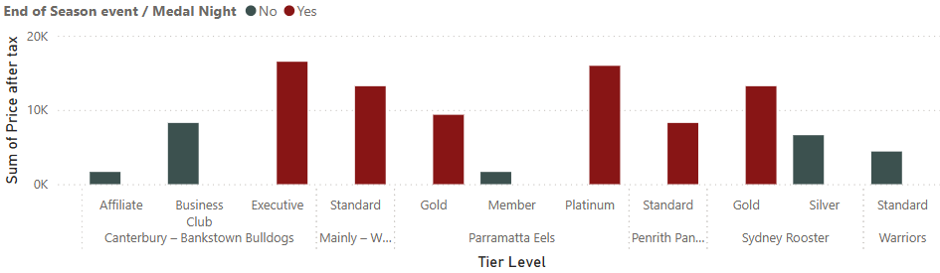
  - Figure 5: Tier levels in the packages of NRL that have End of Season event or Medal Night
In terms of season launch and match day hospitality, most of the clubs offer this for their members, excepting for Affiliate at Canterbury – Bankstown Bulldogs, Silver at Sydney Rooster, and Standard at Warriors that is not included the access for this event. This is because the charges for these tier levels that might be lower compared to the others.
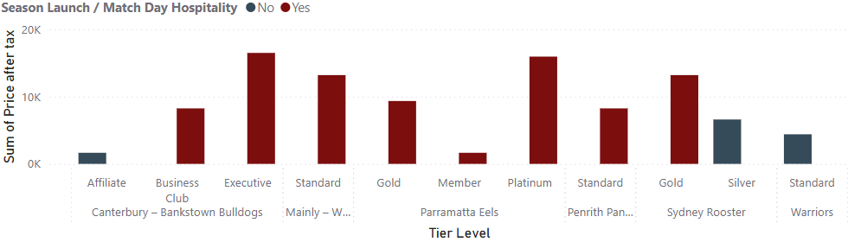
  - Figure 6: Tier levels in the packages of NRL that have Season Launch or Match Day Hospitality

AFL
Figure 7 shows that the Master Melbourne package uniquely includes a Golf Day, setting it apart from other clubs that generally do not offer this feature. The Platinum ST Kilda tier shows the highest price point (over $20K) even though it does not include the Golf Day, indicating other premium inclusions. Golf Day packages range from under $5K (Standard Gold Coast SUNS) to over $10K (Master Melbourne), which is the only club that include Golf Day in this comparison.
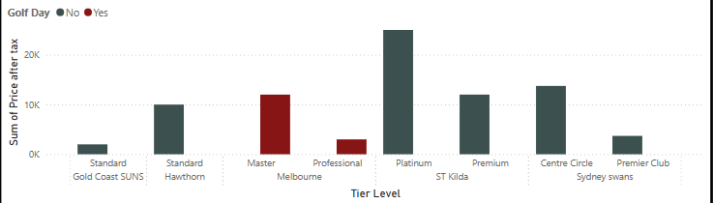
  - Figure 7: Tier levels in the packages of AFL that have Golf Day
In this figure, Standard Hawthorn is the only club that uniquely includes the End of Season event or Medal Night, shown in red, at a price point slightly above $10K. Other high-tier packages like Platinum ST Kilda and Centre Circle Sydney Swans reach up to or over $20K but do not include the event, suggesting they focus on other exclusive and premium events, such as.
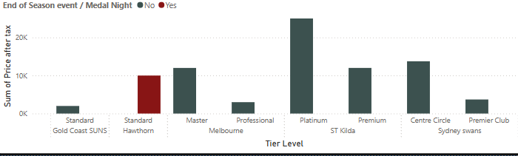
  - Figure 8: Tier levels in the packages of AFL that have End of Season event or Medal Night
Season Launch & Match Day Hospitality consistently offered across all clubs and tiers, reinforcing their role as core services. Premium tiers like Platinum ST Kilda, Master Melbourne, and Centre Circle Sydney Swans ranged from $10K to over $20K, emphasizing high demand for these offerings.
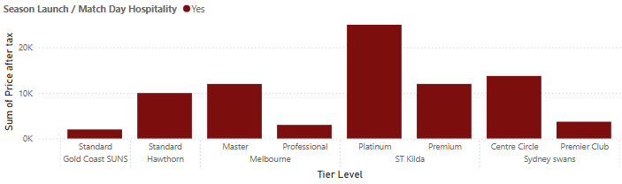
  - Figure 9: Tier levels in the packages of AF that have Season Launch or Match Day Hospitality

Overall Findings
NRL Insights: Higher-tier memberships typically bundle exclusive experiences such as Golf Days and End-of-Season events, with package prices ranging from $9,000 to over $16,000. For example, Parramatta Eels fully integrate Golf Day within top tiers, whereas others like Penrith Panthers offer it as an add-on. Season launches and matchday hospitality are commonly offered from mid-tiers upward, while entry-level tiers focus on branding and limited engagement to maintain affordability.

AFL Insights: Packages are tailored strategically, with unique inclusions like Golf Day (Master Melbourne) and Medal Night (Standard Hawthorn) serving as value differentiators regardless of tier. Meanwhile, matchday experiences remain universally embedded across all tiers, especially in premium offerings such as Platinum ST Kilda and Centre Circle Sydney Swans.

Besides of the services and events, A wide services of B2B networking events and exclusive events with more ticket’s allocations are included in the prices ranging from $7,000 to $16,000 after tax in NRL and AFL based on tier level of businesses. For example, with the higher investment, the businesses can have more business networking events, the rights to use the boardroom during the season, have breakfasts, lunches or dinners with CEO, Inner Sactumn Experience.

Gap & market opportunities for Newcastle Knights

Gap identified:
The Newcastle Knights currently offer a Business Club Lounge priced at $3500 (seasonal access) or $350 (casual access). This membership is primarily focused on matchday hospitality services, including:
- Located at the southern end of the Western Grandstand, adjacent to the Sports Lounge
- Undercover seating in front of room
- Promote business through marketing material & networking opportunity with like-minded businesses.
- Access to the Knights Business Club directory.
- Premium grazing menu with classic half-time footy food
- 4hr platinum beverage package including beer, wine and soft drinks.

The current offer provides an excellent game-day experience; however, it may lack structured year – round business engagement to connect the businesses in the professional environments compared to the others professional rugby teams in NRL and AFL, such as formal business networking events, branding and promotion opportunities through Knights’ corporate networks, and B2B concierge services. By launching a comprehensive Business Club Program will allow the Knights to fill the gap and capture growing demand for professional business networking and partnership building.

Local market strengths:
The Newcastle Knights are ideally positioned to leverage a diverse and robust local business community. Currently, the Knights has a strong regional and business presence in Newcastle, Hunter and Maitland Region, which was driven by such as health, finance, construction, education, technology, and food services. These partnerships and sponsorships are organised with a well – established base with leading brands across the multiple sectors.

Program Proposal for Newcastle Knights (2026)

Objectives
The Newcastle Knights Business Club Program is strategically designed to deliver key outcomes for both the Knights and the participating business members. Drawing on successful models from leading professional sports organizations and tailored to the Newcastle region’s unique market dynamics, the program aims to:
- Generate new revenue streams: establish a consistent, diversified income source beyond traditional matchday revenues through membership fees, events, and partnerships activations.
- Strengthen business relationships: forge deeper connections between the club and the wider corporate community, enhancing loyalty, mutual support and long-term strategic partnerships.
- Facilitate Business-to-Business (B2B) engagement: create a dynamic environment and structured program where Business Club members can network, collaborate, and drive new commercial opportunities with one another, positioning the Knights as a catalyst for local economic growth.

Evidence – based pricing and package recommendations
Benefits to the customers (Business Club members):
- Business Development Opportunities: Members will access a curated network of decision-makers and potential clients in a trusted, professional, and socially engaging setting through exclusive, club-hosted events.
- Enhanced Brand Exposure: Members will receive consistent visibility and association with a respected, community-embedded sporting brand—supporting reputation-building and local market recognition.
- Lead Generation & Partnerships: Structured B2B activities will allow members to explore partnerships, build pipelines, and secure strategic collaborations within the Business Club network.
- Premium Experiences: Members will enjoy elevated experiences such as VIP matchday hospitality, behind-the-scenes access, and exclusive interactions with Knights players and coaching staff—fostering deeper brand loyalty and emotional engagement.

The pricing structure has been developed using a value-based approach, informed by competitive benchmarking across leading sports clubs:
  - Core-tier: Access-focused tier designed to foster engagement, brand affiliation, and networking.
  - Partnership-tier: Premium-tier experience offering strategic visibility, hospitality, and VIP access.

Value-Based Tier Pricing:
Tier | Price (excl. GST) | Target Business Size
Core | $6,000 | Established regional businesses,  Growing SMEs
Partnership | $11,500 | Medium to Large enterprises

Target market
The Knights’ Business Club strategically target businesses that strong align with the club’s existing partnerships and sponsorships ecosystem, community presence, and the broader economic landscape of the Hunter and Maitland Region. Besides that, the Knights’ potential market focus on the businesses that want to grow their networks in the industry. Based on market research and competitive analysis, the target market should be defined through:

- Geographic (Region – based) segmentation:
- Primary Focus: Newcastle, Hunter Valley, Maitland, Lake Macquarie.
- Secondary Reach: Central Coast, Upper Hunter, Northern Sydney, and key NSW business centres with interest in regional expansion.
- The Knights’ deep roots in Newcastle and the Hunter Region provide a strong brand trust foundation to connect with local enterprises.

- Firmographic segmentation: based on company size, industry specifics.
- Business size: medium to large enterprises and high-growth SMEs, which seek for the opportunities to grow and expand their networks, are appropriate for the Business Club in Newcastle Knights.
- Industries: the current partnerships and sponsorships can help the Knights to attract the larger range of customers, which is the Business Club members in several areas, for example, these can be seen in the table below.
Industry Sector | Example Businesses to Target | Related Knights Sponsor(s)
Construction & Property | Property developers, builders, real estate, surveying | McDonald Jones Homes, Bella Group, McCloy Group
Mining & Energy | Mining companies, service contractors, renewables | NSW Mining, Thiess, Red Energy
Health & Insurance | Health clinics, insurers, aged care providers | nib, Hunter Imaging, Lite n’ Easy
Technology & Security | IT services, cybersecurity, automation | New Era Technology, Surevision
Finance & Legal | Accountants, banks, brokers, legal firms | Newcastle Permanent, PKF, Ausure, Brydens
Food & Beverage | Distributors, producers, hospitality providers | Coca-Cola, Jim Beam, M&J Chickens
Automotive & Transport | Dealerships, fleet services, logistics | Hunter City Motor Group, Thrifty
Education & Training | RTOs, corporate trainers | University of Newcastle, Allara Learning
Waste & Recycling | Environmental services, waste management | Benedict Recycling
Media & Communications | Local broadcasters, publishers, agencies | NBN, Triple M, Newcastle Herald

- Behavioural segmentation: customers’ interactions with services
- Regularly attend corporate or industry networking events (e.g., chamber of commerce, industry breakfasts).
- Already sponsor local sports, community, or charity initiatives.
- Invest in corporate hospitality (e.g., box seats, golf days, client entertainment).
- Show consistent interest in B2B networking, co-marketing, or event sponsorship.
- Demonstrate strong digital engagement with Newcastle Knights content (e.g., LinkedIn, event registrations).

Activities and engagement plan
Activity | Description | Frequency | Core | Partnership | Strategic Purpose
Price (before tax) |  |  | $6000 | $11500
Club Season Launch | Kick-off breakfast with club executives, coaches & players. | Annual (Feb) | ✅  (2 tix) | ✅  (3 tix) | Introduce season themes, create buzz & connect members early.
Business Networking Luncheons | Structured luncheons with speakers & peer networking. | 2x Annually | ✅  (2 tix) | ✅  (3 tix) | Facilitate business-to-business opportunities and build local connections.
VIP Game Day Access (Business Lounge) | Access to exclusive game-day lounge with food, beverages & premium seats. | Based on the packages | ✅ (3 VIP homes games w/ 3 tix) | ✅ (6 VIP home games w/ 3 tix) | Enhance client entertainment and brand association.
Inner Sanctum Experience | Behind-the-scenes access to training, facilities & Q&A w/ players /coaches. | 1x anually | ❌ | ✅ (2 tix) | Deepen emotional connection to the club and foster exclusivity.
Chairman’s Gala Dinner | Formal evening function w/ entertainment, auctions & sponsor recognition. | 1x Annually | ❌ | ✅ (2 tix) | Strengthen high-level relationships and club prestige.
Leadership & Business Workshop | Workshop led by industry leaders or club executives on business/leadership topics. | 1x per year | ❌ | ✅ (3 tix) | Add professional development value to the membership.
Breakfast with CEO | An exclusive breakfast event w/ the Newcastle Knights CEO | 2x Annually | ✅ (2 tix for one selected) | ✅ (2 tix) | foster transparency, deepen members' emotional & opportunity for direct dialogue
Christmas Networking Party | End-of-year celebration with drinks, entertainment, and recap of the season. | Annual (Dec) | ❌ | ✅ (2 tix) | Maintain relationship continuity and foster informal bonding.
Business Club Directory Access | Inclusion in and access to a digital directory of Business Club members. | Ongoing | ✅ | ✅ | Enable member-to-member communication and referrals.
Digital Member Promotion | Business name/logo featured on Knights website or social media platforms. | Ongoing | ✅ | ✅ (Spotlight + features) | Boost brand exposure through club’s marketing channels.
B2B Introduction Support | Facilitation of direct connections by Knights commercial team. | On Demand | ✅ | ✅ | Help members form strategic partnerships.
Monthly eNewsletter | Updates, success stories, upcoming events, and member features. | Monthly | ✅ | ✅ | Keep members informed and consistently engaged.
LinkedIn Business Club Group | Private group for informal connections and content sharing. | Ongoing | ✅ | ✅ | Extend engagement digitally and between events.
Gift pack |  | Ongoing | ✅ | ✅

Measurement of success

Customer success metrics:
Metric | Purpose | Estimated Target
Net Promoter Score (NPS) | Gauge members satisfaction and likelihood to recommend
Retention rate and churn rate | how well the program meets expectations over time.
Average customer lifetime | Average length in which customer stay
Engagement rate | how actively members participate in events and use benefits.

Sales metric
Metric | Purpose | Estimated Target
Lead to customer conversion rate | How successful sales and marketing efforts are in turning interest into memberships.
Customer Acquisition cost | How much sales team spends on marketing and sales strategies to convert a lead into a customer
Total new customers | Indicate growth and adoption of the program

Marketing metrics
Metric | Purpose | Estimated Target
Social media engagement | Track reach, reactions, and shares on digital spotlights and events
Event RSVP vs Attendance | Helps assess trust and excitement around event offerings.
Daily web traffic users | Measure visibility and online interest in the program in the daily basis

Financial forecasts in the next 3 years
To ensure financial sustainability and scalability of the Newcastle Knights Business Club, a structured framework has been developed to support the financial forecast. This includes detailed consideration of revenue generation, cost structure, and projected growth over a 3-year period.
  - Financial Forecast Development Framework
Component | Description
Tier-Based Revenue Projection | Revenue is estimated based on the number of memberships sold per tier (Core and Partnership), priced according to value offerings.
Operational Overheads | Event coordinated, hospitality offering, merchandise, staffing cost to coordinated are included to reflect realistic coordination expenses.
Growth and Retention Rates | Forecast incorporates expected annual growth in new memberships and a baseline renewal rate.

  - Key Revenue Assumptions
In the table below, there are several factors that need to be covered when making the revenue forecasts.
Assumptions | Description
Core Tier Price | $6000 + GST per member per year
Partnership Tier Price | $11500 + GST per member per year
Membership Growth Rates | Core grows by +8 members / year  Partnership grows by + 4 – 5 / year
Add On’s services | The events aren’t included in the core or partnership tier level; the extra charges are calculated by pp per event
Revenue Streams | Approximately 80 – 90% revenue comes from membership fees (Core + Partnership) and the remaining roughly 10 – 20% revenue comes from the Add On’s services
Tier Price Growth Rates | 5 – 10% (depending on the operational expenses)

  - Key Expenses Assumptions
In the table below, there are several factors that need to be covered when making the expenses forecasts.

Assumption | Description
Event Coordinator | Venue rental, catering, event logistics
Hospitality Offering | Food & Beverages, guest hosting for matchdays & B2B events
Merchandise and Gifts | Gift packs, branded materials for all members
Staffing cost to coordinated | Full-time coordinator and casual event staff
Cost Growth Rates | 5 – 10% (inflation buffer, further scaling, etc)

  - Revenues and Operational Expenses Forecasts
Revenue Forecasts:
Year | Core Tier | Partnership Tier | Total Revenue | Tier price growth rate
2026 (base year) | 20 | 12 | $258k | 0%
2027 | 28 | 17 | $363k | 5% (381k)
2028 | 35 | 22 | $463k | 5% (486k)

Operational Expenses Forecasts:
Category | 2026 (base year) | Cost Growth | 2027 | 2028
Event Coordinator | $80k | 10% | $88k | $96.8k
Hospitality Offering | $70k | 10% | $77k | $84.7k
Merchandise & Gifts | $20k | 10% | $22k | $24.2k
Staffing and Admin | $70k | 10% | $77k | $84.7k
Total cost | $250k | 10% | $264k | $290.4k

Conclusion
The 2026 Newcastle Knights Business Club proposal represents a significant step forward in aligning the Club’s commercial strategy with the needs of its regional business community. Through careful benchmarking, structured tier design, and a strong engagement calendar, this program is positioned to deliver tangible benefits for both members and the Club. The dual-tier model ensures broad accessibility while maintaining premium value for high-level partners, and the proposed events and services offer meaningful opportunities for networking, visibility, and brand alignment.
With a clear understanding of market demand, growth projections, and operational costs, the financial model demonstrates strong revenue potential and long-term sustainability. Success will be measured not only by financial returns, but also by member satisfaction, retention, and engagement, which ensures the Business Club remains a valued asset within the Knights’ broader commercial ecosystem. This proposal outlines a credible, research-driven roadmap to elevate the Newcastle Knights' presence in the corporate landscape and build enduring business partnerships for years to come.

