**Report**

-Data Science HW2-



Date : 2021.09.29

Subject : Data Science

Professor : Sangjin Han

Major : Mobile System Engineering

Student Number : 32191818

Name : Jueun Park

1. Exercise 2 (Ch7)

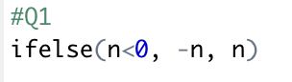

2-a. Make “fibonacci(n)”

2-b. List 3 Applications of Fibonacci Sequence.

3. User Defined Function



4. [t-Test] Find an example of your interest comparing two groups of normal distribution. Run the t-Test by both R and Excel. Include the source code and the result(graphs), and REFERENCE if there is any.

<R>

The data are about the height of high school seniors according to gender in 2016.

As a result of the equal variance test(f-test), the p-value is 0.1126, which is greater than 0.5, so this data is equal variance. Therefore, the equal variance assumption t-Test was performed. As a result, the p-value was less than 0.05. Therefore, the difference in height according to sex is significant.

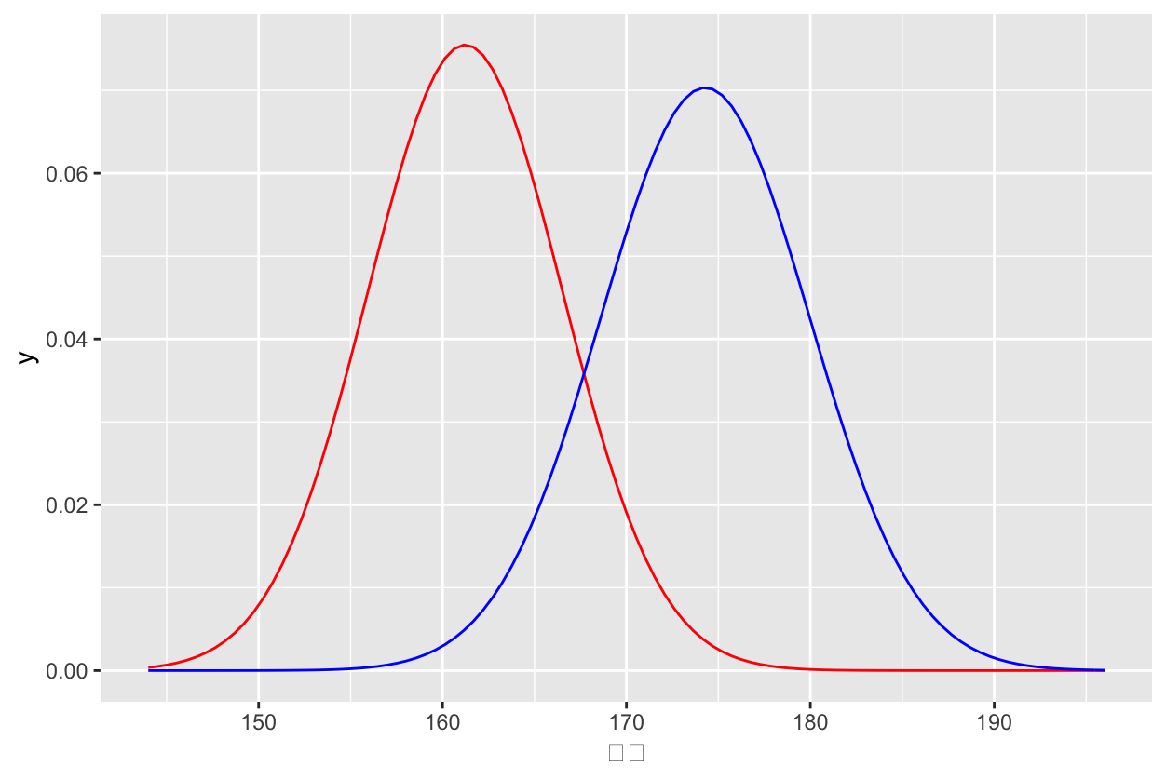

The graph above is a graph showing the data of each man and woman. The red graph represents the height of a woman, and the blue graph represents the height of a man.

<Excel>

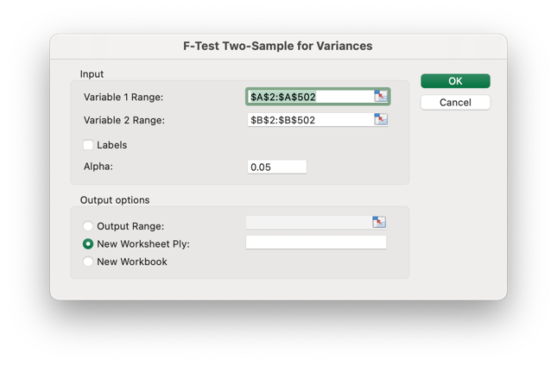

Before starting the t-test, the equal variance test(f-test) should be performed first.

As a result of the f-test, the one-tail test p-value was 0.05630761. So, the real p-value is 0.05630761*2.

if p-value is greater than 0.05, it is “Equal Variances”, while if it is smaller than 0.05, it is “Unequal Variances”. My p-value is larger than 0.05, so it is “Equal Variances”.

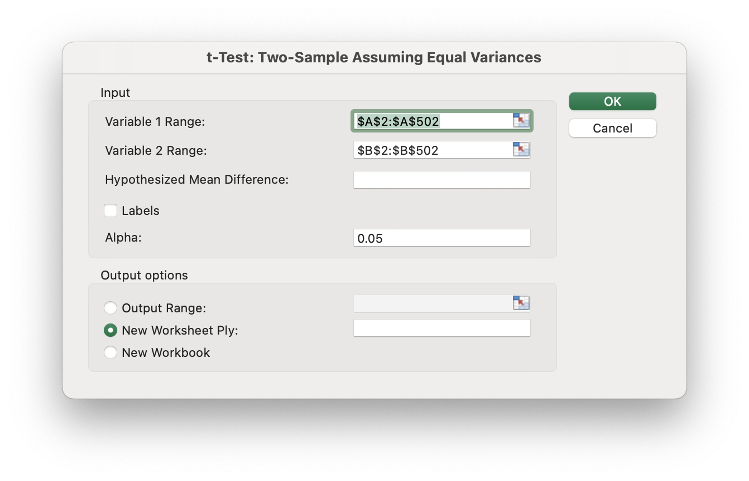

Therefore, I selected ‘t-Test: Two-Sample Assuming Equal Variances”.

The p-value is 4.35E-194, which is smaller than 0.05, therefore the difference in height according to sex is significant.

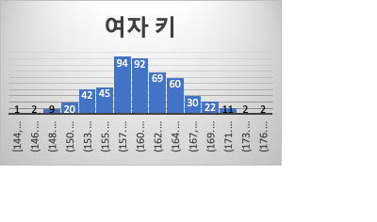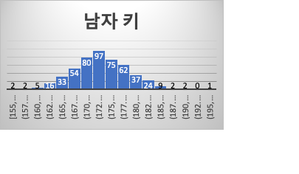

REFERENCE

공공데이터포털 - 교육부_학생건강검사 키rawdata_2016_20190927.csv

(Only high school seniors' data were extracted separately.)