Windows Server Active Directory HomeLab
VirtualBox Domain Controller Deployment and Verification

Editable GitHub Portfolio Draft
Built from the screenshots captured during the lab

Project type | Hands-on implementation / walkthrough
Primary server | DC01
Active Directory domain | homelab.local
Virtualization platform | Oracle VirtualBox 7.2.16
Host environment | Windows 11 desktop

Project Summary
This project documents the creation of a Windows Server Active Directory home lab in Oracle VirtualBox. The lab begins with installing the virtualization platform and obtaining a Windows Server evaluation ISO, then creates a server virtual machine named DC01, configures virtual networking, installs Active Directory Domain Services (AD DS), creates a new forest and domain named homelab.local, promotes DC01 to a domain controller, and verifies the finished domain through Active Directory Users and Computers.
The purpose of the project is to demonstrate practical entry-level system administration skills in virtualization, Windows Server deployment, Active Directory, DNS, networking, domain controller promotion, testing, and troubleshooting. The document is written as both a portfolio artifact and a repeatable tutorial that can later be converted into a GitHub README.

Project Requirements / Technologies
- Languages used: No scripting language was required for this phase.
- Host environment: Windows 11 desktop computer.
- Virtualization: Oracle VirtualBox 7.2.16.
- Server operating system: Windows Server evaluation media.
- Server role: Active Directory Domain Services (AD DS).
- Supporting services/tools: DNS, Server Manager, Active Directory Users and Computers, Command Prompt, and VirtualBox NAT networking.

Lab Configuration
Component | Configuration
Virtual machine | DC01
Memory | 4095 MB (approximately 4 GB)
Processors | 2 vCPUs
Virtual disk | 80 GB
Domain | homelab.local
NetBIOS name | HOMELAB
Network type | VirtualBox NAT Network
Observed IPv4 address | 10.0.2.3 during the lab
Observed default gateway | 10.0.2.1
AD DS functional levels shown | Windows Server 2025
Important: The screenshots include Windows Server 2022 Evaluation Center download pages, while the completed Active Directory wizard later displays Windows Server 2025 functional levels. Before publishing this portfolio publicly, verify which ISO was actually installed and replace the early download screenshots if necessary so the version labeling is consistent.

Note: The VirtualBox creation summary identifies the guest OS type as Windows 11 (64-bit). The VM was later booted from Windows Server installation media. In a polished rebuild, selecting the matching Windows Server guest type would make the configuration cleaner, but it did not prevent this lab from operating.

Architecture Overview
Windows 11 Host
|
+-- Oracle VirtualBox 7.2.16
|
+-- NAT Network (10.0.2.0/24 observed)
|
+-- DC01
Windows Server
AD DS + DNS
Domain: homelab.local
NetBIOS: HOMELAB

Step-by-Step Demonstration
The following steps are organized from the captured screenshots and reflect the workflow used during the lab. Each screenshot is placed with the stage it documents so this section can be adapted directly into a GitHub walkthrough.

Step 1 - Install Oracle VirtualBox
I first installed Oracle VirtualBox, which provides the virtualization platform used to run the Windows Server virtual machine.
Procedure
- Launch the Oracle VirtualBox 7.2.16 installer.
- Continue through the installation wizard using the standard installation options.
- Open Oracle VirtualBox Manager after installation completes.
Why this matters: VirtualBox allows the server to run in an isolated virtual environment without requiring a separate physical computer.
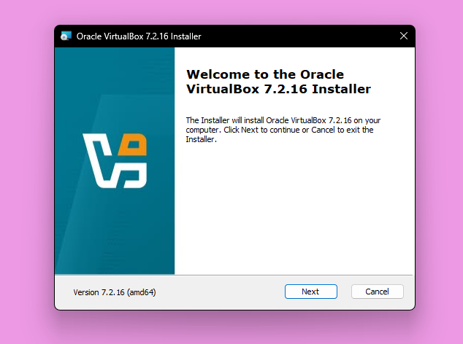
Figure 1. Oracle VirtualBox 7.2.16 installer.
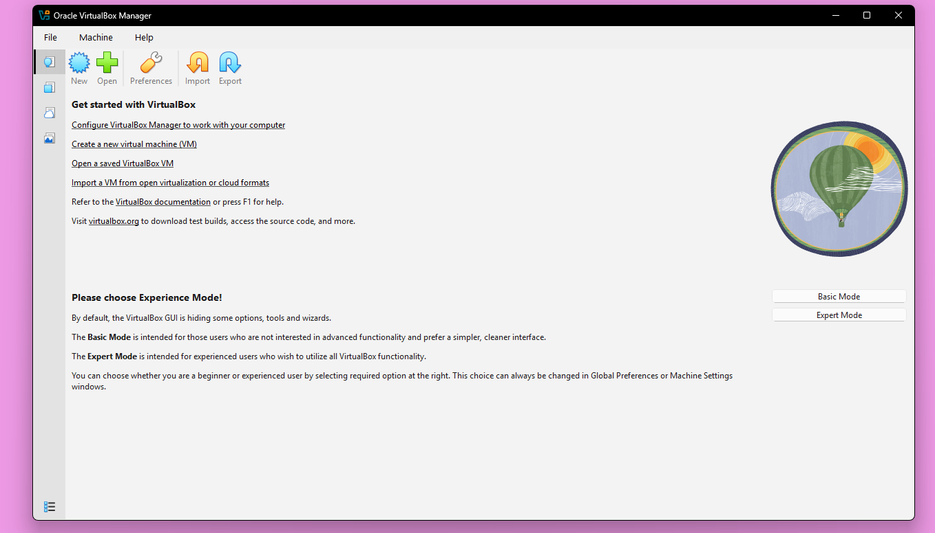
Figure 2. VirtualBox Manager after installation.

Step 2 - Obtain the Windows Server Installation ISO
I used the Microsoft Evaluation Center to obtain Windows Server installation media. The ISO file is attached to the virtual machine and used like a virtual installation DVD.
Procedure
- Open the Microsoft Windows Server Evaluation Center.
- Choose the ISO download option.
- Complete any required evaluation registration fields.
- Download the 64-bit ISO to the host computer.
Why this matters: The ISO provides the bootable Windows Server installer that will be used to build DC01.
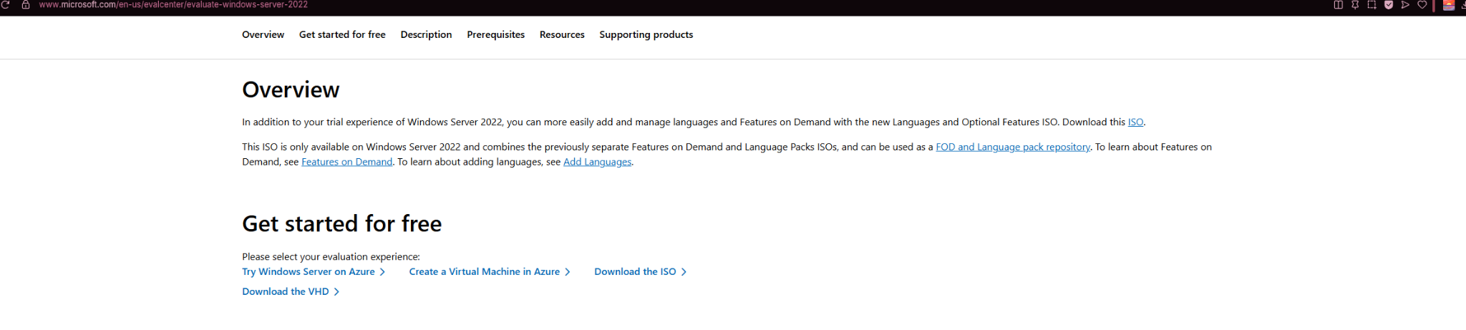
Figure 3. Windows Server Evaluation Center overview and ISO download option.
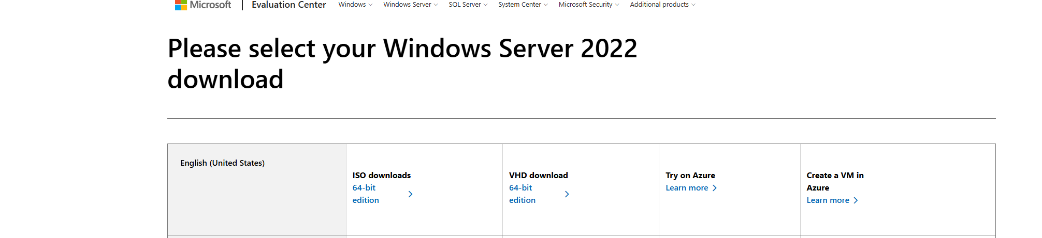
Figure 4. 64-bit ISO download selection.

Step 3 - Create the DC01 Virtual Machine
Next, I created the server virtual machine that would become the domain controller. I named the VM DC01 to match its planned role in the lab.
Procedure
- In VirtualBox Manager, select New.
- Enter DC01 as the VM name.
- Attach the downloaded Windows Server ISO.
- Continue to the hardware configuration page.
Why this matters: Using a descriptive hostname such as DC01 makes the machine role immediately recognizable in an Active Directory environment.
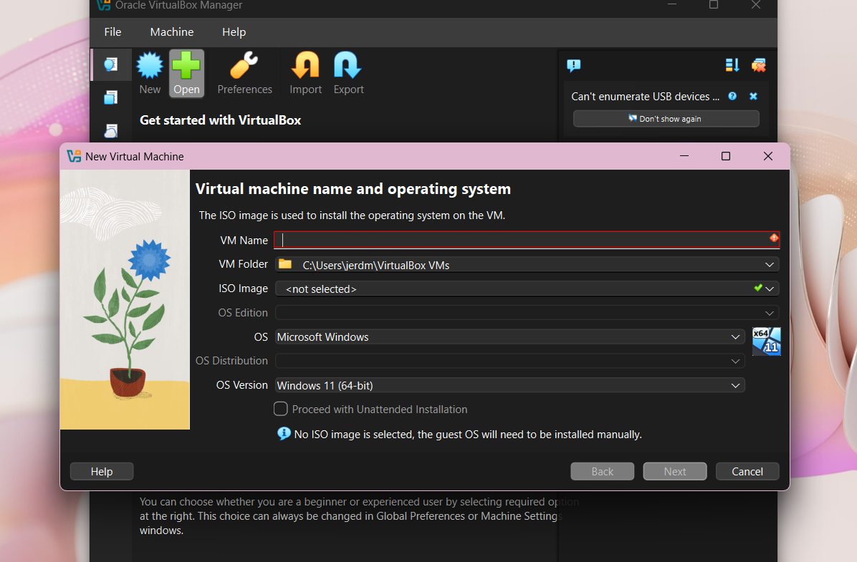
Figure 5. New Virtual Machine wizard used to define the VM name and installation media.
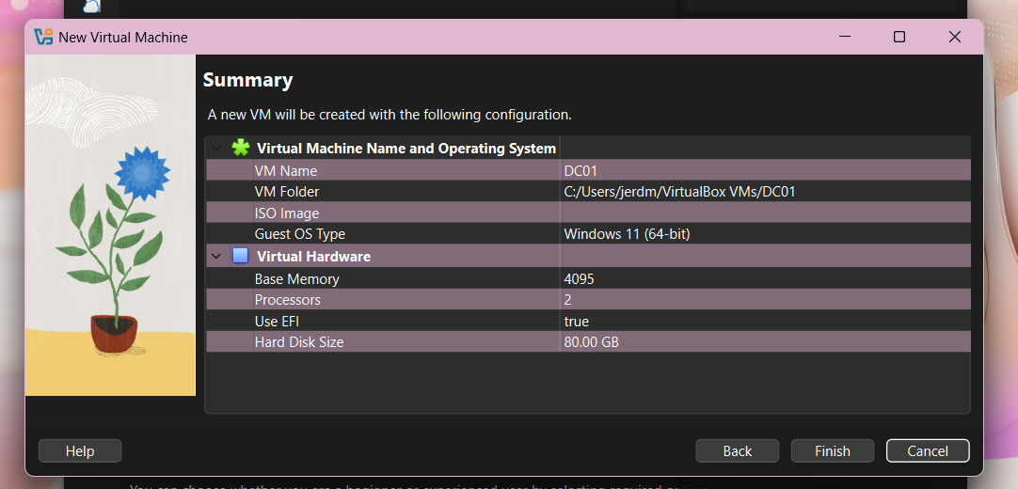
Figure 6. VirtualBox VM summary showing DC01 before creation.

Step 4 - Allocate Virtual Hardware
I assigned enough virtual resources for Windows Server and Active Directory to operate comfortably while keeping the lab lightweight.
Procedure
- Set base memory to approximately 4 GB (4095 MB).
- Assign 2 virtual CPUs.
- Create an 80 GB virtual disk.
- Leave EFI enabled as shown in the captured setup.
Configuration used
Base Memory: 4095 MB
Processors: 2
Virtual Disk: 80 GB
Why this matters: Active Directory itself is lightweight in a small lab, but enough memory and disk space are needed for the operating system, updates, DNS, and management tools.
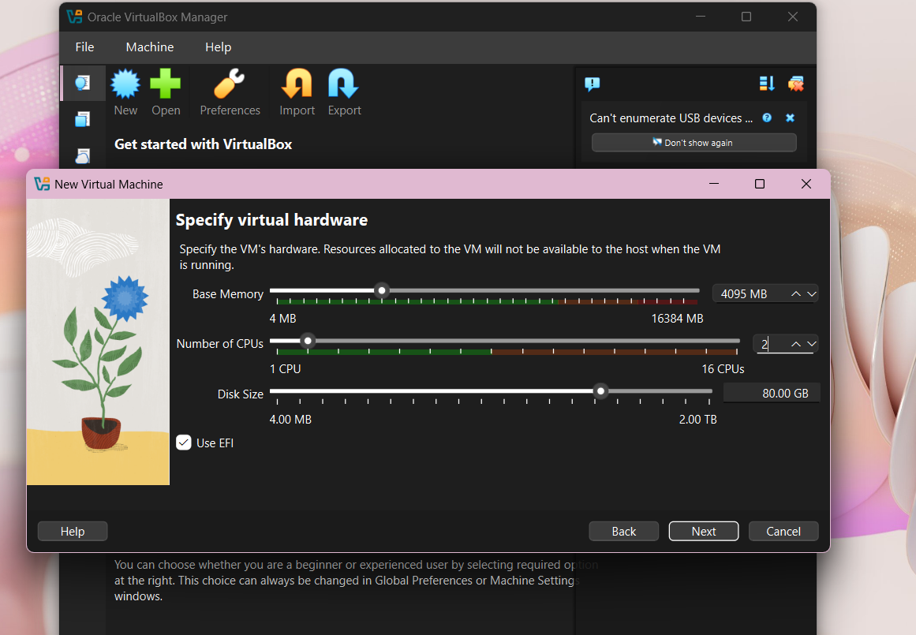
Figure 7. DC01 hardware allocation: 4095 MB RAM, 2 CPUs, and 80 GB disk.

Step 5 - Boot the VM and Install Windows Server
After creating DC01, I booted the VM from the attached Windows Server ISO and started the operating-system installation.
Procedure
- Start DC01 in VirtualBox.
- At Windows Server Setup, confirm the language and regional settings.
- Proceed through the Windows Server installation and create the local Administrator password.
- After installation, rename the server to DC01 if the Windows installer assigned a temporary computer name, then restart.
Why this matters: The computer name is important because the same server identity will appear later in Active Directory and DNS.
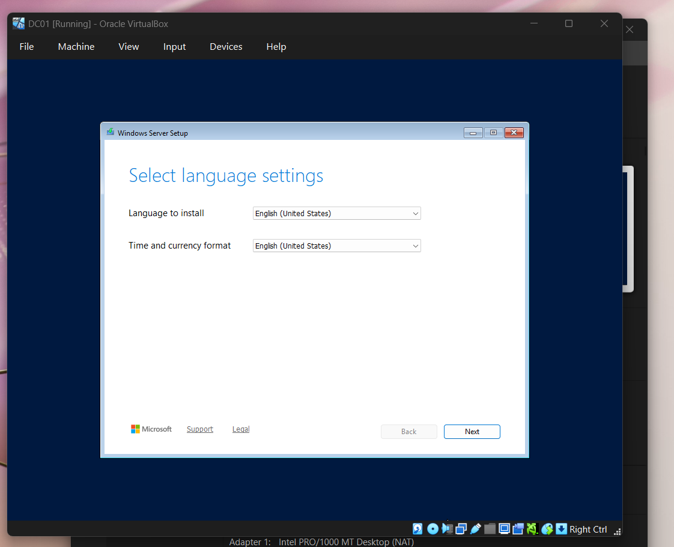
Figure 8. Windows Server Setup language selection.
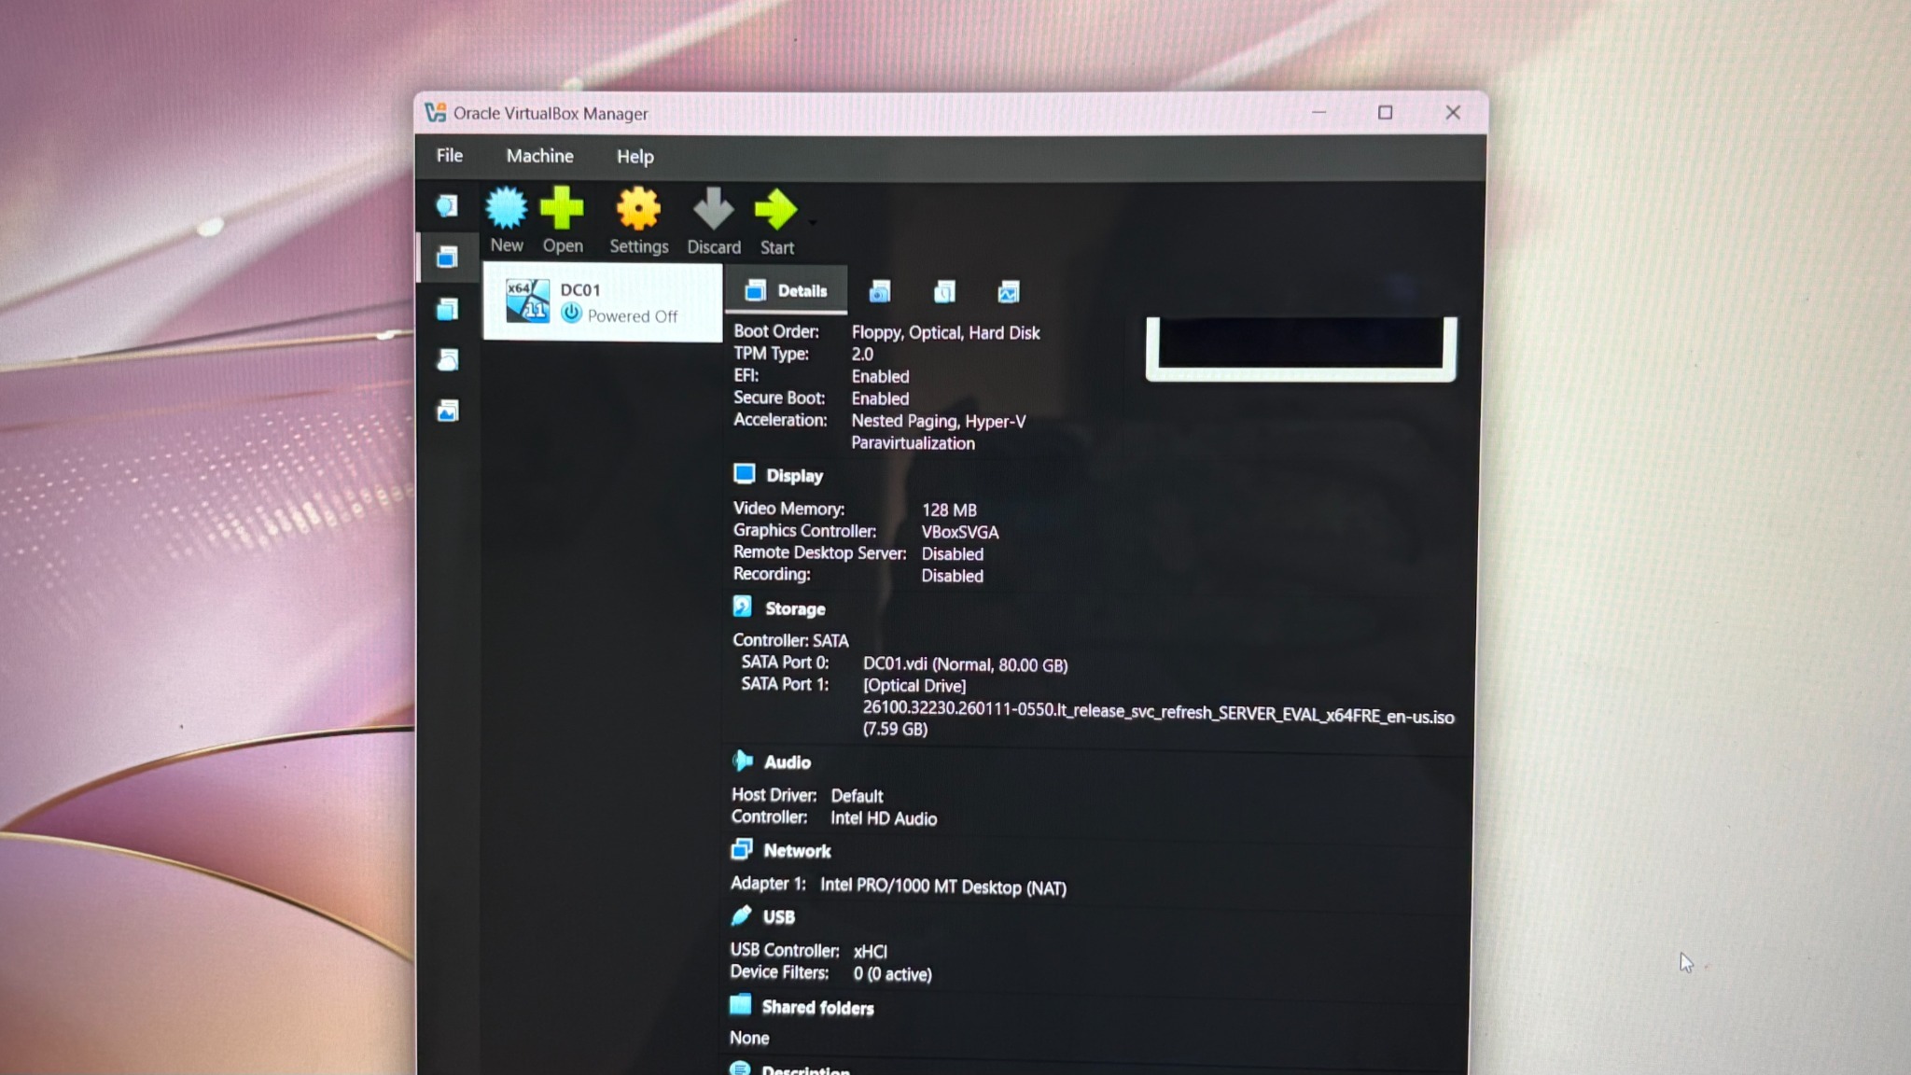
Figure 9. DC01 powered off in VirtualBox with the server ISO attached to the optical drive.

Step 6 - Prepare DC01 Virtual Networking
The server initially used the default VirtualBox NAT adapter. I then adjusted the networking so that additional lab virtual machines could later communicate with DC01 on the same virtual network.
Procedure
- Shut down DC01 before changing the adapter configuration.
- Open DC01 Settings > Network.
- Confirm Adapter 1 is enabled.
- Change the adapter from the default NAT mode to a NAT Network after the lab NAT Network is created.
Why this matters: A shared NAT Network allows multiple virtual machines to communicate with each other while still providing outbound connectivity through the host.
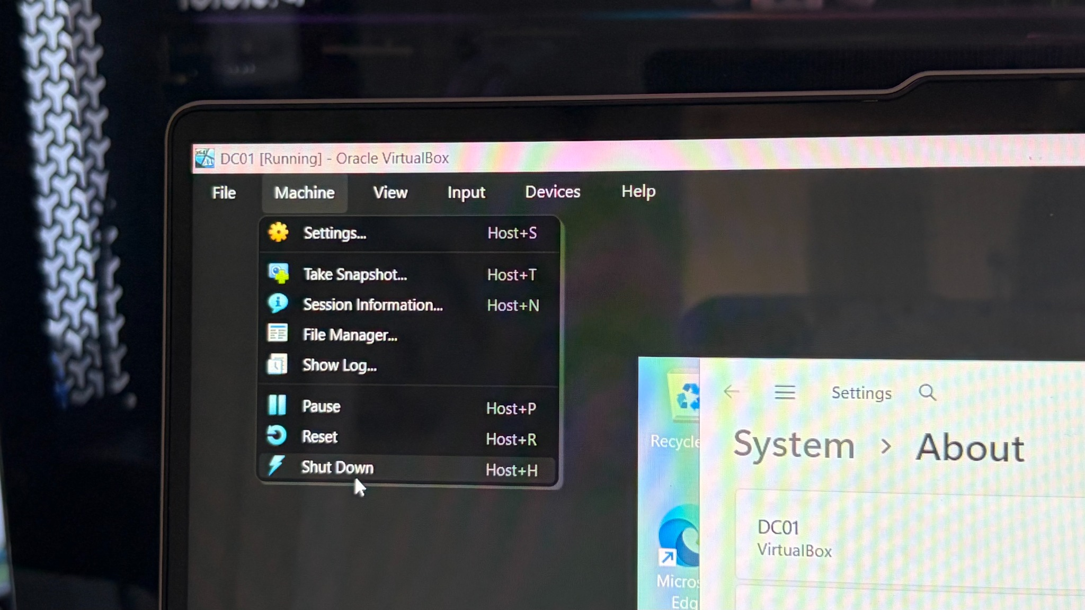
Figure 10. Shutting down DC01 before changing VirtualBox networking.
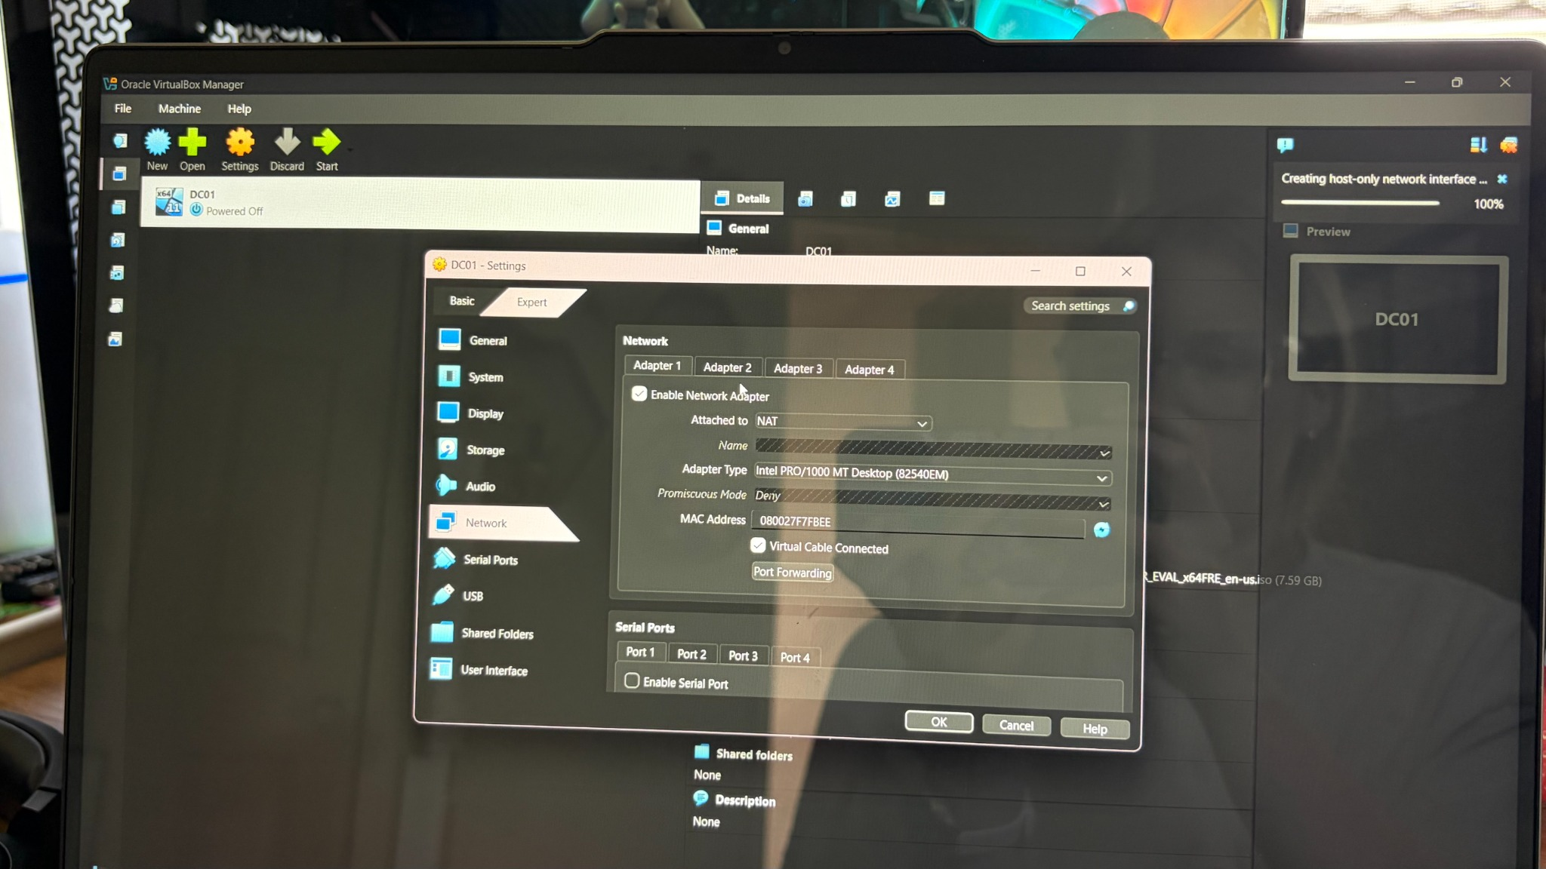
Figure 11. DC01 Adapter 1 initially configured for standard NAT.

Step 7 - Create and Select the NAT Network
I opened the VirtualBox Network Manager and created a NAT Network. The screenshots show the network listed as NatNetwork. Earlier lab notes referred to this logical network as the home-lab network.
Procedure
- Open the VirtualBox Network tool.
- Select the NAT Networks tab.
- Create a NAT Network.
- Use the NAT Network for DC01 Adapter 1.
Configuration used
Network prefix observed later in the lab: 10.0.2.0/24
DC01 IPv4 observed: 10.0.2.3
Default gateway observed: 10.0.2.1
Why this matters: Unlike the per-VM default NAT mode, a NAT Network can place multiple VMs on the same virtual segment so the future Windows client can reach the domain controller.
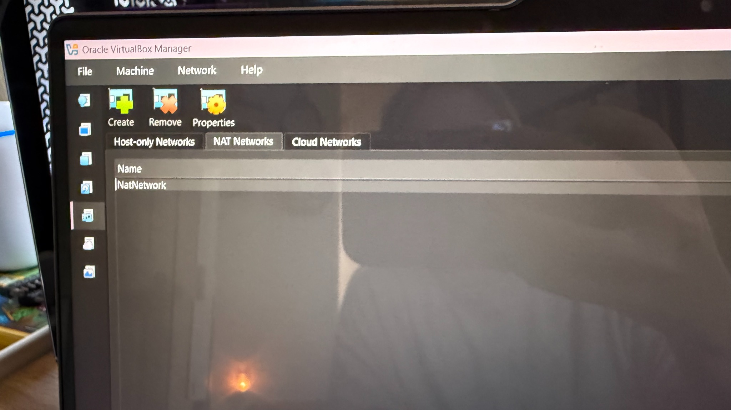
Figure 12. VirtualBox Network Manager with the NAT Networks tab.
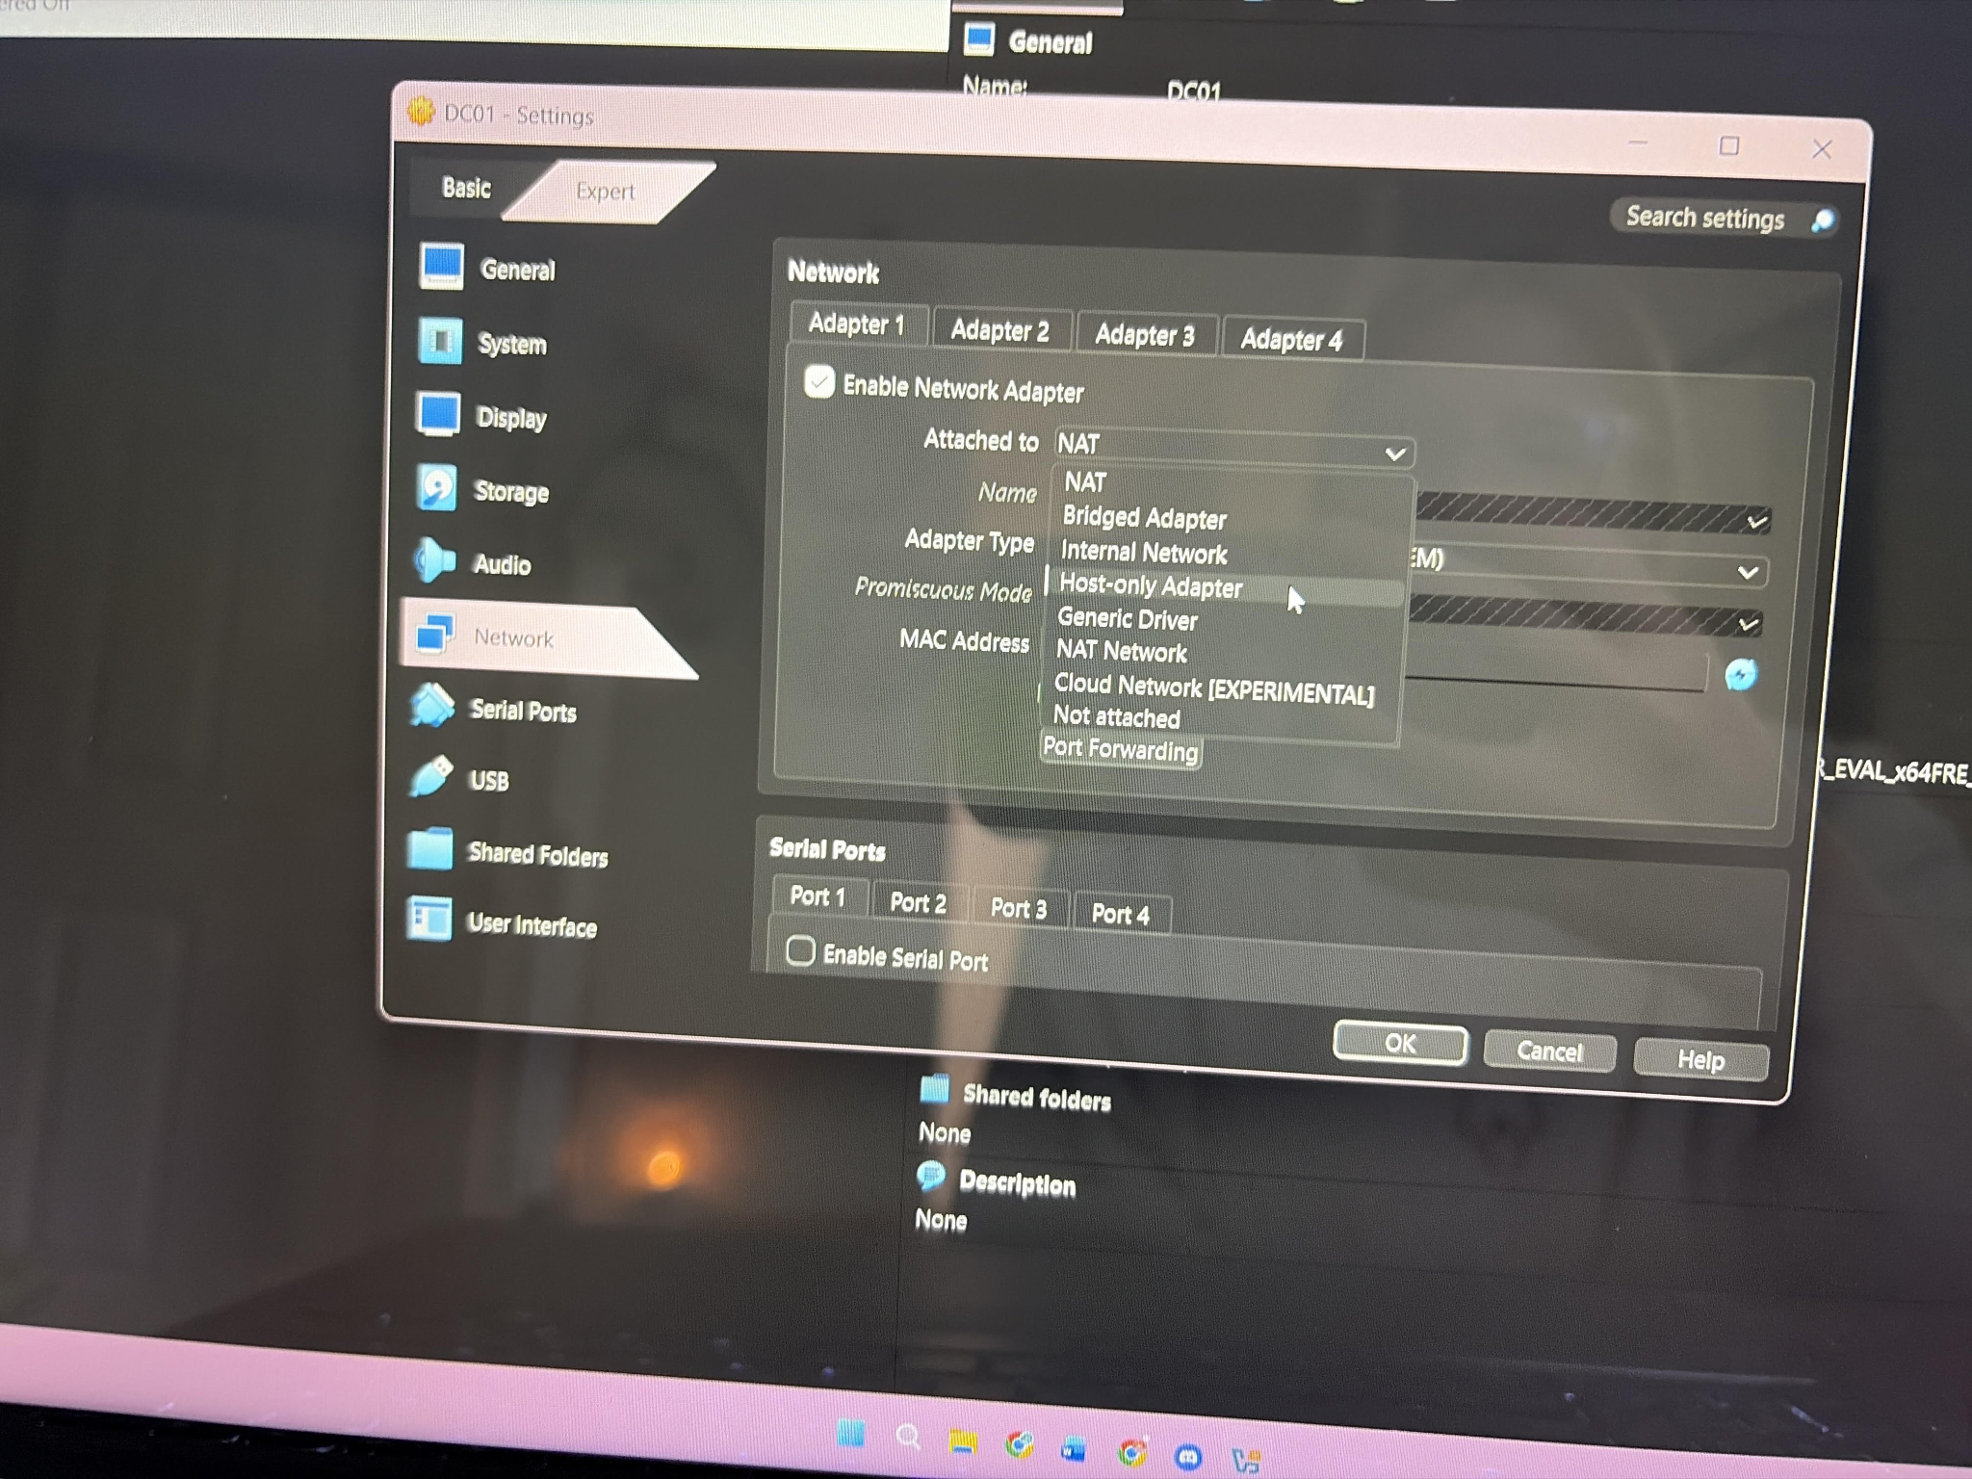
Figure 13. Selecting NAT Network from the DC01 network adapter type menu.

Step 8 - Verify Basic Network Connectivity
After starting DC01 on the NAT Network, I used Command Prompt to confirm that the server had an IPv4 configuration and could reach both its virtual gateway and an external IP address.
Procedure
- Open Command Prompt on DC01.
- Run ipconfig and record the IPv4 address and default gateway.
- Ping 10.0.2.1 to test the VirtualBox gateway.
- Ping 8.8.8.8 to test outbound IP connectivity.
Configuration used
ipconfig
ping 10.0.2.1
ping 8.8.8.8
Why this matters: Successful replies confirm that the server has basic Layer 3 connectivity before Active Directory and DNS are installed.
Note: During the lab, DC01 reported IPv4 address 10.0.2.3 and default gateway 10.0.2.1, and both ping tests returned replies.

Step 9 - Install Active Directory Domain Services
With Windows Server and networking working, I installed the Active Directory Domain Services server role through Server Manager.
Procedure
- Open Server Manager.
- Select Manage > Add Roles and Features.
- Choose Role-based or feature-based installation.
- Select DC01 as the destination server.
- Enable Active Directory Domain Services and add the required management features.
- Complete the wizard and wait for the role installation to finish.
Why this matters: Installing the AD DS role adds the binaries and management tools needed before a Windows Server can be promoted to a domain controller.
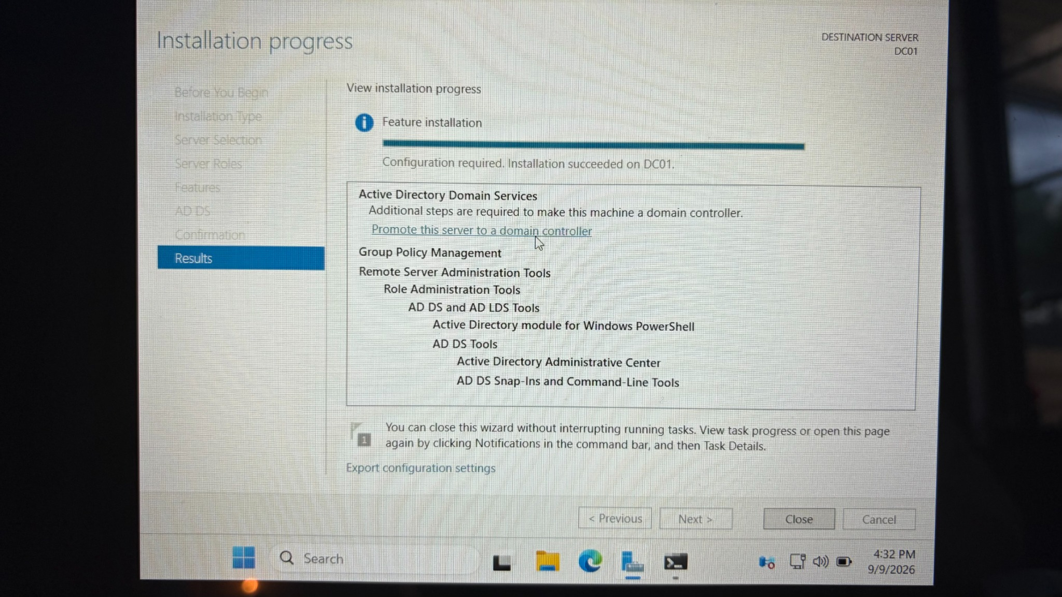
Figure 14. AD DS role installation completed successfully; the server is ready for promotion.

Step 10 - Create a New Forest and Domain
After AD DS installed, I selected the option to promote DC01 to a domain controller. Because this was a new lab with no existing Active Directory environment, I created a new forest.
Procedure
- Click Promote this server to a domain controller.
- Select Add a new forest.
- Enter homelab.local as the root domain name.
- Continue to Domain Controller Options.
Configuration used
Root domain name: homelab.local
Why this matters: A forest is the top-level Active Directory structure. Creating a new forest also creates the first domain and establishes DC01 as the first domain controller in that environment.
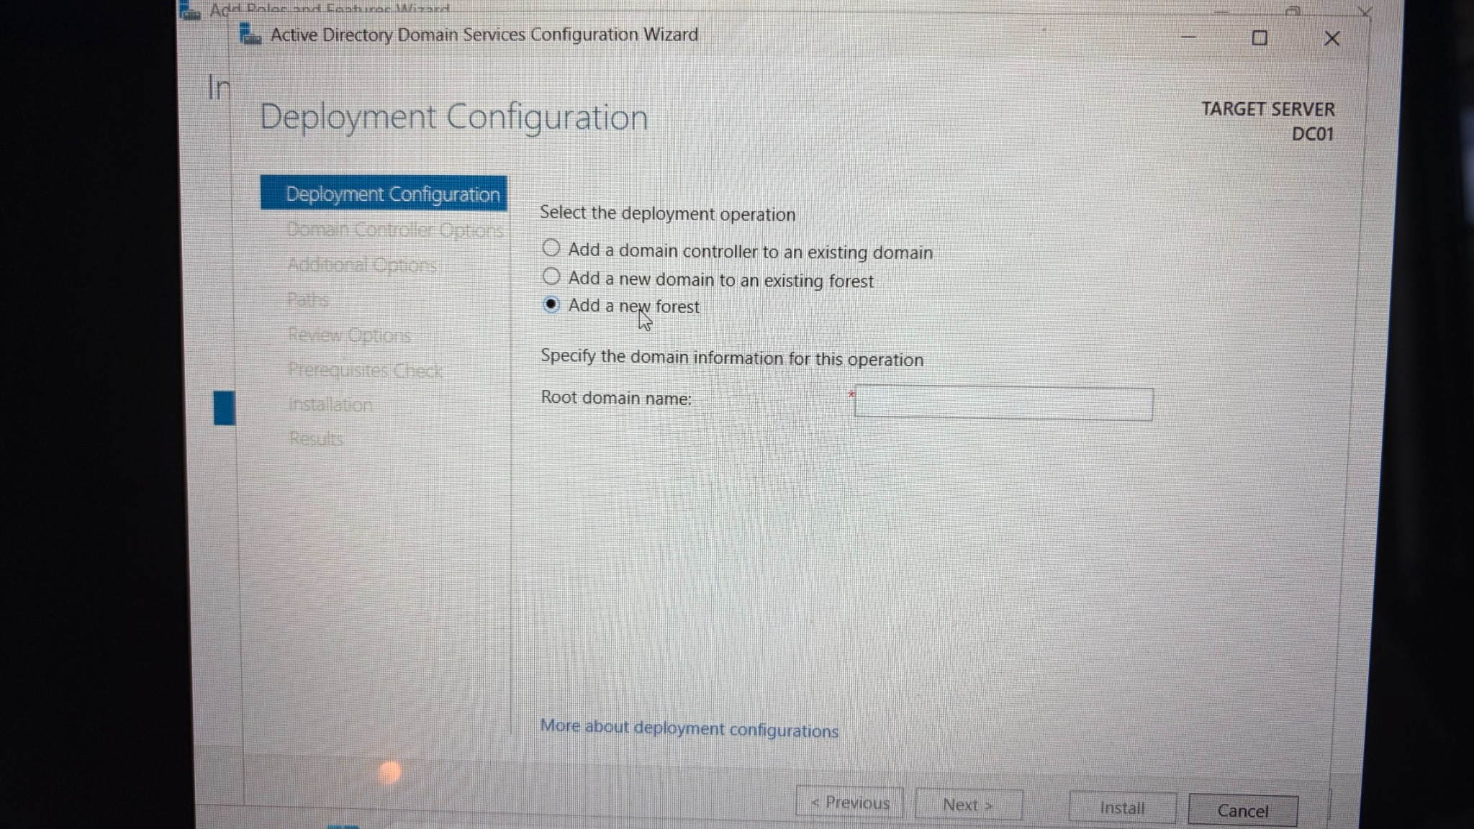
Figure 15. Deployment Configuration screen with Add a new forest selected.

Step 11 - Configure Domain Controller and DNS Options
I configured DC01 as a writable domain controller, DNS server, and Global Catalog server. I also created a Directory Services Restore Mode (DSRM) password.
Procedure
- Leave the forest and domain functional levels at the values shown by the wizard.
- Keep Domain Name System (DNS) server enabled.
- Keep Global Catalog (GC) enabled.
- Leave Read Only Domain Controller (RODC) unchecked.
- Create and confirm a DSRM password.
- On DNS Options, leave Create DNS delegation unchecked for this standalone lab.
Configuration used
Forest functional level shown: Windows Server 2025
Domain functional level shown: Windows Server 2025
DNS Server: Enabled
Global Catalog: Enabled
RODC: Disabled
Why this matters: DNS is essential to Active Directory because domain members use DNS service records to locate domain controllers and other AD services. The Global Catalog supports forest-wide directory lookups.
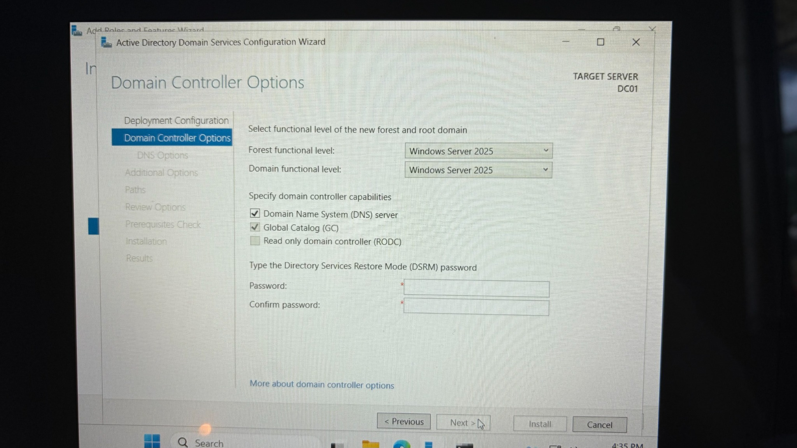
Figure 16. Domain Controller Options showing DNS and Global Catalog enabled.
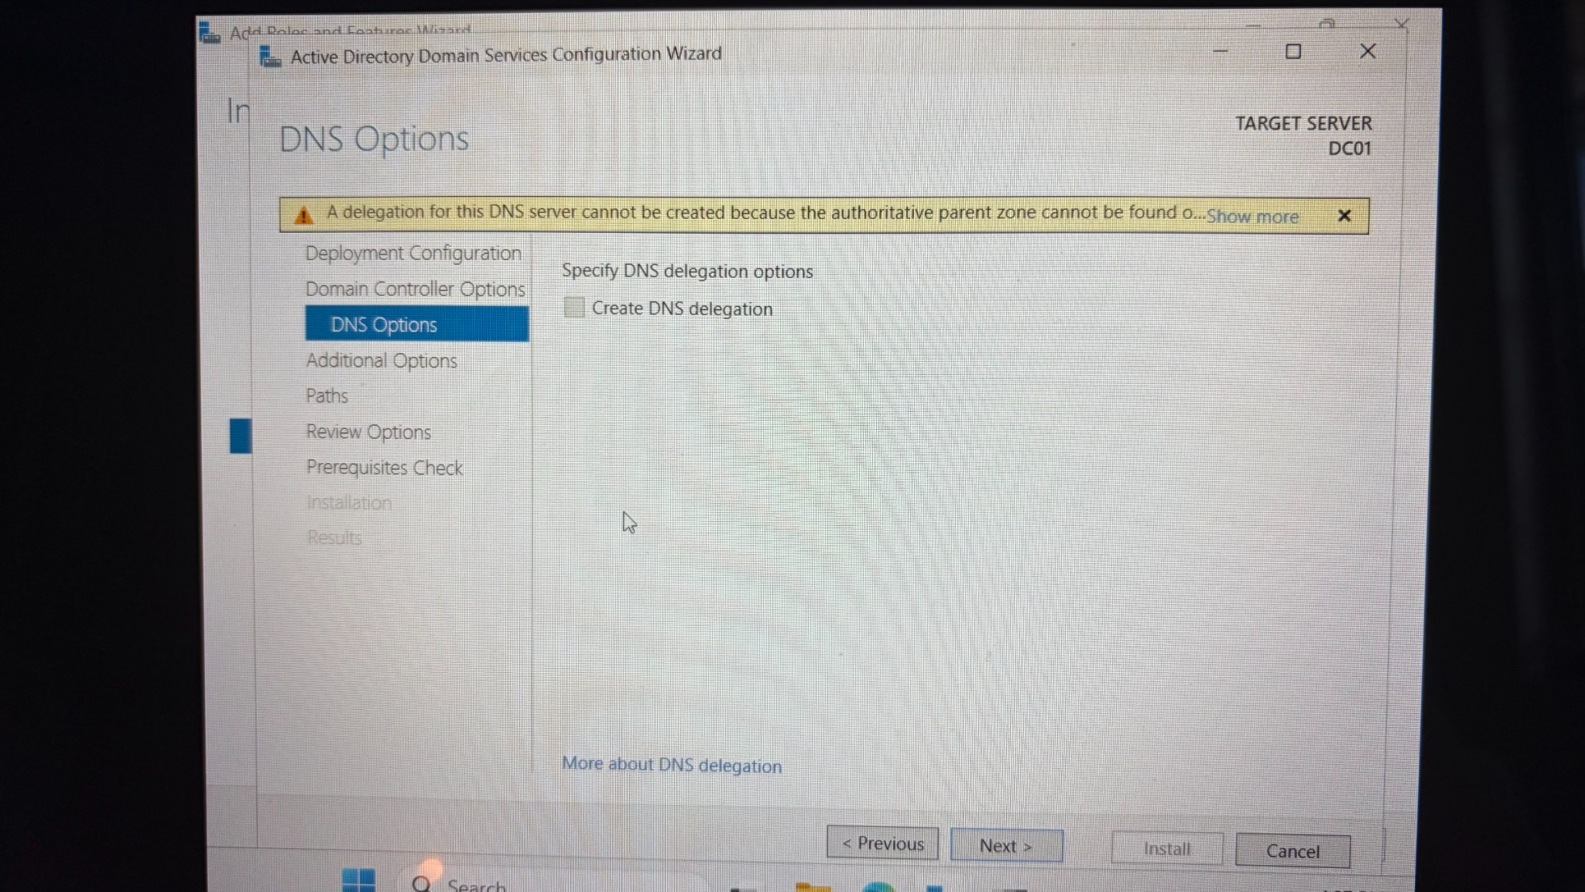
Figure 17. DNS Options screen with the expected delegation warning.

Step 12 - Confirm NetBIOS Name and Active Directory Paths
The configuration wizard automatically generated the NetBIOS name HOMELAB. I kept the default Active Directory database, log, and SYSVOL locations.
Procedure
- Confirm the NetBIOS domain name is HOMELAB.
- Continue to Paths.
- Leave the NTDS database and log files in C:\Windows\NTDS.
- Leave SYSVOL in C:\Windows\SYSVOL.
Configuration used
NetBIOS domain name: HOMELAB
Database: C:\Windows\NTDS
Logs: C:\Windows\NTDS
SYSVOL: C:\Windows\SYSVOL
Why this matters: The NetBIOS name provides the short form of the domain name, such as HOMELAB\Administrator. Default AD paths are appropriate for a small single-disk lab.
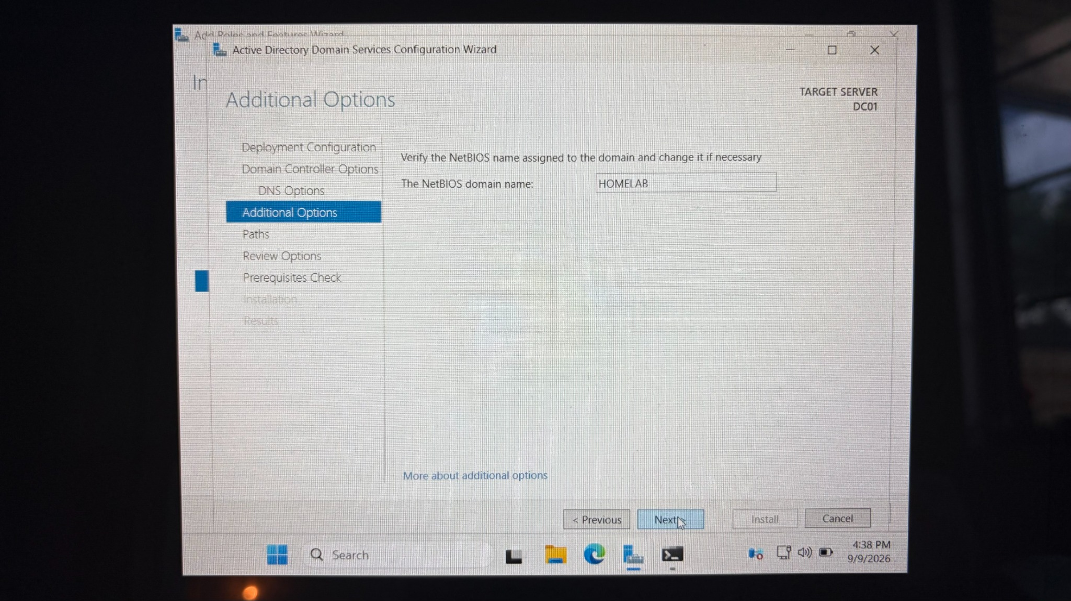
Figure 18. Additional Options showing NetBIOS domain name HOMELAB.
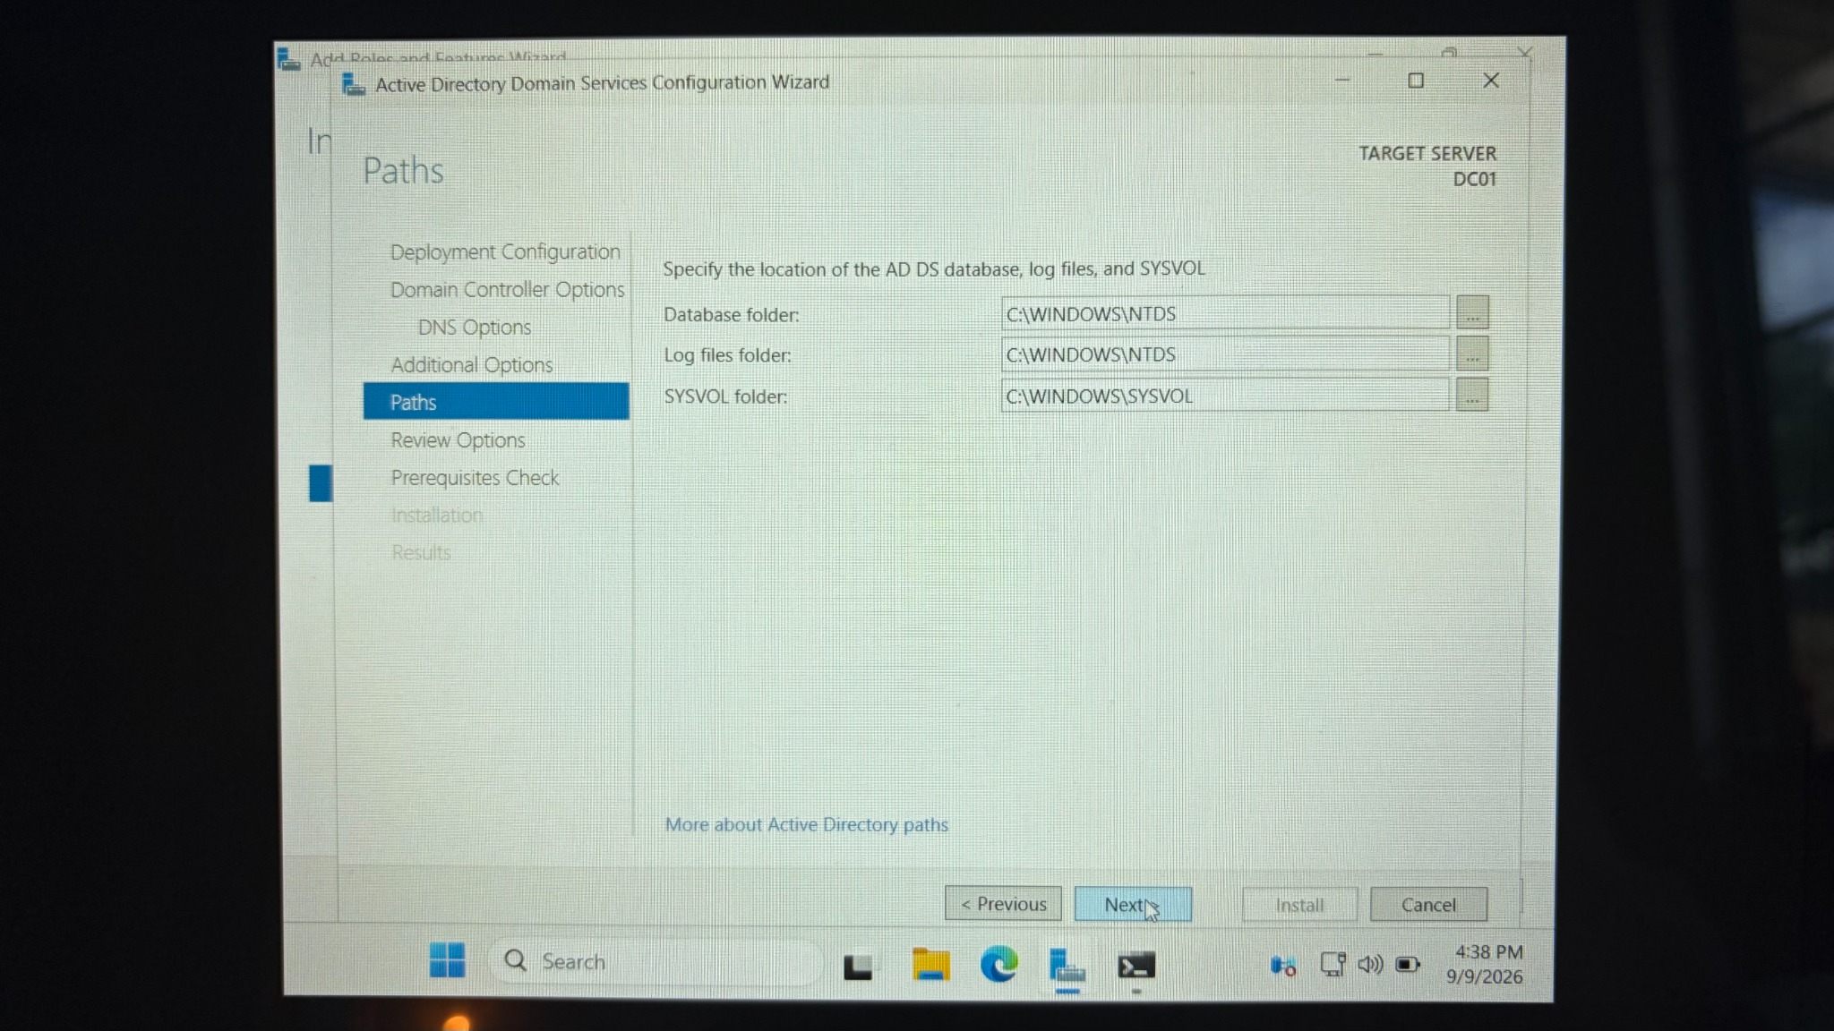
Figure 19. Default AD DS database, log, and SYSVOL paths.

Step 13 - Review the Configuration and Run Prerequisite Checks
Before installation, I reviewed the domain configuration and allowed the wizard to run prerequisite validation.
Procedure
- Review the forest name, domain name, NetBIOS name, DNS setting, and Global Catalog setting.
- Select Next to run prerequisite checks.
- Confirm the green status message that all prerequisite checks passed successfully.
- Review any warnings before selecting Install.
Why this matters: The prerequisite stage helps identify configuration problems before the server is promoted. This screenshot also documents an important networking warning that should be addressed in a more production-like build.
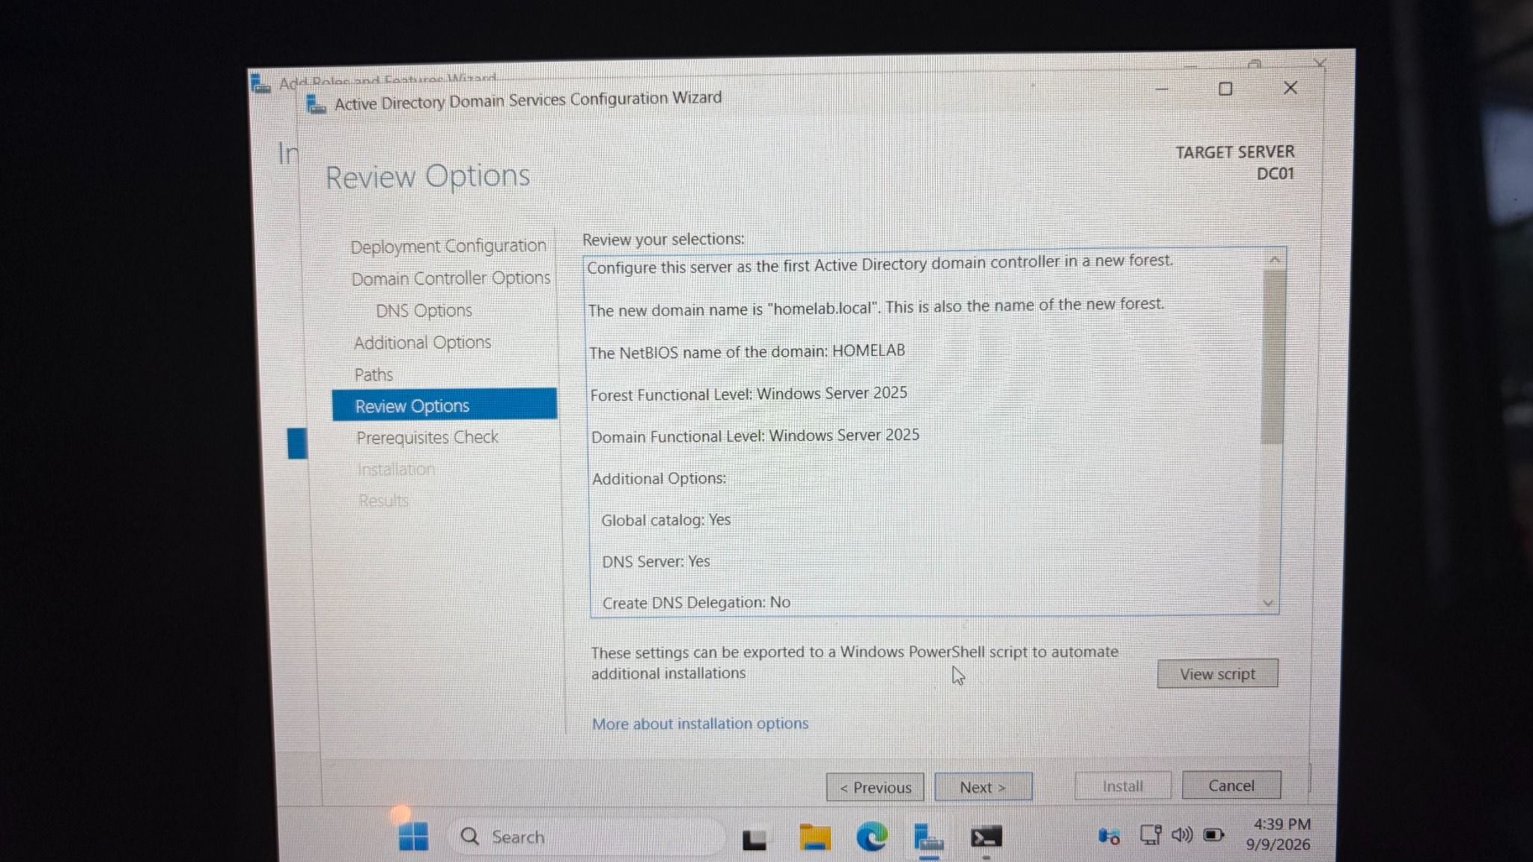
Figure 20. Review Options confirms homelab.local, HOMELAB, DNS, and Global Catalog.
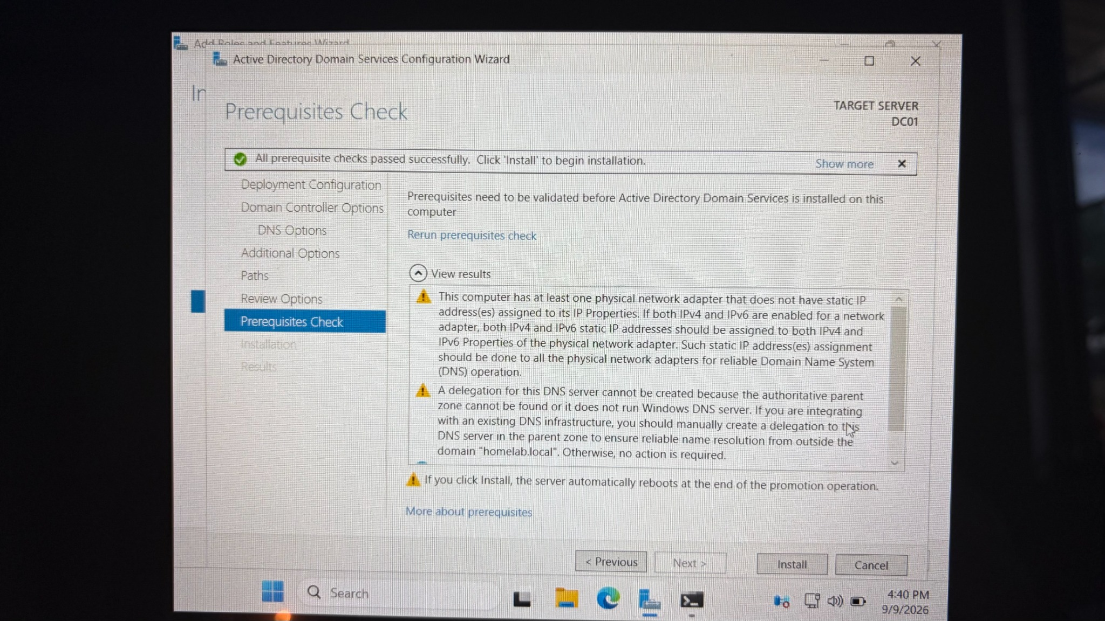
Figure 21. Prerequisite checks passed, with warnings displayed for review.
Important: The prerequisite screen warns that a network adapter does not have a static IP address. The lab still passed and continued, but a domain controller should normally use a stable/static IP address. For the next phase of this project, assign DC01 a predictable address and ensure domain clients use DC01 for DNS.

Step 14 - Promote DC01 and Restart
After the checks passed, I installed the Active Directory configuration. Windows Server successfully promoted DC01 to a domain controller and then restarted automatically.
Procedure
- Click Install from the Prerequisites Check page.
- Wait while the promotion completes.
- Allow Windows Server to restart automatically.
- At the login screen, sign in using the domain Administrator account.
Why this matters: A successful promotion creates the Active Directory database and SYSVOL, configures the DNS integration, and changes the server from a standalone server into a domain controller.
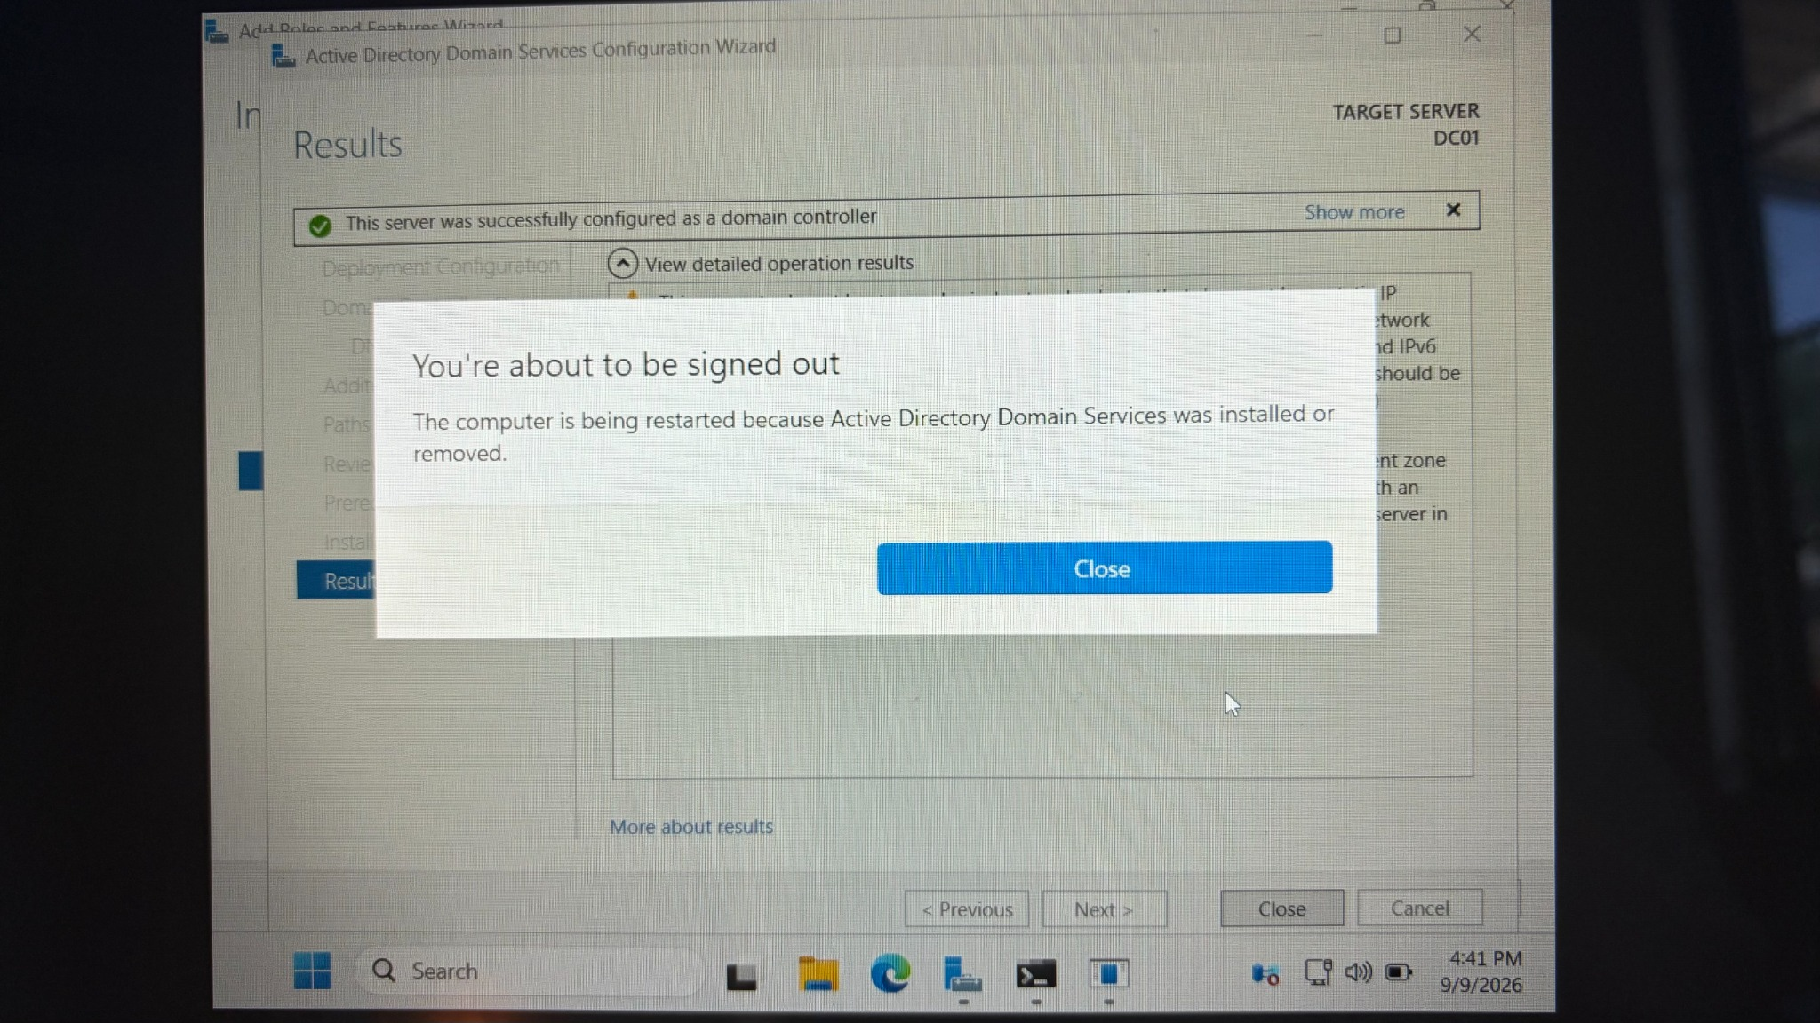
Figure 22. Successful domain controller configuration and automatic restart notification.
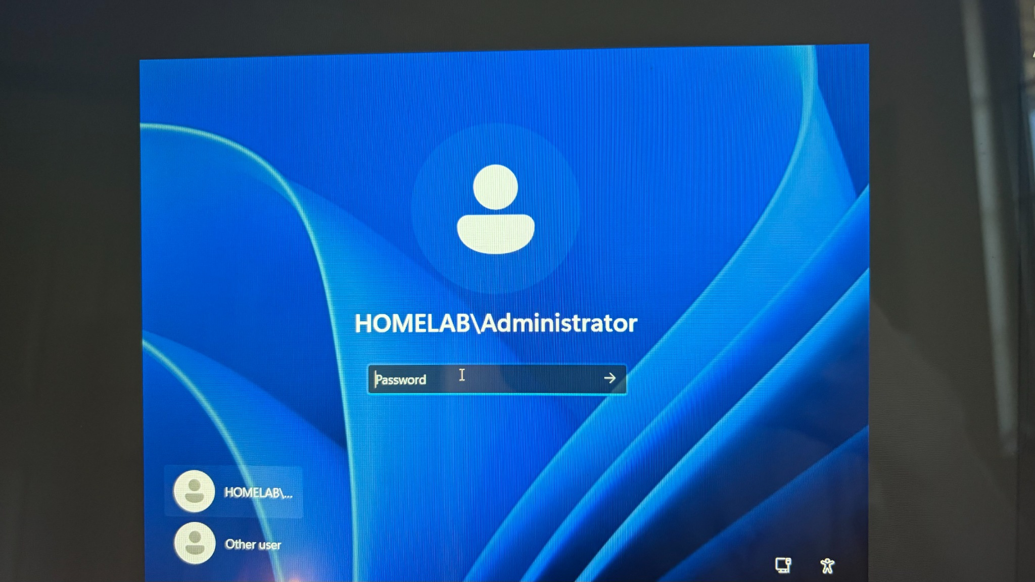
Figure 23. Post-promotion login screen showing HOMELAB\Administrator.

Step 15 - Verify Active Directory
After the reboot, I used Server Manager and Active Directory Users and Computers (ADUC) to verify that the domain had been created and that the AD DS management tools were available.
Procedure
- Open Server Manager.
- Open Tools > Active Directory Users and Computers.
- Confirm that homelab.local appears in the console tree.
- Expand the domain and verify the standard Active Directory containers and the Domain Controllers organizational unit.
- Optionally open DNS Manager and use nslookup or ping to continue validating name resolution.
Configuration used
dsa.msc
nslookup homelab.local
ping DC01
Why this matters: Verification proves that the role installation and domain controller promotion completed successfully and that the domain is available for later user, group, OU, client-join, and Group Policy work.
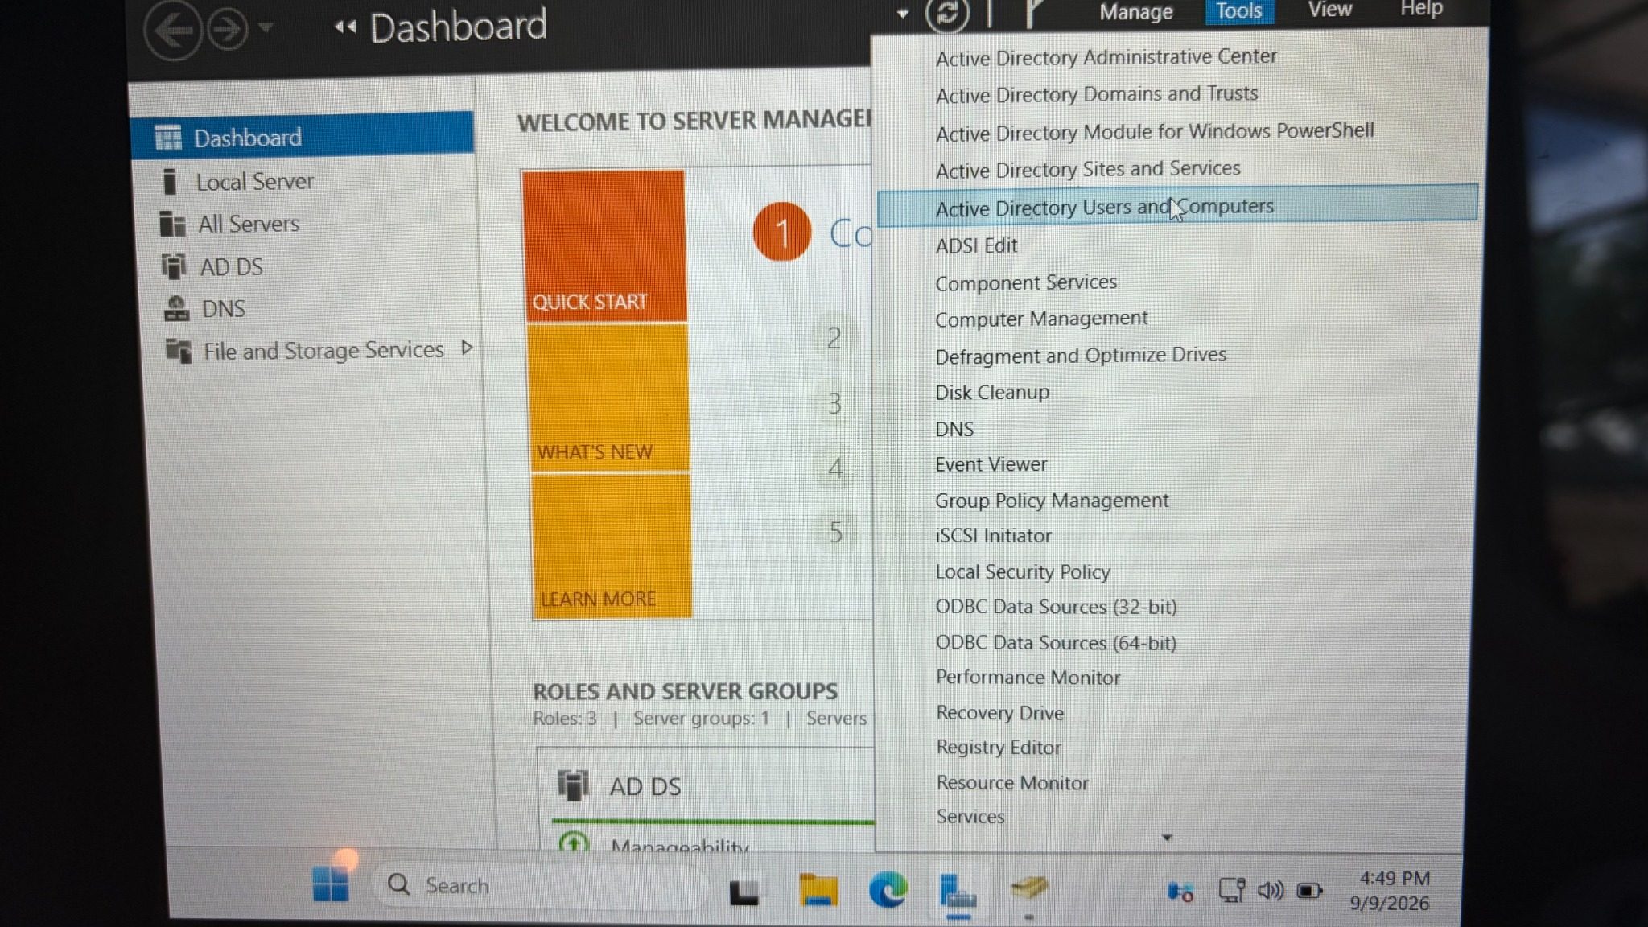
Figure 24. Server Manager Tools menu showing Active Directory Users and Computers.
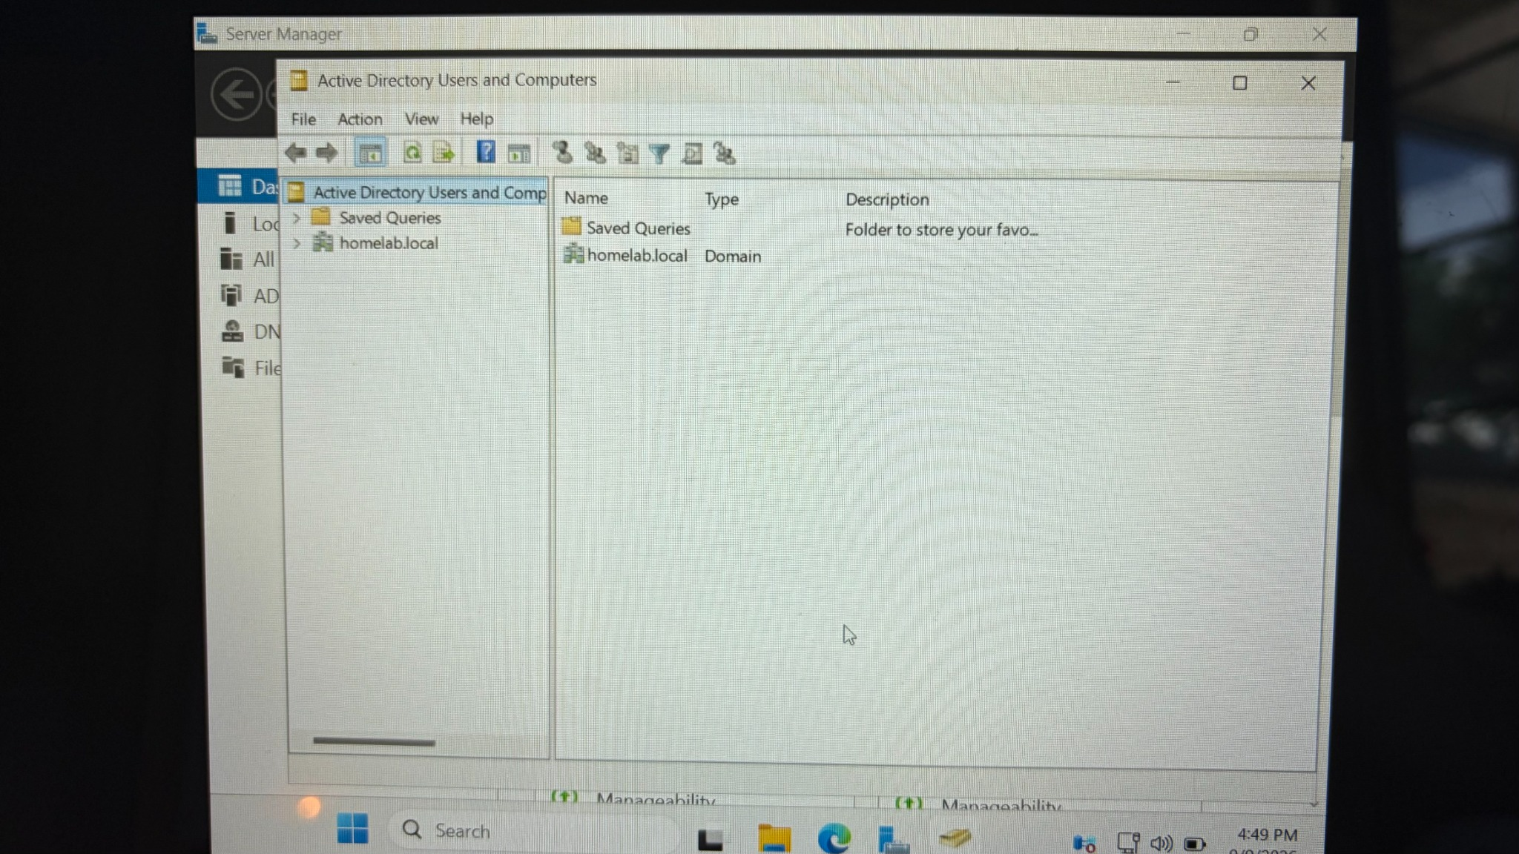
Figure 25. Active Directory Users and Computers showing the homelab.local domain.

Testing and Verification
The following checks were used or planned to confirm that the environment was functioning correctly after the domain controller promotion.
Test | Tool / Command | Expected Result | Lab Result
Gateway connectivity | ping 10.0.2.1 | Replies from virtual gateway | Successful
Outbound IP connectivity | ping 8.8.8.8 | Replies from external IP | Successful
Domain presence | Active Directory Users and Computers | homelab.local visible | Successful
Domain administrator login | Windows sign-in | HOMELAB\Administrator available | Successful
DNS/domain resolution | nslookup homelab.local | Domain resolves through lab DNS | Verify/retain screenshot in next phase
DC hostname resolution | ping DC01 | DC01 resolves to the domain controller | Verify/retain screenshot in next phase

Troubleshooting and Lessons Learned

1. Initial VM boot / installation media issue
During the early VM setup, the server did not immediately boot into the installer. The troubleshooting process involved checking that the Windows Server ISO was attached to the VM optical drive and confirming the VM boot configuration. Once the installation media was correctly available to DC01, Windows Server Setup started successfully.

2. VirtualBox network-mode confusion
The VirtualBox interface initially made it unclear whether Host-Only Adapter, standard NAT, or NAT Network was the correct choice. The final design used a NAT Network so DC01 could retain outbound connectivity while also being reachable by future lab VMs on the same virtual segment.

3. Dynamic IP warning during domain promotion
The Active Directory prerequisite check passed but warned that a network adapter did not have a static IP address. This is an important lesson: even when a small lab works using a DHCP-provided address, domain controllers should normally use stable addressing because DNS and domain clients depend on being able to locate the server consistently.

4. DNS delegation warning
The AD DS wizard displayed a DNS delegation warning because this was the first DNS server and domain controller in a standalone new forest. No parent Windows DNS zone existed to create a delegation, so the warning was expected in this lab design.

Skills Demonstrated
- Virtual machine creation and resource allocation
- Windows Server installation and basic server configuration
- VirtualBox NAT and NAT Network configuration
- IPv4 connectivity testing and troubleshooting
- Windows Server role installation with Server Manager
- Active Directory Domain Services deployment
- New forest and domain creation
- DNS and Global Catalog configuration
- Directory Services Restore Mode configuration
- NetBIOS naming and AD DS database/SYSVOL path review
- Domain controller promotion
- Active Directory verification using ADUC
- Technical documentation using screenshots and repeatable procedures

Project Result
This phase of the home lab successfully produced a functioning Active Directory environment with DC01 acting as the first domain controller for homelab.local. The server has AD DS and DNS installed, the HOMELAB domain identity is active, and the domain is visible in Active Directory Users and Computers. The environment is now ready to be expanded with organizational units, users, security groups, a Windows client VM, domain joining, Group Policy, and additional troubleshooting demonstrations.

Recommended Next Phase for the GitHub Portfolio
- Assign DC01 a stable/static IPv4 address on the lab network and point its DNS configuration appropriately.
- Create organizational units for users, computers, and administration.
- Create sample users and security groups.
- Create a Windows client VM and attach it to the same NAT Network.
- Set the client DNS server to DC01 and join the client to homelab.local.
- Sign in to the client with a domain user account.
- Create and apply a Group Policy Object.
- Document testing with gpupdate /force, gpresult /r, nslookup, ping, and domain login screenshots.

GitHub Publishing Structure
Windows-Server-Active-Directory-Homelab/
|-- README.md
|-- screenshots/
| |-- 01-virtualbox-install/
| |-- 02-server-iso/
| |-- 03-dc01-vm/
| |-- 04-networking/
| |-- 05-ad-ds-install/
| |-- 06-domain-controller-promotion/
| `-- 07-verification/
`-- troubleshooting/
When converting this document into a GitHub README, keep the explanations concise and place each screenshot directly under the step it demonstrates. Use the Troubleshooting section to show problem-solving ability rather than hiding the issues encountered during the build.

Screenshot Inventory Used in This Draft
The main screenshots used in the walkthrough were selected from the uploaded image set and ordered according to the lab workflow. Duplicate photographs and video files were not embedded when a clearer still image documented the same action. This keeps the portfolio readable while preserving the strongest evidence for each major step.
Note: This Word document is intentionally editable. Before publishing it to GitHub, verify the Windows Server version label, decide whether you want the NAT Network to be named NatNetwork or Homelab consistently, and replace any screenshots you would prefer to retake at higher clarity.

