**Reverse Engineering IoT Systems Final Project Report**

**Air Quality on 14 Segment Display**

Ahmad Qatanani, Jun Wang, Minh Nguyen & Vijay Thakkar

Southern Alberta Institution of Technology

**Introduction**

The aim of this lab is to display air quality indexes on 14 segment display. This lab is accomplished by connecting the SGP30 gas sensor, Adafruit 14 segment display and Beaglebone Black board on an I2C bus network and driving by python scripts.

The SGP30 gas sensor is able to test 2 air quality indexes: Total Volatile Organic Compounds (TVOCs) and Carbon dioxide (CO2). The python scripts enable Beaglebone Black to read these two air quality indexes from SGP30 and send data to 14 segment display.

Total Volatile organic compounds (TVOCs) are a group of carbon-based chemicals with low evaporation or vaporization points. Some TVOCs are toxic, examples are: alcohols, aldehydes, ketones, organic acids, amines, organic chloramines, aliphatic and aromatic hydrocarbons. CO2 is colorless, odorless, tasteless gas. CO2 comprises less than 0.04 % (400ppm) of the air. However, staying in poorly ventilated spaces having carbon dioxide levels from 2000-5000 parts per million(ppm) causes headaches, impaired mental function, lethargy, and increased heart rate. So monitoring these two indexes is important for maintaining health and safety. SGP30 can be applied in industries to monitor the concentration of toxic gases or detecting fire.

**Responsibilities for Group Members:**

Ahmad Qatanani: Documentation

Jun Wang: Coding, Wiring and research (Team Leader)

Minh Nguyen: Wiring and research

Vijay Thakkar: Documentation

**Scope of the project:**

Display TVOCs or CO2 level on Adafruit 14-segment LCD Display

**Hardness:**

The difficult points are resource searching and python coding.

**Time Spent:**

Research: 2 hours

Wiring: 5 minutes

Coding: 2 hours

Debugging: 5 hours

Report Writing: 2 hours

**Outcomes:**

1. Practiced wiring multiple sensors on one I2C bus network
2. Developed python scripts for controlling the communication between devices on I2C bus network.
3. Analyzed the security vulnerabilities of bus network, I2C protocol and SGP30 gas sensor.
4. Reverse engineered Adafruit 14 segment display.

**Devices:**

1 X Beaglebone Black

1 X Breadboard

1 X SGP30 Gas Sensor

1 X Adafruit 14-Segment Display

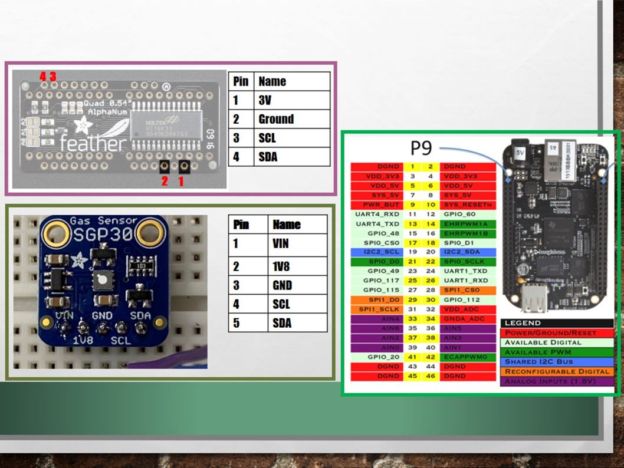

**Connection:**

Network: Bus

Protocol: I2C

Feature: Shares single clock line and single data line.

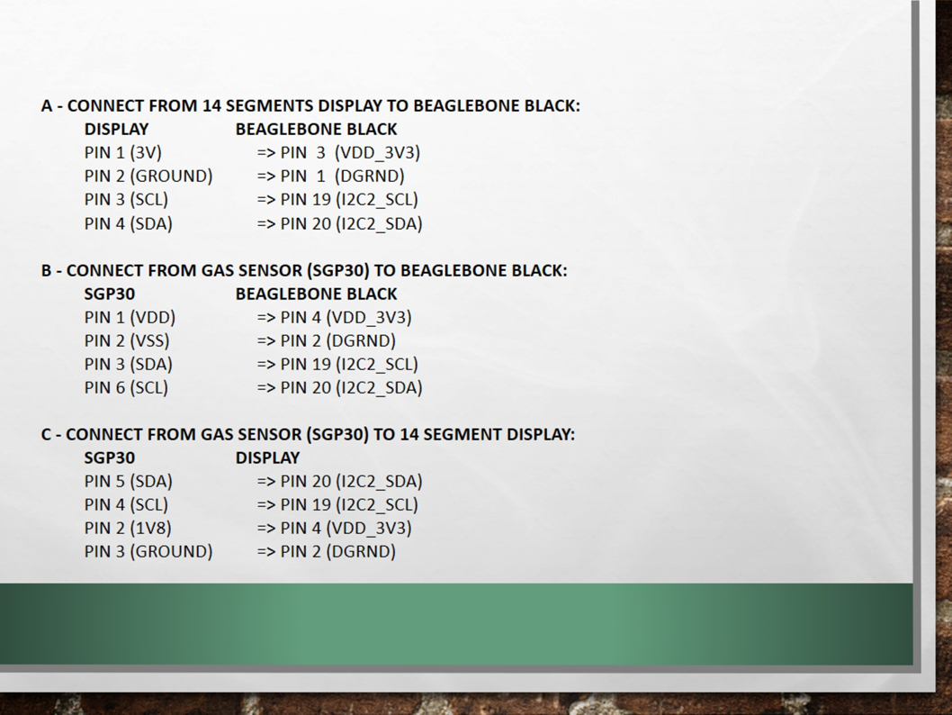

# 

# 

**Shell command for detecting the attached devices:**

I2cdetect -r 2

SGP30 address: 0x58

14-Segment-Display: 0x70

**Python Scripts:**

1) displayv4.py

Usage: python displayv4.py 123.4

* This program is used for displaying numbers and characters on Adafruit 14 segment LCD display.
* The range of numbers that the program can display is 0.000-99999. For strings, it displays the first 4 characters or digits, the rest will be discarded. It can display decimal numbers in the following format: 1.234 12.34 123.4 1234.

2) gasdemo.py

Usage: python gasdemo.py [-t] [-c]

-c: display CO2 level in unit ppm

-t: display TVOCs level

* This program is used for reading air quality indexes from SGP30 gas sensor, parsing the data and then sending data onto a 14-segment LCD display.
* It utilizes i2cset shell command to control the 14 segment display.
* When displaying CO2 level, if the level is less than 2000 ppm, the display is stable. When CO2 level is at 2000-5000 ppm, the display blinks slowly at a rate of 1Hz. When CO2 level is greater than 5000ppm, the display blinks faster at a rate of 2Hz.

**Vulnerability Analysis:**

This lab used I2C protocol on a simple bus network. I2C is typically used for the internet of things to connect sensors.

On the physical layer, the bus network is famous for one point failure. One breakdown will affect the whole network functionality. It is easy to implement but hard to troubleshoot. I2C does not have any authentication mechanism, the masters recognize and communicate with slaves based on the associated device addresses. It is so easy for hackers to spoof as a fake device and send malicious data to the master. Data sent on the I2C network is in clear text, this makes intercepting a piece of cake. The I2C standard allows for multiple clock-masters to take turns on the bus. If the hacker can reach bus network, spoofing as a master will be a wiser choice. Because a master can take down the whole network immediately.

The SGP30 gas sensor is not reliable. It requires 15 seconds to boot up and in the first 12 hours after booting the sensor is not stable. While spoofing as a master, a hacker can reboot the whole network by sending one simple shell command.

Thus, neither I2C bus network or SGP30 gas is recommended to be implemented in any critical environment.

References

Indoor Air Quality Management Group, Hong Kong SAR Government, *A Guide on Indoor Air Quality Certification Scheme for Offices and Public Places*, 2003.

Sensirion_Gas_Sensors_SGP30_Datasheet_EN-1148053.pdf

SGP30_Driver-Integration-Guide_HW_I2C.pdf

<https://cdn-learn.adafruit.com/downloads/pdf/14-segment-alpha-numeric-led-featherwing.pdf>