**Task 1:** Use nslookup or dig to do a dns lookup on www.growthschool.io and see what is the response coming as.

**ANS:**

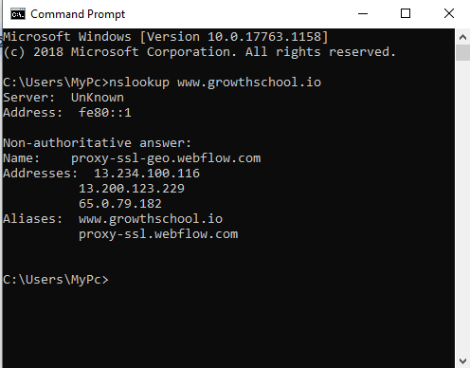

**Task 2:** Figure out how can you use nslookup to find name and IP address of SMTP server of gmail.com

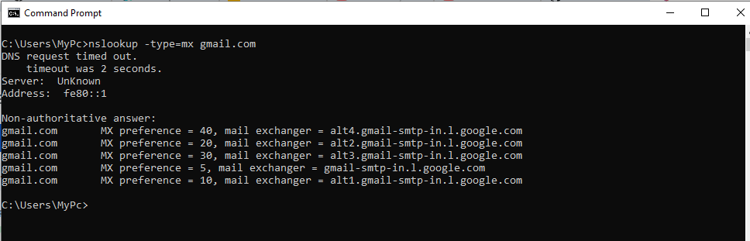**Ans :**

**Task 3:** Suppose you have a web server running    on your network that is listening on port 80. Write a TCPdump command that captures all HTTP traffic coming to the server and saves it to a file called "http_traffic.pcap"

**ANS :**

**tcpdump -i eth0 -w http_traffic.pcap -c 100 tcp port 80**