Interactive Service Scholarship Incubator (ISSI)
User Guide & Documentation


KAIST College of Business · ASU W. P. Carey School of Business
2025

1. System Overview

1.1 What is Interactive Service Scholarship Incubator (ISSI)
Interactive Service Scholarship Incubator (ISSI) is a specialized dashboard for analyzing and predicting emerging research priorities in the service research field. By constructing co-occurrence networks from service research journal papers and applying link prediction models, the AI model forecasts which concept pairs are likely to be connected by 2030.

Purpose
Predict concept relationships in service research that are likely to emerge by 2030, helping researchers identify promising research directions and emerging interdisciplinary connections.

Data Sources
- FT50 Data: 5,725 Service research papers from Financial Times Top 50 journals and 811 papers from JSR
- Service Data: 4,976 papers from Top 8 Service Research journals
Important: When you click the Data Selection button and switch between datasets, the system displays prediction results that were trained on that specific dataset. Each dataset has its own trained model, so switching datasets shows you different prediction outcomes based on different training data.

1.2 Dashboard Layout
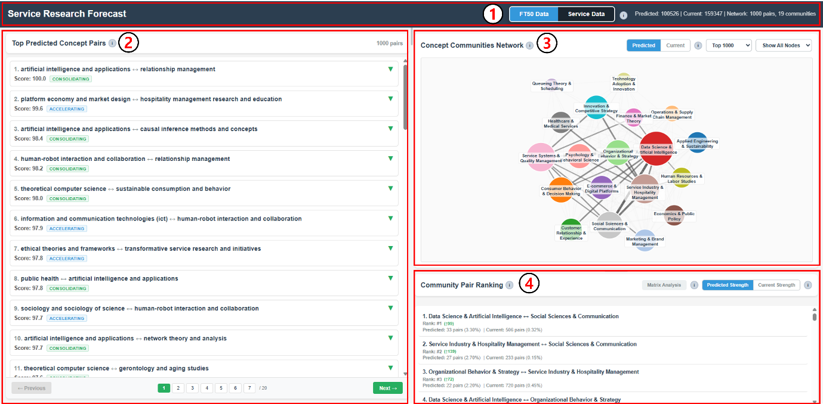
The dashboard is divided into four main areas:
- Top Bar: Dataset selection (FT50 Data / Service Data) - switching between datasets displays results from models trained on each respective dataset
- Left Panel: Top Predicted Concept Pairs list
- Right-Top Panel: Community Network
- Right-Bottom Panel: Community Pair Ranking

2. Top Predicted Concept Pairs

2.1 Overview
This component displays concept pairs ranked by prediction score, showing links likely to emerge by 2030 in service research.

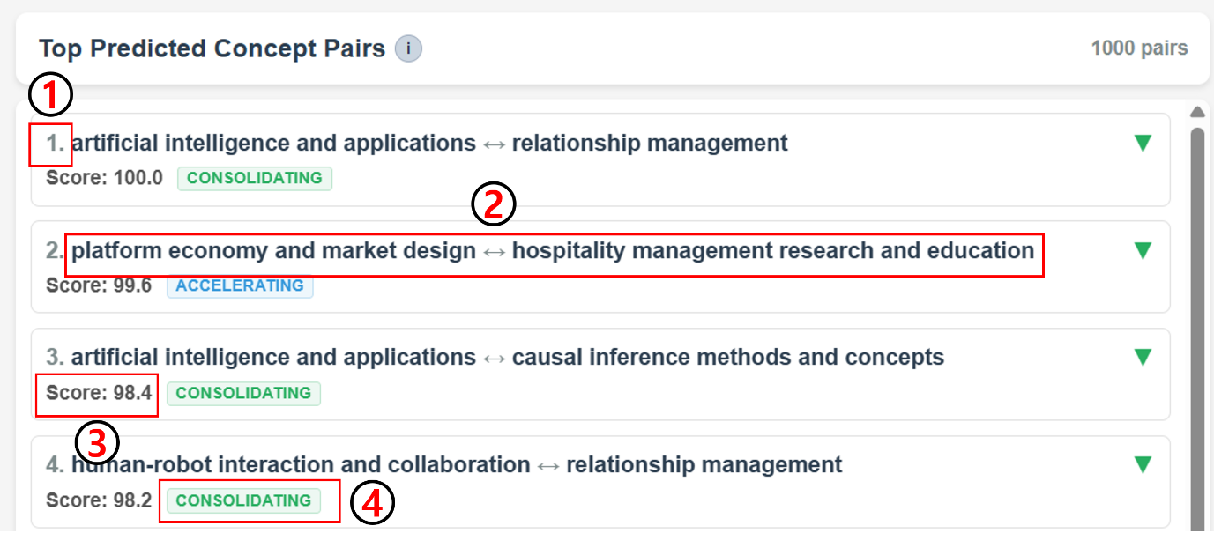

Key Metrics Displayed
- Rank number: Position based on Prediction Score
- Concept pair (Concept 1 ↔ Concept 2): Two concepts predicted to connect by 2030. These pairs do not currently co-occur but are likely to emerge
- Prediction Score (0-100): The score represents the model's prediction probability that has been scaled from the original 0.0-1.0 range to 0-100 for easier interpretation. Higher values indicate greater likelihood of future connection in service research literature
- 2 by 2 Matrix Category: Classification based on 2×2 matrix comparing predicted vs. current connection strength. A more detailed explanation is provided in Section 4.2

2.2 Detailed Information (Click to Expand)
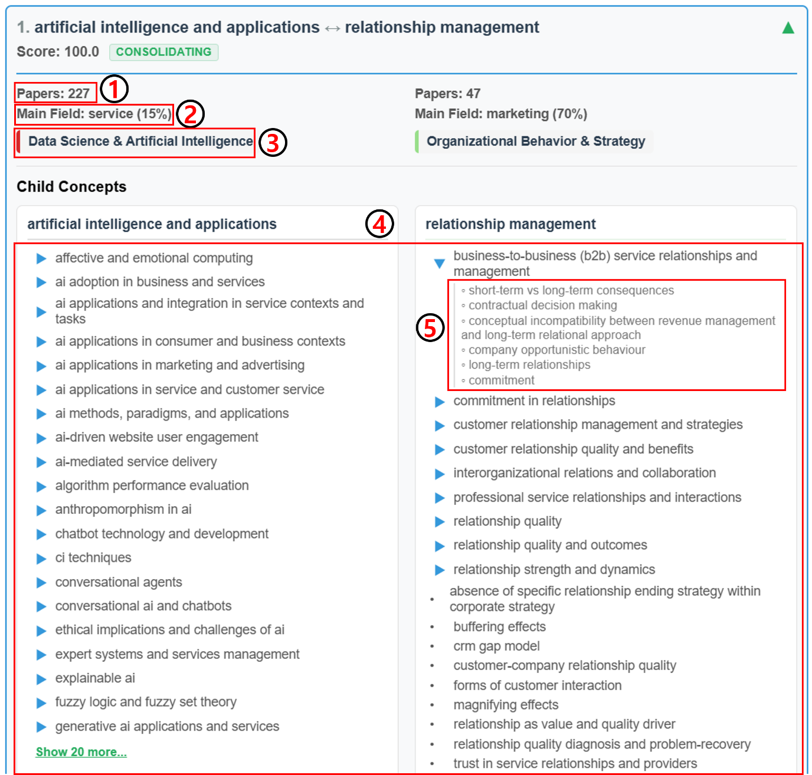
When you click on a concept pair, you can see detailed information for each concept:

1. Concept Metadata
- Paper Count: Number of distinct service research papers containing this concept
- Dominant Field: Primary research field where the concept appears most frequently, shown with percentage
- Community Label: Thematic cluster assignment. Concepts are grouped into communities based on semantic similarity—each concept is embedded using allenai/specter, then clustered via K-means. Community labels are generated by GPT-4o-mini for interpretability. This corresponds to the community nodes shown in the right panel's network visualization.

2. Hierarchical Child Concepts
Child concepts are narrower, more specific terms related to the parent concept. The system displays a hierarchical structure:
- Child Concepts: Narrower terms that were extracted as children of the parent concept. Only children appearing ≥2 times across the corpus are displayed. If no children meet this threshold, it relaxes to ≥1 occurrence.
- Sub-child Concepts: Third-level hierarchical terms nested under child concepts. Click ▶ to expand.

Purpose of Child Concepts
- Understand concept granularity and specificity
- Identify specific research areas within broader service research concepts
- Explore related terminology and semantic relationships

3. Concept Community Network

3.1 Overview
The Community Network provides a graph visualization showing relationships between service research concept communities. It helps identify inter-community connections and emerging trends in the field.
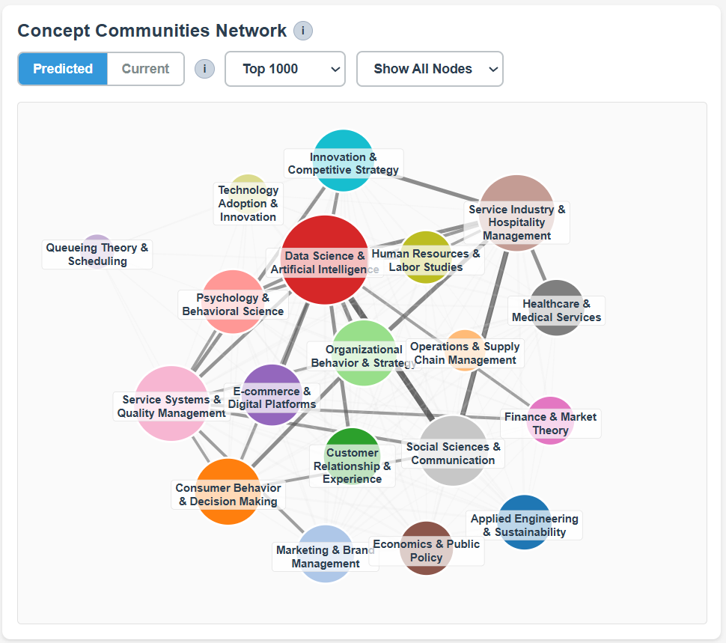

What It Shows
Nodes: Concept Communities (thematic clusters of similar service research concepts) Node size is proportional to number of concept pairs in that community (Larger node = more concept pairs)
Edges: Number of connections between communities (Connection strength) Thickness is proportional to connection strength.

3.2 Two Network Views

Predicted Network
Shows future connections predicted by the link prediction model based on historical patterns in service research.
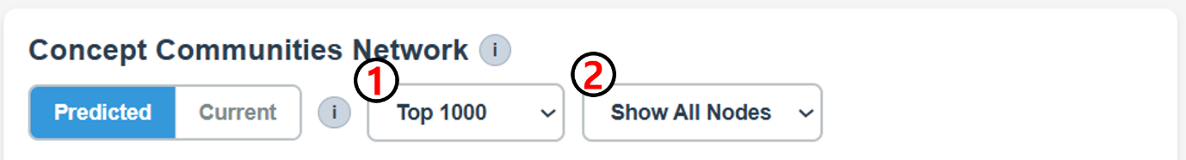
- Filter Top N Pairs: Filters the concept pairs used to construct the network. Only the top N highest-scoring predicted pairs are included
- Hide Nodes: Optionally hide communities with low connection frequency. Useful for focusing on major communities and reducing visual clutter

Current Network
Shows existing connections from training data based on actual co-occurrence in published service research papers.
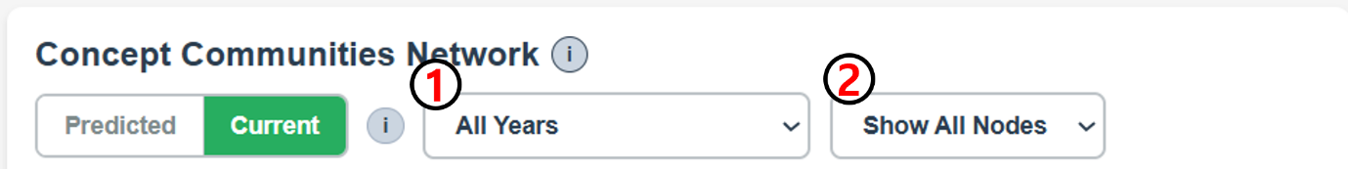
- Filter Year Range: Filters concept pairs by publication year (default: 2000-2025). Enables temporal analysis—see how connections evolved over time
- Hide Nodes

3.3 Interactive Features

1. Click Node (Single Community Filter)
Clicking a community node filters the left panel's concept pair list to show only pairs where at least one concept belongs to that community. That community's concepts are highlighted in color.

2. Click Edge (Community Pair Filter)
Clicking an edge between two communities filters the concept pair list to show only pairs that connect those two specific communities—where one concept belongs to Community A and the other belongs to Community B. Both communities' concepts are highlighted in their respective colors

3. Drag Nodes
Click and drag individual nodes to rearrange the layout and untangle complex networks for better visualization.

4. Community Pair Ranking

4.1 Overview
The Community Pair Ranking shows which community combinations have the strongest connections—ranked by the number of concept pairs linking them.

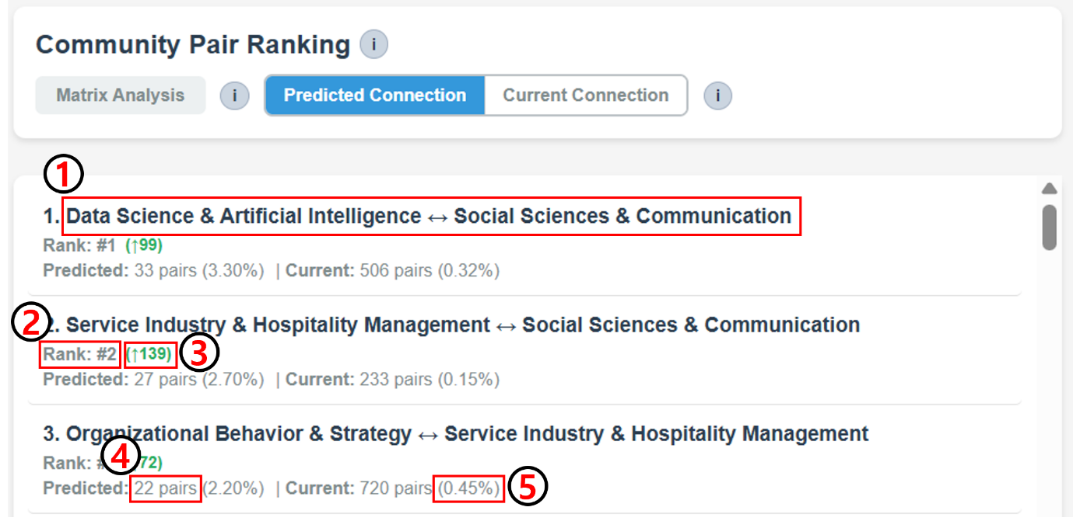

Understanding Connection Strength
Connection strength is defined as the number of concept pairs that belong to a community pair.
- Predicted Connection: Ranks community pairs by connection strength in the Predicted Network (future predictions by 2030)
- Current Connection: Ranks community pairs by connection strength in the Current Network (historical co-occurrences)
Note: Changing filters in the network panel (Top N for Predicted, Year Range for Current) automatically recalculates the rankings.

Metrics
- Community Pair Name: Community A × Community B
- Rank: Position based on connection strength
- Rank Change: Number in parentheses shows rank difference compared to the current network
- Concept Pairs Count: Number of concept pairs connecting the two communities
- Percentage: Share of total edges in the network

Interaction
Click a pair to filter the concept pairs list to show only pairs from that community combination (same as clicking an edge in the network graph).

4.2 Matrix Analysis View
Click the "Matrix Analysis" button to open this view.
Matrix Analysis provides a 2×2 classification of community pairs based on their predicted vs. current connection strengths using a median-split.
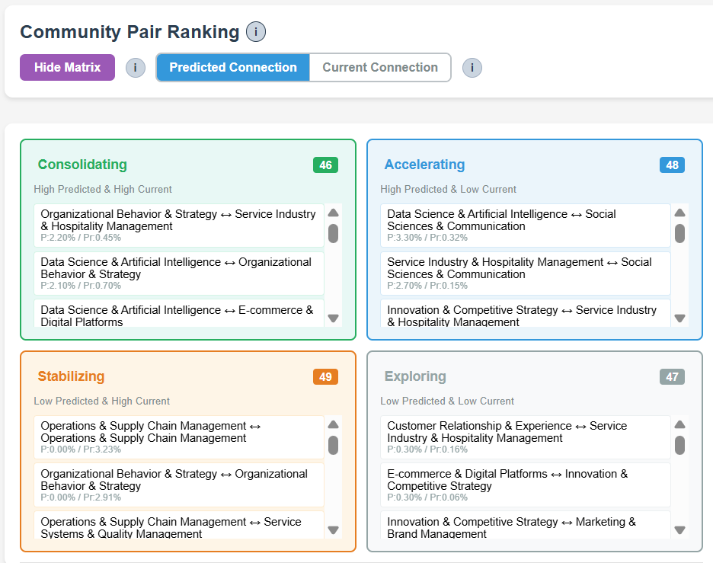

Four Categories
Category | Predicted | Current | Interpretation
Accelerating | High (>median) | Low (≤median) | Fast-growing connections—emerging research frontiers gaining momentum
Stabilizing | Low (≤median) | High (>median) | Maturing relationships—established connections reaching steady state
Consolidating | High (>median) | High (>median) | Core research pillars—strong foundations continuing to strengthen
Exploring | Low (≤median) | Low (≤median) | Open territories—potential spaces for novel interdisciplinary research

5. Recommended Workflows
Here are four recommended workflows for different service research analysis goals:

5.1 Workflow 1: Exploring a Specific Service Research Area
- Start with the Network Graph (Predicted view)
- Click on your community of interest (node)
- Review the filtered concept pairs in the left panel
- Expand individual pairs to see child concepts and metadata

5.2 Workflow 2: Identifying Accelerating Service Research Trends
- Go to Community Pair Ranking
- Click "Matrix Analysis" button
- Focus on the "Accelerating" quadrant (high predicted, low current)
- Click on pairs in the Emerging category
- Review specific concept pairs showing this trend

5.3 Workflow 3: Comparing Datasets
- Start with Service Data selected
- Note the top predicted pairs and network structure
- Switch to FT50 Data - this will load results from a different trained model
- Compare differences in predictions and community relationships
- Identify dataset-specific trends and common patterns in service research
Why compare? FT50 Data focuses on top business journals, while Service Data covers specialized service research venues. Comparing reveals field-specific vs. cross-disciplinary trends.

5.4 Workflow 4: Temporal Analysis
- Go to Current Network view
- Start with a broad time range (e.g., 2000-2025) to see the overall landscape
- Narrow the range progressively—try recent 10 years (2016-2025), then 5 years (2021-2025)
- Observe how community connections strengthen, weaken, or emerge over different periods
- Identify which relationships are long-standing vs. recently formed
- Switch to Predicted Network to see if recent trends are expected to continue or shift by 2030

For questions or support, please contact: 8666baek@kaist.ac.kr

KAIST College of Business · ASU W. P. Carey School of Business
© 2025 Interactive Service Scholarship Incubator (ISSI) Project All Rights Reserved

