CSRF security
CSRF Protection

Enable CSRF and XSS filter in app/Config/Filters.php
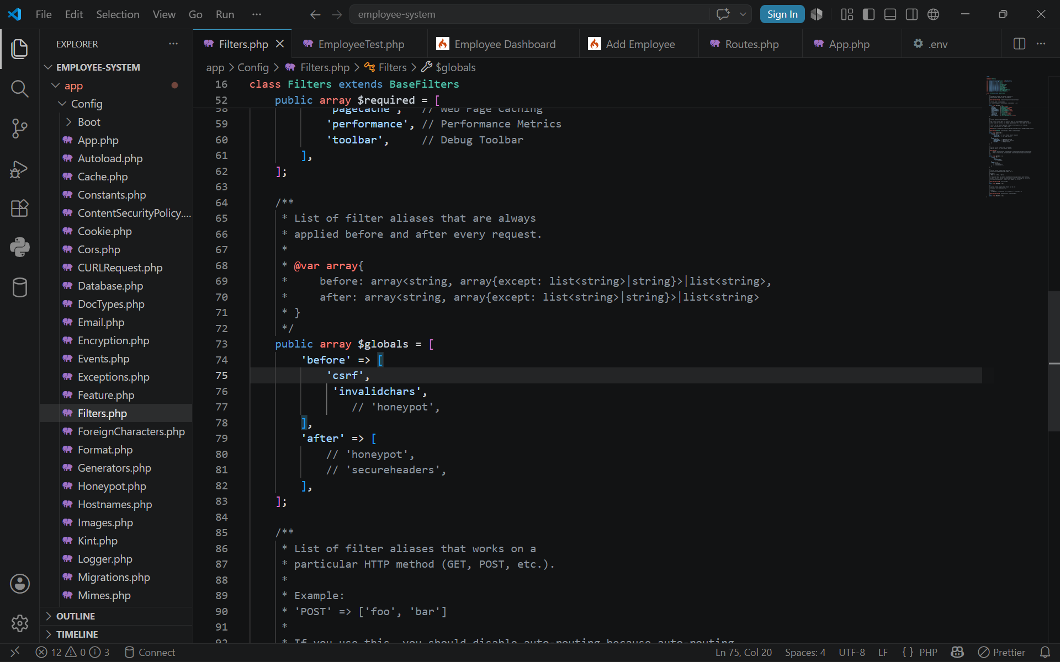

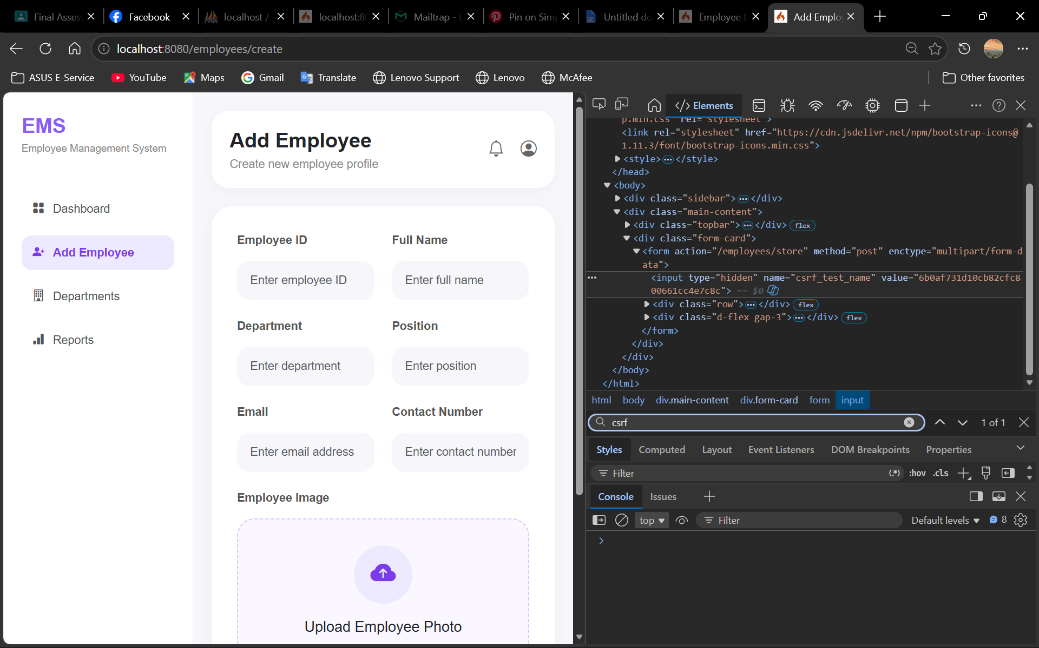

Demonstrate a 403 Forbidden response when the token is absent

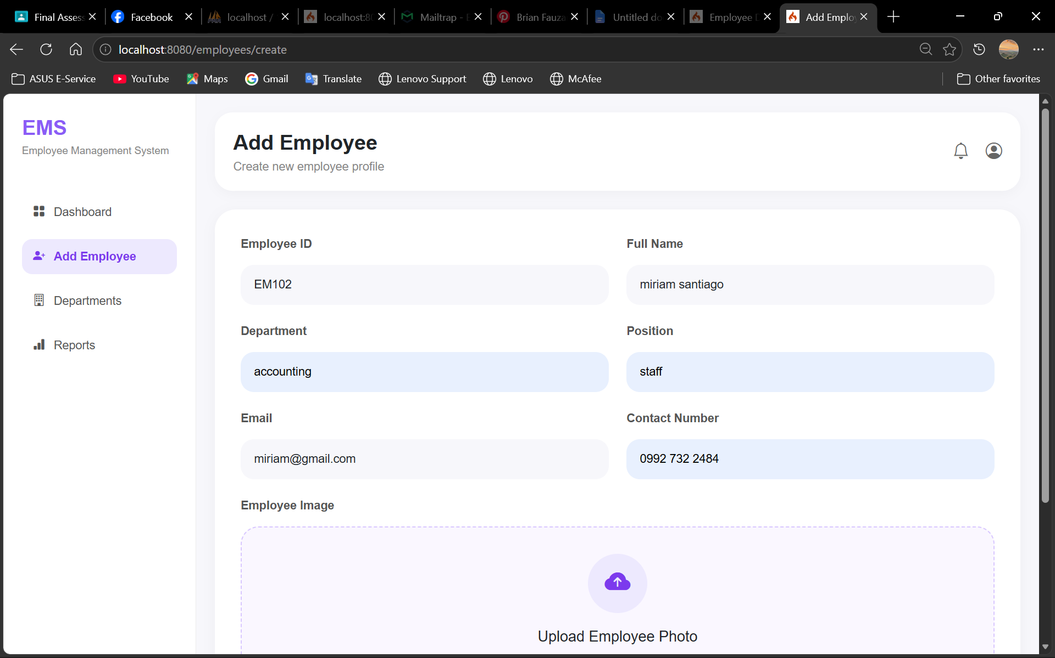

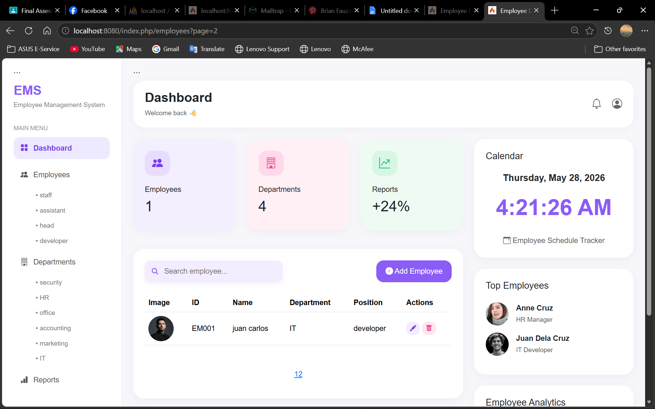

The system uses CSRF protection to secure form submissions. A CSRF token is automatically added to every form using csrf_field(). During testing, when the CSRF token was removed, the form submission no longer saved data, showing that unauthorized requests were blocked by the system.
The system also prevents XSS attacks using the esc() function. When the input alert(1) was tested without esc(), a browser popup appeared. After applying esc(), the script was displayed only as plain text and no popup appeared, proving that malicious scripts could not execute in the browser.
Include before/after screenshots: raw vs. escaped output
Before
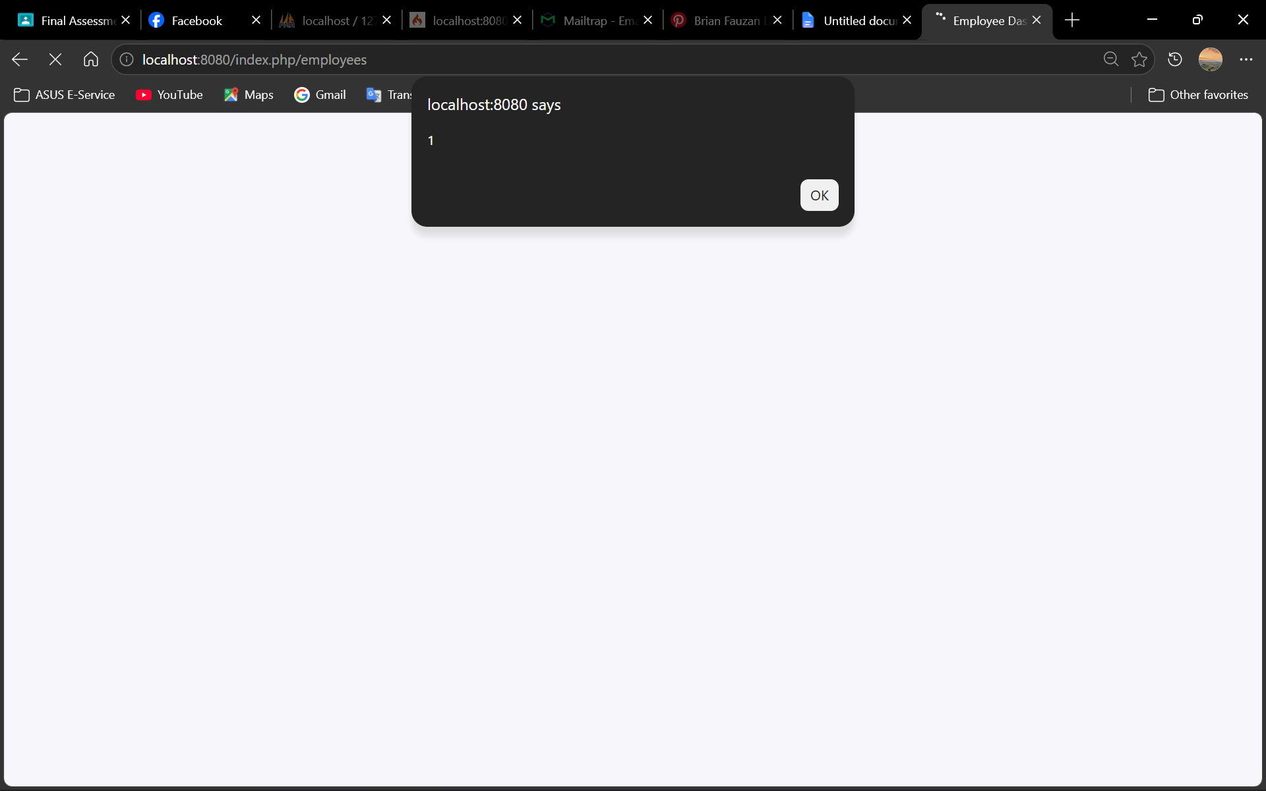

After
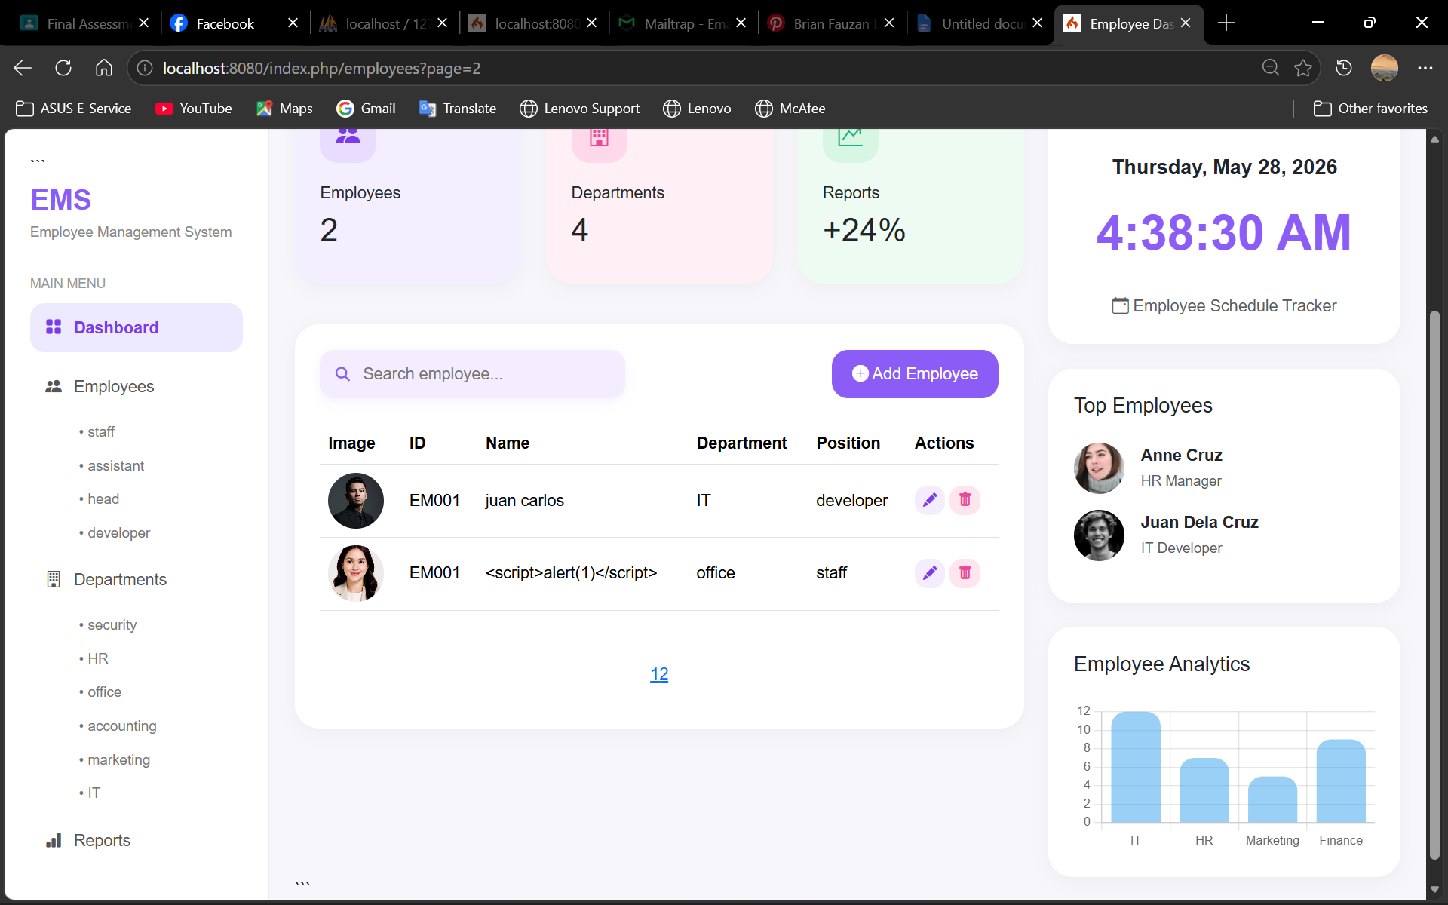

email
Configure SMTP settings in app/Config/Email.php

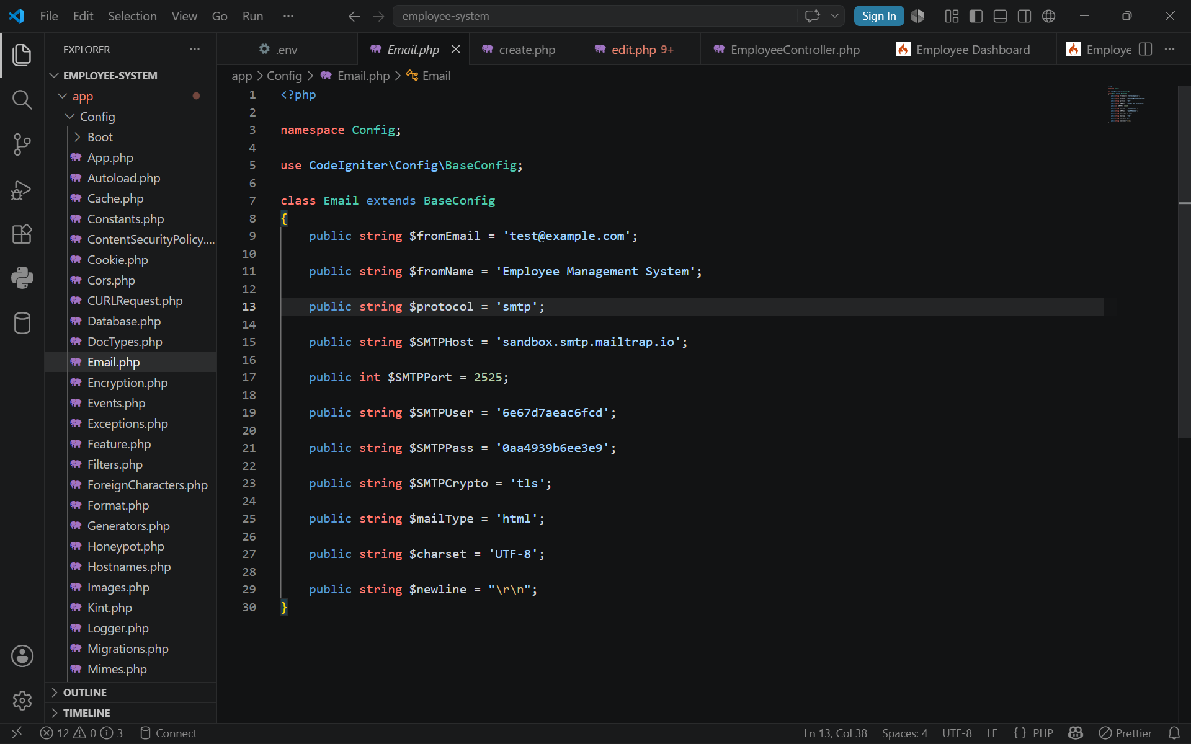

New added employee

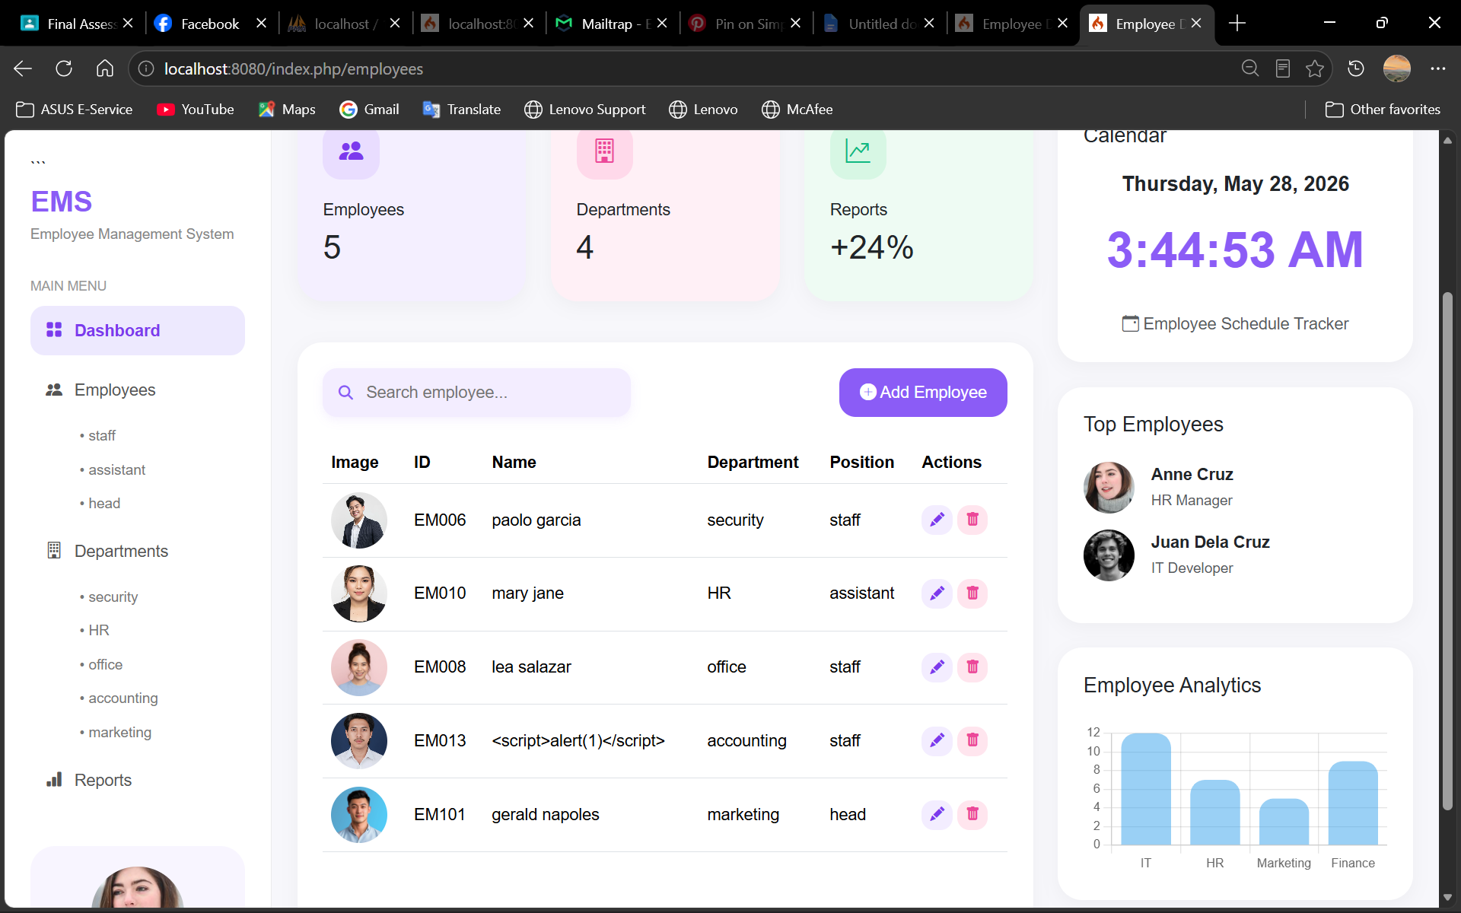

Plain text fallback message

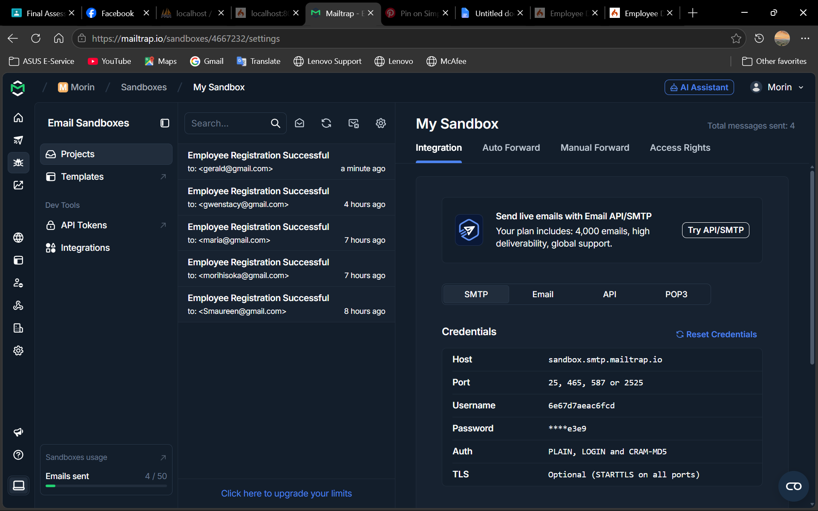

Send an HTML email on a user action (e.g. registration)

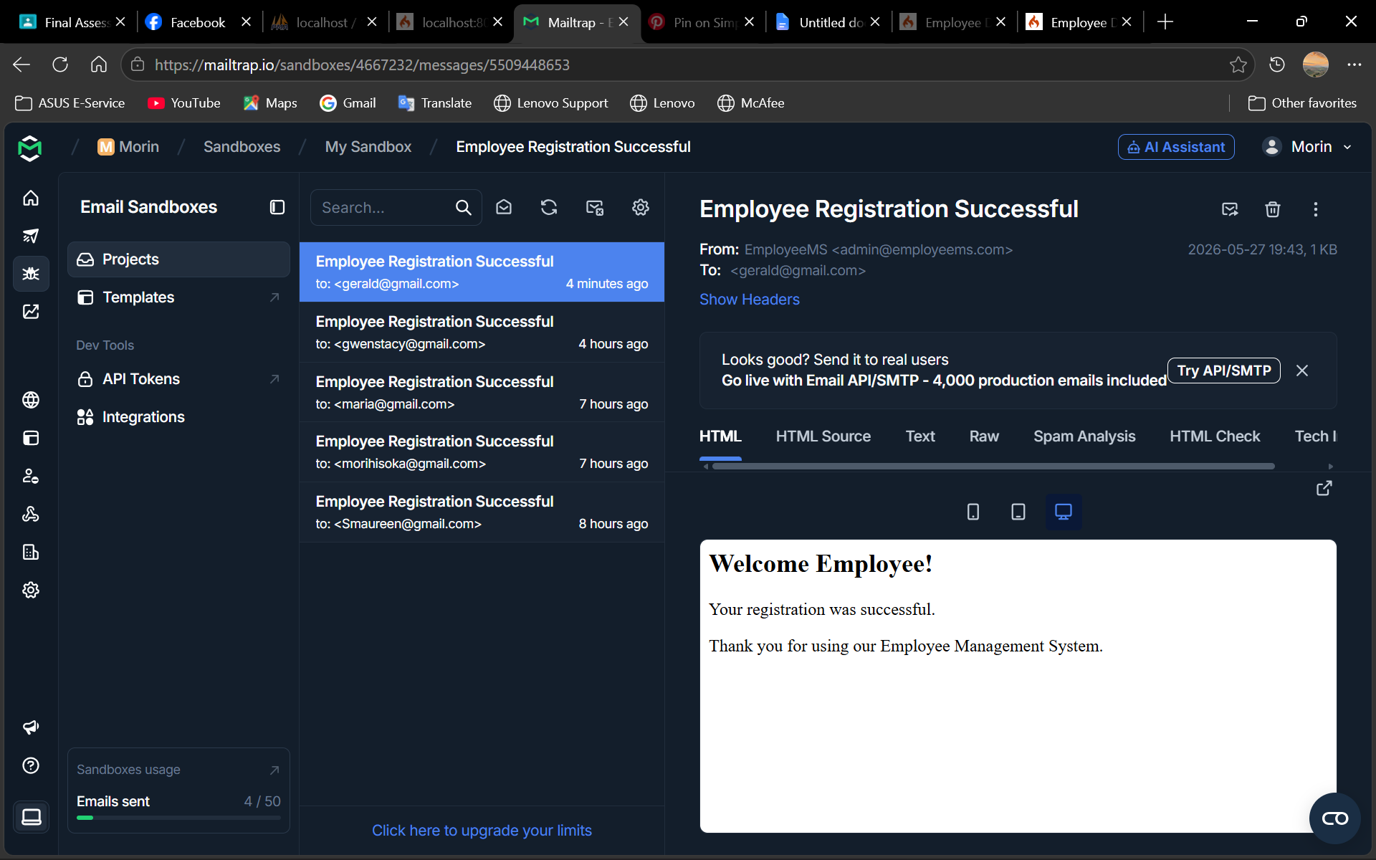

unit testing & debugging

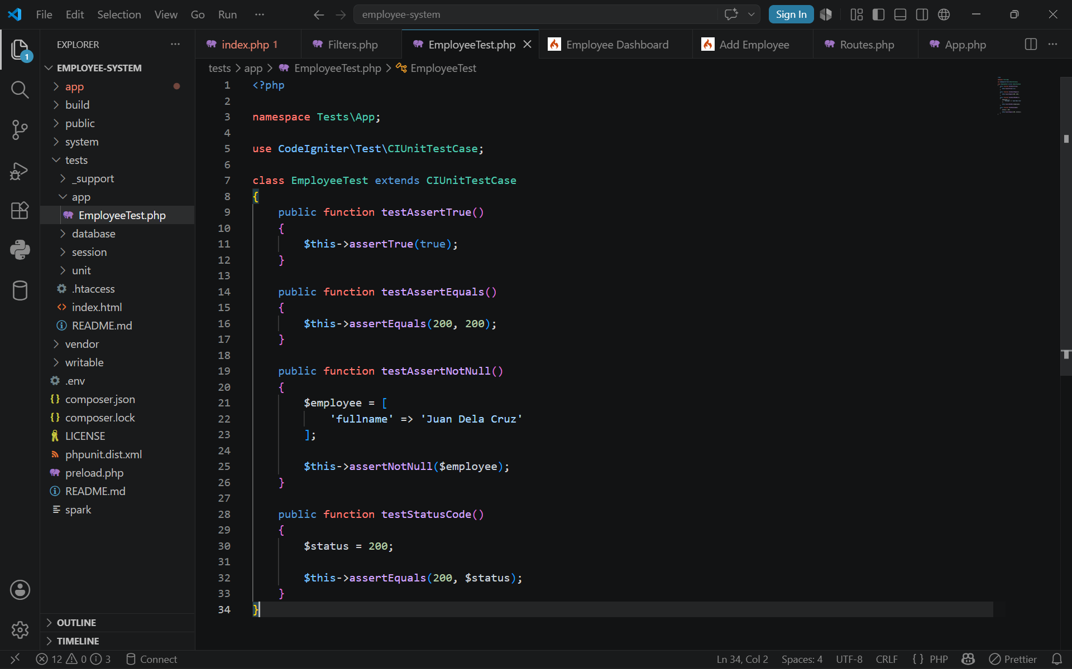

Run suite via ./vendor/bin/phpunit; screenshot PASS output
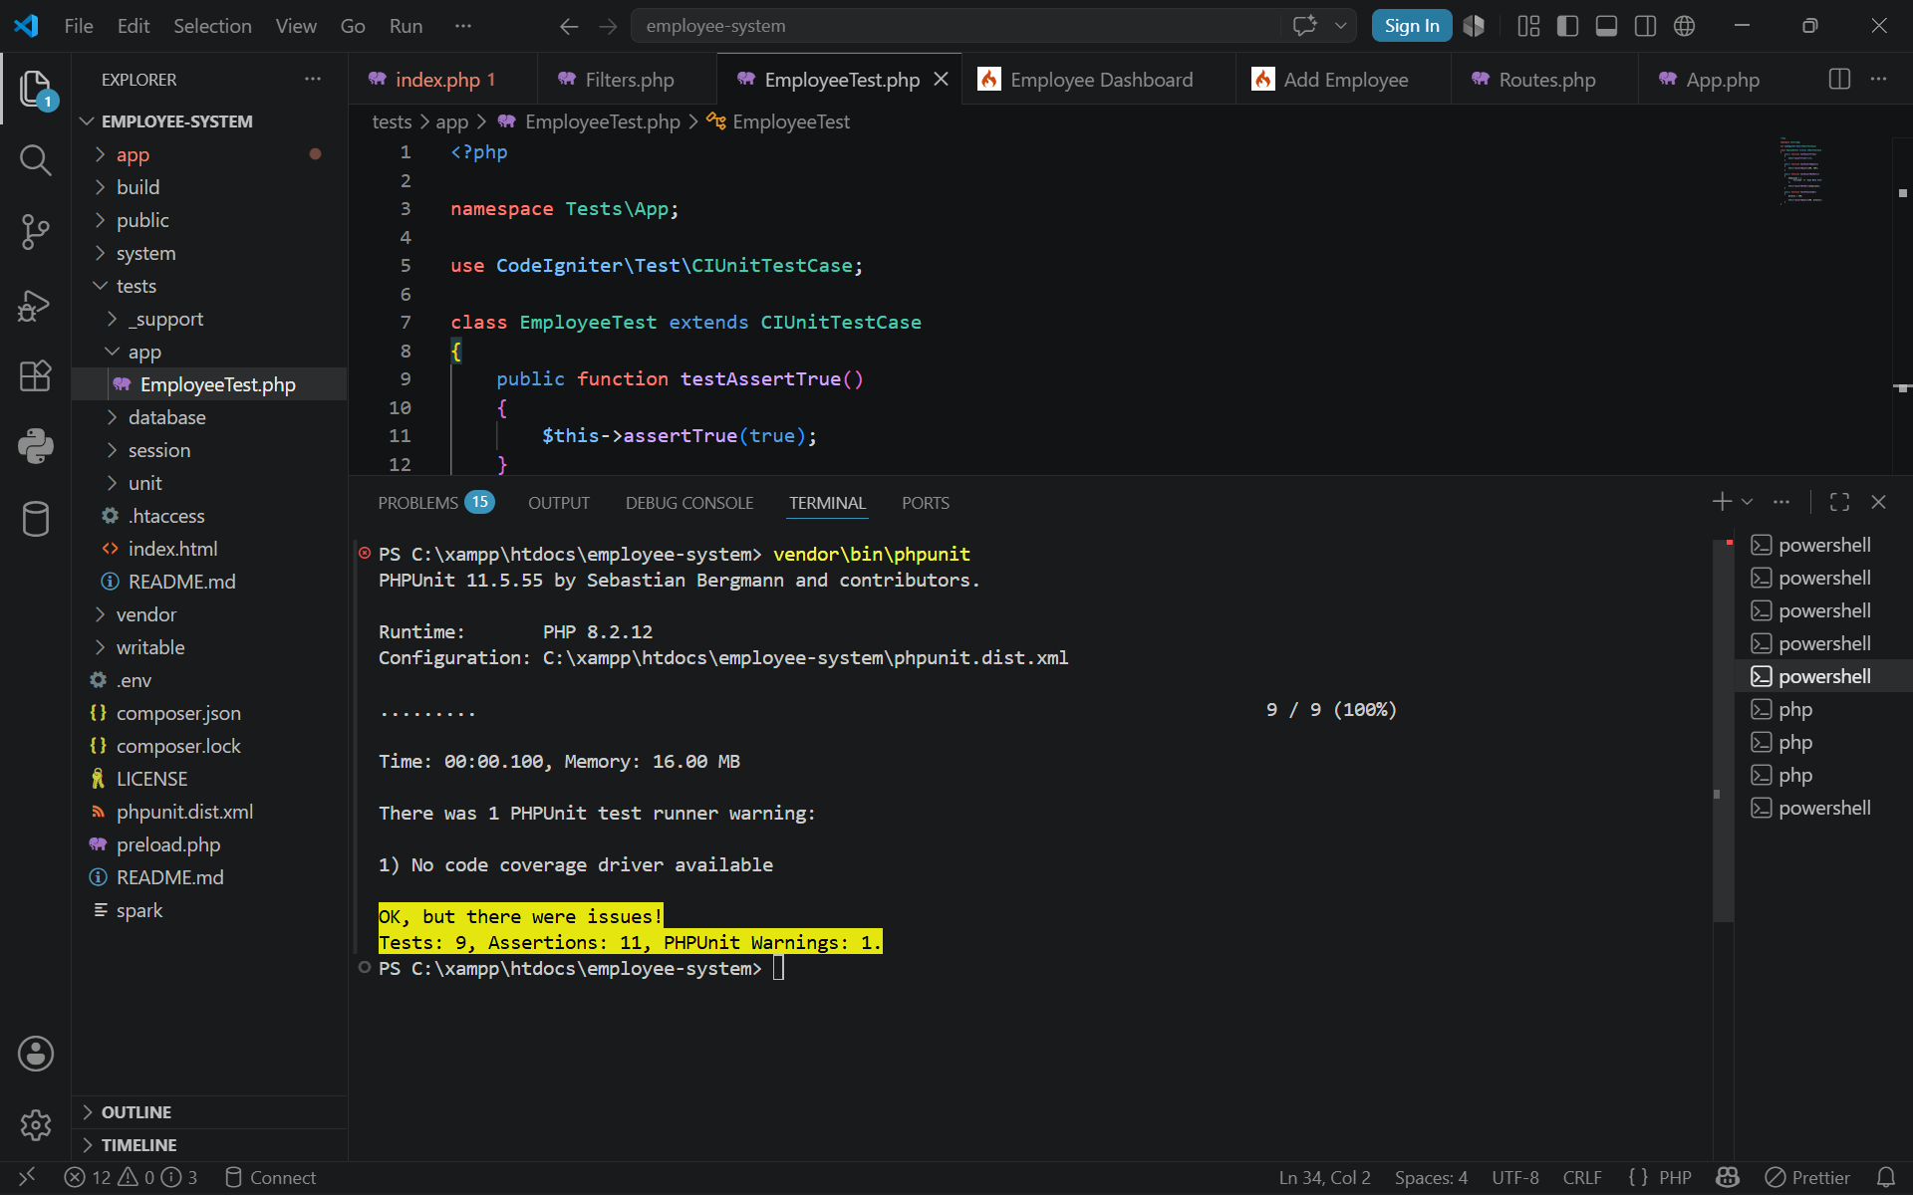

database
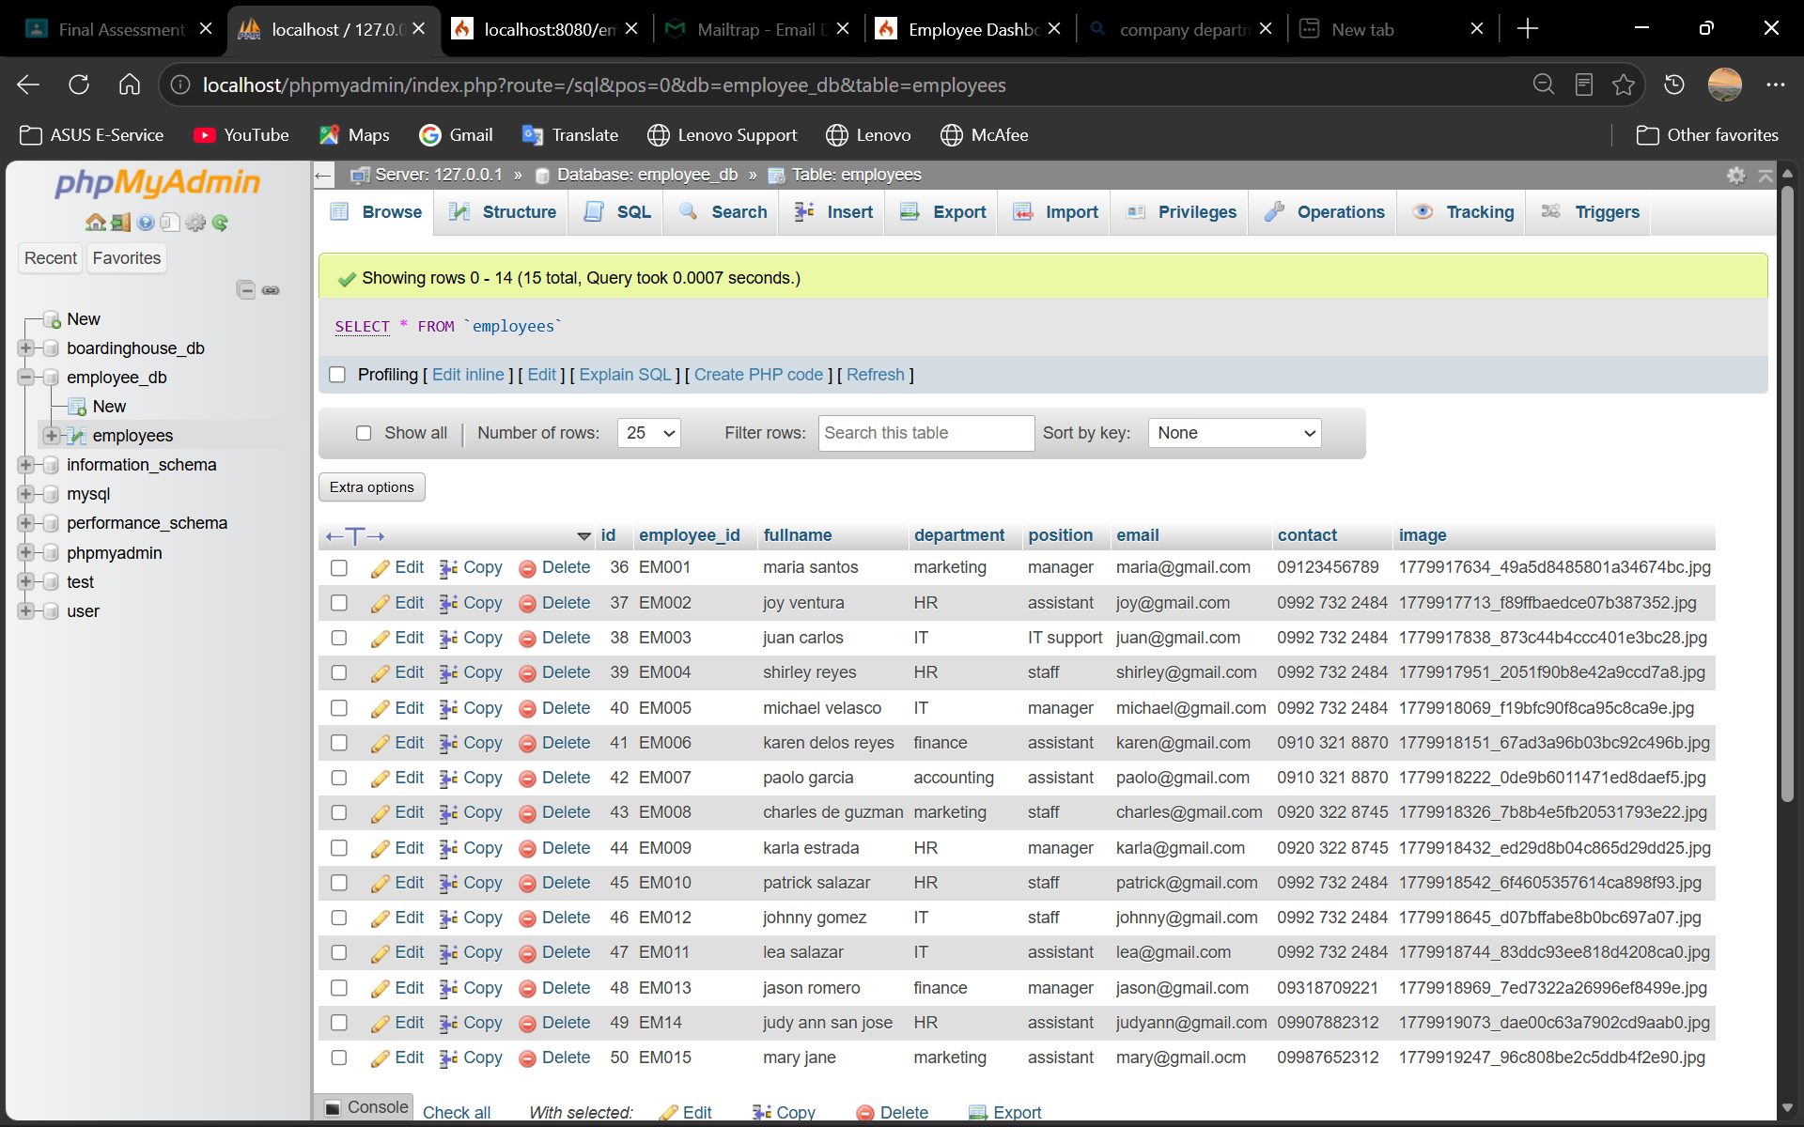

Mailtrap

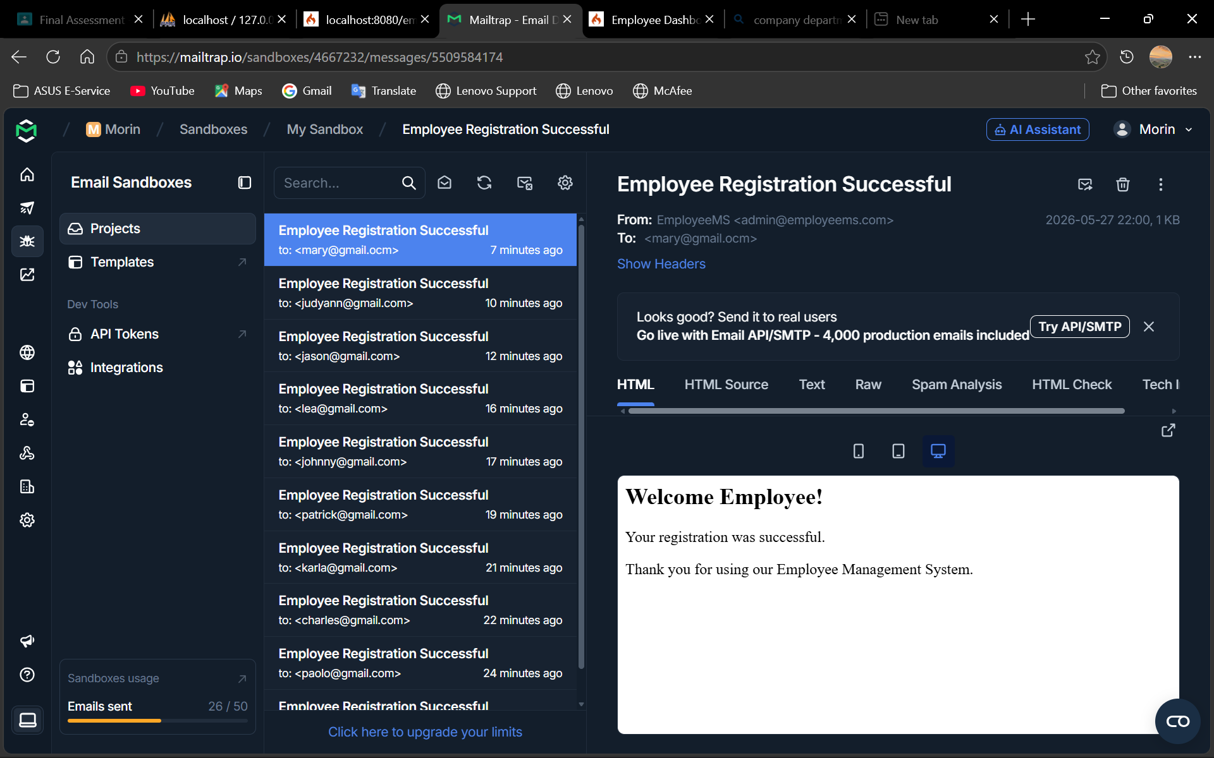

Tab 5
Introduction
This project is an Employee Management System developed using CodeIgniter 4. The system was created to help manage employee records in a more organized and efficient way. It includes features such as adding, editing, deleting, and viewing employee information. The project also focuses on implementing important web development concepts including security, advanced system features, and debugging techniques. The main goal of this project is to apply the lessons learned in CodeIgniter 4 and develop a functional web application with proper security and user-friendly features.

Security Features
Security is one of the most important parts of web development. In this project, protection against CSRF (Cross-Site Request Forgery) and XSS (Cross-Site Scripting) attacks was implemented.
- CSRF protection was added using the csrf_field() function of CodeIgniter 4. This helps protect forms from unauthorized requests submitted by attackers. Every form submission includes a unique security token that verifies if the request is valid.
- To prevent XSS attacks, the esc() function was used when displaying user input. This prevents harmful scripts from being executed inside the browser. By escaping user data, the application becomes safer and more secure for users.
These security features help protect both the system and the users from common web vulnerabilities.

Advanced Features
File Upload
- The system allows users to upload employee images. Uploaded files are stored inside the uploads folder and displayed in the employee table and edit page. This feature improves the visual presentation of employee records.
Email Notification
- An email notification feature was added after successfully registering an employee. Once the form is submitted, the system automatically sends a confirmation email using CodeIgniter 4 email services.
Pagination
- Pagination was implemented to organize employee records into multiple pages. Instead of displaying all records at once, the system only shows a limited number of employees per page. This improves readability and system performance.
Performance Optimization
- Basic performance optimization was applied by organizing the code properly and limiting displayed records using pagination. This helps reduce page loading time and improves the overall user experience.

Debugging Skills
During the development process, several errors and issues were encountered such as layout problems, pagination errors, undefined variables, and routing issues. These problems were solved through debugging and testing.

The debugging process helped improve problem-solving skills and understanding of CodeIgniter 4. Different solutions were tested carefully until the application worked correctly. This experience also improved knowledge in handling errors and maintaining clean code structure.

