## summarize problematic values
print(problematic_obs)

year | country | std_residual | hat_value | cooks_d | is_outlier | is_leverage | is_influential
2015 | Rwanda | -2.76365936 | 0.14904759 | 1.911132e-01 | FALSE | TRUE | TRUE
2015 | Syria | -2.57161151 | 0.10703475 | 1.132408e-01 | FALSE | TRUE | TRUE
2015 | Pakistan | 2.56565317 | 0.07256301 | 7.357474e-02 | FALSE | FALSE | TRUE
2015 | Central African Republic | 1.71703406 | 0.14396812 | 7.083309e-02 | FALSE | TRUE | TRUE
2015 | Botswana | -1.54528786 | 0.15075853 | 6.055799e-02 | FALSE | TRUE | TRUE
2015 | Cambodia | -1.91681637 | 0.07747792 | 4.408229e-02 | FALSE | FALSE | TRUE
2015 | Hong Kong S.A.R. of  China | -2.41106137 | 0.04578958 | 3.985116e-02 | FALSE | FALSE | TRUE
2015 | Gabon | -2.07053903 | 0.04630848 | 2.973866e-02 | FALSE | FALSE | TRUE
2015 | Mexico | 2.75703526 | 0.02350341 | 2.613646e-02 | FALSE | FALSE | TRUE
2015 | Qatar | -0.75402583 | 0.11203030 | 1.024735e-02 | FALSE | TRUE | FALSE
2015 | Myanmar | -0.59521760 | 0.15321175 | 9.157370e-03 | FALSE | TRUE | FALSE
2015 | Georgia | -0.61861541 | 0.12088846 | 7.517688e-03 | FALSE | TRUE | FALSE
2015 | Swaziland | 0.58058046 | 0.09208687 | 4.884051e-03 | FALSE | TRUE | FALSE
2015 | Somaliland region | 0.26045464 | 0.10172450 | 1.097444e-03 | FALSE | TRUE | FALSE
2016 | Rwanda | -2.91626936 | 0.13994380 | 1.976897e-01 | FALSE | TRUE | TRUE
2016 | Somalia | 2.91330712 | 0.10144311 | 1.368836e-01 | FALSE | TRUE | TRUE
2016 | Syria | -2.17992248 | 0.13489574 | 1.058556e-01 | FALSE | TRUE | TRUE
2016 | Botswana | -2.64734774 | 0.04578032 | 4.803462e-02 | FALSE | FALSE | TRUE
2016 | Hong Kong S.A.R. of China | -2.56307602 | 0.04612233 | 4.537780e-02 | FALSE | FALSE | TRUE
2016 | Pakistan | 2.19461289 | 0.05290499 | 3.843447e-02 | FALSE | FALSE | TRUE
2016 | Sri Lanka | -2.52418247 | 0.03890395 | 3.684431e-02 | FALSE | FALSE | TRUE
2016 | Cambodia | -1.89470606 | 0.06078644 | 3.319159e-02 | FALSE | FALSE | TRUE
2016 | Nigeria | 1.53763283 | 0.08636003 | 3.192603e-02 | FALSE | FALSE | TRUE
2016 | Qatar | -1.17828430 | 0.11592837 | 2.600785e-02 | FALSE | TRUE | TRUE
2016 | Myanmar | -0.88163129 | 0.14350584 | 1.860463e-02 | FALSE | TRUE | FALSE
2016 | Georgia | -0.97774865 | 0.11193197 | 1.721331e-02 | FALSE | TRUE | FALSE
2016 | Somaliland Region | 0.51287198 | 0.09931802 | 4.143587e-03 | FALSE | TRUE | FALSE
2016 | Angola | 0.14210052 | 0.13464226 | 4.488270e-04 | FALSE | TRUE | FALSE

##### create report #####

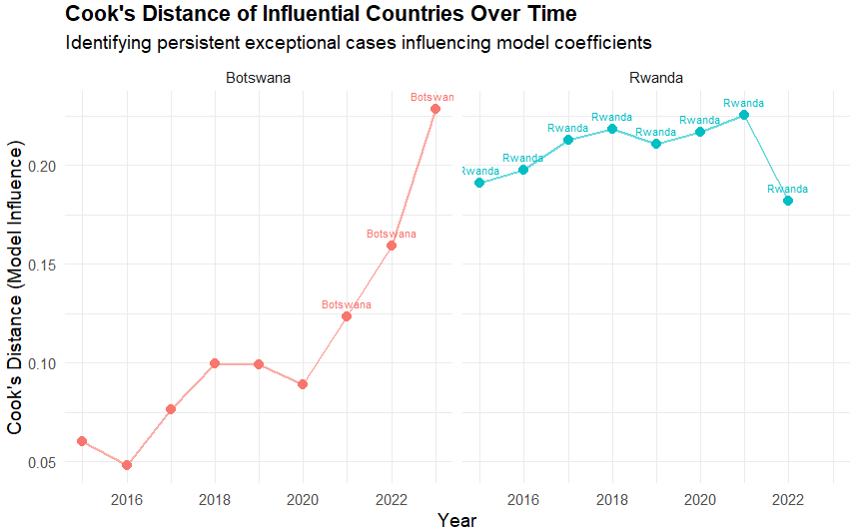

# Dive into Botswana and Rwanda.
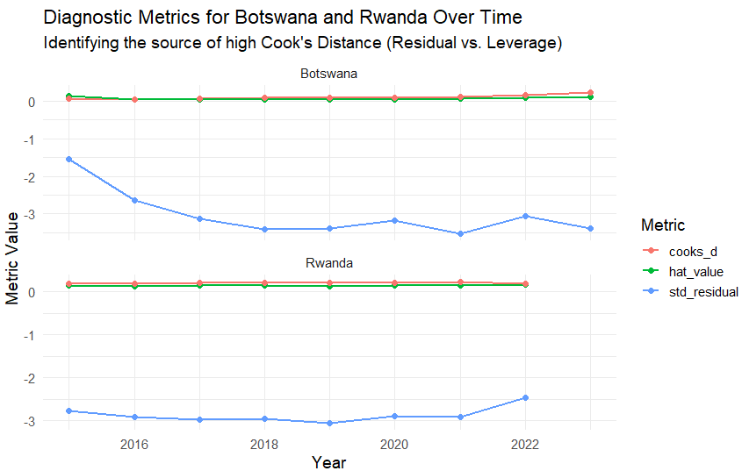

############ analyze Rwanda ###############

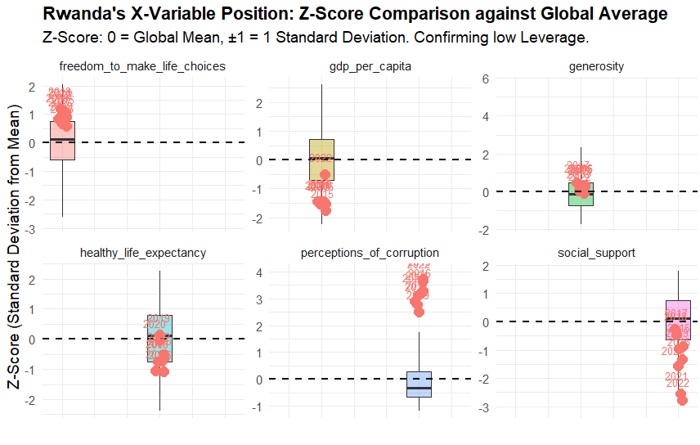

Rwanda is classified as a pure Y-value Outlier because its X variables are near the global average (low Leverage), but its Happiness Score is exceptionally low (high Residual). The data shows the std_residual persistently around -3 for most years. This suggests powerful unmeasured negative factors are at play, likely stemming from the lasting historical trauma of the 1994 genocide and the impact of the authoritarian governance model. The strict control, while promoting growth, suppresses individual psychological freedom and trust, driving the perceived happiness down despite moderate economic indicators.

### Analyze Botswana ###################

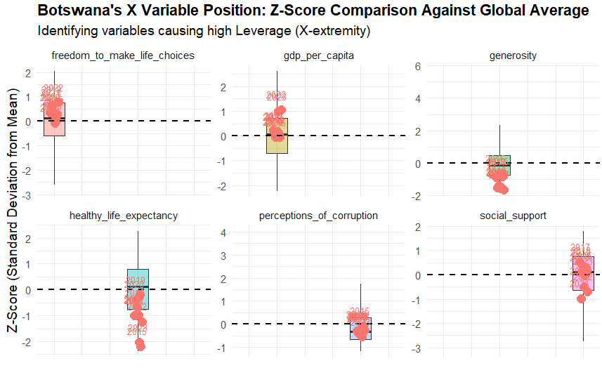

Botswana's anomaly is driven by Leverage (extreme X values) that distorts the general regression line. Its economy's heavy reliance on diamond wealth creates a non-typical X profile: very high GDP (high Z-Score) combined with very low Healthy Life Expectancy (low Z-Score) due to the persistent HIV/AIDS crisis. This unusual pairing violates the positive correlation seen in most countries, causing the regression coefficients to be pulled/biased toward Botswana's position. While its std_residual is also high (around -3), the unique X-combination makes it a critical Leverage point, as removing it would significantly change the model's slopes.

