Data structure(10 columns) : year(2015~2023) - manually input, country, region, happiness_score, gdp_per_capita, social_support, healthy_life_expectancy, freedom_to_make_life_choices, generosity, perceptions_of_corruption

1. Randomforest

# package install & load
install.packages("randomForest")
library(randomForest)

# data processing
df <- read.csv("data/full_data.csv")
df$year <- as.integer(df$year)
df$country <- as.factor(df$country)
df$region <- as.factor(df$region)
key_vars <- c(
"happiness_score",
"gdp_per_capita",
"social_support",
"healthy_life_expectancy",
"freedom_to_make_life_choices",
"generosity",
"perceptions_of_corruption"
)

# drop out missing values
df_clean <- na.omit(df)
df_clean$perceptions_of_corruption[df_clean$perceptions_of_corruption == "N/A"] <- NA
df_clean <- df_clean[complete.cases(df_clean), ]
df_clean$perceptions_of_corruption <- as.numeric(df_clean$perceptions_of_corruption)

# divide data into train set, and test set
train_data <- df_clean[df_clean$year <= 2022, ]
test_data <- df_clean[df_clean$year == 2023, ]

str(df_clean)

# RF model training!!
rf_model <- randomForest(happiness_score ~ gdp_per_capita + social_support +
healthy_life_expectancy + freedom_to_make_life_choices +
generosity + perceptions_of_corruption,
data = train_data, ntree = 100)

print(rf_model)

# predict
predictions <- predict(rf_model, newdata = test_data)

comparison <- data.frame(Actual = test_data$happiness_score, Predicted = predictions)
print(comparison)

# R^2 & RMSE check!
rmse_rf <- sqrt(mean((predictions - test_data$happiness_score)^2))
rsq_rf <- 1 - (sum((predictions - test_data$happiness_score)^2) / sum((test_data$happiness_score - mean(test_data$happiness_score))^2))

cat("Random Forest RMSE:", rmse_rf, "\n")
cat("Random Forest R^2:", rsq_rf, "\n")
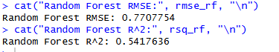

# making plots!!!!!!
predictions <- predict(rf_model, newdata = test_data)

# Actual vs Predicted plot
plot(
test_data$happiness_score, predictions,
xlab = "Actual Happiness Score (2023)",
ylab = "Predicted Happiness Score (2023)",
main = "Prediction Model: Actual vs Predicted (2023)",
pch = 19,
col = rgb(0, 0.4, 0.8, 0.6)
)

# y = x lines
abline(0, 1, col = "red", lwd = 2)

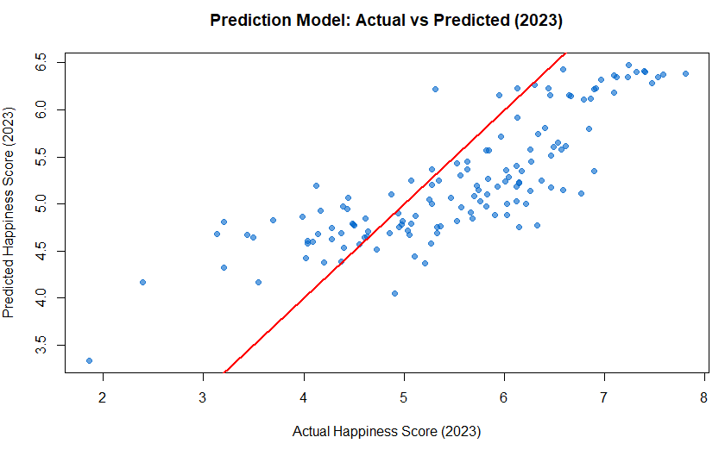

#### heatmap
# call packages
library(ggplot2)
library(reshape2)

# set variables
vars <- c(
"happiness_score",
"gdp_per_capita",
"social_support",
"healthy_life_expectancy",
"freedom_to_make_life_choices",
"generosity",
"perceptions_of_corruption"
)

# calculate correlation
cor_mat <- cor(df_clean[, vars], use = "complete.obs")

# to use in heatmap
cor_df <- melt(cor_mat)
names(cor_df) <- c("Var1", "Var2", "value")

# draw heatmap
ggplot(cor_df, aes(x = Var2, y = Var1, fill = value)) +
geom_tile() + # 타일을 사용하여 색을 채움
geom_text(aes(label = round(value, 2)), size = 3) + # show the correlation values
scale_fill_gradient2(
low = "white",
high = "darkred",
mid = "orange",
midpoint = 0,
limits = c(-1, 1)
) + # color
labs(
title = "Correlation Heatmap of Happiness and Explanatory Variables",
x = "",
y = ""
) + # title and label
theme_minimal(base_size = 14) +
theme(
axis.text.x = element_text(angle = 45, hjust = 1) # adjust x-axis
)
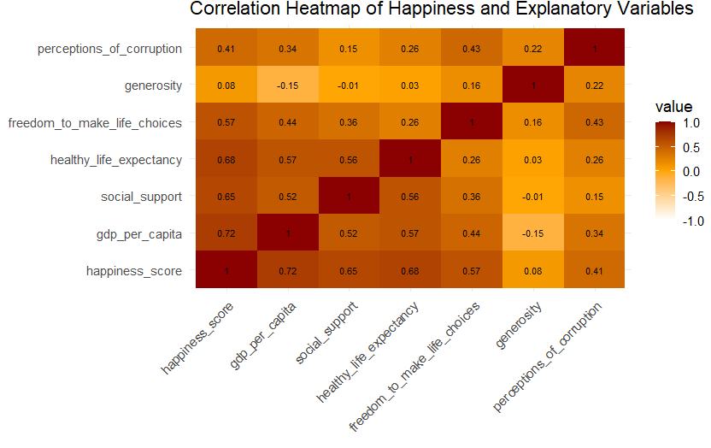

# cross-validation
install.packages("caret")
library(caret)

#
train_control <- trainControl(method = "cv", number = 10)

# adjust `mtry` by `tuneLength`
rf_model_cv <- train(
happiness_score ~ gdp_per_capita + social_support + healthy_life_expectancy +
freedom_to_make_life_choices + generosity + perceptions_of_corruption,
data = df_clean,
method = "rf",
trControl = train_control,
tuneGrid = data.frame(mtry = 1:6) # `mtry` from 1 to 6
)
# print out model
print(rf_model_cv)
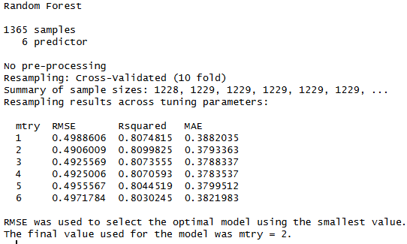

This means that the model has learned the **noise** or specific patterns in the training data too precisely, failing to predict general patterns in new data. It’s like memorizing test questions and answers but being unable to handle new types of problems.

# SHAP !!!
install.packages("iml")
library(iml)

X <- df_clean[, c("gdp_per_capita", "social_support", "healthy_life_expectancy", "freedom_to_make_life_choices",
"generosity", "perceptions_of_corruption")]

# Predictor
predictor <- Predictor$new(rf_model, data = X, y = df_clean$happiness_score)

# SHAP values
shap <- Shapley$new(predictor, x.interest = X[1, ]) # SHAP calculation

# SHAP plot
shap$plot()
