My name is Junemo.
My part is
1. Diagnosis(Analyzing Outliers)
2. Random Forest & Cross-Validation
3. XGBoost, LightGBM
4. Time Regression

1. Diagonosis
I performed a diagnosis of the datasets to find outliers, leverages, and influential points. I set thresholds for them: (|outliers| > 3, leverage > 2(k+1)/n, Cook’s distance > 4/n). Then, I obtained the table “problematic_obs”. However, Cook’s distance was very small in most cases. The maximum value of Cook’s distance was less than 0.3, which means that we don’t have to drop any data from the dataset.
2. Random Forest
To gain more insights, I performed more advanced model random forest.
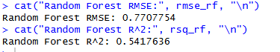
The R² value was about 0.54, which suggests that the model is not very accurate. However, after performing cross-validation (CV), the R² value improved significantly, indicating that the model's performance is much better when evaluated across different subsets of the data.
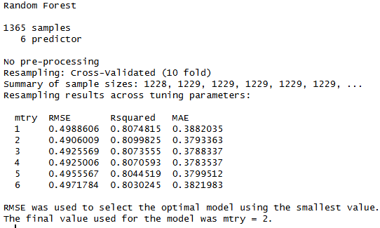
After performing cross-validation (CV), the model’s performance improved significantly. CV evaluates the model on multiple subsets of the data, helping to reduce overfitting by providing a more reliable estimate of its generalization ability. By training and testing the model on different data folds, it mitigates bias from a single train-test split. As a result, the Random Forest model’s performance became more stable and consistent, with low variance between folds. The final model explains 81% of the variance in happiness scores across countries, which is a very strong result. This indicates that the model is well-calibrated and generalizes well to unseen data.

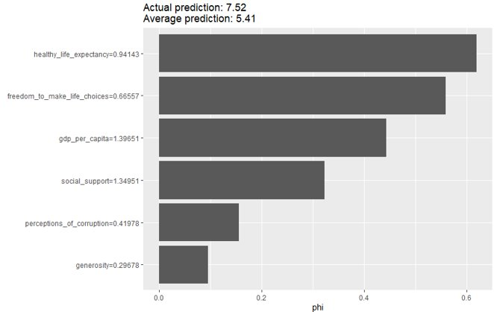
The SHAP plot helps explain how each feature contributes to the model’s predictions, enhancing interpretability. In this case, gdp_per_capita (+1.396) is the largest positive contributor to the prediction, followed by social_support (+1.350), which is the second largest contributor. Healthy_life_expectancy (+0.941) also plays a significant role, while factors like generosity (+0.267) have a much smaller impact on the prediction. This allows for a clearer understanding of how each feature influences the model’s output.
3. XGBoost, LightGBM
Model | RMSE (Root Mean Squared Error) | R_squared (R2)
Linear Regression | 0.51961166 | 0.7917468
XGBoost | 0.05255821 | 0.9978693
LightGBM | 0.24288414 | 0.9544978
SVR | 0.44421372 | 0.8477989
The performance comparison of various models shows that XGBoost significantly outperforms the others, with an RMSE of 0.0526 and an R² of 0.9979, indicating excellent prediction accuracy. LightGBM also performs well, achieving an R² of 0.9545 and an RMSE of 0.2429, while Linear Regression and SVR have lower R² and higher RMSE values. The tree-based boosting models (XGBoost and LightGBM) clearly dominate traditional methods like Linear Regression for the happiness prediction task, demonstrating their superior capability in capturing complex patterns.
4. time regression
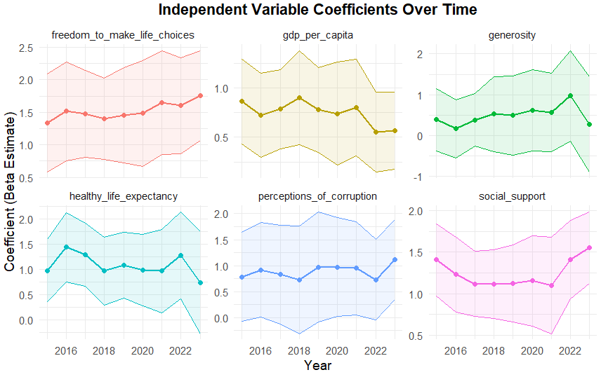
This plot illustrates how each variable's coefficient, reflecting its impact on happiness, evolves over time from 2016 to 2022. We can observe that freedom_to_make_life_choices and gdp_per_capita have relatively stable coefficients, suggesting consistent importance in predicting happiness. Generosity shows a gradual increase, while healthy_life_expectancy fluctuates somewhat over the years. Notably, social_support appears to have spiked in importance during 2020-2021, likely reflecting the heightened relevance of social connections during the pandemic. Overall, the plot highlights shifting trends in the factors influencing happiness over the years.

