**3.6.** If unidirectional composites are loaded in the fiber direction, calculate the ratios of fiber stress to matrix stress and fiber stress to composite stress when *Vf* = 10%, 25%, 50%, and 75%. Assume  *Ef* = 400 GPa and *Em* = 3.2 GPa.

**3.7.** Estimate *EL*, *ET*, *GLT*, and *νLT*, of glass–epoxy, graphite–epoxy, Kevlar–epoxy, and boron–aluminum composites with *Vf* = 25%, 50%, and 75%. Constituent properties are

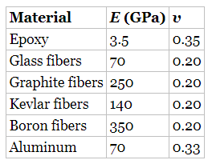

For the purpose of calculations, assume all fibers to be isotropic.

**3.8.** A rod consists of a binder and two types of fibers with the following properties:

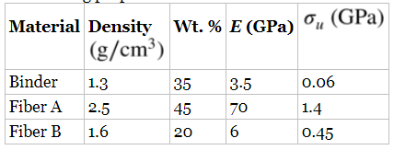

1. What maximum load can this rod carry without rupturing any of the constituents? (Assume that the cross-sectional area of the rod = 10 cm2.)
2. What is the maximum load the rod can carry?
3. What constituent will rupture last?
4. Plot the load–elongation curves for the rod to failure in load- maintained and elongation-maintained tests.

**3.9.** Two unidirectional composites are fabricated with glass fibers (*Vf* = 50%) and matrices *A* and *B*, whose stress–strain curves are shown in [Figure 3.49](https://jigsaw.vitalsource.com/books/9781119389972/epub/OPS/c03.xhtml?create=true#c03-fig-0049). The glass fibers are elastic up to failure and have an elastic modulus of 70 GPa and ultimate tensile strength of 2.8 GPa. If the composites are stressed parallel to the fibers, calculate

1. the composite stress at 1% and 4% strains for each composite, and
2. minimum and critical fiber volume fractions for each composite.

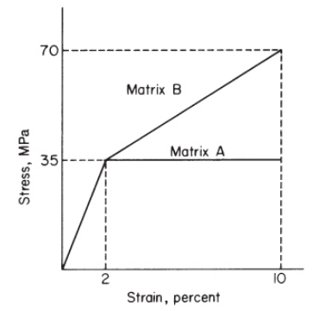

[**Figure 3.49**](https://jigsaw.vitalsource.com/books/9781119389972/epub/OPS/c03.xhtml?create=true#R_c03-fig-0049). Stress-strain curves for matrices A and B (Exercise Problem 3.9).

**3.11.** A tension link is made of an aluminum alloy. If aluminum is replaced by a unidirectional graphite–epoxy composite, calculate the required fiber volume fraction in the composite so that its longitudinal modulus matches the modulus of aluminum alloy. What is the percentage weight saving in this material replacement? Use the properties given in [Table 1.1](https://jigsaw.vitalsource.com/books/9781119389972/epub/OPS/c01.xhtml#c01-tbl-0001). The elastic modulus of epoxy is 3.5 GPa, and its density is 1.2 g/cm3.

