**xml 화면**

*<?***xml version="1.0" encoding="utf-8"***?>*<**LinearLayout  
 xmlns:android="http://schemas.android.com/apk/res/android"  
 android:id="@+id/activity_main"  
 android:layout_width="match_parent"  
 android:layout_height="match_parent"  
 android:orientation="vertical"  
 android:gravity="center"**>  
 <**LinearLayout  
 android:layout_width="match_parent"  
 android:layout_height="match_parent"  
 android:orientation="vertical"  
 android:gravity="center"  
 android:layout_marginTop="20dp"**>  
 <**LinearLayout  
 android:layout_width="match_parent"  
 android:layout_height="match_parent"  
 android:orientation="horizontal"  
 android:layout_marginLeft="10dp"  
 android:layout_marginRight="10dp"  
 android:layout_weight="1"  
 android:gravity="center"  
 android:layout_marginBottom="20dp"**>  
 <**Button  
 android:layout_width="40dp"  
 android:layout_height="60dp"  
 android:id="@+id/result_btn11"** />  
 <**Button  
 android:layout_width="40dp"  
 android:layout_height="60dp"  
 android:id="@+id/result_btn12"** />  
 <**Button  
 android:layout_width="40dp"  
 android:layout_height="60dp"  
 android:id="@+id/result_btn13"** />  
 <**Button  
 android:layout_width="40dp"  
 android:layout_height="60dp"  
 android:id="@+id/result_btn14"** />  
 <**Button  
 android:layout_width="40dp"  
 android:layout_height="60dp"  
 android:id="@+id/result_btn15"** />  
 <**Button  
 android:layout_width="40dp"  
 android:layout_height="60dp"  
 android:id="@+id/result_btn16"** />  
 <**Button  
 android:layout_width="40dp"  
 android:layout_height="60dp"  
 android:id="@+id/result_btn17"** />  
 </**LinearLayout**>  
 <**LinearLayout  
 android:layout_width="match_parent"  
 android:layout_height="match_parent"  
 android:orientation="horizontal"  
 android:layout_marginLeft="10dp"  
 android:layout_marginRight="10dp"  
 android:layout_weight="1"  
 android:gravity="center"  
 android:layout_marginTop="-20dp"  
 android:layout_marginBottom="40dp"**>  
 <**Button  
 android:layout_width="40dp"  
 android:layout_height="60dp"  
 android:id="@+id/result_btn21"** />  
 <**Button  
 android:layout_width="40dp"  
 android:layout_height="60dp"  
 android:id="@+id/result_btn22"** />  
 <**Button  
 android:layout_width="40dp"  
 android:layout_height="60dp"  
 android:id="@+id/result_btn23"** />  
 <**Button  
 android:layout_width="40dp"  
 android:layout_height="60dp"  
 android:id="@+id/result_btn24"** />  
 <**Button  
 android:layout_width="40dp"  
 android:layout_height="60dp"  
 android:id="@+id/result_btn25"** />  
 <**Button  
 android:layout_width="40dp"  
 android:layout_height="60dp"  
 android:id="@+id/result_btn26"** />  
 <**Button  
 android:layout_width="40dp"  
 android:layout_height="60dp"  
 android:id="@+id/result_btn27"** />  
 </**LinearLayout**>  
 <**LinearLayout  
 android:layout_width="match_parent"  
 android:layout_height="match_parent"  
 android:orientation="horizontal"  
 android:layout_marginLeft="10dp"  
 android:layout_marginRight="10dp"  
 android:layout_weight="1"  
 android:gravity="center"  
 android:layout_marginTop="-40dp"  
 android:layout_marginBottom="60dp"**>  
 <**Button  
 android:layout_width="40dp"  
 android:layout_height="60dp"  
 android:id="@+id/result_btn31"** />  
 <**Button  
 android:layout_width="40dp"  
 android:layout_height="60dp"  
 android:id="@+id/result_btn32"** />  
 <**Button  
 android:layout_width="40dp"  
 android:layout_height="60dp"  
 android:id="@+id/result_btn33"** />  
 <**Button  
 android:layout_width="40dp"  
 android:layout_height="60dp"  
 android:id="@+id/result_btn34"** />  
 <**Button  
 android:layout_width="40dp"  
 android:layout_height="60dp"  
 android:id="@+id/result_btn35"** />  
 <**Button  
 android:layout_width="40dp"  
 android:layout_height="60dp"  
 android:id="@+id/result_btn36"** />  
 <**Button  
 android:layout_width="40dp"  
 android:layout_height="60dp"  
 android:id="@+id/result_btn37"** />  
 </**LinearLayout**>  
 <**LinearLayout  
 android:layout_width="match_parent"  
 android:layout_height="match_parent"  
 android:orientation="horizontal"  
 android:layout_marginLeft="10dp"  
 android:layout_marginRight="10dp"  
 android:layout_weight="1"  
 android:gravity="center"  
 android:layout_marginTop="-60dp"  
 android:layout_marginBottom="80dp"**>  
 <**Button  
 android:layout_width="40dp"  
 android:layout_height="60dp"  
 android:id="@+id/result_btn41"** />  
 <**Button  
 android:layout_width="40dp"  
 android:layout_height="60dp"  
 android:id="@+id/result_btn42"** />  
 <**Button  
 android:layout_width="40dp"  
 android:layout_height="60dp"  
 android:id="@+id/result_btn43"** />  
 <**Button  
 android:layout_width="40dp"  
 android:layout_height="60dp"  
 android:id="@+id/result_btn44"** />  
 <**Button  
 android:layout_width="40dp"  
 android:layout_height="60dp"  
 android:id="@+id/result_btn45"** />  
 <**Button  
 android:layout_width="40dp"  
 android:layout_height="60dp"  
 android:id="@+id/result_btn46"** />  
 <**Button  
 android:layout_width="40dp"  
 android:layout_height="60dp"  
 android:id="@+id/result_btn47"** />  
 </**LinearLayout**>  
 <**LinearLayout  
 android:layout_width="match_parent"  
 android:layout_height="match_parent"  
 android:orientation="horizontal"  
 android:layout_marginLeft="10dp"  
 android:layout_marginRight="10dp"  
 android:layout_weight="1"  
 android:gravity="center"  
 android:layout_marginTop="-80dp"  
 android:layout_marginBottom="100dp"**>  
 <**Button  
 android:layout_width="40dp"  
 android:layout_height="60dp"  
 android:id="@+id/result_btn51"** />  
 <**Button  
 android:layout_width="40dp"  
 android:layout_height="60dp"  
 android:id="@+id/result_btn52"** />  
 <**Button  
 android:layout_width="40dp"  
 android:layout_height="60dp"  
 android:id="@+id/result_btn53"** />  
 <**Button  
 android:layout_width="40dp"  
 android:layout_height="60dp"  
 android:id="@+id/result_btn54"** />  
 <**Button  
 android:layout_width="40dp"  
 android:layout_height="60dp"  
 android:id="@+id/result_btn55"** />  
 <**Button  
 android:layout_width="40dp"  
 android:layout_height="60dp"  
 android:id="@+id/result_btn56"** />  
 <**Button  
 android:layout_width="40dp"  
 android:layout_height="60dp"  
 android:id="@+id/result_btn57"** />  
 </**LinearLayout**>  
 <**LinearLayout  
 android:layout_width="match_parent"  
 android:layout_height="match_parent"  
 android:orientation="horizontal"  
 android:layout_marginLeft="10dp"  
 android:layout_marginRight="10dp"  
 android:layout_weight="1"  
 android:gravity="center"  
 android:layout_marginTop="-100dp"  
 android:layout_marginBottom="120dp"**>  
 <**Button  
 android:layout_width="40dp"  
 android:layout_height="60dp"  
 android:id="@+id/result_btn61"** />  
 <**Button  
 android:layout_width="40dp"  
 android:layout_height="60dp"  
 android:id="@+id/result_btn62"** />  
 <**Button  
 android:layout_width="40dp"  
 android:layout_height="60dp"  
 android:id="@+id/result_btn63"** />  
 <**Button  
 android:layout_width="40dp"  
 android:layout_height="60dp"  
 android:id="@+id/result_btn64"** />  
 <**Button  
 android:layout_width="40dp"  
 android:layout_height="60dp"  
 android:id="@+id/result_btn65"** />  
 <**Button  
 android:layout_width="40dp"  
 android:layout_height="60dp"  
 android:id="@+id/result_btn66"** />  
 <**Button  
 android:layout_width="40dp"  
 android:layout_height="60dp"  
 android:id="@+id/result_btn67"** />  
 </**LinearLayout**>  
 <**LinearLayout  
 android:layout_width="match_parent"  
 android:layout_height="match_parent"  
 android:orientation="horizontal"  
 android:layout_marginLeft="10dp"  
 android:layout_marginRight="10dp"  
 android:layout_weight="1"  
 android:gravity="center"  
 android:layout_marginTop="-120dp"  
 android:layout_marginBottom="140dp"**>  
 <**Button  
 android:layout_width="40dp"  
 android:layout_height="60dp"  
 android:id="@+id/result_btn71"** />  
 <**Button  
 android:layout_width="40dp"  
 android:layout_height="60dp"  
 android:id="@+id/result_btn72"** />  
 <**Button  
 android:layout_width="40dp"  
 android:layout_height="60dp"  
 android:id="@+id/result_btn73"** />  
 <**Button  
 android:layout_width="40dp"  
 android:layout_height="60dp"  
 android:id="@+id/result_btn74"** />  
 <**Button  
 android:layout_width="40dp"  
 android:layout_height="60dp"  
 android:id="@+id/result_btn75"** />  
 <**Button  
 android:layout_width="40dp"  
 android:layout_height="60dp"  
 android:id="@+id/result_btn76"** />  
 <**Button  
 android:layout_width="40dp"  
 android:layout_height="60dp"  
 android:id="@+id/result_btn77"** />  
  
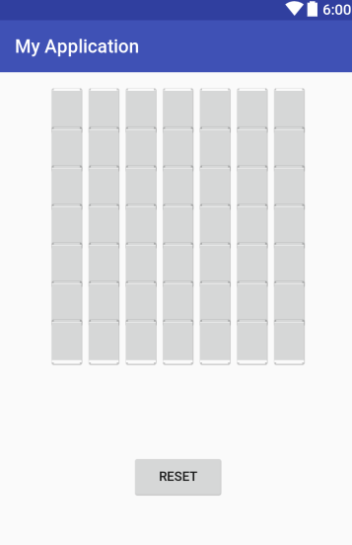 </**LinearLayout**>  
 <**LinearLayout  
 android:layout_width="match_parent"  
 android:layout_height="match_parent"  
 android:orientation="horizontal"  
 android:layout_marginLeft="10dp"  
 android:layout_marginRight="10dp"  
 android:layout_weight="1"  
 android:layout_marginTop="-50dp"  
 android:layout_marginBottom="40dp"  
 android:gravity="center"**>  
 <**Button  
 android:layout_width="100dp"  
 android:layout_height="50dp"  
 android:text="RESET"  
 android:id="@+id/btnReset"**/>  
 </**LinearLayout**>  
 </**LinearLayout**>  
  
</**LinearLayout**>

SubActivity.java

**package** com.example.jungwan.myapplication;  
  
**import** android.app.Activity;  
**import** android.content.Intent;  
**import** android.graphics.Color;  
**import** android.os.Bundle;  
**import** android.util.Log;  
**import** android.view.View;  
**import** android.widget.Button;  
**import** java.lang.Math.*;  
  
*/**  
 * Created by JungWan on 2016-11-25.  
 */***public class** SubActivity **extends** Activity {  
 Button **btn_output**[] = **new** Button[49]; *//생성한 버튼들의 id를 저장* Button **btnReset**; *//reset버튼* **double pattern1**[] = { *//ㄱ 패턴* 1,1,1,1,1,1,1,  
 0,0,0,0,0,0,1,  
 0,0,0,0,0,0,1,  
 0,0,0,0,0,0,1,  
 0,0,0,0,0,0,1,  
 0,0,0,0,0,0,1,  
 0,0,0,0,0,0,1  
 };  
 **double pattern2**[] = { *//ㄴ 패턴* 1,0,0,0,0,0,0,  
 1,0,0,0,0,0,0,  
 1,0,0,0,0,0,0,  
 1,0,0,0,0,0,0,  
 1,0,0,0,0,0,0,  
 1,0,0,0,0,0,0,  
 1,1,1,1,1,1,1  
 };  
 **double pattern3**[] = { *//ㄷ 패턴* 1,1,1,1,1,1,1,  
 1,0,0,0,0,0,0,  
 1,0,0,0,0,0,0,  
 1,0,0,0,0,0,0,  
 1,0,0,0,0,0,0,  
 1,0,0,0,0,0,0,  
 1,1,1,1,1,1,1  
 };  
  
 **double pattern4**[] = { *//ㄹ 패턴* 1,1,1,1,1,1,1,  
 0,0,0,0,0,0,1,  
 0,0,0,0,0,0,1,  
 1,1,1,1,1,1,1,  
 1,0,0,0,0,0,0,  
 1,0,0,0,0,0,0,  
 1,1,1,1,1,1,1  
 };  
  
 **double pattern5**[] = { *//ㅁ 패턴* 1,1,1,1,1,1,1,  
 1,0,0,0,0,0,1,  
 1,0,0,0,0,0,1,  
 1,0,0,0,0,0,1,  
 1,0,0,0,0,0,1,  
 1,0,0,0,0,0,1,  
 1,1,1,1,1,1,1  
 };  
  
 **double pattern6**[] = { *//ㅂ 패턴* 1,0,0,0,0,0,0,1,  
 1,0,0,0,0,0,0,1,  
 1,0,0,0,0,0,0,1,  
 1,1,1,1,1,1,1,1,  
 1,0,0,0,0,0,0,1,  
 1,0,0,0,0,0,0,1,  
 1,1,1,1,1,1,1,1  
 };  
  
 **double pattern7**[] = { *//ㅅ 패턴* 0,0,0,1,0,0,0,  
 0,0,0,1,0,0,0,  
 0,0,1,0,1,0,0,  
 0,0,1,0,1,0,0,  
 0,1,0,0,0,1,0,  
 0,1,0,0,0,1,0,  
 1,0,0,0,0,0,1  
 };  
  
 **double pattern8**[] = { *//ㅇ 패턴* 0,0,1,1,1,0,0,  
 0,1,0,0,0,1,0,  
 1,0,0,0,0,0,1,  
 1,0,0,0,0,0,1,  
 1,0,0,0,0,0,1,  
 0,1,0,0,0,1,0,  
 0,0,1,1,1,0,0  
 };  
  
 *//각 패턴들을 출력패턴 8가지로 임의설정* **double pattern1_outputLayer**[] = {  
 1,0,0,0,0,0,0,0  
 };  
 **double pattern2_outputLayer**[] = {  
 0,1,0,0,0,0,0,0  
 };  
 **double pattern3_outputLayer**[] = {  
 0,0,1,0,0,0,0,0  
 };  
 **double pattern4_outputLayer**[] = {  
 0,0,0,1,0,0,0,0  
 };  
 **double pattern5_outputLayer**[] = {  
 0,0,0,0,1,0,0,0  
 };  
 **double pattern6_outputLayer**[] = {  
 0,0,0,0,0,1,0,0  
 };  
 **double pattern7_outputLayer**[] = {  
 0,0,0,0,0,0,1,0  
 };  
 **double pattern8_outputLayer**[] = {  
 0,0,0,0,0,0,0,1  
 };  
  
 *//은닉층 -> 출력층과정에서의 크기사이즈 설정* **int output_size** = 8;  
  
 *//은닉층의 노드들을 생성* **double pattern_hiddenLayer1**[] = **new double**[49];  
 **double pattern_hiddenLayer2**[] = **new double**[49];  
  
 *//입력층의 노드들을 생성* **double pattern_outputLayer1**[] = **new double**[49];  
 **double pattern_outputLayer2**[] = **new double**[49];  
 **double pattern_outputLayer3**[] = **new double**[49];  
 **double pattern_outputLayer4**[] = **new double**[49];  
 **double pattern_outputLayer5**[] = **new double**[49];  
 **double pattern_outputLayer6**[] = **new double**[49];  
 **double pattern_outputLayer7**[] = **new double**[49];  
 **double pattern_outputLayer8**[] = **new double**[49];  
  
 *//가중치값을 설정* **double weight1** = 0.001;  
 **double weight2** = 0.003;  
  
 *//입력층 -> 은닉층의 출력값을 구하기 위한 변수 설정* **double total_inputLayerValue1** = 0.0;  
 **double total_inputLayerValue2** = 0.0;  
  
 *//은닉층 -> 출력층의 출력값을 구하기 위한 변수 설정* **double total_outputLayerValue1** = 0.0;  
 **double total_outputLayerValue2** = 0.0;  
 **double total_outputLayerValue3** = 0.0;  
 **double total_outputLayerValue4** = 0.0;  
 **double total_outputLayerValue5** = 0.0;  
 **double total_outputLayerValue6** = 0.0;  
 **double total_outputLayerValue7** = 0.0;  
 **double total_outputLayerValue8** = 0.0;  
  
 *//입력층 -> 은닉층에 나오는 출력값에서 시그모이드 함수 적용을 하기위한 변수* **double input_sigmoid1** = 0.0;  
 **double input_sigmoid2** = 0.0;  
  
 *//은닉층 -> 출력층에 나오는 출력값에서 시그모이드 함수 적용을 하기위한 변수* **double output_sigmoid1** = 0.0;  
 **double output_sigmoid2** = 0.0;  
 **double output_sigmoid3** = 0.0;  
 **double output_sigmoid4** = 0.0;  
 **double output_sigmoid5** = 0.0;  
 **double output_sigmoid6** = 0.0;  
 **double output_sigmoid7** = 0.0;  
 **double output_sigmoid8** = 0.0;  
  
 *//출력층 오차계산(델타)한 변수* **double output_errorCalValue1** = 0.0;  
 **double output_errorCalValue2** = 0.0;  
 **double output_errorCalValue3** = 0.0;  
 **double output_errorCalValue4** = 0.0;  
 **double output_errorCalValue5** = 0.0;  
 **double output_errorCalValue6** = 0.0;  
 **double output_errorCalValue7** = 0.0;  
 **double output_errorCalValue8** = 0.0;  
  
 *//은닉층 오차계산(델타)한 변수* **double hidden_errorCalValue1** = 0.0;  
 **double hidden_errorCalValue2** = 0.0;  
  
 *//출력되는 값을 배열로 저장* **int result_array**[] = **new int**[49];  
  
 @Override  
 **protected void** onCreate(Bundle savedInstanceState) {  
  
 **super**.onCreate(savedInstanceState);  
 setContentView(R.layout.***activity_sub***);  
  
 *//버튼들이 기능을 적용시키기 위해 아이디들을 배열로 저장* **int** btn_id[] = {  
 R.id.***result_btn11***, R.id.***result_btn12***, R.id.***result_btn13***, R.id.***result_btn14***, R.id.***result_btn15***, R.id.***result_btn16***, R.id.***result_btn17***,  
 R.id.***result_btn21***, R.id.***result_btn22***, R.id.***result_btn23***, R.id.***result_btn24***, R.id.***result_btn25***, R.id.***result_btn26***, R.id.***result_btn27***,  
 R.id.***result_btn31***, R.id.***result_btn32***, R.id.***result_btn33***, R.id.***result_btn34***, R.id.***result_btn35***, R.id.***result_btn36***, R.id.***result_btn37***,  
 R.id.***result_btn41***, R.id.***result_btn42***, R.id.***result_btn43***, R.id.***result_btn44***, R.id.***result_btn45***, R.id.***result_btn46***, R.id.***result_btn47***,  
 R.id.***result_btn51***, R.id.***result_btn52***, R.id.***result_btn53***, R.id.***result_btn54***, R.id.***result_btn55***, R.id.***result_btn56***, R.id.***result_btn57***,  
 R.id.***result_btn61***, R.id.***result_btn62***, R.id.***result_btn63***, R.id.***result_btn64***, R.id.***result_btn65***, R.id.***result_btn66***, R.id.***result_btn67***,  
 R.id.***result_btn71***, R.id.***result_btn72***, R.id.***result_btn73***, R.id.***result_btn74***, R.id.***result_btn75***, R.id.***result_btn76***, R.id.***result_btn77*** };  
  
 *//사용자가 클릭한 버튼들의 값을 넘겨받아 대입하는 변수* Intent intent = getIntent();  
 **double** getResult[] = intent.getDoubleArrayExtra(**"array"**);  
  
 *//각 버튼들의 id등록* **for**(**int** i=0; i<**btn_output**.**length**; i++){  
 **btn_output**[i] = (Button)findViewById(btn_id[i]);  
 }  
  
 **while**(**true**) {  
 pattern1_function(getResult);  
 pattern2_function(getResult);  
 pattern3_function(getResult);  
 pattern4_function(getResult);  
 pattern5_function(getResult);  
 pattern6_function(getResult);  
 pattern7_function(getResult);  
 pattern8_function(getResult);  
 **if**(**hidden_errorCalValue1** < -1.0 || **hidden_errorCalValue1** > 1.0){  
 *//hidden_errorCalValue1 = 1 - hidden_errorCalValue1;* **weight1** += 0.001;  
 **continue**;  
 }**else if**(**hidden_errorCalValue2** < -1.0 || **hidden_errorCalValue2** > 1.0) {  
 *//hidden_errorCalValue2 = 1 - hidden_errorCalValue2;* **weight2** += 0.001;  
 **continue**;  
 }**else if**((**hidden_errorCalValue1** > -1.0 && **hidden_errorCalValue2** > -1.0) || ((**weight1** > 1) || (**weight2** > 1)) )  
 **break**;  
 }  
  
 **for**(**int** i=0; i<**btn_output**.**length**; i++){  
 **if**(getResult[i] == 0){  
 **btn_output**[i].setBackgroundColor(Color.*rgb*(204,204,204));  
 **result_array**[i] = 0;  
 }**else**{  
 **btn_output**[i].setBackgroundColor(Color.*rgb*(0,255,0));  
 **result_array**[i] = 1;  
 }  
 }  
  
 *//reset버튼의 기능을 부가하기 위한 설정* **btnReset** = (Button)findViewById(R.id.***btnReset***);  
  
 *//reset버튼의 적용* **btnReset**.setOnClickListener(**new** View.OnClickListener() {  
 @Override  
 **public void** onClick(View view) {  
 Intent intent = **new** Intent(SubActivity.**this**, MainActivity.**class**);  
 startActivity(intent);  
 finish();  
 }  
 });  
 }  
  
 *//패턴1의 오류역전파 알고리즘을 적용* **public void** pattern1_function(**double**[] result){  
 **for**(**int** i=0; i<**btn_output**.**length**; i++){  
 **pattern_hiddenLayer1**[i] = (**weight1**\*result[i]) * 1;  
 **total_inputLayerValue1** += **pattern_hiddenLayer1**[i];  
 **pattern_hiddenLayer2**[i] = (**weight2**\*result[i]) * 1;  
 **total_inputLayerValue2** += **pattern_hiddenLayer2**[i];  
  
 }  
  
 *//입력층 -> 은닉층으로 시그모이드함수 적용한 값* **input_sigmoid1** = sigmoid_function(**total_inputLayerValue1**);  
 **input_sigmoid2** = sigmoid_function(**total_inputLayerValue2**);  
  
 *//은닉층 -> 출력층으로 시그모이드함수 적용한 값* **for**(**int** i=0; i<**output_size**; i++){  
 **pattern_outputLayer1**[i] = ((**input_sigmoid1**\***weight1**)+(**input_sigmoid2**\***weight2**));  
 **total_outputLayerValue1** += **pattern_outputLayer1**[i];  
 **pattern_outputLayer2**[i] = ((**input_sigmoid1**\***weight1**)+(**input_sigmoid2**\***weight2**));  
 **total_outputLayerValue2** += **pattern_outputLayer2**[i];  
 **pattern_outputLayer3**[i] = ((**input_sigmoid1**\***weight1**)+(**input_sigmoid2**\***weight2**));  
 **total_outputLayerValue3** += **pattern_outputLayer3**[i];  
 **pattern_outputLayer4**[i] = ((**input_sigmoid1**\***weight1**)+(**input_sigmoid2**\***weight2**));  
 **total_outputLayerValue4** += **pattern_outputLayer4**[i];  
 **pattern_outputLayer5**[i] = ((**input_sigmoid1**\***weight1**)+(**input_sigmoid2**\***weight2**));  
 **total_outputLayerValue5** += **pattern_outputLayer5**[i];  
 **pattern_outputLayer6**[i] = ((**input_sigmoid1**\***weight1**)+(**input_sigmoid2**\***weight2**));  
 **total_outputLayerValue6** += **pattern_outputLayer6**[i];  
 **pattern_outputLayer7**[i] = ((**input_sigmoid1**\***weight1**)+(**input_sigmoid2**\***weight2**));  
 **total_outputLayerValue7** += **pattern_outputLayer7**[i];  
 **pattern_outputLayer8**[i] = ((**input_sigmoid1**\***weight1**)+(**input_sigmoid2**\***weight2**));  
 **total_outputLayerValue8** += **pattern_outputLayer8**[i];  
 }  
  
 *//각 출력층에서 시그모이드 식을 적용* **output_sigmoid1** = sigmoid_function(**total_outputLayerValue1**);  
 **output_sigmoid2** = sigmoid_function(**total_outputLayerValue2**);  
 **output_sigmoid3** = sigmoid_function(**total_outputLayerValue3**);  
 **output_sigmoid4** = sigmoid_function(**total_outputLayerValue4**);  
 **output_sigmoid5** = sigmoid_function(**total_outputLayerValue5**);  
 **output_sigmoid6** = sigmoid_function(**total_outputLayerValue6**);  
 **output_sigmoid7** = sigmoid_function(**total_outputLayerValue7**);  
 **output_sigmoid8** = sigmoid_function(**total_outputLayerValue8**);  
  
 *//출력층 오차계산(델타)한 결과를 저장* **output_errorCalValue1** = (**output_sigmoid1**\*(1-**output_sigmoid1**)*(**pattern1_outputLayer**[0]-**output_sigmoid1**));  
 **output_errorCalValue2** = (**output_sigmoid2**\*(1-**output_sigmoid2**)*(**pattern1_outputLayer**[1]-**output_sigmoid2**));  
 **output_errorCalValue3** = (**output_sigmoid3**\*(1-**output_sigmoid3**)*(**pattern1_outputLayer**[2]-**output_sigmoid3**));  
 **output_errorCalValue4** = (**output_sigmoid4**\*(1-**output_sigmoid4**)*(**pattern1_outputLayer**[3]-**output_sigmoid4**));  
 **output_errorCalValue5** = (**output_sigmoid5**\*(1-**output_sigmoid5**)*(**pattern1_outputLayer**[4]-**output_sigmoid5**));  
 **output_errorCalValue6** = (**output_sigmoid6**\*(1-**output_sigmoid6**)*(**pattern1_outputLayer**[5]-**output_sigmoid6**));  
 **output_errorCalValue7** = (**output_sigmoid7**\*(1-**output_sigmoid7**)*(**pattern1_outputLayer**[6]-**output_sigmoid7**));  
 **output_errorCalValue8** = (**output_sigmoid8**\*(1-**output_sigmoid8**)*(**pattern1_outputLayer**[7]-**output_sigmoid8**));  
  
 *//은닉층 오차계산(델타)한 결과들을 저장* **hidden_errorCalValue1** = (**total_inputLayerValue1** * (1-**total_inputLayerValue1**)  
 + ((**output_errorCalValue1**\*1) + (**output_errorCalValue2**\*1) + (**output_errorCalValue3**\*1) + (**output_errorCalValue4**\*1)  
 + (**output_errorCalValue5**\*1) + (**output_errorCalValue6**\*1) + (**output_errorCalValue7**\*1) + (**output_errorCalValue8**\*1)));  
  
  
 **hidden_errorCalValue2** = (**total_inputLayerValue2** * (1-**total_inputLayerValue2**)  
 + ((**output_errorCalValue1**\*1) + (**output_errorCalValue2**\*1) + (**output_errorCalValue3**\*1) + (**output_errorCalValue4**\*1)  
 + (**output_errorCalValue5**\*1) + (**output_errorCalValue6**\*1) + (**output_errorCalValue7**\*1) + (**output_errorCalValue8**\*1)));  
   
 }

}

=> 패턴 ㄴ,ㄷ….마찬가지로 함수에 적용

결과화면

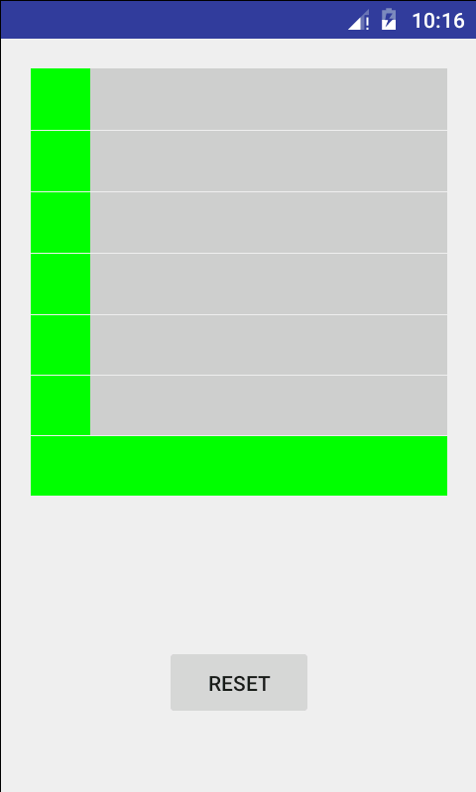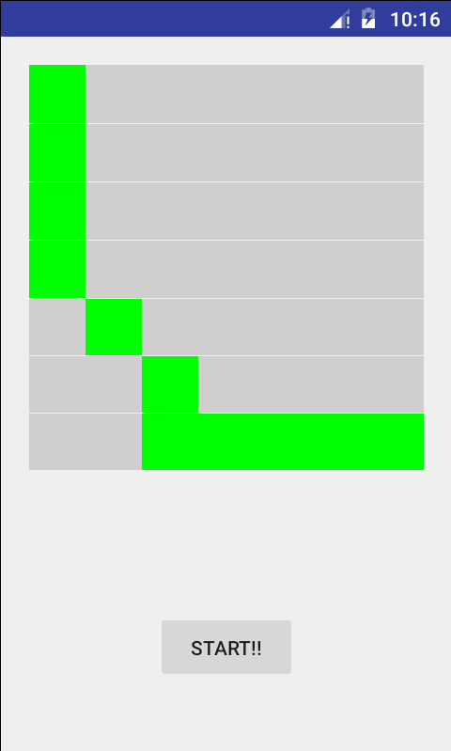

입력층의 노드 수 : 49개

은닉층의 노드 수 : 2개

출력층의 노드 수 : 8개

Weight 수의 변화 : 시그모이드 활성화 함수를 통해서 값들이 변화

변경 전

D/final_result1: -0.601137263913642

변경 후

D/final_result2: -0.482865263913642