Back ground (~5000)

- Introduction (300) o History and brief info about the topic?

- Motivation (600)

Congestion and overcrowding

operation research (smoothness and robustness)

we want to look at abnormality

- Anomaly detection (1000)

- Hierarchical model (1000)

o Matrix

o Equations and Notations

o Algorithms

- Bayesian Model (1000)

o How Bayesian is applied

o Why it is useful

o Poisson distributions

o How this suit our data o Algorithms

o Intro o Types of anomaly o Detection algorithms –

Outline of Thesis (800)

o What did I implement

o What kind result is expected

o Chapter summary (1 Sentence /chapter)

**Motivation [921/600]**

While the world population continues to grow and age at an unprecedented rate, public healthcare system all over the world are expected to experience increasing number of situations where large influx of patients overwhelms the current healthcare capability and in which congestion occur [ref 1, 2], other similar terms used to describe this situation include bottle neck and overcrowding.

Shortage of staff for public healthcare services has been a prominent issue ever since a decade of decrease in proportion of healthcare funding and deficit for the public health system in New Zealand [ ref 4]. As there are limited resources, hospital staff often had to operate at full capacity and are under tremendous stress. Study has shown that under-staffing is one of the key factors that contribute to the high prevalence of professional burnout in New Zealand’s public hospital senior medical workforce [ref 5]. Described as “erosion of the soul”, professional burnout is a term used in industry research that refers to a sense of emotional exhaustion that often lead to reduced work effectiveness. [ ref 6]

Due to increasing patient and understaff, some Emergency Department (ED) in the country struggled to cope with increasing patient arrivals, and this can be clearly reflected from unacceptable delays before patients are being admitted to hospital, transferred or sent home. Patient delay is a direct result of triage strategy [ref 8] utilised by ED when there is a congestion of patients. When there is not enough staff, patient at a higher triage is given priority for treatment. However, a critical flaw of the current strategy is that if congestion does not get resolved, the patient that is evaluated to be less urgent often gets delay after delay, in theory a patient can be delayed for infinity if he is unfortunate enough, and chance of further complication will only rise at every second of clock ticking by [ref 8]. We already have a tragic case that happened back in 2015, where a woman in Wellington died after 12 hours of delay [7]. During the fatal day, “The emergency department was stretched by an influx of patient which lead to congestion and overcrowding” , and Ed staff had decide that she was not in Immediately life-threatening situation and she was essentially backlogged, what supposed to be a 30 minute delay had turned into more than an hour, and over the last 12 hour of her life ED staff failed to provide adequate monitor and care, which result in the woman’s tragic death. it just breaks your heart when you hear such case happening and you cannot stop wondering, what if her got treated in time?

Located at the start of healthcare pathway [ref 2] the ED and other forms of emergency health care are feeling tremendous pressure from increasing healthcare demands. Compare to primary healthcare, emergency health care is a 24/7 operating service that it is characterised with unscheduled visits, and critical conditions that needs immediate attention [ref 3], therefore they frequently meet an influx of unanticipated emergency situations such as major traffic accident and disease outbreaks. Unfortunately, due to limited and often diminishing resources, public healthcare facilities often had to operate at near full capacity to reduce operation costs [ref 1.3], and this leave a very small buffer zone and staff are often underprepared for congestion.

Fortunately, the crisis in the New Zealand healthcare service is well recognised and there is a substantial amount of recent and ongoing research that aimed at providing alternative strategies, for example T. Adams, M. O’Sullivan, C. Walker (2018)[ref] is currently working on A Simulations of Auckland City Hospital’s Emergency Department with Pod model, where doctors formed small cross-functional and multidisciplinary team, and experimental trials had taken place at the Auckland city hospital during December 2018 - January 2019. Another interesting study is a study by Isaac D. Cleland, Andrew Mason, and Michael O’Sullivan (2018)[ref] that looked at developing algorithms to optimise Staff Rostering. As we can see, we do have people approaching the problem in various ways, for this thesis we want to approach the problem of congestion through the perspective of Healthcare Logistics. (maybe delete this paragraph later)

As Stephan Nickle Quoted during the 2018 NZSA-ORSNA conference[ref], “Healthcare Logistics is all about the robustness and smoothness of the operation”. ED congestion often occurs during the periods of abnormal arrivals when the max capacity is overwhelmed, therefore a success prediction/anticipation of such abnormal arrivals could provide valuable insight for operational planning and management. We were well prepared, facilities are built, supplies are prepared, and staff are recruited base on prediction from historical **mean**s, you would have thought that we were well prepared, right? But what we did is that we well prepared for normality, and the abnormality is being over looked. And, congestion occur dur these abnormalities.

If we could predict abnormal patient arrivals, Doctors can be transferred, medical supplies can be prepared as soon as we believe there is enough evidence suggesting an abnormal event is or will be happening. And with better preparation and faster response to abnormal situations, the problem of congestion could be alleviated for both patient and healthcare staff. For patients’ shorter delay will reduce stress and reduce risk of further complications, and for doctors more preparedness should reduce burnout and increase in efficiency. [ref 1.3, 1.4] (there is a study mentioning more preparedness reduce burnout, find it)

With this the idea in mind, we would want to

in this thesis, we will explore the possible applications of hierarchical Bayesian model for benchmarking purpose and evaluate how different levels of the hierarchy affect the accuracy and predictability of anomaly detection.

- [Ref1 population and congestion

<https://www.nzma.org.nz/journal/read-the-journal/all-issues/2010-2019/2015/vol-128-no-1422-25-september-2015/6662>

<https://www.ncbi.nlm.nih.gov/pubmed/20078914>

<https://www.sciencedirect.com/science/article/pii/S0716864017300354>

<https://www.ncbi.nlm.nih.gov/pmc/articles/PMC6117060/>]

- [Ref 2 pathway

<https://www.health.govt.nz/our-work/hospitals-and-specialist-care/elective-services/how-electives-process-works>

<https://www.health.govt.nz/our-work/hospitals-and-specialist-care/emergency-departments/interface-primary-health-care>]

- [Ref 3 ED character

<https://www.health.govt.nz/publication/emergency-department-use-2014-15>

<https://www.health.govt.nz/our-work/hospitals-and-specialist-care/emergency-departments/about-emergency-departments>]

- [ref4 reduced proportion GPD, years of underfunding <https://data.worldbank.org/indicator/SH.XPD.CHEX.GD.ZS?locations=NZ>

<https://www.nzherald.co.nz/nz/news/article.cfm?c_id=1&objectid=12128639>]

- [ ref 5 burnout nz <https://bmjopen.bmj.com/content/6/11/e013947>]

- [ ref 6 HemOnc Today. The psychology of oncology: Physician burnout is going unrecognised. HemOnc Today 10 June 2008:www.hemonctoday.com. Accessed: 8 March 2011.

<https://www.nzma.org.nz/journal/read-the-journal/all-issues/2010-2019/2011/vol-124-no-1333/view-paterson> ]

[ref 7 woman died 12 hour delay <https://www.pressreader.com/new-zealand/the-southland-times/20150519/281539404539263>]

- [ref 8 triage

<https://www.health.govt.nz/our-work/hospitals-and-specialist-care/emergency-departments/emergency-department-triage>]

- [ref 9 delay ( good article, spent more time on this) <https://www.ncbi.nlm.nih.gov/pmc/articles/PMC6117060/>]

- [ ref nickle <https://r-resources.massey.ac.nz/nzsa2018/nickel-stefan.html>, for his quote ref email communication between me and him]

**Anomaly Detection**} /1000

According to English, an anomaly is “something that deviates from what is standard, normal, or expected.” [ref 1] We can clearly see has a complementary nature with normality, where there is normality, there must be abnormality, and what is normal, must be not be abnormal and vice versa, what is abnormal, must not be normal. ( probably delete this later)

Anomaly detection refers to the problem of ﬁnding patterns in data that do not conform to expectation, or out of normality. Study of anomaly can be traced back to 19th century, an example is that in 1887, F. Y. Edgeworth a lecturer from King’s college, London wrote about what he termed as Discordant observations, observations which “present the appearance of differencing in respect of their law of frequency from other observation with which they are combined” [ref 2]. The term anomaly is very similar to the term outlier, which is defined by “A data point that differs significantly from other observations” [ref 3]. These two terms are often used interchangeably, however the term anomaly have a stronger contextual connection to application side of the statistics.

Anomaly detection found extensive application in field such as for cyber-security, finance, and healthcare. The reason why anomaly is so significant, is that it often directly translates into critical situations. The classic example of anomaly detection is the intrusion detection systems that are triggered by signatures of cyber-attacks. Indicator such as abnormally high website visits could be an indication of an HTTP POST attack, where the website processing capacity is overwhelmed, or illegal data scraping, where private information is processed and exported from a website. [ ref 4] For the field of healthcare, anomaly detection had already been well explored and utilised. For example, back in 2003, Wong et al has tested this algorithm called WSARE 3.0, which stands for "What’s Strange About Recent Events, version 3” for the detection of Disease Outbreaks in the US. [ref 6]

For patient arrivals, we could classify the type of data as time series data, that is, a set of data that is recorded over specific time intervals [ref 7], we have the time of each patients visit and this can be counted over intervals and give us data such as number of arrivals per day. And from the perspective of time series data, there are several important types of anomaly. In this thesis, we want to focus on three. The first and the simplest type are Point anomalies, where a single time period is anomalous. For example, traffic of a website may spike during a single night, when the website is under cyber-attack. The second type are Period anomalies: Where a series of time period is anomalous. For example, money spent during the Christmas period is expected to be much higher compare to the usual spending. And the last type, Contextual anomalies, where occurrence of anomalous time period is context specific. For example, Admission rate for Emergency department patients may spike on any given day, when there is a mass injury event such as major car crashes.

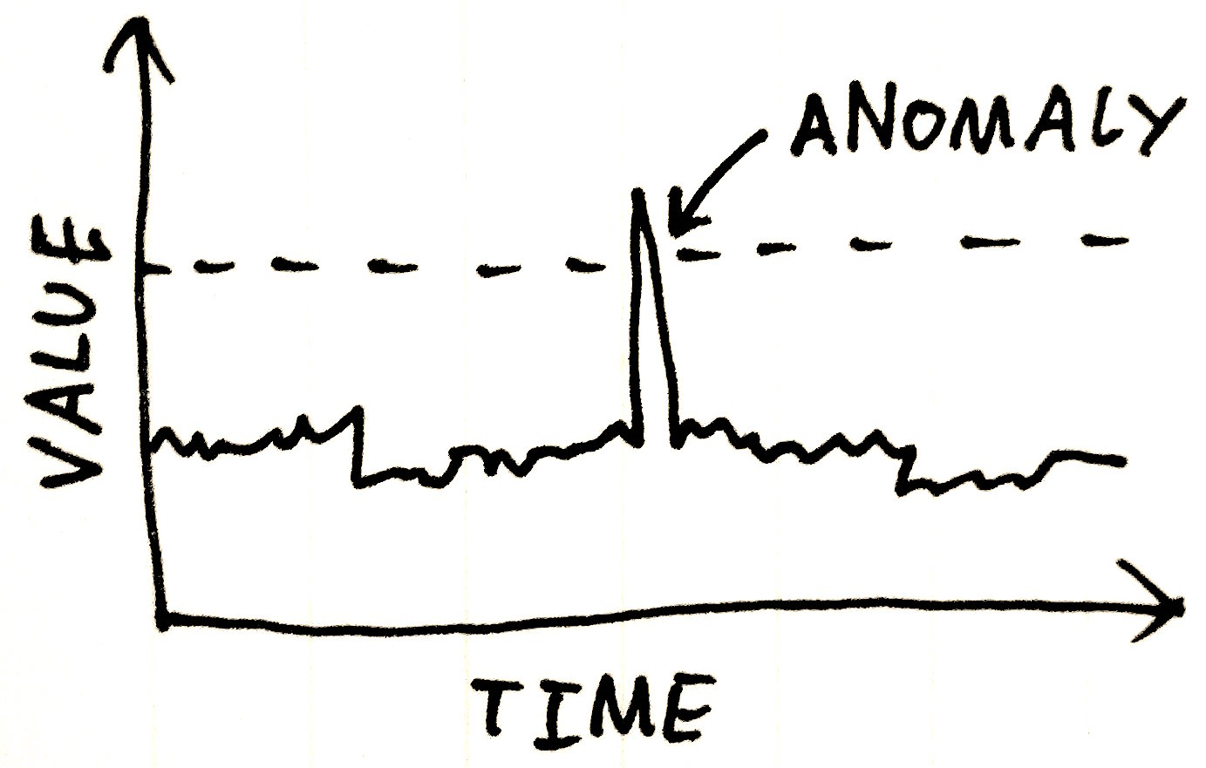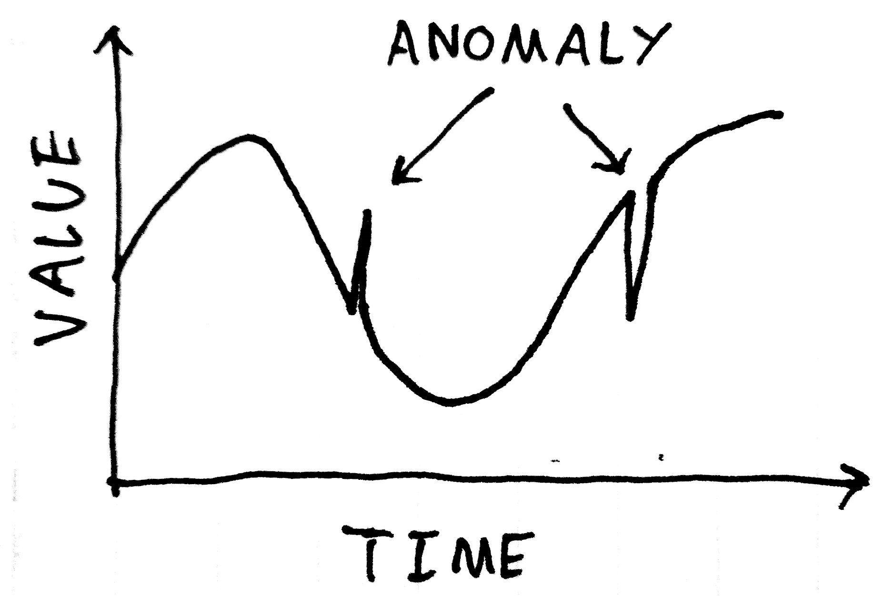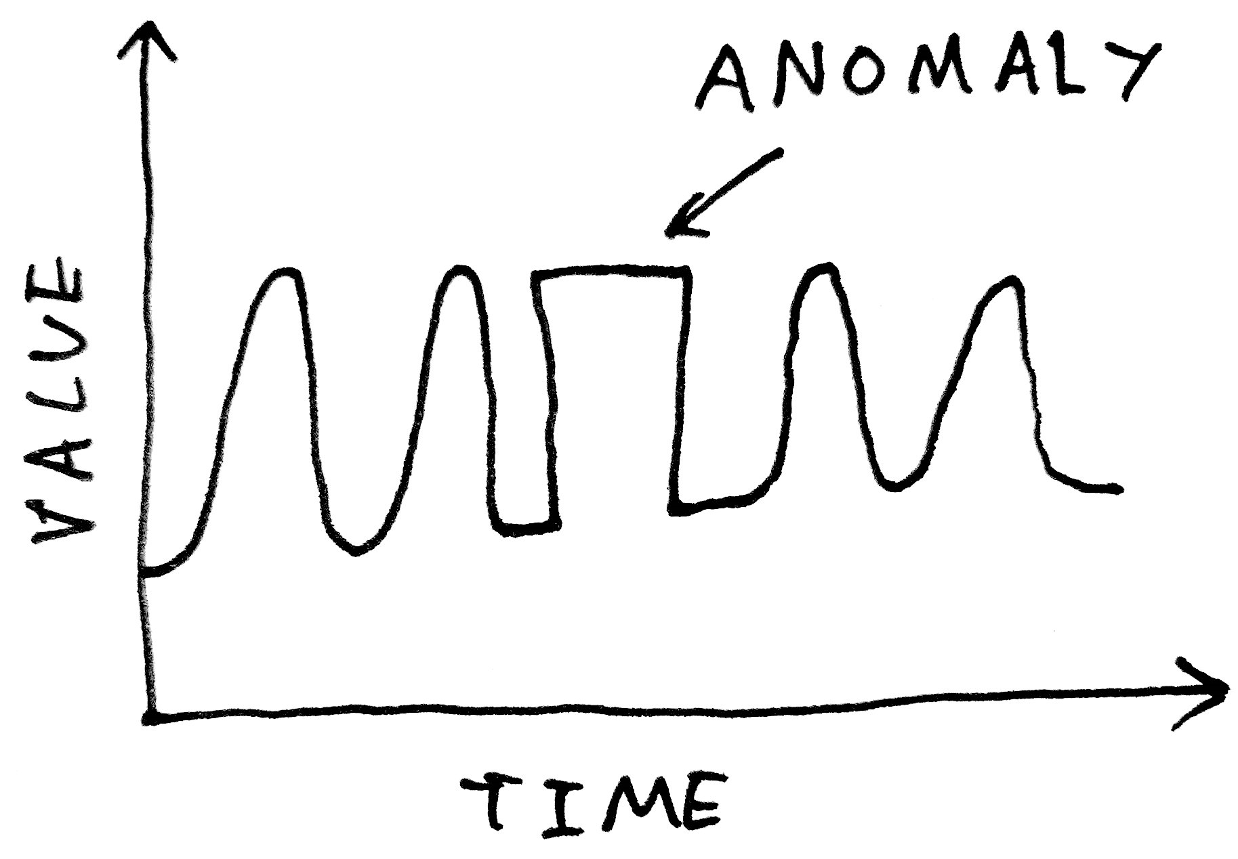

There are countless ways where a point, or a pattern is abnormal and deviate from the expected [ref 8 plot], the simplest and often used approach is to set up a value as threshold and then we will be able to detect anomalies simply by looking for any values beyond the threshold [ref 6] . Therefore, for patient arrivals, abnormal arrival can be defined as arrival from a given time period that exceed a particular threshold. If we assume that the healthcare system is expected to be operating at certain capacity percentage k, for example, 80%, we could hypothesise a threshold multiplier by taking the inverse of the value, for our case it is 1.25. We could multiply the threshold multiplier on the expected daily arrival , for example, 100 arrival per day, and derive a threshold count, 125. This is a very arbitrary estimation of the threshold. How ever it should be adequate to use for a simulation setting.

The idea is, if we observe a daily arrival greater than the threshold arrival we will label the day as abnormal. When the threshold is reached, in theory the value of patient arrival had exceeded the healthcare capacity and congestion would have occurred.

Supervise vs un supervise

Parametric vs non-parametric

Strength and weakness

CONCLUDING REMARKS AND FUTURE WORK In this survey we have discussed…and for a simulation study setting…

- [ ref 1 https://en.oxforddictionaries.com/definition/anomaly]\]

- [ ref 2 Chandola, V., Banerjee, A., and Kumar, V. 2009. Anomaly detection: A survey. ACM Comput. Surv. 41, 3, Article 15 (July 2009), 58 pages. DOI=10.1145/1541880.1541882 http://doi.acm.org/10.1145/1541880.1541882] <https://blog.pandorafms.org/anomaly-detection-in-monitoring>]

- [ ref 3 EDGEWORTH, F. Y. 1887. On discordant observations. Philosoph. Mag. 23, 5, 364–375]

- [ref 4 <https://www.sciencedirect.com/science/article/abs/pii/S138912860700062X>

<https://www.targetinternet.com/what-is-data-scraping-and-how-can-you-use-it/>

<https://www.cloudflare.com/learning/ddos/http-flood-ddos-attack/>]

- [ref 5 <http://wzcx.hmxjv.com/ayqr/89318.html>]

-[Ref 6] Wong, W. K., Moore, A. W., Cooper, G. F., & Wagner, M. M. (2003). Bayesian network anomaly pattern detection for disease outbreaks. In *Proceedings of the 20th International Conference on Machine Learning (ICML-03)* (pp. 808-815).

- [ref 7 Das, S. (1994). *Time series analysis*. Princeton University Press, Princeton, NJ.]

- [ref 8 Plot http://amid.fish/anomaly-detection-with-k-means-clustering]

\section{Hiercrchical Bayesian Models}

How do you tell if a statistician is a true Bayesian?

Ask them what time it is

If they tell you the time, they’re a frequentist;

A Bayesian will ask “ What time do you think it is?

[ref Geoff Jones NZSA 2018, authoirised to be reused]

\centering

$\underbrace{\Pr(\text{parameters} | \text{data})}_{\text{posterior}} = \frac{\overbrace{\Pr(\text{data} | \text{parameters})}^{\text{likelihood}} \overbrace{\Pr(\text{parameters})}^{\text{prior}}}{\underbrace{\Pr(\text{data})}_{evidence}} .$

where \Pr(\text{data}) \neq 0 .

As the name suggest, hierarchical bayesian models (sometimes called multilevel Bayesian models) are \textbf{i)} written in hierarchical form and is \textbf{ii)} implicated using Bayesian methods.

A hierarchical model refers to

A good example of this is Geographical locations, New Zealand can be break down into different levels , first it can be break down into North and South Island, and then into regions, and then into cities, towns. So each time the regions are divided we create a hierarchy, and we could quickly

Hospital petient diagnosis also appllied a hierarchical structure......

Bayesian statistics

\color{red}

is a centuries-old method that was once controversial but is now gaining

acceptance in the scientific community, particularly in marketing.

\color{black}

In this thesis we will

\color{red}

provide an introduction to hierarchical Bayes models and overview of

successful applications.

Underlying assumptions are discussed in the next section, followed by an

introduction to MCMC methods. A case study is then used to illustrate the use of Bayesian methods

in the context of a conjoint study. Examples of successful applications follow, closing with a

discussion of challenges to using hierarchical Bayes models.

\color{black}

According to statistics, a normal person has one breast and one testicle

* [ref <https://news.ycombinator.com/item?id=1878916>]
* \paragraph{}

%\comm{

\begin{center}

$\begin{bmatrix}

y_{t} \\

y_{A,t}\\

y_{B,t} \\

y_{AA,t} \\

y_{AB,t}\\

y_{BA,t} \\

y_{BB,t}

\end{bmatrix}$

=

$\begin{bmatrix}

1 & 1 & 1 & 1 \\

1 & 1 & 0 & 0 \\

0 & 0 & 1 & 1 \\

1 & 0 & 0 & 0 \\

0 & 1 & 0 & 0 \\

0 & 0 & 1 & 0 \\

0 & 0 & 0 & 1

\end{bmatrix}$

$\begin{bmatrix}

y_{AA,t} \\

y_{AB,t} \\

y_{BA,t} \\

y_{BB,t}

\end{bmatrix}$

\end{center}

%}

\begin{equation}

{y}_t={S}{b}_{t},

\tag{add tag here}

\end{equation}

%------------------------------------------------------------------------------------------

\section{}

\section{Models}

N = number of simulations\\

Y = count of patient arrivals everyday\\

S = Seasonality\\

T = Trend\\

C = cycles? \\

A = Anomalies\\

d = Dummies\\

D = disease category (bottom level)\\

$\mu_0$ = mean

$\sum{Y} = 1,000,000$\\

\begin{equation}

Y = \mu_0 + \sum{d_iS_i}+ \sum{d_iA_i} + \sum{d_iD_i} + \sum{d_iT_i}\\

\end{equation}

$L(\theta|x)$

%------------------------------------------------------------------------------------------

\newpage