

Blood Glucose Prediction Model Applicable to Continuous Glucose Monitoring Systems

Author:  Jiang Yijun | Supervisor:  Prof. Shiming Zhang

A thesis submitted in fulfillment of the requirements
for the degree of Master of Science
in the
Department of Electrical and Computer Engineering
Faculty of Engineering

July, 2026

Blood Glucose Prediction Model Applicable to Continuous Glucose Monitoring Systems

by

Jiang Yijun
Bachelor of science in Robotics Engineering , Chongqing University

A thesis submitted to attain the degree of
Master of Science
at

The University of Hong Kong
July, 2026

Copyright ©2026, by Jiang Yijun
ALL RIGHTS RESERVED.

Abstract
Continuous glucose monitoring (CGM) systems provide high-frequency time-series data essential for proactive diabetes management. Specifically, 30-minute-ahead blood glucose prediction offers a critical intervention window to prevent severe hypoglycemic and hyperglycemic events. However, real-world predictive modeling faces three primary bottlenecks: inherent sensor noise, an over-reliance on hard-to-collect multimodal data, and the severe "cold-start" problem for new users.
To address these limitations, this thesis proposes a data-driven prediction framework utilizing only historical CGM sequences and basic demographic features (age and BMI). The framework is validated on an integrated dataset of 174 subjects, encompassing healthy, prediabetic, and type 1 and type 2 diabetes populations. A Savitzky-Golay filtering pipeline is implemented to suppress sensor noise while preserving critical glycemic peak shapes and local extrema. Following a systematic evaluation of eight predictive models, the Transformer architecture is selected as the base model due to its parallel computing efficiency, long-range dependency modeling, and modular structure.
To resolve the conflict between individual physiological differences and limited calibration data, a frozen-encoder transfer learning strategy is applied. By freezing the pre-trained Transformer encoder, the model retains shared population-level glucose dynamics. Simultaneously, fine-tuning only the regression head allows the model to capture individual-specific metabolic parameters without the risk of overfitting. Utilizing just 30% of an individual's data—approximately two to three days of monitoring—this approach achieved an average Root Mean Square Error (RMSE) reduction of 20.35% across ten independent hold-out subjects.
However, standard transfer learning has limitations in extreme "cold-start" scenarios with severely restricted calibration data. To address this, a First-Order Model-Agnostic Meta-Learning (FOMAML) algorithm is introduced.Instead of optimizing for an average population fit, FOMAML explicitly optimizes the initialization parameters to maximize rapid individual adaptation. Experimental results demonstrate that in low-sample regimes (fewer than 100 samples), this meta-transfer strategy significantly outperforms standard transfer learning, reducing the Mean Absolute Error (MAE) by an average of 25.67%. In extreme cases using only 30 samples (about 2.5 hours of data), the MAE reduction reaches 31.58%. This framework offers a robust, data-efficient solution for rapid personalization in real-world CGM deployment.

Declaration

I, Jiang Yijun, declare that this thesis titled, “Blood glucose prediction model applicable to continuous glucose monitoring systems”, which is submitted in fulfillment of the requirements for the Degree of Master of Science, represents my own work except where due acknowledgement have been made. I further declared that it has not been previously included in a thesis, dissertation, or report submitted to this University or to any other institution for a degree, diploma or other qualifications.

Acknowledgement

I would like to thank all the people I love
Contents
Abstract iv
Declaration v
Acknowledgement vii
List of Figures x
List of Tables xi
Chapter 1 Introduction 1
1.1 Background 1
1.2 Literature Review 2
1.3 Contributions 4
Chapter 2 Data Selection and Standardization 6
2.1 Dataset Selection 6
2.2 Data Standardization 8
Chapter 3 CGM Noise Analysis and Filtering 11
3.1 Noise Analysis 11
3.2 Filtering Theory 15
3.2.1 Kalman Filter 15
3.2.2 S-G Filter 16
3.2.3 Butterworth Filter 18
3.3 Evaluation of Filtering Effect 18
3.4 Conclusion 20
Chapter 4 Model Building and Comparison 22
4.1 Experiment and Evaluation 22
4.2 Baseline and Machine Learning Models 24
4.3 Deep Learning Models 31
4.4 Results Analysis 38
4.5 Conclusion 43
Chapter 5 Transfer Learning 46
5.1 Introduction 46
5.2 Transfer Strategy 47
5.3 Result Analysis 49
5.4 Conclusion 53
Chapter 6 Meta-Transfer Learning 54
6.1 Introduction 54
6.2 Meta-learning Theory 55
6.3 Experiment and Analysis 57
6.4 Discussion 61
Chapter 7 Conclusion 66
Reference 68

List of Figures

Figure 1.1 CGM devices provide continuous glucose monitoring through subcutaneous sensors. 1
Figure 3.1 (1)SNR distribution (2)noise level distribution (3)anomaly change ratio distribution (4)SNR vs noise level scatter plot. 14
Figure 4.1 The ARIMA prediction on Hold-out set(subject 2 and 306). 26
Figure 4.2 The linear prediction on Hold-out set(subject 2 and 306). 27
Figure 4.3 The KNN prediction on Hold-out set(subject 2 and 306). 29
Figure 4.4 The random forest prediction on hold-out set(subject 2 and 306). 30
Figure 4.5 The XGBoost prediction on hold-out set(subject 2 and 306). 31
Figure 4.6 The CNN prediction on served set(subject 2 and 306). 33
Figure 4.7 The RNN prediction on hold-out set(subject 2 and 306). 34
Figure 4.8 The LSTM prediction on hold-out set(subject 2 and 306). 36
Figure 4.9 The transformer prediction on hold-out set(subject 2 and 306). 38
Figure 4.10 The CEG Clarke error grid of different models. 41
Figure 4.11 Prediction results of different models on subject 306. 42
Figure 5.1 The data split for transfer learning on subject 306. 48
Figure 5.2 Comparison of baseline and fine-tuned model prediction curves on subject 124 during the test set period. 51
Figure 5.3 Comparison of baseline and fine-tuned model prediction curves on subject 146 during the test set period. 52
Figure 6.1 FOMAML algorithm framework. 56
Figure 6.2 The learning curve of basic transfer learning and meta transfer learning. 59
Figure 6.3 The prediction of meta transfer and basic transfer on subject 124. 60

List of Tables

Table 2.1 physiological parameters and blood glucose distribution. 7
Table 3.1 analysis of noise assessment results. 13
Table 3.2 comparison of filtering results. 19
Table 4.1 comparison of different models’ prediction. 39
Table 5.1 Transfer Learning Parameter Settings Table. 49
Table 5.2 Prediction results of the baseline model and fine-tuned model on the participant 306 test set. 49
Table 5.3 Results of transfer learning experiments conducted on 10 subjects. 50
Table 6.1 FOMAML Meta-Training Hyperparameter Configuration 57
Table 6.2 Comparison of the predictive indicators of basic transfer and meta transfer. 61
Table 6.3 Comparison with Related Meta-Learning Approaches for Personalized Glucose Prediction 62

- Introduction
  - Background
Diabetes mellitus is a chronic metabolic disease with an increasing global prevalence. It can lead to serious problems in the heart, kidneys, eyes, and nerves, causing heavy burden on both patients and healthcare systems^{[1]}. Keeping blood glucose levels stable is the most important way to reduce these risks. However, traditional measurement methods such as fasting glucose, postprandial blood glucose, and glycated hemoglobin (HbA1c) only give average values at certain times. Self-Monitoring of Blood Glucose (SMBG) can give more frequent readings, but many patients find it hard to do it regularly, especially at night^{[2]}.
Continuous glucose monitoring (CGM) solves many of these problems. A small sensor placed under the skin measures the glucose level in the interstitial fluid, usually once every five minutes, and sends the data to a phone or receiver in real time^{[3]}. This produces a detailed time series that can show the glucose changes after meals, during exercise, and overnight, which are often missed by single-point measurements.
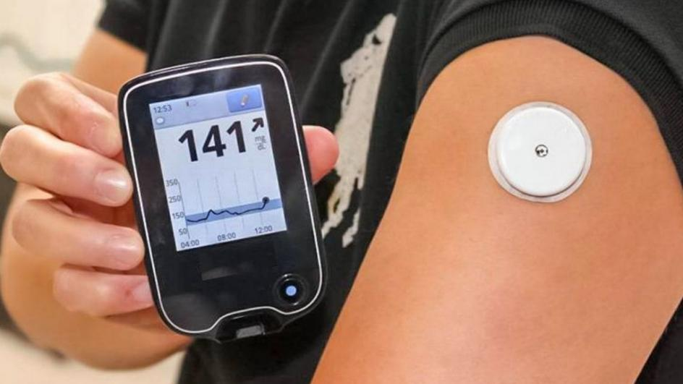
          - CGM devices provide continuous glucose monitoring through subcutaneous sensors.
CGM is useful for more than just monitoring. New clinical metrics like Time in Range (TIR), which measures how long a patient's glucose stays between 3.9 and 10.0 mmol/L each day, have been accepted by the American Diabetes Association as an important measure alongside HbA1c^{[2]}. For this study, the key value of CGM is the rich time series data it provides. If a model can predict glucose levels 30 minutes ahead, patients have enough time to eat something before a low or take insulin before a high^{[6]}. This changes diabetes care from reacting to problems to preventing them.
However, CGM data has several quality issues. There is a 5–10 minute delay between the glucose level in interstitial fluid and in blood^{[4]}. Sensor degradation, motion artifacts, pressure on the sensor, and wireless connection problems can all add noise and gaps to the data^{[5]}. Before using CGM data for prediction, these problems must be handled carefully, because they directly affect how well the model works.
There is still a big gap between research results and systems that can be used in practice. Many high-accuracy models in the literature use multi-modal data such as meal records, exercise logs, insulin doses, and even heart rate signals^{[8]}. In the real world, patients rarely provide all this information. Some models that only use CGM data still need days of data from each person before they work well^{[13][14]}. But new users expect useful predictions from the first day they wear the device.These limit the practicality in real-world CGM deployment.
This study aims to address this practical challenge. We propose a prediction framework that uses only CGM sequences and two basic features: age and BMI. To tackle the cold-start problem for new users, we combine transfer learning with meta-learning, with the goal of adapting a general model to a new individual using only 30–50 glucose samples, equivalent to approximately 2.5 to 4 hours of data. Previous studies have demonstrated that accurate prediction is feasible using only CGM data^{[18]}. Our work delivers a complete pipeline that translates this concept into a validated, operational system.
  - Literature Review
Blood glucose prediction based on CGM time series has received much research interest worldwide, and its progress has generally gone through three stages^{[3]}:
1. Physiological mechanism model stage: Initial research mostly employed a group of differential equations to simulate physiological processes like glucose metabolism and insulin dynamics (for example, Bergman Minimum Model or Hovorka Model). Although these models provide good clinical interpretability, their complicated structures require detailed personalized parameter identification and it is hard to apply them on a large scale in actual environment.
2. Statistical time series model stage: With the accumulation of high-frequency CGM data, researchers began to adopt more data-driven statistical methods, such as autoregression (AR), autoregressive moving average (ARMA) and autoregressive integrated moving average (ARIMA) models. In addition, state-space methods such as Kalman filtering are also widely used in real-time filtering and smoothing CGM data to reduce the impact of noise^{[7]}. This kind of model has small computational overhead and can basically perform in short-term forecasts.
3. Machine learning and deep learning stage: In the past decade, machine learning (ML) and deep learning (DL) methods have been widely used in blood glucose prediction. Traditional ML methods (such as support vector regression and random forests) usually rely on handcrafted feature engineering to encode historical blood glucose values, diet, exercise and other information as features^{[8]}. Deep learning uses the network's own representation learning ability to extract features directly from the original sequence. Among them, recurrent neural networks (RNN), long short-term memory(LSTM) and gated recurrent units(GRU) are widely used because of their natural advantages in processing sequence data^{[9][10]}.
On this basis, the researchers also explored more complex model structures, such as combining one-dimensional convolutional networks (CNN) with recurrent structures to capture local change patterns and long-term trends at the same time^{[10]}. For multi-step prediction and longer prediction horizons, Attention Mechanism and Seq2Seq structures are also introduced to more effectively model the evolution of blood glucose over time^{[9]}.
For current application, machine learning and deep learning methods have become the mainstream technical routes for blood glucose prediction because of their strong nonlinear fitting ability^{[8]}.
Under the traditional machine learning framework, the key is feature design. Researchers usually extract lag terms, sliding window statistics (such as mean, variance, rate of change), etc. from the historical CGM sequence, and combine them with dietary, exercise, drugs and other auxiliary information as input features. Under the premise of reasonable feature engineering, these models are often significantly better than simple linear models in short-term prediction tasks.
Because of the progress in deep learning, sequence models such as LSTM and GRU are used more and more often. They can deal with and eliminate the past information along the time sequence by themselves, which is suitable for processing the blood glucose signal depending on time. It has been found that when the predicting time is proper (e.g., over 30 minutes), the deep sequence model shows certain advantages in prediction accuracy and the capability to reveal the complex patterns in comparison with the traditional methods. Additionally, the Transformer architecture also works well in forecasting the minute variations of blood glucose due to its excellent parallel processing ability and the ability to model long-term dependencies^{[20]}.
However, this data-driven approach encounters some difficulties in practical application. First, the model's performance is greatly affected by the quantity and representativeness of the training data, and sufficient and abundant Continuous Glucose Monitoring (CGM) datasets are relatively lacking, which reduces the model's generalization ability. Second, the complicated deep models have a 'black box' feature which is not applicable to the needs of interpretability and traceability in the medical field, and this should be taken into consideration during the actual use. Furthermore, from the perspective of engineering implementation, the real-time and deployment efficiency of the model are also important points to consider. To adapt to the resource constraints of mobile devices or wearable devices, the structure of the model should be simplified while keeping its predictive function.
Although significant progress has been made in blood glucose prediction based on CGM, from the perspective of engineering implementation and clinical application, the existing work still has the following limitations:
First of all, the disconnect between multimodal data dependence and actual application scenarios is one of the main challenges. Existing high-performance models are often built in an ideal and data-rich experimental environment, while ignoring the difficulty and incompleteness of user data collection in commercial applications.
Secondly, the challenges of individual differences and model generalization have not been fully solved. The individualized model trained for a single patient has high accuracy, but it is difficult to generalize; the population-level model trained with multiple subject data is highly generalized, but may not fully reflect the different characteristics between individuals. How to design a transfer learning strategy that can both use cross-individual information and take into account individual differences under the condition of limited data is the current research focus^{[13][14]}.
Transfer learning and meta-learning offer an effective way to solve this issue. A pretrained population model can represent the general trends of glucose changes; by keeping most of its parameters unchanged and changing only a small part of the head with a limited amount of individual data, we can obtain quick personalization without losing memory^{[11][12]}. Meta-learning techniques such as MAML make this idea better: by adjusting the initialization which is particularly designed for fast modification, they can achieve efficient personalization from just a few examples^{[15][16]}.

  - Contributions
The combination of these two methods – transfer learning for structure reuse and meta-learning for initialization quality – has not been thoroughly investigated in a single CGM-based forecasting system. In this thesis, some new results are presented in the CGM blood glucose prediction. We design and test a complete glucose prediction system which is entirely based on CGM time series and two basic characteristics (age and BMI). No information about meals, exercises, insulin or other extra data is needed at any time. The investigation includes healthy individuals, type I/II diabetic patients and abnormal groups. The system covers the whole process: dealing with raw data from different CGM databases, eliminating noises, building sliding window inputs, training models and evaluating the outcomes using both standard error indices and Clarke Error Grid.
We compare eight prediction models under the same conditions: ARIMA, Linear Regression, KNN, Random Forest, XGBoost, CNN, RNN/LSTM, and Transformer. These models cover statistical methods, traditional machine learning, and deep learning. Among them, the Transformer encoder gives the best results for 30-minute-ahead prediction. We then use it as the base model for all personalization experiments.
We prove that both transfer learning and meta-transfer learning can effectively adapt the pre-trained Transformer to new individuals with very little data. With frozen-encoder transfer learning, fine-tuning on a small calibration set reduces RMSE by over 20% across ten test subjects. With FOMAML-based meta-transfer learning, the model adapts well from only 30–50 samples (about 2.5–4 hours of CGM data), cutting MAE by more than 30% compared with standard transfer learning. These experiments confirm that few-shot personalization is practical for real-world CGM deployment.

- Data Selection and Standardization
  - Dataset Selection
In order to verify the generalization ability of the transfer learning framework proposed in this study in different populations, different monitoring devices and different physiological states, we are not limited to a single data source, but integrate three public continuous blood glucose monitoring (CGM) data sets widely recognized in the academic community and with significant differences, and construct a comprehensive data set covering normal people and type 1 diabetes and type 2 diabetes: Colas data set, Hall data set and OhioT1DM data set.
1. Colas data set^{[21]}:
The data set was released by Colás et al. in 2019, and its research focuses on assessing the early warning value of CGM data in high-risk people with type 2 diabetes (T2D). The uniqueness of this data set is that its subject population has high clinical heterogeneity, covering a variety of metabolic states from normal glucose tolerance (NGT) to prediabetes and confirmed T2D. At the level of data acquisition, the study adopted the Medtronic MiniMed iPro monitoring system. The Colas data set provides rich samples of T2D and prediabetic states.
2. Hall data set^{[22]}:
Published by Hall and others from Stanford University in 2018, the study put forward the concept of "Glucotypes", revealing that even in individuals with normal traditional diagnostic indicators (such as HbA1c), there are significant glycemic dysregulation. The Hall data set adopts the Dexcom G4 monitoring system. The data set contains a large number of healthy and sub-health samples, and provides more detailed static physiological indicators (such as BMI, age).
3. OhioT1DM data set^{[44]}:

Published by the University of Ohio Marling and Bunescu and others (2018/2020), it is a benchmark data set specially built for blood glucose prediction tasks. The data set contains the data of 12 subjects diagnosed with T1D, which usually faces the most serious challenge of blood glucose fluctuations and should be treated with insulin pumps. The data is extremely rich. In addition to the CGM readings at 5-minute intervals, it also contains insulin doses (basal rate and bolus doses), self-reported diet, exercise, sleep, stress and other life events data, as well as physiological signals such as heart rate and electrodermal activity (EDA) from the bracelet. The introduction of the OhioT1DM data set fills the data gap under the extreme blood glucose fluctuation scenario of type 1 diabetes.
By integrating the above three data sets, we successfully built a full spectrum blood glucose monitoring database, covering the complete pathological evolution process from "health -> prediabetes -> type 2 diabetes -> type 1 diabetes". This cross-population and cross-device heterogeneous data fusion greatly enhances the generalized verification the model’s capability in different physiological states, especially in verifying the adaptability of transfer learning strategies to extreme individual differences (such as between T1D and healthy people).
In order to ensure the scientificity of model input, we strictly screened the subjects of the integrated data, removing invalid samples with a recording duration of under 48 hours or a data missing rate exceeding 30%. A total of 174 subjects were finally included in the study, with 117,570 observation points. Table 2-1 shows the statistical characteristics of the basic physiological indicators and blood glucose distribution of the subjects.
            - physiological parameters and blood glucose distribution.
Metric | Mean±Standard Deviation | Range（Min-Max）
Number of subjects | 174 | -
Age(year) | 54.71±13.21 | 25.0-88.0
BMI(kg/m²) | 29.07 ± 4.57 | 18.1 - 43.9
Average blood glucose level(mg/dL) | 111.46 ± 38.42 | 40.0 - 350.0
Coefficient of Variation( %) | 21.49 ± 8.12 | 8.5 - 42.3

It can be seen from Table 2-1 that the sample shows obvious characteristics of "old age and high BMI". The average BMI is close to the clinical threshold for obesity of 30 kg/m², which is highly consistent with the characteristics of high incidence of diabetes and its complications. At the same time, the span of blood glucose variation coefficient (CV) is large (8.5% to 42.3%), indicating that the data set includes both healthy individuals with normal blood glucose fluctuations and diabetic patients with severe fluctuations. This high inter-individual variability is the fundamental motive for the introduction of transfer learning strategies - it is difficult for a single population-level model to adapt to such a broad physiological distribution at the same time.
  - Data Standardization
The original CGM data is usually stored in a messy CSV or Excel format, and the column name definitions of different studies (such as `GlucoseValue` vs `gl`), time format (Unix timestamp vs ISO 8601) and blood glucose units (mmol/L vs mg/dL) are different. In order to build a tensor input that can be directly read by the deep learning model, we design and implement a set of standardized data preprocessing pipelines.
1. Field alignment: map all original fields into a standardized tuple: {id, time, gl, age, bmi}.
2. Unit standardization: Considering the universality of mg/dL in international clinical research, we converts all data in mmol/L units to mg/dL.
3. Global ID renumbering: In order to maintain uniqueness in multi-center data fusion, we renumbers the Colas data set, Hall data set and OhioT1DM data set to ensure the uniqueness of the subject number.
Although the nominal sampling frequency of these data sets is 5 minutes, during the actual collection process, the actual sampling interval often fluctuates between 4.8 and 5.2 minutes due to the delay in internal processing of the sensor or system dormancy. This unequally spaced time series will interfere with the perception of time step length by the neural network model (RNN, etc.).
We adopt Linear Resampling technology to interpolate and align the original sequence with a strict 5-minute time step. For the small time offset that occurs in the resampling process, the distortion of the signal in the frequency domain is minimized through linear weighting.
In the practical application of continuous blood glucose monitoring (CGM), missing data is an inevitable common problem. Sensor signal loss, calibration interruption, device drop or wireless transmission failure can lead to different degrees of gaps in the time series^{[23]}. For deep learning models that rely on time continuity (such as LSTM, RNN), inappropriate missing value processing (such as direct elimination or simple mean imputation) will destroy temporal dependencies and introduce serious prediction deviations^{[24]}. Therefore, based on relevant literature^{[25]}, we have formulated a graded processing strategy to ensure the physiological authenticity of the input signal while retaining valid data to the greatest extent.
According to the length of the missing duration, we divide the data gap into two categories and set 15 minutes (i.e. 3 consecutive sampling points) as the processing threshold. The setting of this threshold refers to the study of Martinsson et al.^{[25]}, which points out that blood glucose changes in a short period of time usually have high self-correlation, and the interpolation error is controllable; after exceeding this threshold, external factors such as diet or exercise may lead to nonlinear violent fluctuations in blood glucose, and the interpolation is no longer reliable.
For the short gap with a length of ≤ 15 minutes, we use Cubic Spline Interpolation to fill it.
Compared with simple linear interpolation, cubic spline interpolation can ensure the continuity of the first-order and second-order derivatives of the interpolation curve, so as to better fit the smooth characteristics of blood glucose fluctuations and avoid unnatural corners at wave peaks or troughs^{[23]}. This is especially important for gradient-based neural network training, which helps the model capture more accurate blood glucose change rate characteristics.
For long gaps with a length of > 15 minutes, we do not perform interpolation for these gaps to prevent the introduction of false data (Artifacts). We adopt the sequence segmentation strategy:
1. Using the long gap as the breakpoint, the original long sequence is cut into several independent continuous sub-sequences.
2. The length of the segmented subsequence is screened to exclude insufficient data fragments with a length of less than 6 hours (72 data points). The 6-hour threshold is set to ensure that each sample can provide sufficient history window to build sliding window inputs, while ensuring that the model can learn the complete postprandial blood glucose fluctuation pattern.
Through the above strategy, we have effectively solved the discontinuity problem in the original data. Compared with directly eliminating subjects with missing values (which will lead to a large amount of valuable data loss), the segmentation strategy significantly improves the utilization rate of data. The final data set consists of a series of strictly continuous, equiintervals (5 minutes) and length of blood glucose fragments that meet the modeling requirements, which provides a high-quality data basis for subsequent deep learning model training.

- CGM Noise Analysis and Filtering
  - Noise Analysis
Although the continuous blood glucose monitoring (CGM) system provides significant clinical advantages for diabetes management, its data quality is not perfect. The signal output by the CGM sensor inevitably superimposes various noise components, and the existence of these noises will have a significant negative impact on the subsequent blood glucose prediction model^{[26]}. Understanding the source and characteristics of noise is the prerequisite for designing an effective filtering strategy.
From the perspective of physical mechanism, the noise of CGM signals mainly comes from the following aspects:
(1) Inherent noise of electrochemical sensors
The CGM sensor works based on the electrochemical reaction principle of glucose oxidase, and the chemical reaction process on the surface of the sensor electrode itself has random fluctuations^{[27]}. The current signal generated by the redox reaction of glucose molecules on the surface of the enzyme electrode has statistical ups and downs, which is the main source of the inherent noise of the sensor. In addition, the aging of the electrode material, the attenuation of enzyme activity and the change of electrolyte concentration will lead to the sensitivity Drift of the sensor over time, which is manifested as low-frequency baseline drift noise^{[28]}.
(2) Physiological delay and dynamic error
The CGM sensor measures the glucose concentration in the interstitial fluid (ISF), not the direct concentration in the blood. There is a physiological delay of 5-15 minutes in the diffusion of glucose from blood to interstitial fluid (Physiological Lag)^{[29]}. When blood glucose changes rapidly (such as a sharp increase in blood glucose after meals or a rapid decrease after insulin injection), there will be a significant dynamic error between the CGM reading and the actual blood glucose value. Although this error is essentially a systematic deviation, it is often regarded as a noise component in time series analysis^{[30]}.
(3) Motion artifacts and pressure interference
The physical movement of the subject will cause the relative displacement of the sensor and the subcutaneous tissue, resulting in instantaneous measurement abnormalities, which is called Motion Artifact^{[31]}. The Pressure-Induced Sensor Attenuation (PISA) phenomenon is even more common. When the subject presses the sensor wearing side for a long time (such as sleeping on the side), local tissue blood flow is blocked, resulting in an abnormal decrease in CGM readings, forming a spurious hypoglycemic events^{[32]}. This kind of noise has obvious non-stationary characteristics and is closely related to the behavior pattern of the subject.
(4) Thermal noise and quantization error
Sensor signals will introduce thermal noise and quantification errors of electronic systems during analog-to-digital conversion (ADC) and wireless transmission. Although the electronic circuit design of modern CGM equipment is highly mature, the contribution of this part of the noise is relatively small, but it cannot be ignored under the condition of low signal-to-noise ratio.
In order to quantify the noise level in CGM signals, we adopt multiple statistical indicators for comprehensive evaluation. Set the original CGM sequence as $\{g_{k}\}_{k=1}^{N}$, where gk represents the blood glucose reading of the kth sampling point, and the sampling interval is $Δt=5$ minutes.
（1）Noise Standard Deviation
The first-order difference of adjacent sampling points can effectively separate high-frequency noise components from low-frequency blood glucose trends:
$$Δg_{k}=g_{k+1}−g_{k}$$
The standard deviation of noise is defined as:
$$σ_{noise}=std(Δg)=\sqrt{\frac{1}{N−1}\sum_{k=1}^{N−1}{(}Δg_{k}−\bar{Δg})^{2}}$$
This indicator reflects the intensity of random fluctuations in signals on a 5-minute time scale. In healthy populations, the rate of blood glucose change is typically less than 2−3 mg/dL/5 min^{[33]}, and variations exceeding this threshold are often attributed to measurement noise or abnormal physical events.
（2）Signal-to-Noise Ratio(SNR)
Signal-to-noise ratio (SNR) is a classic metric for evaluating signal quality. In this study, it is defined as the ratio of the standard deviation of the signal to the standard deviation of the noise.
$$SNR=\frac{σ_{signal}}{σ_{noise}}=\frac{std(g)}{std(Δg)}$$
The $σ_{signal}$ reflects the variability of blood glucose levels throughout the monitoring period. A higher SNR value indicates that the true variability component of the signal is more relative to the noise component. Literature has shown that when the SNR is below 10, noise will significantly affect the performance of blood glucose prediction models^{[26]}.
（3）Abnormal Change Ratio
A blood glucose change exceeding 5 mg/dL within 5 minutes is defined as an abnormal spike event:
$$R_{abnormal}=\frac{\sum_{k=1}^{N−1}{1}(|Δg_{k}|>5)}{N−1}×100\%$$
This indicator reflects the frequency of extreme change events in the signal that may be caused by noise or equipment failure. Under normal physiological conditions, the ratio is usually less than 10%^{[34]}.
Based on the above index system, we conduct a systematic noise evaluation of the integrated CGM data set (a total of 174 subjects). The evaluation process is as follows: calculate three noise indicators for the continuous blood glucose sequence of each subject, the average noise, SNR and abnormal spike rate, and judge whether filtering is needed based on the preset threshold.
Among them, the abnormal spike rate is a very important measure in blood glucose data, because according to a large number of experiments, the change of human blood glucose is relatively slow, and the change rate is usually lower than 2-3mg/dL/5min. Therefore, the proportion of data exceeding the change threshold in the blood glucose sequence can effectively measure the validity of the data.
            - analysis of noise assessment results.
Metric | Mean | Standard Deviation | Threshold
Average Noise(mg/dL) | 1.54 | 0.56 | 1.5
SNR | 8.18 | 2.18 | 10.0
Abnormal Change Ratio(%) | 4.2 | 4.7 | 10%

Based on the evaluation results in Table 3-1, we established the criteria for determining the need for filtering: when the subject's data met any of the following conditions, it was determined that filtering was required: (1) average noise exceeding 1.5 mg/dL; (2) SNR below 10.0; (3) proportion of abnormal spikes exceeding 10.0%.

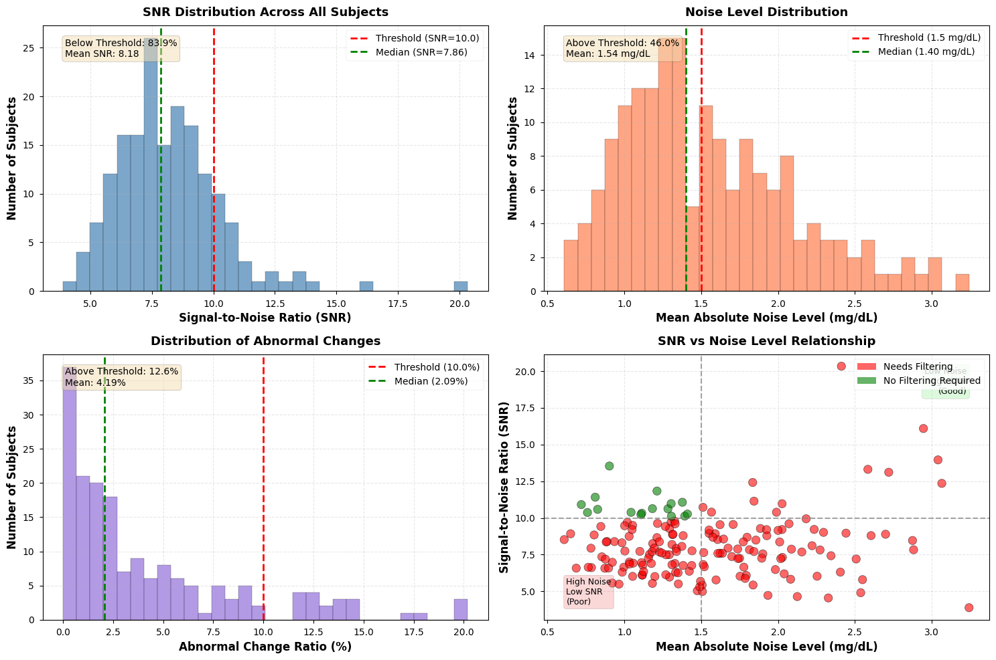
          - (1)SNR distribution (2)noise level distribution (3)anomaly change ratio distribution (4)SNR vs noise level scatter plot.
According to Figure 3.1, 158 (90.8%) of the 174 subjects met at least one filtering condition. This proportion is very high, indicating that there is a common noise problem in the original CGM data, and it is necessary and reasonable to carry out unified filter preprocessing for all data.
From the analysis of specific causes, the subjects with low SNR (<10) accounted for 83.9%, which is the main source of filtering demand; the subjects with excessive abnormal spike rate (>10%) accounted for 12.6%; and the subjects with excessive average absolute change (>1.5 mg/dL) accounted for 45.9%. These results are basically consistent with the CGM noise characteristics showed in the literature^{[26][35]}, which verifies the ability of the noise evaluation method.

  - Filtering Theory
In order to effectively inhibit the noise component in CGM signals while retaining the real change characteristics of blood glucose to the greatest extent, we compare three digital filtering methods widely used in the field of biomedical signal processing: Kalman Filter, Savitzky-Golay Filter (S-G Filter) and Butterworth Filter. The following introduces the theoretical principles of each method and its applicability in CGM signal processing.
    - Kalman Filter
Kalman filter is an optimal recursive estimation algorithm based on the state space model, which was originally developed by Rudolf E. Kalman proposed it in 1960 and has been widely used in aerospace, robotic navigation and other fields ^{[36]}. In recent years, Kalman filter has been successfully introduced into real-time denoising processing of CGM signals^{[27][28]}. The key logic of Kalman filtering is in the optimal estimation of noisy signals through the fusion of system state prediction and observation values. It does not rely entirely on the mathematical modeling of the signal, nor does it rely entirely on observation data, but dynamically fuses the two, which is very suitable for blood glucose data with noise.
We employ the Constant Velocity Model to describe the dynamic changes in blood glucose levels. The state vector $x_{k}=[g_{k},v_{k}]^{T}$, where $g_{k}$ represents the actual blood glucose concentration and $v_{k}$ denotes the rate of change in blood glucose. The state transition equation is:
$$x_{k}=Fx_{k−1}+w_{k−1}$$
The state transition matrix:
$$F=\left[\begin{matrix}1 & Δt \\ 0 & 1\end{matrix}\right]$$
The observation equation is:
$$z_{k}=Hx_{k}+v_{k}=g_{k}+v_{k}$$
$H=[1,0]$ denotes the observation matrix, with $w_{k−1}$ and $v_{k}$ representing process noise and measurement noise respectively, both assumed to follow a zero-mean Gaussian distribution.
Kalman filtering achieves optimal state estimation through the following two recursive steps:
Prediction step:
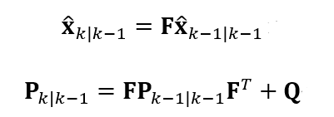
Update:
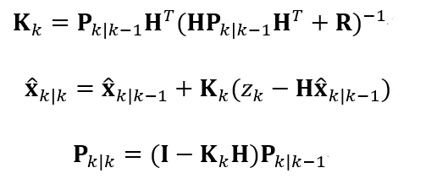
Where $Q$ denotes the process noise covariance matrix, $R$ represents the measurement noise covariance matrix, and $K_{k}$ is the Kalman gain.
In the implementation, the key parameters were set as follows: process noise variance $Q=0.5$, measurement noise variance $R=10.0(mg/dL)²$. A larger R value indicates lower trust in CGM measurements, leading the filter to rely more on state prediction and thus producing a stronger smoothing effect; whereas Q controls the system's response speed to blood glucose changes. These parameter settings were referenced from the empirical experience of Facchinetti et al. in CGM denoising research^{[27]}.

    - S-G Filter
Unlike the state-space method of Kalman filter, Savitzky-Golay filter adopts a more direct polynomial fitting idea. The filter was made by Abraham Savitzky and Marcel J.E. Golay proposed in 1964, which is a digital smooth filtering method based on local polynomial fitting^{[37]}. This method has a long history of application in spectroscopy, chromatography and other fields of analytical chemistry, and has also been widely used in biomedical signal processing in recent years^{[38]}.
The core idea of the S-G filter is to fit a low-order polynomial for the data point in the sliding window centered on the current point, and then use the center point value of the polynomial as the filter output.
Set the window length to $2m+1$ (an odd number) and the polynomial order to $p$. For the data points $\{y_{i−m},y_{i−m+1},...,y_{i},...,y_{i+m}\}$ within the window, fit the polynomial:
$$\hat{y}(t)=\sum_{k=0}^{p}{a_{k}}t^{k}$$
where $t∈\{−m,−m+1,...,0,...,m\}$. The filter output is $\hat{y}(0)=a_{0}$.
S-G filtering can be equivalently expressed as a convolution operation.
$${\hat{y}}_{i}=\sum_{j=−m}^{m}{c_{j}}⋅y_{i+j}$$
The coefficient of the convolution kernel $\{c_{j}\}$ depends only on the size of the window and the polynomial order, which can be calculated in advance. This makes S-G filtering very efficient in implementation, which is especially suitable for real-time processing applications.
The parameters used in this study are: window length 2m+1=15, polynomial order p=3. At a 5-minute sampling interval, the 15-minute window corresponds to a time span of 75 minutes, which can effectively smooth short-term noise fluctuations while retaining important physiological characteristics such as postprandial blood glucose peaks. The third-order polynomial can better fit the smooth change curve of blood glucose and avoid the oscillation caused by overfitting^{[39]}.
The main advantage of the S-G filter is that it can keep the shape of the signal's peak. In comparison with simple moving average filter, S-G filtering can preserve more the extreme points (peaks and valleys) and high-order derivative information of the signal while reducing noise^{[40]}. This property is significant not only for clinical evaluation, where the accurate recognition of postprandial peaks is an important quality standard, but also for model prediction: the local extrema and the rate of change are the main features which the sequence models learn about the glucose dynamics, and any distortion in these features will definitely lower the prediction accuracy.

    - Butterworth Filter
In addition to the above two methods, we consider the classical frequency domain filtering technique. The Butterworth filter, invented by Stephen Butterworth in 1930^{[41]}, is a well-known Infinite Impulse Response (IIR) filter. It has the maximum flat amplitude and frequency characteristics in the passband and is one of the most commonly used low-pass filters in digital signal processing ^{[42]}.
The amplitude-frequency response of Butterworth low-pass filter is:
$$|H(jω)|^{2}=\frac{1}{1+(ω/ω_{c})^{2n}}$$
Here, $ω_{c}$ stands for the cut-off frequency and n indicates the filter order. A distinctive feature of Butterworth filters is their nearly constant amplitude-frequency response in the passband ($ω<ω_{c}$), without any ripples, thus the name "maximum flatness" filter.
The key parameters are set as follows: filter order $n=2$, normalized cutoff frequency $W_{n}=0.15$. With a 5-minute sampling interval, the Nyquist frequency is $f_{Nyq}=1/(2×5)=0.1cycles/min$, so the actual cutoff frequency is:
$$f_{c}=W_{n}×f_{Nyq}=0.15×0.1=0.015 cycles/min$$
The appropriate cut-off time is about $T_{c}=1/f_{c}≈66$ minutes. It indicates that high-frequency noise with intervals shorter than 66 minutes will be greatly reduced, whereas physiological changes like postprandial blood glucose variations (which usually have intervals longer than 1 hour) will be preserved.

  - Evaluation of Filtering Effect
To objectively evaluate the performance of three filtering methods, we developed a multi-faceted evaluation index system:
(1) Noise reduction ability-calculated by the filtered sequence's first-order difference standard deviation ($σ_{filtered}$), which indicates the residual noise level.
Noise Reduction Rate (NRR):
$$NRR=\frac{σ_{raw}−σ_{filtered}}{σ_{raw}}×100\%$$
（2）signal fidelity
Root Mean Square Error(RMSE): The discrepancy between the experimental sequence and the true standard of blood glucose. As there is no exact standard for the actual blood glucose measurement, a longer moving average period has been adopted as an approximate standard.
（3）time response
Peak Preservation Ratio(PPR): The ratio of the largest value of the treated signal to that of the original one, indicating the ability of the method to retain the largest values.
Phase Lag: The time interval between the processed signal and the original one. It is determined by cross-correlation.
            - comparison of filtering results.
Index | Kalman | S-G | Butterworth
NRR | -6.6±3.7 | 14.0±6.2 | 18.8±7.1
SNR | 7.9±2.0 | 9.4±2.2 | 9.9±2.3
PPR | 1.009±0.005 | 0.987±0.007 | 0.972±0.008
Phase Lag | 1.7±2.4 | 0 | 0

The Butterworth filter has the highest noise suppression rate (18.8%) and signal-to-noise ratio (9.9) in the statistical results, showing its superiority as a classical low-pass filter in frequency domain denoising. The S-G filter is close behind (NRR 14.0%, SNR 9.4). However, the Kalman filter shows a negative noise suppression rate under such circumstances, which may be associated with its sensitivity to high-frequency changes. Although some dynamic information is maintained, it cannot effectively reduce the first-order difference fluctuations.
The peak retention ratio (PPR) of the S-G filter is 0.987, which is the closest to the ideal value of 1.0, and the standard deviation is very small (0.007), indicating high stability and accuracy in preserving the true blood glucose peak. Although the Butterworth filter is also effective (0.972), it is slightly lower than the S-G filter (the higher the value approaches 1, the better, and the Butterworth filter attenuates some peaks). The PPR of the Kalman filter is slightly greater than 1 (1.009), suggesting a possible slight overshoot. Considering the importance of detecting extreme values such as hypoglycemia and hyperglycemia in blood glucose prediction, the accurate preservation of the S-G filter is clinically significant.
The S-G filter and the Butterworth filter (with bidirectional or symmetric window implementation) have zero minute phase delay, maintaining the exact time relationship with the original data. The Kalman filter has an average phase delay of 1.7 minutes, which might cause a slight delay in systems requiring high real-time performance.
As the filtered data will be used directly as input for the model, the main issue is not which filter removes the most noise, but the balance between noise reduction and the preservation of the local signal shape. The Butterworth filter has the highest NRR (18.8%), but its PPR is only 0.972. Therefore, approximately 3% of each postprandial peak and hypoglycemic trough will be eliminated. For a sequential model, these peaks and rapid changes are important for learning glucose trends. Their removal reduces the input signal and negatively affects the prediction. The Kalman filter has more serious problems including a negative NRR and a 1.7-minute phase lag, thus it is inappropriate for this situation.
The S-G filter sits in the middle, and that turns out to be the best place. Its NRR of 14.0% is enough to bring the noise down to a safe level, below 2 mg/dL per 5 minutes for most subjects. At the same time, its PPR of 0.987 keeps the peaks and valleys almost unchanged. So the model gets a clean signal without losing the dynamic details it needs. On top of that, S-G filtering has zero phase delay and runs fast. Sadıkoğlu et al.^{[39]} reached a similar conclusion in their CGM filtering study. Our own results in Chapter 4 also back this up: models trained on S-G filtered data predict much better than those trained on raw data.

  - Conclusion
This chapter systematically studies the noise characteristics of CGM signals and the preprocessing method of digital filtering. The main work and conclusions are as follows:
1. Analysis of noise sources: From the perspective of physical mechanism, the four major sources of CGM signal noise are systematically analyzed - the inherent noise of electrochemical sensors, physiological delay error, motion artifacts and pressure interference, and electronic system noise, which provides a theoretical basis for the selection of subsequent filtering methods.
2. Noise quantitative evaluation: A multi-indicator evaluation system based on the first-order difference standard deviation, signal-to-noise ratio (SNR) and the abnormal spike rate was established, and the CGM data of 174 subjects were systematically evaluated. The results show that 90.8% of the subject data has significant noise problems, which confirms the necessity of filtering preprocessing.
3. Comparison of filtering methods: We implement and compare three methods, Kalman filtering, Savitzky-Golay filtering and Butterworth low-pass filtering. There is a clear trade-off between noise removal and signal fidelity. Butterworth removes the most noise but also flattens the peaks. Kalman filtering does not suppress noise well and adds phase lag. S-G filtering removes a moderate amount of noise while keeping the local peaks and valleys nearly intact.
4. Method selection: The S-G filter gives the best balance between denoising and keeping the local features — peaks, troughs and change rates. So we consider this as the required denoising method to be adopted.
The data set after filtering provides high-quality input for the prediction model training in the subsequent chapters, which significantly reduces the interference of noise on the model learning process. It is an indispensable key link in the realization of the whole blood glucose prediction system project.

- Model Building and Comparison
  - Experiment and Evaluation
All experiments in this chapter share the same prediction task, the same input format and the same evaluation metrics. The input data comes from the S-G filtered dataset produced in Chapter 3. No model receives any extra information such as meal logs, insulin doses or exercise records.
We define the prediction task as a supervised time series regression problem. Let $t$ denote the current time step, and $\{g_{t−k}\}_{k=0}^{N_{past}−1}$ represent the CGM readings over the past $N_{past}$ time steps. In addition to the glucose sequence, the model takes two static features — the subject's age and BMI — denoted as the vector $s$. The full input is:
$$X_{t}=[g_{t−N_{past}+1},…,g_{t},s]$$
The target output is the glucose value $g_{t+H}$ at $H$ steps into the future. With a sampling interval of $Δt=5$ minutes, we set $N_{past}=12$ (60 minutes of history) and $H=6$ (30-minute prediction horizon). The 30-minute window gives patients enough time to act on a predicted high or low through food intake or insulin injection^{[45]}. The 60-minute look-back captures both recent trends and short-term history, which is a common setup in CGM prediction studies^{[46]}.
We use a combination of statistical error metrics and clinical accuracy metrics to evaluate each model.
Statistical error indicators include:
Mean Absolute Error (MAE): represents the absolute magnitude of the difference between the predicted value and the actual value. It is not as sensitive to abnormal values as RMSE, and can better reflect the general prediction accuracy.
$$MAE=\frac{1}{N}\sum_{i=1}^{N}{|}y_{i}−{\hat{y}}_{i}|$$
Root Mean Square Error (RMSE): Higher punishment for large errors reflects the stability of model prediction. In blood glucose prediction, it is especially important to avoid great prediction bias (such as unpredicted severe hypoglycemia), so RMSE is a key indicator.
$$RMSE=\sqrt{\frac{1}{N}\sum_{i=1}^{N}{(y_{i}}−{\hat{y}}_{i})^{2}}$$
Mean Absolute Percentage Error (MAPE): Eliminates the influence of the quantitative framework and facilitates cross-data set comparison. However, numerical instability may occur when the hypoglycemia value (the denominator is small).
$$MAPE=\frac{1}{N}\sum_{i=1}^{N}{\left|\frac{y_{i}−{\hat{y}}_{i}}{y_{i}}\right|}×100\%$$
Root Mean Square Percentage Error (RMSPE): combines the characteristics of RMSE and percentage error.
$$RMSPE=\sqrt{\frac{1}{N}{\sum_{i=1}^{N}{\left(\frac{y_{i}−{\hat{y}}_{i}}{y_{i}}\right)}}^{2}}×100\%$$
Combining the above statistical indicators, we can comprehensively evaluate the prediction accuracy and stability of the model and eliminate the bias that may be caused by a single indicator.
Clinical accuracy index: Clarke Error Grid Analysis (CEGA):
Statistical indicators only reflect the numerical proximity, and cannot fully reflect the impact of the forecast results on clinical decision-making. For this reason, we introduce Clarke error grid analysis^{[50]} as the core clinical evaluation tool. The Clarke index is a widely recognized blood glucose prediction evaluation standard in clinical practice. CEGA divides the scatter chart of the predicted value (Y axis) and the reference real value (X axis) into five zones: A, B, C, D and E:
Zone A (Clinically Accurate): Accurate prediction within the deviation of 20% or within the range of hypoglycemia. The prediction results of this region are clinically accurate.
Zone B (Clinically Acceptable): The deviation exceeds 20%, but it will not lead to improper treatment decisions.
Zone C (Overcorrection): It may lead to unnecessary corrective treatment (such as falsely reporting hypoglycemia when blood glucose is normal), which is not directly dangerous but affects the quality of life.
Zone D (Failure to Detect): Failure to detect dangerous hyperglycemia or hypoglycemia events (such as missing hypoglycemia) may lead to serious medical consequences.
Zone E (Erroneous Treatment): The predicted value is completely opposite to the real value (such as predicting hypoglycemia as hyperglycemia), which will induce completely wrong treatment operations, which is extremely dangerous.
For an excellent blood glucose prediction model, most of its prediction points (>95%) should fall in Zone A and Region B, and try to avoid falling into Zone D and Zone E. Therefore, we can quantify the clinical applicability of the model by calculating the point ratio of each region.
In order to strictly evaluate the temporal generalization ability of the model, we adopt the "past-future" division strategy (Past-Future Split) instead of the traditional random division. For each subject:
1. Test Set: Choose the last 6 hours (72 time points) of each subject's monitoring record as the test data. This simulates the prediction scenario of the model for the blood glucose value in the next 6 hours in actual use.
2. Training Set: All historical data except the test set and the necessary verification set.
3. Hold-out Set: Among all subjects, select the data of 10 subjects as the hold-out set, do not participate in the training and verification of the model, and only use the independent verification of the final model to ensure that the model can maintain good performance on individuals that have never been seen. Also prepare for later transfer learning.

  - Baseline and Machine Learning Models
We first implemented several traditional models as baselines: a statistical time series model (ARIMA), a linear regression model, and three nonlinear machine learning methods (KNN, Random Forest, XGBoost). All of them take the same input described in Section 4.1.
$$X_{t}=[g_{t−11},g_{t−10},…,g_{t},Age,BMI]∈ℝ^{14}$$
1. ARIMA
The Autoregressive Integrated Moving Average (ARIMA) model is a classic statistical method for time series forecasting. The general form of the $ARIMA(p,d,q)$ model is:
$$ϕ(B)(1−B)^{d}g_{t}=θ(B)ε_{t}$$
$B$ denotes the lag operator (defined as $Bg_{t}=g_{t−1}$), where $ϕ(B)=1−ϕ_{1}B−⋯−ϕ_{p}B^{p}$ is the autoregressive polynomial, and the moving average polynomial is $θ(B)=1+θ_{1}B+⋯+θ_{q}B^{q}$. $d$ represents the order of the difference.
In the process of determining the model order, the Augmented Dickey-Fuller (ADF) test is initially utilized to examine the stationarity of the blood glucose series.Subsequently, the optimal parameters $(p,d,q)$ are determined based on the Autocorrelation Function (ACF) and Partial Autocorrelation Function (PACF) plots. Due to the non-stationary nature of the blood glucose series, a first-order difference ($d=1$) is typically required to eliminate trends.
Although ARIMA is very interpretable, it can only capture linear timing dependencies and is difficult to integrate external static characteristics (Age, BMI), which has limitations in application.
Predicted results on the hold-out set subject 2 and subject 306:
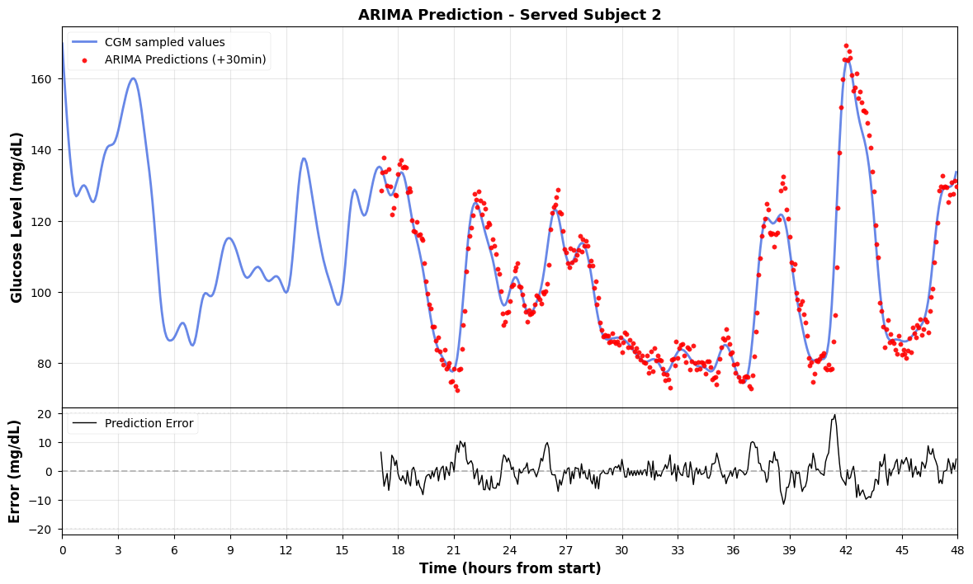
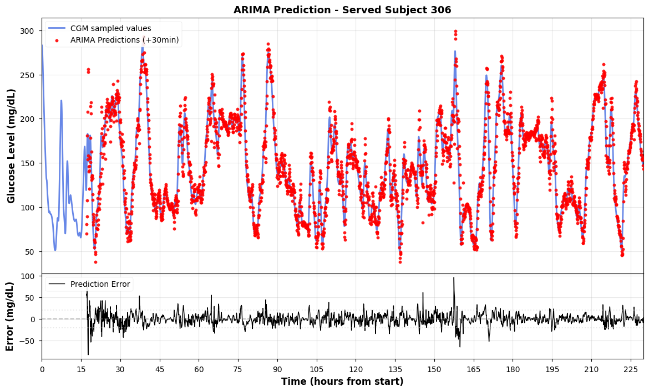
          - The ARIMA prediction on Hold-out set(subject 2 and 306).
2. Linear Regression
By constructing a lag feature matrix (Lag Features), time series prediction is transformed into a standard supervised regression problem. The linear regression model solves the weight vector through the Ordinary Least Squares (OLS):
$${\hat{g}}_{t+H}=w_{0}+\sum_{k=0}^{11}{w_{k+1}}⋅g_{t−k}+w_{13}⋅Age+w_{14}⋅BMI$$
Where $H=6$ indicates the prediction time span (30 minutes). The OLS loss function is:
$$ℒ={\sum_{i=1}^{N}{\left(g_{i}^{(true)}−{\hat{g}}_{i}\right)}}^{2}$$
Before training, all input features are standardized by Z-score to eliminate the difference in the scale. The model has a simple structure and high computing efficiency. It can give a reasonable trend estimate for a stable blood glucose period, but it performs poorly in nonlinear rapid change periods (such as post-meal rise and post-exercise).
Predicted results on the hold-out set subject 2 and subject 306:
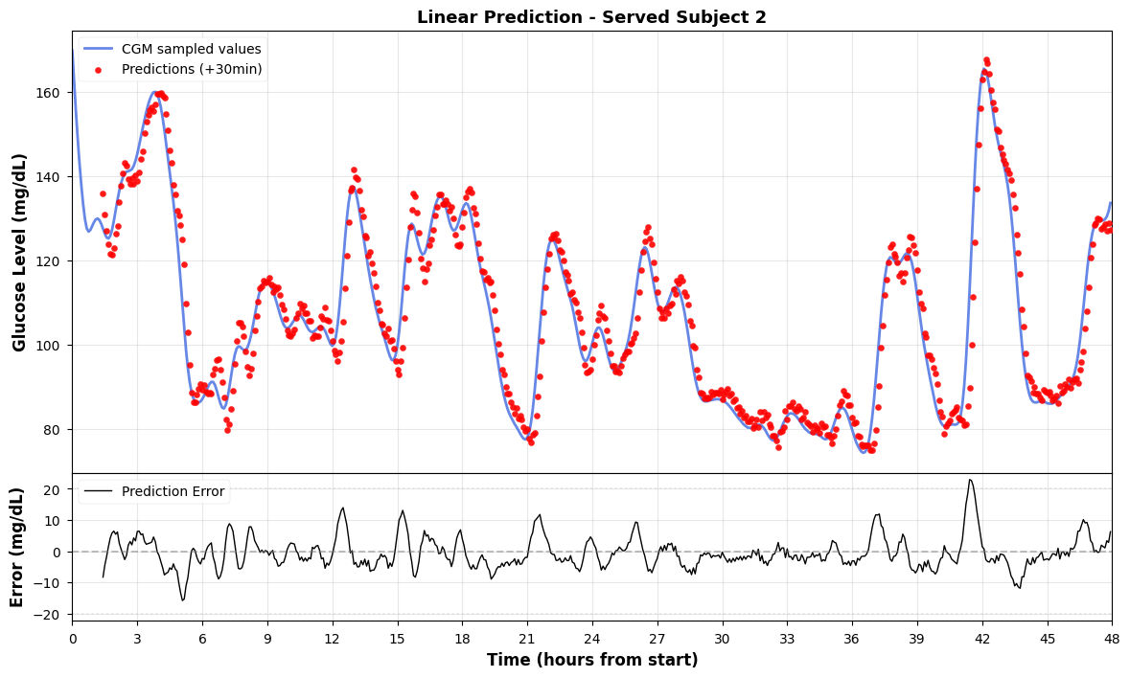
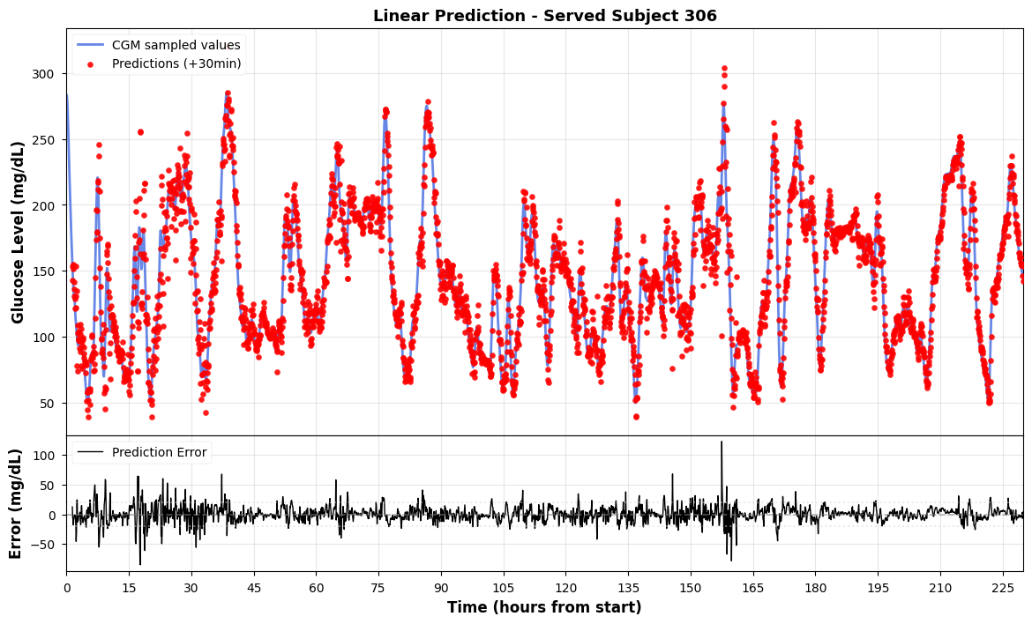
          - The linear prediction on Hold-out set(subject 2 and 306).
The above statistical model mainly relies on linear assumptions, and it is difficult to capture the complex nonlinear pattern of blood glucose dynamics. To address these limitations, we have further introduced three nonlinear machine learning methods, KNN, Random Forest and XGBoost.
3. KNN
K-Nearest Neighbors is an instance-based non-parametric learning method^{[24]}. The core idea is to find the K historical samples most similar to the sample to be predicted in the feature space, and use the weighted average of its target value as the prediction result:
$${\hat{g}}_{t+H}=\frac{1}{K}\sum_{i∈N_{K}(X_{t})}{g_{i}^{(target)}}$$
$N_{K}(X_{t})$ denotes the set of $K$ nearest neighbors of input $X_{t}$ in the training set. We set the K-Nearest Neighbors (KNN) parameter to $K=5$.Adopt the equal weight average strategy. The advantage of KNN lies in its non-parametric characteristics - no explicit training process is required, and the model expressive power increases with the amount of data. However, due to the need to calculate the distance on the entire training set, the inference speed is slow on large-scale data sets. In addition, KNN is sensitive to feature scaling, so all features are standardized by Z-score before training.
Predicted results on the hold-out set subject 2 and subject 306:
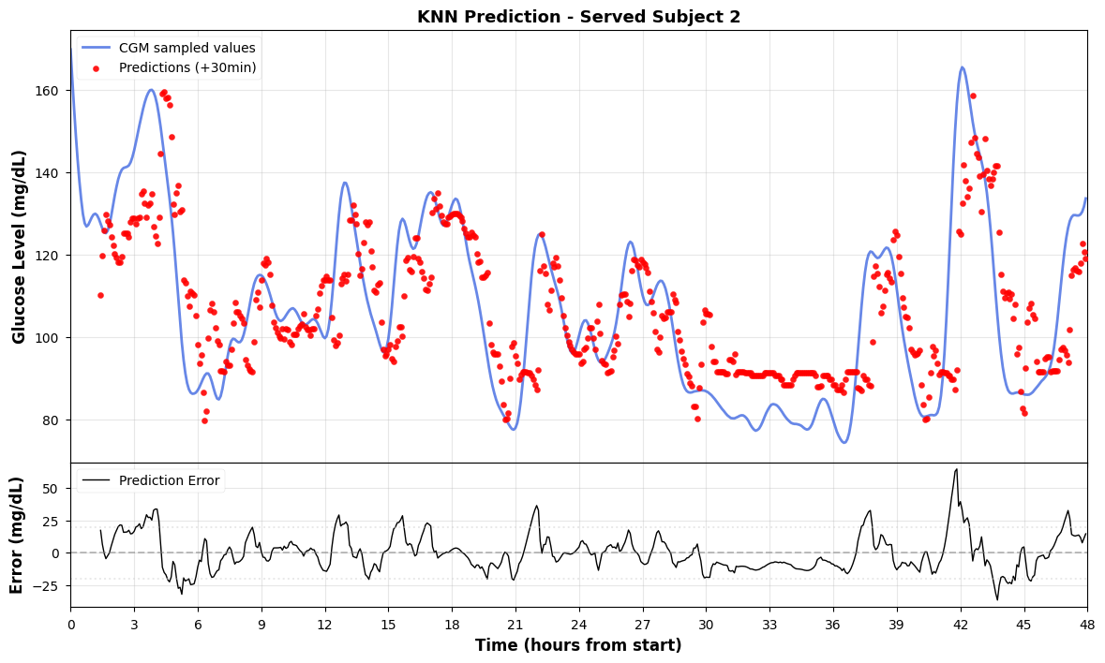
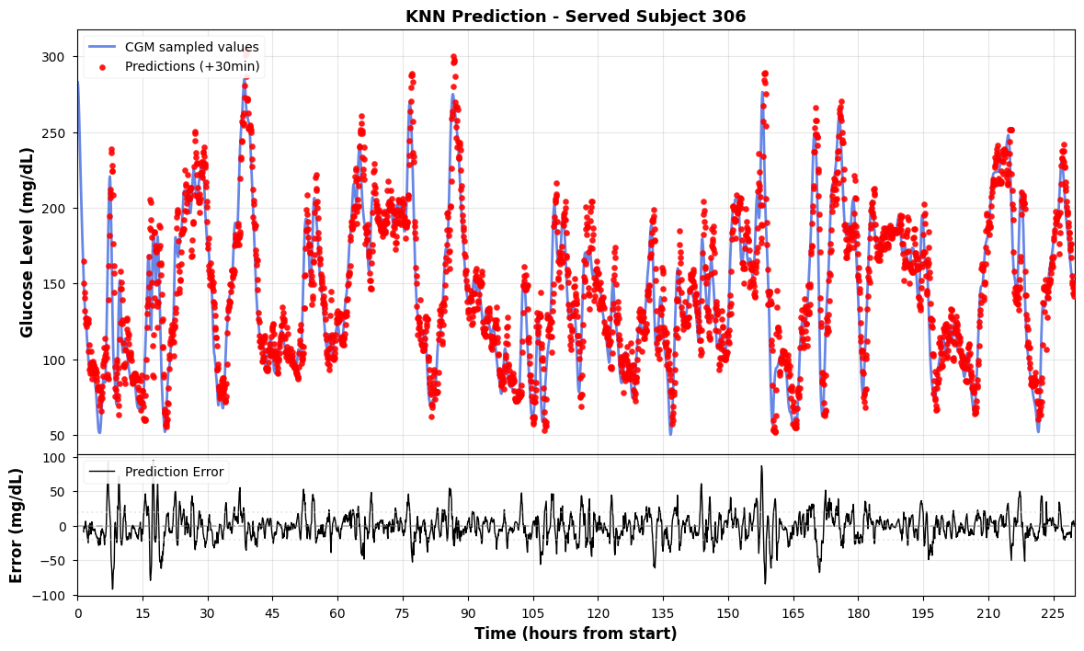
          - The KNN prediction on Hold-out set(subject 2 and 306).
4. Random Forest
Random forest uses the Bagging strategy to reduce variance by building multiple independent decision trees, averaging their outcomes.:^{[8]}
$${\hat{g}}_{t+H}=\frac{1}{T}\sum_{i=1}^{T}{h_{i}}(X_{t})$$
Here, $T$denotes the number of decision trees, and $h_{i}$ represents the prediction function of the $i$-th decision tree.
During training, every individual tree employs Bootstrap Sampling and selects random subsets of features to promote diversity among the base learners. We set the ensemble size to 100 decision trees, and do not limit the maximum depth of a single tree to fully fit the training data. In addition, the model additionally introduces Time of Day (integers coded with 0-23), so that the tree model can learn the circadian rhythm characteristics of blood glucose.
Predicted results on the hold-out set subject 2 and subject 306:
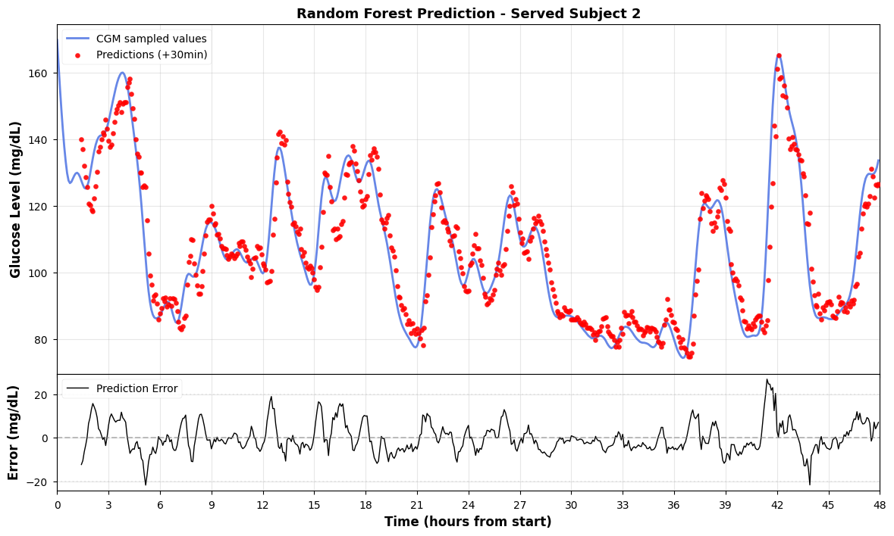
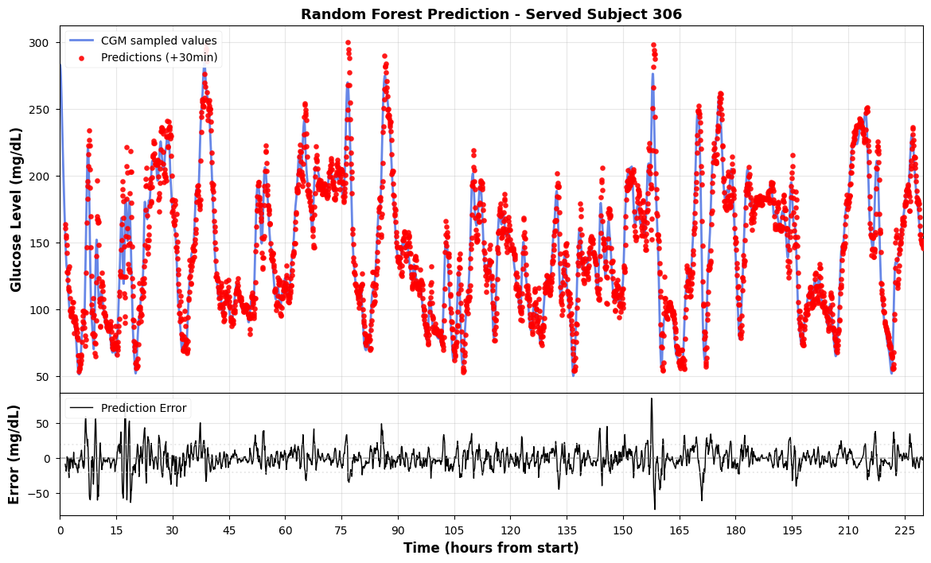
          - The random forest prediction on hold-out set(subject 2 and 306).
5. XGBoost
XGBoost, proposed by Chen and Guestrin, short for eXtreme Gradient Boosting, is an ensemble learning technique that uses the Gradient Boosting framework.^{[45]}. It iteratively adds weak learners to fit the residuals of the previous round. Its objective function is:
$$ℒ^{(t)}=\sum_{i=1}^{N}{l}(g_{i},{\hat{g}}_{i}^{(t−1)}+f_{t}(X_{i}))+Ω(f_{t})$$
$l$ denotes the loss function (using squared loss), and $Ω(f_{t})=γT+\frac{1}{2}λ‖w‖^{2}$ functions as the regularization component to manage model complexity and avoid overfitting.. We set the boosting rounds to 100, the learning rate $η=0.1$, and the maximum depth of a single tree to 5. Similar to random forests, XGBoost incorporates temporal features. With its robust nonlinear fitting capability and built-in regularization mechanism, XGBoost typically outperforms baseline models and is widely used as a key benchmark for evaluating the effectiveness of deep learning models.
Predicted results on the hold-out set subject 2 and subject 306:
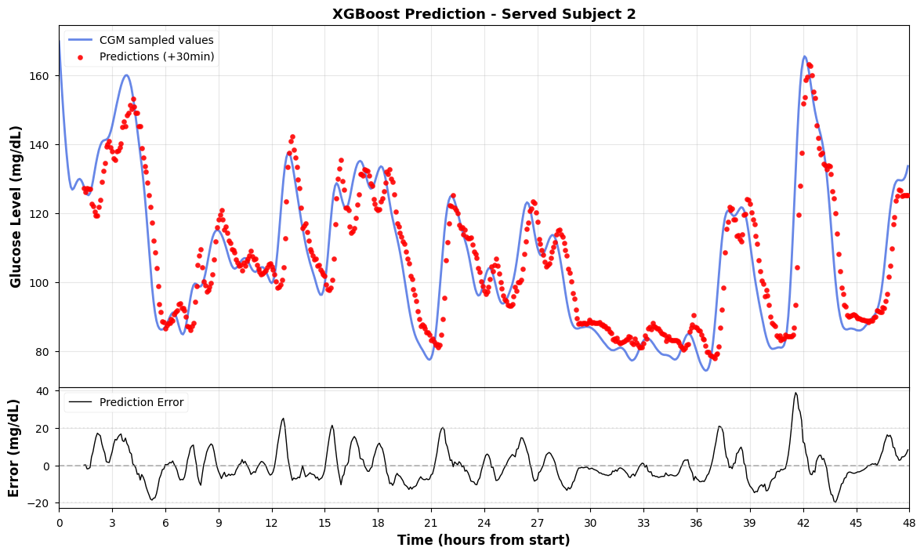
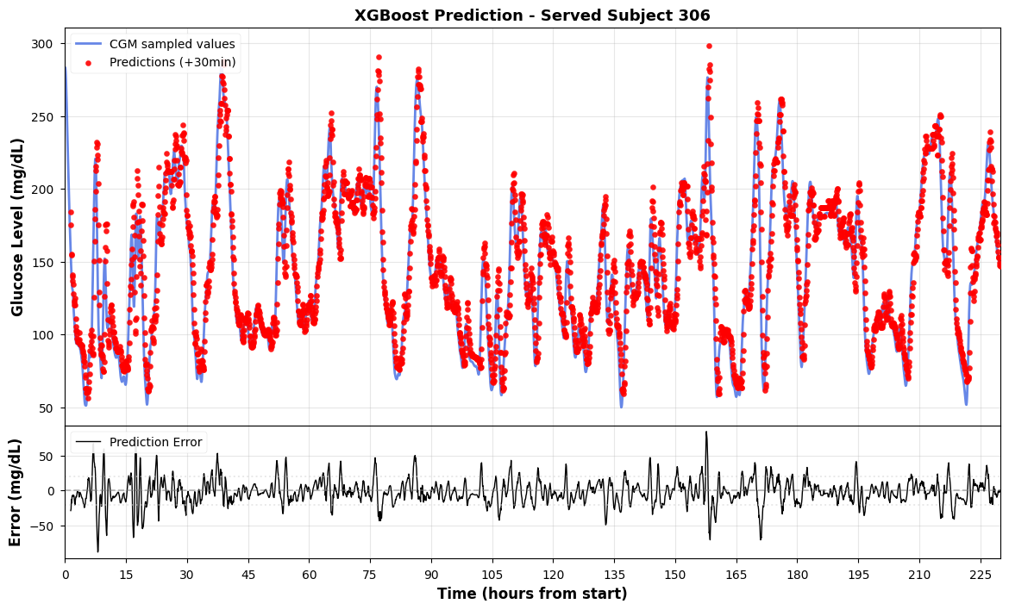
          - The XGBoost prediction on hold-out set(subject 2 and 306).

  - Deep Learning Models
For the temporal dependencies and nonlinear characteristics of blood glucose data, we have built four deep neural network architectures: one-dimensional convolutional neural network (CNN), recurrent neural network (RNN), long short-term memory(LSTM) and transformer. In order to ensure the fairness of comparative experiments, all deep learning models adopt a unified training strategy: the batch size is set to 64, the Adam optimizer [50] is used to update the parameters with a learning rate $η=0.001$, the loss function is selected as Mean Squared Error (MSE), and the training process lasts 50 cycles (epochs). The input data is standardized and processed by Z-score before training.
1.CNN
Convolutional neural networks have made breakthroughs in the field of image processing, while one-dimensional Convolution is equally efficient in time series feature extraction^{[47]}. One-dimensional convolution operation can be formalized as:
$$y[n]=\sum_{k=0}^{K−1}{w}[k]⋅x[n−k]$$
Among them, $K$ is the size of the convolution kernel, and $w$ is the weight of the convolution kernel that can be learned.
The CNN architecture we designed adopts a two-layer cascade convolution structure. The first convolutional layer is configured with 16 convolution kernels of size 3, and zero filling (padding=1) is used to maintain the sequence length. After the maximum pooling of the ReLU activation function and step length of 2, the sequence length is halved. The second convolution layer is equipped with 32 convolution kernels, and the structure is the same as that of the first layer. After two pooling operations, the feature map is flattened and concatenated with static features (Age, BMI), and finally the predicted value is output through a two-layer fully connected network (the hidden layer dimension is 64). The advantage of CNN is its translation invariance and efficient parallel computing ability, which can quickly capture short-term local fluctuation patterns.
Predicted results on the hold-out set subject 2 and subject 306:
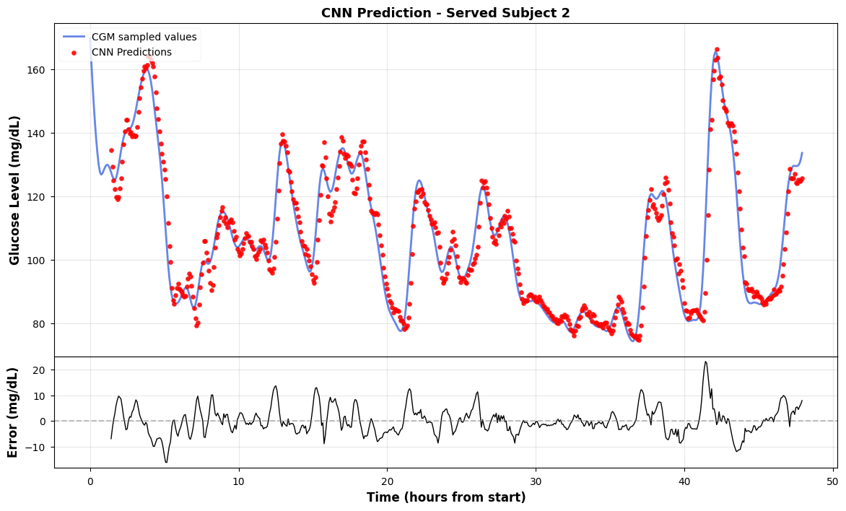
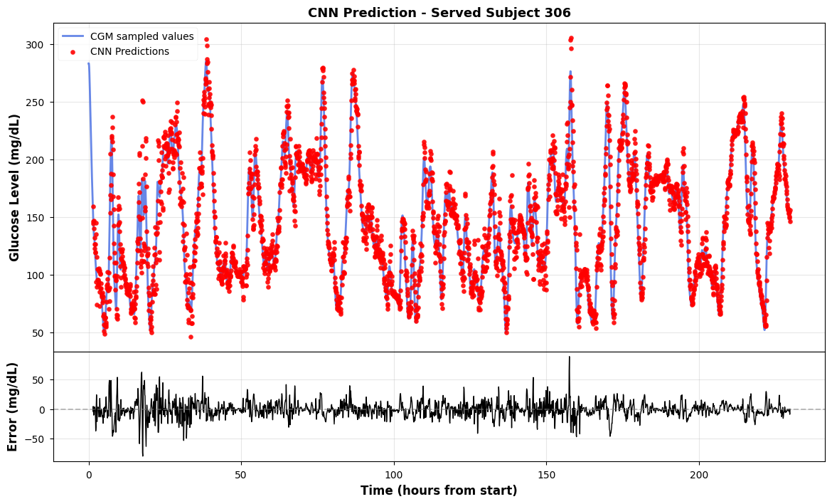
          - The CNN prediction on served set(subject 2 and 306).
2. RNN
Recurrent Neural Networks (RNNs) model temporal dependencies in sequential data through recurrent connections^{[25]}. The core recursive formula is:
$$h_{t}=\tanh{(}W_{xh}x_{t}+W_{hh}h_{t−1}+b_{h})$$
$h_{t}∈ℝ^{d_{h}}$ denotes the hidden state at time $t$, with $W_{xh}∈ℝ^{d_{h}×d_{x}}$ and $W_{hh}∈ℝ^{d_{h}×d_{h}}$ being the weight matrices for input-to-hidden and hidden-to-hidden respectively. And the dimensions $d_{h}$ and $d_{x}$ represent the hidden layer and input dimensions.
We adopt a single-layer RNN structure. The hidden layer dimension $d_{h}=32$ model takes the hidden state $h_{T}$ of the last time step as the global representation of the sequence, and outputs the predicted value through the two-layer fully connected network (the hidden layer dimension is 64) after concatenated it with static features. However, there is a vanishing gradient problem in the basic RNN, and it is difficult to effectively capture long-term dependencies.
Predicted results on the hold-out set subject 2 and subject 306:
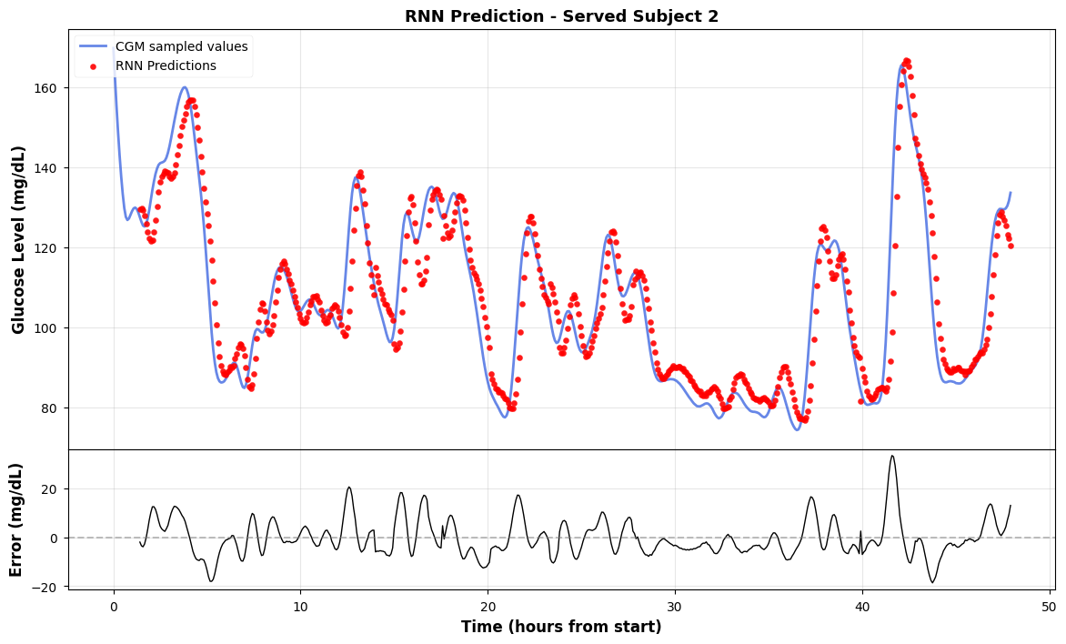
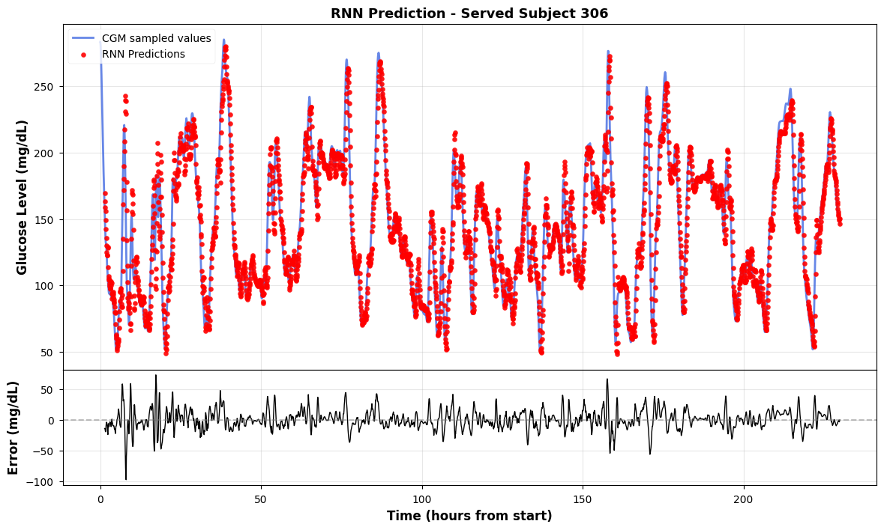
          - The RNN prediction on hold-out set(subject 2 and 306).

3. LSTM
To overcome the long-range dependence of RNN, Hochreiter and Schmidhuber proposed Long Short-Term Memory (LSTM)^{[46]}. LSTM realizes fine control of information flow by introducing a gate control mechanism. Its core computing unit contains three gates and one cell state:
Forget Gate controls the retention ratio of historical information:
$$f_{t}=σ(W_{f}⋅[h_{t−1},x_{t}]+b_{f})$$
The Input Gate controls the amount of new information written:
$$i_{t}=σ(W_{i}⋅[h_{t−1},x_{t}]+b_{i})$$
$${\tilde{C}}_{t}=\tanh{(}W_{C}⋅[h_{t−1},x_{t}]+b_{C})$$
Cell state is updated through gated weighting:
$$C_{t}=f_{t}⊙C_{t−1}+i_{t}⊙{\tilde{C}}_{t}$$
The output gate controls the output of the hidden state:
$$o_{t}=σ(W_{o}⋅[h_{t−1},x_{t}]+b_{o})$$
$$h_{t}=o_{t}⊙\tanh{(}C_{t})$$
$σ(⋅)$denotes the Sigmoid activation function, and $⊙$represents the Hadamard product.
We adopt a single-layer LSTM structure, and the hidden layer dimension is set to 32. The model architecture is: LSTM layer extracts temporal features → takes the hidden state of the last time step → concatenated with static features → two layers of fully connected network output prediction. LSTM can effectively remember the trend of long-term blood glucose evolution, which is one of the mainstream methods in the field of blood glucose prediction at present^{[46][48]}.
Predicted results on the hold-out set subject 2 and subject 306:
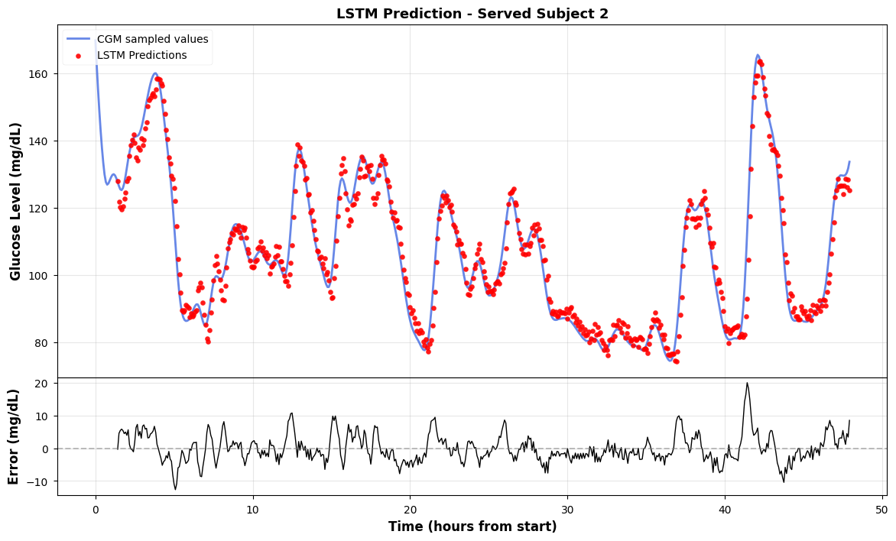
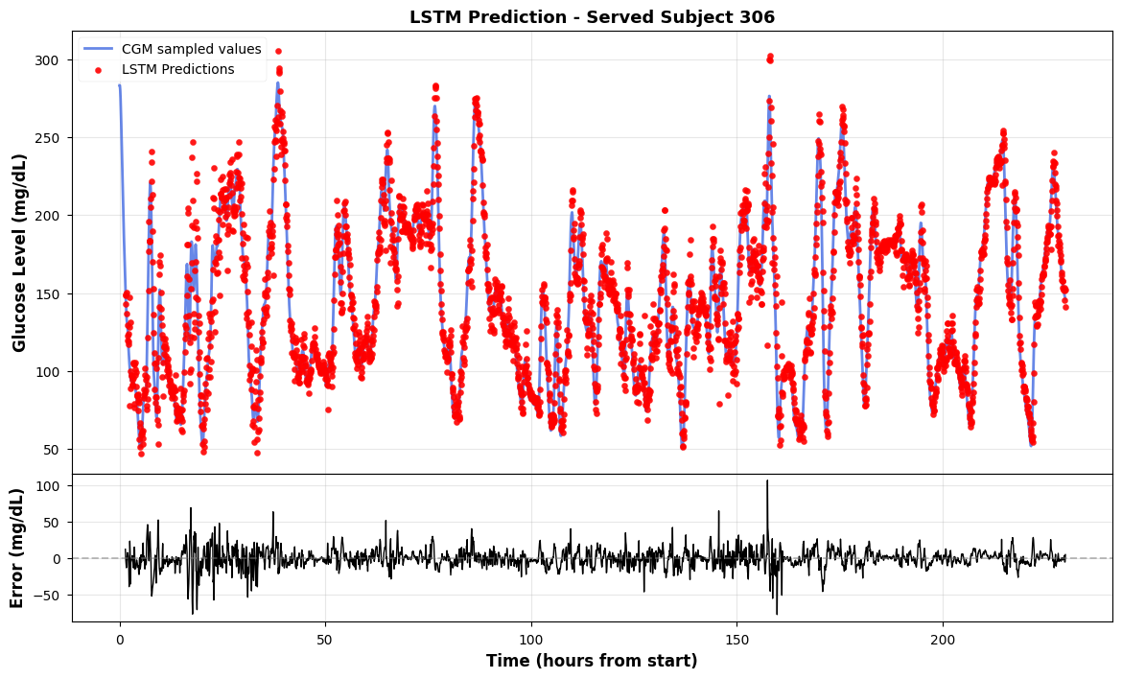
          - The LSTM prediction on hold-out set(subject 2 and 306).
4.Transformer
Considering the serial calculation limitations and long-distance information attenuation of RNN models, we introduce the Transformer model based on Self-Attention^{[49]}. Transformer abandons the cyclic structure and relies entirely on the dependency between any two positions in the attention mechanism modeling sequence, It achieves long-range dependency modeling capability of $O(1)$.
Since Transformer itself does not have the ability to perceive sequence order, it is necessary to explicitly inject time position information through Positional Encoding. We adopt the sinusoidal positional encoding scheme:
$$PE_{(pos,2i)}=\sin\left(\frac{pos}{10000^{2i/d_{model}}}\right)$$
$$PE_{(pos,2i+1)}=\cos\left(\frac{pos}{10000^{2i/d_{model}}}\right)$$
$pos$ denotes the position index in the sequence, $d_{model}$ represents the model's embedding dimension, and $i$ is the dimension index.
The core computation of Transformer's self-attention mechanism is as follows:
$$Attention(Q,K,V)=softmax\left(\frac{QK^{T}}{\sqrt{d_{k}}}\right)V$$
$Q∈ℝ^{n×d_{k}}$、$K∈ℝ^{n×d_{k}}$, and $V∈ℝ^{n×d_{v}}$ stand for the Query, Key, and Value matrices respectively. $\sqrt{d_{k}}$ denotes the scaling factor, while $n$ indicates the sequence length. This factor prevents the softmax gradient from vanishing due to excessively large dot product values.
To enable the model to focus on feature representations across different subspace, Transformer employs a multi-head attention mechanism:
$$MultiHead(Q,K,V)=Concat({head}_{1},…,{head}_{h})W^{O}$$
Each attention head independently computes ${head}_{i}=Attention(QW_{i}^{Q},KW_{i}^{K},VW_{i}^{V})$, where $W_{i}^{Q},W_{i}^{K}$ and $W_{i}^{V}$ are learnable projection matrices, and ℎ denotes the number of attention heads.
We adopt a simplified architecture that contains Encoder-only. The model configuration is as follows: the embedding dimension $d_{model}=64$, the number of encoder layers is 2, the number of attention heads $h=4$, the hidden dimension of the feedforward network is 128, and the Dropout ratio is 0.1. So the model architecture: the linear embedding layer maps the input to the $d_{model}$dimension space → superimposed position coding → two-layer Transformer encoder → take the hidden representation of the last time step → concatenated with static features → two-layer fully connected network output prediction.
The advantages of Transformer are: (1) the self-attention mechanism realizes global dependence modeling, which is not limited by sequence length; (2) fully parallel computing, and the training efficiency is significantly better than that of the RNN model; (3) the attention weight is explainable and can be used to analyze the historical time point of the model. In recent years, Transformer and its variants have shown strong modeling potential in the field of blood glucose prediction^{[23]}.
Predicted results on the hold-out set subject 2 and subject 306:
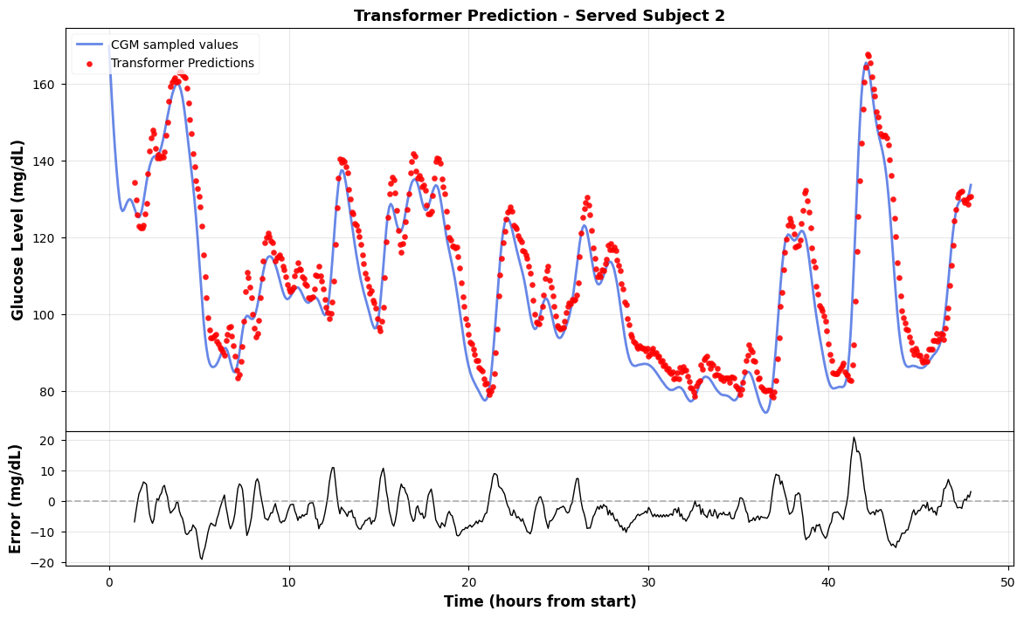
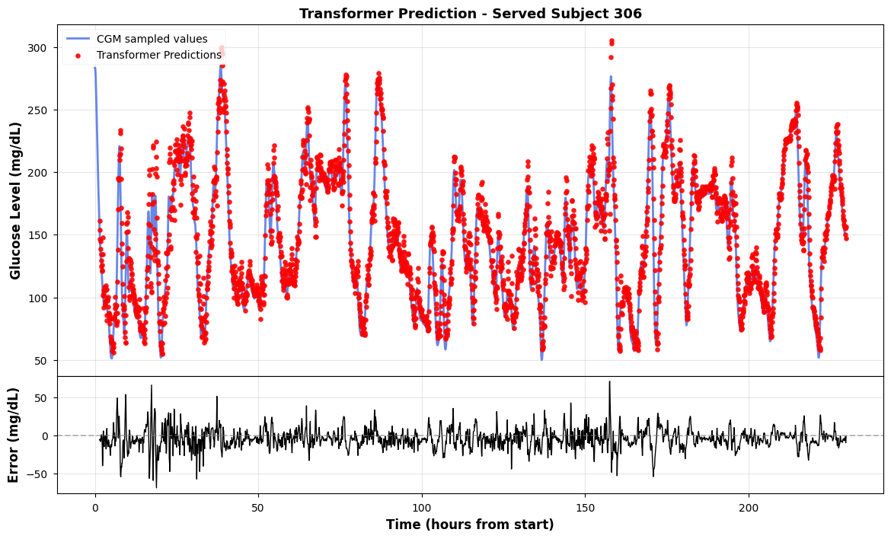
          - The transformer prediction on hold-out set(subject 2 and 306).
  - Results Analysis
Table 4-1 summarizes the performance of each model on the test set (with a prediction time span of H=30 minutes).
            - comparison of different models’ prediction.
 | MAE  (mg/dL) | RMSE  (mg/dL) | MAPE(%) | RMSPE(%) | CEG(A+B)(%)
ARIMA | 5.7965 | 8.9621 | 4.4696 | 6.9105 | 99.8±0.2
Linear | 5.2298 | 8.5292 | 4.3827 | 6.8298 | 99.8±0.2
KNN | 11.3252 | 15.6312 | 9.9544 | 13.6284 | 93.4±6.3
Random Forest | 6.6398 | 10.2797 | 5.5753 | 8.2342 | 99.2±0.6
XGBoost | 8.2151 | 12.3310 | 6.9834 | 10.1447 | 98.1±1.6
CNN | 5.4077 | 8.6982 | 4.5519 | 7.0817 | 99.8±0.2
RNN | 7.4727 | 11.0343 | 6.3253 | 8.9341 | 99.0±0.9
LSTM | 5.0236 | 8.1853 | 4.2701 | 6.7352 | 99.8±0.2
Transformer | 6.5029 | 9.1394 | 5.7825 | 7.9993 | 99.6±0.3

From the experimental results, a clear performance stratification can be observed across the three model categories.
Two achievements in the traditional and machine learning groups are noteworthy. Firstly, the Linear Regression has a relatively small RMSE value of 8.53 mg/dL which is approximately the same as the results obtained by the deep learning techniques. This might be due to the fact that the sliding window input reflects the recent glucose trend in a nearly linear way and the fewest number of parameters in the model avoids overfitting. However, it cannot identify the nonlinear variations and there is a delay in the prediction when the glucose changes rapidly, as demonstrated in the waveform analysis below. The ARIMA (with an RMSE of 8.96) performs slightly worse as it only takes into consideration the single variable glucose series and does not involve the static features (such as age and BMI) used in other models. Secondly, the KNN produces quite unsatisfactory results when compared with other methods (an RMSE of 15.63). The non-stationary characteristics of the glucose dynamics make it hard to average the outputs of the five neighboring points which frequently leads to large errors. Among the tree-based models, the Random Forest (with an RMSE of 10.28) performs better than the XGBoost (with an RMSE of 12.33), possibly because the XGBoost is closer to the training distribution and is more sensitive to the difference between the training and test subjects, while the bootstrap aggregation of the Random Forest acts as a natural regularizer.
In the deep learning part, the Long Short-Term Memory (LSTM) achieves the lowest overall RMSE (8.19). Its gating mechanism can choose to keep or discard information from each past step, thus remembering the trend from ten minutes ago and ignoring a noise spike five minutes ago. This selective keeping is appropriate for the glucose data, where the recent rate of change is more important than the absolute value several steps earlier. The Convolutional Neural Network (CNN) performs well too (with an RMSE of 8.70) as one-dimensional convolution is efficient in detecting local slope patterns over two to three consecutive readings, and these short-term features contain the main information needed for a 30-minute prediction. Conversely, the basic RNN has a larger RMSE (11.03) because of the vanishing gradient problem – with a 12-step window, the earliest time steps are largely forgotten before the hidden state reaches the output layer.
Transformer reaches an RMSE of 9.14, slightly behind LSTM but with distinct structural advantages. The self-attention mechanism gives it direct access to any past time step without the information decay that affects recurrent models, allowing it to attend simultaneously to the most recent reading for short-term momentum and an earlier reading for detecting an ongoing meal-induced rise. Its RMSE is marginally higher than LSTM's, likely because a 12-step input window is short enough that the LSTM's sequential inductive bias is actually helpful. However, the Transformer offers better parallel training efficiency and, more importantly for this thesis, a modular architecture (embedding layer, encoder, prediction head) that is well suited for the transfer learning and fine-tuning experiments in the following chapters.
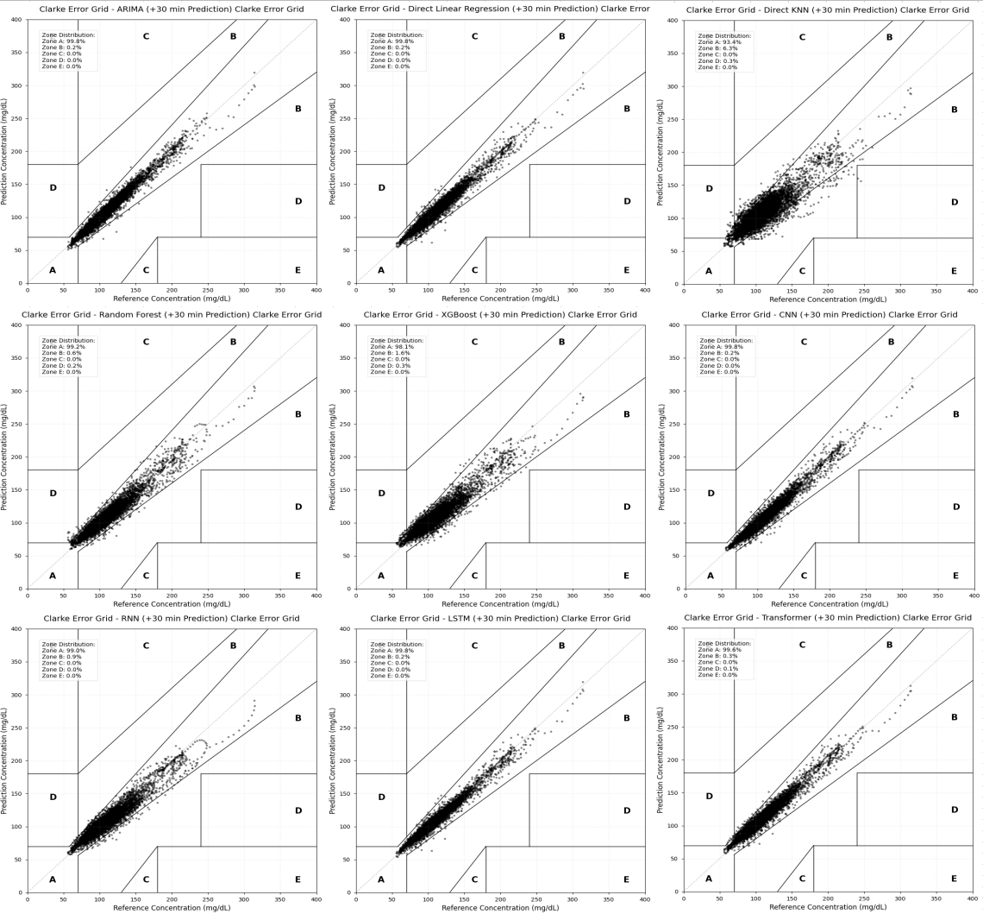
          - The CEG Clarke error grid of different models.
Judging from the results of the Clarke error grid, all models except KNN have achieved a clinical safety level of more than 99% in the A+B zone. Among them, the proportion of Zone A of LSTM, Linear, CNN and ARIMA all reached 99.8%, and Transformer accounted for 99.6%, all of which meet the basic requirements of predictive safety for clinical applications. The proportion of zone A of KNN is only 93.4%, which means that more than 6% of the prediction points deviate from the clinically acceptable accuracy range, which may lead to delays in clinical decision-making in key scenarios such as hypoglycemia warning. Overall, under the 30-minute prediction window, the difference in clinical safety of the top-ranked models is no longer significant, and the distinction of each model is mainly reflected in numerical accuracy rather than safety level.
In order to visually show the prediction effect, Figure 4-11 selects a representative subject (ID: 306) to show the prediction curves of different models over a continuous period of time.
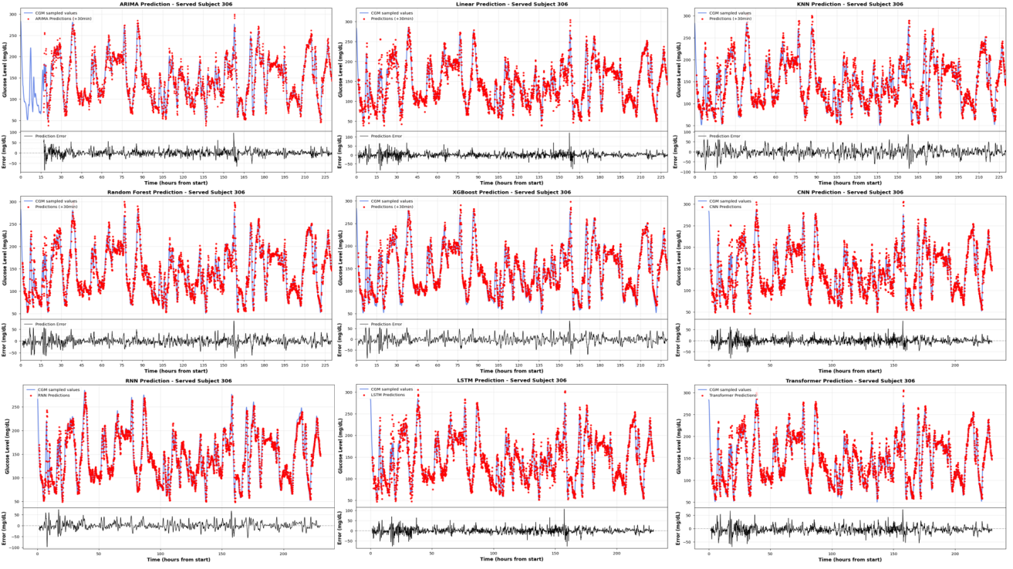
          - Prediction results of different models on subject 306.
Through the detailed analysis of the predicted waveform, the following phenomena can be observed:
Performance in the stable period: During the period when blood glucose is relatively stable, all models can give more accurate predictions, and there is not much difference between models. This is because the changes in blood glucose in the stable period are mainly dominated by inertia, and the historical value itself can provide sufficient predictive information.
Performance of rapid change period: During the period when blood glucose rises rapidly (such as after meals) or decreases rapidly (such as after exercise), the performance difference between models is significantly amplified. Traditional models (ARIMA, linear regression) have obvious prediction lag (phase lag), that is, there is a delay of about 5-10 minutes between the prediction curve and the actual glucose curve. The essential reason for this phenomenon is that traditional models rely too much on the latest historical observations. When the blood glucose trend is reversed, the model needs to wait for new observation information to respond.
Response advantages of deep learning: In contrast, LSTM and Transformer respond more acutely to changes in blood glucose, and the prediction lag is significantly reduced. This is due to the implicit learning ability of deep learning models to sequence trend characteristics - they can extract second-order or higher dynamic information (such as acceleration and curvature) from historical sequences, so as to perceive the trend of blood glucose changes in advance. The Transformer model can directly model the dependencies between any two time points through the self-attention mechanism, showing unique advantages in capturing periodic patterns and mutation events of blood glucose.
Based on the above experimental results, we further analyze the core advantages of the deep learning model compared with the traditional method:
1. Automatic characteristic learning ability
Traditional machine learning methods (such as KNN, random forest, XGBoost) rely on the characteristics of artificial design (lag value, statistics, time coding, etc.), and its upper performance limit is subject to the quality of feature engineering. Through multi-layer nonlinear transformation, the deep learning model can automatically extract hierarchical abstract features from the original blood glucose sequence without the prior knowledge intervention of experts in the field.
2. Long-range dependence modeling
Blood glucose dynamics are affected by many factors, including recent eating, exercise, and longer-term physiological rhythms (such as dawn phenomenon). Although the RNN model can model dependencies of any length in theory, it is limited by the vanishing gradient problem in practice. LSTM partially alleviates this problem through the gate control mechanism, and Transformer realizes the long-range dependence modeling of O(1) through the self-attention mechanism, which can directly pay attention to the information at any time in the history window without the information loss transmitted in the intermediate state.
3. Scalability and transfer learning potential
Another core advantage of the deep learning model is its transfer learning ability. Deep models pre-trained on large-scale population data can learn the general laws of blood glucose dynamics (such as post-meal rise mode, post-exercise decline mode, etc.), which can be efficiently transferred to new individuals through fine-tuning. In contrast, traditional machine learning models lack an effective knowledge transfer mechanism, and every new user needs to be trained from scratch.
The Transformer model has unique advantages in transfer learning: its modular architecture design (embedded layer, encoder layer, prediction head) allows flexible freezing or fine-tuning of different components; the interpretability of self-attention weight helps to understand the adaptation process of the model on new individuals; in addition, Transformer's successful transfer learning practices in the fields of natural language processing and computer vision (such as BERT, ViT) also provide theoretical and practical support for its application in the field of blood glucose prediction^{[23]}.

  - Conclusion
This chapter elaborately describes the construction of blood glucose prediction models, ranging from conventional statistical techniques to advanced deep learning technologies, and comparatively analyzes the performances of nine prediction algorithms. The main research results are as follows:
1. The completeness of the experimental system
We have developed a standardized blood glucose prediction assessment scheme, taking the 60-minute historical data as input to forecast the blood glucose value within the next 30 minutes. The evaluation system not only covers traditional statistical indices (MAE, RMSE, MAPE) but also incorporates the Clinical Error Grid Analysis to guarantee that the model evaluation considers both the numerical accuracy and clinical safety.
2. The significant advantages of deep learning models
The experimental results clearly confirm that the deep learning model is superior to the traditional method in blood glucose prediction tasks. Deep sequence models such as LSTM and Transformer have achieved good performance in terms of prediction accuracy, response speed and clinical safety. The core advantages are reflected in:
- Automatic feature learning: no need to manually design complex timing features, end-to-end learning abstract representation of blood glucose dynamics
- Long-range dependence modeling: effectively capture the periodic patterns and trend information of blood glucose changes
- Improvement of lag problem: significantly reduce the prediction delay of traditional models when blood glucose changes rapidly
3. The unique value of Transformer model
In the deep learning model, Transformer shows predictive performance comparable to LSTM, and has the following unique advantages:
- Global dependency modeling: the self-attention mechanism realizes the long-range dependence of O(1), not limited by the length of the sequence
- Parallel computing efficiency: abandon the circular structure, train and reason faster
- Interpretability: Attention weight visualization helps to understand the decision-making basis of the model

- Transfer learning-friendly: modular architecture design facilitates knowledge transfer and personalized fine-tuning
4. Limitations and personalized needs of general models
Although the overall performance of the deep learning model is excellent, the prediction effect of some subjects was still observed in the experiment. This phenomenon reveals the inherent limitations of the General Model based on population data training: there are significant differences in insulin sensitivity, metabolic rate, eating habits, etc. of different individuals, and it is difficult for a single general model to perfectly adapt to the unique physiological patterns of all individuals.
5. Transfer Learning and Personalized Prediction
The above analysis shows that the realization of high-precision personalized blood glucose prediction requires individual adaptation on the basis of the general model. Transfer learning provides an efficient solution: using pre-trained models on large-scale population data as knowledge carriers, fine-tuning through a small amount of individual data, and quickly adapting to the physiological characteristics of new users.
Considering the excellent performance and architectural advantages of the Transformer model in this chapter experiment, we choose Transformer as the basic model for transfer learning. The next chapter will discuss in depth how to use transfer learning technology to efficiently transfer the general knowledge of the Transformer pre-training model to specific individuals.

- Transfer Learning
  - Introduction
The experimental results of the previous chapter show that although the general model based on Transformer performs well at the group level, the prediction accuracy on some individuals still needs to be improved. This performance difference is mainly due to the physiological differences between individuals: the blood glucose metabolism patterns of different patients are significantly affected by their unique physiological parameters (such as insulin sensitivity, gastric emptying rate) and living habits (diet structure, exercise frequency)^{[22][24]}.
The general model tries to fit the average distribution of all subjects during training, which often leads to an "averaging" compromise, that is, the ability to capture specific highly variable individuals is sacrificed in order to reduce the overall average error. In response to this problem, the traditional solution is to collect a large amount of data for each new user and retrain an independent model (Isolated Training). However, for new patients (Cold Start Problem), there is often a lack of sufficient historical data to train complex deep learning models; even for long-term users, the high computing cost of training deep neural networks from scratch makes its real-time deployment on mobile or wearable devices challenging.
Transfer Learning provides an effective way to solve the above contradictions between "data scarcity" and "cost computing". Its core idea is to use the general knowledge learned on the large-scale Source Domain data set (such as the basic physiological laws of blood glucose response to carbohydrates) to assist the learning of the Target Domain^{[13][51]}. Through a "Pre-train -> Fine-tune" paradigm, we can quickly adapt the general model to a personalized model with only a small amount of individual data (Few-shot Learning).
This chapter will delve into the personalized transfer learning strategy based on Transformer. Specifically, we will select the typical subjects (ID 306) in the hold-out set in the previous chapter as the research object to verify the effectiveness of the strategy in small sample scenarios.

  - Transfer Strategy
In blood glucose prediction tasks, we can treat data from different subjects as distinct distribution domains. Let the source domain data (population data) be $D_{S}=\{(x_{S}^{i},y_{S}^{i})\}_{i=1}^{N_{S}}$, and the target domain data (individual-specific data) be $D_{T}=\{(x_{T}^{j},y_{T}^{j})\}_{j=1}^{N_{T}}$. Due to physiological differences, although the feature spaces are identical (both being historical blood glucose sequences), their marginal distributions and conditional distributions exhibit offsets, i.e., $P(X_{S})≠P(X_{T})$ and $P(Y_{S}|X_{S})≠P(Y_{T}|X_{T})$.
Applying the source domain model $f_{S}$ directly to the target domain (i.e., Zero-shot prediction) typically leads to performance degradation (Negative Transfer). Our objective is to leverage $D_{S}$ and a minimal amount of $D_{T}$ (i.e., $N_{T}≪N_{S}$) to identify an optimal target function $f_{T}$ that minimizes empirical risk on the target domain test set.
One option is to fine-tune the entire model on the calibration data. But the calibration set has only a few hundred samples, far too few to update all the parameters without overfitting.
In particular, the Transformer encoder contains most of the model's parameters. Updating it on such a small set would erase the general temporal patterns it learned during pre-training. So we freeze the encoder and only update the prediction head. This way, the shared representations stay intact, the number of trainable parameters drops to a manageable level, and the model does not forget how to handle cases missing from the calibration data, like sudden hypoglycemia.
The Transformer model is decoupled into two parts in this architecture:
1. Encoder: composed of a multi-layer Self-Attention mechanism and a Feed Forward Network, it is responsible for mapping the original timing input to the high-dimensional semantic feature space. We assume that what we learn in this part is the general Physiological Dynamics of blood glucose, which has strong cross-individual reusability.
2. Regression Prediction Head: It is composed of a Fully Connected Layer, which is responsible for mapping high-dimensional features to specific future blood glucose values. This part of the parameter depends more on the individual's absolute blood glucose level and specific metabolic parameters (such as basal blood glucose bias).
In the process of transfer learning, we take the following specific steps:
1. Pre-training: Train the Transformer model from scratch on a large-scale dataset comprising all subjects from the training set, obtaining the parameters $θ_{Enc}$ and $θ_{Head}$.
2. Fine-tuning: For new individuals, pre-trained parameters are loaded. The encoder gradient is frozen ($θ_{Enc}$) during backpropagation, and the regression head parameters ($θ_{Head}$) are updated using only a small amount of calibration data from the individual.
In order to fully verify the effectiveness and generalization ability of personalized transfer learning, we select 10 subjects (ID: 2, 27, 49, 71, 98, 124, 146, 170, 192, 306) from the Hold-out Set excluded from Chapter 4 for independent verification. These subjects did not participate in the pre-training of the general model and were able to simulate real "new user" scenarios. Among them, the subject 306 had a high prediction error (RMSE > 13 mg/dL) under the general model, and blood glucose fluctuated violently. We take it as the object of detailed case analysis.
For each subject, we divide their data in chronological order to simulate the real clinical application scenario:
- Calibration Set: Take the data of the first 30%. This simulates the first few days (about 2-3 days) when the patient begins to wear the CGM device, which is mainly used for personalized fine-tuning of the model.
- Test Set: Take the last 70% of the data. It is utilized to show the model's predictive performance in the future.
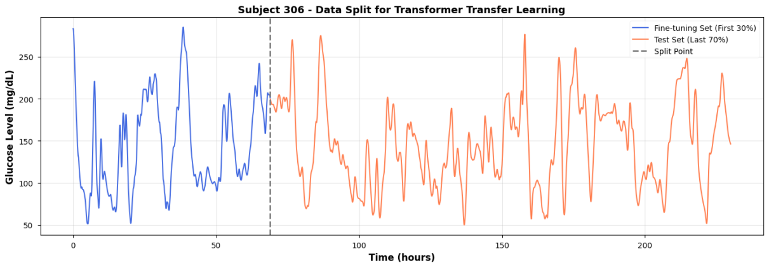
          - The data split for transfer learning on subject 306.
This division strictly follows the causality of time, and the data volume of the test set is much larger than that of the calibration set, which is a typical Few-shot Learning scenario.：
The fine-tuning parameters are configured as follows:
            - Transfer Learning Parameter Settings Table.
Parameter | Setting
Optimizer | Adam optimizer
Learning rate | 1e−4
Loss function | Mean Squared Error
Batch size | 16
Epochs | 100

  - Result Analysis
Table 5-1 shows the prediction results of the general model (Baseline) and the fine-tuned model on the test set of subject 306.
            - Prediction results of the baseline model and fine-tuned model on the participant 306 test set.
Metric | Baseline(mg/dL) | Fine-tuned(mg/dL) | Improvement(%)
MAE | 9.9727 | 9.2107 | +7.64
RMSE | 13.5865 | 12.6926 | +6.58
MAPE | 7.6601 | 7.2057 | +5.93
RMSPE | 10.8066 | 10.2925 | +4.76

The data shows that with only 30% of the calibration data for fine-tuning, the error indicators of the model have been significantly reduced, which means that the standard deviation of the forecast results has been significantly reduced and the uncertainty of the model has been effectively reduced. To show the strategy's generalization capability, we repeated the above experimental process on all 10 subjects.
            - Results of transfer learning experiments conducted on 10 subjects.
subject ID | Baseline(mg/dL) | Fine-tuned(mg/dL) | Improvement(%)
2 | 6.4151 | 5.2000 | +18.94
27 | 4.4126 | 3.6794 | +16.62
49 | 8.4029 | 7.6321 | +9.17
71 | 4.9080 | 3.1654 | +35.51
98 | 6.5078 | 6.4157 | +1.41
124 | 4.7742 | 3.1472 | +34.08
146 | 5.5901 | 3.8671 | +30.82
170 | 5.1325 | 4.1259 | +19.61
192 | 4.4688 | 3.0256 | +32.29
306 | 13.5865 | 12.6926 | +6.58
Mean | 6.3925 | 5.2900 | +20.35

It can be seen from the table that the transfer learning strategy has achieved a positive performance improvement in all 10 subjects, with an average RMSE reduction of 20.35%. This result verifies the universality of the freeze encoder strategy - the pre-trained Transformer encoder does capture the dynamic characteristics of migrable blood glucose.
In order to visually show the improvement brought about by fine-tuning, we have drawn a comparison chart of the prediction curve in the time period of some test sets (Figure 5-1).
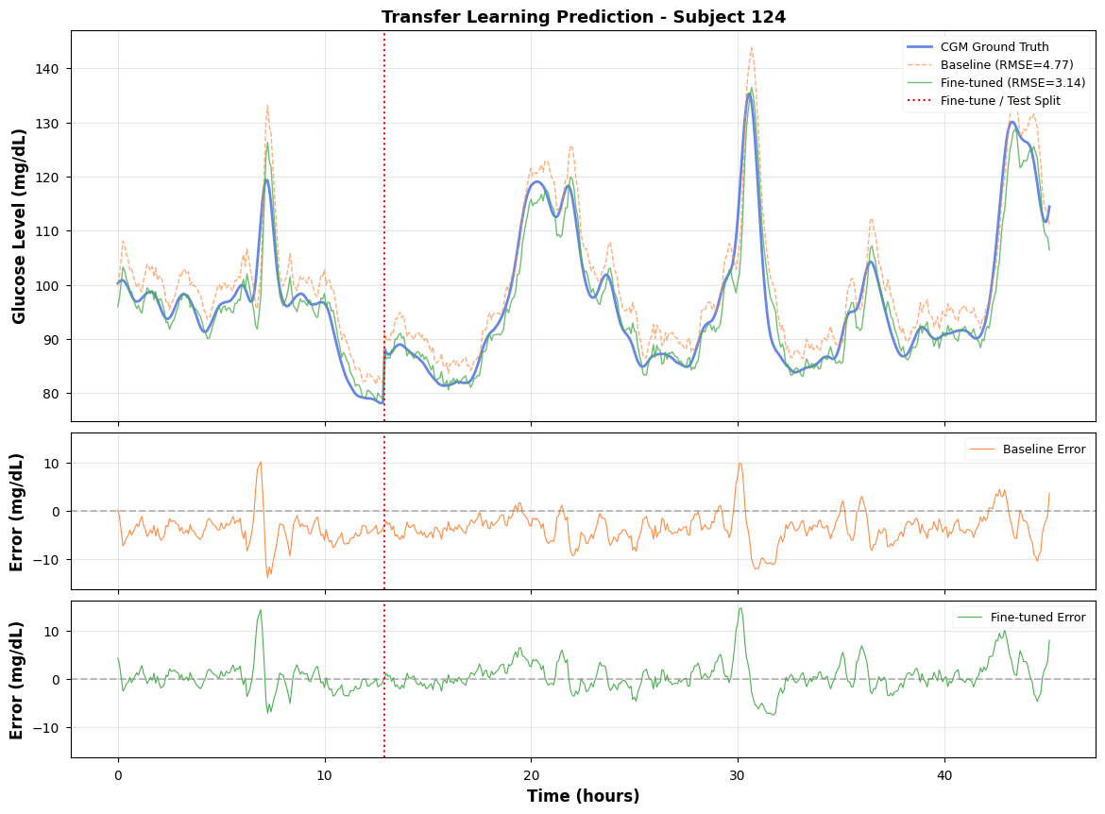
          - Comparison of baseline and fine-tuned model prediction curves on subject 124 during the test set period.

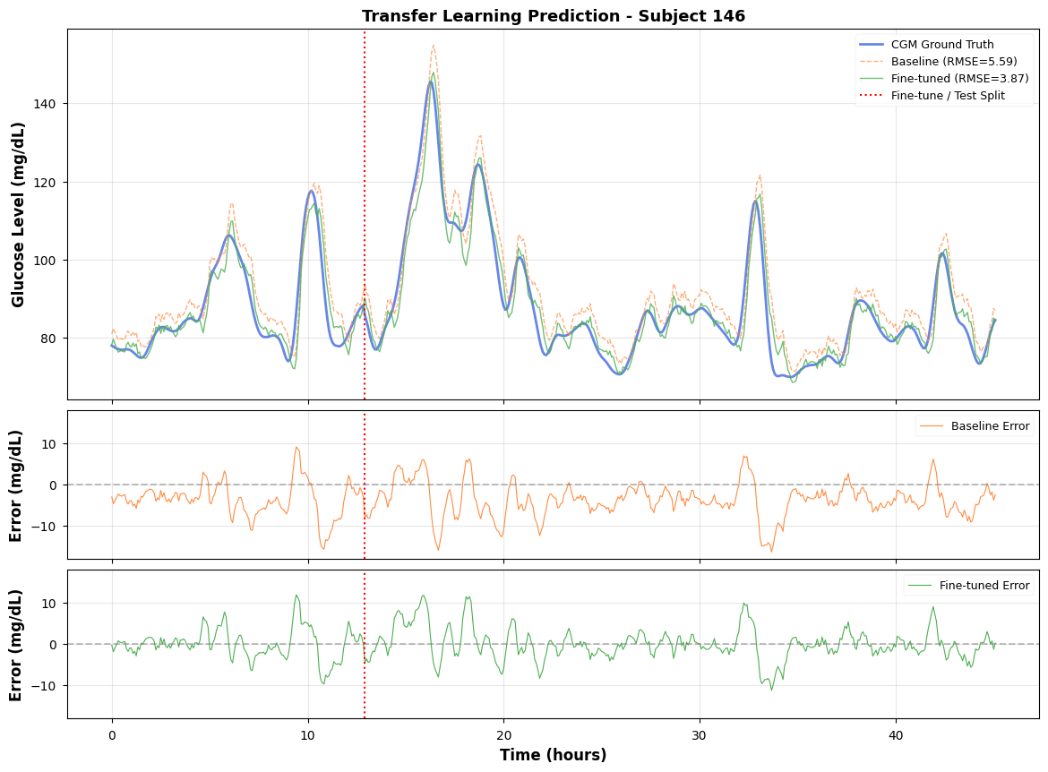
          - Comparison of baseline and fine-tuned model prediction curves on subject 146 during the test set period.
From the details of the waveform, we can analyze that fine-tuning has brought the following improvements
1. Peak Consistency: The general model (Baseline) often shows "over-shooting" at the peak of blood glucose, that is, the highest point of the prediction is higher than the highest point of the ground truth. This is because the general model tends to output the group average, thus highlighting the extreme peak. After fine-tuning, the Fine-tuned model can reach the real peak height more accurately, which is crucial for hyperglycemia warning.
2. Phase Lag improvement: The general model exhibits a noticeable temporal lag in the stage of rapid change of blood glucose (such as the period of rapid increase after meals). By adapting to the unique ascending slope of the individual, the fine-tuning model significantly reduces this lag phenomenon, making the prediction curve more suitable for the real curve on the timeline.
3. Baseline Shift: Fine-tuning effectively adjusts the bias of the regression head, so that the overall prediction curve moves upwards, thus reducing the average deviation of the system.

  - Conclusion

The blood glucose regulation mechanism includes not only the physiological laws common to all human beings (such as the glucose-lowering effect of insulin and the glycemic effect of carbohydrates), but also highly personalized parameters (such as insulin sensitivity coefficient ISF, carbohydrate coefficient CIR).
The pre-trained Transformer encoder successfully captures the former (commonality) and encodes it into deep features; while the fine-tuning output layer is equivalent to the rapid calibration of the latter(patient-specific parameters), only updating the output layer, which improves the prediction ability of specific individuals.
This strategy has a high engineering application value. In the actual product, we can preset a high-performance general model trained in the cloud. When the user starts to use the device, the system collects data a few days ago, and then quickly runs the fine-tuning algorithm locally (mobile phone or wearable chip) (only updating a simple linear layer) to generate the user's exclusive model. This not only ensures the basic availability of the cold start stage (using a general model), but also provides a personalized experience that is constantly optimized over time, and greatly protects user privacy (no need to upload individual data to the cloud for retraining).
In general, this chapter proposes and verifies the personalized transfer learning strategy based on Transformer in response to the problem that individual differences lead to limited accuracy of general models. By freezing the pre-trained encoder and fine-tuning the regression head, we achieved a consistent performance improvement on a small sample data set of 10 independent subjects. The experimental results show that this method reduces RMSE by an average of 20.35% in all subjects. It provides a practical technical path to realize a low-cost and high-performance personalized blood glucose health management system.

- Meta-Transfer Learning
  - Introduction
Chapter 5 showed that freezing the encoder and fine-tuning the prediction head works well when about 30% of a subject's data (2–3 days) is available for calibration. But in practice, a new user may only have a few hours of CGM records, like 30 to 50 samples. With so few samples, the prediction head cannot move far enough from its pre-trained weights to fit the individual's glucose pattern, and the improvement stays small. The question this chapter addresses is: can we find a better starting point for fine-tuning, so that even 30 samples are enough?
To see why the current starting point is not ideal, consider what pre-training actually optimizes. In Chapter 4, the model learns parameter θ by minimizing the average loss across all source domain subjects:
$$θ^{=}\arg{\min_{θ}{\sum_{i=1}^{N}{ℒ}}}(f_{θ},D_{i})$$
This gives good overall accuracy, but the $θ$ is not close to the best weights for any one person. When only a very small amount of calibration data is available, standard transfer learning may not adapt quickly enough; therefore, meta-learning is introduced to improve sample-efficient personalization.
Meta-learning gives a direct answer to this problem^{[52][53]}. Instead of looking for a $θ$ that predicts well on average, it looks for an initialization $θ_{meta}$ that is easy to adapt — one where a few gradient steps on a small calibration set produce a large drop in error:
$$θ_{meta}=\arg{\min_{θ}{\sum_{i=1}^{N}{ℒ}}}(f_{θ−α∇_{θ}ℒ(f_{θ},D_{i}^{support})},D_{i}^{query})$$
Here $D_{i}^{support}$ and $D_{i}^{query}$ are the support set and query set for task $i$. The key difference from standard pre-training is that the outer objective evaluates performance after adaptation, not before. So the optimization explicitly rewards fast learning.
This chapter uses the FOMAML algorithm to meta-train on the source domain subjects and obtain such an initialization. We then compare Meta-Transfer Learning with Basic Transfer Learning across different calibration set sizes, to test whether the meta-learned starting point actually helps when data is scarce.

  - Meta-learning Theory
In the meta-learning framework, we formalize the problem as optimization over a task distribution $p(T)$. Each task $T_{i}$represents an independent learning problem, where in the blood glucose prediction scenario, each subject constitutes a distinct task.
For subject $i$, the corresponding task $T_{i}$ includes:
-Support Set $D_{i}^{sup}$: a small subset of samples for model adaptation.
-Query Set $D_{i}^{qry}$: samples used to evaluate adaptation effectiveness.
The objective of meta-learning is to learn an initialization parameter $θ_{meta}$, enabling the model to rapidly adapt to any new task $T_{new}∼p(T)$ sampled from the task distribution using only a small number of samples from $D_{new}^{sup}$, while maintaining strong performance on $D_{new}^{qry}$.
Model-Agnostic Meta-Learning (MAML)^{[53]} is one of the most influential algorithms in the field of meta-learning. Its core concept can be summarized as an optimization process involving two layers of loops:
Inner Loop: For each sampled task $T_{i}$ , perform k-step gradient descent on the support set to obtain the adapted parameters:
$$θ'_{i}=θ−α∇_{θ}ℒ(f_{θ},D_{i}^{sup})$$
Outer Loop: Calculate the loss of the adapted parameter $θ'_{i}$ on the query set, and update the meta-parameter:
$$θ←θ−β∇_{θ}\sum_{i}{ℒ}(f_{θ'_{i}},D_{i}^{qry})$$
The theoretical advantage of MAML is to directly optimize the "performance after adaptation", but its calculation cost is high - it needs to calculate the second-order derivative (Hessian) to reverse propagate the gradient update through the internal loop.
FOMAML (First-Order MAML)^{[53]} is a first-order approximate variant of MAML, which was also proposed by Finn and others in the original MAML work. Its core simplification lies in: when calculating the meta gradient in the outer loop, ignore the higher-order dependence of the internal loop gradient update on the meta parameter, and directly use the first-step gradient at the adapted parameter $θ'_{i}$ to approximate the meta gradient. Specifically, the meta-gradient in the external circulation of MAML:
$$∇_{θ}\sum_{i}{ℒ}(f_{θ'_{i}},D_{i}^{qry})$$
Approximately:
$$\sum_{i}{∇_{θ'_{i}}}ℒ(f_{θ'_{i}},D_{i}^{qry})$$
This approach effectively reduces the need for second-order derivatives (Hessian vector product) while preserving MAML's dual-layer evaluation framework for support set and query set. The algorithmic process is as follows:
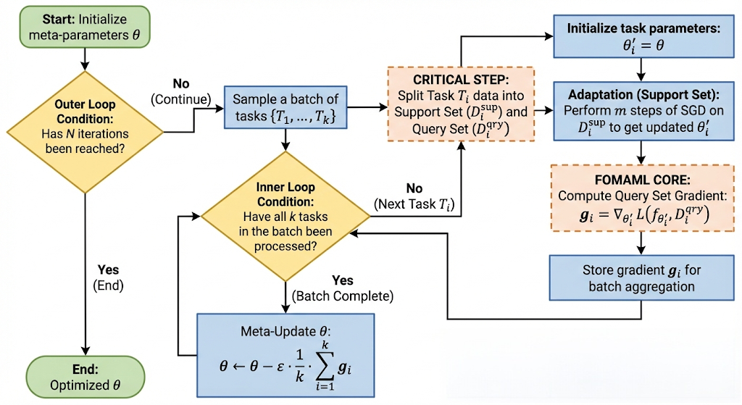
          - FOMAML algorithm framework.
Finn et al.^{[53]} found in the experiment that this first-order approximation is almost the same as the effect of complete MAML in most scenarios, but reduces the computational complexity from O(m) Hessian-vector product to zero, significantly reducing memory and computational overhead. This feature makes it more suitable for online learning on resource-limited devices such as blood glucose meters.
In the context of blood glucose prediction, this means that the initialization parameters obtained by meta-learning not only encode the general dynamic laws of blood glucose, but also encode the "meta-knowledge" of how to quickly adjust to adapt to individual differences.

  - Experiment and Analysis
We conduct FOMAML meta training on the source domain data set. Each subject is regarded as an independent task. Table 6-1 lists the hyperparametric configuration of the meta-training stage.
            - FOMAML Meta-Training Hyperparameter Configuration
Hyperparameter | Value
Meta-training iterations $T_{meta}$ | 1000
Meta learning rate $ϵ$ | $$1×10^{−4}$$
Meta optimizer | Adam ($λ=1×10^{−5}$)
Task batch size $K$ | 8
Inner loop steps $m$ | 5
Inner loop learning rate $α$ | $$1×10^{−3}$$
Support set size $D_{i}^{sup}$ | 64
Query set size $D_{i}^{qry}$ | 64

In each meta-iteration, we randomly sample $K=8$ tasks from the source domain subjects. For each task, we perform $m=5$ inner-loop adaptations on its support set, then compute loss on the query set and update the meta-parameters with a step size at the adapted parameters. The meta-optimizer uses Adam, incorporating weight decay ($λ=1×10^{−5}$) and a learning rate scheduler (decay factor 0.5, patience value 20) to enhance convergence stability.
We adopt the Warm Start strategy: the initial parameters of meta-training are not randomly initialized, but the Transformer model weight obtained by loading the standard pre-training in Chapter 4. This approach integrates the knowledge of standard pre-training with the fast adaptability of meta-learning, and its performance proves to be more stable in practical applications.
In order to evaluate the advantages of meta-learning initialization, we selected 10 subjects in the Hold-out Set for verification. The data division strategy for each subject is as follows:
- Pool set (top 50%): can be used for fine-tuning the data pool to simulate the data accumulated in the early days of the user wearing the device.
- Test set (last 50%): The test data used for final evaluation simulates the time period that needs to be predicted in the future.
In the fine-tuning stage, we select the most recent N samples from the end of the Pool set as fine-tuning data. This strategy of "taking the latest data" has two considerations: (1) the latest data is closer to the test set in time, and the distribution offset is smaller; (2) it simulates the use mode of "updating the model with the latest data" in actual deployment.
We will compare basic transfer learning and meta transfer learning. The two methods use exactly the same fine-tuning strategy and hyperparameters. The only difference is the source of the initialization parameters. This ensures the fairness of the experimental comparison - any performance difference can be attributed to the difference in the initialization quality.
We established multiple fine-tuning sample size gradients $N∈\{10,20,30,40,50,80,100,200\}$ to cover the full spectrum from minimal sample sizes (~50 minutes of data) to moderate sample sizes (~8 hours of data), thereby plotting the Learning Curve.
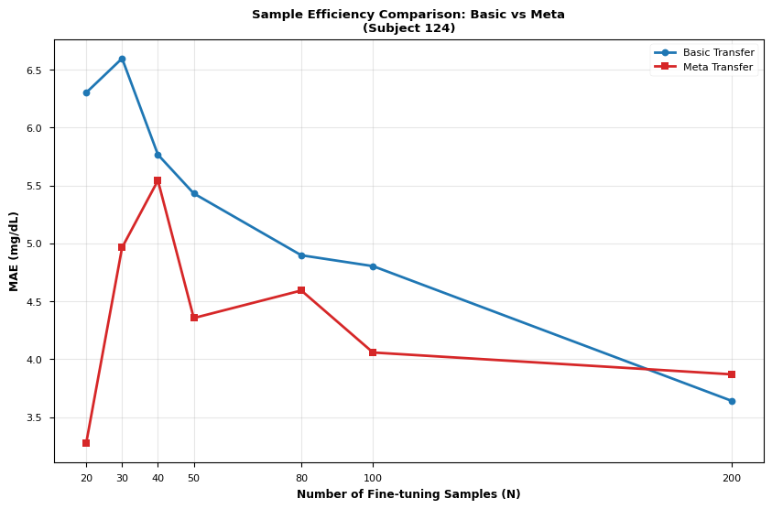
          - The learning curve of basic transfer learning and meta transfer learning.
Figure 6-2 presents the comparison of Mean Absolute Error (MAE) between Basic Transfer and Meta Transfer for subject 124 across different fine-tuning sample sizes, which is the core finding of this chapter.
From the learning curve, Meta Transfer showed its clearest advantage over Basic Transfer when the fine-tuning set contained fewer than 100 samples, with MAE reduced by an average of 25.67%. The gap was even larger when N < 40, where MAE dropped by 31.58%. Beyond N = 100, the two methods began to converge.
With the increase of fine-tuning samples, the performance gap between the two methods is gradually narrowing. When N > 150, the MAE of the two tends to be close. This is expected — with enough data, any reasonable initialization will eventually converge to a similar result. The value of meta-learning lies specifically in the low-sample regime (N < 100), where the starting point matters most.
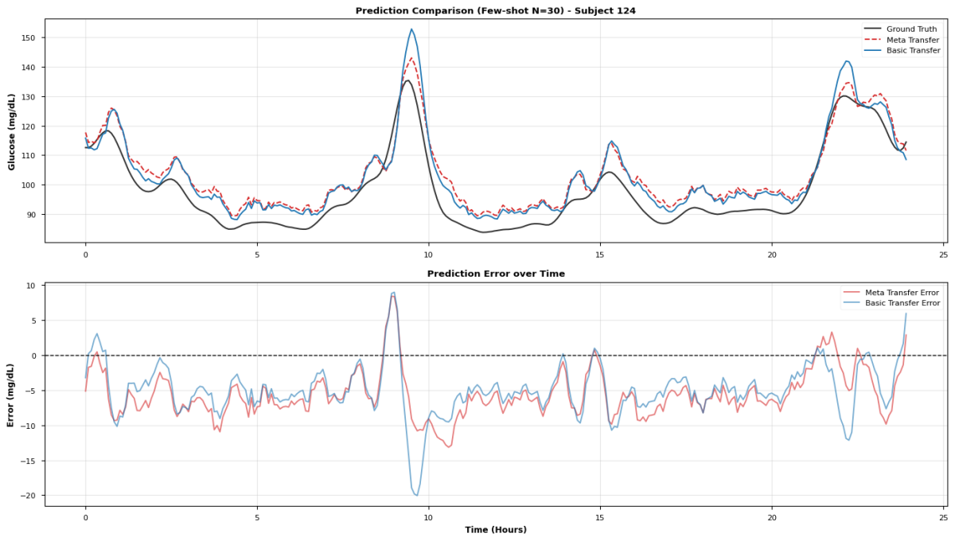
          - The prediction of meta transfer and basic transfer on subject 124.
In order to show the advantages of meta-learning more intuitively, we choose N=30 (about 2.5 hours of data), a typical small sample scenario, for detailed analysis.
Figure 6-3 shows the comparison of timing prediction waveforms on the subject' 124 test set.
It can be observed from the details of the waveform that in the stage of rapid increase in blood glucose (such as after meals), the Meta Transfer model can track the peak position and height more accurately, while there is an obvious peak overshoot phenomenon in Basic Transfer. At the same time, the Meta Transfer model responds faster at the change point of blood glucose, and the phase lag is significantly reduced.
In the stable stage of blood glucose, the performance of the two methods is similar, but the predicted variance of Meta Transfer is slightly smaller. This shows that Meta Transfer not only reduces the average error, but also reduces the fluctuation of the error, showing a more stable prediction quality.
            - Comparison of the predictive indicators of basic transfer and meta transfer.
Metric | Basic Transfer | Meta transfer | Improvement(%)
MAE | 5.9383 | 5.3762 | 9.4653
RMSE | 6.4932 | 6.2146 | 4.2901
MAPE | 6.2666 | 5.5451 | 11.5136
RMSPE | 6.9014 | 6.2370 | 9.6266
From Table 6-2, we can see that in addition to helping to fit faster in small sample data, Meta Transfer also improves the prediction accuracy. Using the Meta Transfer strategy to extract personalized characteristics from the sparse data of a specific individual, it can not only predict faster, but also predict better.
  - Discussion
The experimental results of this chapter confirm the advantages of meta-learning in extremely small sample scenarios. Theoretically, this advantage can be explained by the consistency of gradient direction.
In the process of meta-training, the FOMAML algorithm tends to find a parameter point, so that the gradient direction of different tasks has high consistency. Mathematically, the Hessian matrix near this point has similar characteristic vector directions between different tasks. This means that from this point, updating the parameters along the gradient direction of any new task is unlikely to have a serious conflict with the optimal direction of other tasks. Therefore, even if there is only a small amount of gradient steps (corresponding to a small amount of fine-tuning data), it can effectively approach the optimal solution of the new task. During this period, the self-attention mechanism of Transformer is very crucial in this process - unlike RNN/LSTM, which compresses the timing history into a fixed-dimensional hidden state, self-attention retains an independent characterization vector for each time step, which provides a richer parameter space for the gradient optimization of FOMAML. In the meta-training stage, the attention weighting learns to identify common timing-dependent patterns (such as post-meal upward trend and night steady segment) among different subjects, so that the features of the encoder output naturally have cross-individual transferability, thus reducing the degree of conflict between different tasks of meta-gradients.
The meta transfer learning strategy proposed in this chapter and the frozen encoder strategy in Chapter 5 are not a substitution relationship, but a complementary relationship. Both can be understood as the optimization of different links within the same framework: Chapter 5 solves "fine-tune what" - by freezing the Transformer encoder, the update range is limited to the regression header and reduce the risk of overfitting; this chapter solves "where to start fine-tuning" - obtain an initialization point that is more sensitive to new tasks through FOMAML meta training. The reason why this division of labor is particularly effective in the Transformer architecture is that there is a natural functional boundary between the self-attention encoder and the fully connected regression head: the encoder is responsible for extracting the general timing feature representation, and the regression head is responsible for mapping these characteristics to individualized blood glucose prediction values. FOMAML further strengthens this boundary - meta-training allows the encoder to converge to a feature space that can serve multiple blood glucose patterns at the same time, and the regression head only needs a small number of samples to anchor the mapping relationship of individuals in this space.
In the experiment of this chapter, we combine the two: using meta-learning initialization + freezing encoder fine-tuning. This combination strategy not only inherits the rapid adaptability of meta-learning in small sample scenarios, but also retains the anti-fitting advantage of the freezing strategy.
            - Comparison with Related Meta-Learning Approaches for Personalized Glucose Prediction
Study | Backbone Model | Meta-Learning Algorithm | Dataset | Adaptation | Key Contribution
Zhu et al.^{[16]} (2023) | FCNN | MAML | OhioT1DM (T1D) | Limited training data | Uncertainty-aware prediction via evidential deep learning
Langarica et al.^{[55]} (2023) | LSTM | MAML | Custom T1D | 1-day CGM data | Demonstrated effectiveness of personalized meta-learning
Ours | Transformer | FOMAML | Colas + Hall (T2D) +OhioT1DM (T1D) | 30–50 samples (~2.5–4 h) | Few-shot adaptation with frozen encoder; attention-based transferable representations

We, Zhu et al.^{[16]} both use MAML series algorithms for meta-learning, which verifies the effectiveness of the MAML framework in personalized scenarios of blood glucose prediction from different angles. The first-order approximation of FOMAML we use avoids the computational overhead of second-order derivatives in complete MAML, which is more suitable for deployment on devices with limited resources. Zhu et al.'s FCNN provides predictive uncertainty estimates through the evidence deep learning layer, which is a direction worth learning from. In the selection of backbone networks, Zhu and others use FCNN, Langarica and others use LSTM, and we choose Transformer as the backbone network. This choice is not simply to pursue the improvement of model capacity. Transformer's self-attention mechanism enables it to flexibly capture the dependence of blood glucose dynamics on different time scales. This flexibility has additional advantages under the meta-learning framework: in the meta-training stage, the attention mode can learn universal timing attention strategies across the subjects; in the fine-tuning stage, the regression head only needs a small sample to complete individual adaptation under the premise of keeping the encoder attention mode unchanged. This paradigm of "attention sharing, mapping personalization" enables us to achieve effective and rapid adaptation under extremely few samples (30-50 samples).
Compared with the work of Langarica et al.^{[55]}, we further pushed the boundaries of small samples to the extreme - verifying that meta-learning can still bring significant benefits under the condition of only 30 samples (about 2.5 hours). This discovery is of great value for the pursuit of "instant personalized" product experience.
Although the experimental results are encouraging, we still have the following limitations:
1. Task distribution hypothesis: The effectiveness of metalearning depends on the assumption that the source domain task and the target domain task come from the same distribution (or similar distribution). If there is a significant difference between the blood glucose pattern of the new user and all subjects in the training set (such as extremely rare metabolic types), the advantage of metalearning may be weakened.
2. Requirements for the number of source domain tasks: FOMAML meta-training requires enough source domain tasks to learn the "common adaptation mode across tasks". The source domain we use contains 164 subjects, and the effect may be discounted on smaller-scale data sets.
3. Hyperparameter sensitivity: The hyperparameters of metalearning (such as INNER_STEPS, META_LR) have a great impact on the final effect, and the optimal value may change with the data set. We have determined the current configuration through experience tuning, but the hyperparameter search of the system may further improve the performance.
In summary, meta-transfer learning is most useful when the calibration set is small, roughly fewer than 100 samples, or under 8 hours of CGM data. Beyond that, standard transfer learning catches up. For real-world deployment, this means meta-learning provides prediction for new users during the first few hours after starting to wear their CGM devices.

- Conclusion
This thesis presented a blood glucose prediction framework designed to address data scarcity and individual physiological variability in continuous glucose monitoring systems. The proposed system relies exclusively on historical CGM sequences supplemented by age and BMI without requiring meal logs or insulin records.
The proposed pipeline was built on raw CGM readings from 174 subjects. After standardization, the glucose series were smoothed with a Savitzky-Golay filter, mainly because this filter reduces short-term sensor noise while retaining the shape of glucose peaks. In the comparison of the nine prediction algorithms, the Transformer-based model gave the strongest overall result. Its self-attention structure was useful for this task because it could attend both to recent glucose changes and to dependencies occurring over a longer window, which recurrent models handled less flexibly. From the clinical perspective, the predictions were also reliable: more than 99% of the points fell within Zones A and B of the Clarke Error Grid. This indicates that the 30-minute-ahead predictions were not only numerically accurate, but also clinically acceptable for most decision-support scenarios considered in this study.
Personalization further improved the model after deployment to unseen subjects. The basic transfer learning setting kept the Transformer encoder frozen and recalibrated only the prediction head, using roughly two to three days of data from each new patient. Even with this simple design, the average RMSE across the ten hold-out subjects decreased by more than 20%. The meta-transfer learning experiment then examined a more difficult case, where only a very small calibration set was available. By using FOMAML to learn an initialization that is easier to adapt, the model performed better than standard transfer learning when fewer than 100 calibration samples were provided. In this range, MAE was reduced by 25.67% on average. With only 30 samples, equivalent to about 2.5 hours of CGM data, the MAE reduction reached 31.58%. This result is important from an engineering point of view, because the first few hours after a new user starts wearing a sensor are exactly when individual data are scarce and personalization is most difficult.
There are still several limitations. First, the public datasets used in this work were collected in controlled research environments. Their noise characteristics and wearing conditions may not fully represent daily use with consumer-grade CGM devices. Second, the meta-learning configuration and the learned initialization were obtained from the 174 source subjects. If the available source population were much smaller or less diverse, the initialization might not adapt as well to new users. Third, the current system predicts a single glucose value 30 minutes ahead. This is useful for short-term warning and decision support, but it does not provide the full future trajectory required by closed-loop insulin delivery.
Future work should therefore move from single-point prediction to multi-step forecasting over a 30- to 120-minute horizon. Such an output would give a clearer view of the expected glucose trend and would be more suitable for automated delivery systems. The model should also be extended with online updating, so that its parameters can continue to adjust as more data are collected from the same user. Finally, the complete pipeline needs to be evaluated prospectively with consumer-grade CGM hardware in unconstrained daily-life settings. This step is necessary before the method can be considered clinically useful outside retrospective benchmark experiments.

Reference
- American Diabetes Association (ADA). Standards of Care in Diabetes—2025. Diabetes Care 2025; 48 (Supplement_1). [https://doi.org/10.2337/dc25-S007]
- Kwon SY, et al. Advances in Continuous Glucose Monitoring: Clinical Applications and Future Perspectives. Endocrinology and Metabolism 2025. [https://doi.org/10.3803/EnM.2025.2370]
- Alam MA, et al. Machine Learning And Artificial Intelligence in Diabetes Prediction And Management: A Comprehensive Review of Models. 2024. [https://papers.ssrn.com/sol3/papers.cfm?abstract_id=5079613]
- Xie X, et al. Reduction of measurement noise in a continuous glucose monitor. Nature Biomedical Engineering 2018; 3: 892–901.[https://doi.org/10.1038/s41551-018-0273-3]
- Kim SJ, et al. Long-term blood glucose prediction using deep learning-based noise reduction. Computer Methods and Programs in Biomedicine 2025. [https://doi.org/10.1016/j.cmpb.2025.108571]
- Kozinetz RM, et al. Machine Learning and Deep Learning Models to Predict Nocturnal Glucose. Diagnostics 2024; 14(7): 740. [https://doi.org/10.3390/diagnostics14070740]
- Facchinetti A, et al. Kalman smoothing for objective and automatic preprocessing of glucose data. IEEE Transactions on Biomedical Engineering 2018; 65(1): 114-123. [https://doi.org/10.1109/TBME.2017.2702326]
- Liu K, Li L, Ma Y, et al. Machine learning models for blood glucose level prediction in patients with diabetes mellitus: systematic review and network meta-analysis. JMIR Medical Informatics 2023; 11: e47833. [https://doi.org/10.2196/47833]
- Ryu JS, et al. A deep learning approach for blood glucose monitoring and forecasting. Scientific Reports 2025. [https://doi.org/10.1038/s41598-025-97391-8]
- Ghimire S, et al. Deep learning for blood glucose level prediction: How well do models perform across diverse datasets? PLOS ONE 2024; 19(9): e0310801. [https://doi.org/10.1371/journal.pone.0310801]
- Zheng Y, et al. Enhancing personalized blood glucose prediction in type 1 diabetes with meta-transfer learning: A few-shot approach. Biomedical Signal Processing and Control 2026; 101: 107234. [https://doi.org/10.1016/j.bspc.2025.108468]
- Shen Y, et al. Personalized Blood Glucose Forecasting From Limited CGM Data Using Incrementally Retrained LSTM. IEEE Transactions on Biomedical Engineering 2024. [https://doi.org/10.1109/TBME.2024.3491434]
- Yu X, et al. Deep transfer learning: a novel glucose prediction framework for new subjects. Complex & Intelligent Systems 2022; 8: 3123–3137. [https://doi.org/10.1007/s40747-021-00360-7]
- Deng Y, et al. Deep transfer learning and data augmentation improve glucose levels prediction in type 2 diabetes patients. NPJ Digital Medicine 2021; 4: 91. [https://doi.org/10.1038/s41746-021-00480-x]
- Moon K, et al. Personalized blood glucose prediction in type 1 diabetes using meta-learning with bidirectional LSTM-Transformer hybrid model. Scientific Reports 2025; 15: 13491. [https://doi.org/10.1038/s41598-025-13491-5]
- Zhu T, et al. Personalized Blood Glucose Prediction for Type 1 Diabetes Using Evidential Deep Learning and Meta-Learning. IEEE Transactions on Biomedical Engineering 2023; 70(1): 193-204. [https://doi.org/10.1109/TBME.2022.3187703]
- Wang L, et al. Heterogeneous Covariates-Aware Pseudo Supervised Meta-Learning for Few-shot Diabetes Classification. IEEE Transactions on Medical Imaging 2025. [https://doi.org/10.1109/TMI.2024.3416513]
- Singh R, et al. Personalized glucose prediction using in situ data only. Frontiers in Nutrition 2025; 12: 1539118. [https://doi.org/10.3389/fnut.2025.1539118]
- Manchanda E, et al. Data-Efficiency with Comparable Accuracy: Personalized LSTM models on limited individual data. Diabetology 2025; 6(10): 115. [https://doi.org/10.3390/diabetology6100115]
- Tominaga H, et al. Prediction of Postprandial Blood Glucose Variability Using Transformer-based Models. PMC 2025. [https://pmc.ncbi.nlm.nih.gov/articles/PMC12735845/]
- Colás, A., Vigil, L., Vargas, B., Enríquez de Salamanca, R., & Lázaro, P. (2019). Detrended Fluctuation Analysis in the prediction of type 2 diabetes mellitus in patients at risk: Model optimization and comparison with other metrics. [https://doi.org/10.1371/journal.pone.0225817]
- Hall, H., Perelman, D., Breschi, A., Limcaoco, P., Kellogg, R., McLaughlin, T., & Snyder, M. (2018). Glucotypes reveal new patterns of glucose dysregulation. PLOS Biology, 16(7), e2005143. [https://doi.org/10.1371/journal.pbio.2005143]
- Zhu, T., Li, K., Herrero, P., & Georgiou, P. (2021). Deep Learning for Diabetes: A Systematic Review. IEEE Journal of Biomedical and Health Informatics, 25(7), 2744-2757. [https://doi.org/10.1109/JBHI.2020.3040225]
- Woldaregay, A. Z., Årsand, E., Walderhaug, S., & Albers, D. (2019). Data-driven modeling and prediction of blood glucose dynamics: Machine learning applications in type 1 diabetes. 25(4), 1610-1641. [https://doi.org/10.1016/j.artmed.2019.07.007]
- Martinsson, J., Schliep, A., Eliasson, B., & Mogren, O. (2020). Blood Glucose Prediction with Variance Estimation Using Recurrent Neural Networks. Journal of Healthcare Informatics Research, 4, 1-18. [https://doi.org/10.1007/s41666-019-00059-y]
- Facchinetti, A., Sparacino, G., & Cobelli, C. (2010). An online self-tunable method to denoise CGM sensor data. IEEE Transactions on Biomedical Engineering, 57(3), 634-641. [https://doi.org/10.1109/TBME.2009.2033264]
- Sparacino, G., Facchinetti, A., & Cobelli, C. (2010). "Smart" continuous glucose monitoring sensors: On-line signal processing issues. Sensors, 10(7), 6751-6772. [https://doi.org/10.3390/s100706751]
- Facchinetti, A. (2016). Continuous glucose monitoring sensors: Past, present and future algorithmic challenges. Sensors, 16(12), 2093. [https://doi.org/10.3390/s16122093]
- Rebrin, K., & Steil, G. M. (2000). Can interstitial glucose assessment replace blood glucose measurements? Diabetes Technology & Therapeutics, 2(3), 461-472. [https://doi.org/10.1089/15209150050194332]
- Breton, M. D., & Kovatchev, B. P. (2008). Analysis, modeling, and simulation of the accuracy of continuous glucose sensors. Journal of Diabetes Science and Technology, 2(5), 853-862. [https://doi.org/10.1177/193229680800200517]
- Bequette, B. W. (2010). Continuous glucose monitoring: Real-time algorithms for calibration, filtering, and alarms. Journal of Diabetes Science and Technology, 4(2), 404-418. [https://articles.researchsolutions.com/continuous-glucose-monitoring-real-time-algorithms-for-calibration-filtering-and-alarms/doi/10.1177/193229681000400222]
- Baysal, N., Cameron, F., Buckingham, B. A., et al. (2014). A novel method to detect pressure-induced sensor attenuations (PISA) in an artificial pancreas. Journal of Diabetes Science and Technology, 8(6), 1091-1096. [https://doi.org/10.1177/1932296814553267]
- Kovatchev, B. P., Gonder-Frederick, L. A., Cox, D. J., & Clarke, W. L. (2004). Evaluating the accuracy of continuous glucose-monitoring sensors. Diabetes Care, 27(8), 1922-1928. [https://doi.org/10.2337/diacare.27.8.1922]
- Garnica, O., Lanchares, J., Velasco, J. M., & Hidalgo, J. I. (2020). Noise spectral analysis and error estimation of continuous glucose monitors under real-life conditions of diabetes patients. Biomedical Signal Processing and Control, 60, 101902. [https://doi.org/10.1016/j.bspc.2020.101934]
- Facchinetti, A., Del Favero, S., Sparacino, G., Castle, J. R., Ward, W. K., & Cobelli, C. (2014). Modeling the glucose sensor error. IEEE Transactions on Biomedical Engineering, 61(3), 620-629. [https://doi.org/10.1109/TBME.2013.2284023]
- Kalman, R. E. (1960). A new approach to linear filtering and prediction problems. Journal of Basic Engineering, 82(1), 35-45. [https://doi.org/10.1115/1.3662552]
- Savitzky, A., & Golay, M. J. E. (1964). Smoothing and differentiation of data by simplified least squares procedures. Analytical Chemistry, 36(8), 1627-1639. [https://doi.org/10.1021/ac60214a047]
- Schafer, R. W. (2011). What is a Savitzky-Golay filter? IEEE Signal Processing Magazine, 28(4), 111-117. [https://doi.org/10.1109/MSP.2011.941097]
- Sadıkoğlu, F., & Kavalcıoğlu, C. (2016). Filtering continuous glucose monitoring signal using Savitzky-Golay filter and simple multivariate thresholding. Procedia Computer Science, 102, 342-350. [https://doi.org/10.1016/j.procs.2016.09.410]
- Luo, J., Ying, K., & Bai, J. (2005). Savitzky-Golay smoothing and differentiation filter for even number data. Signal Processing, 85(7), 1429-1434. [https://doi.org/10.1016/j.sigpro.2005.02.002]
- Butterworth, S. (1930). On the theory of filter amplifiers. Wireless Engineer, 7(6), 536-541.
- Rangayyan, R. M., & Krishnan, S. (2024). Biomedical Signal Analysis (3rd ed.). Wiley-IEEE Press. [https://doi.org/10.1002/9781119825883]
- Gustafsson, F. (1996). Determining the initial states in forward-backward filtering. IEEE Transactions on Signal Processing, 44(4), 988-992. [https://doi.org/10.1109/78.492552]
- Marling, C., & Bunescu, R. (2020). The OhioT1DM Dataset for Blood Glucose Level Prediction: Update 2020. CEUR Workshop Proceedings, 2675, 71-74. [https://pmc.ncbi.nlm.nih.gov/articles/PMC7881904/]
- Xie, J., & Wang, Q. (2020). Benchmarking Machine Learning Algorithms on Blood Glucose Prediction for Type I Diabetes in Comparison With Classical Time-Series Models. IEEE Transactions on Biomedical Engineering, 67(11), 3101-3124. [https://doi.org/10.1109/TBME.2020.2975959]
- Rabby, M. F., Tu, Y., Hossen, M. I., Lee, I., & Maida, A. S. (2021). Stacked LSTM based deep recurrent neural network with kalman smoothing for blood glucose prediction. BMC Medical Informatics and Decision Making, 21, 101. [https://doi.org/10.1186/s12911-021-01462-5]
- El Idrissi, T., Idri, A., & Bakkoury, Z. (2020). Deep learning for blood glucose prediction: Cnn vs lstm. International Conference on Computational Science and Its Applications (pp. 385-399). Springer. [https://doi.org/10.1007/978-3-030-58802-1_28]
- Sun, Q., Jankovic, M. V., Bally, L., & Mougiakakou, S. G. (2018). Predicting blood glucose with an lstm and bi-lstm based deep neural network. 14th Symposium on Neural Networks and Applications (NEUREL) (pp. 1-6). IEEE. [https://ieeexplore.ieee.org/document/8586990]
- Vaswani, A., Shazeer, N., Parmar, N., Uszkoreit, J., Jones, L., Gomez, A. N., ... & Polosukhin, I. (2017). Attention is all you need. Advances in Neural Information Processing Systems, 30. [https://arxiv.org/abs/1706.03762]
- Clarke, W. L., Cox, D., Gonder-Frederick, L. A., Carter, W., & Pohl, S. L. (1987). Evaluating clinical accuracy of systems for self-monitoring of blood glucose. Diabetes Care, 10(5), 622-628. [https://doi.org/10.2337/diacare.10.5.622]
- Zhuang, F., Qi, Z., Duan, K., Xi, D., Zhu, Y., Zhu, H., ... & He, Q. (2021). A Comprehensive Survey on Transfer Learning. Proceedings of the IEEE, 109(1), 43-76. [https://doi.org/10.1109/JPROC.2020.3004555]
- Hospedales, T., Antoniou, A., Micaelli, P., & Storkey, A. (2022). Meta-learning in neural networks: A survey. IEEE Transactions on Pattern Analysis and Machine Intelligence, 44(9), 5149-5169. [https://doi.org/10.1109/TPAMI.2021.3079209]
- Finn, C., Abbeel, P., & Levine, S. (2017). Model-agnostic meta-learning for fast adaptation of deep networks. Proceedings of the 34th International Conference on Machine Learning (ICML), 70, 1126-1135. [https://arxiv.org/abs/1703.03400]
- Nichol, A., Achiam, J., & Schulman, J. (2018). On first-order meta-learning algorithms. arXiv preprint arXiv:1803.02999. [https://arxiv.org/abs/1803.02999]
- Langarica, S., Rodriguez-Fernandez, M., Núñez, F., & Doyle III, F. J. (2023). A meta-learning approach to personalized blood glucose prediction in type 1 diabetes. Control Engineering Practice, 135, 105498. [https://doi.org/10.1016/j.conengprac.2023.105498]

