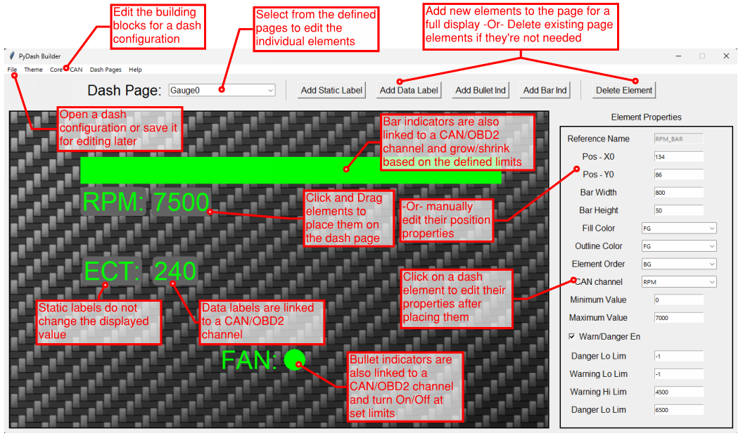
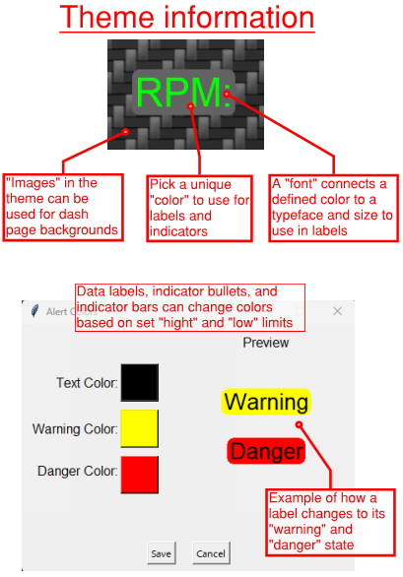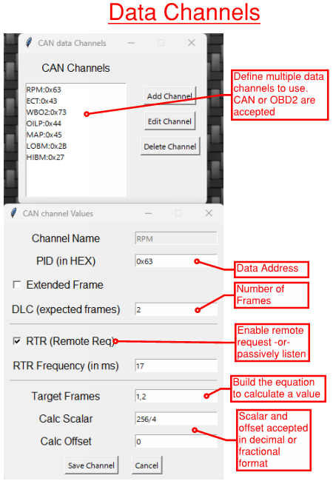

Steps to Creating a new PyDash Configuration:
- Click “new” under the “file” menu for a fresh configuration
- Build a “Theme” to use for the various dash elements
  - Add enough “colors” to use for fonts in labels and any desired indicators
  - Created pre-defined styles with “fonts” to easily set label properties
  - Include any “images” for page backgrounds
  - Update the “warning limit” colors to match your theme
- Add at least one page under the “Dash Pages” menu before adding new elements
  - Include as many pages as you’d like to scroll between for easy access to information
- Be sure to define any data channels under the “CAN” menu and “CAN Channels”
  - Both CAN and OBD2 protocols are currently supported
  - Data channels are used by various dash elements to define where they get their value
  - Data channels can be listened to passively or enable “RTR” (remote request) to periodically ask for the value at the listed address
- Select the page to edit in the “Dash Page” drop-down Box
- Start adding new elements
  - Static Labels
    - Never-changing labels. Great for providing context to data labels and bullet indicators.
  - Data Labels
    - Good ole numbers. Simple, straight-forward, and easy to read. These are labels that
  - Bullet Indicators
    - Think of these as a digital indication light that turns on and off at set limits. Make them as big or small as you need to catch your attention.
  - Bar Indicators
    - The dynamic version of a bullet indicator that changes size. Define a minimum and maximum value for the size of the bar. As the data value changes, the bar does too.
- Build the dash to fit your needs!
  - Click on an element to edit its properties or click-and-drag to move it around
  - Don’t like a defined color or font style? Update it in the configuration menu and all linked elements will automatically update!
- When you think you’re done
  - You can save for later if you ran out of time
  - Make a configuration “output” to upload to a PyDash and see your new dash

