Supplementary material
TSHR and IGF1R expression in Graves disease: Mendelian randomization and colocalization

Supplementary Methods

Expression instruments and allele alignment
Cis-eQTL instruments met P < 5×10⁻⁸ within ±1 Mb of the gene and were clumped at r² < 0.001 within 10 Mb using 1000 Genomes Phase 3 Europeans (n = 503). Exposure SE = 1/√[2f(1−f)(N + Z²)] and β = Z × SE, where f is allele frequency and N is the variant-specific sample size [19]. TwoSampleMR harmonise_data (action = 2) aligned alleles and excluded palindromic variants with MAF > 0.42; missing estimates were not imputed. BBJ/FinnGen retained their reported log-odds scales. UKB linear-model β and SE were divided by μ(1−μ), with μ = 3,731/484,598. Source GWAS covariate adjustments were retained; participant-level re-adjustment was unavailable.

MR sensitivity and regional linkage
Single instruments used the Wald ratio; multiple instruments used multiplicative random-effects IVW with under-dispersion correction. Weighted-median/mode estimates, the MR-Egger intercept and Cochran’s Q were assessed where estimable (Table S1; Supplementary Data 5) [21, 22]. Few instruments limit pleiotropy testing. Steiger directionality [23] and bidirectional MR were not performed. Post hoc leave-one-out analysis used the original reference-frequency harmonized sets, applying IVW when at least two SNPs remained and the Wald ratio for one. All 15 omissions (11 IGF1R, four CTLA4) and five comparators are in Figure S2 and Supplementary Data 6. TSHR in all outcomes and CTLA4 in BBJ had one original SNP and were ineligible. An independent base-R implementation reproduced all nine full-set estimates and verified the omissions. Two-sided normal tests and 95% CIs retained the primary SE conventions. These correlated checks are not independent replication. This analysis was not repeated under substituted eQTLGen frequencies.
TSHR clumping combined eQTL thresholds of 5×10⁻⁸/5×10⁻⁶, r² thresholds of 0.001/0.01/0.1 and European (n = 503)/East Asian (n = 504) panels. rs179252 remained an index variant in all 12 combinations. Primary settings selected one European and two East Asian instruments; relaxed settings selected up to 12. Post-review PLINK r² between rs179252 and rs179247 was 0.957116/0.991625 in Europeans/East Asians; for rs179252–rs12101255 it was 0.459227/0.855574. All three variants had complete genotypes. These reference-panel checks support instrument retention, not conditional association, a single-signal model or shared tissue-specific regulation.
At chromosome 16p11.2, rs4889606, rs34649473 and rs78924645 span approximately 143 kb (East Asian pairwise r² = 0.854, 0.761 and 0.863). GCTA-COJO selection at P < 5×10⁻⁶ retained rs8050588 (P = 1.15×10⁻⁸); conditioning gave P = 0.928, 0.839 and 0.806 for the three variants, respectively. This supports regional dependence without identifying a causal gene.

Colocalization and prior assumptions
coloc.abf used all available gene-specific cis-eQTL statistics without significance filtering, matched to outcomes by rsID and allele pair; GRCh37 expression and GRCh38 outcome coordinates were not joined directly. Duplicate rsIDs and allele mismatches were excluded. Both datasets supplied β and variance: dataset 1 was the outcome, dataset 2 expression (sdY = 1). Outcome frequencies were not used in the Bayes factors. The top_snp field identifies the highest-probability variant conditional on H4, not necessarily the GWAS lead SNP. H0–H4 denote neither trait, outcome only, expression only, distinct variants and a shared variant. Priors were p1 = p2 = 10⁻⁴ and p12 = 10⁻⁵, with 5×10⁻⁶ and 10⁻⁶ sensitivity settings [24]. Figure 3B displays selected genes; Supplementary Data 3 preserves all nine genes × three outcomes × three priors. Low H4 does not establish absence of disease association. Multi-variant colocalization and formal colocalization power were not evaluated.

Cohort-frequency sensitivity and detection limits
The eQTLGen frequency release covers 26,609 participants, excluding Framingham. All 50,245 requested SNPs, including 6,135 instrument records, had valid frequencies and matching GRCh37 positions. Assessed-allele frequencies replaced reference frequencies in β/SE reconstruction while Z and N were fixed (maximum |ΔZ| = 5.54×10⁻¹³). Identical-variant comparisons preceded repeat action = 2 harmonization. Of 27 changed inclusion decisions, 24 involved palindromic frequencies and three restored missing reference frequencies. No retained outcome estimate changed direction. Estimable genes became 2,232/2,506/2,481 in BBJ/UKB/FinnGen; the discovery denominator remained 2,544 (Table S2; Supplementary Data 2). Across 81 colocalization settings, maximum |ΔH4| was 0.000245 for identical variants and 0.002142 when newly covered variants were included; none crossed 0.80. Primary MR was independently checked. Substitution reran Wald/IVW, colocalization and detection limits, but not all alternative MR estimators.
The approximate 80% minimum detectable absolute log-OR was (z₁₋α/₂ + z₀.₈₀) × SE, with α = 0.05/2,544 in BBJ and 0.05 in UKB/FinnGen; exponentiation gives the detectable OR. Percentages use each scenario’s estimable-gene denominator (Table S3; Supplementary Data 4). These describe MR association detection using observed SEs, not colocalization or combined-filter power. Gene-specific limits were 1.39 (TSHR) and 0.99 (IGF1R) in BBJ (α = 0.05/2,544), and 0.33/0.72 for IGF1R in UKB/FinnGen, respectively (α = 0.05). These benchmarks describe precision; comparing them with observed effects cannot distinguish an absent effect from limited power.

Descriptive orbital expression
Orbital RNA-seq included four TED patients and one control. Technical replicates were combined by biological sample. Figure S1 shows log2[(mean TED TPM + 0.01)/(control TPM + 0.01)]. One control cannot establish control-group biological variance; no differential-expression P value or confirmatory test is reported. This unreplicated descriptive dataset contributes no inferential evidence to the genetic comparison.

Table S1. Sensitivity tests for genes with multiple instruments
Gene | Outcome | Instruments | Primary P | Median P | Mode P | Egger intercept P | Heterogeneity P
IGF1R | BBJ Graves disease | 4 | 0.0212 | 0.0288 | 0.512 | 0.663 | 0.902
IGF1R | UKB hyperthyroidism | 4 | 0.0117 | 0.00244 | 0.367 | 0.562 | 0.25
IGF1R | FinnGen Graves ophthalmopathy | 3 | 0.182 | 0.124 | 0.633 | 0.433 | 0.309
CTLA4 | UKB hyperthyroidism | 2 | 0.0022 | NA | NA | NA | 0.00131
CTLA4 | FinnGen Graves ophthalmopathy | 2 | 0.0118 | NA | NA | NA | 0.0486
Median and mode denote weighted-median and weighted-mode MR. The Egger intercept assesses directional pleiotropy; heterogeneity uses Cochran’s Q. NA means not estimable, not a negative test. TSHR and CTLA4 in BBJ each used one instrument and are omitted from this diagnostic table. IGF1R estimates agreed in direction across estimators, but significance differed. Few instruments limit all these sensitivity checks. These are the original reference-frequency diagnostics; frequency substitution repeated primary Wald/IVW only. Supplementary Data 5 supplies all estimator coefficients, standard errors, ORs and 95% CIs alongside their original P values. Its intervals use the same reference distribution as each test: normal for Wald/IVW/weighted median and Student t for MR-Egger (instruments − 2 degrees of freedom) and weighted mode (instruments − 1).
Table S2. Associations before and after cohort-frequency substitution
Gene | Outcome | Reference OR (95% CI) | Reference P | eQTLGen OR (95% CI) | eQTLGen P
TSHR | BBJ Graves disease | 0.12 (0.07–0.21) | 1.09×10⁻¹⁴ | 0.12 (0.07–0.21) | 1.09×10⁻¹⁴
TSHR | UKB hyperthyroidism | 0.09 (0.06–0.14) | 8.77×10⁻²⁸ | 0.09 (0.06–0.14) | 8.77×10⁻²⁸
TSHR | FinnGen Graves ophthalmopathy | 0.10 (0.04–0.24) | 2.82×10⁻⁷ | 0.10 (0.04–0.24) | 2.82×10⁻⁷
IGF1R | BBJ Graves disease | 1.56 (1.07–2.28) | 0.0212 | 1.58 (1.07–2.34) | 0.022
IGF1R | UKB hyperthyroidism | 1.35 (1.07–1.70) | 0.0117 | 1.37 (1.06–1.78) | 0.0157
IGF1R | FinnGen Graves ophthalmopathy | 1.41 (0.85–2.33) | 0.182 | 1.44 (0.85–2.47) | 0.177
CTLA4 | BBJ Graves disease | 0.18 (0.11–0.27) | 5.45×10⁻¹⁵ | 0.18 (0.12–0.27) | 5.45×10⁻¹⁵
CTLA4 | UKB hyperthyroidism | 0.21 (0.08–0.57) | 0.0022 | 0.20 (0.08–0.49) | 3.86×10⁻⁴
CTLA4 | FinnGen Graves ophthalmopathy | 0.17 (0.04–0.68) | 0.0118 | 0.17 (0.05–0.57) | 0.00458
Reference estimates use 1000 Genomes European frequencies. eQTLGen estimates use cohort frequencies followed by repeat harmonization. For these nine comparisons, estimates using identical variants and repeat harmonization coincide; instrument counts are unchanged from Table 2. All 13 discovery genes remain significant. Results for every gene and each scenario are in Supplementary Data 2.
Table S3. Association detection limits before and after frequency substitution
Outcome | Analysis | Estimable genes | Detectable OR median (IQR) | Detect OR 1.5 (%) | Detect OR 2.0 (%)
BBJ Graves disease | Reference | 2,234 | 2.55 (1.71–5.18) | 14.6 | 35.6
BBJ Graves disease | Cohort frequencies | 2,232 | 2.61 (1.76–5.14) | 12.5 | 34.2
UKB hyperthyroidism | Reference | 2,505 | 1.46 (1.26–1.91) | 53.7 | 77.4
UKB hyperthyroidism | Cohort frequencies | 2,506 | 1.46 (1.26–1.94) | 53.1 | 76.4
FinnGen Graves ophthalmopathy | Reference | 2,480 | 2.12 (1.58–3.81) | 19.4 | 45.5
FinnGen Graves ophthalmopathy | Cohort frequencies | 2,481 | 2.17 (1.60–3.87) | 17.6 | 44.5
Percentages are the proportions of estimable genes with at least 80% power to detect the specified OR under the normal approximation. Alpha is 0.05/2,544 in BBJ and 0.05 in UKB/FinnGen. OR is per reconstructed expression unit. These calculations assess MR association detection, not colocalization or the combined filter. Full precision and identical-variant comparisons are retained in Supplementary Data 4.
Figure S1. Descriptive orbital expression. Transcript abundance for TSHR, IGF1R and CTLA4 in four TED samples and one control. Points are biological samples; the horizontal line is the TED mean. Log2 fold changes use a 0.01-TPM pseudocount. Axes differ by gene. With one control, group variance cannot be estimated reliably; no differential-expression test or P value is reported. These observations did not determine the genetic conclusions.
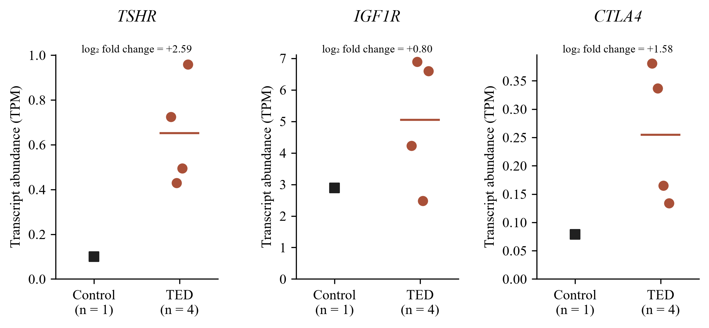

Figure S2. Post hoc leave-one-out sensitivity of the selected-gene MR estimates. Open circles show the 15 SNP-exclusion estimates; filled diamonds show the five corresponding all-SNP estimates. The SNP named on each row was omitted. Horizontal lines represent 95% CIs, and the dashed line marks OR = 1 on a logarithmic axis. ORs, CIs and two-sided P values are displayed for every row; bold P values denote nominal P < 0.05 for descriptive comparison. Original reference-frequency harmonized sets were used. If one SNP remained, its Wald ratio was calculated; otherwise IVW was used. TSHR in all outcomes and CTLA4 in BBJ are not plotted because a single original instrument precluded omission. These correlated post hoc analyses assess sensitivity to the included SNPs and do not constitute independent replication.
