Supplementary material
TSHR and IGF1R in Graves disease and thyroid eye disease: genetic evidence from blood expression

Supplementary methods

Dataset definitions and analysis chronology
BBJ GD (GCST90018627) and UKB self-reported hyperthyroidism/thyrotoxicosis (GCST90038636) retained the source sample sizes and estimates. UKB used BOLT-LMM linear-model statistics; its report included adjustment for sex, age, BMI, assessment centre, ethnicity, genotyping batch and 20 principal components. The available documentation did not establish an exclusively European analysis sample. FinnGen R12 GWAS counts were 858/499,490 for GRAVES_OPHT, 3,962/496,386 for E4_GRAVES_STRICT and 753/499,595 for E4_GRAVES_OPHT_STRICT. Counts refer to the analyzed GWAS files, not later phenotype-browser totals. Strict GD combines specified GD/ophthalmopathy diagnostic criteria with the Graves condition and exclusion of amiodarone exposure; strict ophthalmopathy requires its specified ophthalmopathy and thyrotoxicosis codes. BBJ cases merged physician diagnoses with curated medical histories and text-mined records; controls lacked GD or related diagnoses; covariates were age, age², sex, their interactions and 20 principal components. None supplies GD-only controls.
The original three-outcome analysis preceded the two FinnGen extensions. The expanded analysis plan was recorded before the new endpoint associations were computed, but it was not a prospective registration of the complete study. The 24 colocalization genes comprise 13 BBJ discoveries, IGF1R, nine additional FinnGen GD screen discoveries, and frequency-sensitive HLA-G. No new discovery threshold was optimized from these results.

Instrument selection and effect reconstruction
Of 4,479 druggable-genome genes, 4,462 mapped to GRCh37. Significant cis-eQTL instruments (P < 5×10⁻⁸ within ±1 Mb of the gene) were clumped at r² < 0.001 within 10 Mb using the European 1000 Genomes Phase 3 reference (n = 503). SE = 1/√[2f(1−f)(N + Z²)] and β = Z × SE, where f is the assessed-allele frequency and N is the variant-specific expression sample size (median 28,092; range 232–31,684). Unit expression variance was assumed. Variant F = Z². The estimate is approximately per expression SD, not per SD of the genetic predictor.
TwoSampleMR harmonise_data(action = 2) aligned alleles and excluded ambiguous palindromic variants with MAF > 0.42. Missing outcome estimates were not imputed. BBJ and FinnGen retained log-odds scales; UKB β and SE were each divided once by μ(1−μ), with μ = 3,731/484,598. GRCh37 expression and GRCh38 FinnGen coordinates were not directly joined: identifiers and allele pairs were checked, with duplicate and alias audits. Source covariate adjustments were retained; patient-level re-adjustment and subgroup analysis were unavailable.

MR estimators and instrument diagnostics
For a single instrument, the Wald coefficient is β_{Y}/β_{X} and its first-order SE is SE_{Y}/|β_{X}|. Multiple-instrument MR used inverse-variance weighted regression through the origin. Multiplicative random-effects SEs included under-dispersion correction, so heterogeneity could widen the interval. Normal two-sided tests and 95% CIs were used for the primary estimators. The alternative-estimator worksheet preserves weighted median, weighted mode and MR-Egger results for the original three outcomes; mode and Egger intervals use the corresponding t distributions. These alternative estimators were not rerun for all new endpoints. With three or four IGF1R instruments, these estimators had little power. No Steiger directionality test was performed.
Post hoc leave-one-out analyses applied IVW when at least two variants remained and the Wald ratio when one remained. Single-instrument TSHR and BBJ CTLA4 were ineligible. Original three-outcome results, new-endpoint results for the fixed 14-gene set, and 72 C4B/HLA-G omission estimates under two frequency sources are retained in separately named worksheets. Independent calculations reproduced the eight full-set and 72 omission estimates for C4B and HLA-G. They reuse the same association data and are not independent replications. C4B/HLA-G instrument weights use β_{X}²/SE_{Y}², normalized within each full model. A single-SNP P value can be much smaller than the full IVW P value when heterogeneity inflates the full-model SE.
TSHR clumping sensitivity used eQTL thresholds of 5×10⁻⁸/5×10⁻⁶, r² thresholds of 0.001/0.01/0.1, and European (n = 503) or East Asian (n = 504) reference panels. Primary settings selected one European and two East Asian variants, and rs179252 was retained in every setting. Chromosome 16p11.2 analyses found high East Asian LD among rs4889606, rs34649473 and rs78924645; GCTA 1.95.1 COJO stepwise selection (BBJ; East Asian reference) retained one signal, rs8050588; conditional on it, the three variants had P = 0.81–0.93, supporting regional dependence rather than three independent gene effects.

TSHR allele alignment and reference LD
In a post hoc audit, original full eQTLGen and disease GWAS files were re-extracted for rs179252 and rs179247. Their GRCh37 positions were 14:81435985 and 14:81432546, and GRCh38 positions were 14:80969641 and 14:80966202. Both non-palindromic allele pairs matched across sources. UKB effects were reversed to the G allele after the existing scale conversion; BBJ and FinnGen required no reversal. Exposure coefficients and first-order Wald estimates were independently reconstructed. Original GWAS P values and recalculated MR P values were retained separately.
G-allele counts at both variants were positively correlated in European (n = 503; r = 0.978322812; r² = 0.957115524) and East Asian (n = 504; r = 0.995803919; r² = 0.991625445) references, without missing genotypes. Direct BED decoding agreed with PLINK dosage output. PLINK haplotype estimates supported G–G and T–A coupling; these were inferred from unphased genotypes, not directly observed phased haplotypes. Alignment to the G allele resolved the negative default European correlation obtained when counting T at rs179252. The TSHR_allele_audit worksheet retains both eQTL records, both variants across five disease outcomes, all four inferred haplotypes in each population, and MR reproduction. This audit does not identify a causal variant or establish mediation in thymus or orbit.

Colocalization hypotheses and regional inputs
coloc.abf received beta/varbeta data for disease (dataset 1, case-control type) and expression (dataset 2, quantitative type, sdY = 1), with the default prior effect SDs of 0.2 and 0.15, respectively. Outcome allele frequency was not used in the Bayes factors. Complete available cis-eQTL statistics, not just significant eQTLs, were matched by identifier and allele compatibility. H0 denotes neither trait associated; H1 disease only; H2 expression only; H3 both traits associated through distinct variants; H4 both traits associated through one shared variant. PP.Hk is the posterior probability of hypothesis k, conditional on the model and priors.
Primary priors were p1 = p2 = 10⁻⁴ and p12 = 10⁻⁵; sensitivity p12 values were 5×10⁻⁶ and 10⁻⁶. The PP.H4 ≥ 0.80 threshold was a reporting convention, not a significance test. H3 is a competing distinct-variant model, not a count of causal signals. Multi-signal colocalization was not performed.
Four frequency/availability scenarios were used: original_reference (original available reference frequencies), paired_reference and paired_eqtlgen (the same variants with the respective frequencies), and available_eqtlgen (all matching variants with valid cohort frequencies). There are 1,440 gene–outcome–scenario–prior rows; no PP.H4 changed side of 0.80 across scenarios. The additional TSHR analysis comprises four windows × five outcomes × four scenarios × three priors = 240 rows. Windows were the full source cis-region, ±500 kb and ±250 kb around the recorded GRCh37 GenePos anchor, and the five-outcome variant intersection. The full cis-source contained 7,309 eQTL rows; all three FinnGen full-region analyses matched 6,579 variants, and the five-outcome intersection contained 4,030. Raw outcome regional scans checked whether the strongest disease variants survived matching. New candidate coverage checks also examined marginal expression strength and shared instruments; the absent rs5759410 lead in BBJ was checked against variant aliases without finding a replacement.
For TSHR, IGF1R and CTLA4, colocalization and MR in FinnGen GD and strict ophthalmopathy were independently reproduced from re-downloaded FinnGen R12 regional statistics using two separately written implementations, with the original ophthalmopathy endpoint as a control. The allele-compatible variant sets were the same (6,675, 7,850 and 4,993 variants), and the top variant was the same in all 27 gene–endpoint–prior settings, including the control. The reproduction used gnomAD v2.1.1 European frequencies, which were available for more of these variants than the 1000 Genomes European frequencies used in the reported analysis (6,674, 7,850 and 4,992 analysed, versus 6,579, 7,740 and 4,924). On the control endpoint, PP.H4 changed by at most 4.1×10⁻⁴; for TSHR this difference came from the additional variants. Reported new-endpoint PP.H4 values were reproduced within 1.2×10⁻³, and no setting changed side of 0.80. The TSHR strict-ophthalmopathy value at p12 = 10⁻⁶ was 0.449 rather than 0.451 (0.451 on the reported variant set), and IGF1R PP.H2 and PP.H3 differed by up to 0.003, as on the control endpoint. MR estimates were reproduced to numerical precision on the original exposure scale.

Frequency substitution and precision benchmarks
The published eQTLGen frequency release covered 26,609 participants, excluding Framingham. Reconstructing β_{X} and SE_{X} with fixed Z and N preserves their ratio up to floating-point precision. For a single-IV Wald estimate, frequency scaling changes the effect unit and SE together and preserves the normal-test P value; for IVW, variant weights can change. The new-endpoint MR dataset separates identical-variant scaling from repeat allele harmonization. C4B and HLA-G were audited with identical retained variants and outcome effects, so their differences arise from scaling and weighting rather than a changed variant set. Large frequency discrepancies are documented, not assumed to be resolved by correct identifier matching.
The detection benchmarks use (z_{1−α/2} + z_{0.80}) × SE as the approximate 80% minimum detectable absolute log-OR. Alpha was 0.05/2,544 for BBJ and 0.05 for the original UKB/FinnGen comparisons. These are precision summaries using observed SEs, not prospective sample-size calculations, post hoc proof of power, or colocalization power. The Detection_original worksheet retains these three-outcome results. Applying the same formula to the MR_primary standard errors for FinnGen GD at alpha 0.05/2,544 gave 24.8% and 52.2% of 2,480 estimable genes with 80% power for ORs of 1.5 and 2.0. At alpha 0.05, the detectable IGF1R ORs were 1.72 in BBJ, 1.39 in UKB and 1.36 in FinnGen GD.

Fixed-panel tissue extension
The post hoc tissue extension retained a frozen panel of TSHR and IGF1R in five standard-release GTEx v8 tissues. QTL sample counts were 574 (thyroid), 483 (cultured fibroblasts), 581 (subcutaneous adipose), 469 (visceral adipose) and 670 (whole blood). The original v8 archive supplied significant variant–gene pairs and eGenes records for all tested genes; gene-specific release thresholds exceeded 5×10⁻⁸ for every eligible combination, permitting complete selection at the fixed threshold. Absence from the tested-gene file was distinguished from a minimum eQTL P value above the threshold. The standard release includes multiple ancestries; the overall donor cohort was 85.3% European American, not a tissue-specific percentage.
Variants were restricted to ±1 Mb of the source GENCODE v26 TSS, P < 5×10⁻⁸, F > 10 and MAF ≥ 0.01. GTEx variant IDs identify GRCh38 REF and ALT, with slope referring to ALT. Actual effect-allele frequencies were reconstructed from each selected eGene MAF and ref_factor, not by treating MAF as ALT frequency. GTEx mappings linked GRCh38 variants to rsIDs and GRCh37 reference coordinates. PLINK clumping used 503 European reference samples, r² < 0.001 and a 10-Mb window; an independent genotype-based calculation reproduced selection. One of 20 thyroid IGF1R candidates was absent from the reference, while its strongest candidate was retained. All selected variants were non-palindromic and matched exactly in the five disease datasets; no proxies or relaxed thresholds were used.
Each of the four estimable gene–tissue combinations retained one SNP. Wald estimates used β_{Y}/β_{X} and SE_{Y}/|β_{X}| with normal two-sided P values and 95% CIs; independent calculations reproduced all 20 estimates. The UKB linear-to-log-odds conversion was applied once. ORs represent one unit of inverse-normal-transformed normalized expression; they are not directly comparable to an intervention or to the reconstructed eQTLGen scale. Primary adjusted P = min(1, 10P) for FinnGen GD; secondary adjusted P = min(1, 40P) for the other datasets. The 30 unestimable cells remained in the planned families. Single-instrument analyses cannot support heterogeneity, leave-one-out or MR-Egger diagnostics. Significant-only eQTL pairs were not used for colocalization; full regional data were not obtained from the requester-pays resource, and no tissue posterior was calculated. Tissue_extension in the single Supplementary Dataset retains all 50 cells, availability, selected and excluded candidates, harmonized alleles and source statistics.

Orbital expression and reproducibility
Orbital adipose tissue was collected during orbital decompression from four patients with inactive TED; the control was nasal fat pad from one person without thyroid disease undergoing cosmetic upper blepharoplasty. Paired-end RNA sequencing (Illumina NovaSeq) used two technical-replicate libraries per donor, which were combined by biological sample; reads were trimmed (Trimmomatic 0.38), aligned to GRCh38 (HISAT2 2.1.0) and quantified as TPM (StringTie 2.1.3b). Figure S1 shows sample-level transcript abundance and log₂[(mean TED TPM + 0.01)/(control TPM + 0.01)]. One control cannot estimate control-group biological variance reliably, and no differential-expression P value was used. The dataset is descriptive and did not influence candidate selection.
The workbook Readme and Column_dictionary sheets describe every sheet; reproduction validates implementation, not causal assumptions.

Table S1. Additional FinnGen GD screen discoveries
Gene | Chr | FinnGen GD IVs | FinnGen GD OR (95% CI) | FinnGen GD P | BBJ PP.H4 | FinnGen GD PP.H4 | FinnGen GO strict PP.H4
APOM | 6 (MHC) | 1 | 0.05 (0.04–0.06) | 1.43×10⁻¹⁰⁸ | <0.001 | <0.001 | 0.227
NEU1 | 6 (MHC) | 1 | 0.04 (0.03–0.06) | 1.43×10⁻¹⁰⁸ | <0.001 | <0.001 | 0.061
IGLV2-18 | 22 | 1 | 0.56 (0.48–0.66) | 7.52×10⁻¹² | 0.029 | 0.020 | 0.100
IGLV3-12 | 22 | 1 | 1.20 (1.14–1.26) | 7.52×10⁻¹² | 0.019 | 0.022 | 0.101
TNF | 6 (MHC) | 1 | 0.60 (0.51–0.71) | 4.65×10⁻¹⁰ | <0.001 | <0.001 | <0.001
HIST1H4E | 6 (MHC) | 1 | 2.54 (1.88–3.43) | 1.51×10⁻⁹ | <0.001 | <0.001 | 0.007
LTA | 6 (MHC) | 1 | 0.46 (0.35–0.61) | 3.75×10⁻⁸ | <0.001 | <0.001 | <0.001
LTB | 6 (MHC) | 1 | 0.18 (0.10–0.36) | 4.89×10⁻⁷ | <0.001 | <0.001 | <0.001
C4B | 6 (MHC) | 2 | 1.63 (1.31–2.03) | 1.10×10⁻⁵ | <0.001 | <0.001 | 0.311
Genes outside the BBJ discovery set that passed P < 0.05/2,544 in the post hoc full FinnGen GD screen (1000 Genomes European reference frequencies). These are not independent of the screen and seven of nine are in the MHC. APOM/NEU1 share rs3101018 and IGLV2-18/IGLV3-12 share rs5759410. The lead IGLV expression variant is absent in BBJ, weakening interpretation of its low PP.H4. None reached PP.H4 ≥0.80 (p12 = 10⁻⁵) in any dataset. Chr, chromosome; CI, confidence interval; IV, instrumental variable; MHC, major histocompatibility complex; OR, odds ratio; PP.H4, shared-variant posterior probability; BBJ, Biobank Japan; FinnGen GD, E4_GRAVES_STRICT; GD, Graves disease; GO, Graves ophthalmopathy; UKB, UK Biobank.

Table S2. Frequency-sensitive exploratory candidates
Gene | Dataset | Frequency source | IVs | OR (95% CI) | P value | Q-test P
C4B | FinnGen GD | 1000G EUR | 2 | 1.63 (1.31–2.03) | 1.10×10⁻⁵ | 7.79×10⁻⁷
C4B | FinnGen GD | eQTLGen cohort | 2 | 1.75 (1.31–2.33) | 1.48×10⁻⁴ | 1.36×10⁻⁸
C4B | FinnGen GO strict | 1000G EUR | 2 | 1.68 (1.44–1.95) | 2.74×10⁻¹¹ | 0.122
C4B | FinnGen GO strict | eQTLGen cohort | 2 | 1.80 (1.46–2.23) | 6.17×10⁻⁸ | 0.0587
HLA-G | FinnGen GD | 1000G EUR | 16 | 0.86 (0.72–1.03) | 0.107 | 9.98×10⁻²⁴
HLA-G | FinnGen GD | eQTLGen cohort | 16 | 0.60 (0.47–0.75) | 1.72×10⁻⁵ | 2.26×10⁻¹⁰
HLA-G | FinnGen GO strict | 1000G EUR | 16 | 0.91 (0.76–1.08) | 0.267 | 0.0231
HLA-G | FinnGen GO strict | eQTLGen cohort | 16 | 0.70 (0.53–0.92) | 0.0122 | 0.131
Exposure effects were reconstructed with 1000 Genomes Phase 3 European reference allele frequencies (1000G EUR; primary) or eQTLGen cohort frequencies; variant sets and outcome effects were held fixed, so changes reflect rescaled expression effects and IVW weights. HLA-G was added because its eQTLGen-frequency P crossed the screen threshold (P < 0.05/2,544). Q tests heterogeneity, not directional pleiotropy; its P value is not a gene-association P value. All 72 omission estimates and instrument weights are in the workbook. CI, confidence interval; IV, instrumental variable; IVW, inverse-variance weighted; OR, odds ratio; BBJ, Biobank Japan; FinnGen GD, E4_GRAVES_STRICT; GD, Graves disease; GO, Graves ophthalmopathy; UKB, UK Biobank.

Table S3. TSHR regional colocalization and prior sensitivity
Dataset | Matched variants | Disease lead (P) | rs179252 P | rs179252-G OR (95% CI) | H4 top variant | PP.H4, 10⁻⁵ / 10⁻⁶ | PP.H4 range across windows
BBJ GD | 4,336 | rs28414437 (1.83×10⁻¹⁵) | 1.09×10⁻¹⁴ | 0.80 (0.76–0.85) | rs179252 | 0.951 / 0.661 | 0.951–0.951
FinnGen GD | 6,579 | rs1023586 (1.58×10⁻³⁶) | 3.19×10⁻³² | 0.77 (0.73–0.80) | rs1023586 | 0.264 / 0.035 | 0.264–0.264
UKB hyperthyroidism | 5,667 | rs4903961 (1.17×10⁻⁴³) | 8.77×10⁻²⁸ | 0.77 (0.74–0.81) | rs1023586 | 0.226 / 0.028 | 0.226–0.226
FinnGen GO | 6,579 | rs3783947 (1.23×10⁻⁷) | 2.82×10⁻⁷ | 0.78 (0.71–0.86) | rs179252 | 0.986 / 0.875 | 0.986–0.987
FinnGen GO strict | 6,579 | rs2110695 (1.34×10⁻⁵) | 9.02×10⁻⁵ | 0.82 (0.74–0.90) | rs179252 | 0.891 / 0.451 | 0.891–0.905
Disease lead, the strongest disease-associated variant among the matched cis variants, with its P value; rs179252 P, z-test P of the aligned G-allele disease association (the UKB source BOLT-LMM P was 1.3×10⁻²⁷). H4 top variant, the variant with the highest posterior under the shared-variant hypothesis; it is not necessarily the disease lead. PP.H4 under p12 = 10⁻⁵ and 10⁻⁶ (p1 = p2 = 10⁻⁴); bold, ≥0.80. Window range covers the full source cis-region, ±500 kb, ±250 kb and the five-outcome intersection at p12 = 10⁻⁵; it is not a confidence interval. All 240 window settings are in TSHR_windows. BBJ pairs European eQTL with East Asian disease statistics. CI, confidence interval; eQTL, expression quantitative trait locus; OR, odds ratio; PP.H4, shared-variant posterior probability; BBJ, Biobank Japan; FinnGen GD, E4_GRAVES_STRICT; GD, Graves disease; GO, Graves ophthalmopathy; UKB, UK Biobank.

Table S4. TSHR and IGF1R tissue expression extension

A. Availability
Gene / tissue | GTEx N | Instrument (F) | Status
TSHR / Thyroid | 574 | — | No instrument (minimum eQTL P = 9.60×10⁻⁸)
IGF1R / Thyroid | 574 | rs1815009 (F = 61.1) | Estimable
TSHR / Cultured fibroblasts | 483 | — | Not tested by GTEx in this tissue
IGF1R / Cultured fibroblasts | 483 | rs6598538 (F = 33.8) | Estimable
TSHR / Subcutaneous adipose | 581 | rs12101255 (F = 38.5) | Estimable
IGF1R / Subcutaneous adipose | 581 | — | No instrument (minimum eQTL P = 3.56×10⁻⁷)
TSHR / Visceral adipose | 469 | rs74064796 (F = 32.1) | Estimable
IGF1R / Visceral adipose | 469 | — | No instrument (minimum eQTL P = 7.76×10⁻⁶)
TSHR / Whole blood | 670 | — | No instrument (minimum eQTL P = 2.46×10⁻⁴)
IGF1R / Whole blood | 670 | — | No instrument (minimum eQTL P = 5.42×10⁻⁵)

B. Estimates
Gene / tissue | Dataset | Family | OR (95% CI) | P value | Below family threshold | Direction vs blood
TSHR / Subcutaneous adipose | BBJ GD | Secondary | 0.46 (0.38–0.55) | 1.92×10⁻¹⁵ | Yes | Same
TSHR / Subcutaneous adipose | FinnGen GD | Primary | 0.36 (0.31–0.43) | 1.28×10⁻³⁴ | Yes | Same
TSHR / Subcutaneous adipose | UKB hyperthyroidism | Secondary | 0.31 (0.27–0.37) | 2.86×10⁻⁴² | Yes | Same
TSHR / Subcutaneous adipose | FinnGen GO | Secondary | 0.45 (0.32–0.63) | 5.76×10⁻⁶ | Yes | Same
TSHR / Subcutaneous adipose | FinnGen GO strict | Secondary | 0.51 (0.35–0.74) | 3.67×10⁻⁴ | Yes | Same
TSHR / Visceral adipose | BBJ GD | Secondary | 0.56 (0.46–0.67) | 2.64×10⁻¹⁰ | Yes | Same
TSHR / Visceral adipose | FinnGen GD | Primary | 0.50 (0.43–0.58) | 4.09×10⁻¹⁹ | Yes | Same
TSHR / Visceral adipose | UKB hyperthyroidism | Secondary | 0.39 (0.34–0.45) | 9.19×10⁻³⁸ | Yes | Same
TSHR / Visceral adipose | FinnGen GO | Secondary | 0.69 (0.49–0.98) | 0.0368 | No | Same
TSHR / Visceral adipose | FinnGen GO strict | Secondary | 0.78 (0.54–1.13) | 0.186 | No | Same
IGF1R / Thyroid | BBJ GD | Secondary | 1.23 (0.90–1.68) | 0.200 | No | Same
IGF1R / Thyroid | FinnGen GD | Primary | 0.76 (0.56–1.02) | 0.0692 | No | Opposite
IGF1R / Thyroid | UKB hyperthyroidism | Secondary | 1.33 (0.99–1.80) | 0.0594 | No | Same
IGF1R / Thyroid | FinnGen GO | Secondary | 1.02 (0.54–1.94) | 0.945 | No | Same
IGF1R / Thyroid | FinnGen GO strict | Secondary | 1.23 (0.62–2.44) | 0.549 | No | Same
IGF1R / Cultured fibroblasts | BBJ GD | Secondary | 0.91 (0.70–1.20) | 0.511 | No | Opposite
IGF1R / Cultured fibroblasts | FinnGen GD | Primary | 1.11 (0.89–1.38) | 0.359 | No | Same
IGF1R / Cultured fibroblasts | UKB hyperthyroidism | Secondary | 1.03 (0.82–1.29) | 0.815 | No | Same
IGF1R / Cultured fibroblasts | FinnGen GO | Secondary | 0.78 (0.49–1.25) | 0.301 | No | Opposite
IGF1R / Cultured fibroblasts | FinnGen GO strict | Secondary | 0.78 (0.47–1.30) | 0.341 | No | Opposite
Post hoc fixed-panel extension using GTEx v8; tissue colocalization was not performed. A, availability of the ten gene–tissue combinations; F statistics are for the single retained instrument. ‘Not tested’ means the gene is not among the genes GTEx tested in that tissue. GTEx whole blood (n = 670) yielded no instrument at the fixed threshold, whereas the main analysis used eQTLGen (up to 31,684 participants). B, all 20 estimates. The primary family is the ten FinnGen GD comparisons (P < 0.005); the secondary family is the 40 comparisons with the other datasets (P < 0.00125); unestimable combinations stay in both denominators. ORs are per unit of inverse-normal-transformed tissue expression and are not comparable in size with the blood ORs. With one instrument, each P value equals that variant’s disease-association z-test P value (UKB source BOLT-LMM P values differ slightly). The adipose TSHR instruments (rs12101255, rs74064796; 50 bp apart in TSHR intron 1) are themselves blood TSHR eQTLs near rs179252 and re-express the regional association rather than providing independent evidence. Cultured fibroblasts and adipose tissue are not orbital tissue. Direction, compared with the blood estimate in the same dataset. CI, confidence interval; eQTL, expression quantitative trait locus; GTEx, Genotype-Tissue Expression; OR, odds ratio; BBJ, Biobank Japan; FinnGen GD, E4_GRAVES_STRICT; GD, Graves disease; GO, Graves ophthalmopathy; UKB, UK Biobank.

Figure S1
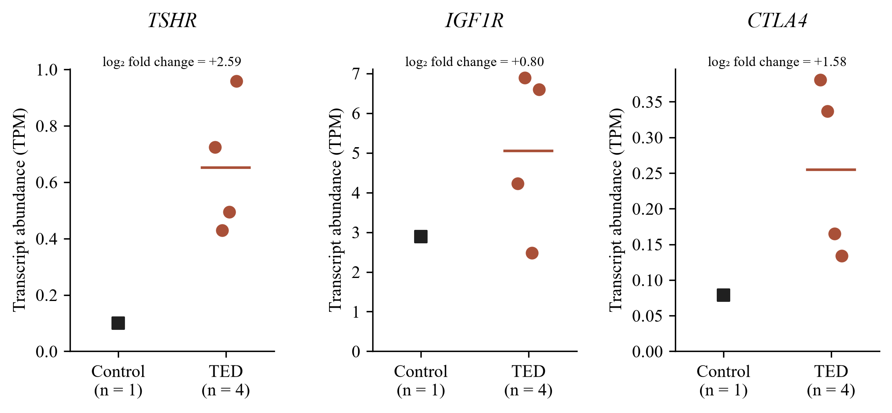
Figure S1. Descriptive orbital expression of TSHR, IGF1R and CTLA4. Transcript abundance in orbital adipose tissue collected during orbital decompression from four patients with inactive TED, and in nasal fat pad from one person without thyroid disease undergoing cosmetic upper blepharoplasty. Points are biological samples (technical replicates combined); horizontal lines show TED means. The log₂ fold change is log₂[(mean TED TPM + 0.01)/(control TPM + 0.01)]. Vertical axes differ by gene. The control came from a different fat depot, and one control cannot estimate control-group variance; no inferential test was performed, and these observations do not validate the genetic findings. TED, thyroid eye disease; TPM, transcripts per million.

Figure S2
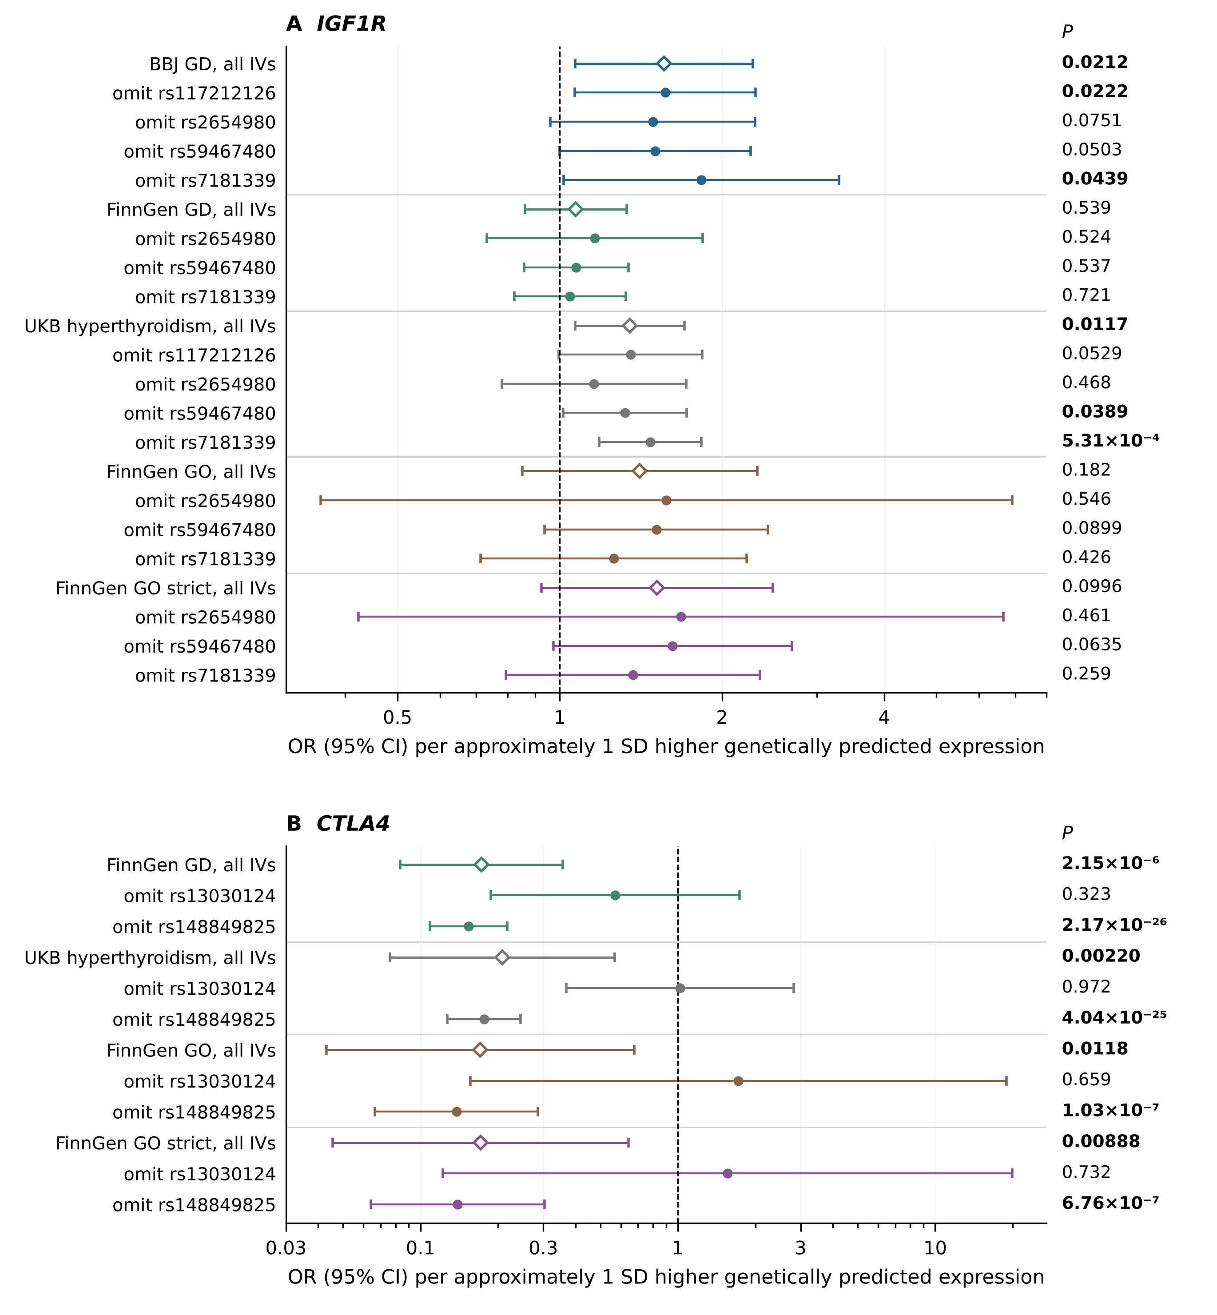
Figure S2. Dependence of IGF1R and CTLA4 estimates on individual instruments. For each dataset, the open diamond is the estimate using all instruments (as in Table 2), and the filled points below it omit the named instrument (IVW when at least two instruments remain, Wald ratio when one remains). Lines are 95% CIs on a logarithmic axis; the dashed line is OR = 1. P values are shown at right; bold, nominal P < 0.05. (A) IGF1R in all five datasets. (B) CTLA4 in the four FinnGen and UKB datasets; BBJ CTLA4 and all TSHR estimates use one instrument and could not be assessed. The 25 post hoc omission estimates reuse the same association data and are not independent replications; loss of nominal significance can reflect reduced precision as well as the omitted variant’s contribution. CI, confidence interval; IV, instrumental variable; IVW, inverse-variance weighted; OR, odds ratio; SD, standard deviation; BBJ, Biobank Japan; FinnGen GD, E4_GRAVES_STRICT; GD, Graves disease; GO, Graves ophthalmopathy; UKB, UK Biobank.

