4-3 회로 응용

201522405 최준하

회로도:

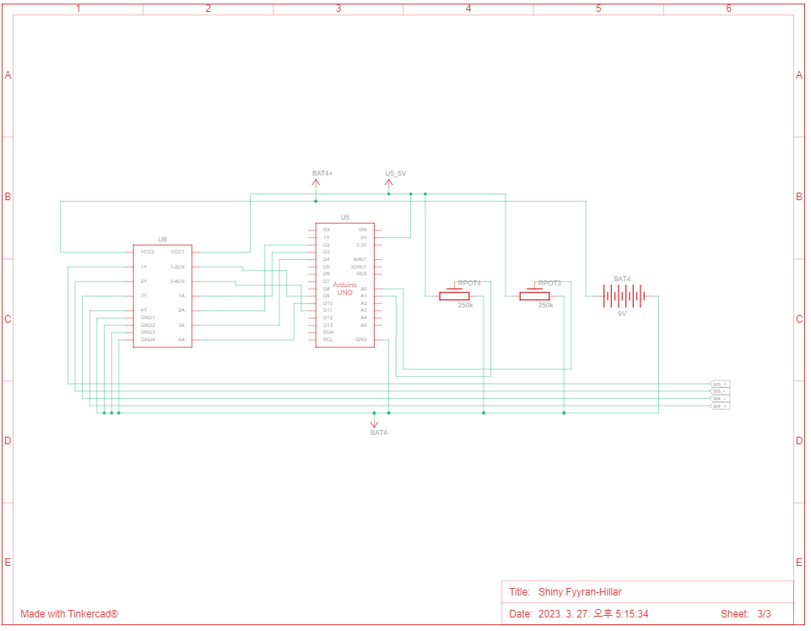

구동코드:

const int right_en =9;

const int left_en =11;

const int r_mc_1 =3;

const int r_mc_2 =2;

const int l_mc_1 =10;

const int l_mc_2 =4;

const int r_pot =0;

const int l_pot =1;

int r_val = 0;

int l_val = 0;

int r_velocity = 0;

int l_velocity = 0;

void setup()

{

pinMode(right_en, OUTPUT);

pinMode(left_en, OUTPUT);

pinMode(r_mc_1, OUTPUT);

pinMode(r_mc_2, OUTPUT);

pinMode(l_mc_1, OUTPUT);

pinMode(l_mc_2, OUTPUT);

new_break();

}

void loop()

{

r_val = analogRead(r_pot);

l_val = analogRead(l_pot);

check_r();

check_l();

}

void check_r()

{

if(r_val > 562)

{

r_velocity = map(r_val, 563, 1023,0,255);

forward("right",r_velocity);

}

else if(r_val < 462)

{

r_velocity = map(r_val, 461, 0, 0, 255);

reverse("right",r_velocity);

}

else

{

new_break();

}

}

void check_l()

{

if(l_val > 562)

{

l_velocity = map(l_val, 563, 1023,0,255);

forward("left",l_velocity);

}

else if(l_val < 462)

{

l_velocity = map(l_val, 461, 0, 0, 255);

reverse("left",l_velocity);

}

else

{

new_break(); //멈춤

}

}

void forward(String dir ,int rate) //정방향 함수

{

if(dir == "right")

{

digitalWrite(right_en,LOW);

digitalWrite(r_mc_1,HIGH);

digitalWrite(r_mc_2,LOW);

analogWrite(right_en, rate);

}

else if(dir == "left")

{

digitalWrite(left_en,LOW);

digitalWrite(l_mc_1,HIGH);

digitalWrite(l_mc_2,LOW);

analogWrite(left_en, rate);

}

}

void reverse(String dir,int rate) //역방향 함수

{

if(dir == "right")

{

digitalWrite(right_en,LOW);

digitalWrite(r_mc_1,LOW);

digitalWrite(r_mc_2,HIGH);

analogWrite(right_en, rate);

}

else if(dir == "left")

{

digitalWrite(left_en,LOW);

digitalWrite(l_mc_1,LOW);

digitalWrite(l_mc_2,HIGH);

analogWrite(left_en, rate);

}

}

void new_break() //멈춤 함수

{

digitalWrite(right_en,LOW);

digitalWrite(r_mc_1,LOW);

digitalWrite(r_mc_2,LOW);

digitalWrite(right_en, HIGH);

digitalWrite(left_en,LOW);

digitalWrite(l_mc_1,LOW);

digitalWrite(l_mc_2,LOW);

digitalWrite(left_en, HIGH);

}

동작 화면:

