x1=[0.2,0.4,0.6,0.8,1.0];

y1=[0.98,0.92,0.81,0.64,0.38];

i=[0,1,11,10];

x2=0.2+0.08.*i;

y2_1=interp1(x1,y1,x2,'spline'); % 三次样条插值

[~,y2_2]=newton(x1,y1,x2); % 牛顿插值

y2_3=lagr1(x1,y1,x2); % 拉格朗日插值

plot(x1,y1,'g',x2,y2_1,'--',x2,y2_2,'c*',x2,y2_3,'b+'); % 绘图

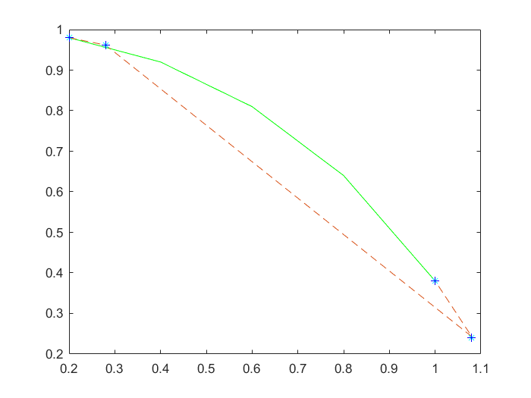

% 图像对比

subplot(2,2,1);

plot(x1,y1,'-o');

title('原函数')

subplot(2,2,2);

plot(x2,y2_1,'-o');

title('三次样条插值')

subplot(2,2,3);

plot(x2,y2_2,'-o');

title('牛顿插值')

subplot(2,2,4);

plot(x2,y2_3,'-o');

title('拉格朗日插值')

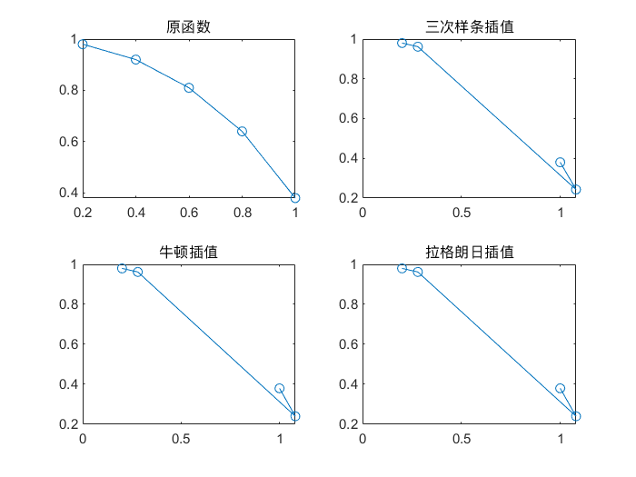

## **相关函数**

function [A,y]=newton(X,Y,x)

% 牛顿插值函数

% 参数含义

% X-样本点

% Y-样本值

% x-查询点

n=length(X);m=length(x);

for t=1:m

z=x(t); A=zeros(n,n);A(:,1)=Y';

s=0.0;y=0.0;c1=1.0;

for j=2:n

for i=j:n

A(i,j)=(A(i,j-1)-A(i-1,j-1))/(X(i)-X(i-j+1));

end

end

C=A(n,n);

for k=1:n

p=1.0;

for j=1:k-1

p=p*(z-X(j));

end

s=s+A(k,k)*p;

end

ss(t)=s;

end

y=ss;

A=[X',A];

end

function y=lagr1(x0,y0,x)

% 拉格朗日插值函数

% 参数含义

% x0-样本点

% y0-样本值

% x-查询点

n=length(x0); m=length(x);

for i=1:m

z=x(i);

s=0.0;

for k=1:n

p=1.0;

for j=1:n

if j~=k

p=p*(z-x0(j))/(x0(k)-x0(j));

end

end

s=p*y0(k)+s;

end

y(i)=s;

end

end